**Effects of Covid 19 Vaccines**

**Gender Differences**

**By Craig Paardekooper (January 10th 2022)**

**WORLD HEALTH ORGANISATION DATA**

**Source :** <http://www.vigiaccess.org> (enter COMIRNATY into search box)

Number of adverse reaction reports for each gender after receiving Pfizer’s vaccine – under brand name COMIRNATY

**VAERS DATA**

**Source :** <https://vaers.hhs.gov/data/datasets.html>

Number of adverse reaction reports for each gender submitted to VAERS in the USA over the entire period of 2021.

The VAERS database as of 29th December 2021 for USA (domestic) vaccinations for Pfizer, Moderna and Janssen.  
  
Female 462539 reports

Male 201459 reports

**EUDRAVIGILANCE DATA TOTALS**

**Source :** [**https://www.adrreports.eu/en/search_subst.html#**](https://www.adrreports.eu/en/search_subst.html)

Number of adverse reaction reports for each gender after receiving Covid 19 vaccine. Totals since beginning of vaccine deployment until 01/01/2022.

**Moderna**

**Pfizer**

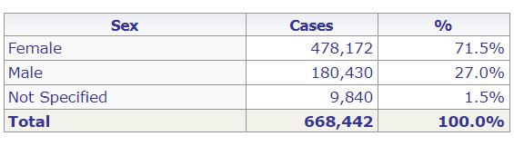

**Astrazeneca**

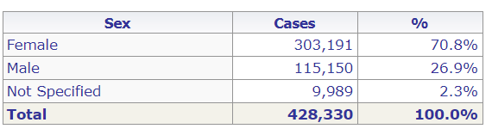

**Janssen**

**EUDRAVILIGANCE DATA BY SYMPTOMS**

**Source :** [**https://www.adrreports.eu/en/search_subst.html#**](https://www.adrreports.eu/en/search_subst.html)

Eudravigilance – Moderna - **(CX-024414) -** (up to 01/01/2022)

Here are the number of cases reported for females and males aged 18-64, by type of disorder.

|  |  |  |
| --- | --- | --- |
| **Disorder** | **Female** | **Male** |
| Blood & lymphatic system disorders | 6,790 | 1,573 |
| Cardiac disorders | 6,086 | 4,765 |
| Congenital, familial and genetic disorders | 66 | 41 |
| Ear and labyrinth disorders | 3,066 | 1,358 |
| Endocrine disorders | 282 | 66 |
| Eye disorders | 3,607 | 1,444 |
| Gastro-intestinal disorders | 24,238 | 6,241 |
| Hepatobiliary disorders | 262 | 180 |
| Immune system disorders | 2,875 | 779 |
| Infections and infestations | 7,482 | 3,574 |
| Metabolism and nutrition disorders | 1,763 | 764 |
| Musculoskeletal and connective tissue disorders | 34,952 | 11,814 |
| Cancers, neoplasms, tumours | 176 | 104 |
| Nervous system disorders | 45,150 | 17,460 |
| Renal and urinary disorders | 904 | 572 |
| Respiratory, thoracic and mediastinal disorders | 9,324 | 4,287 |
| Skin and subcutaneous disorders | 14,807 | 4,203 |
| Vascular disorders | 5,024 | 2,295 |

Eudravigilance – Pfizer – **TOZINAMERAN -** (up to 01/01/2022)

Here are the number of cases reported for females and males aged 18-64, by type of disorder.

|  |  |  |
| --- | --- | --- |
| **Disorder** | **Female** | **Male** |
| Blood & lymphatic system disorders | 29,155 | 6,516 |
| Cardiac disorders | 23,131 | 12,604 |
| Congenital, familial and genetic disorders | 162 | 85 |
| Ear and labyrinth disorders | 11,809 | 4,311 |
| Endocrine disorders | 1,103 | 181 |
| Eye disorders | 13,202 | 4,269 |
| Gastro-intestinal disorders | 79,906 | 16,971 |
| Hepatobiliary disorders | 643 | 397 |
| Immune system disorders | 10,617 | 2,342 |
| Infections and infestations | 28,774 | 14,204 |
| Metabolism and nutrition disorders | 4,799 | 1,547 |
| Musculoskeletal and connective tissue disorders | 375,397 | 32,358 |
| Cancers, neoplasms, tumours | 496 | 192 |
| Nervous system disorders | 155,126 | 44,560 |
| Renal and urinary disorders | 2,202 | 1,098 |
| Respiratory, thoracic and mediastinal disorders | 35,477 | 11,969 |
| Skin and subcutaneous disorders | 41,639 | 11,241 |
| Vascular disorders | 19,217 | 6,639 |

**Source :** [**https://www.adrreports.eu/en/search_subst.html#**](https://www.adrreports.eu/en/search_subst.html)

Eudravigilance – Astrazeneca - **(CHADOX1 NCOV-19)**(up to 01/01/2022)

Here are the number of cases reported for females and males aged 18-64, by type of disorder.

|  |  |  |
| --- | --- | --- |
| **Disorder** | **Female** | **Male** |
| Blood & lymphatic system disorders | 7,805 | 2,443 |
| Cardiac disorders | 11,008 | 3,911 |
| Congenital, familial and genetic disorders | 105 | 53 |
| Ear and labyrinth disorders | 7,552 | 2,401 |
| Endocrine disorders | 406 | 106 |
| Eye disorders | 11,196 | 3,644 |
| Gastro-intestinal disorders | 69,653 | 14,753 |
| Hepatobiliary disorders | 422 | 271 |
| Immune system disorders | 3,211 | 783 |
| Infections and infestations | 18,909 | 8,238 |
| Metabolism and nutrition disorders | 7,626 | 1,970 |
| Musculoskeletal and connective tissue disorders | 104,942 | 30,996 |
| Cancers, neoplasms, tumours | 298 | 121 |
| Nervous system disorders | 140,458 | 42,960 |
| Renal and urinary disorders | 2,041 | 925 |
| Respiratory, thoracic and mediastinal disorders | 21,551 | 7,822 |
| Skin and subcutaneous disorders | 30,608 | 8,510 |
| Vascular disorders | 13,816 | 5,212 |

Eudravigilance – Janssen - **(AD26.COV2.S)** (up to 01/01/2022)

Here are the number of cases reported for females and males aged 18-64, by type of disorder.

|  |  |  |
| --- | --- | --- |
| **Disorder** | **Female** | **Male** |
| Blood & lymphatic system disorders | 578 | 355 |
| Cardiac disorders | 927 | 808 |
| Congenital, familial and genetic disorders | 16 | 13 |
| Ear and labyrinth disorders | 594 | 417 |
| Endocrine disorders | 57 | 21 |
| Eye disorders | 789 | 482 |
| Gastro-intestinal disorders | 5,874 | 2,350 |
| Hepatobiliary disorders | 21,061 | 15,044 |
| Immune system disorders | 249 | 172 |
| Infections and infestations | 2,133 | 2,690 |
| Metabolism and nutrition disorders | 324 | 200 |
| Musculoskeletal and connective tissue disorders | 9629 | 4855 |
| Cancers, neoplasms, tumours | 28 | 23 |
| Nervous system disorders | 12,066 | 7,240 |
| Renal and urinary disorders | 190 | 178 |
| Respiratory, thoracic and mediastinal disorders | 1,757 | 1,359 |
| Skin and subcutaneous disorders | 1,770 | 1,166 |
| Vascular disorders | 1,489 | 1,094 |

**PFIZER’S REPORT**

A document, provided by Pfizer following a Freedom of Information Request, describes 42,086 adverse events between December 1st 2020 and Feb 28th 2021. See - [Pfizer Leak - see p 16](https://howbad.info/pfizerleak.pdf) .

In table 1 of that report, you can see the relative number of adverse reactions for females and males

Females 29,914 adverse reaction cases

Males 9182 adverse reaction cases

If you scroll down to p16 of the report, Pfizer goes into some detail for each of the severe adverse reactions. Remember these reactions all happened in just 90 days from start of deployment of the vaccines, and they are only the ones reported to Pfizer directly.

|  |  |  |
| --- | --- | --- |
| **Adverse Reaction** | **Female** | **Male** |
| Cardio-vascular (e.g. Heart attack) | 1076 | 291 |
| Haematological (e.g. Haemorrhage) | 676 | 222 |
| Hepatic (e.g. liver damage) | 43 | 26 |
| Facial Paralysis | 295 | 133 |
| Auto-immune disease | 526 | 156 |
| Musculo-skeletal (e.g. Arthritis, chronic fatigue) | 2760 | 711 |
| Neurological (e.g. seizures, convulsions, multiple sclerosis, tremors) | 328 | 150 |
| Herpes | 5969 | 1860 |
| Renal (e.g. kidney failure) | 46 | 23 |
| Respiratory (e.g. severe acute respiratory distress) | 72 | 58 |
| Thromboembolic (e.g. blood clots) | 89 | 55 |
| Stroke | 182 | 91 |
| Vascular damage | 26 | 6 |

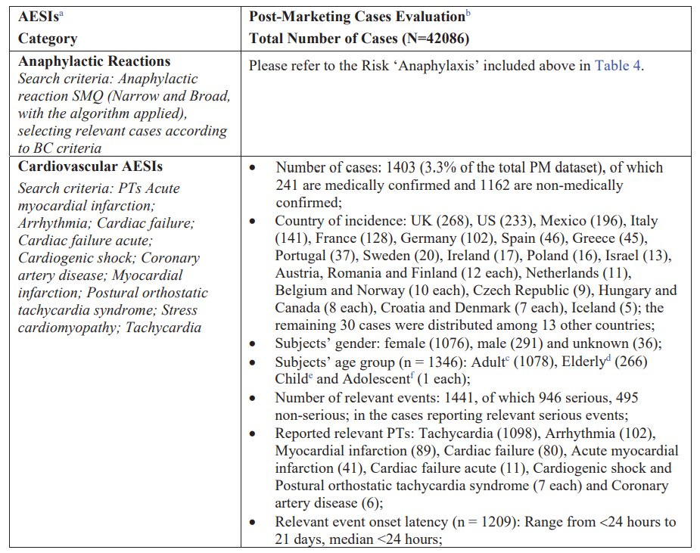

**VARIATION**

Once again we see evidence of massive variation – this time, not between batches, but rather between different groups in the population.

The vaccines were granted EUA because pharma promised to have a consistent reaction for all members of the population – NOT to decimate or seriously afflict one group compared to another.

**INTENTION**

Here we have a strong warning signal – a strong safety alert - that the vaccines are having a worse effect on women than on men.

* Is this warning signal being acknowledged by govt? No.
* Are they carrying out any investigations? No
* Are they exempting women from vaccination? No

So govt intention is to disregard strong safety signals completely? Yes.   
  
If their intention is NOT to protect you from harm – AND they are actively promoting the harmful intervention - then we can only conclude that their intention is to harm.

**PURPOSE**

Once we acknowledge intention to harm, then we can ask WHY. What is the purpose of targeting women in such a comprehensive way?

Harm and injury inhibit reproduction in several ways –

1. Illness is not attractive to others
2. Physical activities become painful or impossible
3. Poisoning of the blood effects pregnancy and child birth

**ACTION**

What can women do?

1. Do not comply with vaccine mandates
2. Keep your self and your family safe
3. Warn others – raise awareness