**What’s your Poison? by Craig Paardekooper**

It seems obvious, but the toxicity of a poison can be determined by its lethality – the % of people who die after taking it.

In the same way, the toxicity of a lot might be measured by the % of adverse reaction reports resulting in a fatality for that lot.

**Some lots appear to be more toxic than others**

When I examined the Pfizer lots, I found that they grouped into alphabetic series such as EN, ER, EW, FA, FC, FF. Within each of these alphabetic groups I observed the following -

1. there was a distinct group of lots displaying very high numbers of adverse reactions – typically 100 times greater than any of the remaining lots in that same alphabetic group.
2. there was no gradual transition from lots with high adverse reactions to lots with low adverse reactions – instead there was a sudden drop by 2 orders of magnitude.
3. the lots with very high adverse reaction numbers had batch codes belonging to the same sequential mathematical series.

Between each of these alphabetic groups I observed the following -

1. there was a linear stepwise decrease in adverse reactions as the group ascended the alphabet.

This gave every appearance that the lots were varying in toxicity, not just within their own alphabetic group, but between groups also, and that this variation in toxicity had been carefully labelled with sequential mathematical batch codes.

**Measuring the lethality**

First, I identified the lots with high adverse reaction numbers in each alphabetic group. (see p 3, 4, 5) .

[Data was from VAERS 2021 for USA only. I will need to repeat this study for VAERS 2021 Outside of USA.]

Then I counted the number of deaths for these lots, and divided that by the total number of adverse reports for these lots.

% Lethality = Number of Deaths/Total number of Reports * 100

This gave me the % of the reports resulting in death.

**Results**

EK Series 7047 adverse reports 99 deaths lethality = 1.4%

EL Series 31140 adverse reports 913 deaths lethality = 2.9%

EN Series 30354 adverse reports 780 deaths lethality = 2.5%

ER Series 24288 adverse reports 243 deaths lethality = 1%

EW Series 49233 adverse reports 311 deaths lethality = 0.6%

**Conclusion**

So the stepwise decline in adverse reactions coincides with a stepwise reduction in the % of reports resulting in death – indicating that the lots with high adverse reaction numbers really are more toxic.

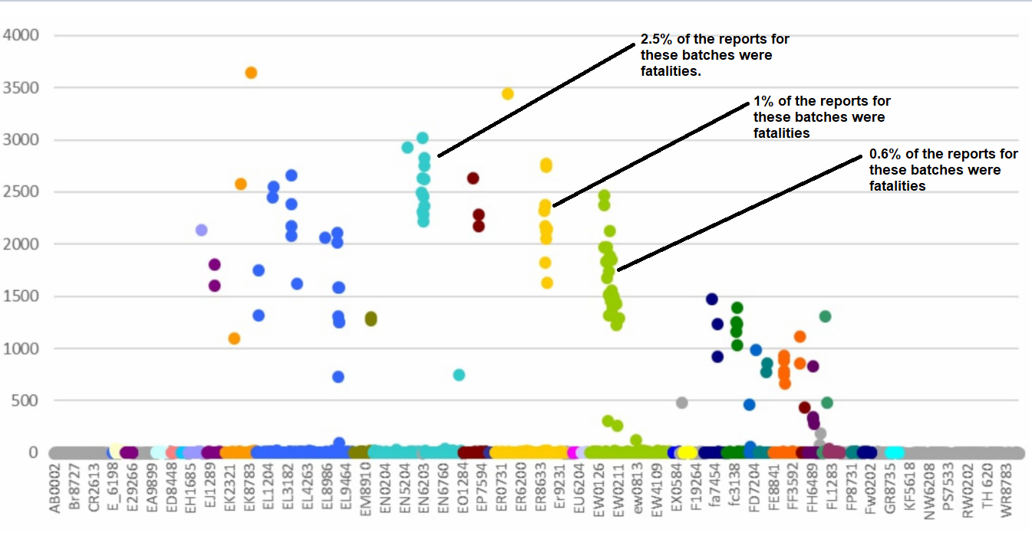

This chart shows the lots arranged by batch code alphabetically along the x axis. The y axis shows the number of adverse reactions for each lot.

You can see how lots form groups with very similar batch codes, where the codes are all part of the same mathematical series. You can also see how these series identify distinct ranges of toxicity.

Here is a close up of the EK Series.

I calculated the % lethality for the lots shaded in yellow.

1.4% of adverse reaction reports ended in fatality.

Here is a close up of the EL Series.

I calculated the % lethality for the lots shaded in yellow.

2.9% of adverse reaction reports ended in fatality.

Here is a close up of the EN Series.

I calculated the % lethality for the lots shaded in yellow.

2.5% of adverse reaction reports ended in fatality.

Here is a close up of the ER Series

I calculated the % lethality for the lots shaded in yellow.

1% of adverse reaction reports ended in fatality.

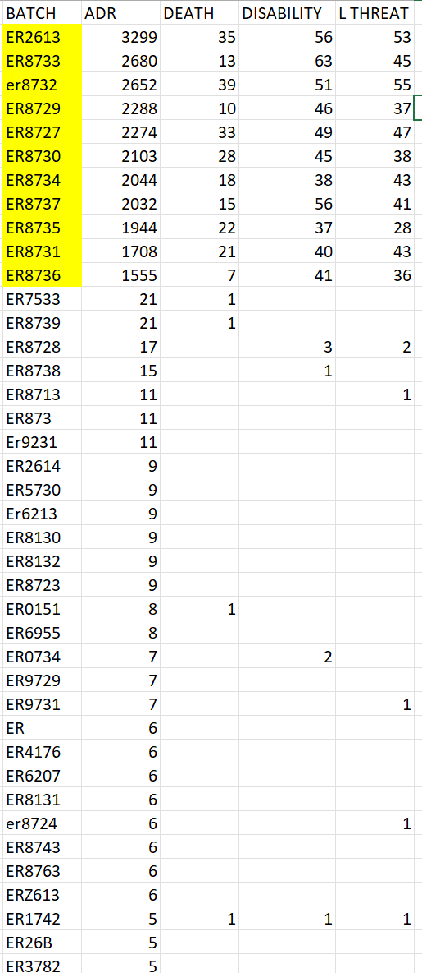

Here is a close up of the EW Series

I calculated the % lethality for the lots shaded in yellow.

0.6% of adverse reaction reports ended in fatality.

