ERD Digaram
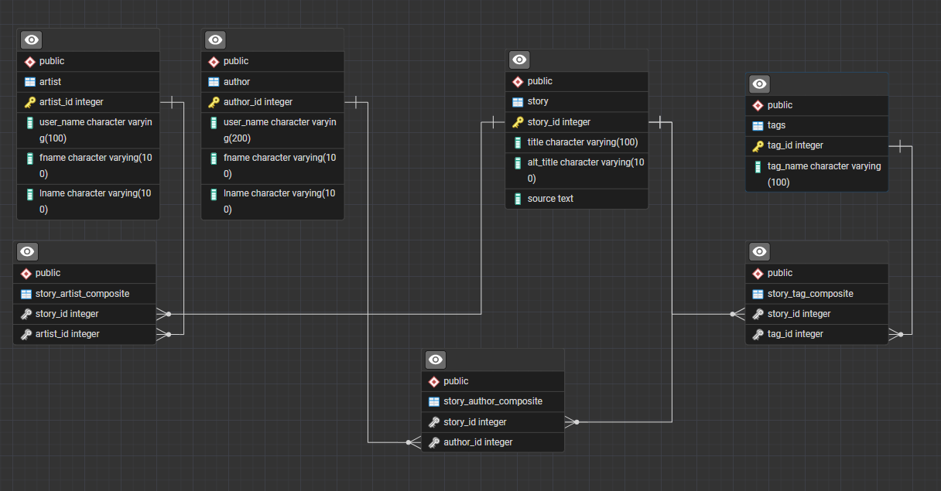

Tables:
Contained in TableCreation.sql.

Author
Author represents an individual author. Each row is a single person. This table contains author_id (INT Primary Key), user_name (varchar 100), fname (varchar 100) and lname(varchar 100).

Artist
Artist represents an individual author. Each row is a single person. This table contains author_id (INT Primary Key), user_name (varchar 100), fname (varchar 100) and lname(varchar 100).

Tags
Tag represents a ‘tag’ for a story, which describes a component or trope someone might be looking for or avoiding. This table has the coloms tag_id (INT Primary Key) and tag_name (varchar 100).

Story
Story represents a story. Each row is a single ‘story’. Series are denoted by ‘Vol’ in the title, and should have some part that is the same across all titles. It has the columns story_id INT PRIMARY KEY, title VARCHAR(100), alt_title VARCHAR(100), and source (text). Alt_title should be used if a story has an alternate title, often common for translated works, or older folk stories. Source describes what the story is in a sense of how one consumes the story. Novel, manga, fan fiction and concept albums are all examples for the source columns.

story_tag_composite
This is a fully dependent table that works to connect the story table to the tag table. It contains the foreign keys story_id (INT) and tag_id (INT).

story_author_composite
This is a fully dependent table that works to connect the story table to the tag table. It contains the foreign keys story_id (INT) and author_id (INT).

story_artist_composite
This is a fully dependent table that works to connect the story table to the tag table. It contains the foreign keys story_id (INT) and artist_id (INT).

Views
Contained in TestingView.sql

Title_AuthorName_Table
Joins story, story_author_composite, and author into one table. This table contains the story_id, author_id, title, and author's username. If a story exist, it will show the author.

Title_Tag
Joins story, story_tag_composite, and tags. This table contains title, tag_id, tag_name, and story_id. All titles and all tags are shown.

Procedures:

NewStory_NewAuthor
This procedure is for inserting a new author and new story at the same time. The ID numbers are not serial and so you must check what the next number should be. It adds values to the following tables: story, author, and story_author_composite. It takes the parameters story_id, title, source, author_id, user_name, fname, and lname.

NewStory
This procedure is fro adding a new story, but there author is already in the database. The ID numbers are not serial and so you must check what the next number should be. It adds values to the tables story and story_author_composite. It takes the parameters: story_id, title, source, author_id.

delete_story
This procedures will take a story out of the database, however it dose not remove an author from the data base. It deletes information from story_author_composite and story. It takes the parameters story_id and author_id.

tag_to_story
This procedure adds values s to story_tag_composite. It takes the parameters of story_id and tag_id.

Query Examples:
Containted in QueryExamples.sql
Various examples of sql code that dose stuff.
SELECT * FROM story Order BY(story_id) DESC;
SELECT * FROM author Order BY(author_id) DESC;
SELECT * FROM title_authorname_table ORDER BY (title);
SELECT * FROM title_tag where story_id = 42;
-- Use to search for key terms in titles
SELECT * FROM title_authorname_table where title LIKE '%Bless%';
-- Use of Max
SELECT Max(author_id) from author;
SELECT Max(story_id) from story;
-- Various use of SELECT and ORDER BY
SELECT * FROM story Order BY(story_id) DESC LIMIT(5);
SELECT * FROM author Order BY(author_id) ;
SELECT distinct user_name FROM title_authorname_table;
-- Various GROUP BY
SELECT source, COUNT(story_id) FROM story GROUP BY (source);
SELECT user_name, COUNT(story_id) FROM title_authorname_table GROUP BY (user_name);
SELECT * FROM title_authorname_table where author_id = 3;
-- Use of Avg, Disintc, Count, Group By and Order By
SELECT AVG(tag_count) FROM (SELECT DISTINCT tag_name, COUNT(tag_id) as Tag_Count FROM title_tag GROUP BY (Tag_name) ORDER BY (tag_count)DESC);
-- Concat
SELECT Concat(title,' by ', user_name) from title_authorname_table;
SELECT * FROM story Order BY(story_id) DESC;
SELECT * FROM author Order BY(author_id) DESC;
SELECT * FROM title_authorname_table ORDER BY (title);
SELECT * FROM title_tag where story_id = 42;
SELECT * FROM title_authorname_table where title LIKE '%One%';
SELECT * FROM title_tag where tag_name LIKE '%Sho%';
SELECT * FROM title_tag where story_id = 60;

