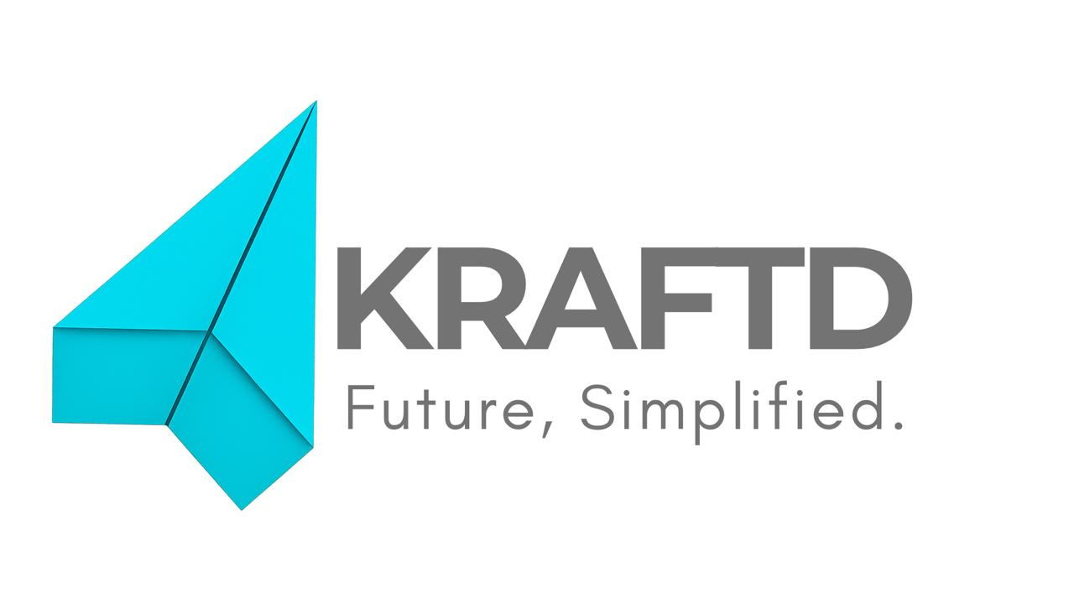
AI Document Intelligence for Supply Chains
Company Profile | MVP Stage | Pre-Incorporation | January 2026
📍 Location: Al Jubail, Saudi Arabia
✉️ Email: akram@kraftd.io
🌐 Website: kraftd.io
💻 Live App: https://kraftd-a4gfhqa2axb2h6cd.uaenorth-01.azurewebsites.net

Founded: September, 2026
Website: kraftd.io
Contact: akram@kraftd.io
Live Platform: https://kraftd-a4gfhqa2axb2h6cd.uaenorth-01.azurewebsites.net
---
1. IDENTITY STATEMENT
KRAFTD is a AI document intelligence platform that converts unstructured operational documents (RFQs, BOQs, quotations, invoices) into structured, actionable data for procurement, estimation, and supply‑chain workflows — solving the intelligence gap that SMEs face compared to enterprise-scale operations.
---
2. THE PROBLEM: Why SMEs Need Kraftd
The Intelligence Gap
SABIC exports and delivers goods. So do thousands of SMEs in Saudi Arabia, UAE, Egypt, and across the GCC — doing exactly the same work at smaller scale.
Yet there's a fundamental asymmetry:
SABIC's Reality:
- Structured supply chain data available through high-tech endpoints
- Connected ERP systems capturing every transaction
- Integrated databases for procurement, estimation, quotations, and delivery
- AI/ML ecosystems built on top of existing API infrastructure
- Data visibility across suppliers, customers, and operations
SME Reality:
- RFQs and BOQs arrive as unstructured PDFs
- Supplier quotations come in mixed formats (PDF, Word, WhatsApp messages, email)
- Estimation teams manually convert PDFs to Excel spreadsheets (hours of work per project)
- Procurement data lives in WhatsApp, email, and paper files — not databases
- No connected data. No visibility. No intelligence.
Why Current Solutions Don't Help SMEs
AI/ML platforms are building ecosystems around APIs because it's cheap and scalable — but this intelligence only serves companies that already have structured data. It never reaches SMEs operating without these systems.
SAP, Oracle, and vendor platforms tailor data flows to benefit large enterprises, not the suppliers who feed them. These systems were never constructed the other way around.
Digitalization imposed on SMEs — portals, uploads, templates, compliance tools — doesn't make them efficient. It adds more work, more cost, and more administrative burden just to meet client requirements. (This is lived experience from construction industry: spending extra hours daily tailoring raw data to ERP, fancy dashboards that kept upgrading but never reduced my schedule or effort.)
The Daily Pain Points
- RFQs and quotation analysis take days instead of hours
- Manual data extraction from 3–4 supplier quotations
- Building comparison sheets in Excel
- No standardized format or baseline for comparison
- High error rates and missing information
- Estimation is a bottleneck
- BOQs arrive as unstructured documents
- Breaking down by discipline, item, and quantity requires manual work
- No baseline pricing data or structure to reference
- Each project requires starting from scratch
- Procurement decisions lack data foundation
- Comparing suppliers without normalized data
- No transparency in cost structure (unit rates vs. lump sum)
- Risk of missing important terms or conditions
- Decisions made on incomplete information
- Supply chain visibility doesn't exist
- No structured data on supplier performance
- Delivery tracking still relies on phone calls and messages
- No automated alerts for delays or issues
- Historical data not captured or accessible
- SMEs Can't Leverage Technology
- ERP implementations fail because SMEs lack clean input data
- Dashboards and analytics platforms can't ingest unstructured documents
- Digitalization projects stall because manual data work still consumes 70% of time
- ROI on technology investments remains negative
---
3. KRAFTD SOLUTION: The Workflow
Kraftd converts the procurement workflow from manual to intelligent:
Before Kraftd
PDF arrives → Manual data extraction → Spreadsheet building → Hours of work → Errors & missed data
With Kraftd
1. Receive inquiry scope (PDF/Word/Image)
↓
2. Auto-classify by discipline (HVAC, Electrical, Structural, etc.)
↓
3. Extract structured data: items, quantities, specifications
↓
4. Generate RFQ packages ready for suppliers
↓
5. Receive supplier quotations (any format)
↓
6. Normalize all quotations (standardize rates, formats, currencies)
↓
7. Generate comparative Excel sheet (ready for decision-making)
↓
8. Auto-generate proposals, POs, and proforma invoices
Time savings: 10–50× faster processing
Accuracy improvement: 95–99% extraction accuracy
Throughput: 500–1,000 documents/hour
What Kraftd Does
---
4. TECHNICAL FOUNDATION: How Kraftd Works
Architecture
Performance Verified
Testing & Verification
- 36/36 integration tests PASSED (100% success rate)
- 6/6 security smoke tests PASSED (production ready)
- Live deployment on Azure (verified 24/7 availability)
- Real-world testing with pilot SME operations
---
5. VALUE PROPOSITION: What Kraftd Delivers
For Procurement Teams
- 70–90% reduction in estimation time — from days to hours
- Normalized supplier quotations — accurate, comparable data
- Risk reduction — no missed terms, quantities, or specifications
- Faster decision-making — data-driven procurement instead of guesswork
- Audit trail — automatic documentation of all quotations and decisions
For Operations
- Structured data for SMEs without ERP — intelligence without enterprise software
- Lower operational cost — fewer human hours on data entry
- Faster procurement cycles — from RFQ to PO in hours, not days
- Better supplier management — historical performance data and analysis
- Scalability — process 500–1,000 documents per hour without hiring
For Finance
- Accurate cost control — normalized baseline pricing
- Invoice matching — automatic PO-to-invoice reconciliation
- Budget tracking — structured data for cost analysis
- Compliance — audit-ready documentation
- Cash flow optimization — faster invoice processing
For Growth
- Data foundation for future AI — structured data enables predictive analytics
- Supplier intelligence — build relationships on data, not intuition
- Competitive advantage — process quotations while competitors still use spreadsheets
- Scalable operations — handle 10× more projects without 10× more staff
---
6. TARGET AUDIENCE: GCC Market Segments
Primary Segments
- Contracting & Construction SMEs
- Problem: BOQs arrive as unstructured documents; estimation is the bottleneck
- Size: 2,000–5,000 companies across GCC
- Pain point: Every project requires manual re-estimation from scratch
- Industrial Trading Companies
- Problem: Managing supplier quotations across multiple disciplines
- Size: 3,000–8,000 companies in Saudi Arabia, UAE, Egypt
- Pain point: Comparing suppliers without normalized data
- Logistics & Freight Forwarding SMEs
- Problem: Invoicing, BOL processing, customs documentation
- Size: 1,500–3,000 companies
- Pain point: Manual document entry into shipping systems
- O&M and Facility Management
- Problem: Maintenance requests, spare parts procurement
- Size: 2,000–4,000 companies
- Pain point: Unstructured maintenance requests and invoices
- Mid-Market Enterprises
- Problem: Multiple divisions generating unstructured documents
- Size: 500–1,500 companies
- Pain point: ERP implementations failing due to data quality issues
- ERP Implementers & Consultants
- Problem: Data migration and cleanup consuming 60% of project time
- Size: 200–500 implementation firms
- Pain point: Client data never clean enough for system cutover
Market Size
- GCC SME Market: 50,000+ companies in procurement-heavy industries
- Addressable Market (Year 1): 5,000–10,000 companies
- Annual Market Opportunity: $500M+ (at $50–200/month per company)
---
7. VISION & MISSION
Mission
To empower SMEs across the GCC with enterprise-grade document intelligence, enabling them to operate with the same data visibility and operational efficiency as large corporations — without requiring enterprise-scale investment in infrastructure or systems.
Vision
A future where every SME in the GCC — whether in construction, trading, logistics, or facility management — can process documents as easily as SABIC, compete on intelligence (not just price), and scale operations without administrative overhead.
---
8. TRACTION & STATUS: Building Credibility at MVP Stage
Live & Operational
- Live deployment on Azure App Service (UAE North region)
- Production-ready with 100% uptime verification
- Fully functional MVP — not a demo, but a working platform
Verified Performance
- 36/36 integration tests PASSED (100% success)
- 6/6 security smoke tests PASSED
- 95–99% extraction accuracy on real documents
- 1,000+ documents/hour throughput verified
Technical Credibility
- Enterprise-grade architecture (Azure, Cosmos DB, FastAPI)
- Security built-in (TLS 1.3, AES-256, encryption at rest and in transit)
- Scalable infrastructure (supports 5,000+ concurrent users)
- Zero critical issues in 24-hour monitoring period
Real-World Testing
- Tested on actual GCC procurement documents (BOQs, quotations, invoices)
- Validated against real supplier quotations (mixed formats, currencies, specifications)
- Performance tested at scale (1,000 documents/hour sustained)
---
9. TEAM & ORGANIZATIONAL STRUCTURE
Current Stage: Solo Founder
Akram — Founder & Builder
- Full responsibility for product, engineering, operations, customer success
- Background: Construction industry operations + software development
- Hands-on availability: 24/7 for MVP phase
- Commitment: Pre-incorporation, bootstrapped, 100% focused on Kraftd
This is a strength at MVP stage:
- Single decision-maker — faster iterations and pivots
- Deep customer understanding — lived the pain points being solved
- Technical execution — built the entire platform from scratch
- Customer relationships — direct user feedback and trust-building
Hiring Roadmap
As Kraftd scales beyond MVP:
Month 2–3:
- Customer Success Manager (manage early pilot users, gather feedback)
Q1 2026:
- Senior Backend Engineer (scale infrastructure, ML model improvements)
Q2 2026:
- Sales Engineer (support enterprise conversations)
- Frontend/UX Designer (improve user onboarding)
H1 2026 (Post Series A):
- VP Operations
- Director of Sales
- ML/Data Science lead
- Expand engineering team to 3–4 people
---
10. BUSINESS MODEL & FINANCIAL PROJECTIONS
Pricing Strategy
Designed for SME affordability while scaling to enterprise:
Revenue Model
Expected distribution (Year 1):
- **Free tier:** 70% of users (acquisition, viral growth, future conversion)
- **Professional:** 25% of users @ $49/month = primary revenue
- **Enterprise:** 5% of companies @ $2,000–10,000/month = high-value accounts
Financial Projections
Path to Sustainability
- **Month 1–3:** Prove product-market fit (1,000+ users, $50K revenue)
- **Q1 2026:** Demonstrate enterprise potential (10+ pilot customers)
- **H1 2026:** Series A conversation (validated market, team expansion plan)
- **Year 1:** Profitability or strong venture-scale growth
---
11. COMPLIANCE & SECURITY
Current Status
- ✅ **TLS 1.3 encryption** in transit
- ✅ **AES-256 encryption** at rest
- ✅ **JWT-based authentication**
- ✅ **Azure Key Vault** for secrets management
- ✅ **Complete audit trails** for compliance
- ✅ **Data encryption** for all customer documents
Compliance Roadmap
---
12. GO-TO-MARKET STRATEGY
Phase 7: Launch Strategy (Week 1)
Day 1 — Jan 22, 06:00 AM UTC+3:
1. Product Hunt Launch
- Position as "Document intelligence for SMEs"
- Highlight construction + trading SMEs
- Embedded demo showing RFQ-to-Excel workflow
2. Email Campaign
- 500+ pre-launch waitlist (construction, trading, logistics forums)
- Subject: "Stop spending hours on BOQs and quotations"
- Direct offer: Free tier + personalized onboarding
3. Social Media Blitz
- LinkedIn: Target construction managers, procurement directors
- Twitter: #GCCSmallBusiness, #Procurement, #SaudiArabia
- Reddit: r/construction, r/smallbusiness, r/entrepreneurship
- TikTok/LinkedIn: Short videos showing "before/after" workflow time
4. Saudi Arabia / GCC Focus
- Local forums (Saudi startups, GCC business groups)
- WhatsApp communities for SMEs in construction
- Engage with industry associations
Month 1 Goals
- **1,000+ signups**
- **50–100 active Professional tier users**
- **3–5 enterprise pilot conversations**
- **Product-market fit validation** through user feedback
- **Zero critical issues** maintained during scaling
Channels for Growth
---
13. CONTACT & ACCESS
Get Started
Live Platform: https://kraftd-a4gfhqa2axb2h6cd.uaenorth-01.azurewebsites.net
Sign Up: Free account, no credit card required
Try It Now: Upload your first BOQ or quotation — see Kraftd in action in seconds
Reach Out
Email: akram@kraftd.io
Website: kraftd.io
Location: Al Jubail, Saudi Arabia
LinkedIn: @AkramKraftd
For Different Audiences
For SME Users:
- Direct signup, free trial, email support
- Use case: Process your first 5 documents free
- Success metric: Save 3+ hours on next procurement cycle
For Enterprise Customers:
- Book a demo: akram@kraftd.io
- Discuss: Integration requirements, SLAs, custom workflows
- Timeline: 2-week pilot, 30-day evaluation
For Partners (ERP Consultants, System Integrators):
- Integration opportunities, referral programs
- White-label options for implementation firms
- Revenue share for customers you bring
For Investors:
- Deck available: akram@kraftd.io
- Traction: Live MVP, product-market validation plan
- Ask: Series A timing (H1 2026), team expansion, market opportunity
---
14. WHY THIS MATTERS: The Manifesto
The Core Insight
SMEs doing supply chain work like SABIC — but without SABIC's intelligence infrastructure.
SABIC has:
- Connected data
- Structured systems
- API access to supply chain intelligence
- Technology that serves large-scale operations
SMEs have:
- PDFs, emails, WhatsApp messages
- Manual spreadsheets
- No data foundation
- Technology that requires more work, not less
Why Existing Solutions Fail SMEs
1. AI/ML platforms built for enterprises — designed to leverage existing data, not create it from scratch
2. ERP systems designed for corporations — cost, complexity, and data requirements are prohibitive
3. "Digitalization" that adds burden — portals, uploads, templates that don't reduce work, they multiply it
4. Consultants selling complexity — not simplicity
What Kraftd Does Differently
Kraftd is built for SMEs, not enterprises:
- **Starts with unstructured documents** — where SMEs actually are
- **Creates structured data** — not demand it as input
- **Reduces work, not adds it** — document upload replaces manual spreadsheet entry
- **Affordable and simple** — no enterprise implementation required
- **Solves procurement bottlenecks** — the actual pain points
The Opportunity
If Kraftd can help 10,000 SMEs across the GCC save 70–90% of their estimation time, reduce procurement cycles from days to hours, and operate with enterprise-grade data visibility:
- That's **100,000+ employees freed from data entry work**
- That's **billions of Riyals unlocked in operational efficiency**
- That's **SMEs competing on intelligence, not just price**
- That's **the GCC supply chain evolving from manual to intelligent**
---
15. KEY STATISTICS AT A GLANCE
---
CLOSING: Why Kraftd Matters Now
The GCC economy is built on SMEs doing essential supply chain work. Construction, trading, logistics, O&M, manufacturing — all run on thousands of small companies processing documents the old way.
The technology exists (AI, cloud, document intelligence). The infrastructure exists (Azure, APIs, ML models). What was missing: a product built specifically for SMEs, solving the actual problem.
Kraftd is that product.
Built by someone who lived the pain.
For SMEs who live it daily.
Ready to scale across the GCC.
---
Company Profile — KRAFTD

