Decentralized Ethereum-Based Crowdfunding Platform

Software Development Document



Supervisor
Dr. Rana Nazeer Ahmad

Submitted By
Hanan Khan
F22BINFT1M01148
BS-IT 7TH 3M

Dept. of Information Technology

Date: 09 Jan 2026

The Islamia University of Bahawalpur

1. Introduction

1.1 Purpose of the Software Design Document
The purpose of this Software Design Document is to provide a detailed technical and architectural translation of the requirements specified in the Software Requirements Specification (SRS). This document serves as a comprehensive blueprint for the development of a decentralized crowdfunding application, ensuring that the implementation phase adheres to the established design philosophy of transparency and cryptographic security. It bridges the gap between high-level functional needs and the physical realization of the system on the Ethereum blockchain.

1.2 Scope of the System
The scope of the system is strictly bounded to the development of a web-based decentralized application (dApp) that utilizes Ethereum smart contracts to manage the lifecycle of a fundraising campaign. This includes:
- Creation of a CampaignFactory for contract deployment
- A responsive user interface built with React.js
- A robust interaction layer using MetaMask for secure transaction signing
The system supports core crowdfunding mechanics such as contribution processing, milestone-based fund release and automated refunds. Explicitly excluded from this design are fiat currency integrations, native mobile applications and multi-chain compatibility.

2. System Overview

2.1 High Level Description of the System
The platform is designed as a standalone decentralized application that shifts the traditional crowdfunding model toward a trustless, client-blockchain paradigm. The system removes the need for centralized intermediaries such as Kickstarter or GoFundMe by utilizing the Ethereum blockchain as its immutable global backend. The user interacts with a React.js frontend which communicates directly with smart contracts deployed on the blockchain via a digital wallet.

2.2 System Goals and Objectives
The primary objective of this system is to eliminate financial and administrative intermediaries to reduce transaction costs and mitigate the risk of platform censorship. The system aims to ensure the transparent handling of funds through an immutable public ledger, providing participants with a trustless environment where predefined contractual rules regarding fund release and refunds are automatically enforced. Additionally, the platform seeks to provide a user-friendly interface that abstracts the complexities of blockchain technology for non-technical users.

2.3 Summary of Core Functionalities
The system provides a complete self-contained workflow for fundraising. Key functionalities include:
- Creators can instantiate new campaigns by providing a title, goal, and deadline.
- Contributors can securely send ETH to active campaigns, with their contribution details recorded immutably on-chain.
- The system evaluates campaign success based on goal attainment before the deadline, allowing creators to withdraw funds if successful or enabling contributors to claim refunds if the campaign fails.

2.4 Operating Environment
The application operates within a standard web browser environment equipped with the MetaMask browser extension. The logic resides on the Ethereum blockchain (mainnet or testnet), while the frontend application is hosted on decentralized or standard hosting platforms such as IPFS, Vercel, or Netlify.

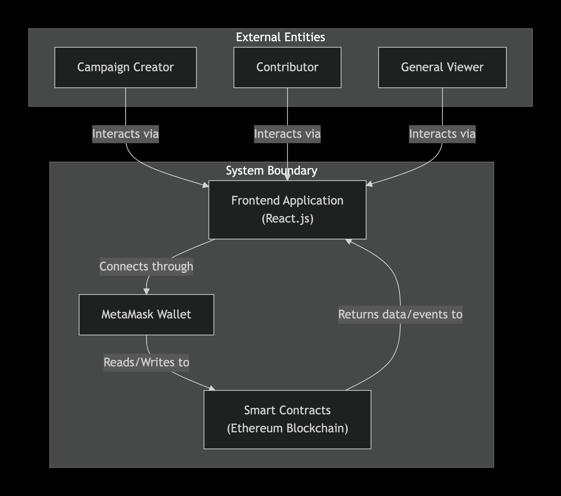
A Context Diagram illustrating the interaction between external entities and system boundary

3. Architectural Design

3.1 Overall System Architecture
The system architecture follows a decentralized model where the presentation layer and the logic layer are decoupled. The React.js application serves as the frontend client, while the Ethereum blockchain functions as the backend. There is no centralized application server or traditional database, all persistent state and business logic are stored within the Smart Contract Suite.

3.2 Description of Architectural Style and Rationale
The chosen architectural style is a client-blockchain paradigm, which provides inherent resistance to censorship and high availability. By utilizing self-executing smart contracts to manage fund custody and disbursement, the system replaces human-centric trust with cryptographic guarantees. This rationale is supported by the need to address the systemic inefficiencies and third-party risks found in centralized crowdfunding models.

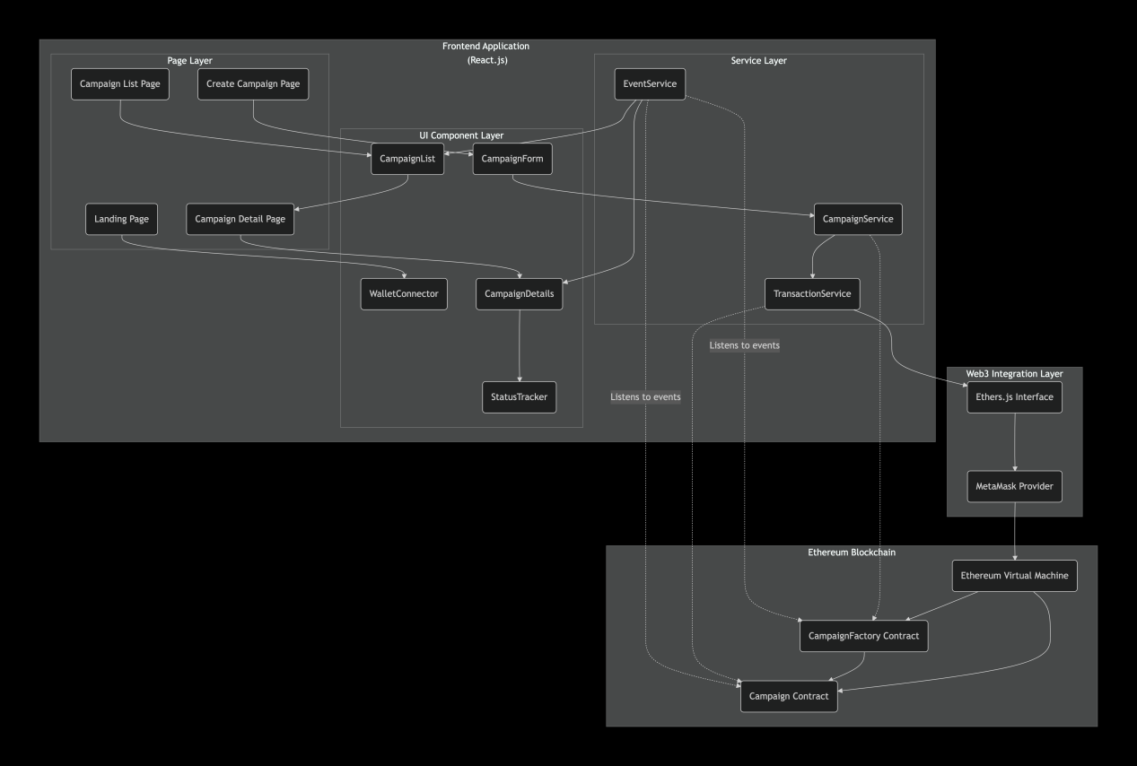
A Component Diagram presenting the modular structure of platform

3.3 Logical and Physical Architecture Explanation
Logically, the system is organized into three layers: the User Interface Layer, the Web3 Interaction Layer and the Blockchain Logic Layer. Physically, the UI layer consists of static assets distributed via hosting services like Vercel or Netlify, while the logic layer is replicated across thousands of nodes in the Ethereum network. This physical distribution ensures that the campaign data remains permanent and auditable as long as the Ethereum network exists.

3.4 Technology Stack Selection and Justification
The technology stack is selected based on security, developer ecosystem support and industry best practices:
- Solidity and Foundry are used for smart contract development due to their dominance in the Ethereum ecosystem and robust testing capabilities.
- React.js is selected for the frontend to create a responsive, single-page application.
- Ethers.js and MetaMask are utilized to bridge the gap between the web browser and the blockchain, ensuring secure transaction signing and network connectivity.

4. Component Level Design

4.1 Identification of Major System Components
The system is comprised of three primary component groups:
- Smart Contract Suite
- Frontend Application
- External Wallet Integration
Within these groups, the CampaignFactory and the Campaign contracts serve as the core logical units.

4.2 Responsibilities and Functionality of Each Component
The responsibilities of each component include:
- CampaignFactory: This component is responsible for instantiating new Campaign smart contracts and maintaining a global index of all deployed campaigns to facilitate browsing.
- Campaign Template: Each instance is responsible for managing its own state, including tracking the balance, fundingGoal, deadline and the backers mapping which records individual contributions.
- Frontend UI Modules: These are responsible for providing forms for campaign creation, displaying real-time data retrieved from the blockchain and providing user feedback during transaction processing.

4.3 Communication and Interaction Among Components
The Frontend interacts with the CampaignFactory to create new instances. Once a campaign is deployed, the Frontend communicates with that specific contract address to fetch its current funding status or to trigger contribution and withdrawal functions. All state-changing communication is mediated by the MetaMask service, which requires a user signature before a transaction is broadcast to the Ethereum network.

4.4 Dependency Considerations
The system is critically dependent on the MetaMask browser extension for all authenticated actions. It also relies on the Ethereum network's availability; if the network is congested, transaction processing times and gas costs will increase accordingly.

5. Data Design

5.1 Overview of Data Storage Approach
Data storage approach is purely decentralized and non-relational. All persistent data is stored within the storage slots of the smart contracts on the Ethereum blockchain, ensuring that all campaign data is immutable and public.

5.2 Description of Data Entities and Relationships
The following entities are crucial:
- CampaignFactory Entity: Stores an array of addresses corresponding to all deployed campaigns.
- Campaign Entity: Contains the campaign title, description, funding goal, deadline, balance and the address of the owner.
- Contribution Relationship: A mapping structure that links a contributor's Ethereum address to the specific amount they have donated in ETH.

5.3 Data Flow Within the System
Data flows from the user's input in the UI into the smart contract state via signed transactions. Conversely, the Frontend fetches data from the blockchain state variables to present current metrics, such as the percentage of a goal raised or time remaining, to the user.

5.4 Data Integrity and Consistency Considerations
Data integrity is guaranteed by the Ethereum consensus protocol and the deterministic nature of the Ethereum Virtual Machine. Smart contracts implement guard checks and require statements to ensure that state changes only occur under valid conditions, such as preventing a withdrawal if the funding goal has not been met.

6. Interface Design

6.1 User Interface Design Principles and Layout Description
The UI design follows principles of simplicity and progressive disclosure to make decentralized technology accessible to a non-technical audience. The layout features a responsive single-page application structure with clear navigation for creating and viewing campaigns.

6.2 Interaction Flow Between Users and the System
The interaction begins with the user connecting their MetaMask wallet to the platform. Once connected, the user can browse campaigns or fill out a campaign creation form. Every state-changing action triggers a MetaMask prompt that displays the estimated gas cost and requires an explicit confirmation signature from the user.

6.3 External Interfaces
The primary external interface is the MetaMask browser extension, which serves as the bridge for identity and transaction signing. Additionally, the system interfaces with Ethereum RPC providers to query the blockchain network for real-time campaign data.

7. Behavioral Design

7.1 Use Case Realizations Based on System Requirements
The following use cases are defined:
- UC001: Create Campaign: The Campaign Creator submits a form containing campaign parameters. The system initiates a transaction to the CampaignFactory contract which deploys a new Campaign instance.
- UC002: Contribute ETH: A Contributor enters an ETH amount on a campaign page. The system calls the contribute function on the specific Campaign contract, transferring the funds and recording the backer's address.

7.2 Description of System Behavior for Key Scenarios
In a success scenario, a campaign reaches its funding goal before the deadline passes, enabling the withdrawFunds functionality for the owner. In a failure scenario, the deadline expires without the goal being met, which shifts the contract's behavioral state to allow contributors to trigger the getRefund function.

7.3 Workflow Explanations for Major Processes
The core workflow is governed by the passage of time on the blockchain. As block.timestamp advances, the smart contract logic automatically transitions the campaign status between active, successful or failed without any manual administrative intervention.

8. Security Design

8.1 Authentication Mechanisms
Authentication is wallet-based. Users are identified by their unique Ethereum public addresses. No traditional username or password system is used, identity is verified cryptographically through MetaMask's transaction signing process.

8.2 Authorization and Access Control Strategies
Authorization is strictly enforced on-chain within the smart contracts. For instance, the withdrawFunds function is protected by an ownership check that verifies if the calling address matches the recorded owner address established during campaign creation.

8.3 Data Security and Privacy Considerations
Security is enhanced by implementing guard checks against re-entrancy attacks and arithmetic overflows. While all transaction data is public for audibility, the system maintains privacy through pseudonymity, as only Ethereum addresses are used rather than personal identification.

9. Error Handling and Logging

9.1 Approach to Exception Handling
Exceptions are handled at both the contract and client levels. If a blockchain transaction fails or reverts due to unmet requirements, the smart contract cancels the operation to prevent state corruption. The Frontend identifies these reverts via transaction receipts and provides clear error messages to the user.

9.2 System Feedback and Error Reporting
Immediate feedback is provided for invalid form data and alerts the user if a transaction is rejected in MetaMask or if the network connection is lost.

9.3 Logging Strategy for Monitoring and Debugging
Logging utilizes Ethereum's event emission mechanism. Events such as CampaignCreated or ContributionReceived are emitted by contracts, allowing the Frontend to index and update UI components efficiently while providing a permanent history for auditing.

10. Design Constraints and Assumptions

10.1 Hardware Constraints
Hardware must be capable of running a modern web browser that supports the MetaMask extension.

10.2 Software and Platform Limitations
Platform limitations include the inherent constraints of the Ethereum blockchain, such as gas costs and network latency. It does not support native mobile applications or traditional fiat currency payments.

10.3 Assumptions Made During the Design Process
Assumptions include that users possess a MetaMask wallet and have sufficient ETH for contributions and gas fees. It is also assumed that the smart contract logic will remain immutable once deployed, making thorough pre-deployment testing essential.

11. Conclusion

11.1 Summary of the Design Approach
This Software Design Document has detailed a decentralized architecture that replaces centralized control with immutable smart contract logic. By leveraging Ethereum and React.js, the system provides a secure, transparent and user-friendly platform for global fundraising.

11.2 Alignment of the Design with Stated Requirements
Every architectural and component-level design decision is directly traceable to the functional and non-functional requirements outlined in the SRS. The design ensures that the platform fulfills its purpose of creating a trustless and censorship-resistant crowdfunding ecosystem.

