Decentralized Ethereum-Based Crowdfunding Platform

System Requirement Specefication



Supervisor
Dr. Rana Nazeer Ahmad

Submitted By
Hanan Khan
F22BINFT1M01148
BS-IT 7TH 3M

Dept. of Information Technology

Date: 05 Dec 2025

The Islamia University of Bahawalpur

Abstract
This document constitutes a formal Software Requirements Specification (SRS) for a Decentralized Ethereum-Based Crowdfunding Platform. The primary objective of this system is to architect a fundraising solution that directly addresses the systemic limitations inherent in conventional, centralized crowdfunding models. By leveraging the Ethereum blockchain's immutable ledger and the autonomous execution capability of smart contracts, the platform is designed to establish a new paradigm for fundraising characterized by cryptographic transparency, enhanced security and inherent resistance to censorship. This SRS provides a comprehensive technical and functional blueprint, delineating the system's design philosophy, operational boundaries and detailed requirements. It further specifies distinct user archetypes, elaborates on core smart contract functionalities, defines the user interface interaction model via MetaMask, proposes a high-level system architecture, identifies the requisite technological stack and provides structured use-case analyses to illustrate system behavior.

1. Introduction

1.1 Problem Statement and Motivation
The contemporary digital crowdfunding ecosystem is dominated by centralized platforms such as Kickstarter, GoFundMe and Indiegogo. While these platforms have democratized access to capital, their centralized operational model introduces significant systemic inefficiencies and risks. These include substantial transaction fees, the potential for arbitrary platform censorship or campaign takedowns, a lack of real-time transparency regarding fund custody and disbursement and a critical dependency on the platform's integrity and solvency for final payout. This concentration of trust and control contradicts the original peer-to-peer ethos of collaborative funding and exposes both project creators and backers to third-party risk.

1.2 Proposed Solution
The proposed system presents a fundamental architectural shift by utilizing the Ethereum blockchain as its trust less backbone. The core innovation is the deployment of self executing smart contracts that autonomously administer the entire crowdfunding lifecycle. These contracts encode the business logic for campaign creation, donation collection, milestone-based or goal-triggered fund release and automated refunds in case of campaign failure. This model effectively disintermediates the traditional platform, removing centralized points of control and failure. Financial operations are governed not by a corporate entity but by transparent, publicly auditable and immutable code deployed on a decentralized network. This ensures deterministic execution, verifiable by all participants, and creates a trust less environment where the need for mutual trust between anonymous parties is replaced by cryptographic guarantees.

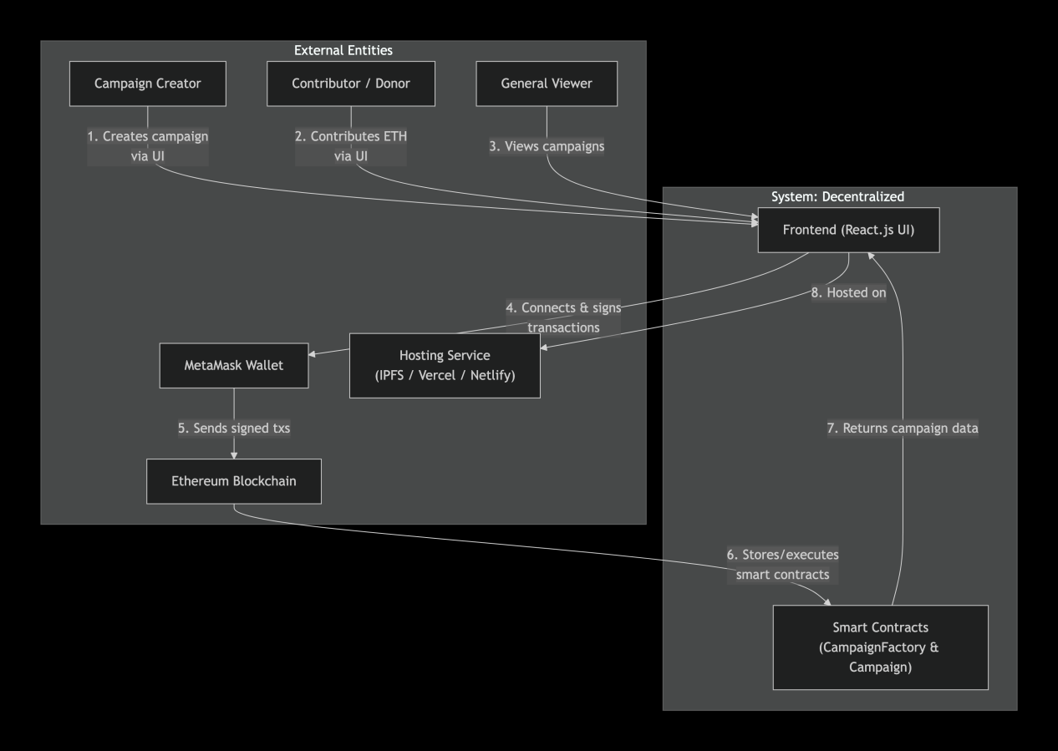
A Context diagram depicting the system

1.1 Purpose
The principal purpose of this development initiative is to research, design and implement a secure, transparent and fully decentralized crowdfunding application powered by Ethereum smart contract technology. This purpose is operationalized through the following specific objectives:

- To eliminate financial and administrative intermediaries in the crowdfunding
process.

- To ensure the transparent and secure handling of fund by leveraging blockchain's immutable public ledger for all transactions, making fund flows permanently auditable.

- To provide a trust less operational environment where predefined contractual rules are automatically enforced by smart contracts, mitigating risks of fraud and non-compliance.

4. To construct an intuitive and accessible user interface that abstracts the complexities of blockchain interaction, making decentralized fundraising viable for a non-technical user base.

1.2 Scope
1.2.1 In-Scope Deliverables
The project scope is bounded to the development and deployment of the following core components:

- Smart Contract Suite: A collection of audited Solidity contracts, including a (Campaign) contract template for individual campaigns and a (CampaignFactory) contract to facilitate their efficient deployment and indexing.

- Web-Based Frontend Application: A responsive single-page application built with React.js that serves as the primary user interface for all system interactions.

- Blockchain Interaction Layer: Full integration with the MetaMask browser extension for wallet management, transaction signing and network connectivity.

- Core Crowdfunding Mechanics: Complete functionality for creating campaigns, contributing Ether (ETH), viewing live campaign data and executing withdrawals or refunds based solely on on-chain logic.

- Testnet Deployment & Verification: Full deployment of the dApp on an Ethereum testnet for public testing, validation and demonstration.

6. Real-Time Data Display: A frontend module that queries the blockchain to display campaign lists, funding progress, and deadlines in real-time.

1.2.2 Out-of-Scope Items
Explicitly excluded from the current project phase are:

- Fiat Currency On/Off-Ramps: Direct integration with traditional payment systems (credit cards, bank transfers).

- Native Mobile Applications: Development of iOS or Android apps. The primary delivery is a web dApp accessible via mobile browsers.

- Multi-Chain or Layer-2 Compatibility: Support for blockchains other than Ethereum or specific Layer-2 scaling solutions in the initial release.

- Non-Fungible Token Integrations: Mechanisms for issuing NFTs as backer rewards or for campaign governance.

5. Centralized Administrative Panels: Any backend dashboard for manual campaign approval, user management or fund intervention.

1.3 Product Perspective
The system is architectured as a standalone decentralized application. It operates within a client-blockchain paradigm, fundamentally differing from traditional client-server models. The React.js frontend, hosted on a decentralized or traditional platform, serves solely as a presentation and interaction layer. All persistent state and business logic reside on the Ethereum blockchain. The frontend interacts with the blockchain via the user's MetaMask wallet, which acts as a secure signer and gateway. No centralized application server or database is required for core functionality. The blockchain serves as the immutable global backend. This architecture maximizes censorship resistance and availability.

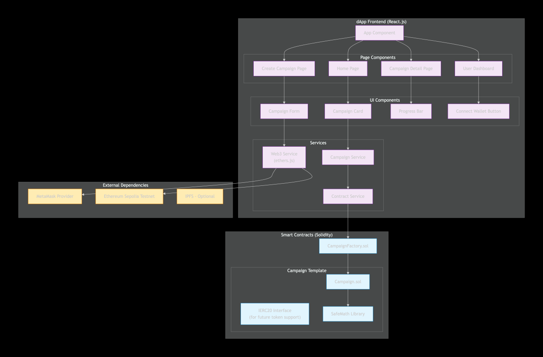
A Component diagram depicting the architecture

1.4 User Characteristics
The system caters to three primary user archetypes with distinct goals and technical prerequisites:

User Type | Description | Technical Prerequisite
Campaign Creator | An individual or entity seeking to raise funds for a project. Primary goals are to create a campaign, promote it and withdraw funds upon successful completion of the funding goal. | Must possess an Ethereum wallet with ETH for gas fees to create a campaign.
Contributor / Donor | A user wishing to financially support active campaigns. Primary goal is to find compelling projects and contribute ETH securely, with the assurance of a refund if the campaign fails. | Must possess an Ethereum wallet with ETH for contributions and gas fees.
General Viewer | A user browsing the platform to discover projects without an immediate intent to transact. Primary goal is to view campaign details and funding progress. | No wallet required for view-only actions.

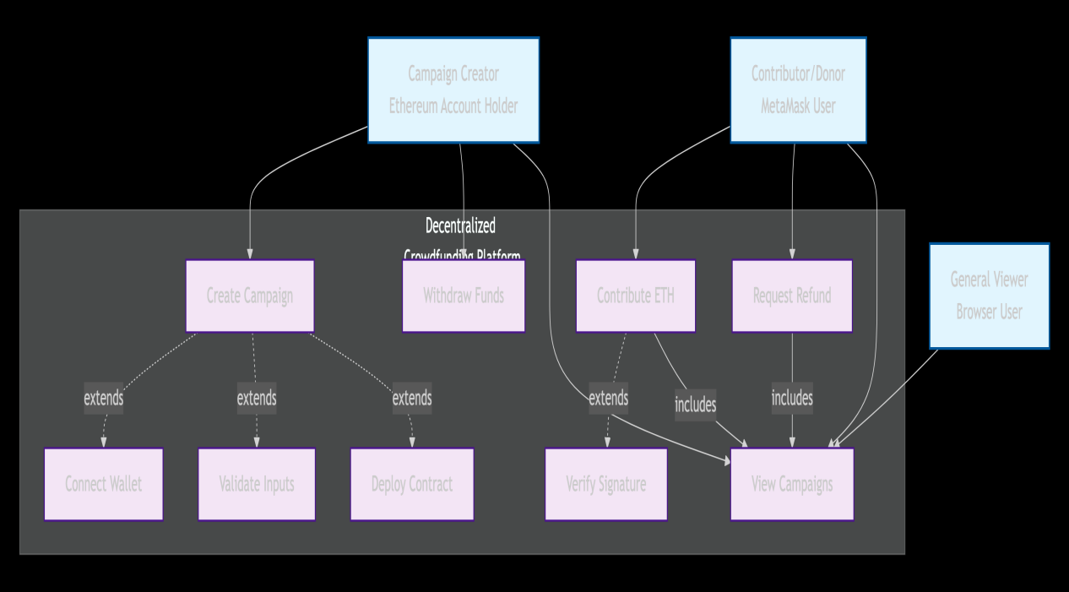
A Use Case representing three types of users

1.5 Analysis of Comparable Systems
A comparative analysis highlights the differentiating value proposition of the proposed system:

Platform | Key Features | Shortcomings
Kickstarter | Massive user base, brand recognition. | High platform fees (5%), centralized control, funds held and released by platform.
GoFundMe | Simple setup, focused on personal causes. | Centralized, requires KYC, subject to payment processor policies.
Indiegogo | Flexible funding models. | Centralized, not decentralized, platform fees apply.
Existing Blockchian dApp | Smart contract-based, decentralized. | Often have complex user interfaces, low adoption, and limited feature sets.

1.6 Proposed Technology Stack
The selection of technologies is guided by the requirements for security, developer ecosystem support and dApp development best practices.

Smart Contract Development: Solidity, Foundry
Frontend Application: React.js, JavaScript, Node.js
Web3 Integration: ether.js, metamask

Hosting & Deployment: IPFS / Vercel / Netlify

Development Tools: Git, Github, VScode

- System Requirements

The system is designed to enable a complete, self-contained crowdfunding workflow on the blockchain. Users can initiate fundraising campaigns, contribute cryptocurrency, monitor progress in real-time and trigger financial outcomes based exclusively on transparent, on-chain conditions. A fundamental tenet is that all campaign parameters, transactions and state changes are recorded immutably on the Ethereum blockchain, ensuring permanent public verifiability and auditability.

2.1 Functional Requirements
Functional requirements specify what the system must do. They are enumerated below in a structured format.

FR001: Campaign Creation
Name: Create Campaign
Purpose:To allow a verified user to instantiate a new, distinct crowdfunding campaign as a smart contract on the Ethereum blockchain.
Actors: Campaign Creator
Preconditions: Actor has a connected and unlocked MetaMask wallet with sufficient ETH for gas fees.
Inputs:
• Campaign Title
• Description
• Minimum Contribution Amount
• Funding Goal
• Campaign Deadline

Process: The frontend collects inputs, validates them and calls the (createCampaign) function on the (CampaignFactory) contract. The factory deploys a new instance of the (Campaign) contract with the provided parameters.

Outputs:
• A new Ethereum address for the deployed (Campaign) contract.
• The campaign is indexed and becomes visible in the platform's campaign list.
• On-chain event emission logging the creation.
FR002: Contribution to Campaign
Name: Contribute ETH
Purpose: To allow a user to send Ether tokens to an active campaign in support of its goal.
Actors: Contributor
Preconditions: Actor has a connected wallet with sufficient ETH for the contribution. Campaign is active.
Inputs:
• Campaign Identifier
• Contribution Amount
• Valid cryptographic signature from the contributor's wallet.

Process: The frontend initiates a transaction to the (contribute) function of the specified (Campaign) contract, attaching the contribution amount in ETH.

Outputs:
• The campaign's (balance) state variable is increased by the contribution amount.
• The contributor's address is recorded in the campaign's (backers) mapping/array.
• An on-chain event is emitted to log the contribution.

FR003: Fund Withdrawal by Creator
Name: Withdraw Funds
Purpose: To allow the campaign creator to transfer the accumulated funds to their wallet, but only upon successful achievement of the funding goal before the deadline.
Actors: Campaign Creator
Preconditions: The calling address is the registered (owner) of the campaign contract. The campaign's (balance) is greater than (fundingGoal). The campaign deadline has passed.
Inputs:
• Campaign Identifier.
• Valid signature from the creator's wallet.

Process: The creator invokes the (withdrawFunds) function on the campaign contract.

Outputs:
• The entire contract balance is transferred to the creator's address.
• The contract's (balance) is set to zero.
• Campaign state is updated to closed or successful.

FR004: Refund for Failed Campaign
Name: Request Refund
Purpose: To allow contributors to reclaim their donations if a campaign fails to meet its funding goal by the specified deadline.
Actors: Contributor
Preconditions: Campaign deadline has passed. Campaign (balance) is less than (fundingGoal). The caller's address is recorded as a backer with a positive contribution balance.

Inputs:
• Campaign Identifier.
• Valid signature from the contributor's wallet.

Process: The contributor invokes the (getRefund) function on the campaign contract.

Outputs:
• The contributor's recorded contribution amount is transferred back to their address.
• The contributor's balance in the contract is set to zero.
• The campaign's total balance is reduced accordingly.

FR005: Campaign Browsing
Name: View Campaigns
Purpose: To provide all users, regardless of authentication status, with the ability to discover and inspect existing campaigns.
Actors: All Users (Creator, Contributor, Viewer)
Preconditions: None.

Inputs: None.

Process: The frontend queries the (CampaignFactory) contract for a list of all deployed campaign addresses. It then fetches the public state variables (title, description, goal, balance, deadline, owner) from each campaign contract.

Outputs:
• A paginated or scrollable list of campaign summaries displayed in the UI.
• For each campaign, key metrics are shown: percentage of goal raised, time remaining and a link to a detailed view.

2.2 Non-Functional Requirements
Non-functional requirements define the qualities and constraints of the system.

Security:
Smart contracts must implement guard checks against common vulnerabilities, notably re-entrancy attacks, integer overflows / underflows and unauthorized access.

• Authorization must be enforced on-chain. Only the campaign owner's Ethereum address can execute the withdrawal function.

• All state-changing operations must require a valid cryptographic signature from an externally owned account via MetaMask.

Performance:
• The initial UI load time, excluding blockchain data fetching, should be under 3 seconds on a standard broadband connection.

• Smart contract functions, particularly the factory's campaign listing and individual campaign data getters, must be gas-optimized to remain efficient when managing a minimum of 20 concurrent campaigns.

Reliability & Availability:
• The availability of campaign data and contract logic is inherited from the underlying Ethereum blockchain, guaranteeing permanence and censorship resistance once confirmed.

• Smart contracts must exhibit deterministic behavior given the same inputs and blockchain state, they must always produce the same outputs.

Usability:
• The user interface must employ clear language, intuitive layouts and progressive disclosure to guide users through wallet connection, campaign creation and contribution processes.

• Wallet connection and transaction confirmation via MetaMask must be seamless, with clear prompts indicating the action and estimated gas cost.

Maintainability:
• Source code for both smart contracts and the frontend must adhere to established style guides and best practices.

• All smart contracts must be thoroughly commented using NatSpec format, and the frontend code must be modular and well-documented to facilitate future development and onboarding.

3. Use Cases and Process Flows
This section provides detailed narratives of how actors interact with the system to achieve specific goals, complementing the functional requirements.

3.1 Use Case Model
Primary Actors: Campaign Creator, Contributor, Viewer.
System Boundaries: Encompasses the dApp frontend, the Web3 interaction layer, and the on-chain smart contracts.

3.2 Detailed Use Case Specification
Use Case ID: UC001
Use Case Name: Create Campaign
Primary Actor: Campaign Creator
Supporting Actors: MetaMask
Stakeholders: Creator, Future Contributors.
Preconditions: User has a web browser with MetaMask installed. MetaMask is connected to the correct Ethereum network. The connected wallet holds ETH for gas fees.

Postconditions: A new (Campaign) smart contract is deployed on the blockchain. The campaign is visible in the platform's global list. The creator is set as the contract owner.

Main Success Scenario (Basic Flow):
1. Actor navigates to the dApp URL in their browser.
2. Actor clicks "Connect Wallet" and authorizes the connection via MetaMask.
3. Actor clicks the "Start a Campaign" button.
4. System presents a form with fields for Title, Description, Minimum Contribution, Funding Goal and Deadline.
5. Actor fills in the form and submits it.
6. System performs client-side validation.
7. System prompts MetaMask to sign a transaction deploying the contract, showing estimated gas.
8. Actor confirms the transaction in MetaMask.
9. System waits for blockchain confirmation.
10. Upon confirmation, system displays a success message and the new campaign's page.
11. The (CampaignFactory) emits an event, allowing the frontend to update the global campaign list.

Alternative Flows:
A1: Invalid Form Data (Step 6):
1. System identifies invalid data.
2. System displays descriptive error messages next to the relevant form fields.
3. Use case resumes at Step 5.

A2: User Rejects Transaction (Step 8):
1. Actor rejects the transaction in MetaMask.
2. System informs the actor that campaign creation was canceled.
3. Use case ends.

A3: Blockchain Transaction Fails (Step 9):
1. The transaction reverts on-chain.
2. System detects the failure from the transaction receipt.
3. System displays an error message.
4. Use case ends. No campaign is created.

Exceptional Flows:
E1: Network Connection Lost: System alerts the user and provides options to retry or check wallet status.

E2: Insufficient Gas: The transaction is likely to fail (A3). MetaMask typically provides a warning.

