Model Documentation

# SN

*Before we get the best parameters*

1. *How many registration window do we need*
2. *How many visiting room do we need*
3. *How many hospital bed do we need*
4. *How many medicine window do we need*

*After we get the best parameters*

1. *How efficient our model is*

# SPD



# CM

* A Patient arrives at the community client;
* He/She go to register in hospital;
* He/She waits in the queue for registering in hospital;
* It’s he/she’s time to register in hospital;
* He/She registered in hospital;
* He/She is waiting for visiting a doctor;
* He/She visited a doctor;
* He/She may need to be in hospital or take medicine or leave directly;
* He/She leave the hospital;

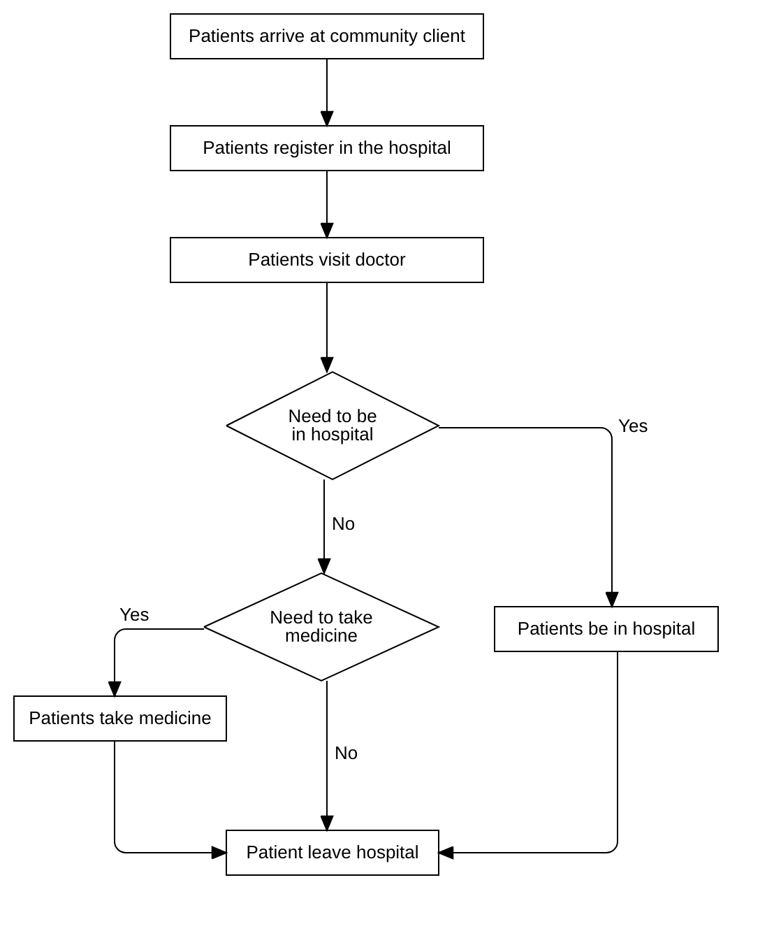

# FM

# EM

# SR

# IR