**CSCE 606: Lightfoot**

Team members: Colton Simpson, Jacob Kelly, Kunal Vudathu, Rahul Shah, Stuart Nelson

**Iteration 0**

* **Team roles**: The team should elect a scrum master and product owner.
  + We have an agreed upon rotation that will shift with each iteration
  + Scrum Master: Jacob Kelly
  + Product Manager: Rahul Shah
* **Customer meeting date/time/place**: The team product owner should contact the customer and set up a regular weekly meeting.
  + Every Friday at 2pm in PETR
* **SCRUM meeting date/time/place**:
  + Every Tuesday and Thursday at 10am
* Github: <https://github.com/Lightfoot-Heavy-Machinery/shockwave_kickers>
* Pivotal Tracker: <https://www.pivotaltracker.com/n/projects/2595510>
* Slack Workspace name:
  + Workspace: tamu.slack.com
  + Channel Name: csce606_shockwave_kickers
* **Features**
  + Colton: Quiz
  + Kunal: View All Student Records
  + Jacob: View Course Profile
  + Rahul: View Student Profiles
  + Stuart: Enter and Store Class Rosters

Write a two-paragraph (max) summary of the main customer need and how the application meets it, including who the stakeholders are. GitHub repo and Pivotal Tracker in the document.

The customer would like a system that enables them to store and track student roster records from current and previously taught classes. The customer also wants a game-based name/face learning system that utilizes spaced repetition and tracks learning progress (e.g. accuracy, recall time, other metrics for measuring skill at identification) to assist them in learning student name/face pairs.

Our application will enable users to search by section, course, semester, name, or other custom tags. This will allow the customer to more easily learn and manage multiple student groups. The system will also enable the user to view and edit student profile pages. Said page will contain the student’s photo, name, course history, and any individualized notes or tags the customer wants to add. The stakeholder of this project is Professor Lightfoot, and potentially any future professors who seek to use this application.

User stories: Create at least 4 user stories on 3x5 cards. These should be in the format shown in Chapter 7. You can submit photos of the 3x5 cards or type them up.

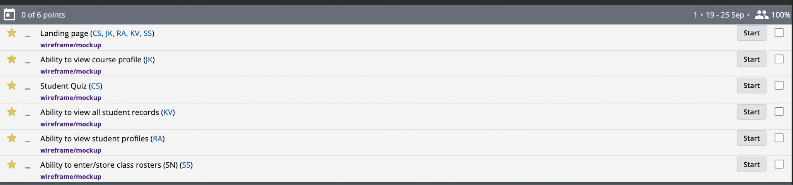

* User Story Name: Ability to view course profile:
  + Description:

As a professor

I want to view the relevant information for specific courses

So that I can more easily understand how my students are grouped

And gain insight into course-specific statistics

* User Story Name: Student Quiz
  + Description:

As a professor

I want to be quizzed on student image/name pairs

So that I can better remember the names of my students

* User Story Name: Ability to view all student records
  + Description:

As a professor,

I want to be able to view my total class records

So that I have an overview of all of my students and can search class, semester, section and student

* User Story Name: Ability to view student profiles
  + Description:

As a professor,

I want to be able to search for a student

So that I can view what courses and sections I have had with them

* User Story Name: Ability to enter/store class rosters
  + Description:

I would like to enter and view my class rosters

As a professor

So that I can view all of my current and previous students.

* User Story Name: Landing Page
  + Description:

As a professor

I want to view the relevant summary information on latest courses and navigate to different features

So that I can more easily navigate around through the application

User interface: Create lo-fi UI mockups and storyboards for at least 4 user stories. Submit photos of these in your document. Don’t redraw them in a drawing package.

