Expert Knowledge Challenge Problem (EKCP) Scenario for the Kickoff Meeting

We propose to use the attached scenario for our kickoff presentation. The scenario consists of a BW case report and a few questions that should be answered based on the report. Our E2E system should enable
an SME to answer this case report in the KB, formulate the questions, and produce the answers.

Please go through the scenario by keeping your planned technical development and produce a few slides showing how you can address this task. For example, we would need to determine which upper/mid-level theories or representation components do we need? Which portion of this knowledge is amenable to analogy or concept maps? Which aspect of the reasoning is best represented as problem solving methods?

After initial explorations in the late 1970s, Iraq’s BW program proceeded in earnest in 1985. The Iraqi biological program consisted of research and development in four loosely defined categories:
- Payload—i.e., the biological agent
- Munition—i.e., a container that keeps the payload intact and virulent
- Delivery system—e.g., missile, aircraft, etc.
- Dispersal mechanism—i.e., an explosive or spray device to dispense the agent.
Of the four stages, the most intensive research occurred in the payload development program.
Beginning in 1985, Iraq initiated a series of investigations to research the biological warfare potential of a number of potential agents, including five bacterial strains, five viruses, four toxins, and a fungal strain. The research eventually yielded three significant payload development programs:
- Anthrax: The program began in 1985 at the Muthanna State Establishment, but moved to Salman Pak in 1987. Utilizing samples from both the US and France along with local isolates, Iraqi scientists produced and animal-tested the virulence of four strains of anthrax. The findings from this research led to mass production of anthrax at the Al Hakam Single Cell Protein Production Plant in 1989.
- Botulinum toxin: Using a strain imported from the US, scientists were able to mass produce botulinum toxin using a fermentation technique during 1989 and 1990. The majority of the work occurred at Al Hakam and the Foot and Mouth Disease Center at Al Manal.
- Aflatoxin: Scientists grew the Aflatoxin-producing organisms Aspergillus flavus and Aspergillus parasiticus on wet rice. From these organisms, scientists then identified different types of aflatoxin and settled on a solution after testing.
While Iraqi scientists would also produce other biological weapon agents, such as 10L of ricin in 1989 and 340L of Clostridium perfringens in 1990, the research never progressed to the weaponization stage.
Concerning deployment, Iraq’s arsenal contained 200 aerial bombs and 25 ballistic missiles laden with biological agents by 1991, and scientists also experimented with Italian-made agricultural aerosol-sprayers mounted on vehicles and aircraft. Since the Iraqi defeat in the 1991 Persian Gulf War, however, the international community has tried to ensure that all vestiges of the Iraqi BW program are eliminated.

Figure 1: Iraqi BW Program Case Report

NOTES

When the user enters this case report, the system will already have a large body of relevant background knowledge to bring to bear.
- The KB would already contain ontologies of the categories described at the beginning of the scenario (payload, munition, delivery system. etc.), as shown in Attachment 1.
- The KB would also contain default/generic BW process models for how to produce these agents, as shown in Attachment 2.

The KB building tasks that our system needs to support, according to the PIP and IET’s proposal, are:
- Creating and maintaining a generic modeling capability. Users may need to extend the default BW process models that are in the system. For example, the user would want to add the new model for aflatoxin production described in this case report.
- Using that capability to create and maintain specific models. For example, add to Iraq’s BW baseline model that it produced 10L of ricin in 1989.
- Creating and maintaining problem-solving methods (PSMs) for reasoning with models. For example, the user would add a piece of problem solving knowledge to say “if the production method used is not technology dependent and the scientists of the BW program are in the country, then the country can produce the weapon anytime”.
- Using the PSMs to reason about models. For example, Irak is capable of producing aflatoxin given what is known about the status of its aflatoxin program. (Answering the sample questions (Figure 8) in the IET proposal).

The question to everyone in the team is: How can our KA tools and User KB interfaces support the user in these tasks?

QUESTIONS TO IET

Vinay’s and Jihie’s question
About Question1:
The case description does not make it clear that Iraq indeed has scientists at the time of interest.
To answer the question, we need to know
- technology needed for producing aflatoxin (growing organism on wet rice, other ways)
- how many scientists of what specialty are needed
- what kind of research facilities are needed
About Question 2: The answer is not in the scenario.
To answer the question, we need to know
- What kind of agricultural biological agents exist (wheat smut,…)
- Did Iraq develop any of them in the past?
- The question talks about ‘weaponizing’ but the answer describes ‘development’. What is the relationship between the two? (development now implies weaponizing in the future?)
About Question 3: There is insufficient knowledge in the scenario to answer.
To answer the question, we need to know
- What kind of technology Iraq has now for anthrax production? (not explicit in the case report)
- What are the differences between wet anthrax and dry anthrax?
About Question 4: the scenario talks about perfringent and the answer talks about the solution. What is the relationship between the two?

About Question 5: the question asks about ‘selection for weaponization’ and the case report describes ‘production’ (and selection implicitly). What is the relationship between weaponization and production?
ATTACHMENT 1

Some of the top-level ontology for the BW problem (from IET’s RKF proposal, Fig 7). We assume that when a user is entering the Iraqi case scenario, the system would have background knowledge about these topics.

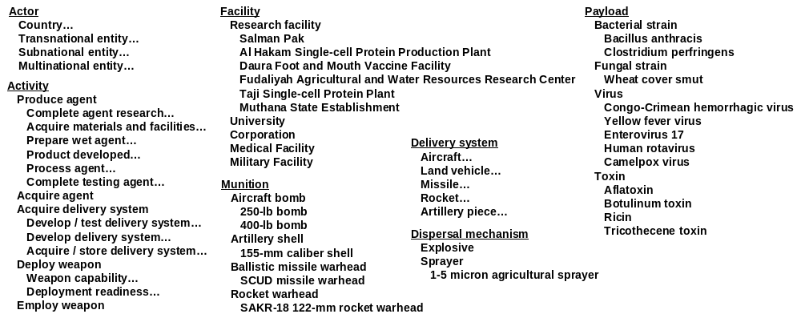

ATTACHMENT 2

The system would contain process models of BW proliferation. One of the steps of that process is to develop BW agents, shown below (taken from Fig 3-3 of Archuleta et al. 96). Other steps include 1) research BW agents; 2) develop delivery systems that will carry the agent; 3) weaponizing the agent; and 4) stockpiling the weapon.

Develop BW Agent
Establish Production Facilities
Acquire Production Materials
Establish Seed Stock
Acquire Equipment
Establish Worker Safety
Produce BW Agent
Stockpile BW Agent

According to Archuleta et al. Appendix B, each of these activities/nodes requires some combination of:
- Activity
- Personality (e.g., microbiologist, process engineers, etc.)
- Material (e.g., culture medium, stabilizers, etc.)
- Related (e.g., refrigerated storage, etc.)
- Equipment (e.g., fermentors, icinerators, bioreactors, etc.)

The KB would also include detailed models for how BW agents are typically generated. The model for botulin toxin, for example, would extend the model above with information such as:

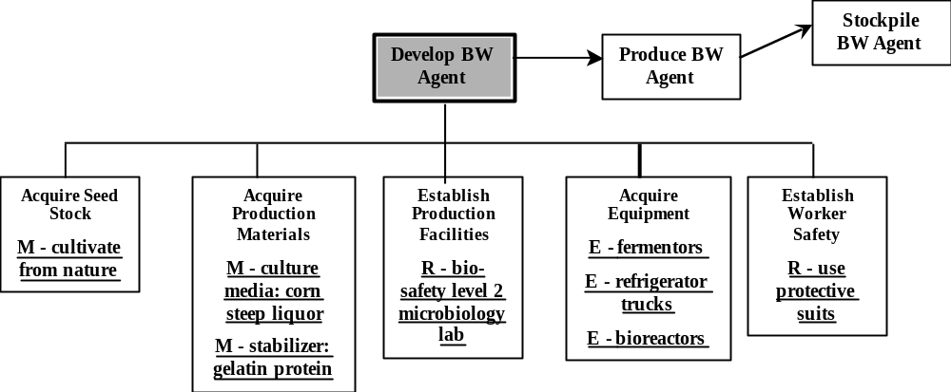

Adapted from Raymond A. Zilinska “Iraq’s Biological Weapons: The Past as Future?” JAMA (Vol. 278, No. 5: 6 August 1997), pp. 418-424.

