Constable user guide

Overview
Constable is a Constraint Editing Tool that helps users modify or add knowledge to an intelligent computer system. This version of Constable is able to critique plans created in Softools. This is done with a number of customizable checks on the plan called constraints. Examples of constraints are that an asset used in a movement should be either a CRRC or a Mk-V, or that the lunar illumination should be less than 0.5. In the following examples and activities, you will apply constraints to a sample Softools plan.

Example Exercises
The following sections use exercises to illustrate some of the things you can do with Constable. They are:

- Introduction to the interface
- Modifying fields and their constraints
- Using the editor to change a constant value in a constraint
- Using the editor to change the way a field (or its constraint) is calculated
- Adding a new field to the plan view
- Using the editor to make a field (or constraint) value depend on another value

Introduction to the Interface

The first window that you will use in modifying or defining a constraint is the Plan View, which displays a number of different fields for the plan. Two other windows will be used in this tutorial, the Sources Window and the Method Editor. The sources window shows all of the information that was used when the plan is checked against a particular constraint. The method editor is described with examples in the last three sections of the guide.

Figure 1 shows an example Plan View window that the user sees on starting the application. It displays information about the plan’s fields and constraints. For example, the field labeled “Lunar illumination” has “0.737” as its value. The red border around the field and its value indicates that a constraint on this field was not satisfied.

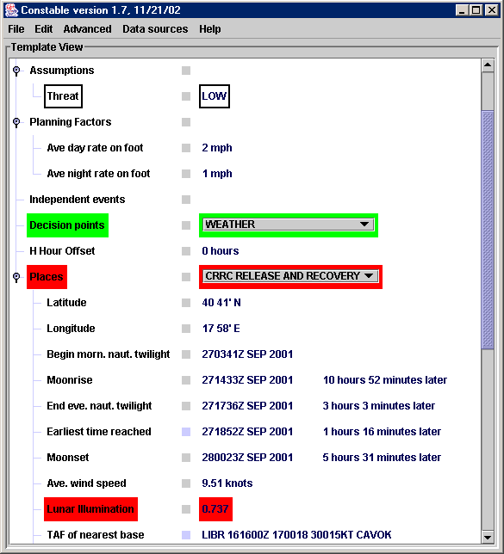

Figure 1. Plan Evaluator

In general, a Constable can use constraints that check a field in many different ways, making use of background information about locations and equipment, and other planning factors and assumptions. Constable gives help for defining certain kinds of constraints, for example a constraint that involves a numerical value and checks against a minimum or maximum value. If the value of a field is not numerical, for instance “CRRC”, the constraint can check if it is a member of a set of preferred values, or a set of values to be avoided. A field and its constraints can be edited using several tools from the menu that appears when you right-click over the field, as described in the next section.

Modifying fields and their constraints

Units may have different preferences about the lunar illumination, depending on the activities or enemy capabilities. In this section and the next one, we increase the maximum value in the constraint that Constable checks for the illumination from 0.3 to 0.5.

- Right-click on the Lunar illumination field to bring up the edit menu.
- Select ‘show sources’ from the menu

A window is created with the title ‘Summary of sources for Lunar Illumination’, showing all the information that Constable used to compute and check the lunar illumination field. When field values are computed and constraints are checked, Constable may combine information from many sources, including other constraints that may solve a part of the problem. The first panel shows that constraints from two general groups were used. The second panel, labeled ‘Live Data Sources’, shows that some of the information came from querying external sources such as web sites. The third panel, labeled ‘Information used’, summarizes the data that was used in order to compute and check the field. In this case, the illumination is for the place called ‘AFSB-GOLD’ and its latitude, longitude and start-time (a Softools field) were used. The fourth panel, labeled ‘Assumptions’ shows some of the constraints that were used to check the field, including a ‘maximum allowed value’ which will be changed in this example.

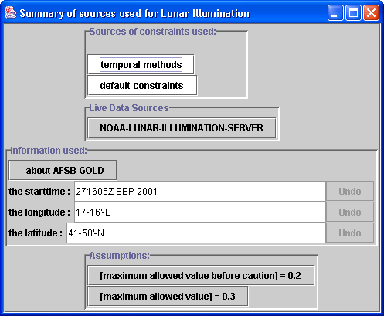

Figure 2. Information sources for the constraint “Lunar Illumination”

You can double-click on any of the pieces of information to change them using a specialized editor. You can also click on any of the lines in the Assumptions panel, like “maximum allowed value” to bring up an editor that can change how the assumption is made, as the next section shows.

Using the constraint editor to change a value

You can change the way any constraint works using the constraint editor. Following on from the previous section, we are editing the Lunar Illumination field and want to increase its maximum allowed value to 0.8:

- Click on the assumption that reads “[maximum allowed value] = 0.3”

The editor should appear. This has three main sections (see Fig. 3). The first section at the top displays the current definition of the constraint. The first part of the definition begins with “In order to…” and is followed by a small description of what the constraint does. Here, it is followed by “estimate a maximum allowed value of the Illumination for a place in a plan.” The second part of the definition is found below. This shows how the constraint does its task; in this case, it always returns the number 0.3.

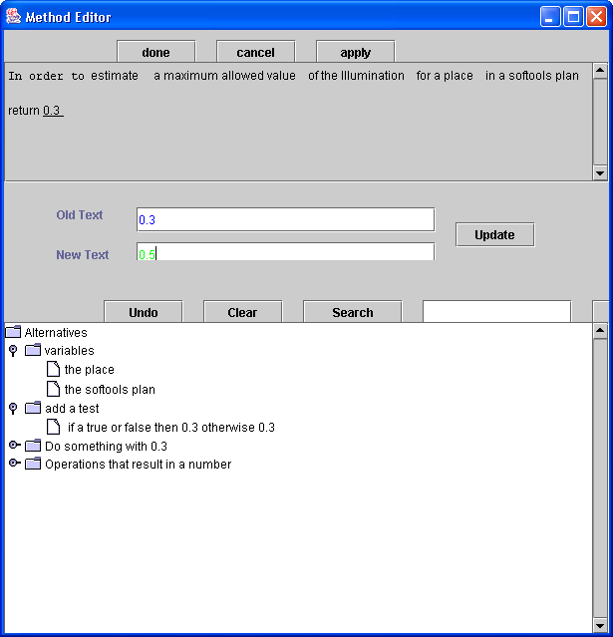

Figure 3. The Editor used to change the maximum allowed illumination to 0.5.

- Click over the 0.3 in the second part of the definition.

The number “0.3” will be underlined and displayed in blue in the middle section of the Editor, next to the label “Old text”.
The bottom section of the Editor contains suggestions for how to change the selected text. These suggestions are organized into categories that group the related method activities. The methods for each constraint can have more complex definitions than simply having constant numbers like “0.3”. For example, they can use simple programming languages that make them very powerful. The suggestions window in the Editor helps you piece together program statements. For instance, if you look under the “do something with 0.3” section you will find options such as “add 0.3 to a number” and “determine whether 0.3 is a member of a set”. If you select one of these options, it appears in the “with” field in the middle of the Method Editor. Then you can use it to replace text in the method definition by clicking “Update”.

- Type the replacement text, in this case “0.8”, in the line next to the “new text” label below the window that displays the 0.3.

- Click the “Update” button to make the change in the method description of the editor’s upper window.

The “Undo” button undoes any change made in this way. The “Clear” button de-selects the text you had selected without making any change.

- Click on the “done” button at the top of the Method Editor window.

You have just modified the lunar illumination constraint with a new maximum value. The new definition will be applied, after a short pause, in the Plan View. Since the maximum illumination, 0.8, is more than the actual illumination, 0.737, the constraint is satisfied and the field’s border will change from red to yellow. It is yellow rather than green because a separate constraint, ‘maximum allowed value before caution’ still has a value of 0.2, so a caution is raised. This can also be changed through the assumptions panel.

Use the editor to change how a field is calculated

The editor can be used to change the way that fields or constraints are computed, as well as to change constants as in the previous section. Suppose that, because of a range of mountains, moonrise is effectively an hour later than the value from astronomical calculations. Rather than give a fixed value, we need Constable to add an hour to any value that is computed.

- Right-click on the “moonrise” field and choose “show critique overview” from the menu.
- Click on the button that reads “Compute a moonrise field of a place in a plan”

The “constraint details” window shows a short summary of how the field is computed and checked. The constraint definition shows how the field value is computed for a place in a Softools plan: first it computes the earliest time the place is reached, then it makes a query to a Fetch agent for the moonrise at this time and location. As before, you can click over an item in the window to change it, and the editor will suggest terms to change it to. For example, if you click on “the place”, the editor will show other information about Softools places that could be used in the constraint. You can try this, then click “clear” to get back to the original screen.

You can change whole phrases, like “the latitude of the place” as well as individual elements like “the chosen date”. To change a whole phrase, move the mouse to the left of the phrase until it shows completely in blue, then click the mouse left button. For example, you can select the whole phrase ‘query Moonrise on the chosen date at the place’ by clicking just to the left of the word query, or on the word ‘and’ to the left of that.

- Click over the word “and” in the method definition window

The options window, the lower window in the editor, now shows different phrases that you could change the phrase into, grouped under headings like “information about the time point” and “do something with the time point”.

- Double-click on “Do something with the result” to see its choices.

A number of options will be shown, including “add a number hours to the time point” and “check that the time point is no later than a time point”. Since we want to add one hour to the moonrise time returned by the wrapper, select the first option.

- click on “add a number hours to the result”, then click “update”.

The option first goes into the “new text” line in the editor, then is used in the method definition when you click “update”. You will see that the editor now shows the phrase “a number” in red, and in the lower window displays “’a number’ is a placeholder that should be filled in”. We will change the placeholder to the number “1”, the same way that the constant was changed in the previous section:

- Click on “a number” in the definition in the editor. The text appears in the “Old text” field.
- Type “1” in the “New text” field of the editor.
- Click “update”. The definition’s last line now reads “add 1 hours to the time point”.
- Click “done”.

Constable will display a new window showing a number of supporting constraints that will be used when the modified constraint is applied. This is useful to check that the modified constraint is still consistent with Constable’s other knowledge. You can ignore this window and remove it by clicking on the standard windows button to kill the window.
As before, the value will change in the Plan View window: the moonrise value is one hour later, and the second number, showing the time elapsed after the nautical twilight begins, is also increased one hour.

Use the editor to make a field value depend on another value

Suppose that the maximum illumination allowed is higher when there is high average wind speed, perhaps because spray will interfere with visibility. We can use the editor to make the constraint reflect this, by making the maximum value that is computed depend on the wind speed.

- Right-click the Lunar illumination field and select ‘show sources’.

- Click on the assumption, “[maximum allowed value] = [0.8]”

The description for this method shows that it always returns 0.8, which was set in an earlier example.

- Click over “0.8”.

Among the options that appear in the lower window is the heading “add a test”, with one sub-heading.

- Click on the line “If a true or false then 0.8 otherwise 0.8”; and then
- Click on “Update” to modify the method to use this line.

The method now makes an as yet unspecified test, denoted in the description as “a true or false”, and produces the same number whether the test turns out to be true as shown after the word “then” or false as shown after the word “otherwise”.

The phrase “a true or false” appears in red at the top window of the editor. This means that the method cannot be used with its current definition, and that the phrase “a true or false” will need to be changed before the method can be used. The lower window now contains the line “Suggestions for what to do next:” followed by the line “’a true or false’ is a placeholder that should be filled in”. This means we must replace this phrase with a statement that will actually produce either true or false when it is used in the method.

Next, modify both the test and the set returned if it is true by performing the following steps.

- Click on “a true or false” in the upper window.

- Type “wind speed” in the field next to the phrase “search for:” in the middle of the editor window.

- Click “Search”.
One suggested term is “compute the ave wind speed of the place in the plan”.
The search tool finds complete phrases that match the terms you type. Shorter terms like ‘wind speed’ or ‘wind’ will also include in this phrase.

- Click on “compute the ave wind speed of the place in the plan”. You will see that a new set of alternatives appears in the lower window, indented below the line that was selected. These alternatives build on the destination – for example, one group is “do something with the result”. Show this group by double-clicking the line if necessary.

- Below the sub-heading “do something with the result”, select “check that the result is greater than or equal to a number”.

- Click “Update” to enter this test.
As shown in Figure 4, the method description will now read:

compute Ave Wind Speed of the place in the softools plan
and if check that the knots is greater than or equal to a number
then 0.8
otherwise 0.8

The phrase “a number” appears in red and a line in the lower editor window warns you that this is a placeholder, just as “a true or false” was before you made the last change.

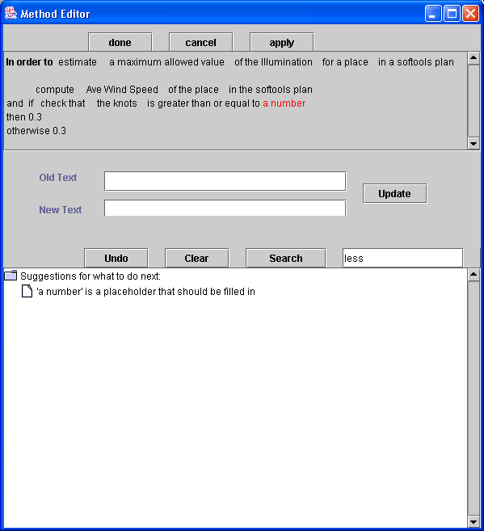
Figure 4: the editor after updating the condition

Next change “a number” 10:

- Click over “a number” in the definition in the upper window of the editor. Type “10” in the “new text” line and select “update”.

Now select the number returned when the test is false:

- Click over the number “0.8” after “otherwise” in the second line of the method description.
- Type “0.3” in the “with” line of the editor.
- Click “update”
- Click “done”.

When the constraint has been updated, the Lunar Illumination field will go back to red, because the wind is not strong enough to use the higher limit on illumination.

Example Tasks
To be updated from the travel planning domain if we decide to have examples

- Modify the maximum allowed value of the hotel distance to meeting to be 2.
- Modify the way the hotel distance is computed. The current definition “compute the distance between the hotel and the meeting of the trip” computes the Euclidean distance, but Pittsburgh is (roughly) on a grid system. Change the method to multiply the original distance computation by 1.3.
- Modify the max hotel cost to depend on the chain of the hotel. Let the maximum cost be 160 if the chain is “Holiday Inn”, otherwise set it to 100.
- Add the hotel chain as a field in the Plan View: add a field called “Hotel chain” as a sub-field of “Hotel”, then edit the definition of “compute the hotel chain..” to retrieve the hotel chain from the data base.
- Try to add as many as possible of the constraints that you originally wrote down for travel planning.

