NYANSA AI
Enterprise Document Intelligence
User Manual
&
Data Protection Overview
28 September 2026

Contents
Part 1 — User Manual
Signing in
The workspace
Asking a question
Verifying an answer
Managing documents
Uploading documents
Dashboards
Managing users
Settings
Training
Part 2 — Data Protection & Confidentiality
What data the platform holds
How your data is processed
Isolation and access control
Encryption, storage and sign-in
Sub-processors and data flows
Model training and your content
Retention and deletion
What the system does not do
Current limitations
Part 3 — Questions and Answers
Security, privacy and model training
Accuracy and hallucination
Adding documents from a web link
Large document sets
API and system integration
What the Training page does
Data residency
Leaving the service

Part 1 — User Manual
Nyansa AI turns your organisation’s documents into a searchable knowledge base that answers questions in plain English, citing the source document and page for every answer. This manual walks through each screen in the order you are likely to meet it.
The screenshots throughout show a demonstration workspace containing fictional documents. Your own workspace will show your organisation’s name and your own documents.

Signing in
Your organisation has its own address, for example yourorganisation.nyansaai.com. Sign in there with your email address and password. The sign-in page carries your organisation’s name, so you can confirm you are in the right workspace before entering anything.
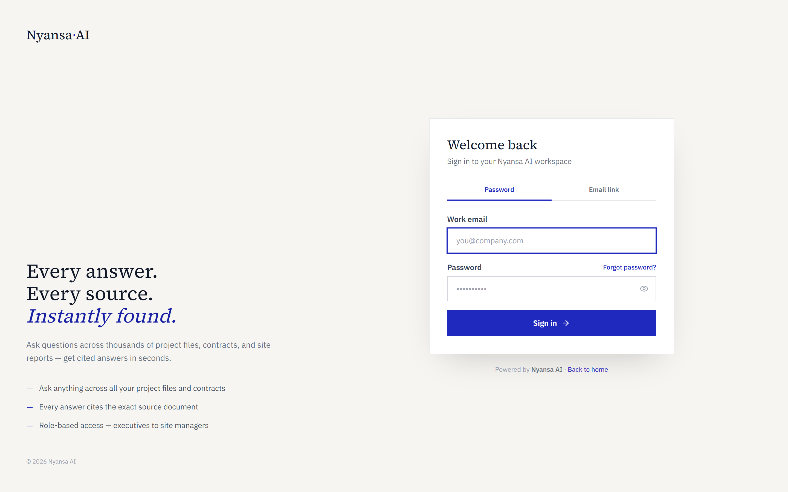
Figure 1 — The sign-in page, branded with the workspace name
If you were invited by an administrator, you will have received an email link to set your own password. Administrators never see or set user passwords. If you forget yours, use the Forgot password link.
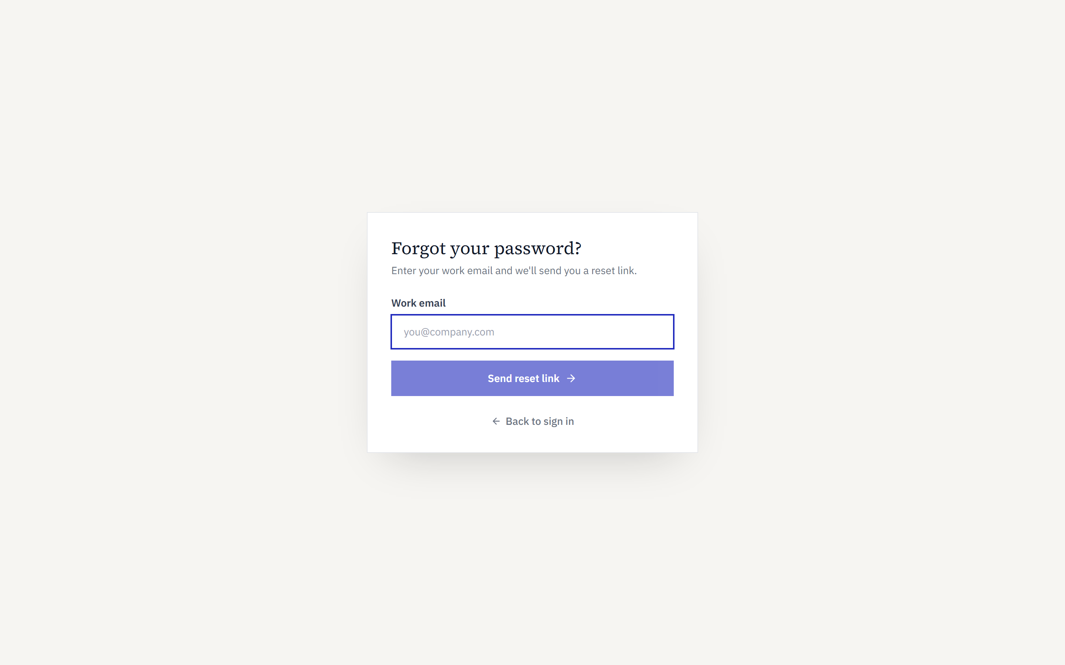
Figure 2 — Requesting a password reset
Two-factor authentication is optional and can be enabled later under Settings. Where it is enabled, you will be asked for a code after entering your password.

The workspace
After signing in you arrive at Ask AI. The navigation sits on the left: Ask AI, Documents, Training, Dashboard, Users and Settings. Which entries appear depends on your role. The workspace name and icon sit at the top, and the sidebar can be collapsed to give the page more room.
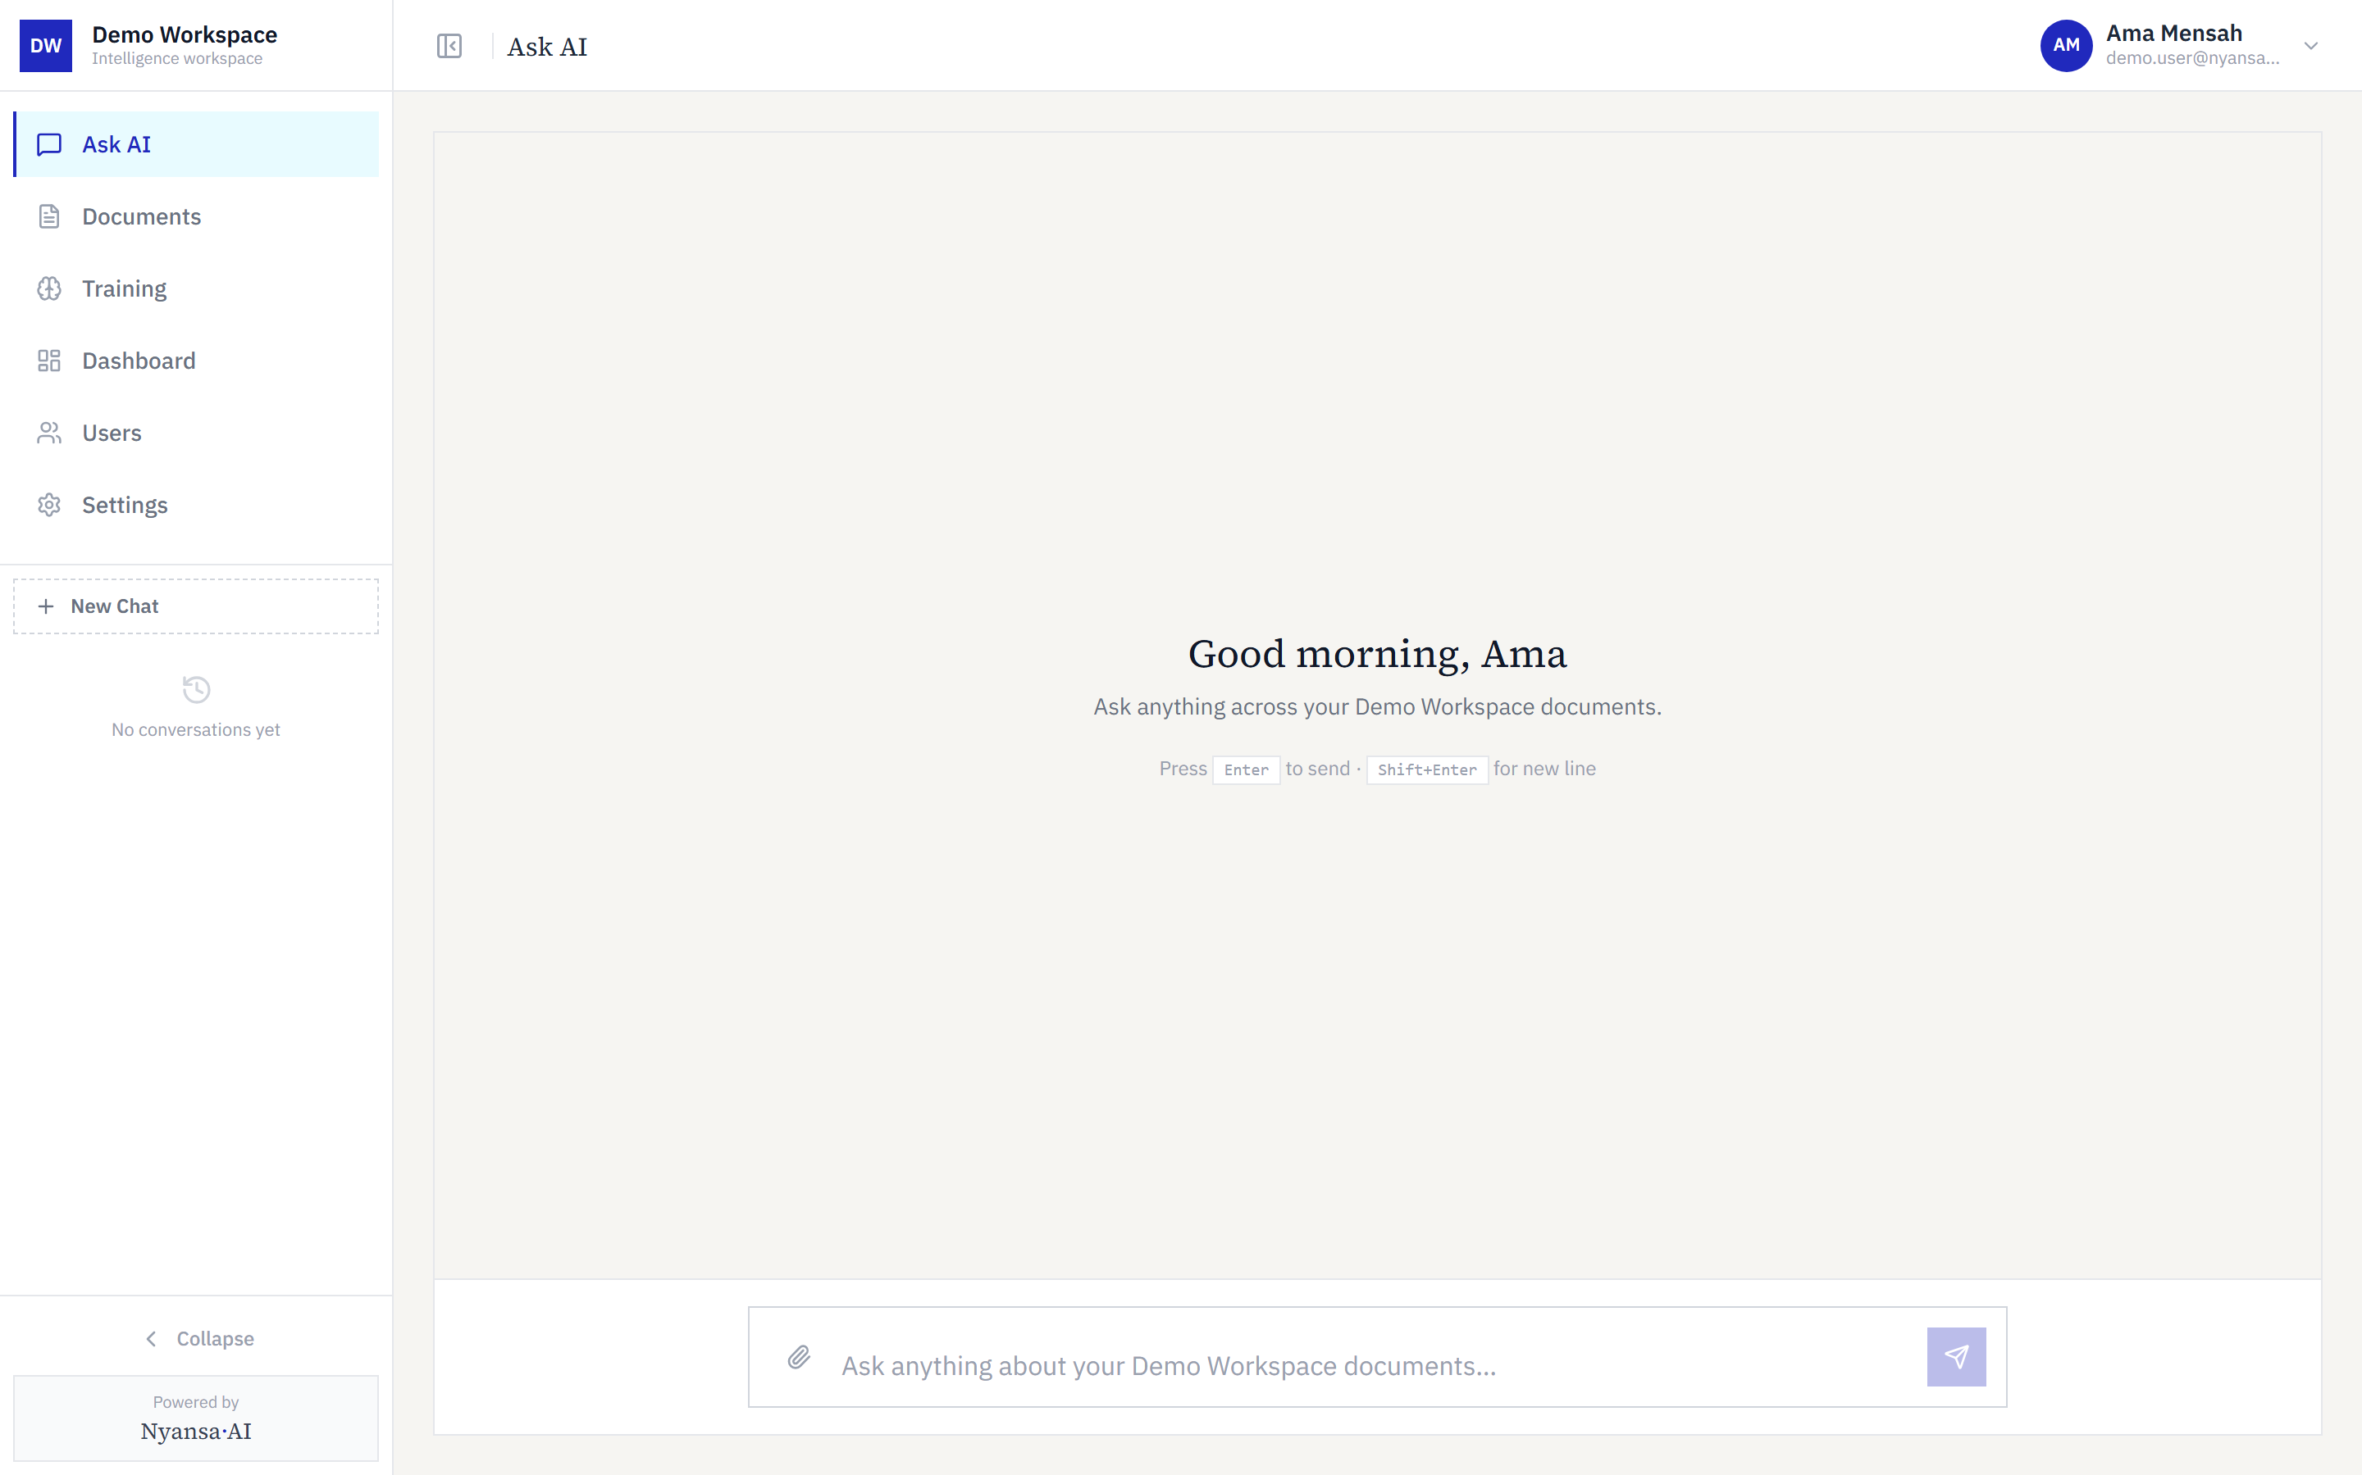
Figure 3 — The workspace on arrival, before any question is asked
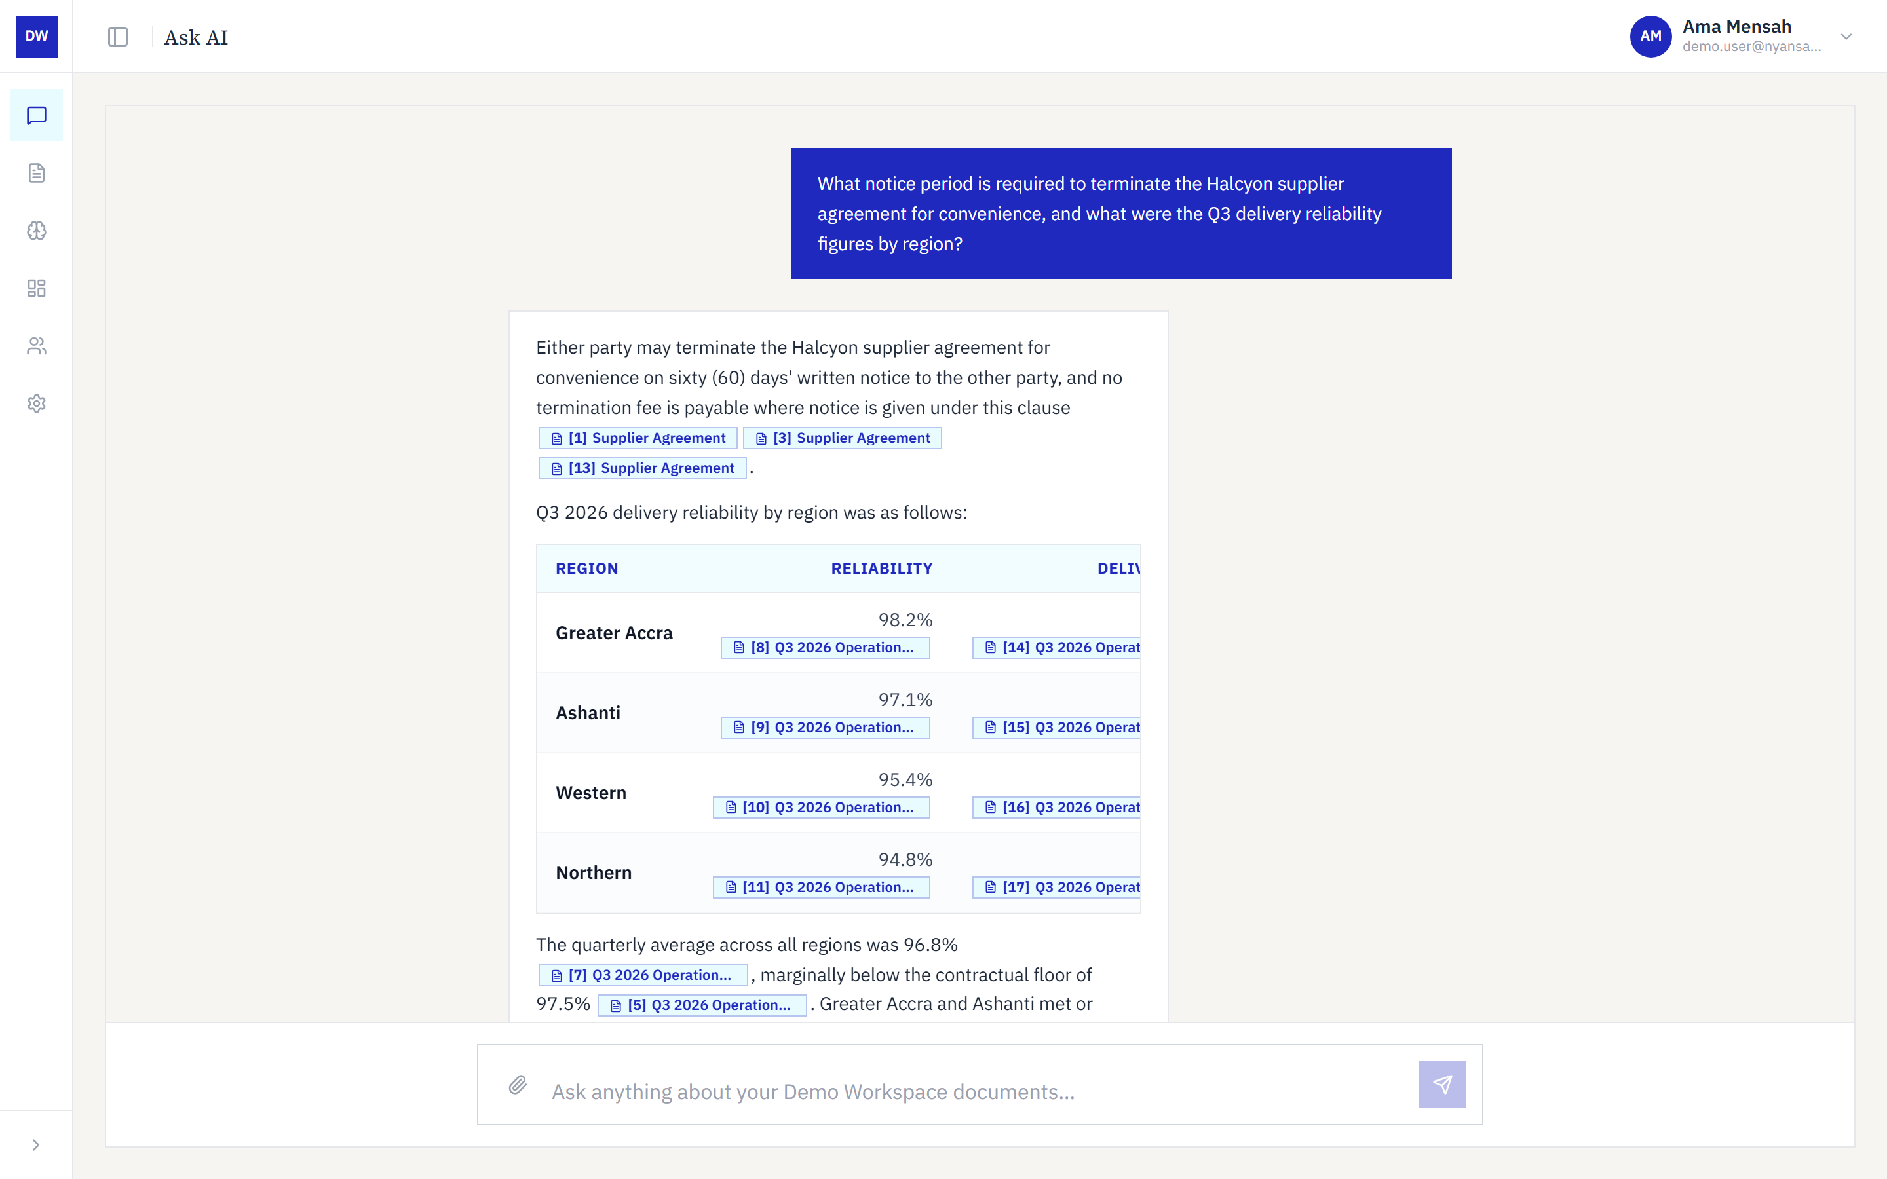
Figure 4 — The same screen with the navigation collapsed

Asking a question
Type a question in plain English into the box at the foot of the Ask AI page and press Enter. There is no need for search operators or keywords. The system searches every document in your workspace at once, including across several documents in a single question.
The answer arrives with citations attached to the specific statements they support. Where the answer contains figures, they are laid out as a table with each value carrying its own citation.
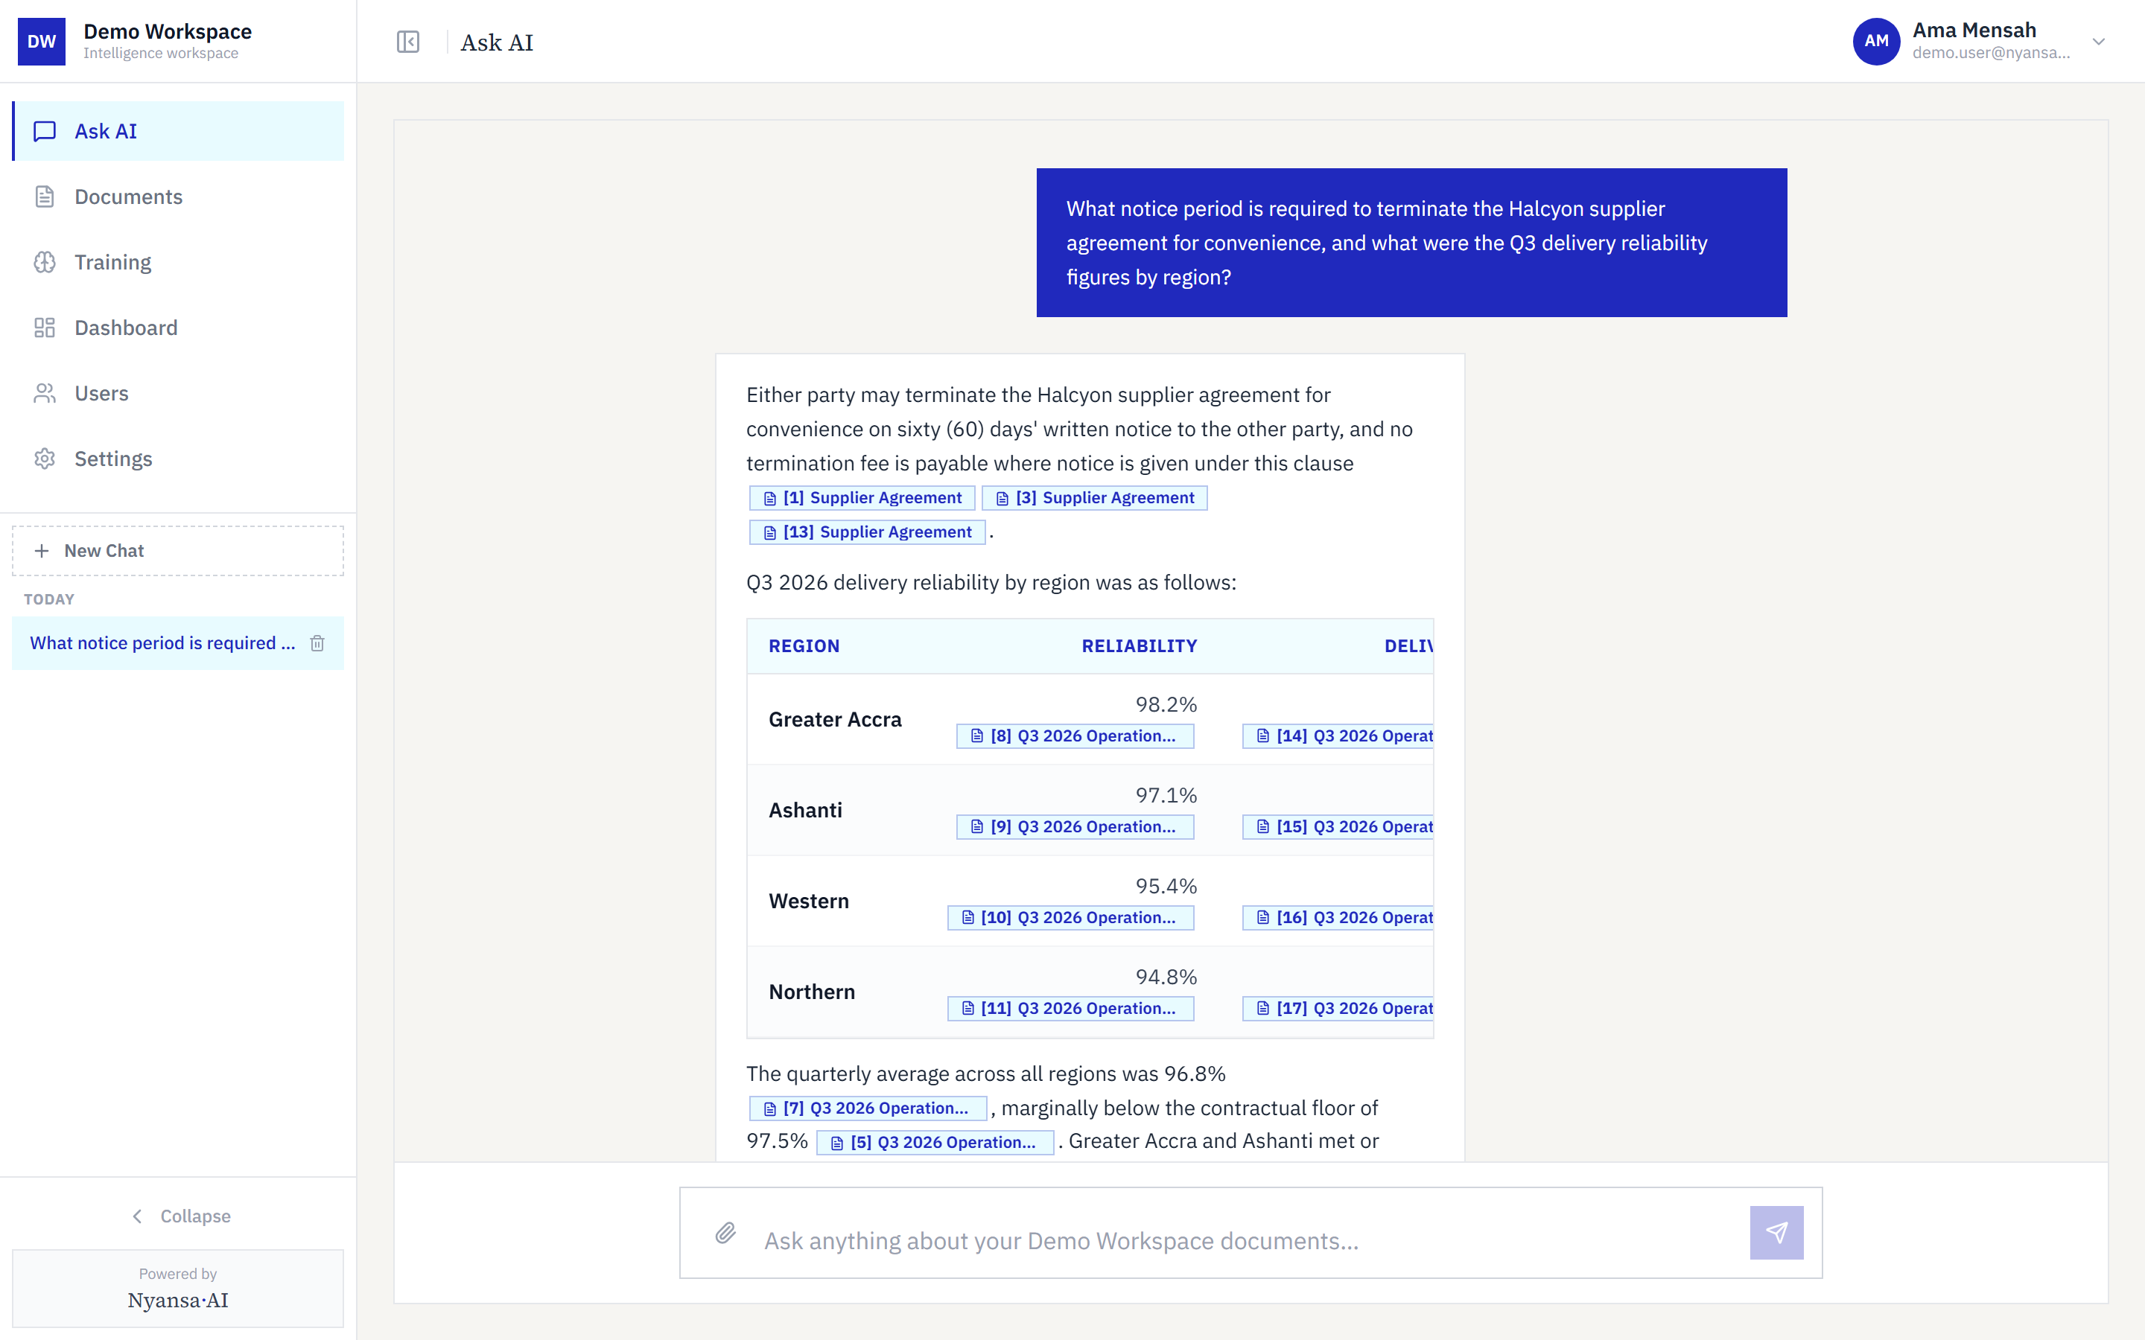
Figure 5 — An answer drawing on two documents, with citations on each statement and figure

Verifying an answer
Never take an answer on trust — the citations exist so you do not have to. Click any citation and the source document opens at the exact page the statement came from, with a match score showing how closely the passage corresponds.
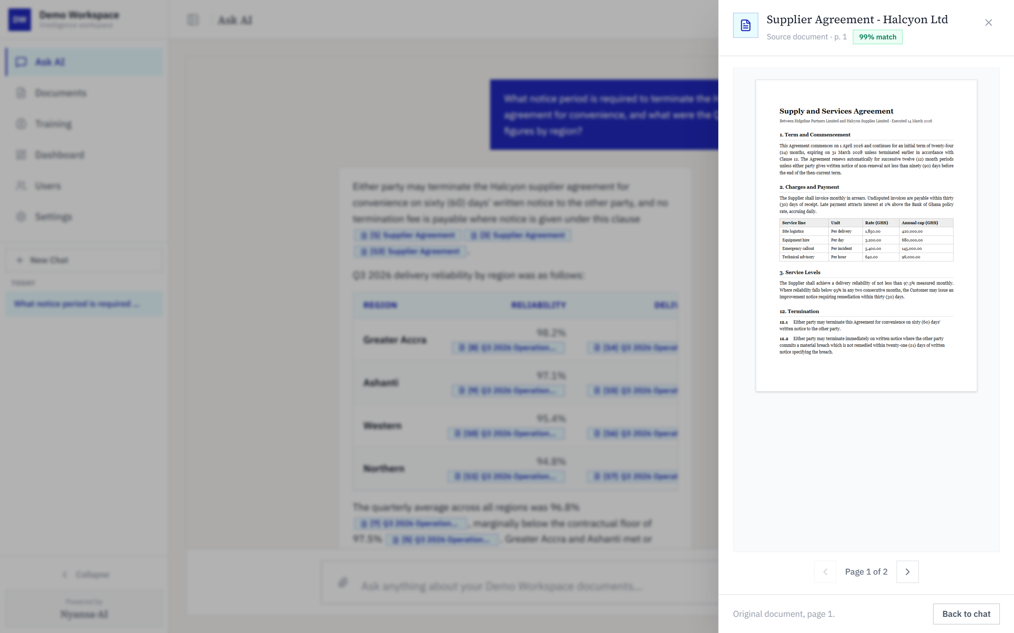
Figure 6 — A citation opened, showing the source document at the cited page
This is the single most important habit to build. If an answer looks surprising, open its citation first: the original passage almost always explains why the answer reads as it does.

Managing documents
The Documents page lists everything in your workspace, with its category, access level and processing status. Documents become answerable once their status shows as ready.
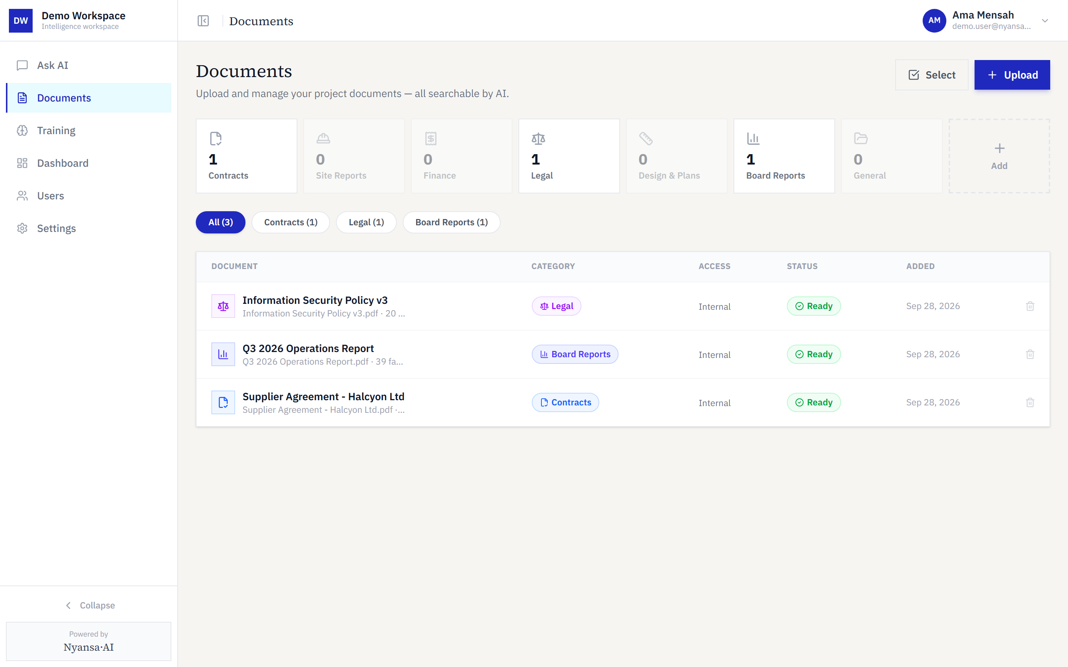
Figure 7 — The Documents page, showing category, access level and status

Uploading documents
Users with the Senior or Middle role can add documents. Open the upload dialog from the Documents page, then drag files in or browse for them. PDFs, Word files, spreadsheets, PowerPoint, CSV and plain text are all accepted, up to 500 MB each.
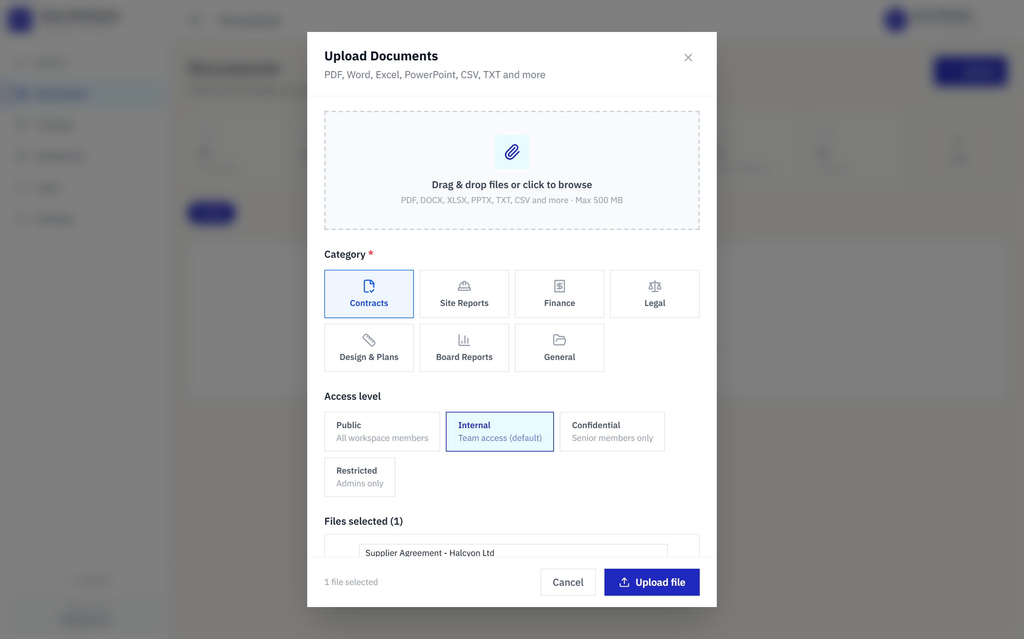
Figure 8 — The upload dialog, with files staged and a category chosen
Two fields must be set before the upload button becomes available:
- Category — Contracts, Site Reports, Finance, Legal, Design & Plans, Board Reports or General. This is required; the upload button stays disabled until one is chosen.
- Access level — Public for all workspace members, Internal for team access, Confidential for senior members only, or Restricted for administrators only.
Text, tables and figures are then extracted automatically. Large files continue processing in the background, so you can leave the page and come back.

Dashboards
Dashboards summarise recurring themes and figures across the whole document set, rather than answering a single question. They are available to Senior and Middle roles.
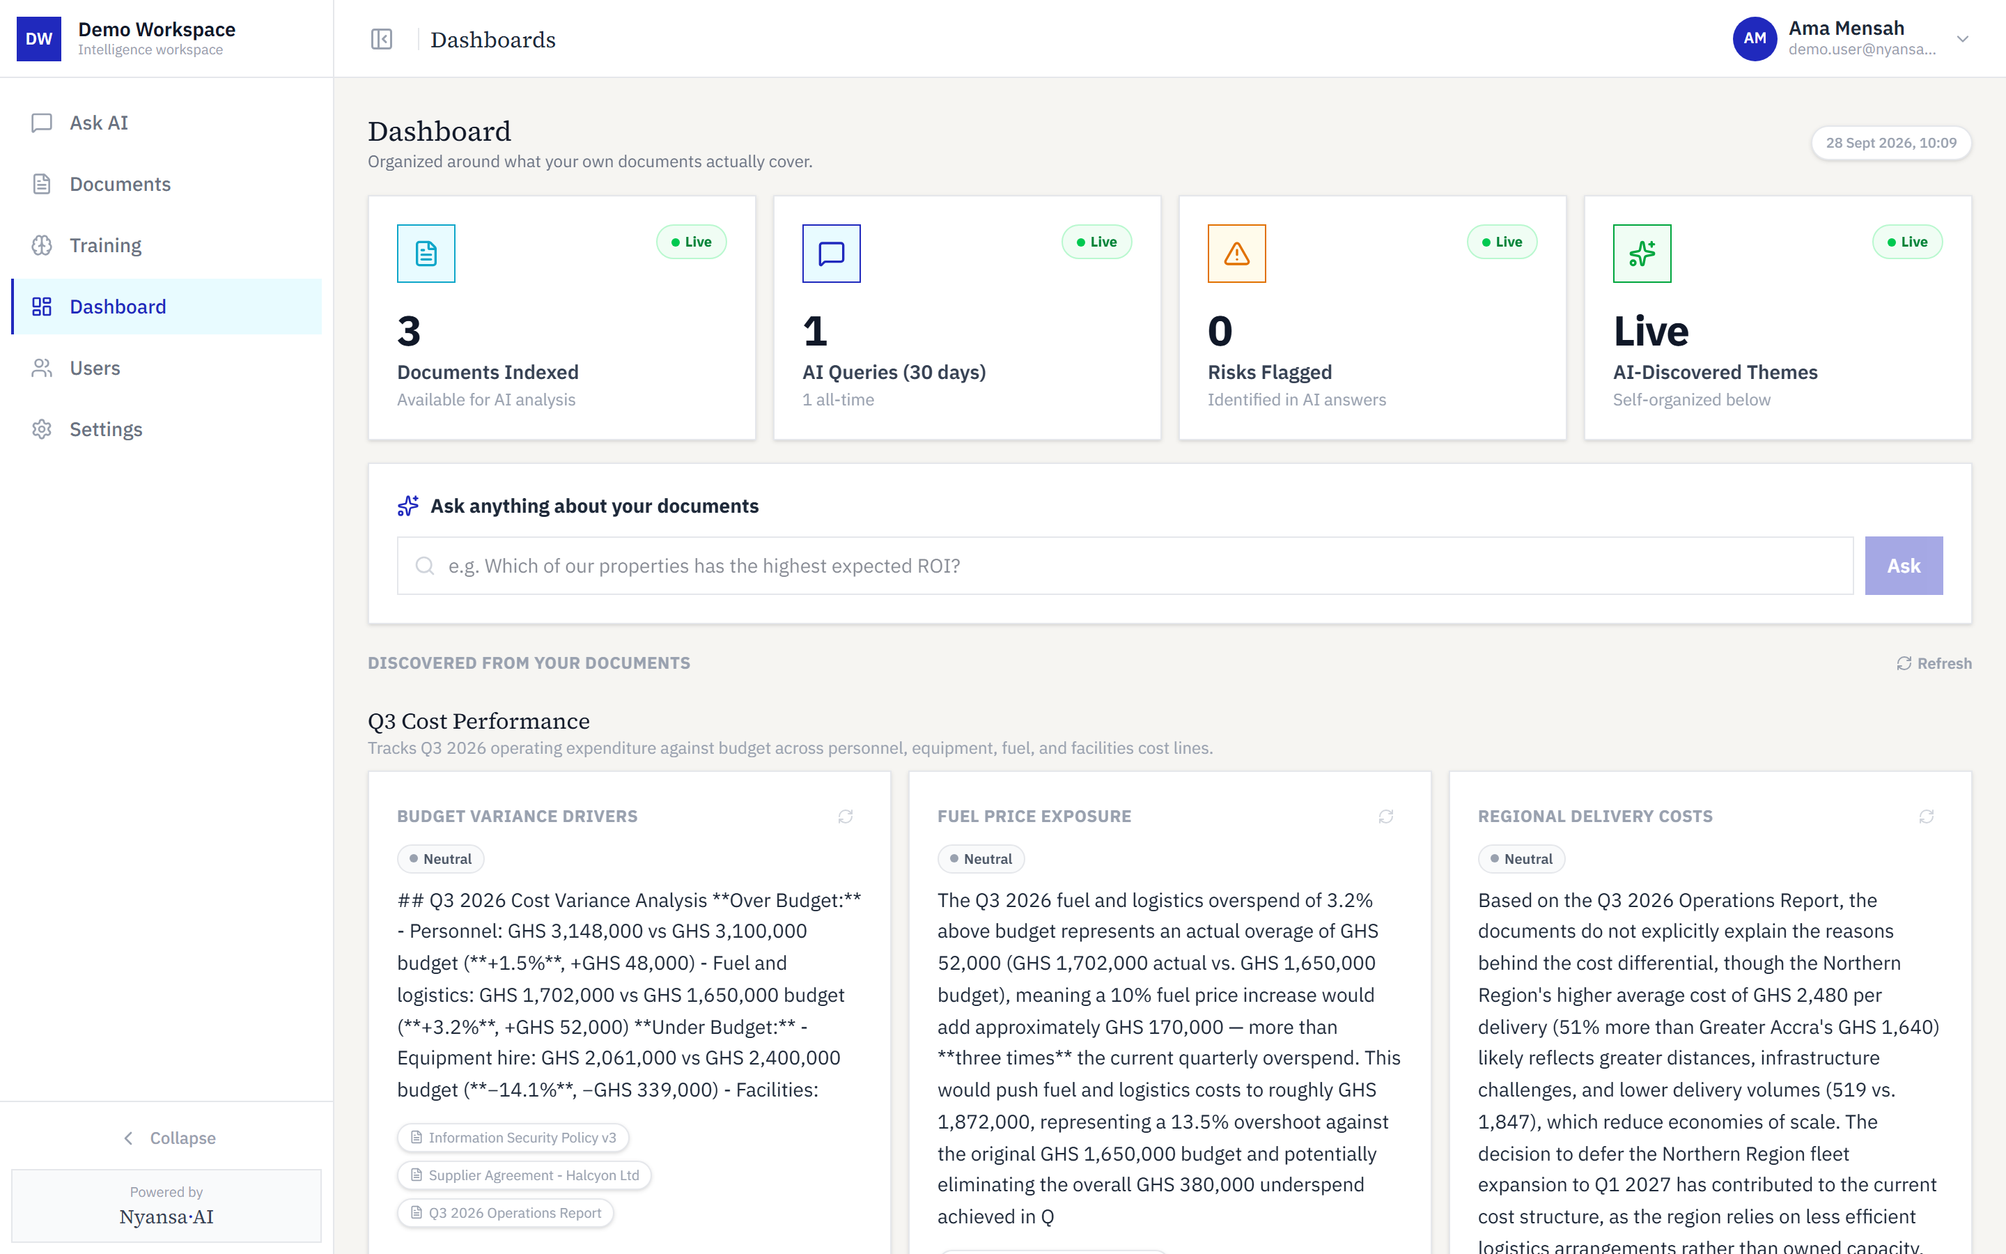
Figure 9 — The dashboard overview
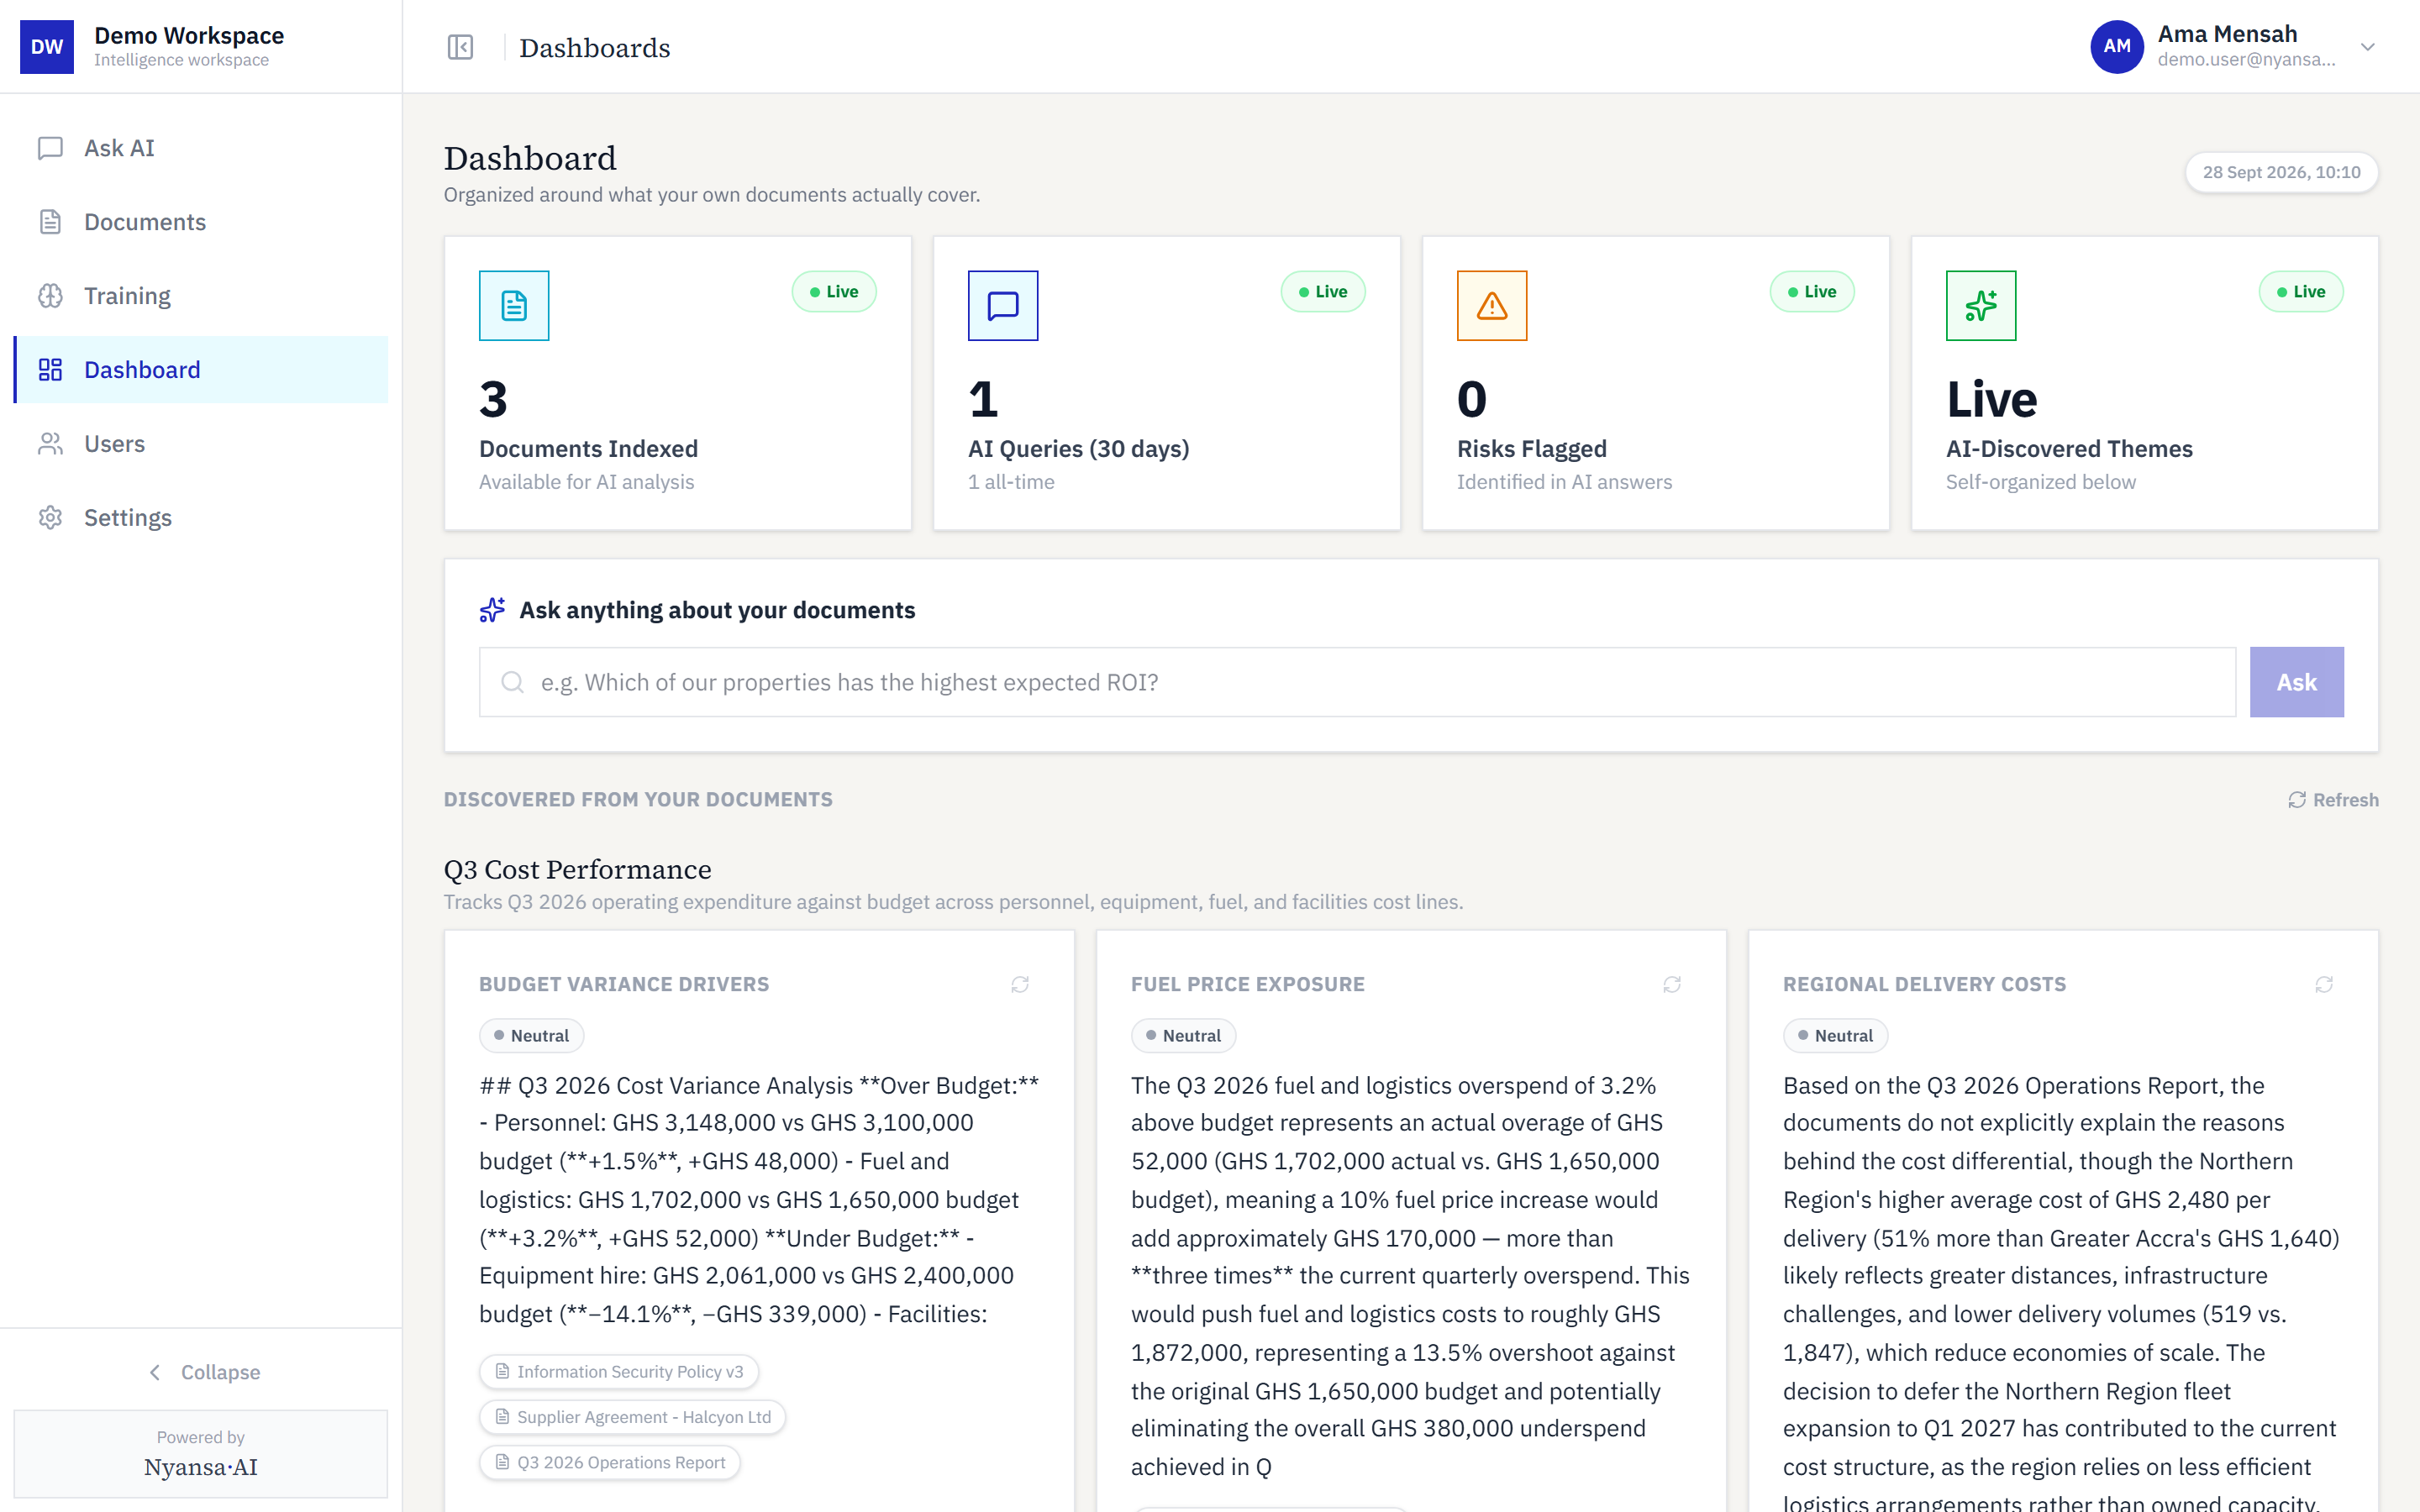
Figure 10 — An individual dashboard

Managing users
Senior users manage workspace membership from the Users page, which lists every member, their role and their recent activity.
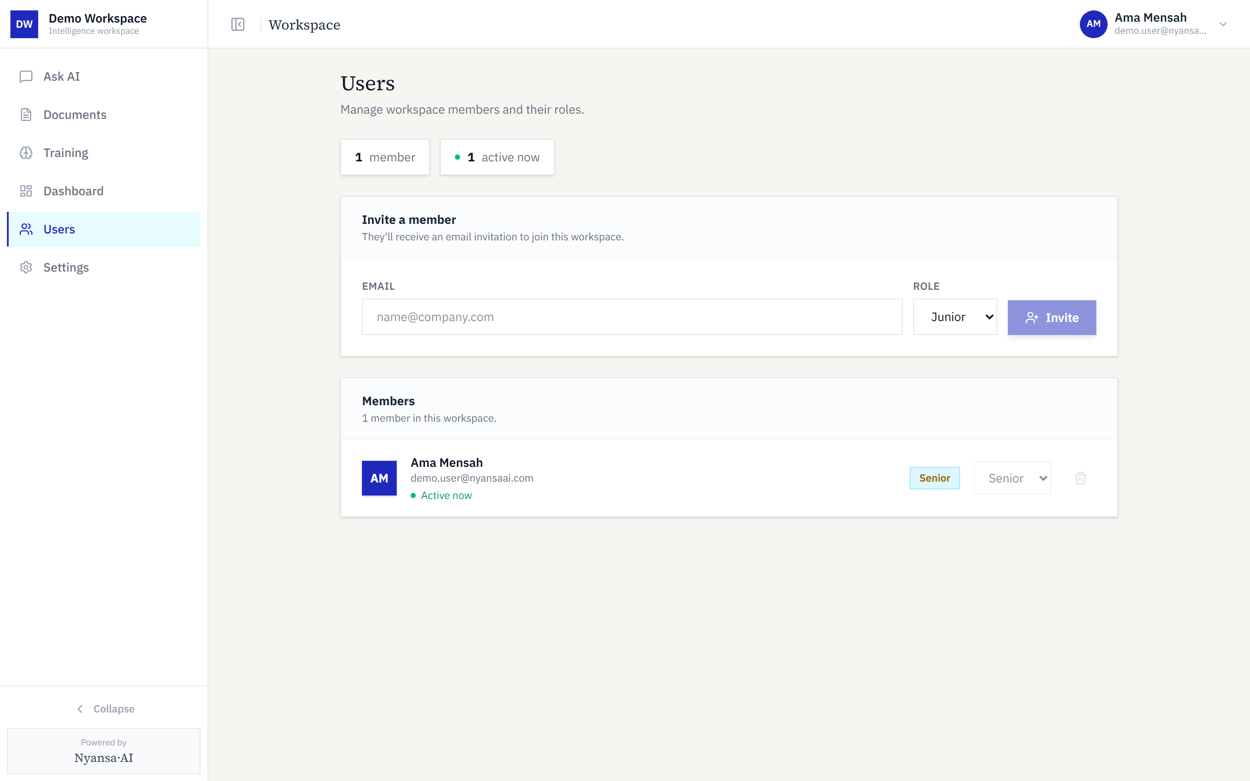
Figure 11 — The Users page
To add a colleague, enter their email address and choose a role. They receive an email inviting them to set their own password.
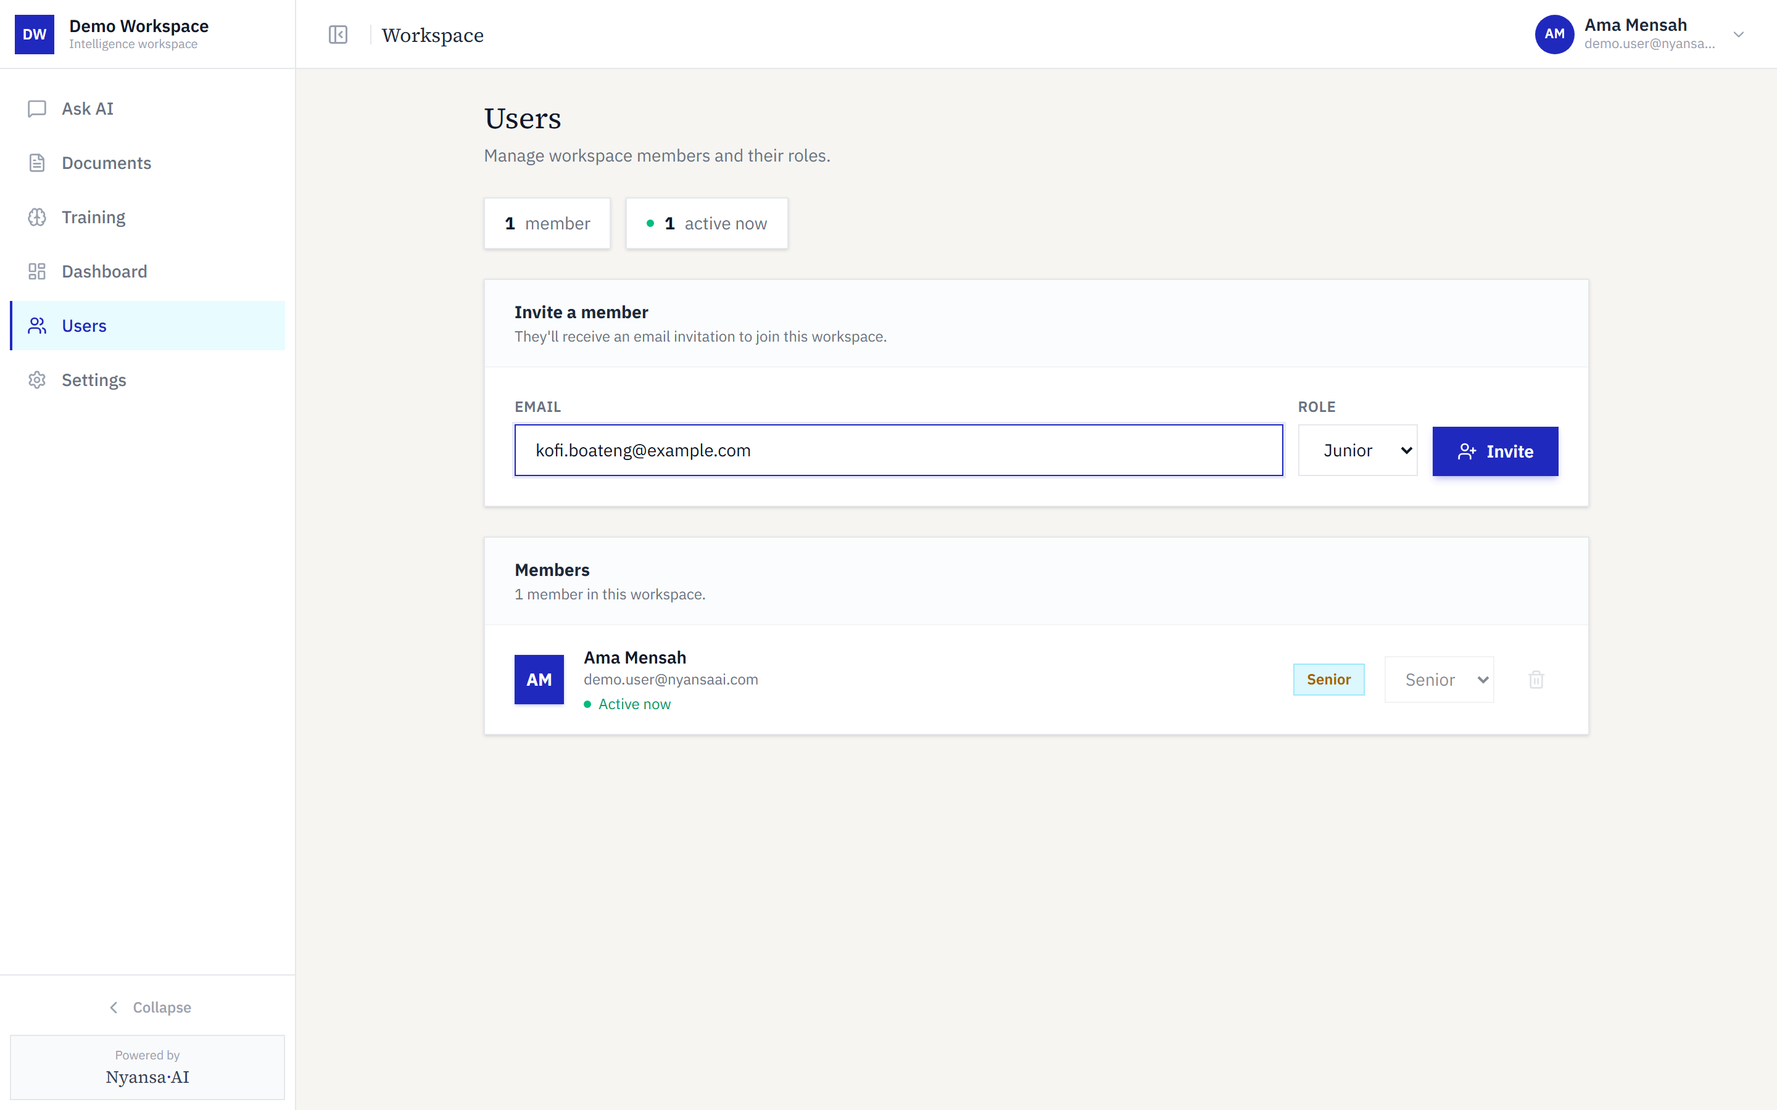
Figure 12 — Inviting a colleague
Roles determine what each member can do:
Role | Ask questions | Upload documents | Delete documents | Dashboards | Manage users
Senior | Yes | Yes | Yes | Yes | Yes
Middle | Yes | Yes | No | Yes | No
Junior | Yes | No | No | No | No

Settings
Settings is divided into three sections. Profile holds your display name and account details.
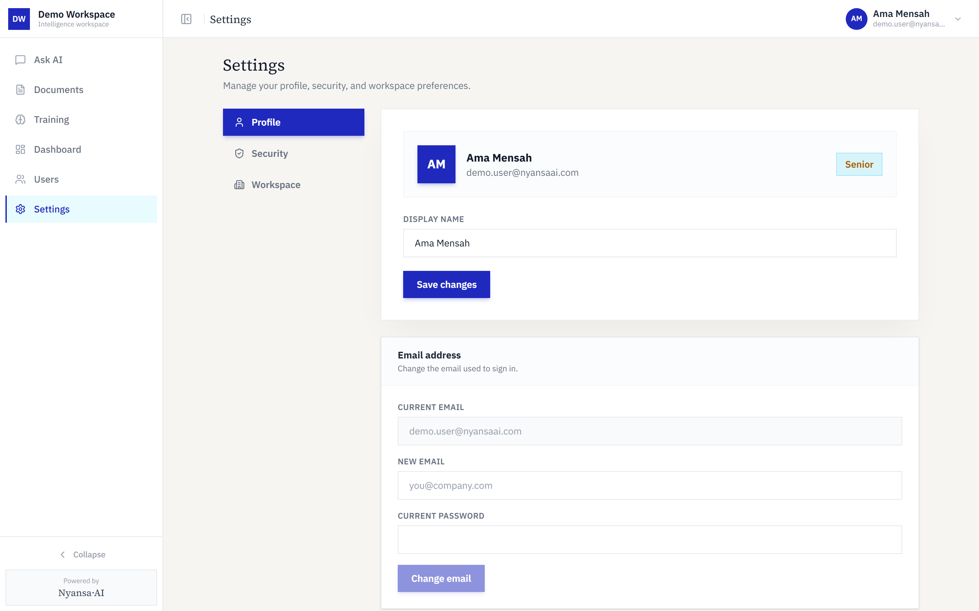
Figure 13 — Profile settings
Security is where you change your password and enable two-factor authentication, either through an authenticator app or by emailed code.
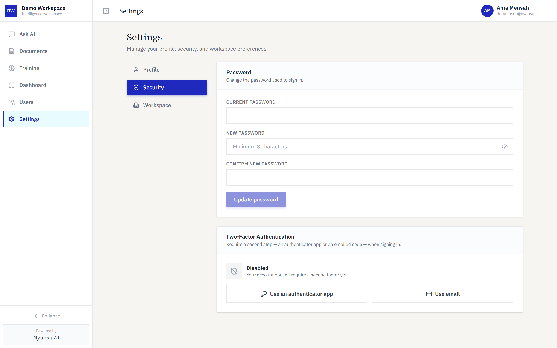
Figure 14 — Security settings, including two-factor authentication
Workspace, available to Senior users, controls the workspace icon shown in the browser tab and sidebar, and which email domains may be invited.
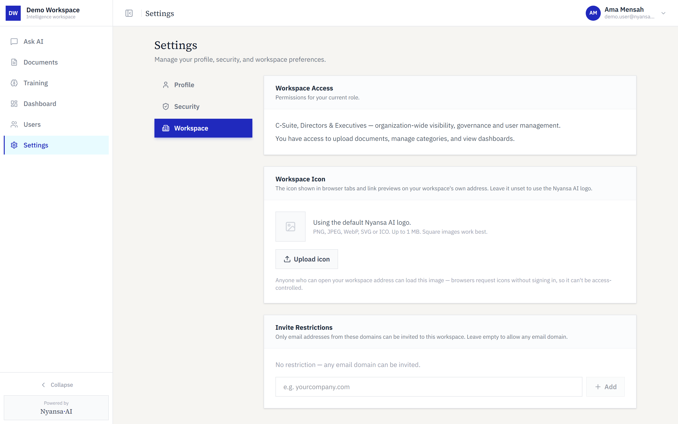
Figure 15 — Workspace settings

Training
The Training page, available to Senior users, is where document processing is reviewed and improved — re-running extraction on a document, or checking how well its tables and figures were read.
What “Training” does not mean. Despite the name, this page does not train any artificial intelligence model, and nothing done here causes your documents to be learned by a model. It re-runs the extraction step that reads text, tables and figures out of a document — useful where a document was read imperfectly the first time. Model training is addressed in Part 2.
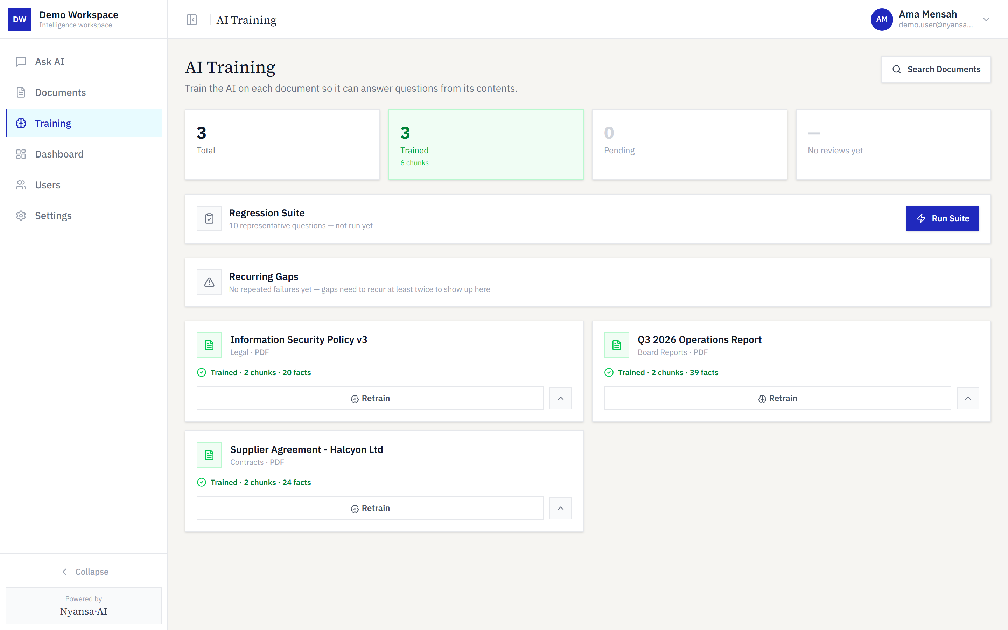
Figure 16 — The Training page

Part 2 — Data Protection & Confidentiality
Nyansa AI is a multi-tenant document intelligence platform. Each client organisation’s documents, extracted data and conversations are isolated at the database level, encrypted in transit and at rest, and processed by the named sub-processors below.
This document states current, implemented controls. Where something is not in place, it is listed under Current limitations rather than omitted.

What data the platform holds
Data held | Where it lives | Notes
Original documents | Private object storage | PDFs, Word files, spreadsheets uploaded by the client
Extracted text and tables | Database | Passages, plus separately extracted tables and figures
Vector embeddings | Database | Numeric representations used to find relevant passages
Questions and answers | Database | Conversation history with citations to source documents

User account data is limited to name, email address, organisation and role. No payment details are collected. No special-category personal data is processed unless a client uploads documents containing it.

How your data is processed
Two pipelines handle your content. Ingestion runs once per document, when it is uploaded. Query runs each time somebody asks a question. Between them, content reaches an external provider at exactly four points, marked below.
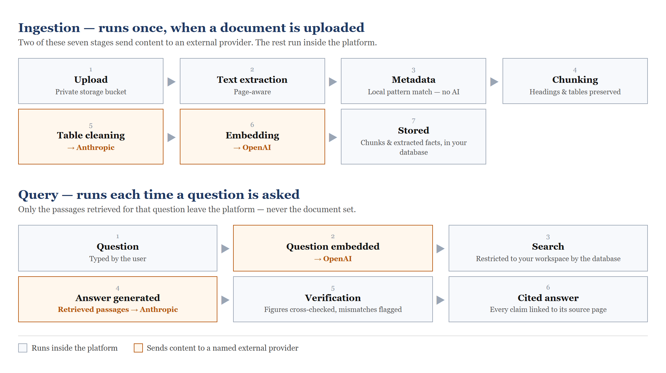
Figure 17 — The ingestion and query pipelines, showing every point at which content leaves the platform
On ingestion, a document is placed in private storage, its text is extracted page by page, metadata is matched locally without any AI involvement, and the text is divided into passages that preserve headings and tables. Two stages then call outward: tables are cleaned with assistance from Anthropic, and passages are converted into embeddings by OpenAI. The results are written to the database.
On query, the question is converted to an embedding by OpenAI, and the search that follows is restricted by the database to your workspace alone. Only the passages retrieved for that particular question — never the document set, and never the original files — are sent to Anthropic to compose an answer. The answer is then checked automatically, with figures cross-referenced and mismatches flagged, before being returned with its citations.

Isolation and access control
Separation between organisations is enforced by the database, not by application code that could be bypassed.
Every table carrying client data has row-level security enabled. Each database request runs as the signed-in user and returns only rows belonging to that user’s organisation. An application bug, a malformed request, or a direct call to the data API cannot return another organisation’s rows, because the filter is applied below the application layer.
Three further controls sit on top:
- Workspace addressing — each organisation uses its own subdomain; a signed-in user reaching another organisation’s subdomain is redirected to their own workspace.
- Membership checks — a user belongs to exactly one organisation through a membership record carrying their role; sign-in against a workspace the account does not belong to is rejected explicitly.
- Server-side permission checks — role permissions are evaluated server-side on every request.
Verification performed 26 September 2026. All 18 tables holding client data were queried using the public API key that any visitor’s browser carries. Every table returned zero rows — documents, extracted passages, extracted figures, citations, conversations, memberships, organisations, authentication codes and the rest. No client data is reachable without an authenticated session.

Encryption, storage and sign-in
In transit. All traffic runs over HTTPS/TLS, including connections to the database, object storage and AI providers.
At rest. Data is stored on encrypted volumes provided by Supabase (running on AWS). Encryption at rest is applied at the storage layer by the provider; the platform does not additionally encrypt individual fields.
Document storage is private. Uploaded files live in a storage bucket marked private, so no file is retrievable by URL without an authorised request. The only public bucket holds organisation logos, used as browser tab icons and intended to be public.
Sign-in. Passwords are hashed by the authentication provider and are never visible to us or to administrators. Two-factor authentication is available as an authenticator app (TOTP) or an emailed six-digit code — the latter stored only as a hash, valid 10 minutes, limited to five attempts and rate-limited between requests. Sessions use signed cookies scoped to the organisation’s domain.

Sub-processors and data flows
Answering questions over documents requires sending document content to AI providers. This is stated plainly rather than left to be discovered during review.
Sub-processor | What it receives | Purpose
Anthropic (Claude) | Passages retrieved for a question, plus the question | Generating the cited answer
OpenAI | Document passages, and each question | Converting text to embeddings for search
Supabase | All stored data: documents, text, embeddings, accounts | Database, authentication, file storage
Vercel | Requests in transit; application logs | Application hosting
Microsoft 365 | Recipient address and content of authentication emails | Invitations, password resets, login codes

Two points a reviewer will reasonably ask about:
- Document content does leave the platform when a question is asked and when a document is first indexed. It goes only to the providers above, over TLS, for those purposes only.
- Retention and training by these providers are governed by the providers’ own API terms rather than by settings inside this platform — see Model training and your content, below.
Hosting and storage are currently in provider regions outside Ghana. Data-residency requirements should be raised before deployment.

Model training and your content
This question deserves a precise answer rather than a reassuring one, because the distinction determines where the assurance actually comes from.
What the platform controls. The platform determines what is sent and what is withheld. Only the passages retrieved for a specific question are sent when that question is asked, together with the question itself. The document set as a whole is never transmitted, and the original files never leave private storage. Everything else — documents, embeddings, conversations and accounts — remains in the platform’s own database and storage.
What the platform does not control. Whether a provider retains or trains on data submitted through its API is determined by that provider’s API terms, not by any setting within this platform. Anthropic and OpenAI both state that content submitted through their commercial APIs is not used to train their models. That assurance rests on those providers’ terms: it is not enforced technically by this platform, and it is stated here as provider policy rather than as a property of the software.
Clients requiring contractual certainty on this point should raise it before deployment, so that the relevant provider terms — including a zero-retention arrangement where one is available — can be put in place and referenced in the contract.
A note on shared provider accounts. Access to these providers runs through the platform operator’s own accounts. Content from all client organisations therefore passes through the same provider accounts, while remaining separated from other clients within the platform’s database at every stage.

Retention and deletion
Documents and their extracted text, embeddings and citations are retained while the workspace is active. A senior user can delete a document at any time, removing the stored file along with its extracted passages and figures. Conversation history is retained so users can revisit earlier answers.
On termination, an organisation’s workspace and associated records can be deleted on request. A defined retention and deletion schedule should be agreed contractually.

What the system does not do
Stated so that expectations are set before deployment rather than during it.
Ingestion from a web address. Documents are added as uploaded files. The platform does not retrieve a document from a URL, and does not crawl or scrape websites. Link-based ingestion would be new development.
Programmatic access. There is no external API. Every route in the application authenticates through a signed-in user session; no API keys are issued to client organisations, and no external system can read from or write to a workspace. An API would be a new surface requiring its own authentication, per-organisation scoping and rate limiting.
Bulk loading and synchronisation. Documents are uploaded through the workspace, up to 500 MB per file, and processed automatically. There is no bulk ingestion route and no synchronisation with an external system, so an initial load of a large archive, or keeping a workspace in step with a system that changes daily, would require development.
On accuracy. Answers are generated only from passages retrieved from your own documents, every statement carries a citation, figures are cross-checked automatically, and the system is built to report insufficient information rather than fill a gap. These measures reduce the risk of an unsupported answer substantially but do not eliminate it — which is precisely why each answer is cited. The source passage is one click away, and verification takes seconds.

Current limitations
Stated deliberately, so they are not discovered later.
Area | Position today
Audit logging | Questions and uploads are recorded with user identity and timestamp. There is no dedicated audit trail of permission changes, and no exportable compliance report.
Certification | No ISO 27001, SOC 2 or equivalent third-party certification. Controls described here are implemented but not externally audited.
Data residency | No in-country hosting option at present.
Penetration testing | No independent penetration test has been commissioned to date.

Each is a roadmap item rather than a refusal. Where a procurement process requires one, it should be raised early so it can be scheduled and priced.
Contact. Questions about this document, or a security questionnaire to complete, can be directed to the Nyansa AI team through your usual contact.

Part 3 — Questions and Answers
These are the questions organisations have actually asked during evaluation, answered directly. Where an answer is “no”, it is given as “no” rather than deferred.
How does Nyansa AI protect the security, privacy and confidentiality of our data, while preventing the AI model from accessing, retaining or using it for external model training?
Nyansa AI is a retrieval system, so answering a question does require sending the relevant material to the AI model. Rather than claim otherwise, the protection is described here in the three parts that actually apply: access is narrowly scoped, retention is governed contractually, and training is excluded by the providers’ terms.
Access is scoped to the question. When somebody asks a question, only the passages relevant to that question are sent, together with the question itself. The document set as a whole is never transmitted, and the original files never leave private storage — the model receives short extracts, never a file. The only other point of contact is when a document is first indexed, when passages are converted into the mathematical representation used for searching.
Access is scoped to the organisation. Which passages can be retrieved at all is decided by the database rather than the application. Each request runs as the signed-in user and returns only rows belonging to that user’s organisation, so a software fault, a malformed request or a direct call to the data interface cannot reach another organisation’s material. This was verified on 26 September 2026 by querying all eighteen tables holding client data with the public key carried by any visitor’s browser: every table returned nothing.
Retention and training are governed by the providers’ terms. Anthropic and OpenAI both state that content submitted through their commercial APIs is not retained for training and is not used to train their models. That assurance rests on those providers’ API terms rather than on a technical control inside Nyansa AI, and is stated plainly here rather than implied to be a property of the software. Where contractual certainty is required, the relevant provider terms — including a zero-retention arrangement where one is available — can be put in place and referenced in the contract.
Will the system hallucinate, and can we rely on its answers?
Answers are generated only from passages retrieved from your own documents, not from the model’s general knowledge. Every statement carries a citation to the source document and page, figures are cross-checked automatically with mismatches flagged, and the system is built to report that it has insufficient information rather than fill the gap.
Those measures reduce the risk of an unsupported answer substantially, but they do not eliminate it, and no honest supplier will tell you otherwise. This is precisely why every answer is cited: the source passage is one click away, and confirming an answer takes seconds. Treat the citation as the control, and verify anything consequential before acting on it.
Can the system extract documents from a web link?
No. Documents are added as uploaded files — PDF, Word, Excel, PowerPoint, CSV and plain text. The platform does not retrieve a document from a web address, and does not crawl or scrape websites. Adding link-based ingestion would be new development rather than configuration.
We hold a large set of documents. How do we load them, and how do we keep them up to date?
Documents are uploaded through the workspace, up to 500 MB per file, and are processed automatically through the extraction pipeline once uploaded. Several files can be selected at once.
For an initial load of a large existing archive, or for keeping a workspace continuously in step with a system whose contents change daily, there is at present no bulk ingestion route and no synchronisation with external systems. Both would require development, and should be scoped separately.
Can we connect to Nyansa AI through an API, or connect it to our own database?
Not today. Every route in the application authenticates through a signed-in user session. No API keys are issued to client organisations, and no external system can read from or write to a workspace.
An API is a substantial addition rather than a setting, and three things determine its shape. First, direction: whether data is read out of Nyansa AI programmatically, or whether Nyansa AI reads from your systems. Second, authentication: in a multi-tenant platform every credential must be bound to one organisation and carry a role, exactly as a user session does, so that a key cannot reach another organisation’s data. Third, whether access is read-only or also permits writing, since writing must respect the same role rules as the upload screen.
These should be settled before an API is scoped, as they materially change the work involved.
The application has a page called Training. Does it train an AI model on our documents?
No. Despite the name, that page re-runs the extraction step that reads text, tables and figures out of a document — useful where a document was read imperfectly the first time. No model is trained, no model weights change, and nothing on that page causes your documents to be learned by a model.
Where is our data held, and can it be held in Ghana?
Hosting, database and file storage currently sit in provider regions outside Ghana. There is no in-country hosting option at present. Where data residency is a requirement, it should be raised before deployment, as it determines which provider regions can be used and may affect cost.
If we stop using the service, what happens to our data?
On termination, the organisation’s workspace and its associated records can be deleted on request — documents, extracted text, search indexes and conversation history. A defined retention and deletion schedule should be agreed in the contract rather than left to be settled at the point of exit.

