NYANSA AI
Enterprise Document Intelligence
Tenant Onboarding
How a new organisation joins the platform
22 October 2026

Summary
A new organisation joins Nyansa AI by signing up on the main site, confirming its email address, and naming its workspace. The platform then provisions a dedicated workspace on its own web address, and the person who created it becomes its first administrator, able to invite colleagues.
The whole sequence takes a few minutes and requires no action from the Nyansa AI team. Every screenshot in this report was captured by completing the process end to end on the live platform, using a fictional organisation created for the purpose.
Stage | What happens
1. Account details | Name, work email and password
2. Organisation | Organisation name; the web address is derived and checked for availability
3. Email confirmation | A confirmation link is sent to the address given
4. Workspace setup | The organisation name and address are confirmed
5. Workspace created | A dedicated workspace opens at its own address
6. Team invited | The first administrator invites colleagues and assigns roles

One point for administrators. There is currently no payment step and no approval step. Anyone who completes this form receives a working workspace immediately. That is appropriate while the platform is in controlled use, and it is the specific thing the planned subscription work changes — a workspace will then be created in a "payment required" state and open only once payment is confirmed.

The onboarding process

Step 1 Create the account
The organisation begins at the sign-up page on the main site. The first stage asks only for the individual’s own details: their name, their work email address and a password of at least eight characters.
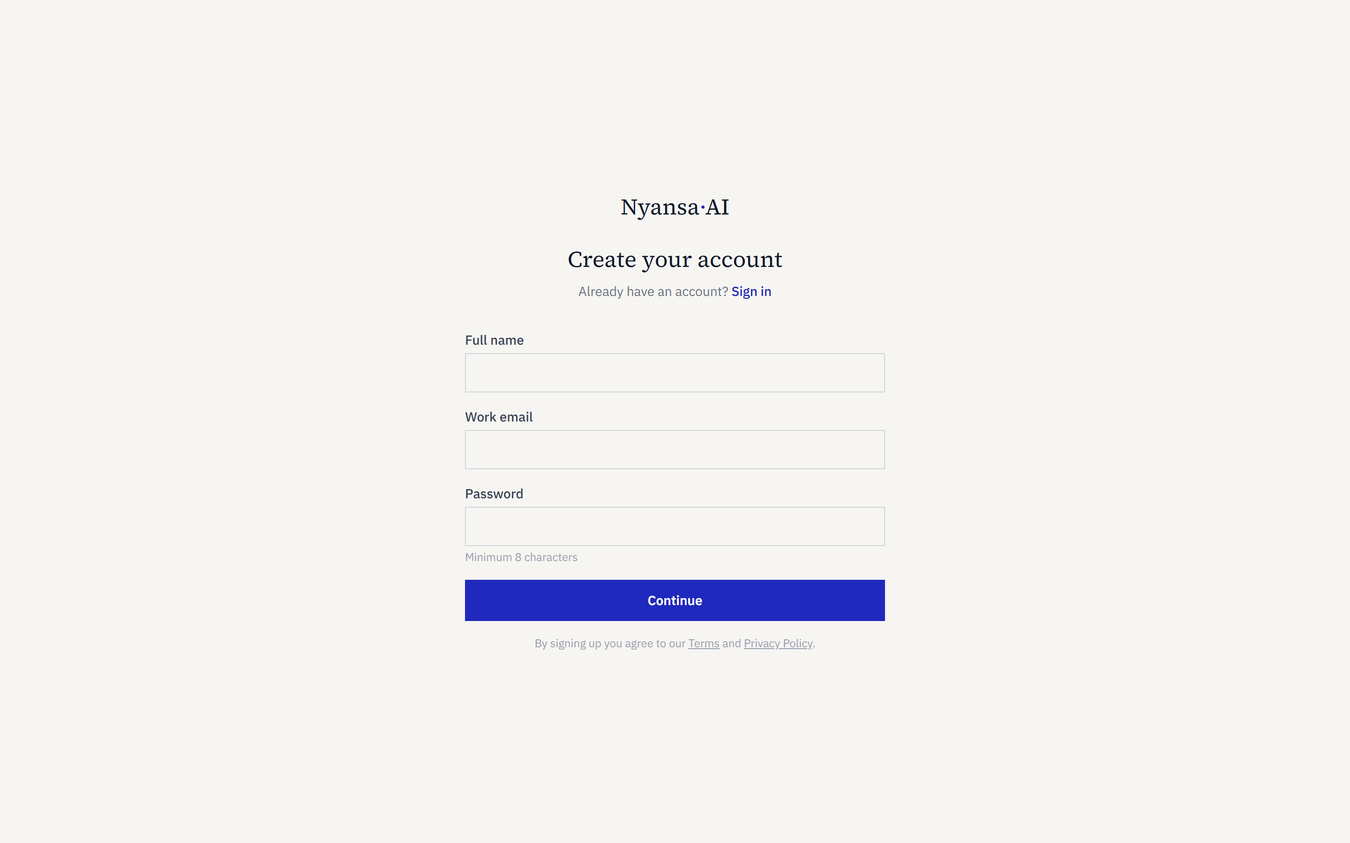
Figure 1 — The sign-up page, first stage
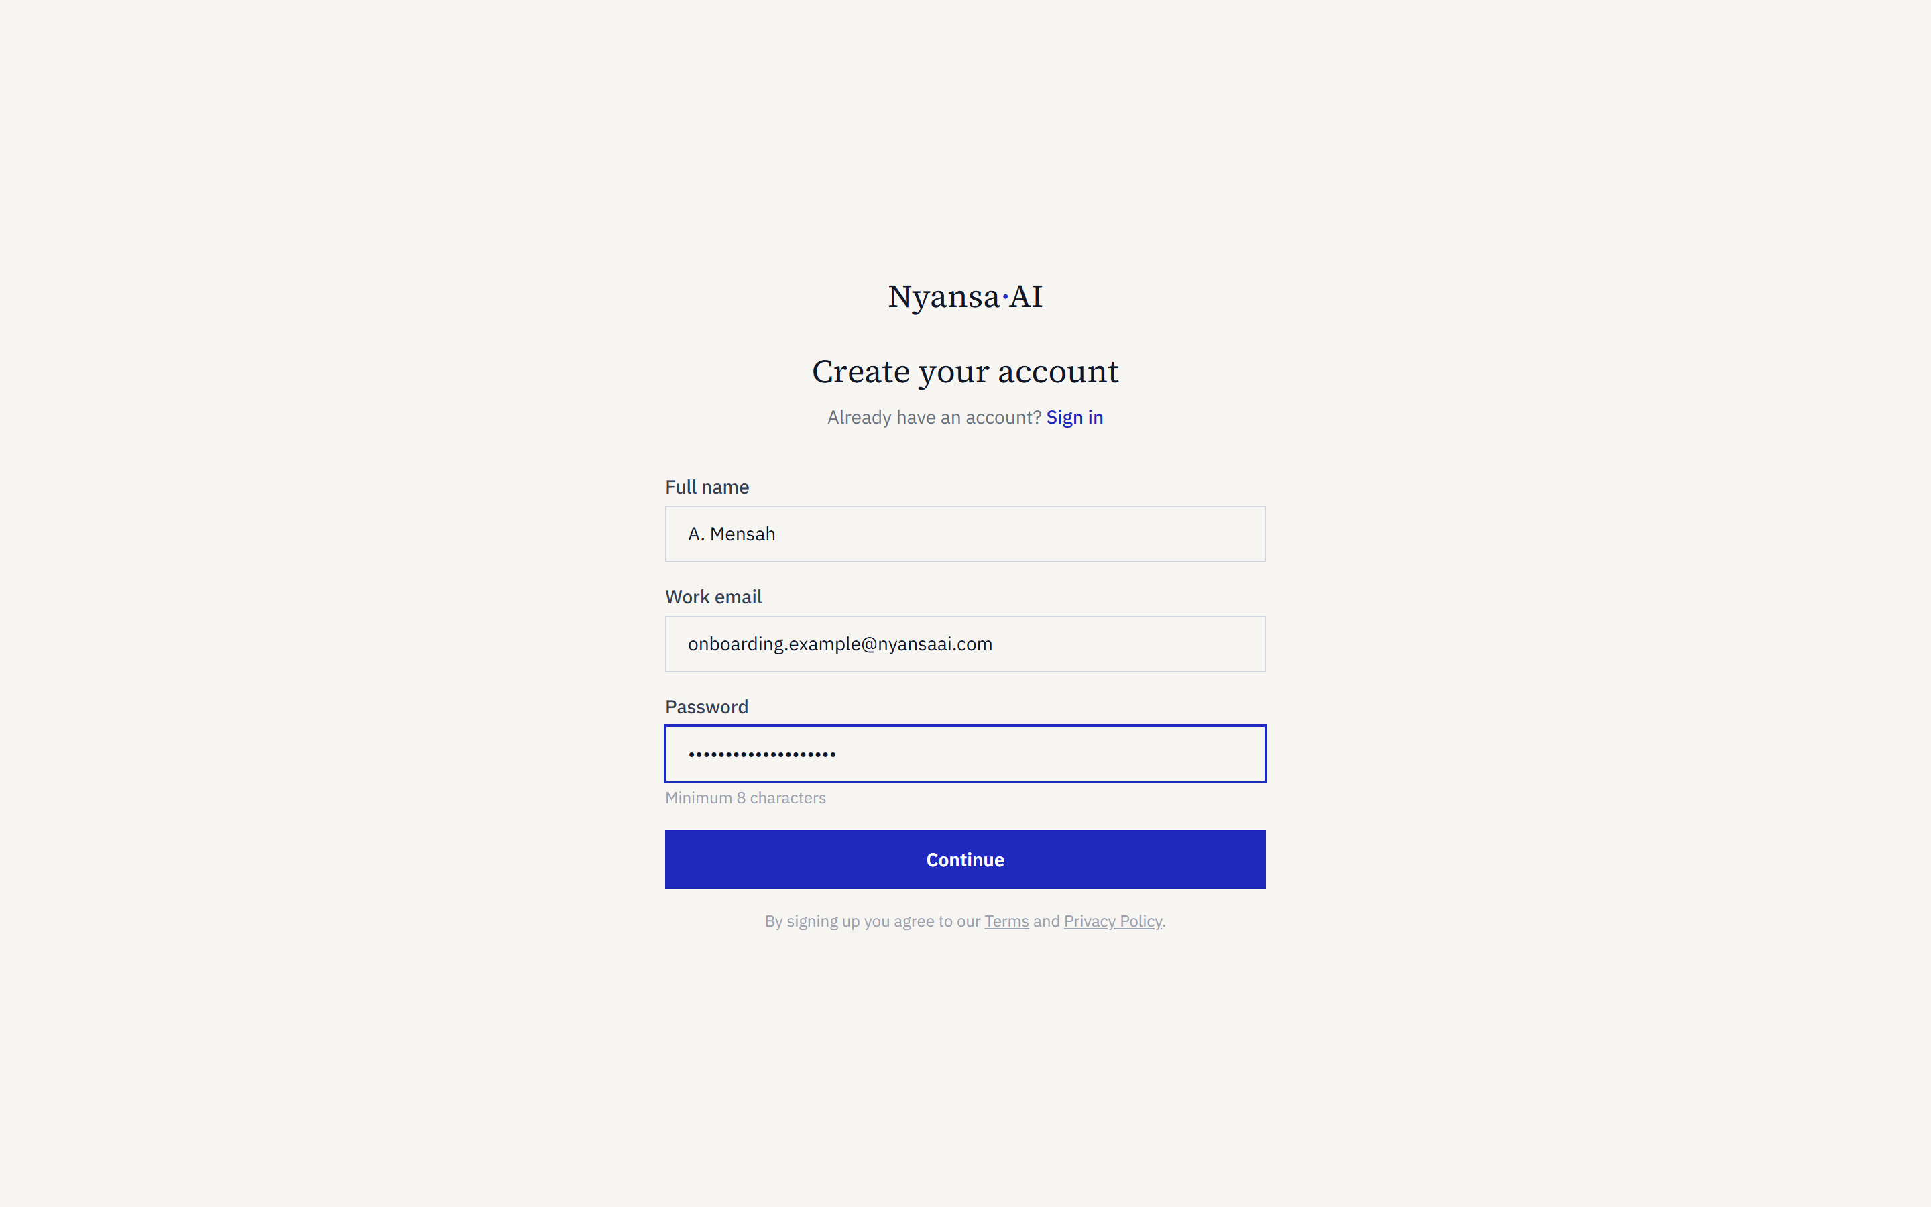
Figure 2 — Account details entered

Step 2 Name the organisation
The second stage asks for the organisation. As the name is typed, the platform derives a web address from it and checks in real time whether that address is free, so a clash is caught before the account is created rather than after.
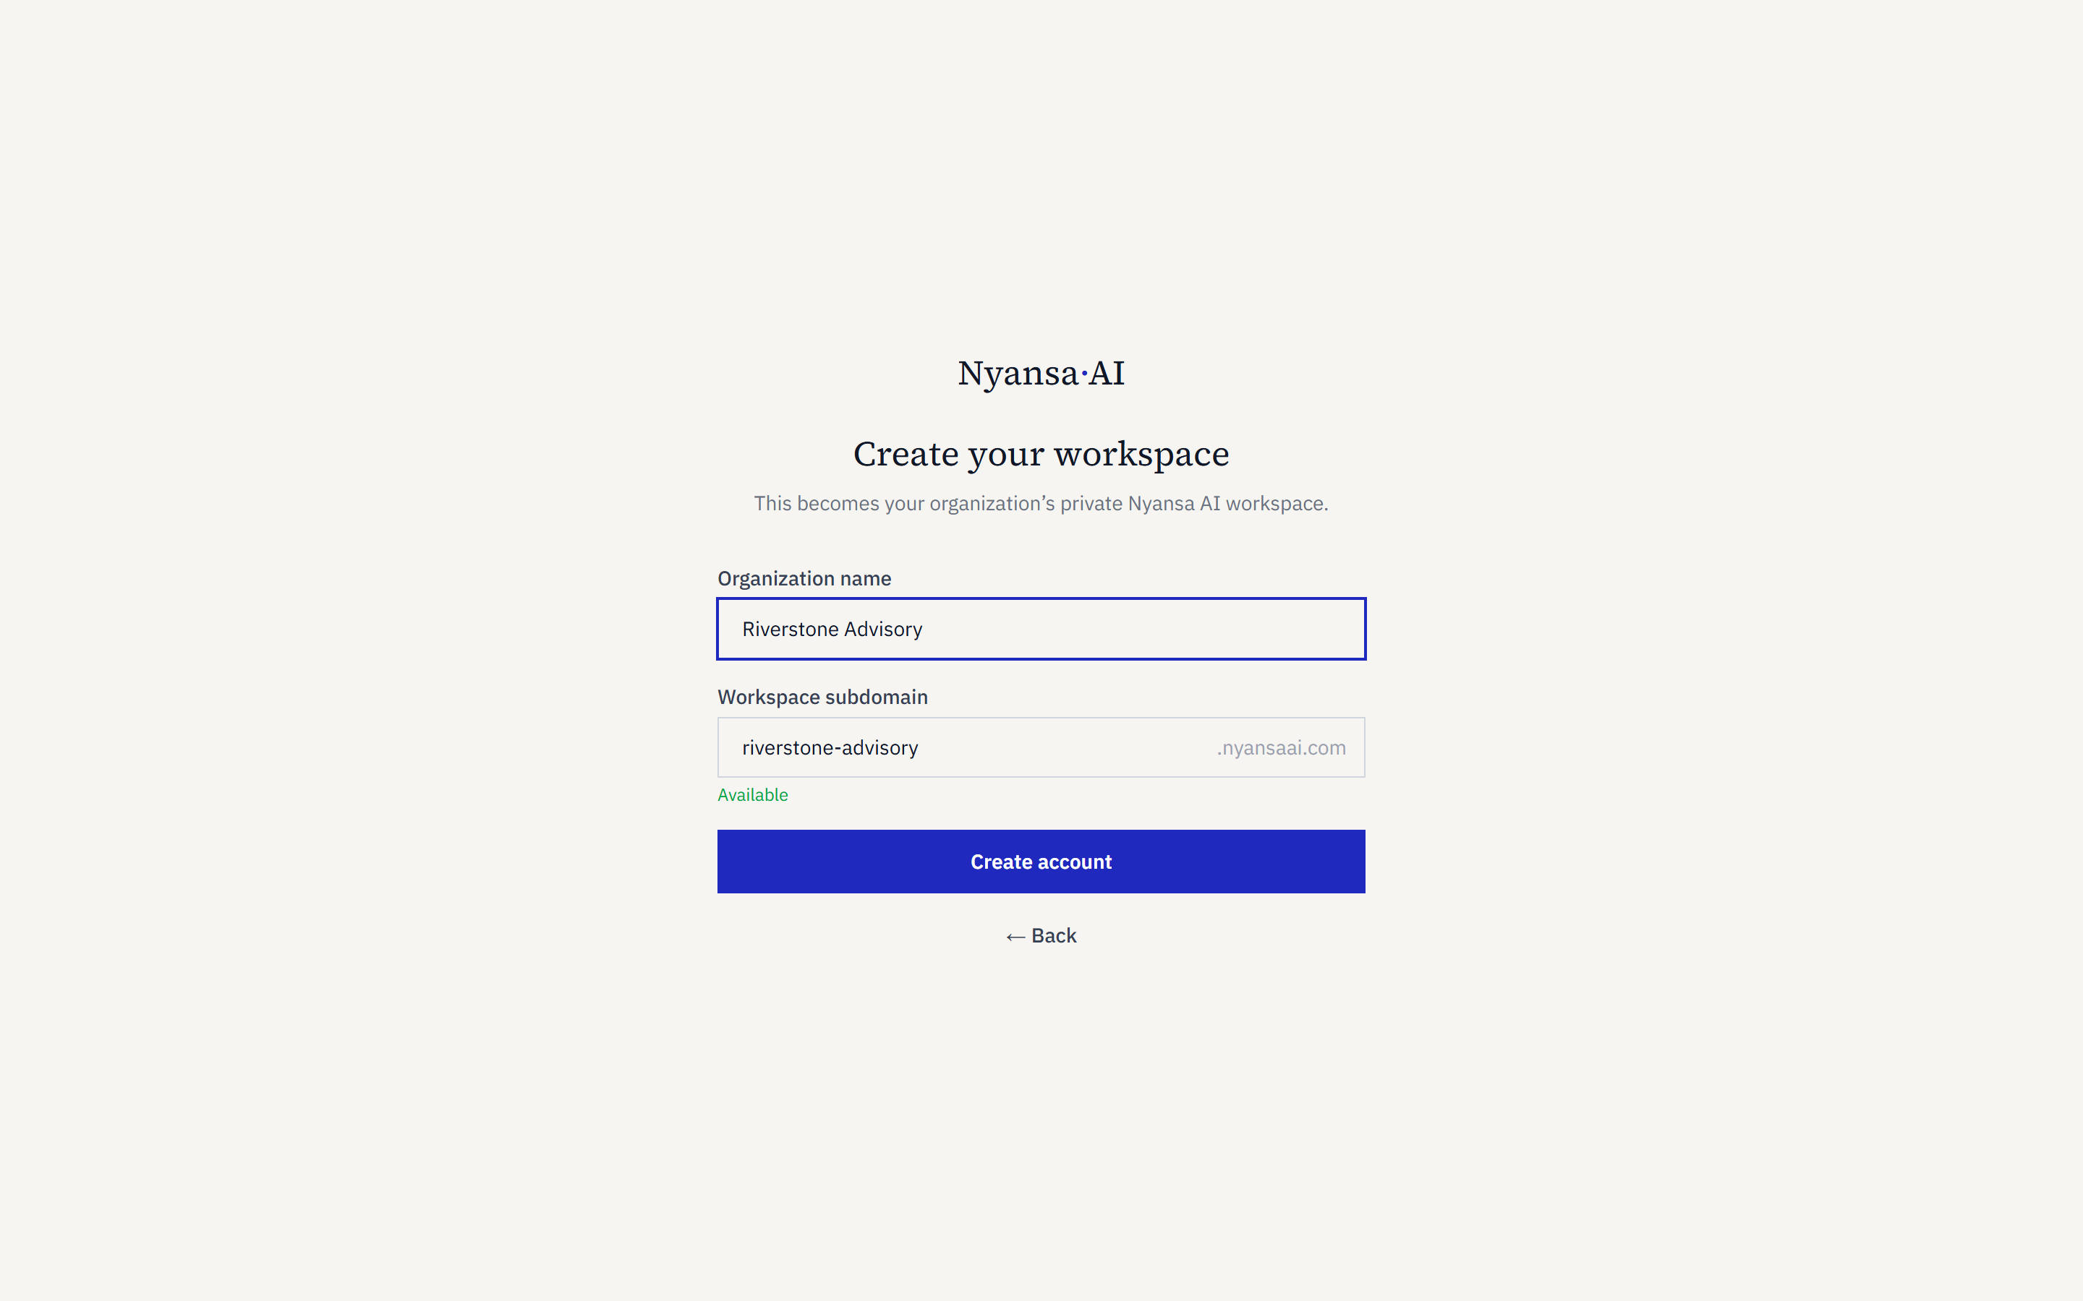
Figure 3 — The organisation name, with its web address checked as it is typed
How the address is chosen. The address is derived automatically from the organisation name: "Riverstone Advisory" becomes riverstone-advisory.nyansaai.com. It can be edited before submitting. Once chosen it identifies the workspace permanently, so it is worth choosing deliberately.

Step 3 Confirm the email address
On submission, a confirmation email is sent to the address given. The account exists at this point but the workspace does not: confirmation proves the address is genuine and reachable before any workspace is provisioned.
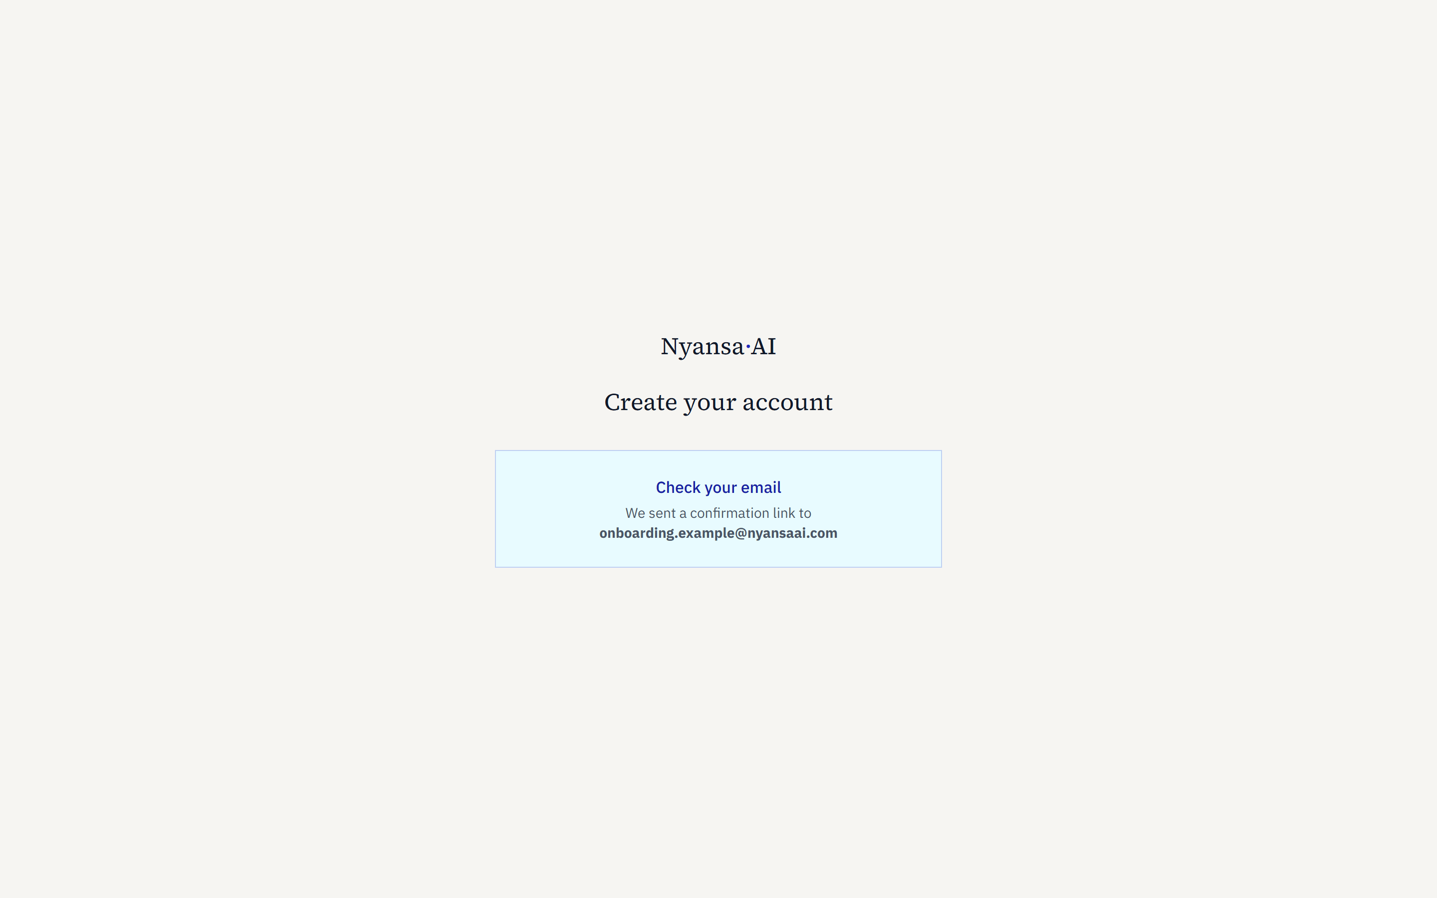
Figure 4 — Confirmation that the email has been sent
If the email does not arrive. It is worth checking the junk folder. Mail filters at many organisations treat a first message from an unfamiliar sender with suspicion. Marking it as not junk means subsequent messages — invitations, password resets — arrive normally.

Step 4 Confirm the workspace
Following the link in the email signs the person in and brings them to the workspace setup step, where the organisation name and web address captured earlier are shown for confirmation. Both can still be changed here.
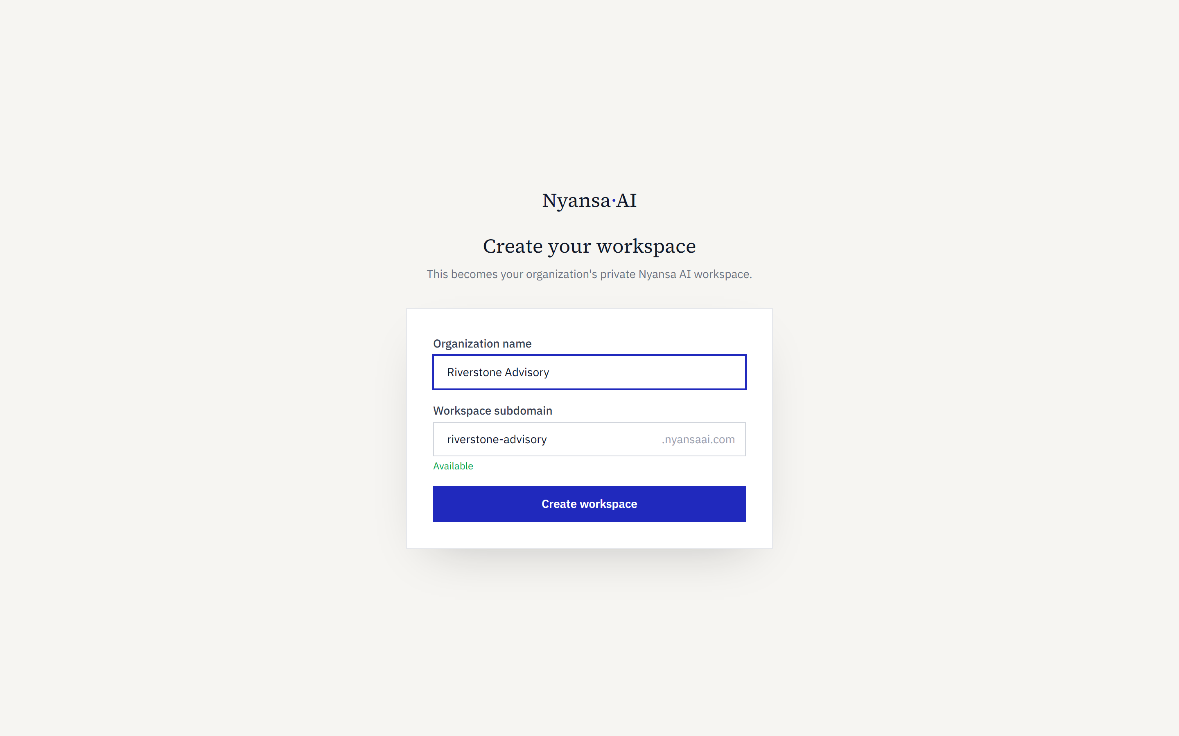
Figure 5 — Confirming the workspace name and address

Step 5 The workspace opens
Confirming creates the workspace and moves the person straight into it, at the organisation’s own address. The workspace is empty and ready for documents.
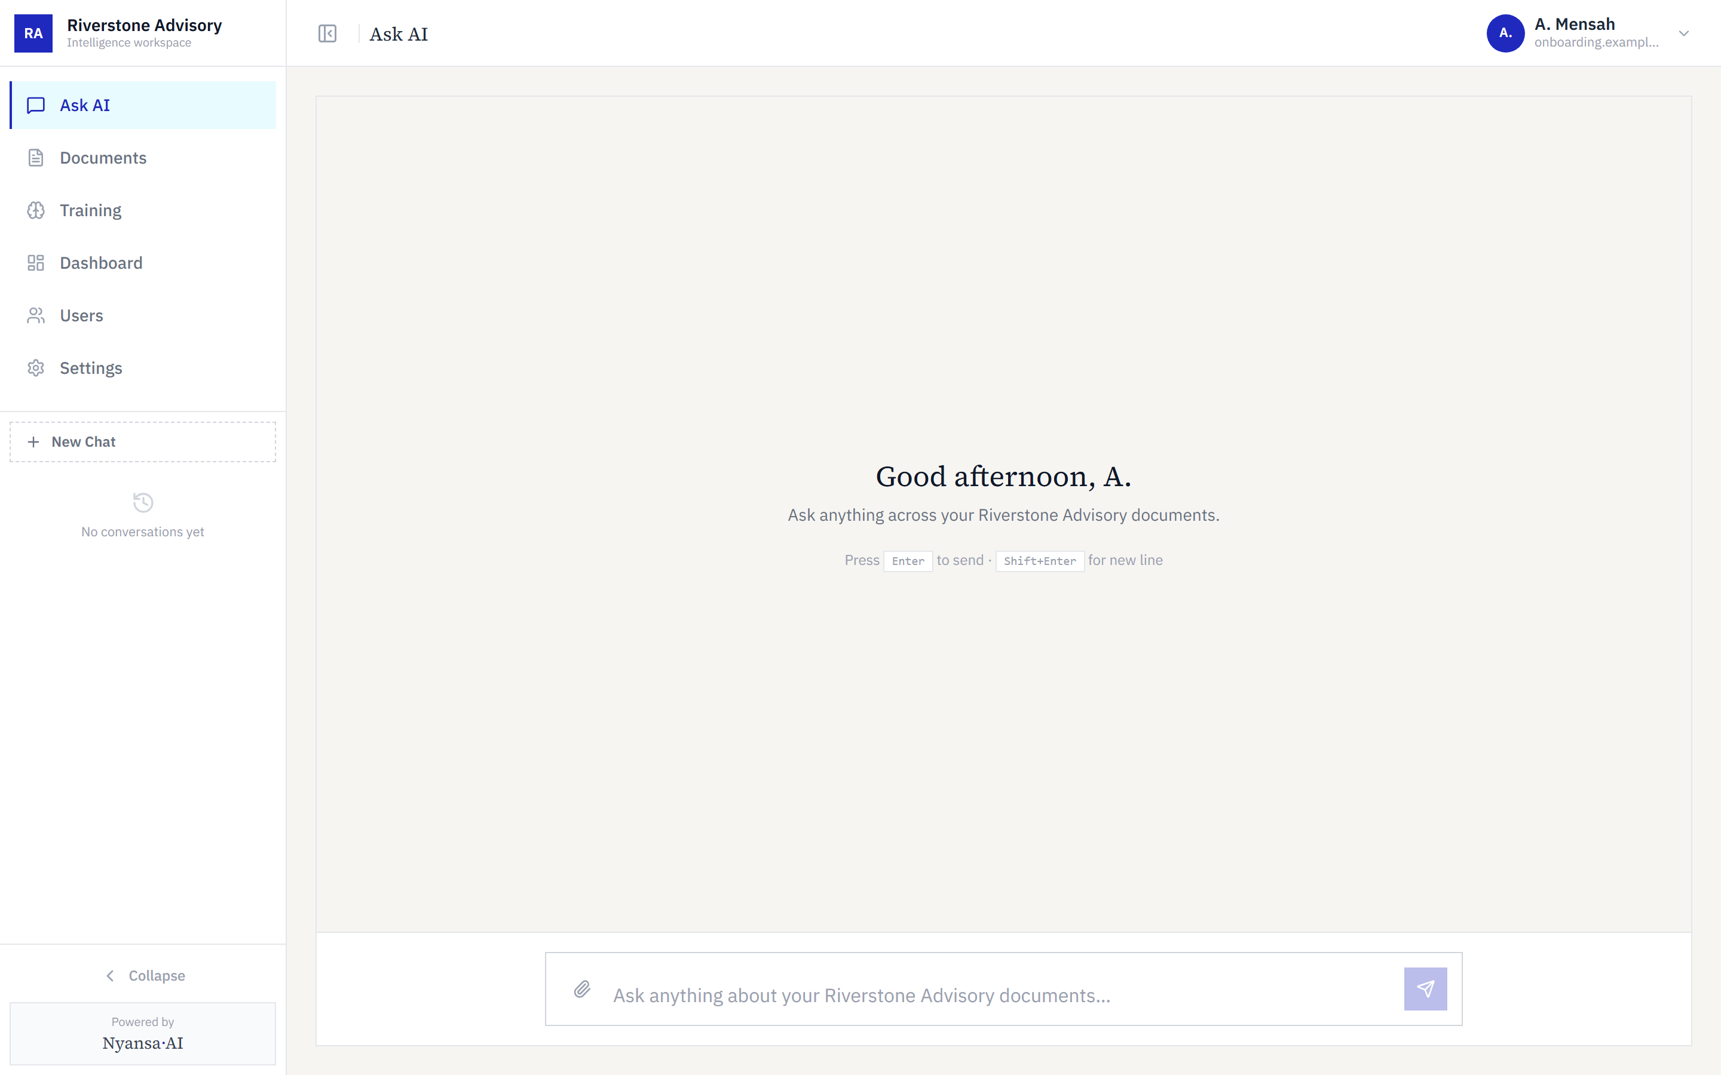
Figure 6 — The new workspace, at its own address
Three things are set automatically at this moment:
- The person who created the workspace becomes its first Senior user, the role that can invite colleagues, manage documents and change workspace settings.
- Invitations are restricted to the email domain of the person who signed up, so an account created from an address at one organisation cannot invite outsiders without that restriction being lifted deliberately in Settings.
- The workspace starts on the Starter plan.

Step 6 Invite the team
The first administrator invites colleagues from the Users page by entering an email address and choosing a role. Each person receives a link to set their own password; administrators never see or set passwords on their behalf.
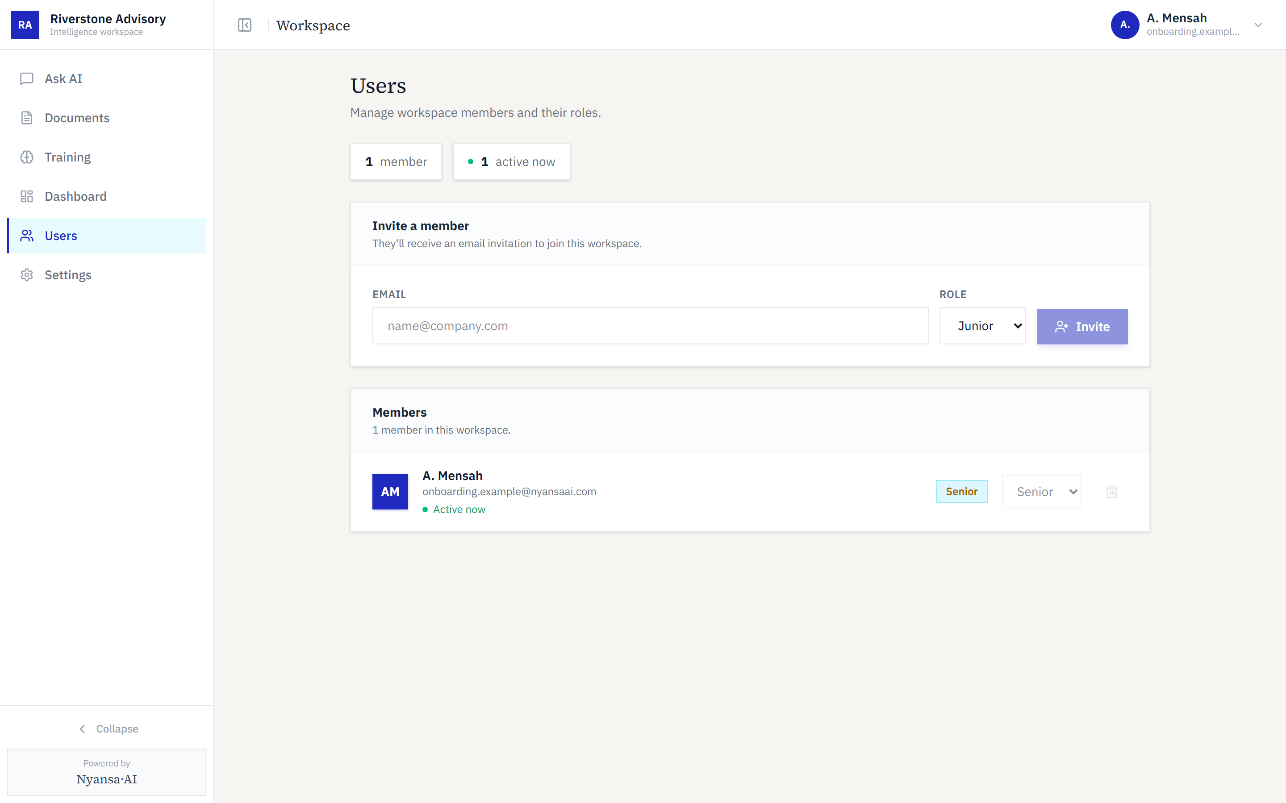
Figure 7 — Inviting colleagues and assigning roles
Role | Ask questions | Upload documents | Delete documents | Dashboards | Manage users
Senior | Yes | Yes | Yes | Yes | Yes
Middle | Yes | Yes | No | Yes | No
Junior | Yes | No | No | No | No

Workspaces created on request
Enterprise and public-sector customers do not use the self-service route. Their commercial terms are agreed first, and the workspace is then created for them. The steps below are the ones actually used to provision such a workspace today.
 | Procedure
1 | Create the workspace record: organisation name, web address, and the email domains from which colleagues may be invited.
2 | Create or identify the administrator’s account for the agreed contact address.
3 | Attach that account to the workspace as a Senior user.
4 | Issue a set-password link to the administrator, who then invites the rest of their team themselves.

Why a set-password link rather than an invitation. An invitation can only be issued to an address that has no account. Where an address has been invited before — including an invitation that was never completed — the account already exists and a fresh invitation is refused. A set-password link reaches the same destination and works in either case, so it is the more reliable instrument.
A note on invitation links and mail filters. Invitation and password links are single-use. Corporate mail security systems routinely open links in incoming messages to inspect them, which would previously consume a link before its recipient ever clicked it, leaving them with an expired-link error. Links now pass through an intermediate page that requires a deliberate click, so an automated inspection no longer consumes them.

Current limitations
Stated so expectations are set in advance.
Area | Position today
Payment | No payment or approval step. A completed sign-up produces an immediately usable workspace.
Administrative creation | No interface for creating a workspace on a customer’s behalf; it is done directly against the platform records. The platform administration screen lists workspaces but does not create them.
Plan assignment | Every workspace begins on Starter. A different plan is applied afterwards.
Approval | No review stage between sign-up and a working workspace.

Each of these is addressed by the subscription work now in progress, which introduces workspace states — awaiting payment, active, past due, suspended — and the ability to activate a workspace against an invoice for customers who do not pay by card.

