**Horizontal Vs Vertical Scaling**

**What is Scaling?**

Scalability can be defined as a process to expand the existing configuration (servers) to handle a large number of user requests or to manage the amount of load on the server.

If we are running a website, web service, or application, its success depends on the amount of network traffic it receives. If the traffic is higher, it could result in a crashed server.

Thus, scalability describes our system’s ability to adapt to change and demand. Accurate scalability protects the server from future downtime and ensures the quality of the provider.

There are two ways to do this:

1. **Vertical Scaling**
2. **Horizontal Scaling**

**Horizontal Scaling:**

* Horizontal scaling refers to adding additional nodes or machines to your infrastructure to cope up with new demands.
* If we are hosting an application on a server and find that it no longer has the capacity or capabilities to handle traffic, adding a server may be the solution.
* It's far pretty just like delegating workload among several employees in preference to one.
* However, the downside of this may be the added complexity of the operation.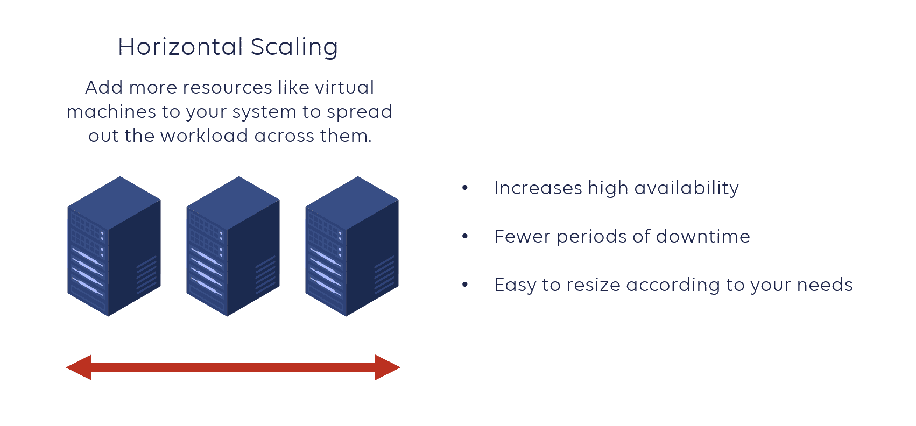

**Vertical Scaling:**

* Vertical scaling describes adding resources to a system so that it meets demand.
* So, the vertical scaling involves upgrading of processing power (CPU), Memory, storage and network speed.
* Vertical scaling may also describe replacing a server entirely or moving a server’s workload to an upgraded one.

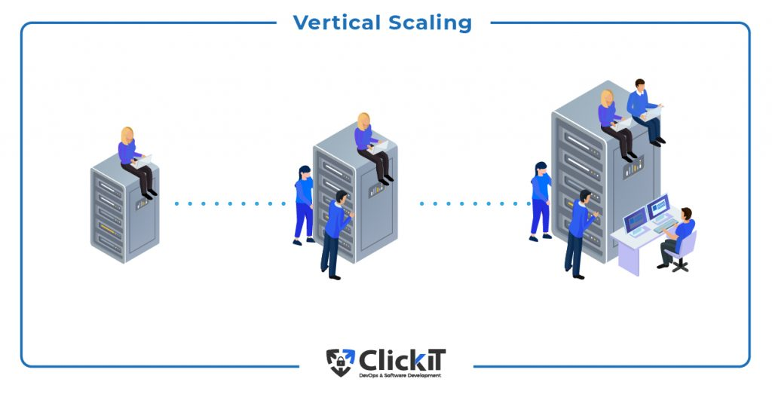

**Pros and Cons of Horizontal Scaling:**

1. **Scaling is easier from a hardware perspective**
2. **Fewer periods of downtime**
3. **Increased performance**
4. **Increased complexity of maintenance and operation**
5. **Increased Initial costs**

**Pros and Cons of Vertical Scaling:**

1. **Less complicated maintenance**
2. **Cost-effective**
3. **Higher possibility for downtime**

