X-Origin Tutorial
Qixin He and Joyce Rodrigues do Prado

This tutorial gives step-by-step guidance through the pipeline in estimating origin of past expansions. Before applying the pipeline, users are strongly recommended to examine whether the data contains evidence of past expansions (details explained below). If so, whether the data represents multiple expansion origins or single origin? The pipeline can be divided in three parts: 1) range expansion simulations over combination of parameter ranges; 2) conversion of summary statistics; and 3) estimation and validation of expansion origins. The tutorial will present required input files or scripts at each step.

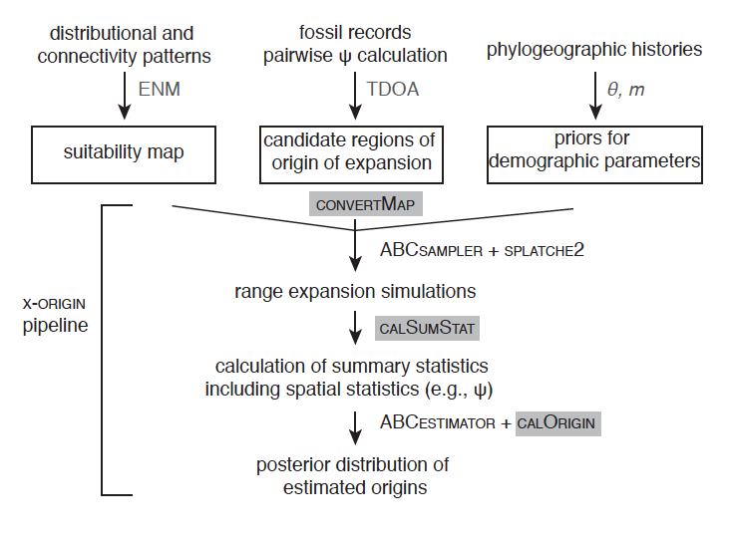
Figure 1. Flowchart of X-origin pipeline.

Prerequisite: linux or windows system with R and Python installed.

Before running the pipeline
Users should calculate population pairwise ψ values first to inspect if there is signature of expansion left in the data. precheck.R calculates pairwise ψ, which requires two input files: the empirical SNP file (see precheck/example.snapp) and the location file (precheck/example_loc.txt).

The SNP file has SNP per line for each individual. Genotype follows the individual’s id immediately, with 0 indicating ancestral homozygote, 1 indicating heterozygote, 2 indicating derived homozygote of the SNP, and ‘?’ for missing genotype. Location file contains columns of id, latitude, longitude and region division. Region division is for grouping individuals based on different origins. If there is one origin, all individuals should have the same region code.
After running precheck.R, if all the ψ values are very close to zero, then there is no expansion signature left in the data, and users should not perform the following analysis.

Part 1. Preparation of required files for spatial simulations

example filenames shown as the ones under example1 folder
  - setting files that specify the following information:
toy_linux.input, splatche2input folder: 1-settings.txt
  - suitability maps that describe the changing/static landscapes.
splatche2input folder: 3-oriworld.asc, 4-dynamic_K.txt (and the files specified within)
  - location of sampling sites
splatche2input folder: 5-Arrival_cell.col, 6-GenSamples.sam
  - types and number of gene markers that are being generated.
splatche2input folder: 7-genetic_data_SEQ.par
  - candidate regions of origin of expansion
toy.est, spalatche2input folder: 2-dens_init.txt
  - priors for demographic parameters
toy.est

1. Demographic and Connectivity patterns: Modeling Habitat Suitability
splatche2 requires a categorical map that defines where the spatial simulations take place (in the example folders, they are called 3-oriworld.asc. The file is in ascii (.asc) raster format is commonly used in GIS-related software. It begins with a header of six lines with basic information of the map, followed by specific values for the matrix depicting the region of interest. Demes that have the same values (category) will have same values of carrying capacities (specified in dynamic_K.txt) in the simulation (i.e., change in the same way during temporal shifts of habitat). We illustrate here with two examples.

1.1 Temporal changes in habitat with barriers
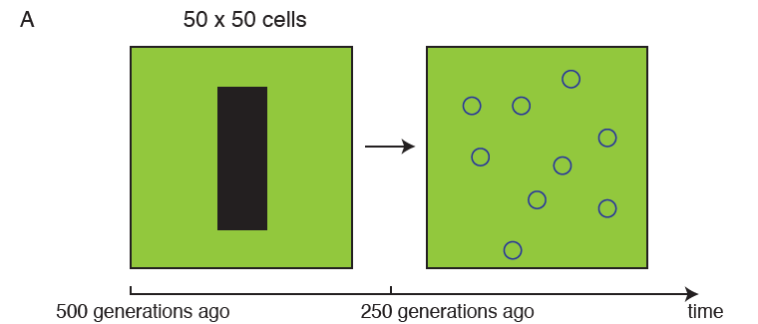
If the suitability for the species is homogeneous except for the central barrier region as shown above, the demes in the landscape can be categorized into two types: demes within the barrier, which is not habitable from 500-250 generations ago, but become habitable from 250 generations ago to current; demes outside the barrier that is constantly habitable.
The input map is therefore an .asc file with two categories:
ncols 50
nrows 50
xllcorner 0
yllcorner 0
cellsize 1
NODATA_value -9999
1 1 1 1 …..1 1 1 1
1 1 1 1 …..1 1 1 1
……
1 1 1 1 …1 0 0 0 0 0 0 0 1..1 1 1 1
1 1 1 1 …1 0 0 0 0 0 0 0 1..1 1 1 1
….
1 1 1 1 …..1 1 1 1
1 1 1 1 …..1 1 1 1

With 0 indicates barrier, and 1 indicates region outside the barrier.
Therefore, the translation table (pastK.txt) for the category to actual carrying capacities for 500-250 generations ago is:
0 0 barrier
1 K habitable
The first column is the category, the second column is the actual carrying capacity, and the third column is a description.
Similarly, the translation table (presentK.txt) for the category to actual carrying capacities for 250-0 generations ago is:
0 K barrier
1 K habitable
Note that these two files contain a “K” parameter inside, because the actual value will change for each spatial simulation based the sampled prior for the particular simulation. For each simulation, ABCsampler will sample a specific value for the parameter, and generates a temp file with the actual value for each input file that contains parameter names, called [filename]-temp.txt.
4-dynamic_K.txt sets the how the change in carrying capacities change in time:
2
1 ./splatche2input/pastK-temp.txt past
250 ./splatche2input/presentK-temp.txt current

The first line depicts how many temporal layers there are, and the following lines specify which layer to use at which time. Note that the time is specified in a time-forward simulation manner.

1.2 Temporal changes with suitability maps inferred from Ecological Niche Modeling (ENM)
Through ENM on bioclim data, we can infer habitat suitability at different time period: current, Mid Holocene and Last Glacial Maximum (http://worldclim.org/paleo-climate1). These layers cannot be directly used in splatche2 for spatial simulations. We need to find out demes that have same temporal changes during different time periods, and generate a categorical map and dynamic K mapping file.
In the example2, habitat suitability during the present and LGM was estimated from bioclimatic variables with MAXENT v3.3.3e (Phillips et al., 2006). Full procedural details to generate the environmental niche models (ENMs) will not be presented.
To have a tractable number of cells for demographic simulations, the cell sizes of the ENMs were statistically downscaled for the current and past climatic conditions to ~50 km² per cell, using the function aggregate in arcgis, with the parameter aggregation technique set for median. Through the reclassify function, the float values of suitability were converted to integers by dividing the original values into 10 classes of equal intervals using the equal interval clustering method. Lastly, the function raster to ascii was used to transform the raster map to ascii format.
Once the two rescaled maps are in ascii format, the “asc2dynKF.py” script under the mapTransformation folder generates the oriworld.asc file that combines the demes with same trends in the LGM and current maps into a categorical map with the following command:
python asc2dynKF.py -a LGM.asc -c CURRENT.asc

The output files include the map file oriworld.asc, and the category number to carrying capacity files for three different time periods that are named: veg2K_cur.txt, veg2K_int.txt, veg2K_lgm.txt.
OBSERVATION: The above script generates veg2K files that have parameter names for converting carrying capacities for use with ABCtoolbox (e.g., k_1, k_9, etc.). k_1 means 10% of the maximum carrying capacity, while k_9 means 90% of the maximum carrying capacity. However for testing purposes with the GUI version of SPLATCHE2, user needs to include actual values of carrying capacities, instead of variable names. To do that, run the above python script with additional options:
python asc2dynKF.py -a LGM.asc -c CURRENT.asc -g –K [maximum K value]
to generate veg2K output into GUI-appropriate ones based on the maximum carrying capacities from the prior.
At the end of this step you must have the following files:
- oriworld.asc
- veg2K_cur.txt
- veg2K_int.txt
- veg2K_lgm.txt

2. Origin of expansion
-dens_init.txt
This file specifies the geographic location where the demographic simulation starts. The first line indicates how many origins there are. And the second line specifies name of the origin, population size, latitude, longitude, resizing information, etc.
If there is a single origin, the file looks like:
1
ori N_ANCESTRAL oriLat oriLon 0 0 0 0 0 0 ori is the name of the origin. N_ancestral oriLat oriLon are three parameters of interest. N_ancestral is the ancestral population size before expansion. oriLat and oriLon indicates the latitude and longitude of the origin. These parameters will be replaced by actual values for each iteration of the simulation. Rest of the fields indicates resizing or migration among origins, which are not used in our simulations. Please read SPLATCHE2 manual for the details of these fields (Ray et al., 2010).
3. Sampling location files
- GenSamples.sam
This file specifies the localization of the sampled populations, as well as the number of genes sampled in each of them. The first line is the number of sampled populations. The second line can be a commented line of column names (marked by #). The following lines define a population sample with 5 fields separated by “tab” or “space” character: name, number of genes (diploid or haploid), identification of the population layer to which the sampled deme belongs (if splatche2 is not run for two competing species, then this column always 0), latitude and longitude:
4
#Name #Size #PopLayer #Lat #Long
1 8 0 16 5
2 14 0 17 2
3 10 0 12 20
4 10 0 4 24

- Arrival_cell.col
The file that indicate the location of the demes for which arrival times will be calculated. We keep the demes the same the sampling locations as above, because we want to make sure that by the end of the simulation all these demes are at least colonized. In the statistics calculation step, the output file of colonization times from these demes will be checked to decide if the current simulation should be included.
4
#Name #PopLayer #Lat #Long
1 0 16 5
2 0 17 2
3 0 12 20
4 0 4 24

4. Gene markers file
- Genetic_data_SEQ.par
This file specifies which type of gene markers should be generated and how many of them should be generated. This is required for the backward coalescent process after the forward simulation of demographic processes.
Users can use “writeGeneSeqFile.py” script to generate the file specific for SNPs in the following way:
python writeGeneSeqFile.py [NumberofSNP] [numberOfTotalSamples]
The Genetic_data_SEQ.par declares the number of chromosomes to simulate. For this example, we want to generate 1000 independent SNPs. Therefore we specify 1000 chromosomes. The following lines specify characteristics for each of the chromosome. In this case, all the SNPs will be equivalent: with the first line indicates 1 block will be generated, and the second line indicates that the type of marker is one SNP, with per generation recombination equals 0, and the minimum frequency of the derived allele equals 1/(2*number of total diploid individuals).
1000 //Num chromosomes
#chromosome 1, //per Block:data type, number of SNP, per generation recombination, Minimum frequency for the derived allele)
1
SNP 1 0 0.010000
#chromosome 2, //per Block:data type, number of SNP, per generation recombination, Minimum frequency for the derived allele)
1
SNP 1 0 0.010000
#chromosome 3, //per Block:data type, number of SNP, per generation recombination, Minimum frequency for the derived allele)
1
SNP 1 0 0.010000

5. Splatche2 settings file
-settings.txt
This file tells the location and names of all the required input files as well as some parameter choices. For a complete explanation about all the parameters in the Settings File see Ray et al., 2010).
Here we explain several specific choices for x-origin.
#Identificator for the demographic model (MANDATORY)
ChosenDemographicModel=3
This means that the demographic model is a stochastic migration model with absolute number of emigrants. The number of emigrants of a deme per generation is a Poisson variable centered around N_{i}m, where N_{i} is the population size of the focal deme at the time.
#Migration rate for neighboring deme migration (MANDATORY)
MigrationRate= MRATE
Migration rate is set as a parameter in the simulation.
#Ancestral population size. Size of the ancestral population at tau (NOT MANDATORY)
AncestralSize= N_ANCESTRAL
Ancestral population size is set as a parameter in the simulation. This is relevant for the coalescent simulation.
#Maximum number of total generations for a simulation. This number corresponds to the number of generation for the demographic simulation + the extra generations for the coalescence process prior to time 0 (MANDATORY)
MaxNumGenerations=1400000
Please set this number to a much larger number than 4N to make sure the coalescent process will be complete (if set smaller, all remaining lineages will be coalesce to one lineage at the end of the coalescent process).

6. Testing the demographic simulation using the GUI version
It is imperative to check if all the files are set correctly and the demographic process makes sense by running a couple of examples using the GUI version on windows. Remember that all the files in the GUI version needs to have actual values instead of parameter tags. First load the settings file by clicking in Open Settings… button on the right top of the software panel. In the graphical interface only a restricted number of parameters can be modified (e.g. migration scenario, number of generation, generation time, start time, etc.), most of the parameters can only be set only in the setting files (like carrying capacities, frictions). For a complete explanation about all the parameters in the Settings File see Ray et al., 2010).
SPLATCHE2 is divided in two parts, demographic and coalescent simulations. For the demographic simulations, besides of the settings files, it is required that the following files be in the same working directory:
- dens_init.txt
- dynamic_K.txt
- veg2K_cur.txt
- veg2K_int.txt
- veg2K_lgm.txt
- Arrival_cell.col
- oriworld.asc
For the coalescent simulation, the following files are required:
- genetic_data_SEQ.par
- GenSamples.sam

In the end of the simulation, you will get an .arp containing the simulated genetic data from the simulations in the folder of GeneticOutput. You will also be able to play the demographic simulations and inspect the expansion processes.

Part 2. Processes involved in running spatial simulations and the calculation of summary statistics

- converting statistics and extracting information
- estimation of the origins
- validation runs using pseudo-observation datasets (PODs)

1. Empirical Summary Statistics

The arlsumstat software is used to calculate the summary statistics of the empirical data. The following files is needed to run arlsumstat:
- arlsumstat executable
- settings file "arl_run.ars"
This file must be created with the windows version of arlequin. In the Windows version or Arlequin, open a project file of the type you want to analyze, choose the computations you want to perform, close the project and copy the generated file to the directory of the arlsumstat executable.
- ssdefs.txt file
Specifies which statistics are outputted in the result file.
- the .arp file
The .vcf file generated from Stacks pipeline transformed in arlequin format (the PGDSpider software can be used for this).

The following command will analyze the file .arp (here called filetransformed.arp ) and write the summary statistics in the file ObservedSumstats.obs.

./arlsumstat_64bit filetransformed.arp ObservedSumstats.obs 0 1

3. Candidate regions of origin of expansion

4. SPLATCHE2 - Simulations in GUI version

The graphical visualization of the simulations is important to check the validity of input data, to understand the influence of input settings on demographic and genetic outputs, and to discover patterns and behaviors of expanding populations and their associated coalescent process (Ray et al., 2010).
First a settings file needs to be constructed, and an example of this file are available with the software package. Then the file can be opened by clicking in Open Settings… button on the right top of the software panel. In the graphical interface only a restricted number of parameters can be modified (e.g. migration scenario, number of generation, generation time, start time, etc.), most of the parameters can only be set only in the setting files (like carrying capacities, frictions). For a complete explanation about all the parameters in the Settings File see Ray et al., 2010). The settings file is filled using available priors published in the literature but also with values that were computational feasible.

SPLATCHE2 is divided in two parts, demographic and coalescent simulations. For the demographic simulations, besides of the settings files, it is required that the following files be in the same working directory:
- dens_init.txt
The first line shows the number of candidate regions of origin of expansion to be considered (resulted from the pairwise _ calculations presented in the first part of this tutorial). The next lines show the information per source population (one line per population). Each of these lines consists of 10 fields separated by “tab” or “space” character: name, size, geographic coordinates, size before the beginning of the expansion, the number of generations before the beginning of the expansion when a second resize occurs, emigration rate, the index of the layer where the source appears and expansion time. For more details about the parameters see Ray et al., (2010).
- dynamic_K.txt
This file shows the changes in carrying capacities over time. On the first line appears the number of changes during a simulation, Then the following lines (one per change) includes: the time of change (in generations), set here as 1, 500, and 1100 because of the computational requirements; the filename of the corresponding table (the tables veg2K generated in the previous step), and an arbitrary description. * Remember that it is important to put the veg2K files in actual values of carrying capacities, not variable names.
- veg2K_cur.txt
The file generated in the previous section.
- veg2K_int.txt
The file generated in the previous section
- veg2K_lgm.txt
The file generated in the previous section
- Arrival_cell.col
Text file with number and coordinates of demes for which arrival times will be calculated. These demes will be the same of the one used in the pairwise _ calculations.
- oriworld.asc
The file generated in the previous section

For the coalescent simulations is required the following files:
- genetic_data_SEQ.par
To generate the genetic_data_SEQ.par file the “writeGeneSeqFile.py” script is used, in the following way:
python writeGeneSeqFile.py NumberofSNP numberOfTotalSamples

- GenSamples.sam
This file specifies the localization of the sampled populations, as well as the number of genes sampled in each of them. The first line is the number of sampled populations. The second line is for the legends for each column. Then, each line defines a sample with 5 fields separated by “tab” or “space” character: name, number of genes (diploid or haploid), identification of the population layer to which the sampled deme belongs.

In the end of the step 2 you need to have all the SPLATCHE2 files (oriworld.asc, veg2K_cur.txt, veg2K_int.txt, veg2K_lgm.txt, dens_init.txt, dynamic_K.txt, Arrival_cell.col, genetic_data_SEQ.par, GenSamples.sam, and Settings file) working and running properly in SPLATCHE2 GUI.

5. ABC sampler

ABC toolbox will be used to estimate model parameters under various ABC algorithms. ABCsampler aims at producing a large collection of simulations, resulting
in a matrix of model parameters and their associated summary statistics.

To run ABC sampler you need to have 3 “groups” of data in the same directory:
- Summary Statistics files
- SPLATCHE2 files
- ABC files

The first and second parts are described in the previous steps.

ABC Sampler and ABC Estimator
The program ABCsampler is designed to interact with two other programs, one to perform simulations (in case SPLATCHE2) and one to calculate summary statistics (in case Arlequin; Wegmann et al., 2009).
The following files are needed:

- ABCsampler.exe
- file.est
- file.input.

The file.est is the file where model parameters and corresponding priors are defined. Migration, Ancestral Range, Carrying Capacities and the original ancestral population coordinates are the parameters used in this pipeline. The parameters need to be in Log form (except for Ancestral Range) and you can put some rule for each one of the parameters to limit the prior distribution of a parameter by the value of another parameter.

The file.input is a simple collection of pairs of parameter tags and corresponding values, enriched with comments. We set estName (name of the .est file generated previously), obsName (name of the file with the observed statistics; here it is necessary put the ObservedSumstats.obs object generated in the first step of this tutorial and the Ψ statistics output), nbSims (número de simulaçãoes), simulationProgram (name of the simulation program; splatche2), simInputName (Name of the input file for the simulation program; settings.txt #./dens_init.txt #./veg2K_cur.txt #./veg2K_int.txt #./veg2K_LGM.txt), simParam (parameters to be passed to the simulation program; SIMINPUTNAME), launchBeforeSS (name of the script or program launched just after the simulation program has been called), launchBeforeSSParam (the parameters passed to the scripted or program launched just after simulation program has been called; arp2snapp.py#GeneticsOutput/settings-temp_GenSamples_1.arp), simDataName (name of the file with simulated data), sumStatProgram (name of the program calculating summary Statistics; arlsumstat), and sumStatParam (parameters to be passed to the program calculating summary statistics; GeneticsOutput/settings-temp_GenSamples_1.arp #SSFILENAME #0 #1;calPsi.r #temprun.snapp #temprun_loc.txt).

Plotting Posteriors
An R script, named plotPosteriors.r, can be used to plot posteriors from the output of ABCestimator. This script produces pdf plots for each data set for which estimates exist. The input file of ABCestimator and, the original simulation file (the file containing all simulations from ABCsampler), the file with the observed statistics and the output files of ABCestimator containing the posteriors estimates are needed. To launch this script on the command line type:
R --vanilla inputfile < plotPosteriors.r

* The inputfile corresponds to the name of the ABCestimator input file.

