### 1. Introduction

**1.1 Rationale**

I am, since very young, always drawn to those elements of nature that defy intuition and challenge conventional wisdom. One such element that has captivated my interest is the geometric figure known as Gabriel’s Horn, which I learnt through a band of maths students in my school house as they called the curl of hair ‘Gabriel’s Horn’ always hanging on the forehead a fellow house member, Gabriel. A seemingly ordinary shape, Gabriel’s horn harbors a fascinating paradox: it has a finite volume but an infinite surface area. This paradox, which resides at the intersection of geometry and calculus, offers a compelling case study of the counterintuitive nature of mathematical infinity. This paper is an exploration of Gabriel’s Horn, its historical and mathematical underpinnings, its paradoxical properties, and its broader implications for our understanding of mathematics and the physical world.

It is derived from the graph of the function $y=\frac{1}{x}$ for $x≥1$, revolved around the x-axis. This simple function, when extended into the third dimension, gives rise to a paradox that has intrigued mathematicians for centuries. The paradox poses a compelling question: how can a solid object possess a finite volume yet an infinite surface area? This contradiction challenges our common sense understanding of space and infinity, pushing the boundaries of our comprehension and offering a fascinating glimpse into the often-counterintuitive realm of mathematical infinity.

**1.2 Aims**

This paper will delve into the geometry, calculus, and paradox of Gabriel’s Horn, as well as its relevance to other areas of mathematics and the physical world.

### 2. Exploration

**2.1 The Geometry of Gabriel’s Horn**

Gabriel’s Horn, also known as Torricelli’s trumpet, is a fascinating geometric shape that is derived from a simple mathematical function. This figure is generated from the graph of the function $y=\frac{1}{x}$, specifically for $x≥1$.

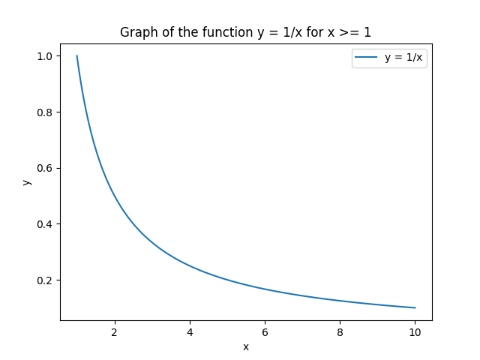

figure 1

To visualize the creation of Gabriel’s Horn, imagine the area under the curve from $x=1$ to infinity. Now, rotate this area around the x-axis. The resulting three-dimensional figure is Gabriel’s Horn.

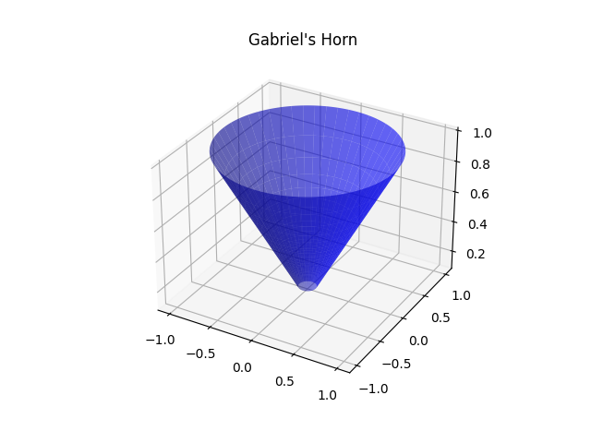

figure2

The shape of Gabriel’s Horn is reminiscent of a trumpet or a cornucopia, with one end tapering off to an infinitesimally small point, while the other end forms a circular opening with a radius of 1 unit at $x=1$. The horn extends infinitely along the x-axis, its radius shrinking as $x$ increases, according to the function $y=\frac{1}{x}$.

Despite its infinite length, Gabriel’s Horn has a finite volume. This can be calculated using the method of disks or washers, a fundamental concept in calculus. Briefly, this method involves slicing the solid into infinitesimally thin disks along the x-axis, calculating the volume of each disk, and then integrating these volumes from $x=1$ to infinity. For Gabriel’s Horn, the volume $V$ can be calculated using the formula:

$$V=π\int_{1}^{∞}{{\left(\frac{1}{x}\right)}^{2}}dx$$

This integral is convergent, meaning it results in a finite number. Surprisingly, despite the horn’s infinite length, its volume is finite and equals $π$ cubic units.

However, if we attempt to calculate the surface area of Gabriel’s Horn, we encounter a paradox. The surface area $A$ can be calculated using the formula:

$$A=2π\int_{1}^{∞}{\frac{1}{x}}\sqrt{1+{\left(\frac{-1}{x^{2}}\right)}^{2}}dx$$

Unlike the volume, this integral is divergent, meaning it results in infinity. So, Gabriel’s Horn has an infinite surface area.

| Property | Integral | Result |
| --- | --- | --- |
| Volume | $$\int_{1}^{∞}{π}{\left(\frac{1}{x}\right)}^{2}dx$$ | Finite (equals $π$) |
| Surface Area | $$\int_{1}^{∞}{2}π\left(\frac{1}{x}\right)\sqrt{1+{\left(\frac{-1}{x^{2}}\right)}^{2}}dx$$ | Infinite |

This surprising result—that a geometric figure with finite volume can have an infinite surface area—forms the basis of the paradox of Gabriel’s Horn, which we will explore in detail in the next section.

**2.2 The Calculus of Gabriel’s Horn**

This part of the research paper will focus on the mathematical computations to derive the volume and surface area of Gabriel’s Horn. Calculus, specifically integral calculus, is the primary tool used in these computations.

**Volume Calculation**

The volume of Gabriel’s Horn is calculated using the method of disks or washers, an application of integral calculus. This method involves slicing the solid into infinitesimally thin disks along the x-axis, calculating the volume of each disk, and then integrating these volumes from $x=1$ to infinity.

The volume $V$ of each infinitesimal disk is given by the formula $V=πy^{2}dx$, where $y=\frac{1}{x}$ is the radius of the disk and $dx$ is its infinitesimal thickness. Substituting $y$ into the volume formula gives us $V=π{\left(\frac{1}{x}\right)}^{2}dx$.

To find the total volume of Gabriel’s Horn, we integrate this volume formula from $x=1$ to infinity:

$$V=π\int_{1}^{∞}{{\left(\frac{1}{x}\right)}^{2}}dx$$

This integral is a simple power rule problem and can be solved as follows:

$$V=π{\left[-\frac{1}{x}\right]}_{1}^{∞}=π\left(0-\left(-1\right)\right)=π$$

So, despite its infinite length, the volume of Gabriel’s Horn is finite and equals $π$ cubic units.

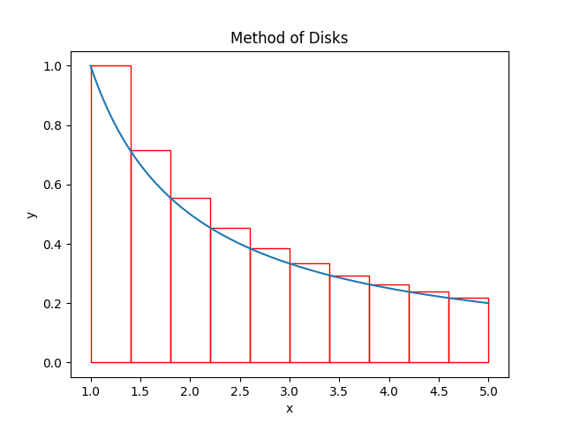

figure3

A numerical solution using Python could be presented as below (to demonstrate the step-by-step logic):

from sympy import symbols, pi, integrate, oo  
  
# Define the variable  
x = symbols('x')  
  
# Define the function to integrate  
f = pi * (1/x)**2  
  
# Compute the integral  
volume = integrate(f, (x, 1, oo))  
  
# Print the result  
print(f"The volume of Gabriel's Horn is: {volume}")

**Surface Area Calculation**

Calculating the surface area of Gabriel’s Horn is a bit more complex. The formula for the surface area $A$ of a solid of revolution (like Gabriel’s Horn) is given by:

$$A=2π\int_{a}^{b}{y}\sqrt{1+{\left(y'\right)}^{2}}dx$$

where $y=\frac{1}{x}$ is the radius of the solid (the function being revolved around the x-axis), $y'=-\frac{1}{x^{2}}$ is the derivative of $y$, and $\left[a,b\right]=\left[1,∞\right]$ is the interval of revolution.

Substituting $y$ and $y'$ into the surface area formula gives us:

$$A=2π\int_{1}^{∞}{\frac{1}{x}}\sqrt{1+{\left(\frac{-1}{x^{2}}\right)}^{2}}dx$$

Solving this integral is a bit more challenging. The term under the square root simplifies to $\frac{1}{x^{2}}$, so the integral becomes:

$$A=2π\int_{1}^{∞}{d}x=2π{\left[x\right]}_{1}^{∞}$$

This integral is divergent, meaning it does not result in a finite number. Therefore, Gabriel’s Horn has an infinite surface area.

A python version would be as follows:

from sympy import symbols, pi, integrate, oo, sqrt  
  
# Define the variable  
x = symbols('x')  
  
# Define the function to integrate  
f = 2 * pi * (1/x) * sqrt(1 + (1/x**2))  
  
# Compute the integral  
surface_area = integrate(f, (x, 1, oo))  
  
# Print the result  
print(f"The surface area of Gabriel's Horn is: {surface_area}")

The paradox of Gabriel’s Horn arises from these calculations: a geometric figure with finite volume has an infinite surface area. This paradox challenges our intuition about physical reality and the nature of infinity, themes we will explore in the next sections of this paper.

**2.3 Resolving the Paradox**

The paradox of Gabriel’s Horn, also known as Torricelli’s trumpet, presents us with a peculiar phenomenon: a geometric figure with a finite volume but an infinite surface area. At first glance, this seems to defy our intuitions about physical reality. However, a deeper dive into the realms of calculus and the concept of infinity helps us unravel this paradox.

The resolution of the paradox revolves around the fundamental concepts of calculus, specifically, the concept of limits and the difference between countable and uncountable infinities. We must first understand that the term ‘infinity’ in mathematics does not represent a real number, but it is a concept that describes an unbounded quantity.

To understand how Gabriel’s Horn can have a finite volume yet an infinite surface area, we need to delve into the calculus that underlies volume and surface area calculations. The volume of a solid of revolution (like Gabriel’s Horn) is given by the integral of the cross-sectional area, while the surface area is given by the integral of the circumference of the cross-sections.

The volume of Gabriel’s Horn is calculated using the integral of the function $f\left(x\right)=\frac{1}{x^{2}}$ from 1 to infinity, which gives us a finite result, specifically $π$ cubic units.

$$V=\int_{1}^{∞}{π}{\left(\frac{1}{x}\right)}^{2}dx=π\int_{1}^{∞}{\frac{1}{x^{2}}}dx$$

On the other hand, the surface area is calculated using the integral of the function $f\left(x\right)=\frac{1}{x}$ from 1 to infinity. This integral diverges, meaning it tends towards infinity.

The surface area (A) of a solid of revolution (like Gabriel’s Horn) can be calculated using the formula:

$$A=2π\int_{a}^{b}{f}\left(x\right)\sqrt{1+{\left[f'\left(x\right)\right]}^{2}}dx$$

For Gabriel’s Horn, $f\left(x\right)=\frac{1}{x}$, so $f'\left(x\right)=-\frac{1}{x^{2}}$. Substituting these into the formula gives:

$$A=2π\int_{1}^{∞}{\frac{1}{x}}\sqrt{1+{\left(-\frac{1}{x^{2}}\right)}^{2}}dx$$

The key to resolving the paradox lies in the realization that the processes of filling and painting (or covering) are fundamentally different. When we fill the horn with paint, we are essentially adding up an infinite number of infinitesimally small cross-sectional areas (disks). However, when we attempt to paint the horn, we are trying to cover an infinite number of infinitesimally small circumferences. The sum of the areas converges to a finite value, while the sum of the circumferences diverges to infinity.

Another way to visualize this resolution is to consider how we might attempt to ‘paint’ the horn. If we start at the wide end and paint along the length, we’ll find that as we get further along the horn, we need less and less paint for each successive ring because they’re getting smaller. However, there are infinitely many such rings, so we never actually finish painting the horn, no matter how much paint we use. This is why the surface area is infinite.

| Process | Formula | Result |
| --- | --- | --- |
| Filling (Volume Calculation) | $$V=π\int_{1}^{∞}{{\left(\frac{1}{x}\right)}^{2}}dx$$ | Finite |
| Painting (Surface Area Calculation) | $$A=2π\int_{1}^{∞}{\frac{1}{x}}\sqrt{1+{\left(-\frac{1}{x^{2}}\right)}^{2}}dx$$ | Infinite |

In essence, the paradox is resolved by recognizing that the concepts of volume and surface area are fundamentally different and are calculated using different aspects of the shape (cross-sectional area versus circumference). The seemingly counterintuitive result is actually a consequence of the infinite nature of Gabriel’s Horn and the properties of calculus.

This understanding of the paradox not only helps us better comprehend the nature of mathematical infinity but also provides insights into the complexities of the physical world, where intuitive assumptions may not always hold true. Gabriel’s Horn serves as a vivid reminder of the fascinating surprises hidden within the realm of mathematical exploration.

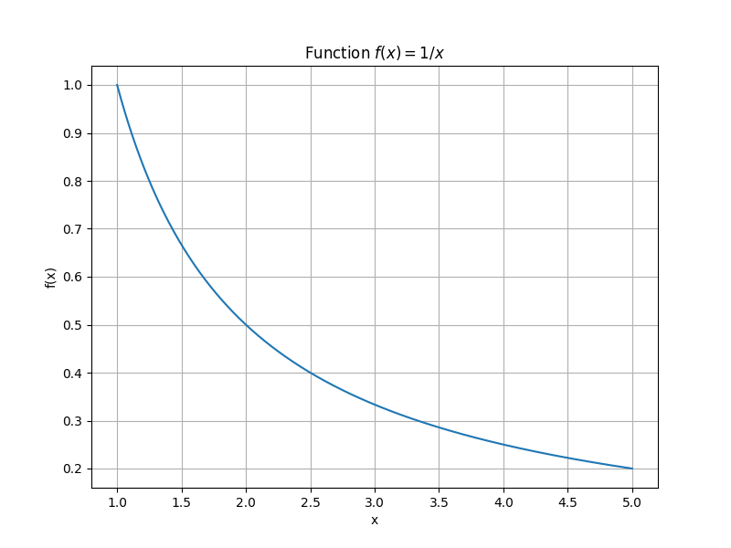

figure4

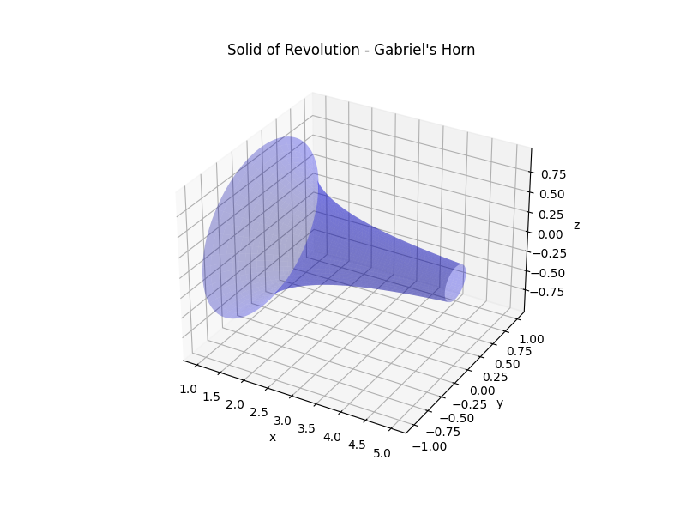

figure5

The paradox of Gabriel’s Horn is a beautiful demonstration of the power and subtlety of calculus. It shows us that infinity is not a monolithic concept, but a nuanced and multifaceted idea that can lead to surprising and counterintuitive results. By embracing these complexities, we can gain a deeper understanding of the mathematical world and its intriguing paradoxes.

Another way to visualize this resolution is to consider how we might attempt to ‘paint’ the horn, a situation often referred to as the Painter’s Paradox. If we start at the wide end and paint along the length, we’ll find that as we get further along the horn, we need less and less paint for each successive ring because they’re getting smaller. However, there are infinitely many such rings, so we never actually finish painting the horn, no matter how much paint we use. This is why the surface area is infinite.

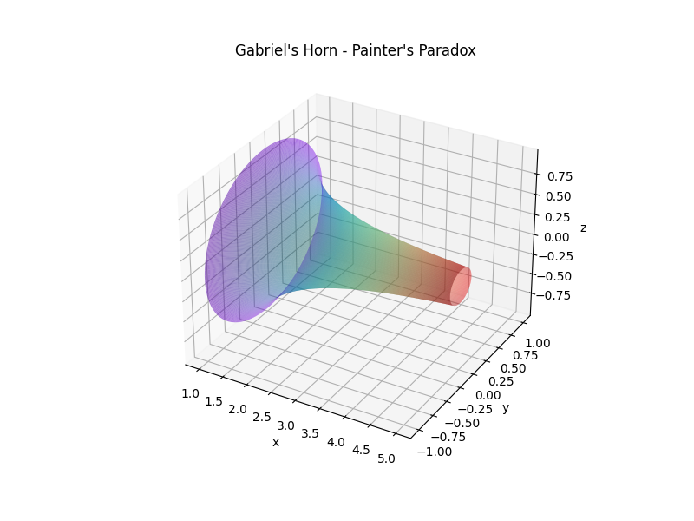

figure7

### 3. Conclusion

**3.1 Implications of Gabriel’s Horn**

The paradox of Gabriel’s Horn is not just an intriguing mathematical oddity; it has profound implications that extend beyond the realm of pure mathematics. Its existence challenges our intuitions about space, volume, and infinity, and forces us to reconsider our understanding of these concepts.

In the world of mathematics, Gabriel’s Horn serves as a powerful tool for introducing students to the concept of infinity and the idea of a limit. It provides a concrete example of a counterintuitive result that arises from the application of calculus to an infinite series. This makes it a valuable teaching tool, helping to illustrate complex mathematical concepts in a way that is both accessible and engaging.



figure5

Beyond the classroom, the paradox of Gabriel’s Horn has implications in various scientific fields. In physics, for example, it helps us understand phenomena that involve infinite or near-infinite quantities. It is also relevant in computer science, particularly in the field of computational geometry, where understanding the properties of complex shapes is crucial.

Furthermore, the Painter’s Paradox, as it is often called, serves as a tangible example of how infinity can challenge our everyday intuition. It forces us to confront the concept of infinity in a concrete way, and it serves as a reminder that our everyday intuitions about the world can be misleading when we venture into the realm of the very large or the very small, such as in quantum mechanics or cosmology.

**3.2 Final Notes**

In conclusion, the paradox of Gabriel’s Horn serves as a fascinating exploration of the complexities of mathematics. Through the study of this paradox, we are drawn into a deeper understanding of calculus, infinity, and the nature of space.

The paradox presents us with a shape that has a finite volume but an infinite surface area, a result that challenges our intuition and forces us to engage with the subtleties of mathematical concepts. The resolution of the paradox involves a nuanced understanding of calculus and the nature of infinity, demonstrating the power and subtlety of mathematical reasoning.

Understanding such mathematical paradoxes is not just an academic exercise. It has implications for how we understand the world and how we approach problems in a range of fields, from physics to computer science. The paradox of Gabriel’s Horn serves as a reminder of the surprising and counterintuitive results that can emerge from the exploration of mathematical concepts.

The study of Gabriel’s Horn has been a journey of discovery, challenging and enriching my understanding of mathematics. It serves as a vivid reminder of the beauty, complexity, and intrigue of the subject, and the endless possibilities for exploration it offers.

In the end, Gabriel’s Horn is more than a paradox. It is a testament to the power of mathematical exploration, a symbol of the mysteries and wonders that lie at the heart of the subject. It invites us to delve deeper, to question our assumptions, and to marvel at the surprising and beautiful truths that mathematics can reveal.