Banknote Authentication with a Multi-Layer Perceptron
CS340 Introduction to Artificial Intelligence and Machine Learning
11 November 2026 last modification

1. Introduction
  - The problem
This project aims to solve a very specific problem: Detecting counterfeit banknotes. Counterfeit banknotes are a real issue, while banknote transactions happen all the time at an enormous scale. Although this is the case, manual checking methods currently used are error-prone and slow. Automatic detection provides can be more effective through pattern recognition using machine learning. ML can be trained to identify patterns given data. This process is called classification and is based on supervised learning. Classification is the task of classifying a banknote as genuine or forged which is what our program does.
  - The approach
The approach has been to build and train a network to classify banknotes using supervised learning. This was done with the use of an MLP, a classic type of neural network consisting of layers. MLP is essentially composed of layers of neurons where each pass its output to every neuron in the next layer. I chose to work with MLP since it learns non-linear patterns, unlike a single perceptron, it is trained with backpropagation and is specified by the project. Scikit-learn library also provided a template for implementation.
  - What I did
What I made is a configurable program divided into sections accessed by a menu. The user can change the settings and run experiments or choose the best combination of settings to run them. Results and analysis of them are also provided. Further view of the exact code structure can be found in the Code Development report section.

2. Design Requirements and Dataset
  - Requirements: What the program had to do
The program had to do a sequence of processes, from reading and processing the data file to implementing an MLP with user-chosen settings. The user can decide the topology, learning step, split through a 7-option menu. 18 in total error graphs for each setting combination were produced, along with the weight graphs. 4 data files were created, and input checking was implemented.
  - Dataset: Which dataset was used
I used the UCI Banknote Authentication dataset, provided in the report. From it, I got all the 1,372 banknotes, along with the 4 image features and what they are; label 0 = genuine / 1 = forged. The file was sorted by class which meant the rows were not mixed. This influenced the raw 60/40 split (split 1) which did not apply shuffling. Split 1 ended up cutting the file and taking the first 60% for training and the rest 40% for testing, meaning bad results-prediction accuracy, because training mostly happens for genuine notes and testing on forged only. The 90/10 split (split 2) mixes the rows, so the test is fair.
Below is a table recording each feature with its description. Class is not a feature; it stores the sate of the banknote.
Table 1: Dataset features
Feature | Description
Variance | how spread out the pixel values of the wavelet-transformed image are (how much contrast and variation it has)
Skewness | how asymmetric the distribution of those values is (leaning towards dark or light)
Curtosis | how peaked the distribution is, and how heavy its tails are (many extreme values or few)
Entropy | how random or complex the image texture is (high = more disorder and detail)
Class | the label to predict: 0 = genuine, 1 = forged (762 genuine and 610 forged notes)

3. Code Development

3.1 Overall structure
The program is a single menu-driven Python program, sectionA.py, that builds, trains and tests an MLP on the banknote dataset.
From a developmental perspective, the program is organized into parts, each doing a specific job. The heart of the program is one complete train/ test session, which happens through run_experiment all run options call. The menu options only choose the settings and how many times that session runs. See table below, tying each part to its functions and role, for a descriptive explanation.
Table 2: Main parts of the program
Part | Functions / code | Role
Settings | TOPOLOGIES, LEARNING_STEPS, SPLIT_OPTIONS, BEST_SETTINGS (constants at the top) | Define the options for the 18-run experiment and the best configuration
Data handling | load_data, split_data, save_data_files | Read the dataset, split it into training and test sets, save the 4 data files
Neural network | MLPWithWeightMargin, train_with_weight_history | Create the MLP (with the optional weight margin) and train it epoch by epoch, recording the weights
Graphs | describe_settings, plot_error_graph, plot_weight_graph | Label each run and draw its error and weight graphs
Experiments | run_experiment, run_all_experiments, print_result | Run one configuration or all 18, and report the results
User input | ask_int, ask_topology, ask_weight_margin | Read and check the values the user types
Menu | main, show_parameters | Show the menu and current settings, and call the right part for each option

3.2 Libraries used
Different libraries were used in the project for different purposes. See table below.
Table 3: Imported libraries
Library | Role
Scikit-learn | for MLPClassifier (the network), train_test_split, StandardScaler, metrics (confusion matrix, accuracy)
pandas | loading the dataset file
NumPy | arrays and number handling
matplotlib | error and weight graphs
shutil, os, time | for the zip file, folders, timing each run
Scikit-learn is a well-known standard library with a ready-made MLP and SGD training, which allowed for focus to be shifted from coding up the network from scratch to experimenting with the project more [2].

3.3 Requirements met
- all 7 menu options work (1–5 settings, 6 best run, 7 single or all 18, 0 exit)
- the 4 data files are saved, plus the error and weight graphs, the CSV and the zip
- 18 configurations run automatically

3.4 Challenges and how they were solved
- Recording the weights every epoch: fit() trains all epochs at once, so partial_fit() was used in a loop to train one epoch at a time and save the weights after each
- The weight margin: MLPClassifier has no option for it, so a subclass (MLPWithWeightMargin) overrides _init_coef to draw the starting weights from −margin to +margin
- Input validation: the ask_* helpers re-ask until the user enters a valid value (e.g. 1–3 layers, 1–50 neurons)

4. Program Design Diagrams
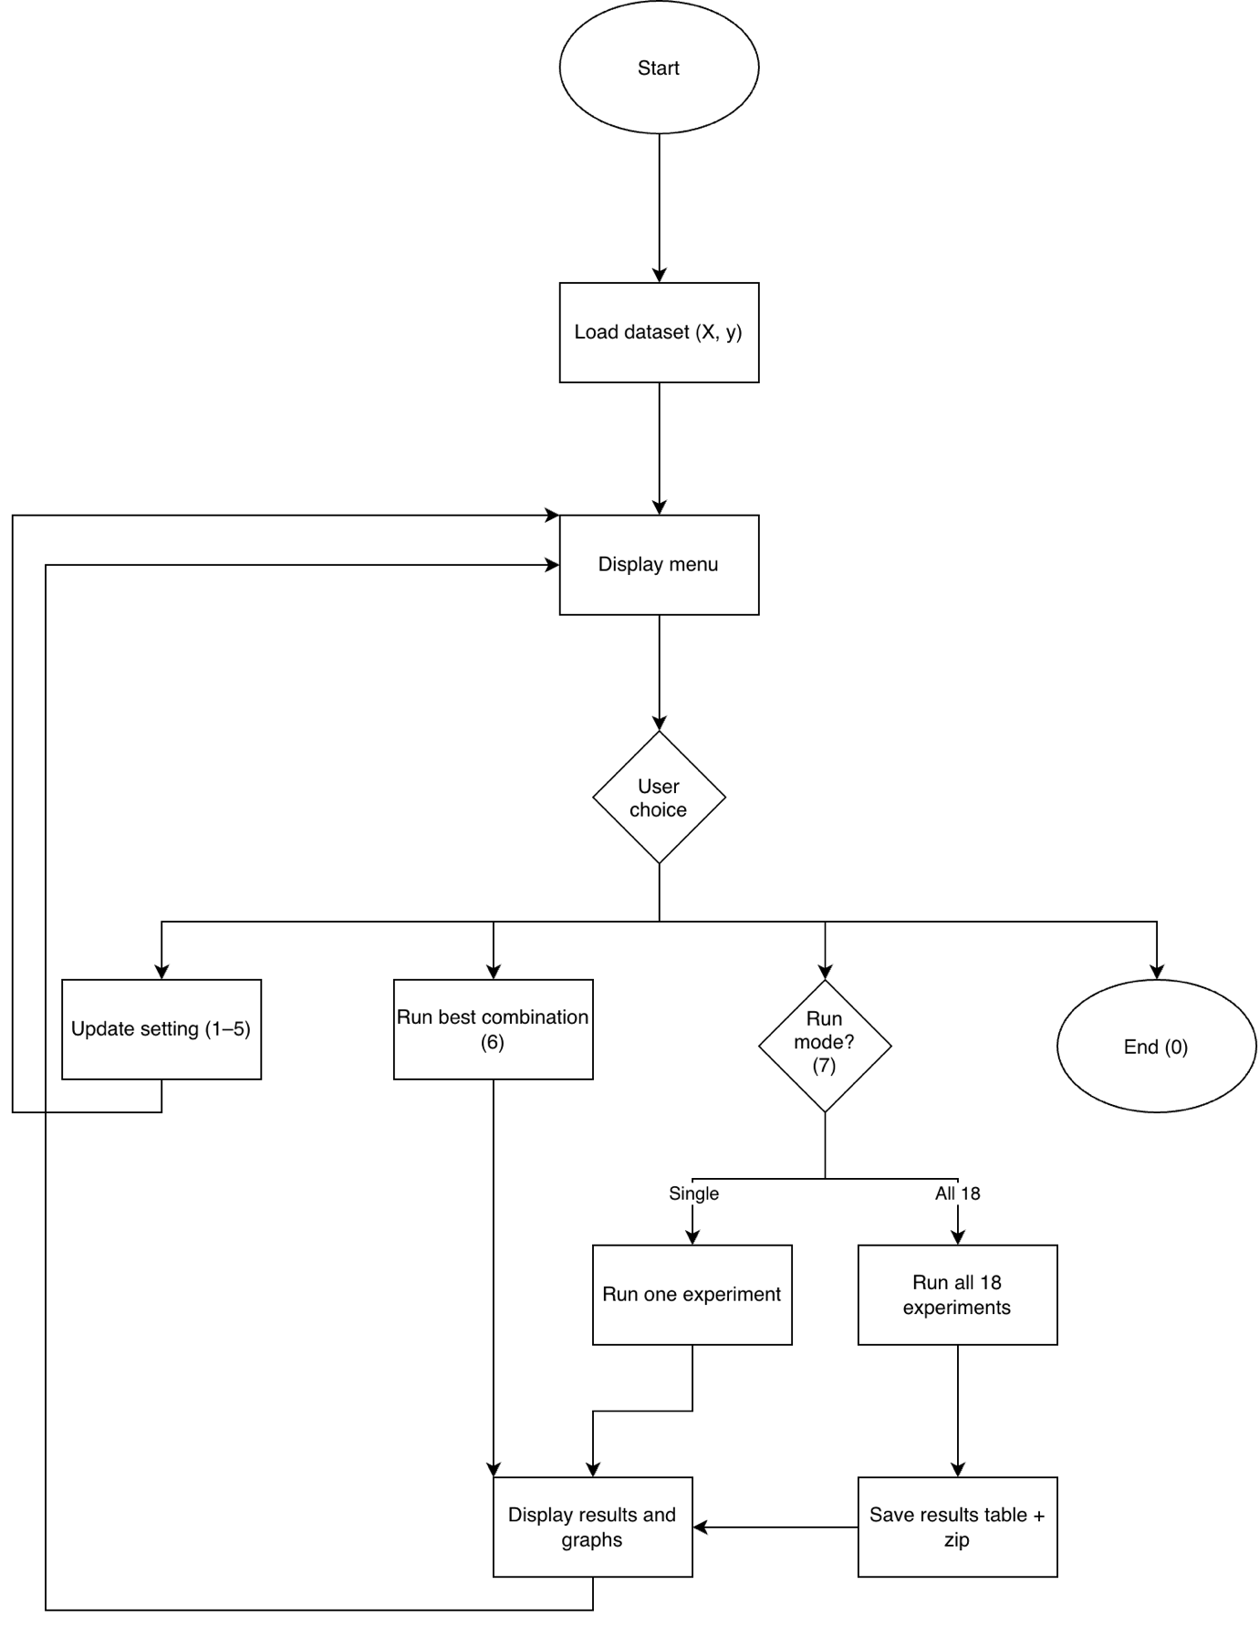
Figure 1: Top-level flowchart
The program starts by displaying a menu and waiting for user choice. Options 1-5 update a setting, then return to the menu. Option 6 runs the best combination. Option 7 checks the run mode: single runs one experiment, all 18 runs every combination and saves the results table and zip. Every path ends by displaying the results and graphs, then goes back to the menu. Option 0 ends the program. Key idea: the program is a loop around the menu; the user can change settings and rerun experiments, until he exits with option 0.
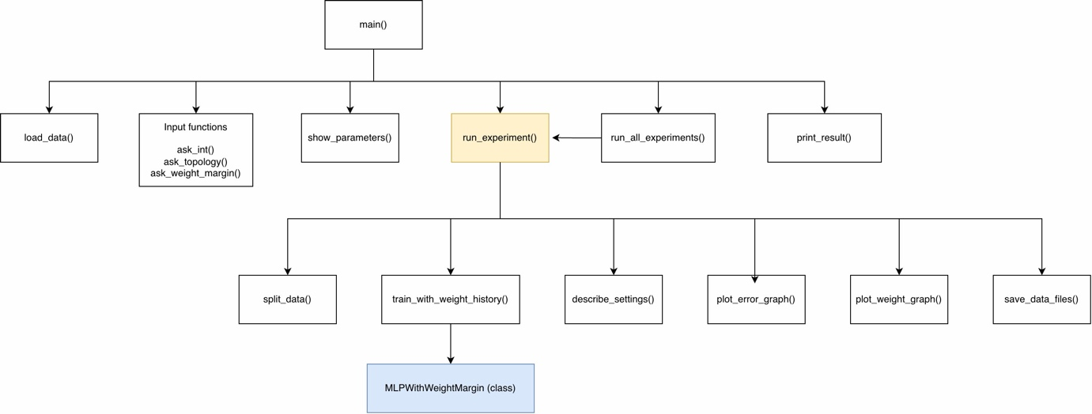
Figure 2: Function interdependency diagram
The function interdependency diagram describes the communication between functions. Main is the one caller the whole program runs from. Row 2 functions are called directly by it and only row 3 ones are called from run_experiment because it includes them. The MLP class in row 4 is called by the train_with_weight_history() function to create the model.
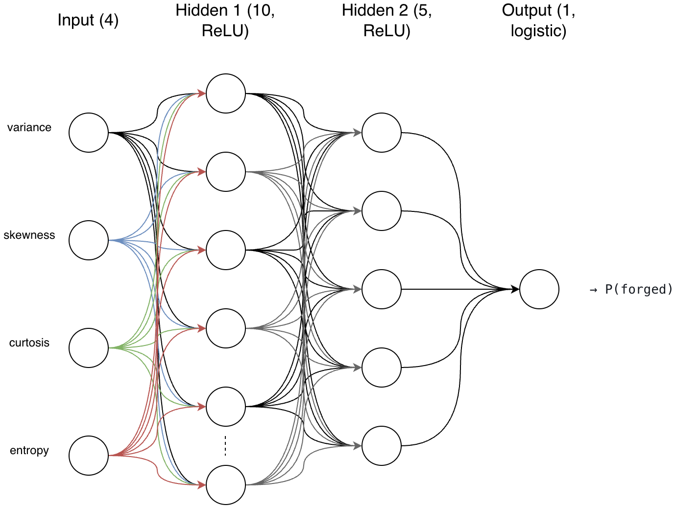
Figure 3: ANN diagram (4 inputs -> 10 neurons -> 5 neurons -> 1 output)
The ANN diagram describes the best network configuration, 4-10-5-1 (this is the network used in menu option 6). It’s an MLP with 2 hidden layers and one input and output layer (4 total layers). Input layer consists of 4 neurons, receiving the 4 features of one banknote: variance, skewness, curtosis, and entropy. It then passes them on (with no calculation) to hidden layer 1 which consists of 10 neurons. Each neuron in hidden layer 1 combines all 4 inputs with its weights, applies ReLU and passes its output to hidden layer 2, which consists of 5 neurons. Each neuron in hidden layer 2 combines all 10 outputs of hidden layer 1, applies ReLU and passes its output to the output layer which consists of 1 neuron. The one neuron in output layer combines the 5 outputs of hidden layer 2 and applies logistic -> P (forged).

5. Sample Input and Output Data
Table 4: Sample test rows with real and predicted class (0 = genuine, 1 = forged)
Variance | Skewness | Curtosis | Entropy | Real class | Predicted class
0.96441 | 5.8395 | 2.3235 | 0.066365 | 0 | 0
1.5077 | 1.9596 | -3.0584 | -0.12243 | 1 | 1
-0.59587 | 2.4811 | -2.8673 | -0.89828 | 1 | 1
0.46901 | -0.63321 | 7.3848 | 0.36507 | 0 | 0
-0.77288 | -7.4473 | 6.492 | 0.36119 | 1 | 1
[1-2 sentences on how to run the program and check the data files]

6. Experiments and Results

6.1 Experimental Setup
This part will cover the 3 settings varied and their options, the fixed settings that remained same (epochs, weight initialization), the metrics used and what each means.
Specifically, it describes the setup used to run the experiments; it does not show any results. Thus, 3 sub-parts for each case.

Part 1: what was varied (3 x 3 x 2 = 18 runs)
Table 5: Parameters varied in the experiments
Setting | Options
Hidden layer topology | (5,), (10, 5), (10, 10, 5)
Learning step | 0.01 constant, 0.1 constant, 0.1 adaptive
Train/test split | 60/40 not shuffled, 90/10 shuffled
Every combination was run, which gives 18 runs (menu option 7, run mode 2).

Part 2: what stayed fixed
- Epochs: 200
- Weight initialization: the scikit-learn default (we set no margin)
- Solver: SGD
- Activation: ReLU in the hidden layers, logistic at the output
- Feature scaling: StandardScaler, fitted on the training data only

Part 3: metrics (forged = 1 is the “positive” class)
- Accuracy: correct predictions/ all predictions
- Sensitivity: TP / (TP + FN), the share of forged notes detected
- Specificity: TN / (TN + FP), the share of genuine notes correctly accepted
- Precision: TP / (TP + FP), of the notes flagged as forged, the share really forged
- Final loss and training time

6.2 Results of All Runs
Table 6: Results of all 18 parameter combinations
Layers | Learning rate | Mode | Split | Accuracy | Sensitivity | Specificity | Precision | Final loss | Time (s)
(5,) | 0.01 | constant | 1 | 0.909 | 0.909 | N/A | 1.0 | 0.0271 | 0.62
(5,) | 0.1 | constant | 1 | 0.958 | 0.958 | N/A | 1.0 | 0.0034 | 0.75
(5,) | 0.1 | adaptive | 1 | 0.954 | 0.954 | N/A | 1.0 | 0.007 | 0.68
(5,) | 0.01 | constant | 2 | 0.993 | 1.0 | 0.987 | 0.984 | 0.0255 | 0.92
(5,) | 0.1 | constant | 2 | 1.0 | 1.0 | 1.0 | 1.0 | 0.0025 | 0.87
(5,) | 0.1 | adaptive | 2 | 1.0 | 1.0 | 1.0 | 1.0 | 0.0049 | 0.83
(10, 5) | 0.01 | constant | 1 | 0.973 | 0.973 | N/A | 1.0 | 0.0106 | 0.6
(10, 5) | 0.1 | constant | 1 | 0.993 | 0.993 | N/A | 1.0 | 0.0003 | 0.72
(10, 5) | 0.1 | adaptive | 1 | 0.984 | 0.984 | N/A | 1.0 | 0.0019 | 0.64
(10, 5) | 0.01 | constant | 2 | 1.0 | 1.0 | 1.0 | 1.0 | 0.0031 | 0.75
(10, 5) | 0.1 | constant | 2 | 1.0 | 1.0 | 1.0 | 1.0 | 0.0002 | 0.94
(10, 5) | 0.1 | adaptive | 2 | 1.0 | 1.0 | 1.0 | 1.0 | 0.0009 | 0.92
(10, 10, 5) | 0.01 | constant | 1 | 0.976 | 0.976 | N/A | 1.0 | 0.0048 | 1.01
(10, 10, 5) | 0.1 | constant | 1 | 0.985 | 0.985 | N/A | 1.0 | 0.0001 | 0.77
(10, 10, 5) | 0.1 | adaptive | 1 | 0.984 | 0.984 | N/A | 1.0 | 0.0011 | 0.73
(10, 10, 5) | 0.01 | constant | 2 | 1.0 | 1.0 | 1.0 | 1.0 | 0.0012 | 1.13
(10, 10, 5) | 0.1 | constant | 2 | 1.0 | 1.0 | 1.0 | 1.0 | 0.0001 | 1.01
(10, 10, 5) | 0.1 | adaptive | 2 | 1.0 | 1.0 | 1.0 | 1.0 | 0.0004 | 0.82
- What stands out overall.

6.3 The Six Most Promising Runs

Why those six
These 6 runs were chosen because they produced the best results (reason were called “promising”). They all have in common:
Criterion | Reason
Split 2 | Split’s 1 test has only forged notes as we previously saw
Learning rate 0.1 | For every topology, 0.01 ended with a higher loss than 0.1
Perfect test results | All metrics (accuracy, sensitivity, specificity, precision): 1.0
Low final loss | Shows that the network learned the training data well (final losses 0.0001–0.0049)

Run 1: (5,), 0.1 constant, split 2
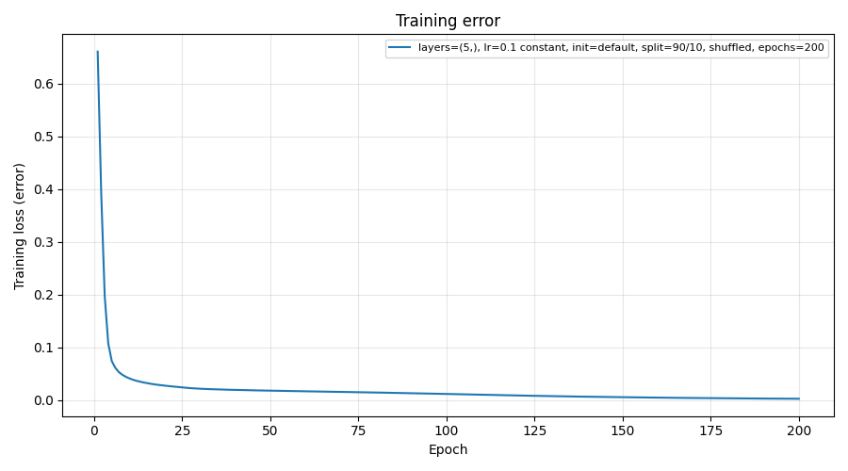
The error graph shows a very fast drop (from ≈0.66 to ≈0.05) in the first few epochs (first ≈10 epochs), followed by a slow gradual decrease until epoch 200.
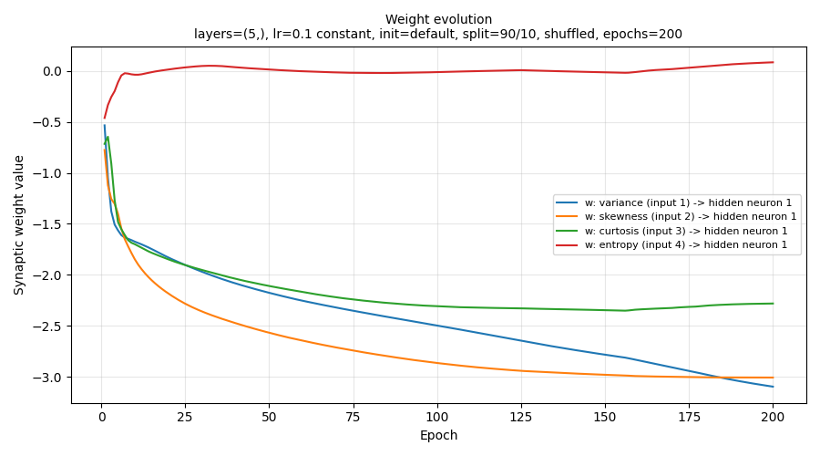
Weight graph shows that all 4 weights change sharply in the first ≈10 epochs and keep changing until epoch 200.

Run 2: (5,), 0.1 adaptive, split 2
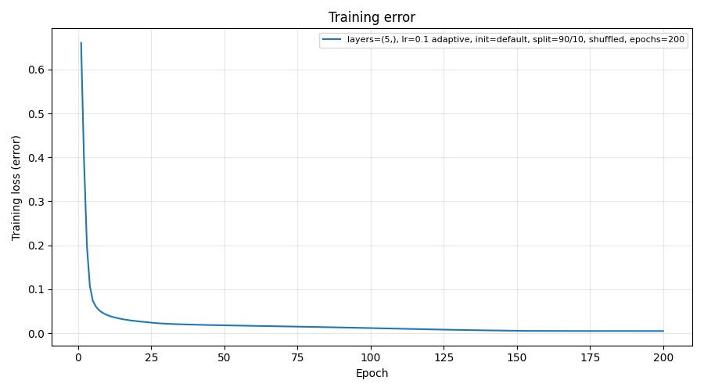
Error graph shows that the loss drops very fast in the first epochs, then decreasing gradually until epoch 200.
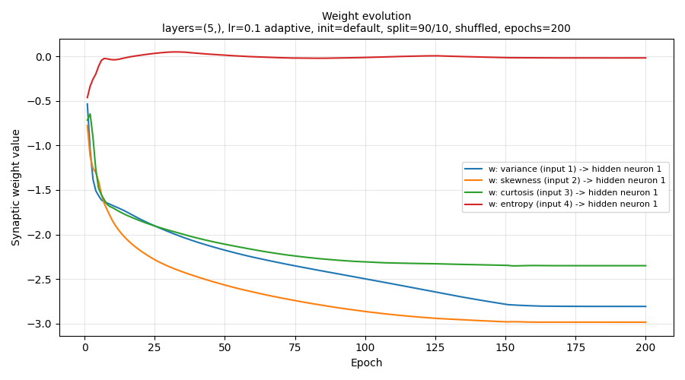
Weight graph shows that all 4 weights change sharply in the first epochs and keep changing until epoch 200.

Run 3: (10, 5), 0.1 constant, split 2
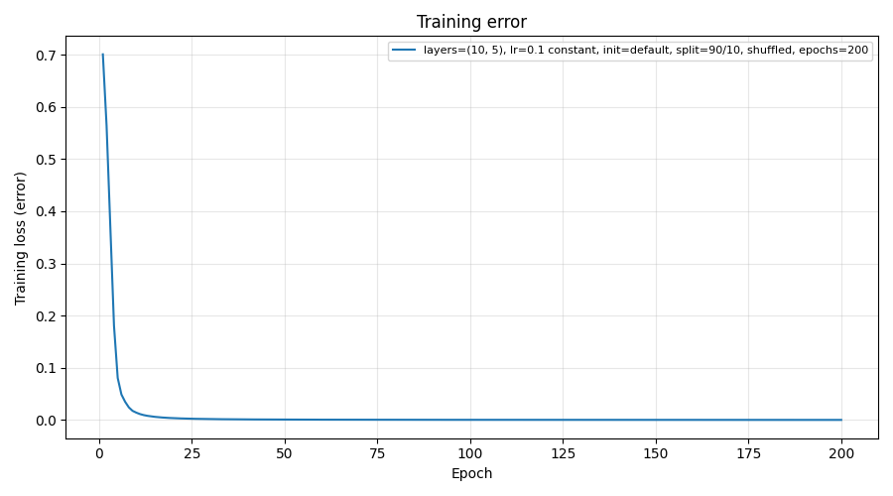
Error graph shows that the loss drops very fast in the first epochs, then decreasing gradually until epoch 200.
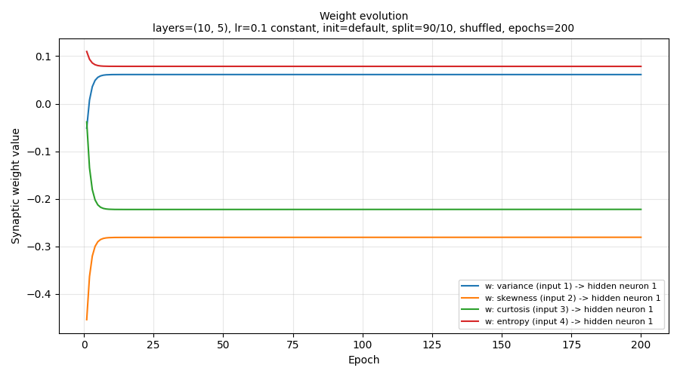
Weight graph this time shows that the weights settle very early at ≈ epoch 10 and then become flattened until epoch 200.

Run 4: (10, 5), 0.1 adaptive, split 2
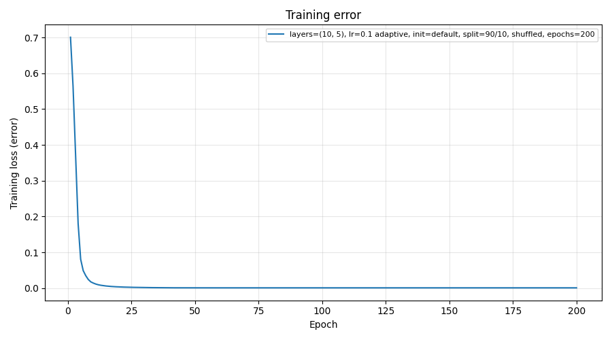
Error graph shows that the loss drops very fast in the first epochs, then decreasing gradually until epoch 200.
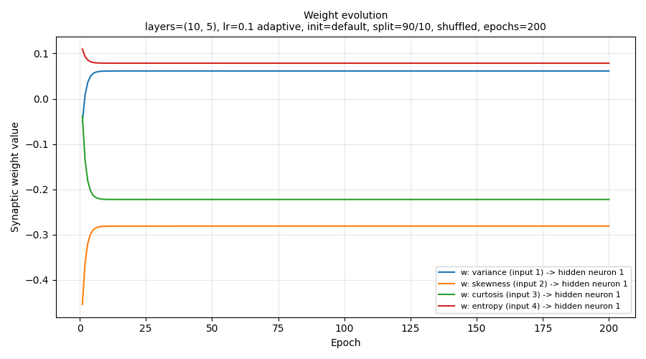
Weight graph this time shows that the weights settle very early at ≈ epoch 10 and then become flattened until epoch 200.

Run 5: (10, 10, 5), 0.1 constant, split 2
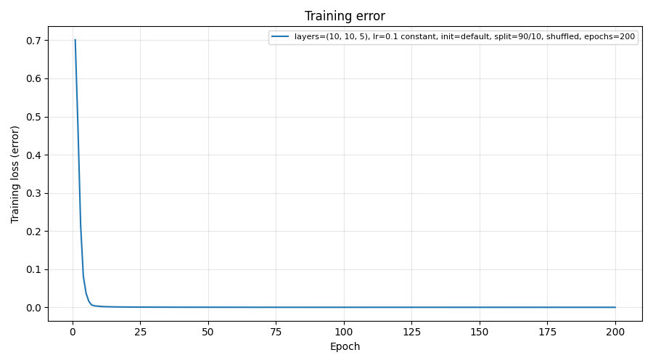
Error graph shows that the loss drops very fast in the first epochs, then decreasing gradually until epoch 200.
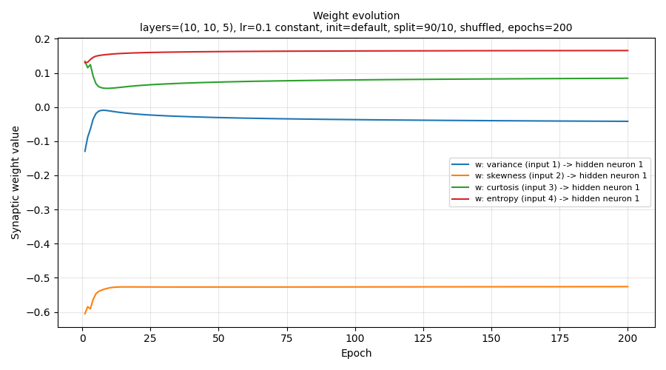
Weight graph shows that the weights try to settle until ≈ epoch 25 and then become steadier (almost flattened) until epoch 200.

Run 6: (10, 10, 5), 0.1 adaptive, split 2
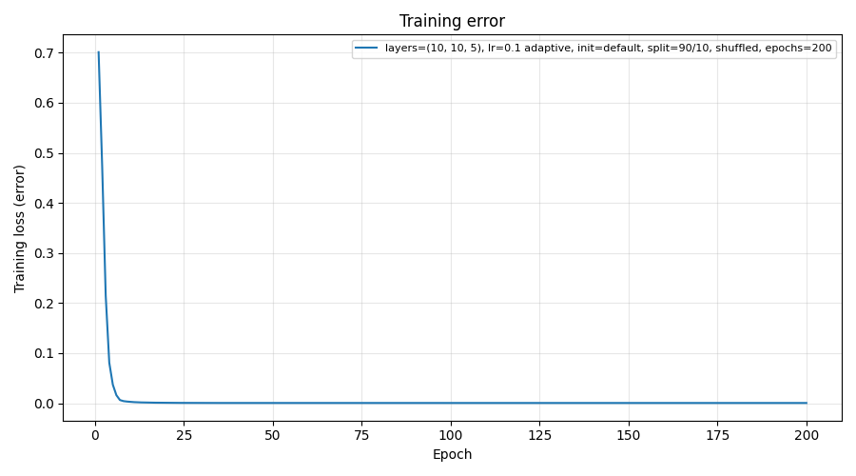
Error graph shows that the loss drops very fast in the first epochs, then decreasing gradually until epoch 200.
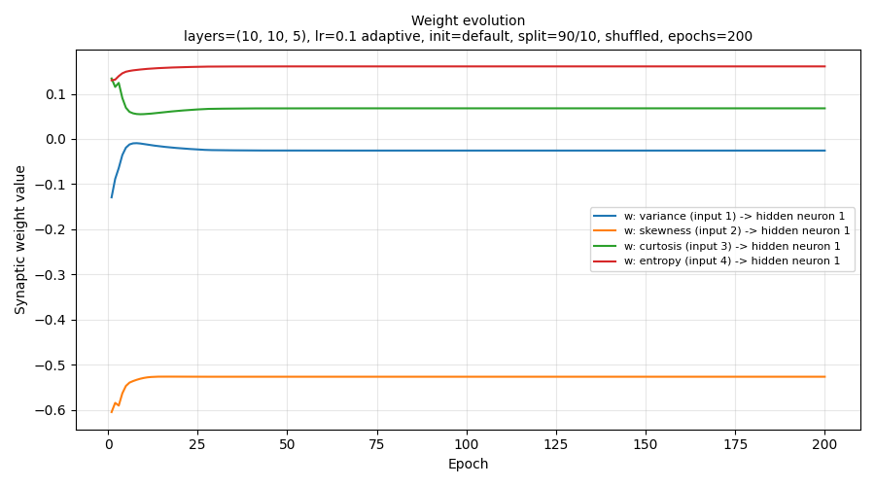
Weight graph shows that the weights try to settle until ≈ epoch 25 and then become steadier (almost flattened) until epoch 200.
Figures 4–15: Error and weight graphs of the six chosen runs

6.4 Chosen Balanced Combination (Menu Option 6)
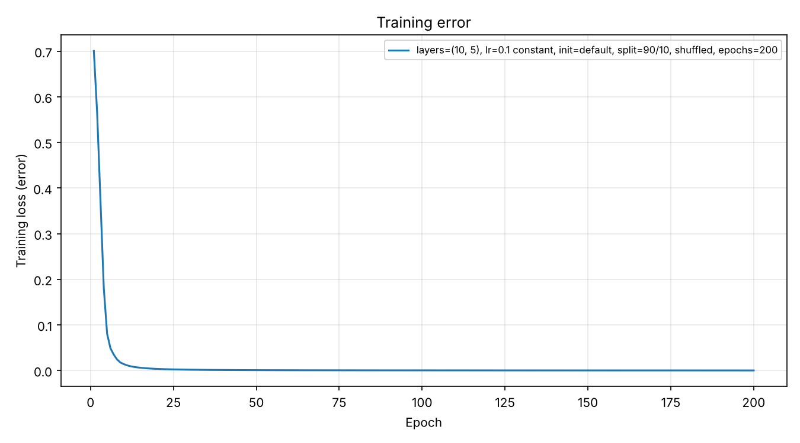
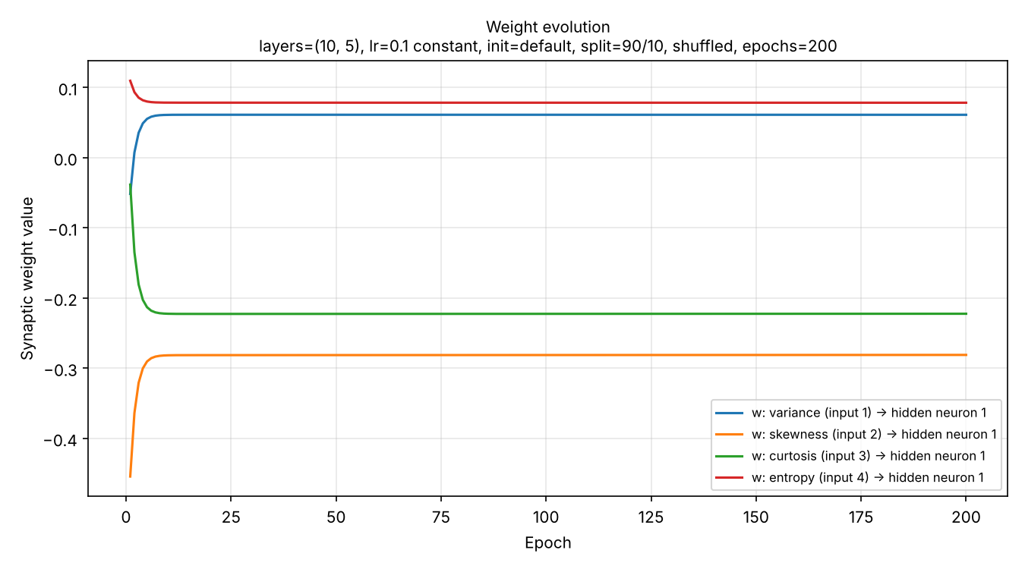
Figures 16–17: Error and weight graphs of the chosen combination
- Which combination, and why (trade-offs between accuracy, sensitivity, specificity, loss and training time).

7. Discussion

Part 1: Which factors affected the metrics and training time the most?
Answer: according to Table 6 split came first, learning rate came second and topology came third (which only mattered on split 1). Split matters because of shuffling. Without shuffling, training was mostly genuine notes and testing only forged ones (split 1). So, split 2 is the most reliable way to split our data. Learning rate comes second since 0.01 always ended with a higher loss compared to 0.1 which came out the most efficient. Topology mattered, but on split 1 only, since on split 2 every topology reached 1.0

Part 2: Can each metric be optimized? Trade-offs
The most apparent trade-off is regarding sensitivity vs specificity. Sensitivity measures true positives, while specificity measures true negatives. In the cases of lowering or increasing the threshold either of those will be automatically affected. The network gives a probability, P(forged). By default, above 0.5 -> forged. Lowering the threshold (e.g. 0.3) will flag more notes as forged, thus increasing sensitivity, while decreasing specificity. Raising it will produce the opposite result. Both can be maximized at once, improving one will always cost the other. Sensitivity matters more here, so we accept the trade-off. It’s more important to catch the forged ones, than to clear out the genuine ones. Precision is linked to specificity, thus lowering the threshold usually lowers precision too. Accuracy vs training time is the last trade-off. Bigger networks can improve learning, but cost time.

Part 3: Factors affecting the speed and quality of learning
First, how we define speed and quality of learning: By speed we mean how many epochs the network needs to reach a low loss (how quickly the curve drops and flattens). By quality we mean how good the end result is: the final loss and the test results.
The main factors were the learning rate (biggest factor), constant vs adaptive, topology, number of epochs, data preparation and weight initialization. When it comes to the learning rate 0.1 reached a much lower loss (about 10x lower) than 0.01 (means biggest learning step was more effective for training, regardless of the modes, modes came second). The learning is the step size in gradient descent and small steps get less far in 200 epochs (see table 6, final loss). Mode came second, with constant vs adaptive making a lighter difference, smaller effect. Adaptive ended with a slightly higher loss in every pair. Because adaptive divided steps by 5 when loss would stop improving, later steps were smaller and learning slowed down (see table 6 + graph pairs). Additionally, topology mattered as well. (5,) was still learning at epoch 200: its weights were still changing, while (10, 5) settled within about 10 epochs. This is because more neurons give more weights to capture the patterns, so the network learned faster in epochs (see weight and error graphs).
Other (not tested, only theoretical) factors include the epochs, feature scaling, shuffling and weight initialization.

Part 4: What would more time and resources allow for as improvements
Improvements can be looked at regarding to the limitation they could cover.
Limitations found
- One split, one seed (42), a small test (138) -> not complete randomness.
- Split 1 tested only forged notes.
- The best run converged by about epoch 20, so 200 was wasted.
- Weight margin and epochs were never varied.
- The threshold was always the default 0.5.
- Only 3 topologies and 3 learning steps
Possible improvement for each limitation
- K-fold cross-validation (e.g. 5 or 10 folds) and several random seeds, then report the average.
- A stratified shuffled split, so both classes appear in both sets in the right proportion.
- Early stopping: stop when the loss stops improving, saving time
- Use different numbers for those two values (provided by the menu) to run the 18 experiments with
- Use predict_proba() to test other thresholds, choose one that favors sensitivity
- Test more options, e.g. other learning rates or the Adam solver

Part 5: Overfitting observed and techniques to minimize or avoid it
Overfitting is when the network memorizes the training data, instead of learning the general pattern, so it ends up doing well on training data, but worse on new data that comes in.
Spotting overfitting usually means a gap between the training and test results (low training loss, but poor test accuracy).
In our network, we mostly did not observe overfitting, however, it is important to note that we only tracked the training loss per epoch, and not the test loss, so we can’t see any possible divergence between the two curves. Also, test set was relatively small (130 notes), from a single division.
Beyond that note, on split 2 the training loss is near 0, and the test accuracy is 1.0. The network performs just as well on unseen notes, so there’s no gap (evidence against overfitting). Split’s 1 lower accuracy again does not point towards overfitting because it comes from unbalanced data.
Techniques to minimize or avoid it:
Technique | What it does
Separate test set | checks performance on unseen data
Cross-validation | tests on several divisions
Early stopping | stops before the network starts memorizing
Regularization (alpha in MLPClassifier) | penalizes very large weights
Smaller network | fewer weights, less room to memorize
More data | harder to memorize

8. Conclusion

Part 1: What the project achieved
The project achieved the built of an MLP with scikit-learn that classifies banknotes as genuine or forged, from 4 image features. The program is a menu-driven tool allowing the user to set the topology, learning step, weight margin, split and epochs, run single or all 18 experiments, and save the data files, graphs and results table. The experiments include 18 configurations compared using accuracy, sensitivity, specificity, precision, loss and time. The main findings include the shuffled 90/10 split being the reliable test, because split 1 only tested forged notes, the learning rate 0.1 producing lower loss at all cases compared to the 0.01 rate, and the best balanced configuration being the (10,5) with 0.1 constant on split 2, reaching 1.0 on all test metrics with very low loss. One limitation was the results coming from a single train/test division of 138 test notes. Cross-validation would make them more reliable.

Part 2: Skills required, developed and improved
The main skills required to complete this project were basic python understanding, the theory behind machine learning fundamental concepts, and especially concepts such as supervised learning, classification, gradient descent, learning step, loss. Knowing those helped me already have an idea of what the project asks, before implementing it. The main tools I needed were the IDE to write the code in, which was PyCharm, and then also scikit-learn and matplotlib for proper implementation. Skills developed were far more than the familiar ones, I learned a lot of new things. I learned how an MLP works, the layers, the weights owned every time by the receiving neuron, the ReLU for transformation and the logistic. I learned why splitting the data properly matters, since not all data comes balanced from the start. Split’s 1 accuracy was misleading for this reason. I learned what sensitivity, specificity and precision measure in action and how altering the threshold can affect each of the first two (improving the one will always affect the second). I learned to read error and weight graphs, error showed the network’s loss performed (how fast or slow it dropped, and when it stopped improving) relative to the epochs set, and weight showed how the weights would fluctuate and settle relative to the epochs. I learned to design diagrams in draw.io which in which I designed my flowchart, function diagram and ANN which made representation of the flow and concepts clearer through visualization. When it comes to skills improved, I improved structuring my code better for when building such a big program and splitting the parts in an effective way. This also helped me for the report later. I improved also when it came to explaining technical results in writing as well as organizing experiments and comparing results fairly.

References
[1] V. Lohweg, “Banknote Authentication,” UCI Machine Learning Repository, 2012. [Online]. Available: https://doi.org/10.24432/C55P57
[2] F. Pedregosa et al., “Scikit-learn: Machine learning in Python,” Journal of Machine Learning Research, vol. 12, pp. 2825–2830, 2011.
[3] D. E. Rumelhart, G. E. Hinton, and R. J. Williams, “Learning representations by back-propagating errors,” Nature, vol. 323, no. 6088, pp. 533–536, 1986.
[4] I. Goodfellow, Y. Bengio, and A. Courville, Deep Learning. Cambridge, MA, USA: MIT Press, 2016.
[5] S. Russell and P. Norvig, Artificial Intelligence: A Modern Approach, 4th ed. Hoboken, NJ, USA: Pearson, 2020.

