**Big Mountain Resort Pricing Strategy Case Study**

Big Mountain Resort recently added a new chair lift to their facilities in an effort to ease patron traffic around their resort. This new lift came with the additional operating costs of $1.54 million. Because of this, Big Mountain Resort has tried implementing a data-centric strategy to find how they might increase revenue, so as to offset the increase in operating costs. This function of this report is to communicate some findings and recommend the best path forward for Big Mountain Resort.

From the data, a model was built to ascertain which features of a ski resort were most correlated to ticket price. Below are some figures that illustrate How Big Mountain Resort compares to the rest of the market. The blue bars signify the distribution of the feature in question, and the red line signifies where Big Mountain lies within the distribution.

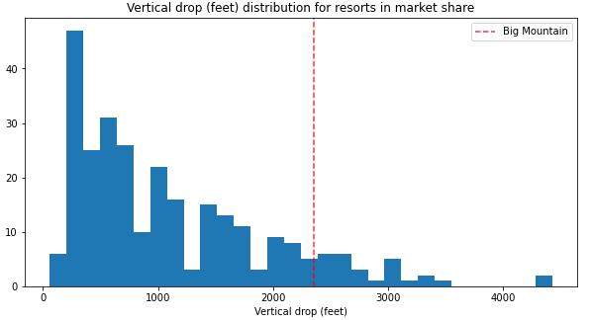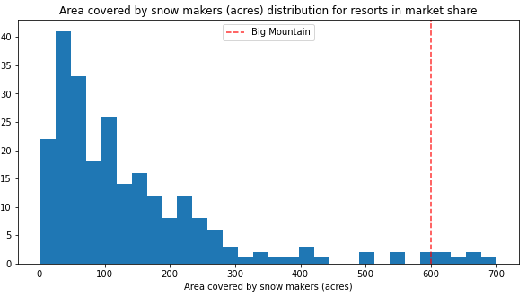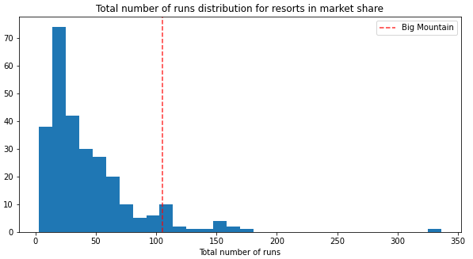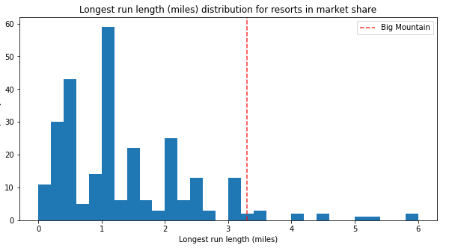

Big Mountain always tends to be towards the top end of each of these distributions. Below is the distribution for Ticket Price.

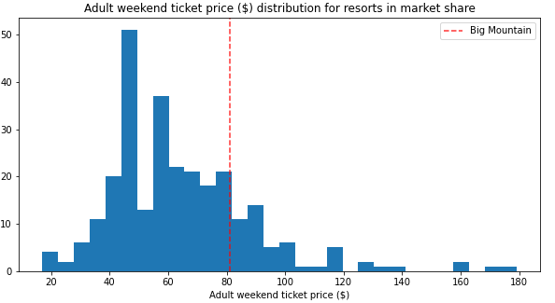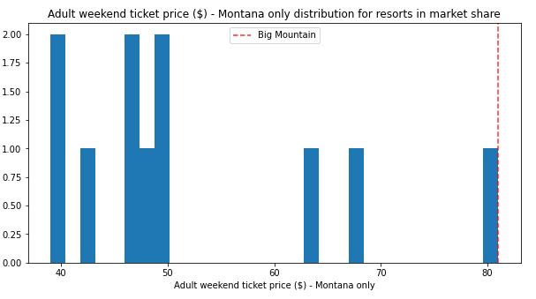

Even though Big Mountain has a lot of incredible features, they are underpriced (within the market of the entire United States). With the model, Big Mountains ticket price value was evaluated to be $95.87 (+/- $10.39) if it were to match their market value based on their features. This is significantly higher than the $80 they are currently charging per ticket.

An additional effort was made to see how Big Mountain might capitalize on their facilities further. After some further work with the model, the data suggested that engaging in a scenario where the longest run was increased by an additional 150 feet in elevation and adding an additional chair lift further cemented the idea of increasing the ticket price and could yield over $3 million in revenue. This scenario suggested the most net gain, in comparison to some other scenarios that were plotted out using the model. In conclusion, These findings are incredibly valuable! It suggests that Big Mountains facilities are valued incredibly high and that if the executive team accepts this model, they could make substantial profits.