**Assignment3: Drawing 2D Polygons with Color**

**Due: Week 6**

Topics:

* Define polygon shapes
* Pass attribute data to vertex shader
* Pass color data to fragment shader
* Draw color-interpolated triangles.

Part 1:

Create a picture similar to:

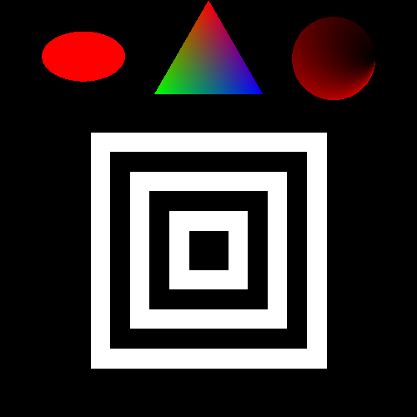

The window should be 500x500 pixels. You can draw the objects with one color.

Part 2:

Write another program that creates another picture with at least 3 different color objects!