Freight Rate Prediction
Validation approach, data split, model and results
Spotter machine learning assessment
Ko Sweet
October 2026

1. Summary
The task is to predict the posted rate for 12,000 truck loads shipped in November and December 2025, using 48,000 labelled loads from January to October 2025, and to produce the fixed December chart for the Lexington to Fort Wayne lane. This report covers how the data was split and validated, what the exploration found, how data quality issues were handled, why the model was chosen, and what to expect from the predictions.
- Validation. The task is a forecast, so models were compared on forward-in-time folds: train on earlier months, test on later ones. A random split was tried and rejected because it hid a 4-point failure.
- Model. A linear model on log price, then gradient-boosted trees fitted to its residuals, then a per-lane correction. Forward-fold error 1.70% (about $40 per load). Linear alone 1.87%, trees alone 1.90%.
- Main finding. The quote_signal column is planted. In five months it is the rate per mile, in four months it is 4.15 minus the rate per mile, and in August, November and December it is random. It is left out of the model, and the report shows how that was established without seeing any validation prices.
- Expected error. About 1.5 to 1.9% on genuine prices if November and December stay at the September to October price level, which every input suggests. About 4 to 6% if the level shifts. The scored error will also include about 1.4% of answer-key rows whose prices are 2 to 5 times off.

2. The data and the task
Each row is one truck load with pickup and delivery city, coordinates, road distance, trailer type (Dry Van, Reefer or Flatbed), weight, date, a market_index value, a quote_signal value, and, in the training file only, the posted rate in dollars. Training covers every day from 1 January to 31 October 2025 (48,000 rows). Validation covers every day of November and December (12,000 rows) with the price removed. The December chart file holds 31 rows for one fixed load, Lexington to Fort Wayne, 360 miles, Dry Van, 32,000 lb, where only the date changes.
The provided score.py checks the format of both output files and draws the December chart. It does not compute an error; Spotter does that after submission. All error figures in this report therefore come from the forward-in-time folds described next.

3. How the data was split and validated

3.1 Why a time-based split
The model will be judged on two months it has never seen, which come after every month it was trained on. The only honest rehearsal is one with the same shape: train on earlier months, test on later months. Four folds were used, and every learned part of the pipeline (fill values, city effects, lane terms, model weights) was refitted inside each fold so that nothing from the test months leaked into training.
Fold | Train on | Test on | What it mimics
1 | January to August | September and October | The real task: two unseen months after the training window
2 | January to June | July and August | Predicting across the summer price peak
3 | January to July | August to October | A three-month horizon
4 | January to September | October | The most training data, one month ahead

3.2 What a random split would have hidden
A stratified random split (25% of each month held out) was run first. For a model with seasonal date features it reported 5.4% error. The same model tested on later months scored 9.7%. The seasonal curve fitted January to October well and extrapolated badly, and the random split could not see that because every month was present on both sides. Without date features the two splits agreed (5.3% and 6.1%). Random splits cannot detect anything that changes over time, and this task is about change over time, so the time-based folds were used for every decision.

3.3 Two caveats
- The folds overlap. September and October appear in three of the four test sets, so the four-fold average is not four independent estimates. Differences under about 0.05 points were treated as ties. The chosen model wins on every fold, not only on average.
- All four folds test months where the price level was flat. Three extra folds that test months where the level was still rising (train January to March, test April and May, and so on) give 4.2%, 5.7% and 4.6%. The model is accurate when the level holds and misses by the size of the shift when it does not. Section 9 states the expected error conditionally for that reason.

3.4 Error does not grow with horizon
October scores 1.69 to 1.70% whether it is predicted one, two or three months ahead, and September scores 2.1% in every fold that contains it. The error depends on how far a month's price level sits from the training average, not on how far ahead it is. December should not be harder than November only for being further out.

4. Data quality issues and how they were handled
The same issues appear in both files, so one shared cleaning function is applied to both. Rows are only ever removed from training; all 12,000 validation rows are kept and predicted.
Issue | Training | Validation | Fix | Evidence
Negative weight | 292 | 145 | Sign flipped | Flipped weights have the same quartiles as normal weights and are priced like normal loads. Left negative, they would teach the model that heavier means cheaper.
Blank weight | 300 | 165 | Training median, 31,496 lb | Weight is the same in every month and trailer type, so there is nothing better to condition on. A typical miss of 5,500 lb moves price by 1.7%, under the 6.5% row-to-row noise.
Blank market_index | 374 | 249 | Average of the other loads on the same day | market_index is a daily market level. Hiding 3,000 known values and refilling them gave a typical miss of 0.016 on a 0.68 to 1.47 scale. Same-weekday and adjacent-day methods were tested and were worse (0.020 and 0.027).
Bad prices | 677 (1.4%) | cannot be seen | Removed from training | Priced 2.2 to 5.4 times too high or 0.17 to 0.47 times too low. The error factor is random, so the true price cannot be recovered. Spread evenly across months, trailers and cities. The cut sits in an empty gap: nearest kept row 1.23x, nearest removed 2.16x.

Removing the bad prices barely changes a log-space model (4.61% versus 4.62% on the September to October fold) because the high and low errors cancel. It does help a model that averages in dollars, which is how a default regression tree behaves (3.94% versus 3.70%). It also makes the fold scores honest: with bad prices left in the test set, the measured error rises from 4.6% to 7.0% and model comparison becomes noisy.
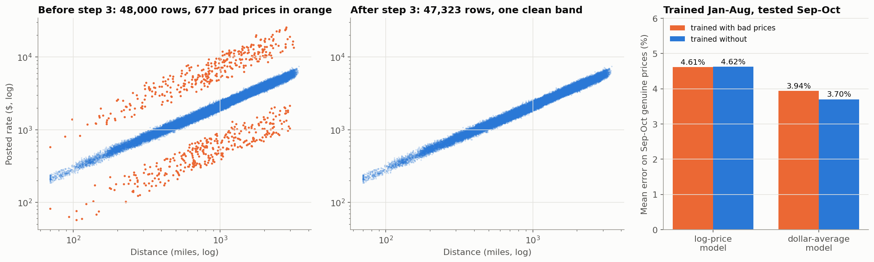
Figure 1. Training prices before and after removing the 677 bad rows, and the effect on a log-space and a dollar-space model.
The validation answer key almost certainly contains the same 1.4% of bad prices. They cannot be detected without the price, so they add roughly the same amount to every candidate's measured error.

5. What the exploration showed

5.1 Price follows distance
Price is close to a straight line in distance on log scales (correlation 0.97). Rate per mile falls from about $2.80 under 200 miles to $1.87 over 2,500 miles, so a flat rate times distance would under-price short loads and over-price long ones. Reefer costs about 12% more per mile than Dry Van, Flatbed about 8% more. Prices rise from January to a June peak and then settle; the validation months lie outside that window.
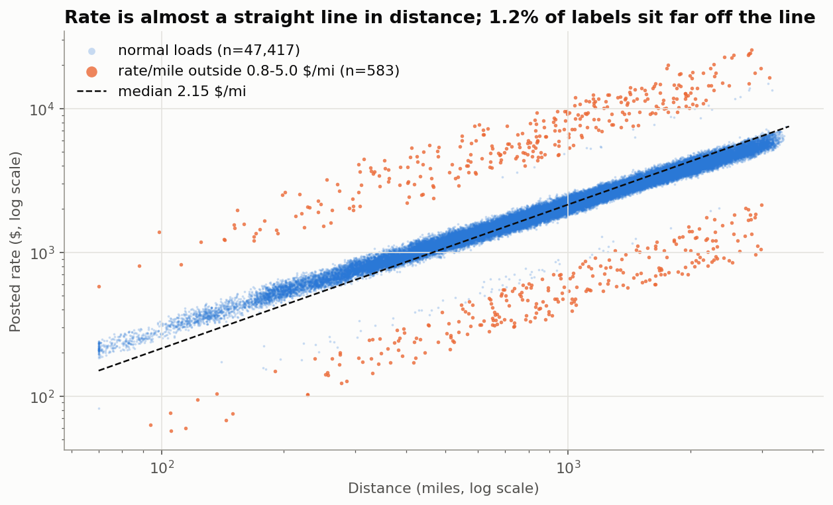
Figure 2. Posted rate against distance on log axes. The orange points are the bad prices described in section 4.
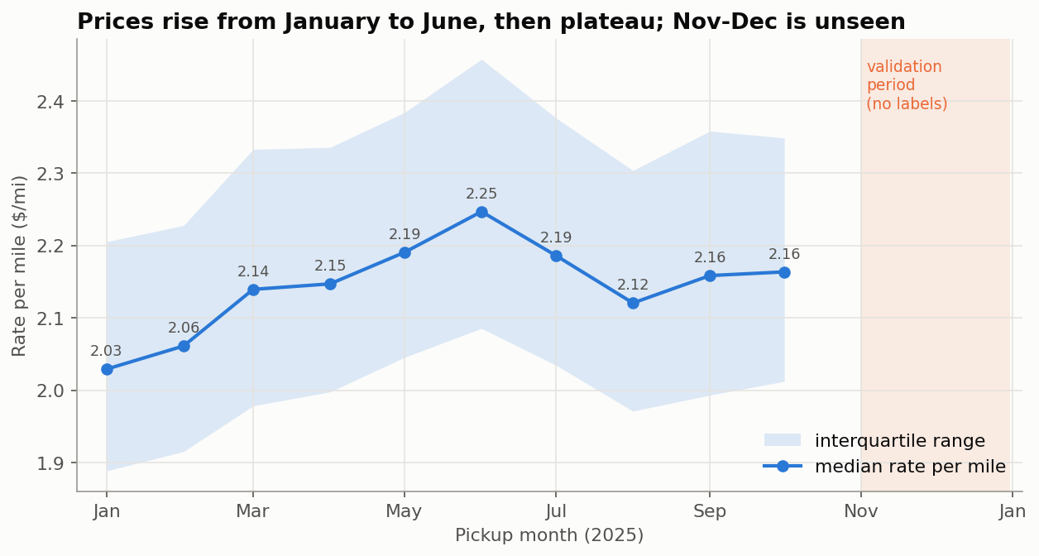
Figure 3. Median rate per mile by month, with the validation period shaded.

5.2 quote_signal is planted
The column has three regimes that switch at month boundaries. In January, February, March, June and September it is the rate per mile: multiplied by distance it reproduces the price within 2% for 95% of rows and predicts price with 0.8% error on its own. In April, May, July and October it is 4.15 minus the rate per mile, accurate to about 3 cents. In August it is random noise.
Which regime November and December are in can be read without any prices, because in the clean and mirrored regimes quote_signal inherits the strong link between rate per mile and distance. Its correlation with log distance is about -0.80 in clean months, +0.81 in mirrored months and 0 in random months. November scores 0.009 and December 0.013. Both are random, and a second test (how tightly the quote agrees with the model's own prediction) gives the same answer, matching August exactly.
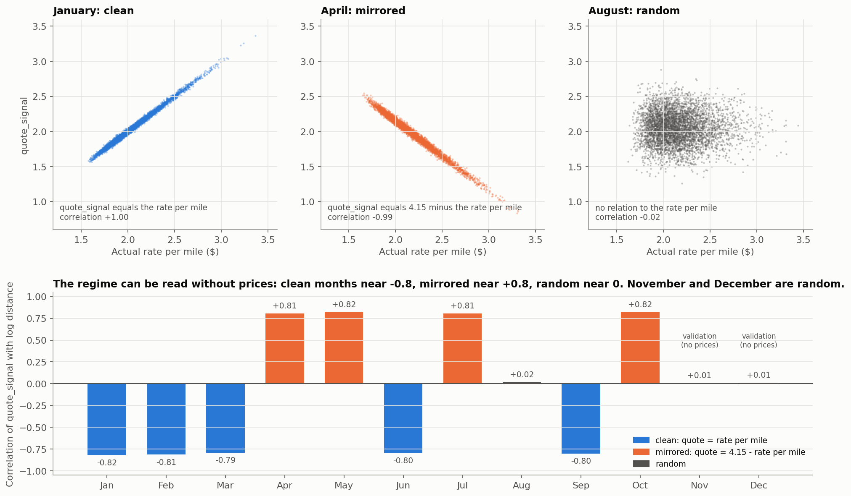
Figure 4. Top: quote_signal against the actual rate per mile in a clean, a mirrored and a random month. Bottom: the regime of every month, including November and December, from a test that needs no prices.
Because the column is random for the months being predicted, it is excluded from the final model. A rule that trusts the quote only when it agrees with the model within a tolerance was also tested on the random months and gave no gain at any tolerance. In the clean and mirrored months the quote can repair most of the removed bad prices, which confirms that only the price column was corrupted in those rows.

5.3 market_index is a daily market level, and a trap when used raw
market_index is nearly identical for every load on the same day, swings with a weekly cycle (tight midweek, loose at weekends), and rose through spring and fell in late July. Used as a raw feature it hurts out of time: its fitted effect falls from +18% per unit in January to April to +8% in September to October, because it took credit for a slow upward price drift that happened at the same time. A model with the raw index under-priced September and October by 4%. Only the short-term part is stable: today's index minus the surrounding 28-day average, which says whether this week is tighter than usual. That is the feature used.

5.4 Location matters and eight cities are new
After distance and trailer type, location is the biggest gain, worth about one point of error. City effects are symmetric: a city costs the same whether the truck starts or ends there, and the leftover for A to B correlates +0.80 with B to A. Effects range from -3.7% to +3.1% per end, with Texas and the Gulf dearer and the Northeast and Great Lakes cheaper. Eight cities appear only in validation (Chicago, Charlotte, Laredo, Norfolk, San Diego, Knoxville, Jackson, Allentown), touching 1,447 rows. Each takes the average effect of its three nearest known cities. Hiding eight random training cities and predicting them this way loses only 0.03 points against knowing them.
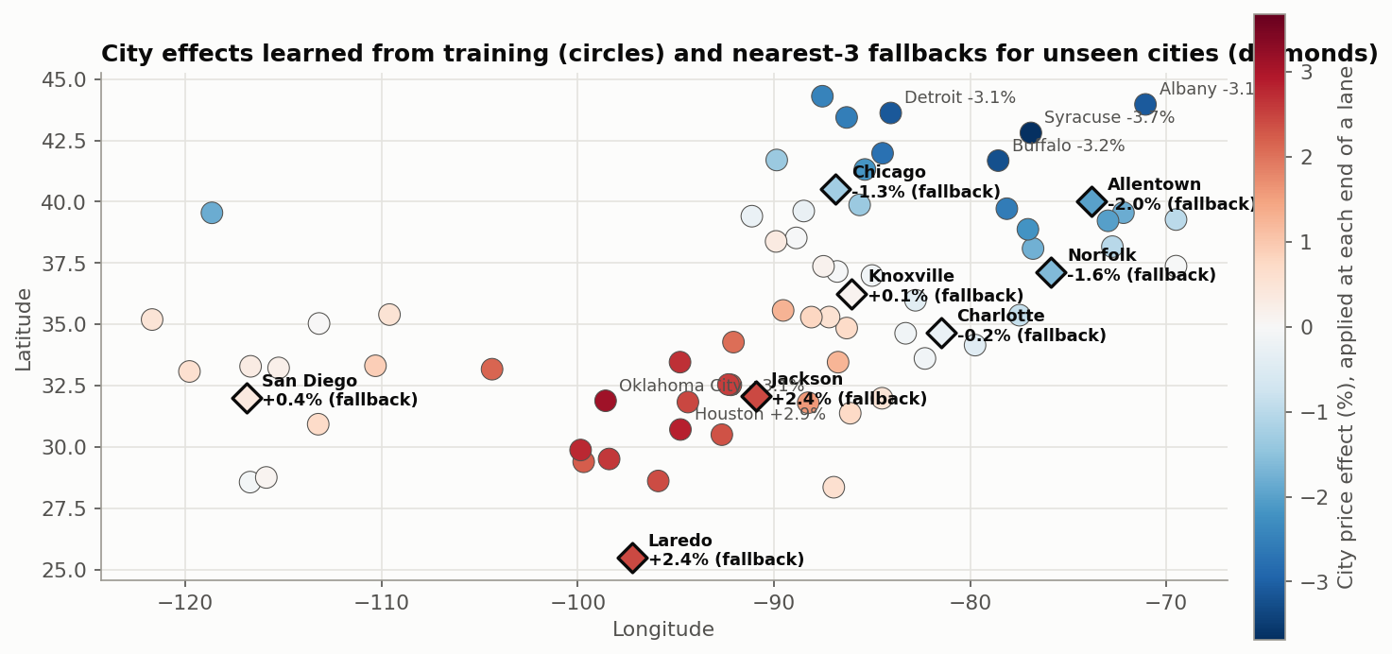
Figure 5. City effects learned from training (circles) and the fallback values for the eight unseen cities (diamonds). Each diamond sits in a region of matching colour.

6. Features
Twenty-three numeric columns, all computed from the training rows and then applied unchanged to validation and to the December rows:
- Distance, log distance and log distance squared.
- Trailer type as three indicator columns.
- Weight and a flag for filled values.
- Day of week as seven indicator columns.
- Short-term market signal (market_index minus its centred 28-day daily average) and a flag for filled values. The daily series is built across January to December because market_index is an input, not the target.
- Latitude and longitude of both ends, from a per-city lookup table. This also serves the December rows, which carry no coordinates.
- Pickup and delivery city effects, with the nearest-three-cities fallback for unseen cities.
Left out on evidence: raw market_index, month, day of year, any trend, lane identifiers, and quote_signal. The same exclusions apply to the tree model, which would otherwise learn the same confounded index effect.

7. Model choice
All candidates predict log price from the same 23 features and are converted back to dollars. Predicting the logarithm turns percentage errors into equal-sized errors, which matches how freight prices vary, and targets the median price, which is right for mean absolute and percentage error metrics.
Model | Average forward-fold error | Worst fold | Average bias
Linear + trees on residuals + lane term (chosen) | 1.70% | 1.93% | -0.6%
Linear + trees on residuals | 1.76% | 1.97% | -0.6%
Linear + CatBoost in the same structure (checked, then removed) | 1.71% | 1.94% | -0.6%
Linear only | 1.87% | 2.06% | -0.6%
Gradient-boosted trees only | 1.90% | 2.11% | -0.6%
Trees only, absolute-error loss | 1.99% | 2.21% | -0.4%

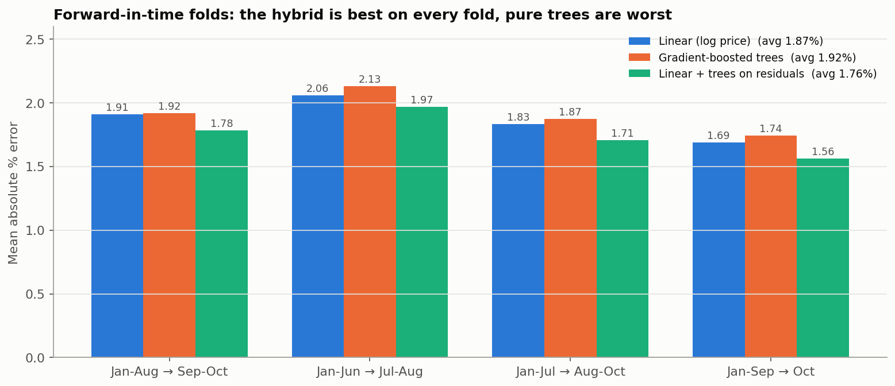
Figure 6. Error by fold for the three main structures. The hybrid wins on every fold.
Why this structure. The linear model captures the distance law, which drives about 90% of the price, and extrapolates smoothly. Trees on their own approximate that curve in steps and go flat at the edges, which is why trees alone lose to the plain linear model here. Fitting trees to the linear model's residuals keeps the smooth backbone and adds the interactions a linear model cannot learn, such as a slightly different distance curve per trailer type. The lane term captures the small lane-specific leftover (1.4% against 0.9% expected from pure noise) and is zero for lanes not seen in training, so it cannot hurt them.
Why not a bigger learner. Random forest, extra-trees, k-nearest neighbours, a neural net, a polynomial ridge, a much larger boosted model and CatBoost were all tried on the same folds. Every tree method landed within 0.01 points of the chosen booster, and the others were worse. When several different algorithms agree to the second decimal, the ceiling belongs to the data, not to the library. CatBoost is not in the provided requirements, so it was removed again and the submission uses scikit-learn only. One implementation detail worth stating: scikit-learn turns on early stopping automatically above 10,000 rows, which would have cut 400 requested trees to 98. It is switched off explicitly.
Level anchor. The model has no time features, so its price level is the January to October average. September and October sat 0.6% above that average, and every validation input (market_index level, trailer mix, distances, weekend share) matches September and October. Predictions are therefore shifted by the model's own mean residual on September and October rows, +0.61%. This is a judgment call: it helps on folds where the level holds and would hurt on a fold where the level moved. It is recorded as such.

8. The December chart
The chart below is the one produced by the provided score.py from the filled December file. Only the date changes across the 31 rows, so the only inputs that move are the weekday and the short-term market signal. The predictions run from $824 to $841 with a weekly cycle of about 1%, higher midweek and lower at weekends. Training contains 21 Dry Van loads on this exact lane with a median price of $808, so the level is plausible. Training shows no holiday price effects (4 July is -0.3%, every other holiday within 0.2%), so a flat Christmas week is the expected shape, not a gap in the model.
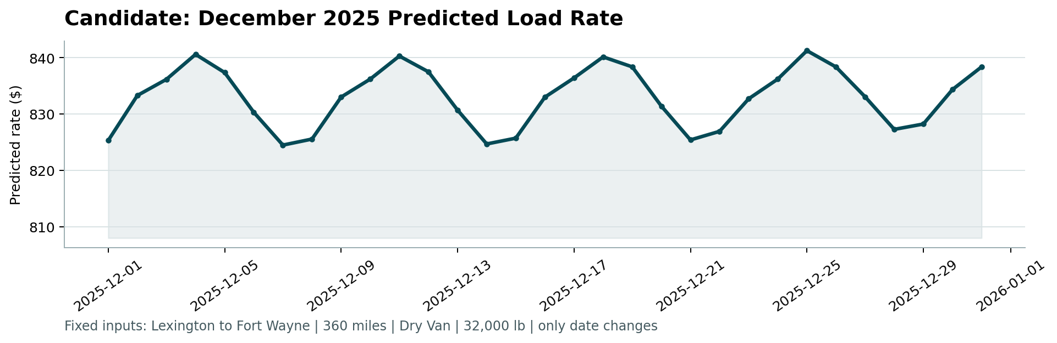
Figure 7. candidate_december.png as generated by score.py: predicted rate for Lexington to Fort Wayne, 360 miles, Dry Van, 32,000 lb, for every day of December 2025.

9. Expected error and assumptions
The remaining error has two parts. Within a single day the model is off by about 1.8%, of which about 1.0% is genuine price noise that nothing can remove (two identical loads on the same lane and day differ by that much, measured from the months where quote_signal reveals the exact price). The rest is a day-level shift shared by every load that day, driven by something not in the data.
Scenario | Expected error on genuine prices | Basis
November and December stay at the September to October price level | 1.5 to 1.9% (about $40 per load) | Four forward folds on flat months: 1.49 to 1.93%
The price level shifts by a few percent | 4 to 6% | Three folds on rising months: 4.2 to 5.7%

Every input in the validation file matches September and October, the market_index for November and December sits at the same level with no spike and no holiday dip, so the first scenario is the expected one. The scored error will be higher than either figure by the share of bad prices in the answer key.
Assumptions stated for the record:
- November and December follow the same rules as January to October.
- The market signal uses a centred 28-day window, so the model is scored in batch. The validation file ships every date up front, so this holds here.
- City effects and the lane term are fitted on the training rows without holding rows out. With about 1,500 rows per city end this is harmless, and fitting the lane term out of fold was checked and gains nothing.
- The weight median and the expected prices used to flag bad rows are computed once on all of January to October. The leak into the folds is negligible; the city and lane terms, which matter, are refitted per fold.
- The log target gives the median price, which is right for mean absolute and percentage error and slightly low for root mean squared error. The scoring metric was not given.

10. Reproducing the results
The repository contains the six pipeline scripts, the exploration charts, a cleaning log and modelling notes with every test result, four tests, and a one-command run script. From a fresh checkout:
python3 -m venv env && source env/bin/activate
python -m pip install -r requirements.txt
./run_all.sh
python -m pytest -q
run_all.sh runs steps 1 to 6 in order and finishes with the scorer command from the assessment README. It takes about two minutes and reproduces validation_predictions.csv, the filled data/december_chart_inputs.csv and scorer_results/candidate_december.png. Dependencies are the provided requirements plus scikit-learn and pytest.

