Revision 01/ 21.04.2026

- Descriptions connectors for external devices included to CIS3 EXTERN 1 – PCB V02
1.1.All connectors for external interfaces
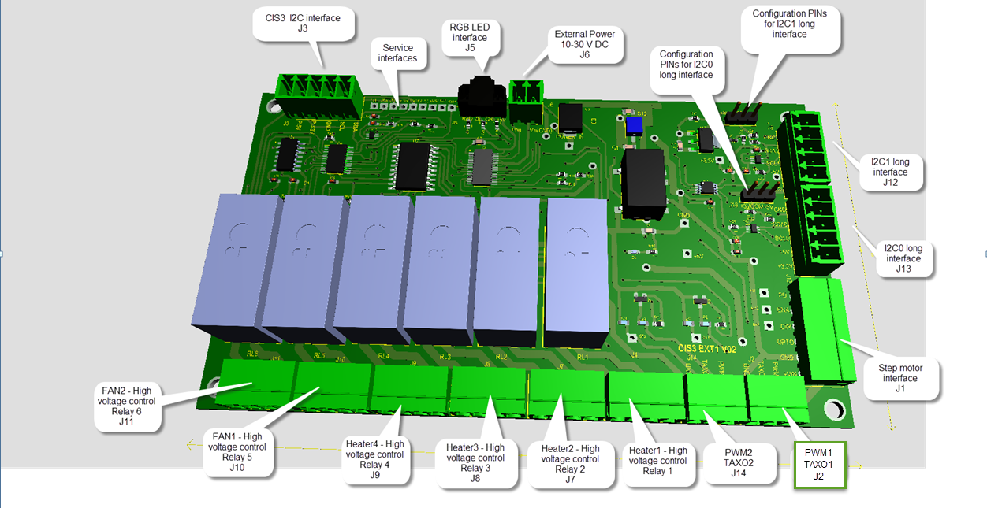

1.2. Included for connectors J4,J7,J8,J9,J10,J11 – High voltage loads
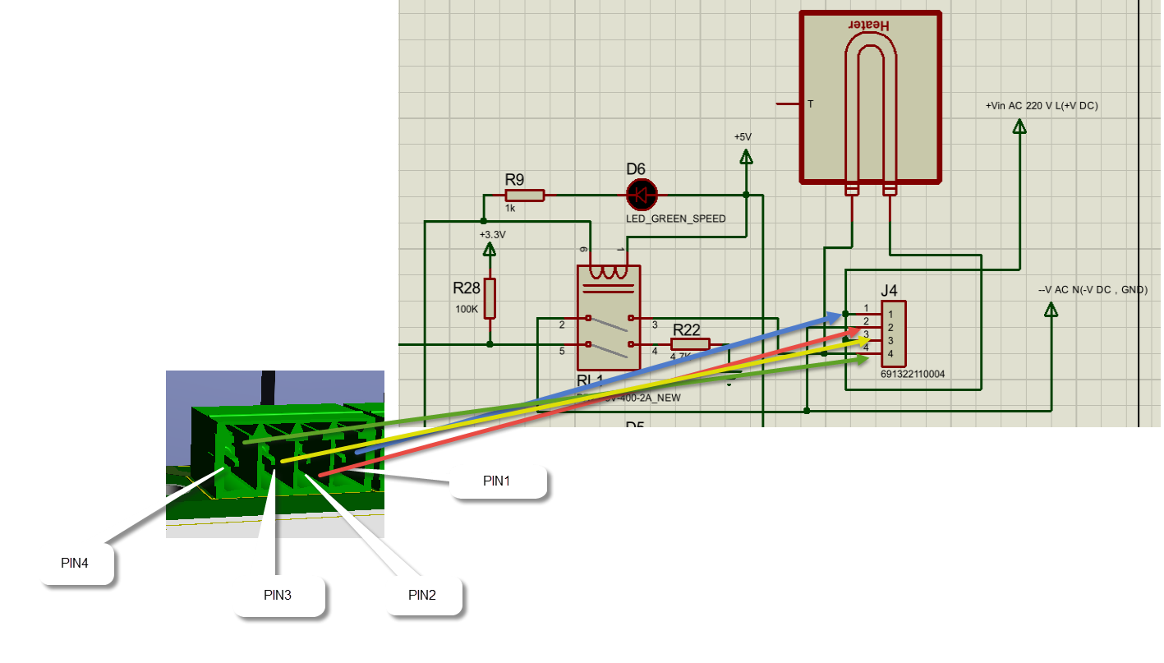
1.3. Included for connectors J14 and J2 - PWM1 and PWM2 channels.

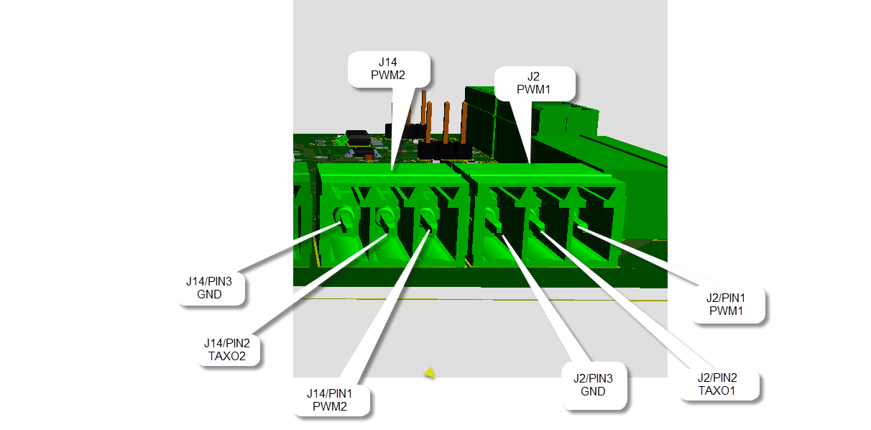

1.4. Included stepper motor interface

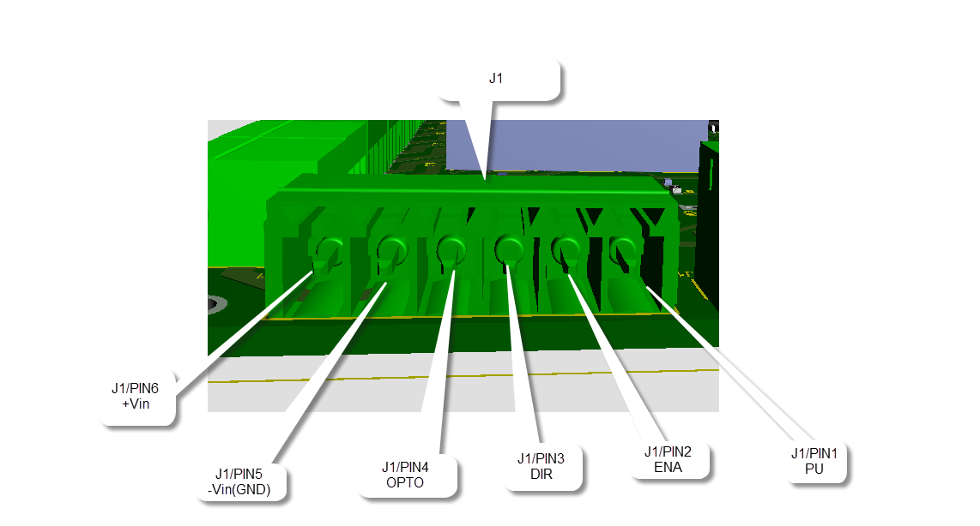

1.5. Included I2C external long interfaces – I2C0 and I2C1

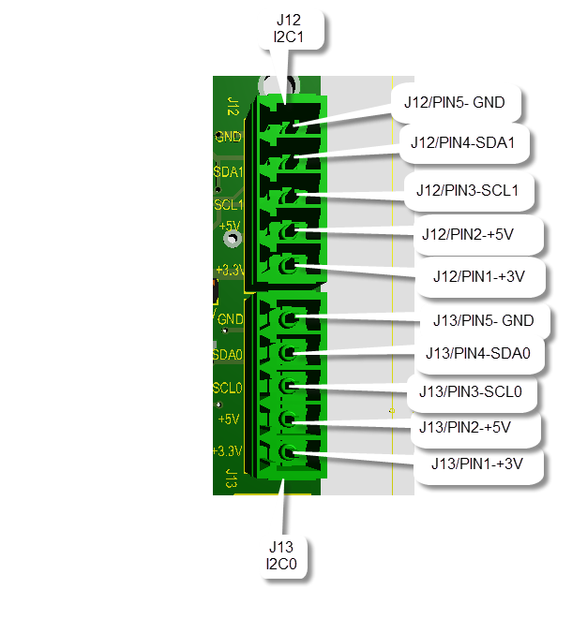

1.6. Included jumpers for choice Power for I2C external channels

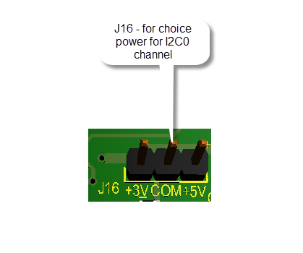

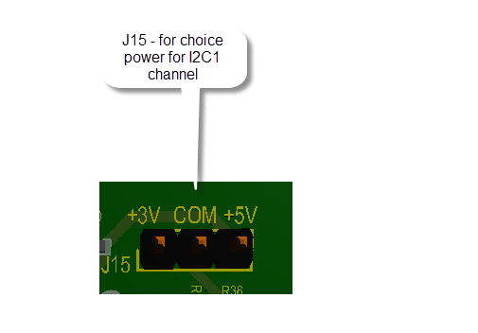

Note:
- COM – common
- +3V – power for channel and devices
- +5V – power for channel and devices

1.7. Included external Power 10-30 V DC

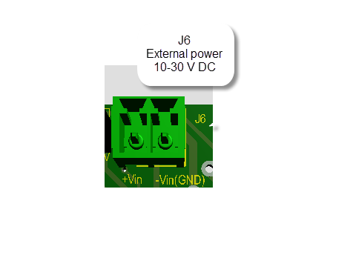

1.8.Included RGB LEDs – J5 connector

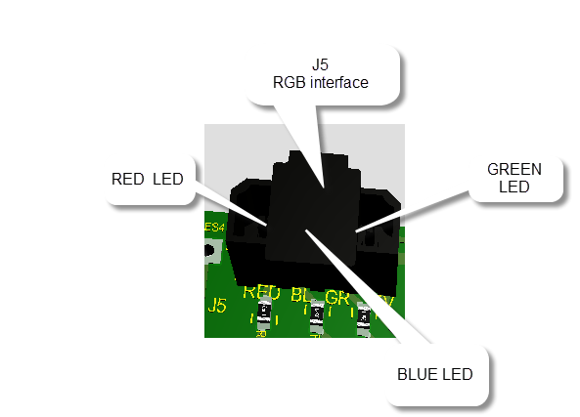

1.9. Included CIS3 I2C interface – J3 connector

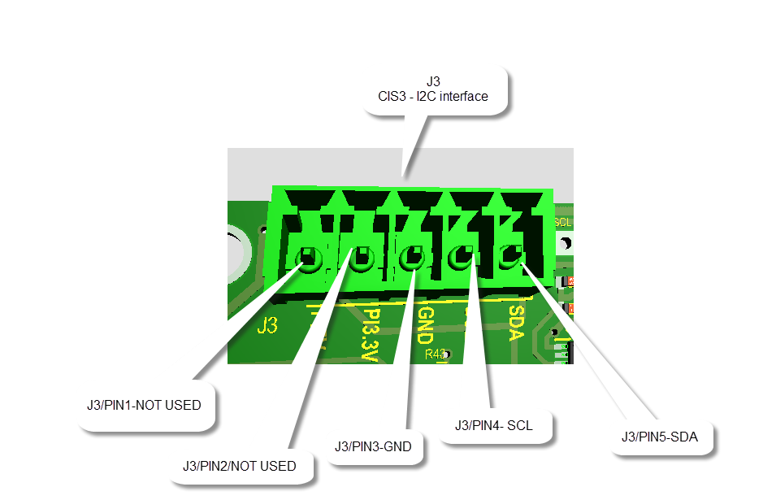

II . Descriptions modules in CIS3 EXTERN1 – PCB V02 . For the programmer.

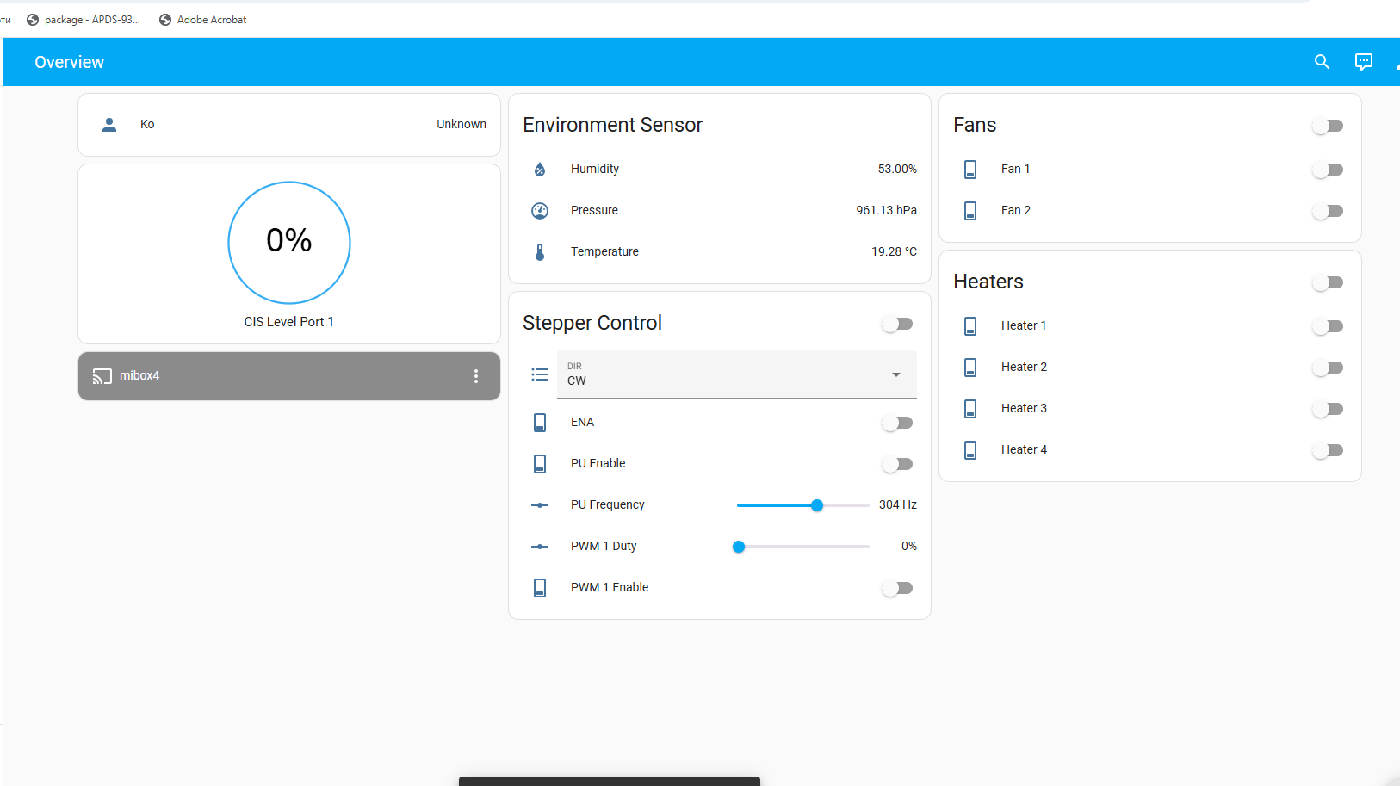

2.1. PCA 9685 controller

I2C Slave address -

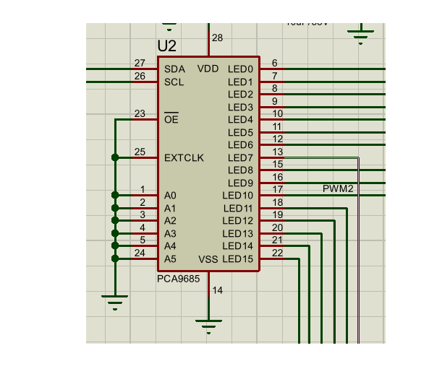

TABLE 2.1

No | PIN Name | Functions | Note
1 | LED 0 | PWM1 | Freq = Duty = 50 % , output
2 | LED 1 | CONTROL WIRE 1(relay 1) | Output . Status ON or OFF
3 | LED 2 | CONTROL WIRE 2(relay 2) | Output . Status ON or OFF
4 | LED 3 | CONTROL WIRE 3(relay 3) | Output . Status ON or OFF
5 | LED 4 | CONTROL WIRE 4(relay 4) | Output . Status ON or OFF
6 | LED 5 | CONTROL FAN1 (relay 5) | Output . Status ON or OFF
7 | LED 6 | CONTROL FAN1 (relay 6) | Output . Status ON or OFF
8 | LED 7 | DIR | Freq = Duty = 50 % , output
9 | LED 8 | ENA | Output . Status ON or OFF
10 | LED 9 | PU | Freq = Duty = 50 % , output
11 | LED 10 | PWM2 | Output . Status ON or OFF
12 | LED 11 | RESERVE1 | Output . Status ON or OFF()
13 | LED 12 | RED LED | Output . Status ON or OFF()
14 | LED 13 | BLUE LED | Output . Status ON or OFF()
15 | LED 14 | GREEN LED | Output . Status ON or OFF()
16 | LED 15 | SYS_LED | Output . Status ON or OFF(blinking mode)

2.2 PCA9540B – U3

The PCA9540B is a 1-of-2 bidirectional translating multiplexer, controlled via the I2C-bus. The SCL/SDA upstream pair fans out to two SCx/SDx downstream pairs, or channels. Only one SCx/SDx channel is selected at a time, determined by the contents of the programmable control register.
Slave address :
We will used for control communications about I2C0 and I2C1 external long bus. For now we will included to external busses BMP280 sensors about 10 m long bus

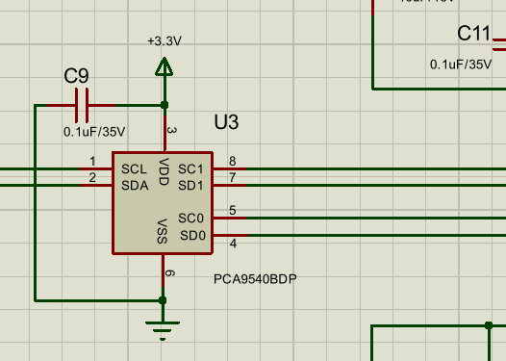

2.3. PCA9539 controller – U11
The PCA9539; PCA9539R is a 24-pin CMOS device that provides 16 bits of general-purpose parallel input/ output (GPIO) expansion with interrupt and reset for I2C-bus/SMBus applications. It was developed to enhance the NXP Semiconductors family of I2C-bus I/O expanders. I/O expanders provide a simple solution when additional I/O is needed for ACPI power switches, sensors, push buttons, LEDs, fans, and so on.
We will used for now about read status relays (for ON/OFF) , status TAX1 and TAXO2 signals from PWM interfaces for diagnostics procedures. These PINs are configured as inputs.
Slave address :

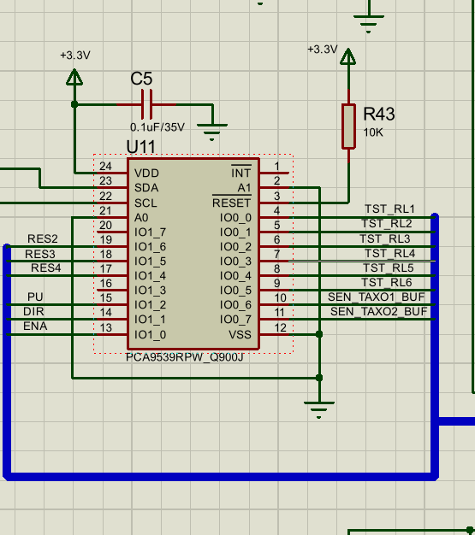
TABLE 2.3

No | PIN name | Function | Note
1 | IO0_0 | TST_RL1 | Input, read status relay 1 (High=OFF relay1,Low=ON relay1)
2 | IO0_1 | TST_RL2 | Input, read status relay 2 (High=OFF relay2,Low=ON relay2)
3 | IO0_2 | TST_RL3 | Input, read status relay 3 (High=OFF relay3,Low=ON relay3)
4 | IO0_3 | TST_RL4 | Input, read status relay 4 (High=OFF relay4,Low=ON relay4)
5 | IO0_4 | TST_RL5 | Input, read status relay 5 (High=OFF relay5,Low=ON relay5)
6 | IO0_5 | TST_RL6 | Input, read status relay 6 (High=OFF relay6,Low=ON relay6)
7 | IO0_6 | SEN_TAXO1_BUF | Input, read status TAXO1 (High Low pulse signal, freq= variable)  Pulse if PWM motor work
8 | IO0_7 | SEN_TAXO2_BUF | Input, read status TAXO2 (High Low pulse signal, freq= variable)  Pulse if PWM motor work
9 | IO1_0 | ENA | Input, read status ENA signal
10 | IO1_1 | DIR | Input, read status DIR signal
11 | IO1_2 | PU | Input, read status PU signal
12 | IO1_3 | Not used
13 | IO1_4 | RES4 | input, reserve
14 | IO1_5 | RES3 | input , reserve
15 | IO1_6 | RES2 | Output , reserve , Possible is and configured as input
16 | IO1_7 | Not used

