DOCUMENTATION

ASSIGNMENT 2

STUDENT NAME: CHAMPION
GROUP: 30424-1

CONTENTS

1. Assignment Objective 3
2. Problem Analysis, Modeling, Scenarios, Use Cases 3
3. Design 3
4. Implementation 3
5. Results 3
6. Conclusions 3
7. Bibliography 3

Assignment Objective

Design and implement a simulation application to analyze and optimize queuing systems, with the goal of reducing client waiting times. Queues are a prevalent feature in both real-world scenarios and models. The primary purpose of a queue is to provide a waiting area for clients before they receive a service. Efficient management of queuing systems aims to minimize the time clients spend waiting in line.
One strategy for reducing waiting times is to add more servers, which translates to additional queues in the system (with each queue having an associated processor). However, this method increases the provider's costs. When a new server is introduced, waiting clients are evenly distributed among the available queues.
The application should simulate a series of clients arriving for service, joining queues, waiting, receiving service, and finally leaving the queue. It should monitor the time clients spend waiting in queues and report the average waiting time.
To determine waiting times, we need to know the arrival time, service time, and finish time. Both the arrival and service times depend on individual clients – when they arrive and the extent of service they require. The finish time is influenced by the number of queues, the number of other clients in the queue, and their service requirements.
Input data:
- Minimum and maximum intervals between client arrivals;
- Minimum and maximum service times;
- Number of queues;
- Simulation interval;
- Any other necessary information;
Minimal output:
- Averages of waiting time, service time, and idle queue time for 1, 2, and 3 queues for both the simulation interval and a specified interval;
- Event log and main system data;
- Queue progression;
- Peak hour within the simulation interval.

Problem Analysis, Modeling, Scenarios, Use Cases
General Overview This application aims to simulate the experience of customers waiting for a service (e.g., supermarkets, banks, etc.) in a real-world setting, where they must wait in queues, with each queue processing clients concurrently. The goal is to analyze how many clients can be served within a specific simulation interval by inputting parameters through an intuitive, user-friendly graphical interface.
Input and Output Customers are generated randomly, each with their own service and arrival times, with the total number of clients determined by the input values. Users can set:
- The maximum number of queues available to process customers.
- Minimum and maximum arrival intervals: the time delay between customers arriving to receive a service (in seconds).
- Minimum and maximum service times: the number of seconds needed for a client to be processed, with a value selected at random.
- Simulation interval: the start and end times of the simulation.
Users can view:
- The total "dead time" for each queue (in seconds).
- The average waiting time for each queue (in seconds).
- The "peak hour," when the most clients were served.
- The total number of clients served during the simulation.
- The average service time duration (in seconds).
- The number of clients and the average waiting time for a user-defined interval.

Use case :
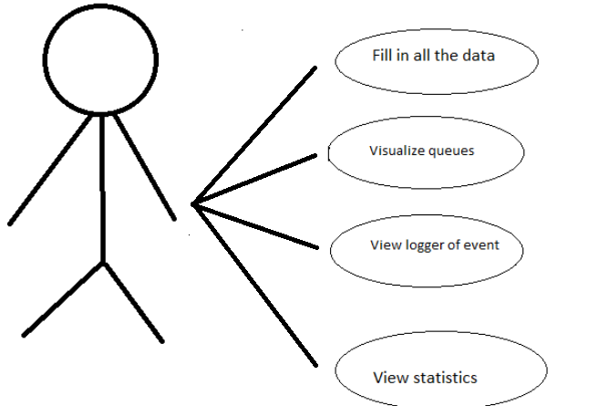
Title: Queue Simulation Setup
Summary: The user must first input the necessary parameters into the graphical user interface for the application to function properly, including minimum and maximum arrival times, service times, the simulation interval, and the number of queues.
Actors: The user
Scenarios:
Preconditions: The user must input all the required data. It is assumed that the entered data is correct and contains only digits. If the data is incorrect, the user will be notified with a pop-up message indicating that the values are invalid.
Normal Scenario: The user successfully inputs all required data and clicks the "Start Simulation" button. Subsequently, the application displays the log and real-time queue evolution. The user can then view the calculated data in the minimal output area generated during the service process.
Alternative Scenario: If the user fails to complete all input fields, an error message will be displayed to remind them to do so.

Implementation

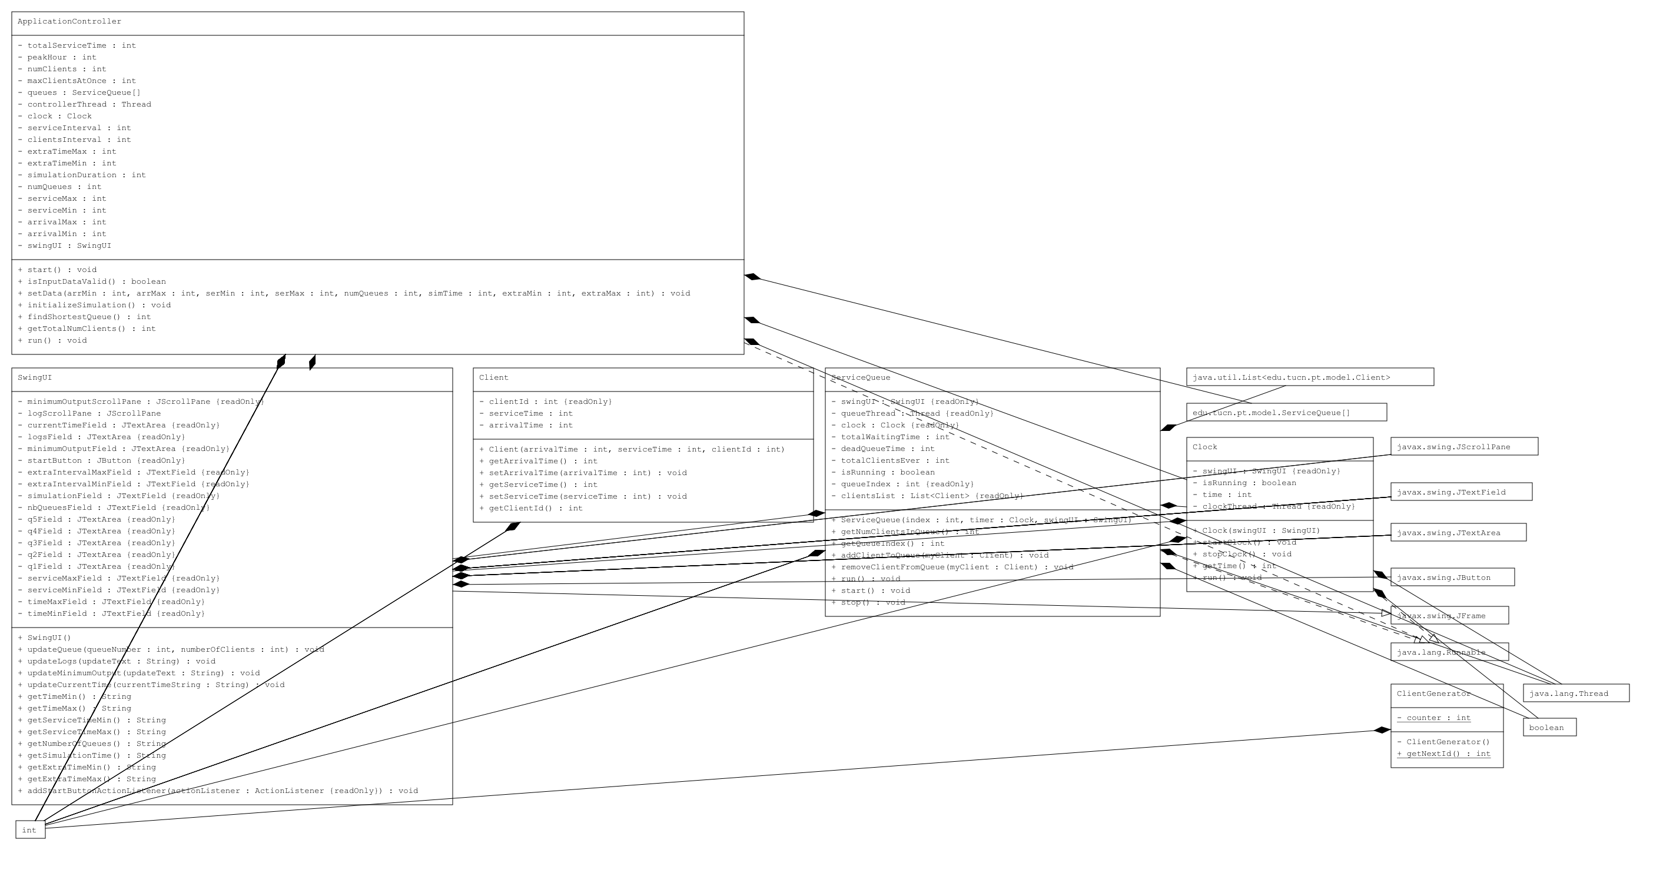

- Data Structures
ArrayList – I chose to use this structure to keep my queues and to temporary hold my clients, because this kind of lists is useful for storing and accessing data
ArrayList internally uses dynamic array to store the elements. Manipulation with ArrayList is slow because it internally uses array. If any element is removed from the array, all the bits are shifted in memory. This class can act as a list only because it implements List only.

Packages Java packages assist in organizing multiple modules by grouping related classes and interfaces together. In object-oriented programming development, the Model-View-Controller (MVC) pattern is a widely adopted methodology for effectively connecting the user interface with underlying data models. The MVC pattern is extensively used in software development with programming languages such as Java, Smalltalk, C, and C++.
Many developers regard the MVC pattern as a valuable approach for reusing object code and significantly reducing the time required to develop applications with user interfaces. The Model-View-Controller pattern suggests three primary components or objects for software development:
- Model, which symbolizes the core, logical structure of data within a software application and its associated high-level class. This object model does not contain any user interface information.
- View, which comprises a set of classes representing elements in the user interface, such as buttons, display boxes, and other visual components that users can interact with.
- Controller, which connects the model and view by representing the classes responsible for communication between the model and view classes.
Packages:
application - contains a single class that includes the main() method model - contains the core logic of the application, including classes that model the problem: Client ServiceQueue ClientGenerator view - contains a single class representing the graphical user interface (SwingUI) control - connects the model and the view
Class Design:
The divide and conquer principle is a general rule applied in various fields, including programming. By dividing a problem into smaller, simpler problems, you can tackle them more effectively. The practice of dividing programs into classes emerged in recent decades, with a focus on object-oriented programming. In this paradigm, objects model the problem, and messages are sent between these objects to solve the problem.
This project is designed using the MVC architecture, with three main components:
- The MODEL - contains the application's logic
  - Client: Stores customer data, such as clientID, arrivalTime, and serviceTime. It has a constructor with parameters, as well as getters and setters for arrivalTime and serviceTime. Only a getter is provided for ClientID.
  - ServiceQueue: Implements the Runnable interface and contains an ArrayList of clients that arrived at the queue. It includes methods for inserting and removing clients from the queue, updating the GUI queues and logs, and a run() method for threading. The constructor initializes all attributes to their default values.
  - ClientGenerator: Contains a static counter variable, incremented as clients are created, ensuring unique identifiers for each client. It has an empty constructor and a method to increment the counter.
- The VIEW - contains the graphical user interface code
  - SwingUI: Extends JFrame and constructs the GUI by initializing all labels, text fields, text areas, and buttons. It features a user-friendly design with five queues and a logging area displaying the simulation's evolution. It includes methods to update the queues, logs, and output statistics, as well as getters for the initial simulation parameters. A "Start Simulation" button activates the application. All actions occur on the "clock," with the simulation time displayed in a box.
- The CONTROLLER - connects the model and the view
  - ApplicationController: A crucial class that manages data flow between the model and view. It implements the Runnable interface and the run() method, creating clients, adding them to the emptiest queue, and calculating output statistics. Additional methods read the initial simulation parameters from the user interface and fetch them for the controller.
  - Clock: Represents the application's global timer, implementing the Runnable interface and the run() method, incrementing the time by one second per iteration. All other application components function according to this clock. The constructor includes parameters like the user interface, which begins the simulation and counter when the start button is pressed.
- The APPLICATION - used to start the application
  - App: Contains the main() method, which starts the controller and thus the application.

Results

The interface represents a simulation of a queue processing system, it contains a logger of events where the user can observe the changes in the queues and a logger with statistics, that appear at the end of the simulation time. Each client is positioned at an optimal queue and, after it gets served, it disappears, being followed by other clients.

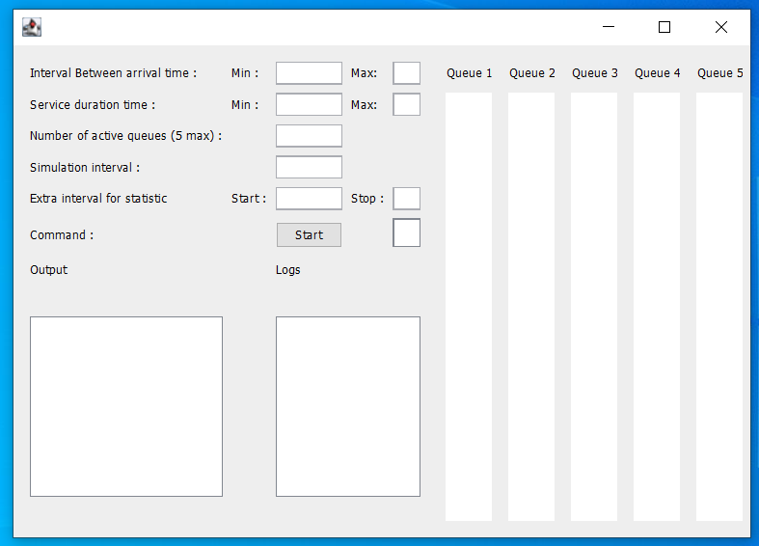

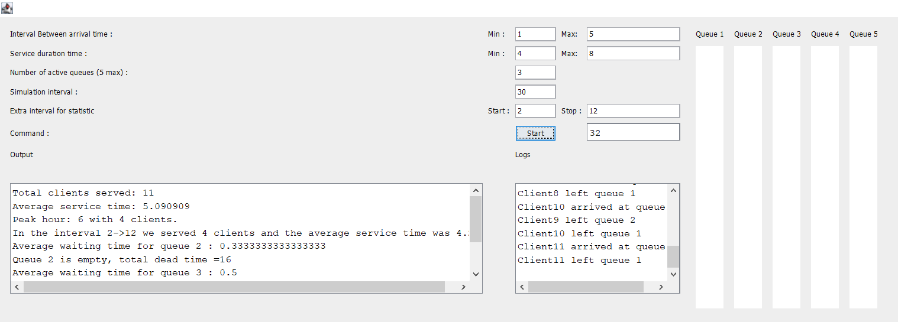

The results are found in the Minimal output area and in the Logs. The logs show the evolution of the queues and the output area show statistics such as the total number of clients served, the average service time, the dead time for each queue and so on.

Conclusions
This project served as a valuable exercise to reinforce OOP concepts learned during the first semester while also introducing new ones. It was both useful and challenging initially. I'd like to highlight a few key takeaways from this experience.
Firstly, time management is absolutely essential. Good organization skills enable you to approach tasks progressively, making the process more efficient.
Secondly, accurately modeling the problem from the start facilitates faster implementation.
Thirdly, encountering issues with your code and attempting to resolve them independently through research allows for learning new concepts and enhancing your understanding of existing ones. One significant lesson I learned was building interfaces from code, as opposed to using GuiGenie last semester. I realized that creating an interface isn't as straightforward as it seems with GuiGenie, but this project has brought my interface-building skills up to speed.
Through this project, I gained a better understanding of queue processing, system implementation, Threads, and synchronization.

Bibliography
- Object-Oriented Programming - Lecture Slides of prof. Marius JOLDOS
- Programming Techniques – Lectures of prof. Ioan SALOMIE
- www.stackoverflow.com
- www.wikipedia.org
- http://whatis.techtarget.com/definition/model-view-controller-MVC
- https://www.draw.io/ (for diagrams)

