2016.12.11笔记
基本的研究内容：
1、 尝试改进二维场景中的边缘检测方法，使得该方法可以直接在三维场景中检测边
2、先在二维贴图中将边缘检测出来，让后再将得到的信息附加到三维模型上

问题描述：在当前的研究进度中，我们尝试着的解决办法是先通过二维贴图的边缘检测的方法实现特征边缘的提取，然后将提取到的贴图还原到三维模型上去，再根据三维模型的集合信息的特征（包括每一条边缘线的走势、高程，空间变化率等）对所提取到的线进行筛选，从而得到我们所需要的三维场景中的便捷分割线。并基于此来对三维场景中的对象进行分离。具体流程图描述如下：

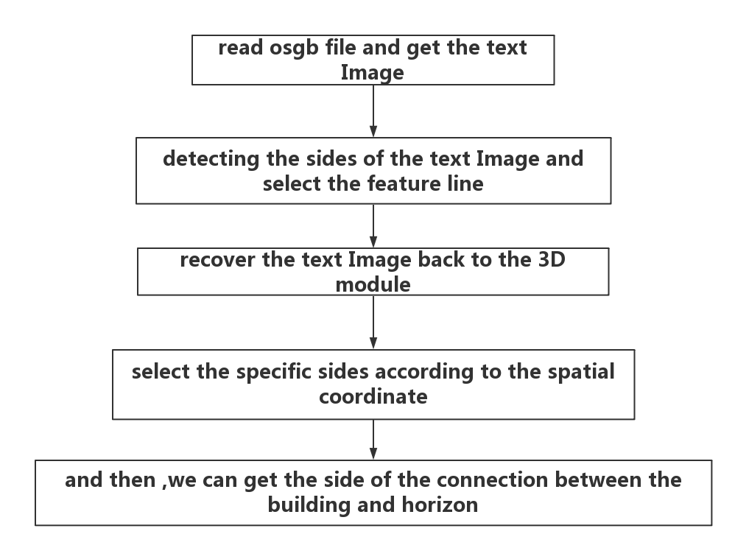
阶段进度与问题：
进度：尝试使用osgb模型的贴图数据重新构建open computer version中可以操作的图像数据
问题提出：在将模型的二维图像直接作为open computer version操作的对象是涉及到图像的格式不兼容的问题，下面有两种解决办法：
1. 将二维的贴图读取到本地，然后在用open computer version的方法将本地的文件在读取到工程中进行边缘检测，此方法的优点是可以节省很多复杂的图像格式转换（在osg模型文件中的图片类型对象是osg::Image ,而在open computer version中的对象是cv::Mat对象，是以矩阵的形式来存储的）；本方案的缺点也很明显，由于图片会预先保存到本地，这就也就造成了存储空间的浪费
2. 根据osg::Image对象的基本信息来重构open computer version中的Mat对象，从本质上来说，open computer version中的Mat对象对应于图片对象，其表现形式是一个类，其中包含很多成员函数和一些基本的成员变量，osg::Image 与Mat的基本结构描述如下：
osg::Image 结构：其中_s，_t，_r分别代表图像的宽度（width），高度（height），深度（depth），unsigned char* _data表示的是将图像数据按照char*对象来存储
对深度信息的理解：深度信息表示的是该像素点距离摄像机的距离，该信息用与贴图过程，其基本含义与深度图像中的深度相同（猜测的）
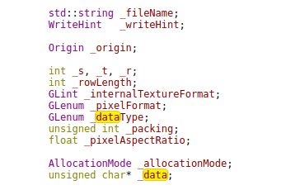
open computer version Mat结构：其中包括图像的行数 rows，列数cols，数据存储的对象 unsigned char* data ,数据存储字符串中的标记信息 data start，data end, data limit，flag，dim（维度）等;
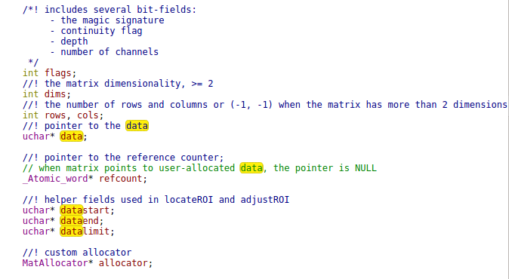

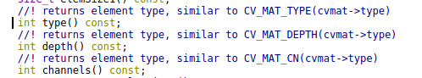
基于以上的基本信息，可以看出，在将open computer version中对贴图对象进行图像的构建的基本信息在osg::Image中都可以提供

由此，选择将第二种方法进行图像的边缘检测

2016.12.12（下阶段）
１、在三维矩阵的构建中出现问题，是的三维矩阵的构建无法完成，具体问题如下：
在三维矩阵的构建过程中，需要处置花矩阵的长宽高，也就是每个维度的大小，而对于倾斜摄影模型来说，将模型的长宽高进行量化是不可能的，我们不可能去统计某一个模型在高度上有多少个像元，而且由于在不同三角面片上的图像拉升层度是不同的，特导致无法统计在高程范围内有多少像元，在长度和宽度上的问题类似，由此，的采用如下的方法来实现：
具体思路表述如下：
（１）将原始的贴图信息转换为ｏｐｅｎｃｖ可以操作的矩阵。
（２）创建一张索引信息表，用于存放每个像素点对应的空间位置信息，此信息用于筛选检测到的边缘
（３）定义操作矩阵的通道数为３个通道，三个通道用于存放像元的ＲＧＢ值，第四通道存放对应像素点对应的高层信息
（４）对于贴图的边缘检测过程与一般的图像的卷积过程没有差别
（５）将检测到的边缘进行筛选，标记边界像元（具体方法为统计每条检测到的像元的高程与高程差的范围，在某一阈值内的而边缘被认为是有效边缘）
（６）利用空间信息，利用将筛选结果绘制到ｏｓｇ的三维场景中（结果受缩放的影响），实现边缘的提取

２、当前获取到的模型的贴图的分辨率很低，根本没法看，展示如下：
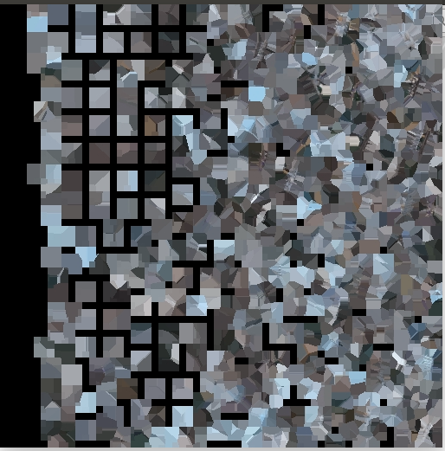
所以，现在的问题就变成了如何选择分辨率最高的贴图，用于边缘检测，此处的解决办法有两种思路： （１）在践行场景缩放的时候，捕捉当前级的贴图
缺点：实时监测到的模型的贴图不是最清晰的模型
（２）利用闲钱构建的树来寻找最底层的模型，并进行贴图的边缘检测
优点： 能够保证用于边缘检测的贴图的清晰度始终是最新的，检测到的边缘就是最准确的，再将边缘信息绘制在osg模型空间中

３、初步边缘检测结果
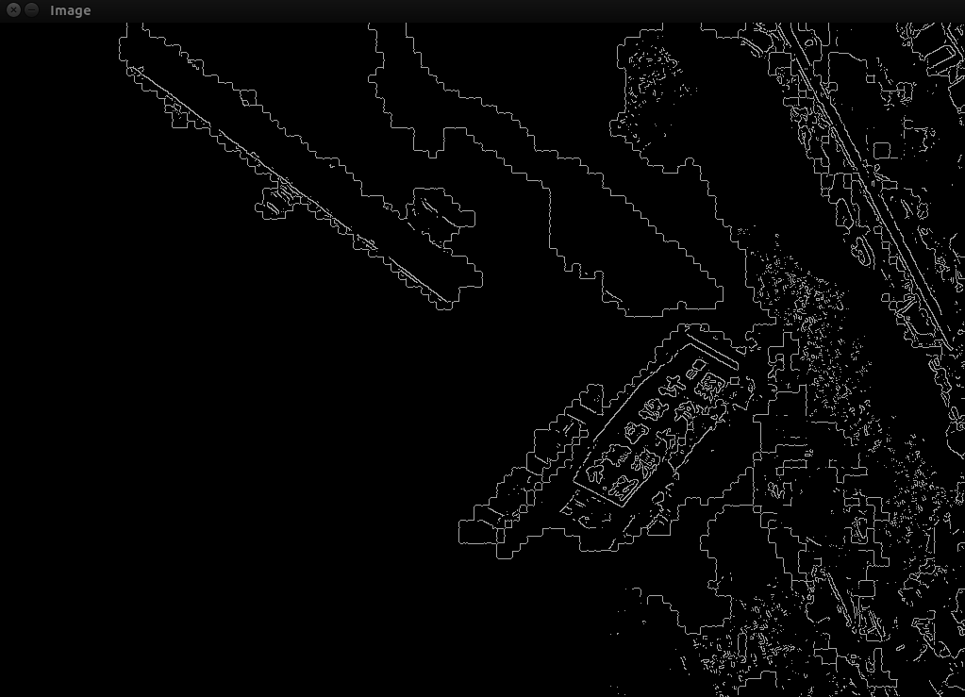
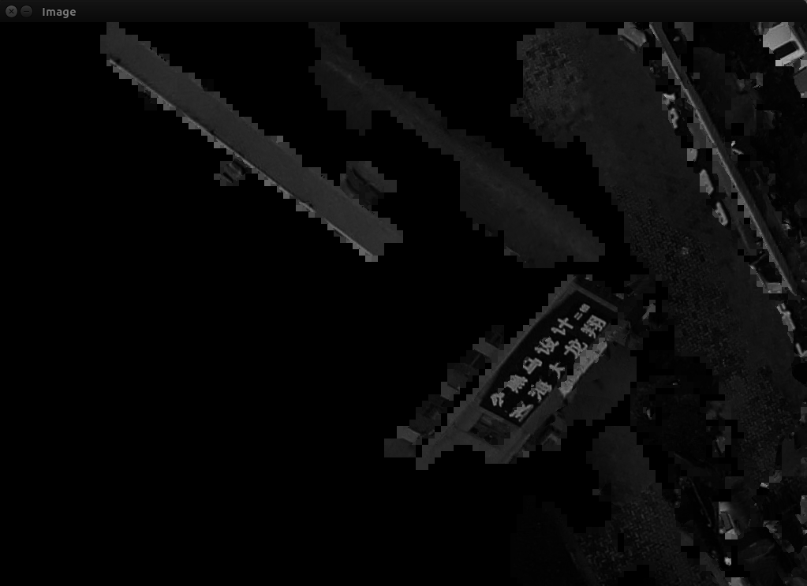
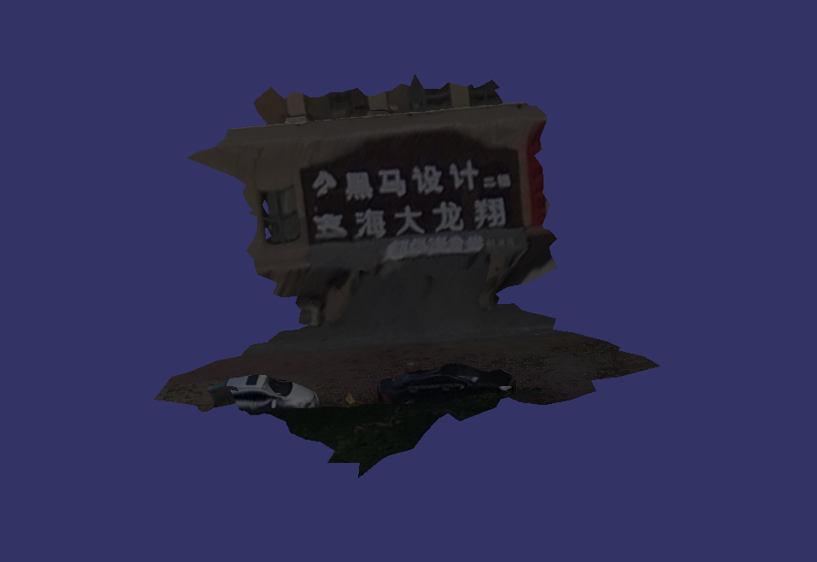
由图中可见的信息，大致能够检测到符合条件的边缘，但是锯齿状的边缘太过于明显，单只这并不影响，此处的锯齿状边缘并不等同于三维场景中的边界，此处是图像分辨率造成的，而在三维场景中是三角面片造成的。
现在的问题就变成了在贴图中不是一个对象，但是边缘检测到的对象那个边缘并不是一个对象，由此，根据边缘线的信息绘制三维场景中的曲线的工作有出现了新的问题，难度有所加深

2012.12.26 periodical tasks:
（１）located the spatial location by using texture image of the specific module
（２）get the row and column index of all the pixel that located in the side,we store the information by using a index table ,every piece of record is stored as follows:
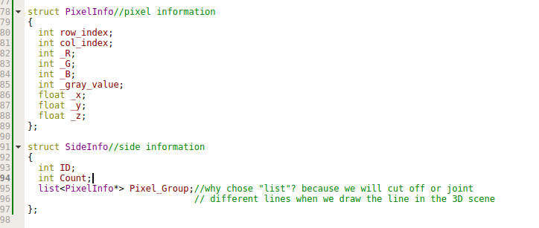
Find all the sides those detected by Canny in the raw Image:
(1)Find all the lines by using open computer version library;the flow chart is showed as follows:
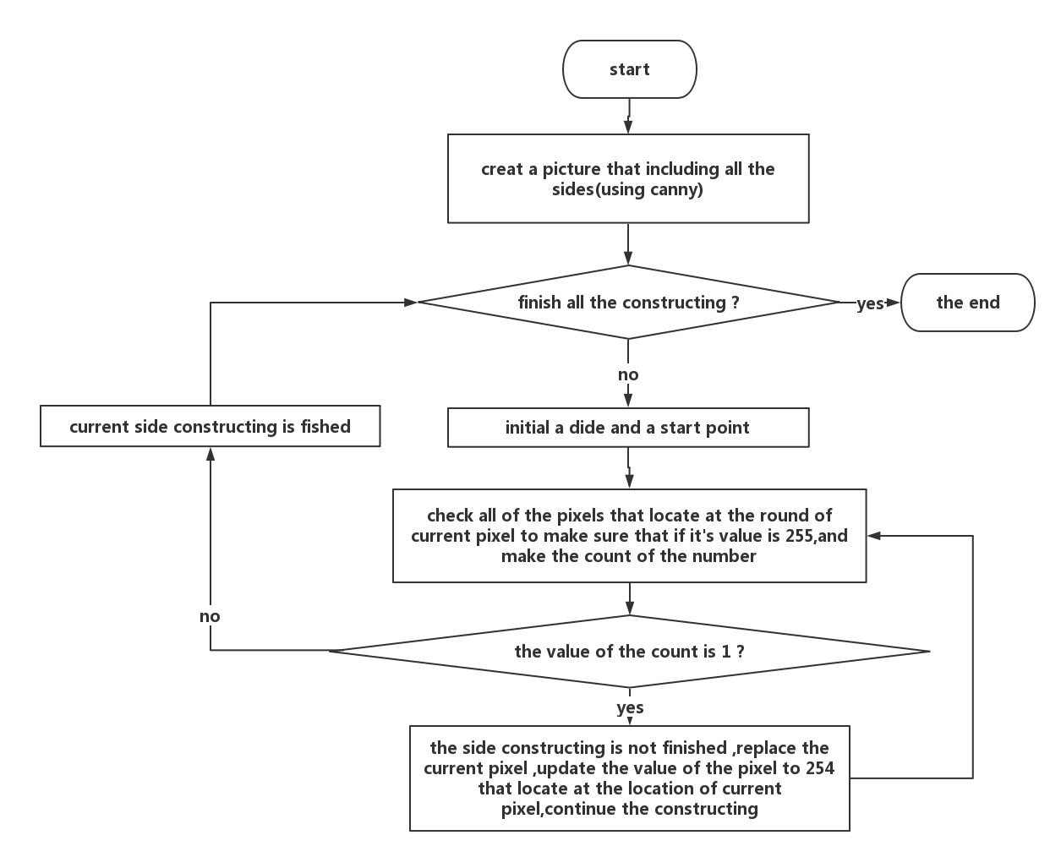

Problems:
(1) The raster matrix is constituted by the pixels ,and the order of the pixel arrange from left to right in the horizontal direction and top to the bottum in the vertical direction . And so ,we should be careful when we traversing the matrix.
(2) The pixel that it’s value is 0 makes no sense to our analysis ,because we never take it into account
(3) the pixels’ location is described as follows:
0 | 1 | 2
3 | pixel | 5
6 | 7 | 8
The question is that we always find the pixel whose value is 255 located in the seven box,and we are trying to fix it.
We type the information of the surrounding out to check the error,it showed as follows:
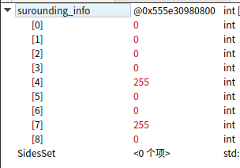
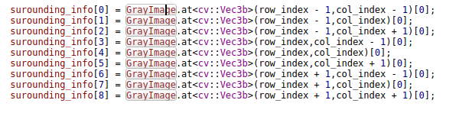

2017.1.3 periodical tasks:
(1)try to construct the side;
(2)find the 3 dimensions information,and draw sides back to 3 dimensions model;

Analyze(shows as structure chart) :
(1) if a point is storage three times ,it must belongs to tree different triangles ,and we can find all triangles out.
(2) apply it to all of the points.
(3) this question is just a case about permutation and combination ,we located the index of every point.

Crash occurred :
(1)The method we update the value of those pixels who located in the side that the pixels’ group count is lease than fifteen is wrong. We got fix it.
Analyze : as it showed in the result that the update occurred every twice a pixel,we find that
(1) The unwise update method cause this problem.
(2) Or it also can be the neighbors’ information get wrong.
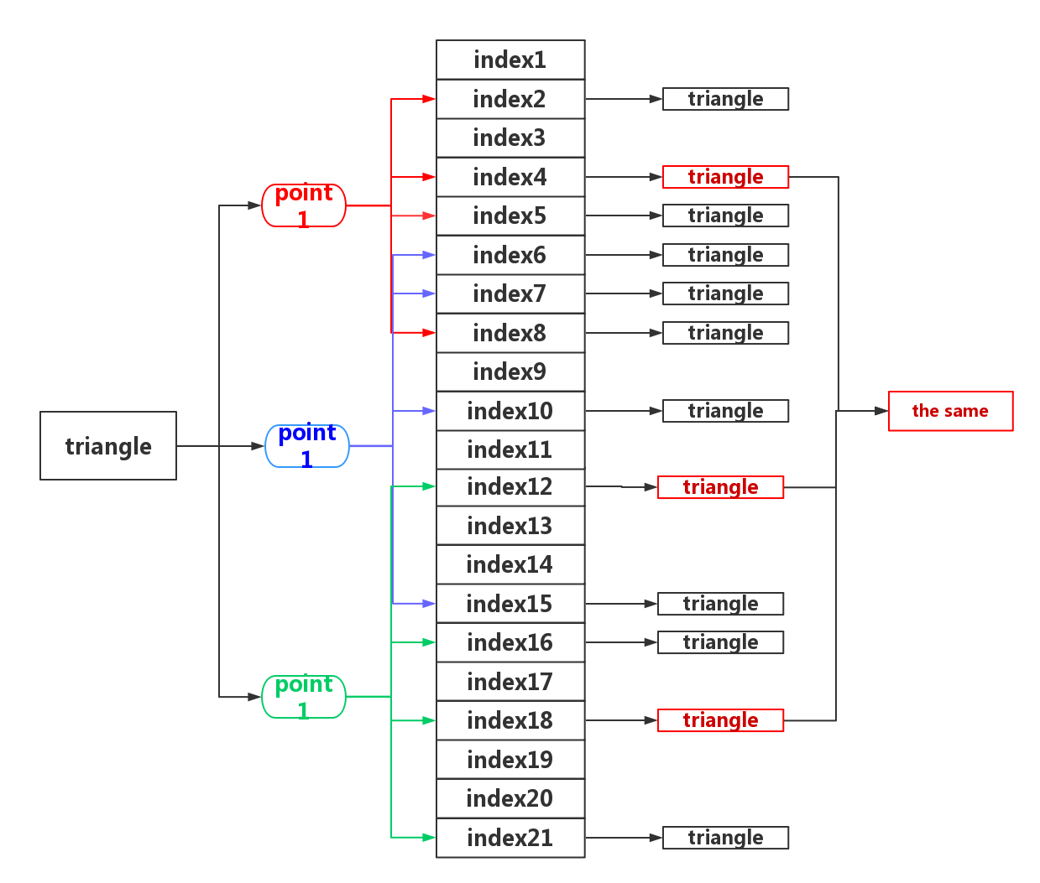
We describe it as followed:
Then, we convert our attention to that how can we find a triangle by using one of index about point?

Some tips:
(1) we change our attitude towards realizing the function of objects detecting.
1. Firstly ,we want to detect all the sides in the texture image by using open computer version library, but the ready-made methods can not be applied to our problems, for there are so many different between side and object
2. Secondly,we find that the algorithm we designed for side constructing is exactly a time killer when we constructing the side set. We always traversing the image matrix and there are so many pixels in only one piece of texture image, and there are so many texture images in our module.
3. Just as described above, we proposed another way to fix it, it’s showed as follows (thanks to my senior fellow apprentice Zeng Ning):
1) find all the sides out, and get their spatial coordinates, we can’t get the side object yet, we only get a lot of pixels and their coordinates.
2) We show all of the points in the 3 dimensions module
3) filter the points those height is out of the rang which we set
4) draw all the left lines in th 3 dimensions module
And in this case, we can save time and useless side detection, we only left those we need.

(2) conclusions:
1) we spent so much time for side constructing, and we still want to work it out.
2) Ma had find a function to get the index of any point that belongs to a specific triangle, we believe that we can show all the points next week.
3) what we should do currently is recovering the points those located in the side back to the 3 dimensions module.
4) propose a method to draw lines in the 3 dimensions by using the left points set.

2017.1.10 periodical tasks:
(1) Get the map relationship between spatial coordinate and texture coordinate.
(2) Draw all the points back to 3 dimensions model .

Problems:
(1) The map relationship between spatial coordinate and texture coordinate is sophisticated. When we apply the method that map the spatial coordinate to texture coordinate to the contrary direction, some error occurred. It is described as follows:

V = A * T (V:spatial coordinate T:texture coordinate A:The parameter matrix)

there is no problem when we map spatial coordinate to texture coordinate, but if we calculate the parameter matrix,there always losing some parameter ,because there lack value “z” in texture coordinate. The elevation value is crucial when we draw all the points back to 3 dimensions model and select the target points. We come up with a method to get value of the elevation.

1) Constructing a plane by using three vertexes of a triangle and get the function of this plane.
2) Compute elevate value by using the value of “x” and “y”

2017.1.17 periodical tasks:
(1) The transfer matrix
(2) Draw all the points back to 3 dimensions model

questions:
(1) A geometry Node have multiple drawable objects, and different drawable object has different texture Image and spatial model, we regard a drawable object as element object when we analysis the map relationship between texture image and spatial 3 dimension model. There are some proves to support my suppose.
1) some suspects: a geometry node has a piece of texture image and different texcoordinateArray,it is impossible ,for there one reason that can explain this phenomena: a geometry node just has only one texture image and spatial 3 dimensions coordinate ,so ,we can just handle it just one time .
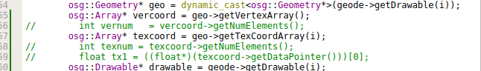
(2) Describe: we are constructing our point set when we calculate the map relationship, we should traverse the pixels by using different triangles rather than pixels to triangles. Using the region of the triangle to traverse the pixels. It is confused when located the spatial coordinate, we got promote a new algorithm to fix it up. The flow chart is showed as follows:
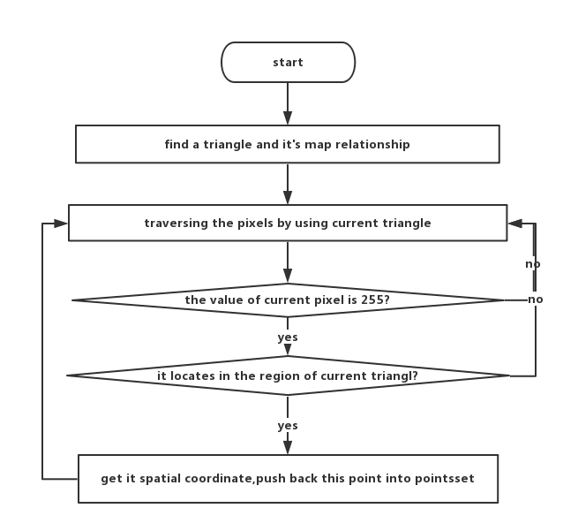
2017.2.20 task describe:
(1) Installing mysql .
(2) Connect mysql and write all the matrix information into table matrix.
(3) Traversing all the matrix and map current pixel to spatial scene.

(1) Installing mysql and check it .
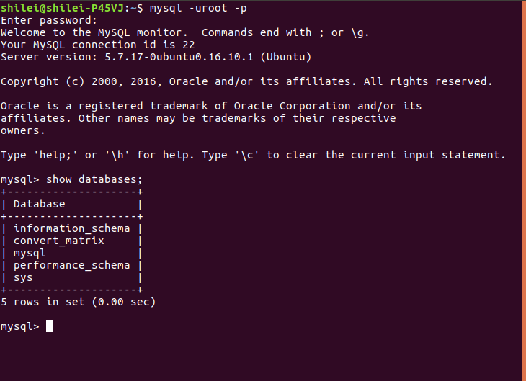
The name of our database is “convert_matrix”,as showed above .
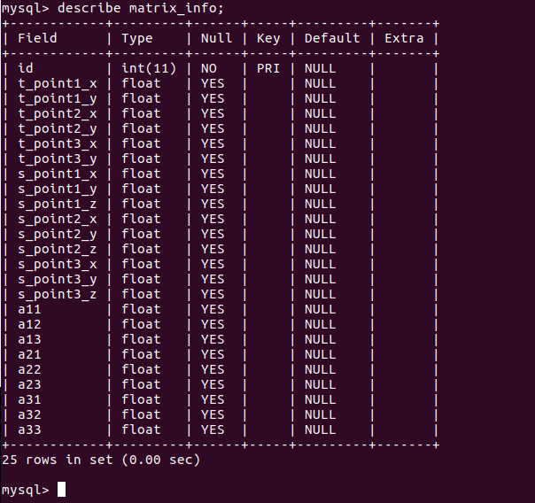
The attributes table matrix_info is showed above,we can find that there are twenty five attributes in table matrix_info .

(2) Connect mysql .
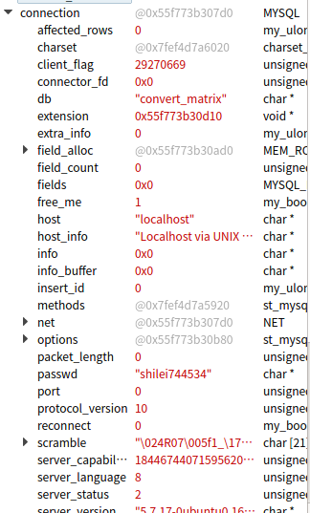
The grammar of inserting a piece of record is as follows:
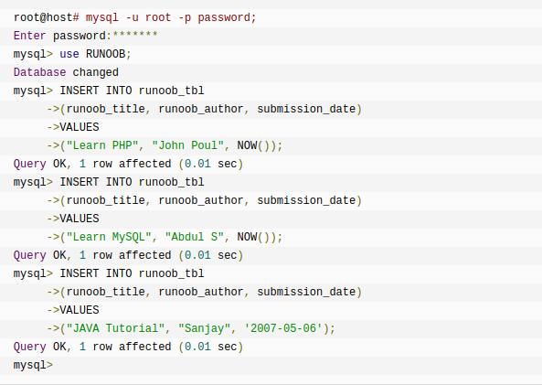
Write all the matrix information into table matrix_info.
The record which id = 1 is showed as follows:
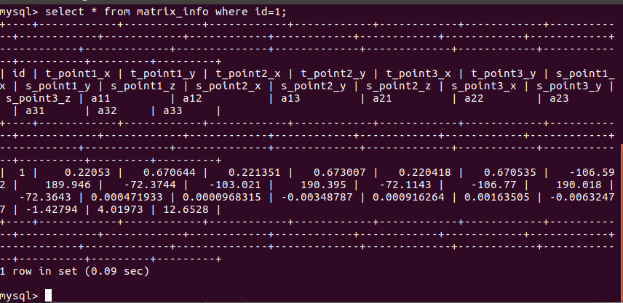
conclusions:
it is so fast when we calculate one piece of data, it just costs one second .
(1) We can apply a variable string to store sql ,and then, we can use specific function like “mysql_query(sql)” to manipulate our database .

How to manipulate mysql by using programing language ?
(1) connect mysql database ;
(2) build a database ;
(3) build a table (attributes);
(4) insert records;

2017.3.7
problems characterizations:
(1) When we try to manipulate the bottom piece of data, we find that it not runs well ,for it not include more drawables, and because of this ,we can not convert it into geonode.

Conclusions:
(1) Different geonode include some drawables, and different drawables belong to the same geonode share the same texture. We find that when we manipulate a piece of medium node, there are a variety of drawables, but it didn’t work when it applied to a bottom one.

Problems:
(1) All the node share the same piece of texture?

2017.3.8
Task: (1) Read all the leaves model and shoe it out.
(2) Map all the white pixels to the spatial coordinate.

(1) read all the leaves:
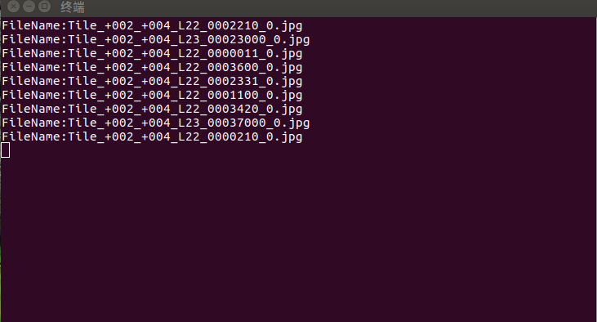
(2) Map all the white pixels back to spatial coordinate:
(1) Create table “pixels_map_table” to store map information:
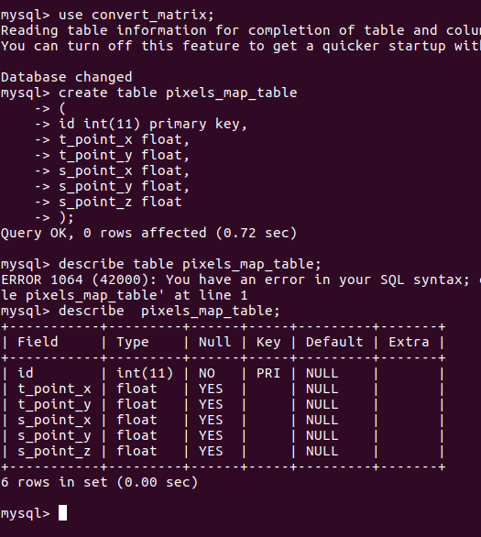
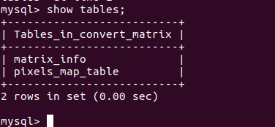
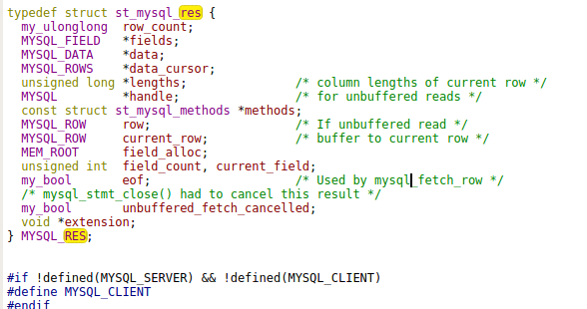
And then, we traversing the matrix_info.Problems describe :
(1) We can get all the white pixels’ spatial coordinates ,but we are not sure if it is right ,and so ,we should show it out in spatial model.
(2) The accuracy of the map method should be discussed carefully
(3) We may try to store the raw information(the column and row information) rather than texture coordinate in database,because we will judge if a specific pixel is located in a specific triangle when we map it to a spatial model,and because of this ,we may change structure of “matrix_info” by adding some attributes.(4) The experiment shows that if we fill the table in advance ,it is faster when we write some record into it .

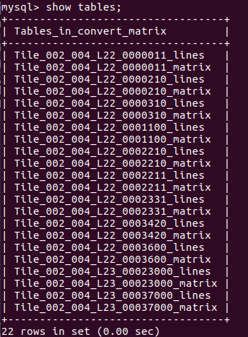
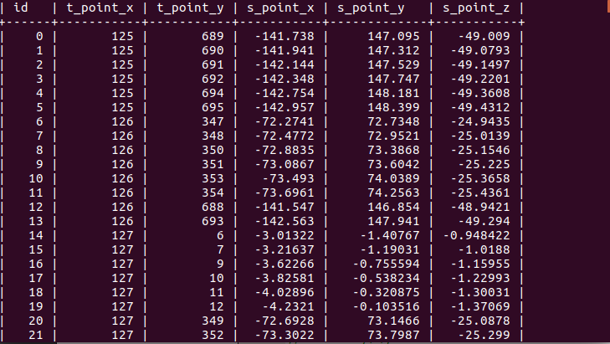

(1) test result
In order to test that whether our map_matrix is correct,we test by using one pixel to test is ,we get a perfect result,it shows below:
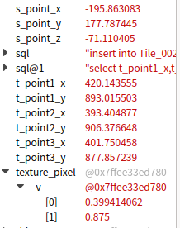
2017.3.28
(1) The contrast:
raw image:
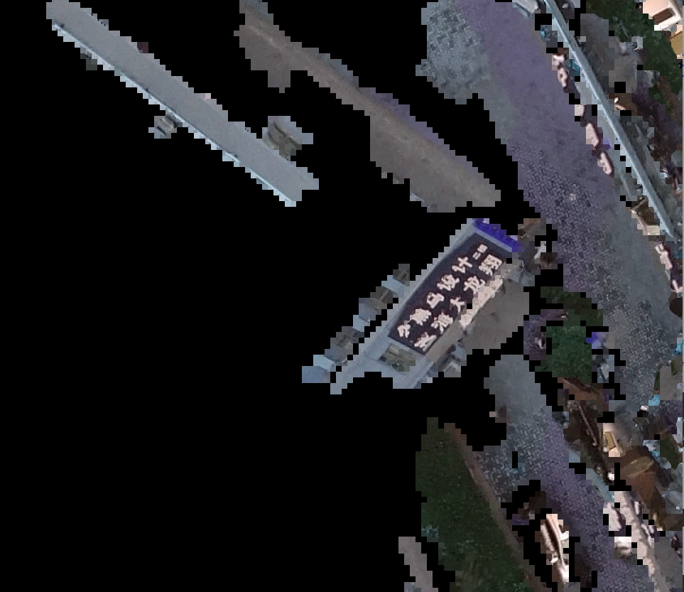
before filter:

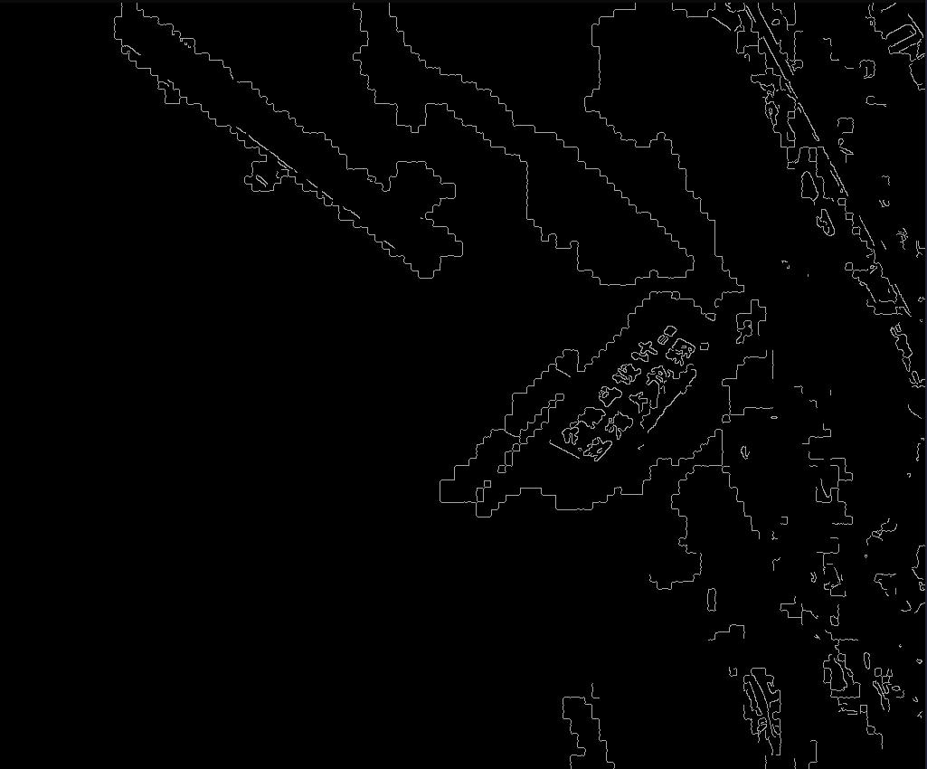

after filter:

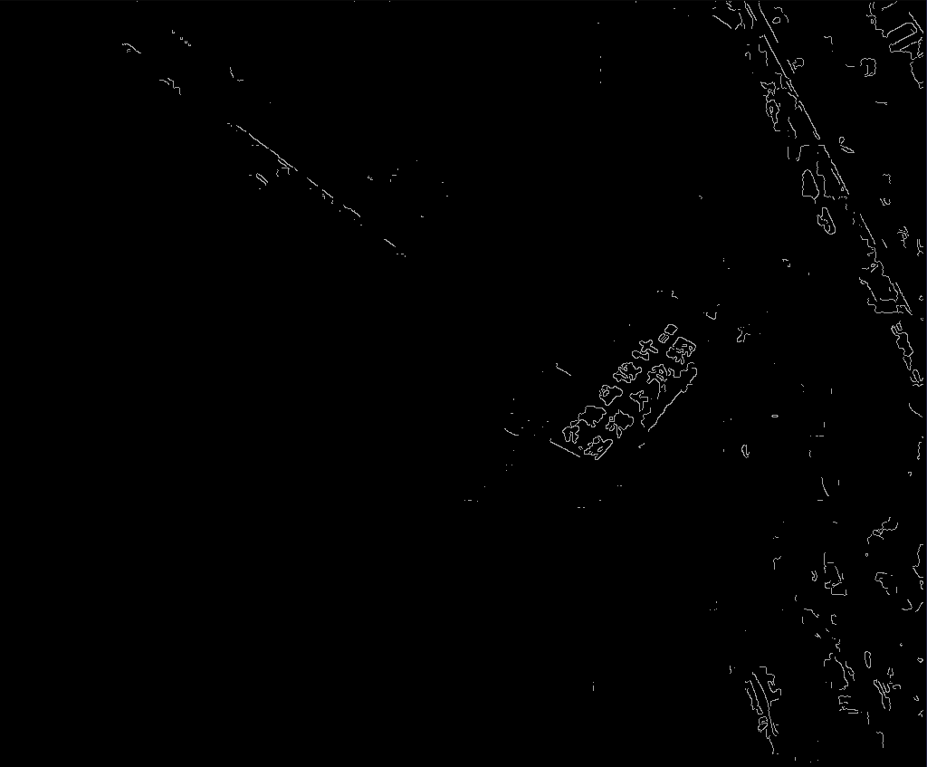
some tips:
we can now filter the pixels those located at the side of the picture patch, and the result is showed.
Further more ,we believe that ,the lines we detect id included in the binary picture, and thus, we can us hough line to filter the lixels.
The experiment:

