Effect of the Increase of the Minimum Wage on the Food Services and Drinking Places Industry in Pennsylvania

By Koba Khitalishvili

**Introduction**

In 1994 Card and Krueger published a study in which they analyzed the effect of the increase of minimum wage in New Jersey on employment in the fast food industry. They found that the minimum wage increase from $4.25 to $5.05 per hour that occurred on April 1st 1992 had insignificant impact on employment in the fast food industry. The state of Pennsylvania where the minimum wage remained constant was used as a control group. In this paper, I intend to study the effect of the increase in the Pennsylvania’s state minimum wage on the employment in the food services and drinking places industry that occurred during the period from 2007 to 2010 during which the state minimum wage increased from $5.15 to $6.15 in January 2007, then to $7.15 in April 2007, and finally to $7.25 in July 2009 (United States Department of Labor). Like Card and Krueger I expect the effect on employment or conversely unemployment to be insignificant. I start with the hypothesis that the increase in minimum wage had significant impact on employment or unemployment in the food services and drinking places industry in Pennsylvania. By measuring the impact of the increase in the minimum wage in PA on the unemployment rate in the food and drinking places industry in PA using an Ordinary Least Squares VAR model I will try to show that the increase in minimum wage did not have a significant impact on the unemployment rate in the said industry.

Carl and Krueger used the restaurant survey data that they gathered themselves to conduct a cross sectional analysis at two points in time, before and after the minimum wage increase. Unlike them, I am using the time series approach and an Ordinary Least Squares model. Also, Card and Krueger surveyed fast food businesses directly to measure the impact on employment whereas I am using the monthly Current Population Survey data gathered by the US Bureau of Labor Statistics where individuals, not businesses are surveyed.

**Minimum Wages Argument**

The impact of the increase in minimum wage on employment has been a highly debatable topic. According to West and McKee, in the framework of the neo classical economics increase in minimum wage will result in “disemployment” (1980). However, labor economists present two opposing arguments using the monopsony and shock models.

The monopsony argument utilizes the idea that labor markets that are unaffected by the increase in minimum wage are monopsonistic and not perfectly competitive. That is one buyer has power over many suppliers. For clarity we can draw a comparison to a monopoly where one supplier has power over many buyers. An example of a monopsony would be a mining firm in a small town, hence, the only employer with the market power. According to West and McKee, in the market where the minimum wage law is absent a monopsonistic employer would employ fewer workers compared to a market where the minimum wage law is present (1980). Nine out of thirteen studies conducted before 1980 find little to no empirical evidence that backs up the monopsony model, hence, the monopsony argument is inconclusive (West and McKee, 1980).

An alternative argument against disemployment as a result of minimum wage increase is the shock model. The shock model utilizes the idea that the productivity of workers increases in response to the increase in minimum wage. The increase in productivity after the increase in minimum wage may happen due to several factors such as (West and McKee, 1980):

* A company increases its capital as a result of the increase in the price of labor.
* Managers reevaluate the production process, optimize it and innovate.
* A firm seeks ways to decrease its production costs.

All above scenarios result in the increase of the output of a company. Unfortunately, the shock theory has not been empirically proven either. As a result, the hypothesis that the increase in minimum wage does not decrease employment has to be studied on a case-by-case basis. It is good know that there is at least a theoretical foundation in favor of the hypothesis.

**Data**

I use the data from the Current Population Survey (CPS) offered by the US Bureau of Labor Statistics (BLS) and the Monthly Retail and Trade Survey (MRTS) offered by the United State Census Bureau (USCB). Also, I utilize the data offered by the US Bureau of Economic Analysis (BEA). Using the CPS data I calculate the employment and unemployment rates for the food services and drinking places industry as well as the proportions of employed that work above and below the new minimum wage in Pennsylvania. From the MRTS I use already calculated monthly food services and drinking places industry output for the US to include it as an explanatory variable in my OLS model.

Monthly food services and drinking places industry output data for Pennsylvania is not available. As a result, to justify the use of the US output data in a study that focuses on the State of Pennsylvania I show, later in the paper, that there is a high correlation between the annual food services and drinking places industry output in PA and in the US.

It is worth noting that the Survey of Business Owners (SBO) offered by USCB would be a better choice of data for the purpose of this paper. Unfortunately, SBO is conducted every five years. The latest two available years are 2002 and 2007 as of writing this paper. Sadly, SBO data for the year 2013, which is necessary for this paper’s analysis, is scheduled to be released in 2015, a year from the moment this paper was finished.

**Overview of the Food Services and Drinking Places Industry in PA**

Before running the regression I evaluate the effect of the increase in minimum wage on employment in the food services and drinking places in PA. I visualize the distribution of workers by hourly wage before and after the minimum wage increase, the proportion of workers that work at or above $7.25 per hour and below $7.25 per hour, and the employment and unemployment rates over the period January 2005 to December 2012.

Figure 1. Distribution of workers by hourly wage in PA in Food services and Drinking Places industry in 2007,2008,2010, and 2011

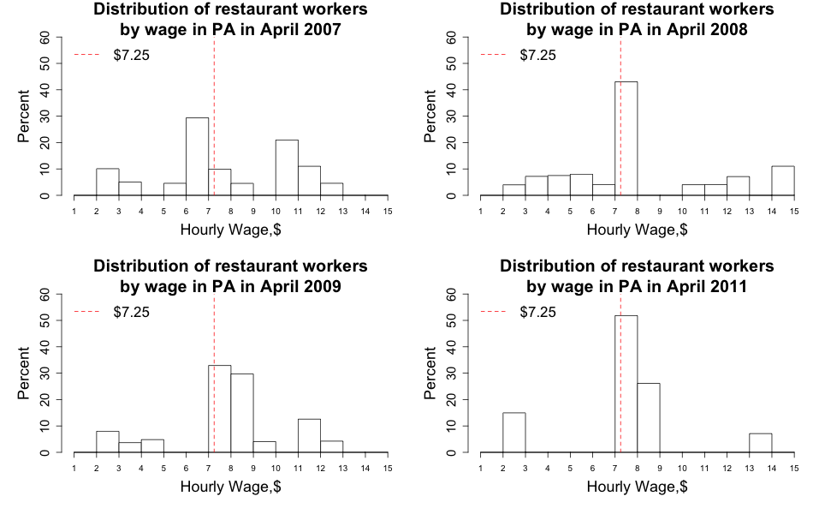

*Source: Author’s calculations using CPS data*

First, I compare the relative distributions of workers by hourly wage for years 2007, 2008, 2010, and 2011 in Figure 1. We can see that after 2007 the proportion of workers in the $7-$8 hourly wage range in the food services and drinking places industry in PA is consistently higher than the proportion of workers in the $6-$7 range. This indicates that employers comply with the increase in the minimum wage from $5.15 to $7.25. There is a small proportion of workers that earns more than 14$ per hour, but they are not of interest because fluctuations in minimum wage affect mostly the low wage workers (Card and Krueger, 1994).

In Figure 2, I look at the proportion of workers that worked at or above $7.25 per hour, the new state minimum wage in PA, and below $7.25 per hour over the period from January 2005 to December 2012. Because of the high volatility of the employment rate I include the trend line. The proportion of workers that work

Figure 2. Proportions of workers working at or above $7.25 and below $7.25 in Food services and Drinking Places industry in PA during period January 2005 to December 2012; blue line is trend

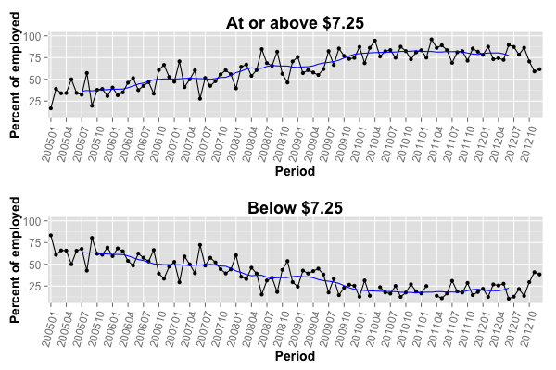

*Source: Author's calculations using CPS data*

at or above the new minimum wage has been consistently increasing and reached a point that is close to around 80% in 2012. The opposite is happening for the proportion of workers working below the minimum wage, which ended up at around 20%. In fact, the two curves are mirror reflections of each other.

Finally, I look at the employment and unemployment rates in the food and drinking places industry in PA. In Figure 3, we can see that the unemployment rate started to increase in April 2007 and peaked in October 2009 at 18%. According to the trend, after January 2010 the unemployment rate has been declining up until July 2012. At this point it is unclear what contributed to the temporary increase in the unemployment rate in the food services and drinking places industry in PA. According to the National Bureau of Economic Research, the period from December 2007 to June 2009 is officially considered to be the recession after the 2007 US financial crisis.

Figure 3. Employment and Unemployment rates in the Food Services and Drinking Places industry in PA over the period from January 2005 to December 2012, blue line is trend

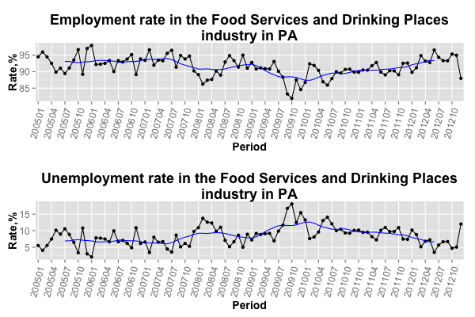

*Source: Author’s calculations using CPS data*

Surely, the recession had its impact on unemployment. In the next section, I run a regression to assess the contribution of the minimum wage increase to the unemployment rate in the food and drinking places industry in Pennsylvania.

**Ordinary Least Squares regression**

To assess the contribution of the minimum wage increase to the change in the unemployment rate in the food and drinking places industry in PA I use the Ordinary Least Squares VAR model. I regress the monthly unemployment rate on the monthly percent growth of the total output of the food and drinking places industry in the US. The start date is January 2005 and the end date is December 2012, hence, I have 96 observations. Since I use lagged variables in my final model I only use 94 observations.

To justify using the monthly US food and drinking places industry output in the study that focuses on the State of Pennsylvania I include the graphs of the **annual** food and drinking places industry output in the US and in PA as well as correlation between them in Appendix A Figure A-5. It is clear that both are highly correlated with the correlation coefficient of 0.94. Therefore, they can be substitutes

Figure

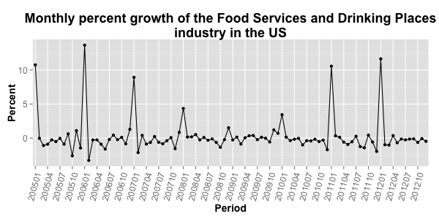

for each other, especially, since I am using relative changes, i.e. percent growth of the industry in question. The graph of the monthly percent growth of the industry in question is in Figure 4.

The model looks like the following:

$$Unemployment rate==β_{0}+ β_{1}Unemployment rate\left(1\right)+β_{2}FoodIndGrowth(2)+β_{3}CrisisMonth+β_{4}MinimumWage(1)$$

The number in parenthesis indicates that the explanatory variable is lagged. For example, the food industry growth variable is lagged by two months.

To account for the impact of the recession I use the crisis month dummy, i.e. months during the crisis and recession years are equal to one. The official recession period was mentioned in the previous section and is the period from December 2007 to July 2009. The explanatory variable of interest is the minimum wage dummy, which is zero for months before July 2007, and one for months after July 2007.

In Appendix A Table A-1 you can see the descriptive statistics of the continuous variables in the model, namely, the food services and drinking places industry output percent growth and the unemployment rate. In Appendix A Figure A-1 I check for normality of the dependent variable, unemployment rate, using a histogram and a normal QQ plot. We see that the unemployment rate in the food services and drinking places industry in PA is very close to a normal distribution. To show that the coefficients in the regression are not biased I check for serial correlation in the unemployment rate and in the monthly percent growth of the industry in question in Figure A-2. The food services and drinking places industry percent growth has no autocorrelation, which indicates that its error term is random. However, the unemployment rate significantly depends on its past values up until lag four. I do include unemployment rate lagged by one month as an explanatory variable, which should diminish the bias in the regression coefficients produced by serial correlation in the unemployment rate.

Additionally, I conduct the Augmented Dickey Fuller test for the unemployment rate and for the monthly percent growth of the industry in question to show that both time series are stationary. The results of the Augmented Dickey Fuller test for both time series are in Table A-2. For the unemployment rate I do include the intercept in the test because the unemployment rate has a non-zero mean which you can see in Table A-1. For the percent growth of the industry in question I do not include the intercept because its mean is very close to zero. The test statistics for both series are significantly smaller than the test’s critical values, negative 4.28 for the unemployment rate and negative 8.15 for the percent growth of the industry in question. As a result, I reject the null hypothesis that there is a unit root. Therefore, both time series are stationary.

To further evaluate the validity of the model I include the plot of the residuals in Figure A-3 as well as the serial correlation of the residuals in Figure A-4. We can see in Figure A-3 that the residuals are equally distributed about the zero horizontal line, which indicates that the model is a good linear fit. In Figure A-4 we do not observe any serial correlation in the residuals, which means that there is no bias in the regression coefficients. It is not to say that the model is perfect. There might be patterns in the error term that the model does not pick up.

**Results**

In Table A-2 Appendix A you can see the regression output. The adjusted R-squared is 0.328, i.e. the model accounts for 32.8% of variation in the unemployment rate in the food services and drinking places industry in PA. The adjusted R-squared is low, but high enough to make an educated conclusion about the impact of the increase in the minimum wage on the unemployment rate. Also, considering that the residual standard error is only 0.026% on 89 degrees of freedom we may certainly use this model.

The coefficient of the lagged unemployment rate is significant at a 1% level, which was expected since there was a high serial correlation for lag one for the unemployment rate.

The coefficient of the food services and drinking places industry percent growth is significant at a 5% level and is equal to negative 0.216. In other words, a one percent increase in the output growth will result in 0.216% decrease in the unemployment rate. The direction of the relationship makes sense, since an increase in output should decrease the unemployment rate in nearly any industry.

The crisis month dummy variable is not significant at any level. A possible explanation would be that during a crisis a fraction of people actually goes to the fast food places more often to save money by buying inexpensive food. This offsets the other fraction of people who go to restaurants less often to save money, and the net impact of the crisis on the unemployment rate in the food industry is insignificant.

Finally, the coefficient for the minimum wage dummy is significant at a 5% level and is equal to positive 1.33. In other words, the increase in minimum wage increased the unemployment rate in the food services and drinking places industry in the State of Pennsylvania by 1.33%.

Using the CPS data I calculated that 461,815 of people indicated that they were part of the food services and drinking places industry’s labor force in December 2012. A 1.33% increase in the unemployment rate would mean that 6,142 people would become unemployed as a result of the increase in the minimum wage. Since a regression model cannot account for all the factors behind the unemployment rate, the 6,142 number is the upper bound of the new unemployed people after the minimum wage increase in the food services and drinking places industry in PA. A fraction of people might have transitioned into unemployment for various other reasons such as change of occupation, seasonal factor, or a need to take care of the household/family. Whether the 1.33 % change in the unemployment rate in the food services and drinking places industry is significant is a debatable question.

------------------------------------------------------------------------------------------------------------

Further discuss and conclusion…

How to cite data?

References:

Card, David Edward and A. B. Krueger. "Minimum Wages and Employment: A Case

Study of the Fast Food Industry in New Jersey and Pennsylvania." The American economic review 84.4 (1994): 772-93. Print.

McKee, Michael, and E. G. West. "Monopsony and "Shock" Arguments for Minimum

Wages." Southern economic journal 46.3 (1980): 883-91. Print.

US Department of Labor. *Changes in basic minimum wage in non-farm employment*

*under state law: selected years 1968 to 2013.* Office of Communications Wage and Hour Division U.S. Department of Labor. Available at:

<http://www.dol.gov/whd/state/stateMinWageHis.htm>

National Bureau of Economic Research. ”US Business Cycle Expansions and

Contractions.” *NBER.,* 20 September 2010. Web. 26 May 2014

<http://www.nber.org/cycles/cyclesmain.html>

U.S. Census Bureau. (2014). *Monthly & Annual Retail Trade Survey*. Historical Time

Series Data: Food Services and Drinking Places. Retrieved from

http://www.census.gov/retail/marts/www/download/text/adv72200.txt

**Appendix A**

Table A-1

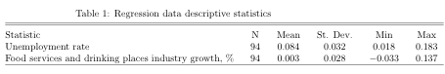

Figure A-1

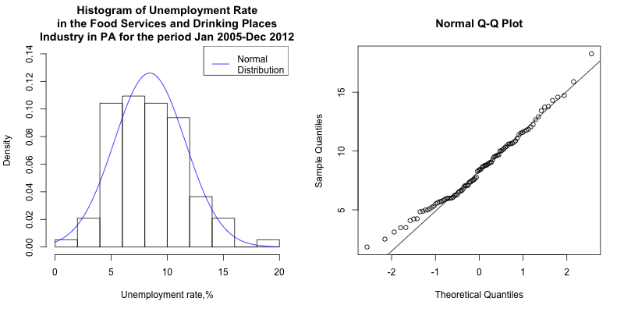

Figure A-2

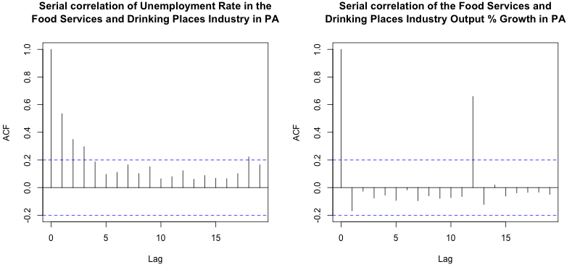

Table A-2

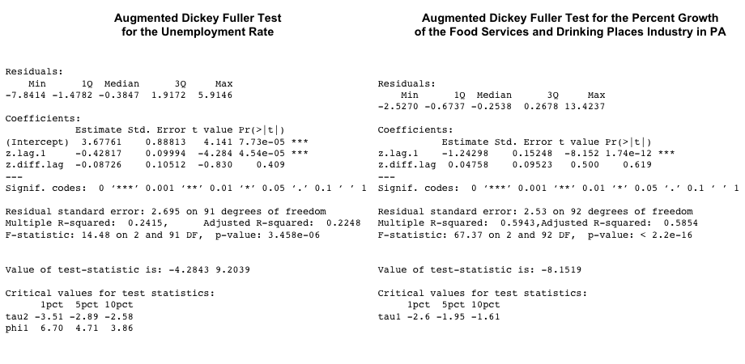

Table A-3

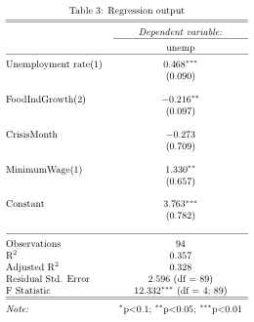

*Standard errors are in parentheses*

Figure A-3

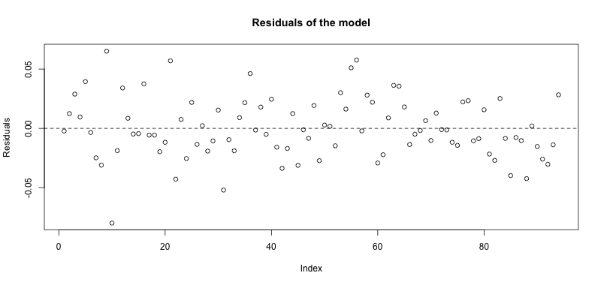

Figure A-4

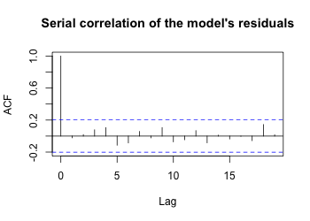

Figure A-5

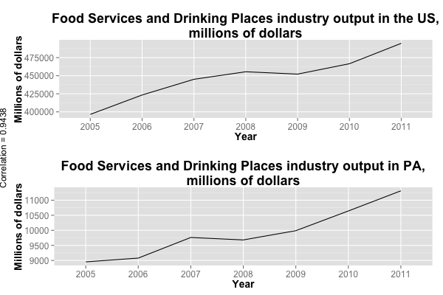

**Appendix B**

To make it possible to reproduce my research I include the link to my github

account where you may find the code I used to process the data, calculate all statistics as well as create the tables and graphs. I performed my analysis in the open source statistical software package R. Github link is below:

https://github.com/KobaKhit/ECON322