Methodology:
This section will describe the methodology followed to train a classification model that determines the movement a patient is doing based on a text file that has certain measurements acquired from sensors on the patient’s arm.
Data Collection:
The process starts with collecting inertial data (acceleration and angular velocity (gyro)) of the group members performing various movements using sensors. The sensors used are the Xsens MTW Awinda sensors where four sensors were strapped to each member’s arm (shoulder, elbow, wrist and hand) individually. Each member then performs 4 sets of 15 reps of a certain movement with plenty of rest in between each set. This amount was chosen as it provides plenty of variation and enough sets that don’t fatigue the member’s arm. For the classification model, the more sets you record, the more robust the training data becomes, which helps the classifier generalize better to unseen movements. For each repetition, the Xsens sensors capture tri-axial (x, y and z) acceleration and angular velocity at a sampling rate of 120 Hz. The four sensor positions allow the system to capture the kinematic chain of the entire arm, which is particularly important for distinguishing movements like “reach and retrieve” from “lifting a cup to mouth”. Data collection concludes with acquiring 256 text files corresponding to 4 sensors per trial for 4 trials. This is done for 4 movements by 4 people.
Data Processing:
Before extracting features to use in the classification model there was a need to pass the data through a filter. Raw inertial signals (acceleration and angular velocity) acquired from the Xsens MTw Awinda sensors contain high-frequency components that do not originate from the intended arm movements. These components arise from:
- Sensor electronic noise: inherent thermal and quantization noise.
- Mechanical vibrations: small, rapid oscillations from skin movement, muscle tremor, or cable motion
Human voluntary movements, especially those performed by stroke survivors during rehabilitation, have a frequency content predominantly below 12 Hz [4]. Reaching, lifting a cup, wrist rotation, and horizontal arm swings typically exhibit fundamental frequencies in the range of 0.5–5 Hz, with negligible energy above 12 Hz. Hence, the data was passed through a low pass filter of order 3 with a cutoff frequency of 12 Hz. This was done to remove the high frequency noise, prevent false peaks, preserve the signal features and improve classifier generalization. This was done using the filter function on MATLAB. Some trials had more noise than others depending on the person that did the movement. Figure x shows an example of a trial that had reasonable noise and the difference between the filtered and unfiltered acceleration.
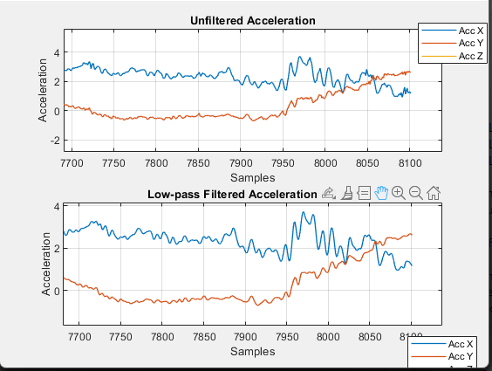
Figure x: filtered and unfiltered acceleration for one trial
Although not very noticeable, there are some differences when observing the later samples around 8100.
After passing all the data through the filter, it was necessary to extract some features from the data to be used in the classification model. 6 features were chosen to be extracted from both acceleration and gyro data. These features are: Standard deviation, root mean square (rms), information entropy, jerk metric, peak number, maximum peak amplitude. These features are computed separately for each sensor axis and then combined into a feature vector per repetition as seen in figure z.
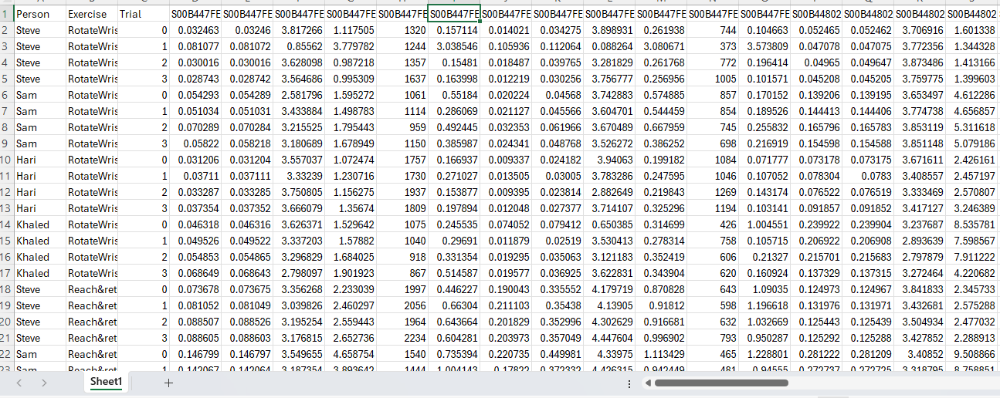
Figure z: Arranging all features in vectors
Now, all that was left is training the model. MATLAB offers various machine learning tools like the classification learner tool. This tool provides an interactive environment for comparing multiple classifiers using the same pre-processed feature set. After importing the feature matrix (samples × features) and the corresponding movement labels, various models were selected like (support vector machine (SVM), k nearest neighbor (KNN), and tree) from the list of available models. The toolbox automatically performs cross-validation (here, 5-fold) to estimate generalization accuracy. Fine KNN was chosen because it is non-parametric, requires no training time, and works well with the relatively small but clean dataset obtained after filtering [5]. The final trained model is then exported as a compact MATLAB function, which classifies new sensor repetitions in real time by computing the Euclidean distance to the nearest neighbors in the feature space.
The final trained model is then embedded into the Decision Support System (DSS) GUI, which runs in MATLAB. The DSS receives real-time or offline sensor data, calls the classification function, and displays the movement type

[4] D. Qiao, G. K. H. Pang, Mui Man Kit, and D. C. C. Lam, “A new PCB-based low-cost accelerometer for human motion sensing,” Sep. 2008, doi: https://doi.org/10.1109/ical.2008.4636119.
‌ [5] IBM, “What is the k-nearest neighbors (KNN) algorithm?,” Ibm.com, Oct. 04, 2021. https://www.ibm.com/think/topics/knn
‌
The model with the highest accuracy turned out to be Fine KNN with an accuracy of 96% with SVM having an accuracy of 95%.

