DATABASE MANAGEMENT
Milestone 1

Willson Financial
Case Study Analysis & Initial ERD
GOLD TEAM
Kobe Alexander | Samuel Dirr | Sebastian Siqueiros | Zachary White
Professor Sue Sampson | Spring 2026

Team Overview

Team Member | Role / Responsibilities | Availability
Kobe Alexander | Data & Population Lead | After 8pm EST
Samuel Dirr | Database Architect | After 8pm EST
Sebastian Siqueiros | Reports & Queries Lead | After 8pm EST
Zachary White | Documentation & Presentation Lead | After 8pm EST

Note: Role assignments and individual availability schedules are to be confirmed with the full team.

Selected Case Study: Willson Financial

Background
Jake and Ned Willson, both finance graduates (Ned additionally holds an MBA), identified an underserved market in their small New Mexico town, which had only one existing financial management firm. Observing a growing population of ranchers, farmers, and retirees in the area, they developed a business plan and launched Willson Financial.

Key Personnel
Name | Title | Responsibilities
Jake Willson | Co-Founder / CFA | Co-manages client portfolios and firm operations
Ned Willson | Co-Founder / CFA, MBA | Co-manages client portfolios; leads strategic direction
Phoenix Two Star | Office Administrator | Client appointments, office supplies, general office duties
June Santos | Compliance Manager (PT) | Ensures compliance with SEC regulations

Business Questions to Address
The owners have identified the following key business questions that the database system must be able to answer:
- How many clients have been added for each of the past six months?
- What is the average amount of assets (in currency) for the entire client list?
- How many clients have a high number of transactions (more than 10 per month)?

Business Rules
The following business rules govern the design of the Willson Financial database. These rules were derived directly from the case study and supplemented with reasonable assumptions where the case study was silent on a specific detail.

Client Rules
- Each client must have a unique client ID, full name, contact information, and enrollment date.
- A client may hold one or more investment accounts with Willson Financial.
- Each client is assigned to a primary advisor (Jake or Ned Willson).
- Client enrollment date is recorded to support the monthly client growth report.

Account Rules
- Each account belongs to exactly one client.
- An account has a type (e.g., individual brokerage, IRA, retirement), a current balance/asset value, and an opening date.
- Asset values are stored in USD currency.
- Total assets per client are the sum of all account balances linked to that client.

Transaction Rules
- Each transaction is associated with exactly one account.
- Transactions include a date, type (buy, sell, deposit, withdrawal), amount, and description.
- The number of transactions per client per month can be queried to identify high-volume clients (more than 10 per month).
- All transaction amounts are stored in USD.

Advisor Rules
- Willson Financial currently has two advisors: Jake Willson and Ned Willson, both holding CFA licenses.
- Each advisor is stored with their name, credentials, and contact information.
- An advisor may be assigned to multiple clients.

Compliance & Regulatory Rules
- Willson Financial is registered with the SEC (not at the state level).
- A compliance record is maintained for each audit or compliance check performed by June Santos.
- Compliance records reference the date, type of review, and outcome.

Staff Rules
- The office administrator (Phoenix Two Star) manages client appointments.
- Appointments are tracked with a date, time, client reference, and advisor reference.
- Part-time employees (e.g., June Santos) are stored with an indication of employment type.

Assumptions
- Each client has a single primary advisor for simplicity; joint accounts or co-advised relationships are out of scope for the pilot.
- Asset values stored in the database reflect the most recent known balance and are not historical time-series data.
- Client enrollment date is the date their first account was opened with the firm.
- For the purposes of this pilot, the database will be pre-populated with at least 6 client records and corresponding accounts and transactions.
- All monetary values are in USD; no multi-currency support is needed at this stage.
- SEC compliance reports are recorded manually by June Santos and entered into the system; automated regulatory feeds are out of scope.

Initial Entity-Relationship Diagram (ERD)
The following section describes the initial ERD designed to satisfy the business rules above. The diagram identifies the core entities, their primary attributes, and the relationships between them.

Entities and Attributes
Entity | Primary Key | Key Attributes
CLIENT | client_id (PK) | first_name, last_name, email, phone, enrollment_date, advisor_id (FK)
ADVISOR | advisor_id (PK) | first_name, last_name, credentials, email, phone
ACCOUNT | account_id (PK) | client_id (FK), account_type, balance, currency, open_date
TRANSACTION | transaction_id (PK) | account_id (FK), transaction_date, transaction_type, amount, description
APPOINTMENT | appointment_id (PK) | client_id (FK), advisor_id (FK), appt_date, appt_time, notes
COMPLIANCE_RECORD | compliance_id (PK) | review_date, review_type, outcome, reviewed_by
EMPLOYEE | employee_id (PK) | first_name, last_name, role, employment_type, email, phone

Relationships
- ADVISOR (1) assigns to CLIENT (Many): One advisor is assigned to many clients; each client has one primary advisor.
- CLIENT (1) owns ACCOUNT (Many): One client may have one or more accounts.
- ACCOUNT (1) contains TRANSACTION (Many): Each account may have many transactions; each transaction belongs to exactly one account.
- CLIENT (Many) schedules APPOINTMENT (Many): Clients and advisors are linked through appointments. Each appointment references one client and one advisor.
- EMPLOYEE includes ADVISOR and staff: Advisors (Jake, Ned) and support staff (Phoenix, June) are all employees, with a role attribute distinguishing type.

ERD Diagram
The contextual ERD below represents the initial entity relationships. A visual diagram (Crow's Foot notation) will be developed collaboratively by the team and included in Milestone 2 revisions. 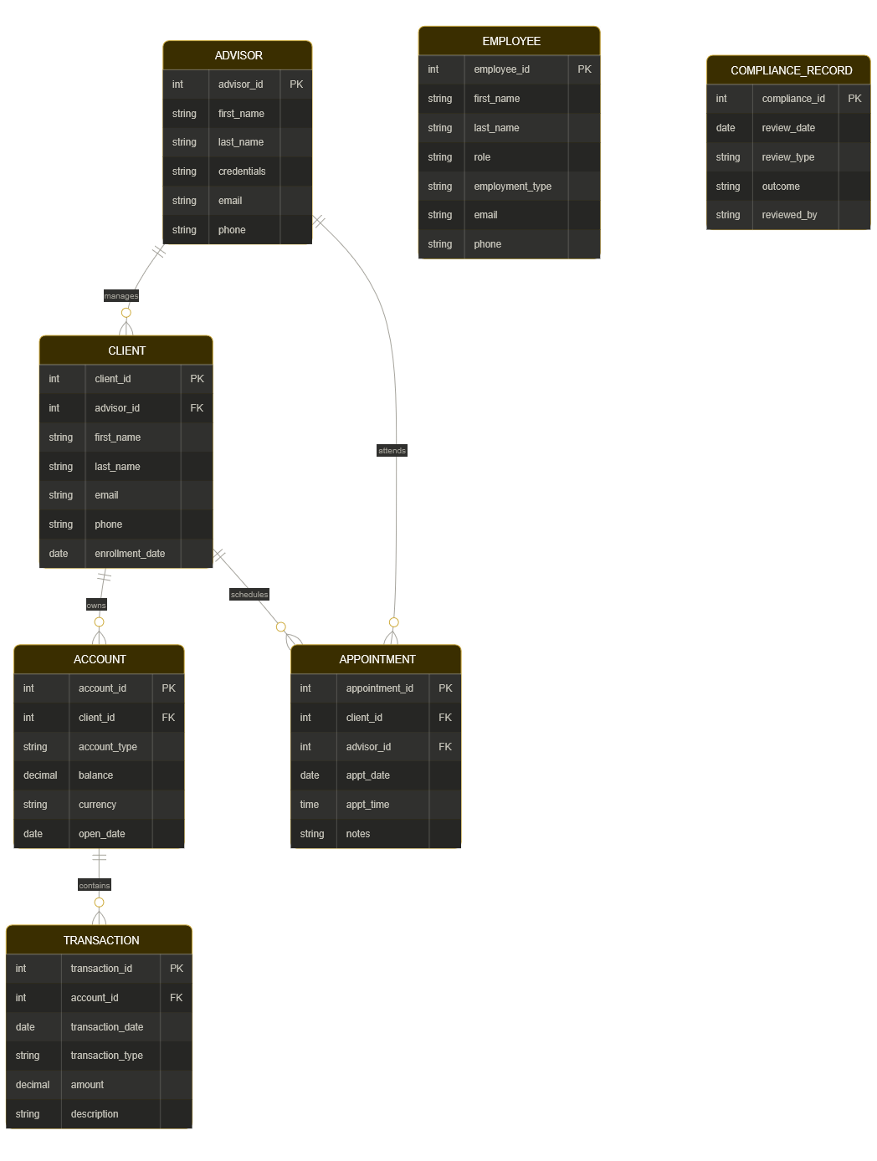

Next Steps - Milestone 2 Preview

The following tasks are planned for Milestone 2. These will be completed collaboratively as a team:

Database Architect
- Finalize the visual ERD using Crow's Foot notation in draw.io or Lucidchart
- Add full attribute detail to each entity, including data types and constraints
Data & Population Lead
- Write Python scripts to create all tables in MySQL
- Populate each table with at least 6 sample records
Reports & Queries Lead
- Write a Python script to display the data in each table and capture screenshots
Documentation & Presentation Lead
- Compile everything into the Milestone 2 Word document group name, members, revised ERD, and screenshots
- Make sure naming and formatting stays consistent across all submitted files

Each team member is encouraged to review the business rules and ERD in this document and raise any questions or revisions in the group discussion forum before Milestone 2 work begins.

