DATABASE MANAGEMENT
Milestone 2

Willson Financial
Revised ERD, Table Creation & Data Population
GOLD TEAM
Kobe Alexander | Samuel Dirr | Sebastian Siqueiros | Zachary White
Professor Sue Sampson | Spring 2026

Contents
Revised Entity-Relationship Diagram 3
3NF Compliance Notes 4
Table Creation create_tables.py 4
Script Output Screenshot 4
Table Creation Order 5
Data Population insert_records.py 5
Script Output Screenshot 5
Data Display display_tables.py 6
Milestone 2 Deliverables Summary 7
Next Steps | Milestone 3 Preview 8
The Three Business Questions to Answer 8
Milestone 3 Task Breakdown by Role 9
Milestone 3 Deliverables Checklist 9

Revised Entity-Relationship Diagram

The ERD below has been revised from Milestone 1 to include full attribute detail for every entity, including data types and constraints. All tables have been reviewed for Third Normal Form (3NF) compliance.
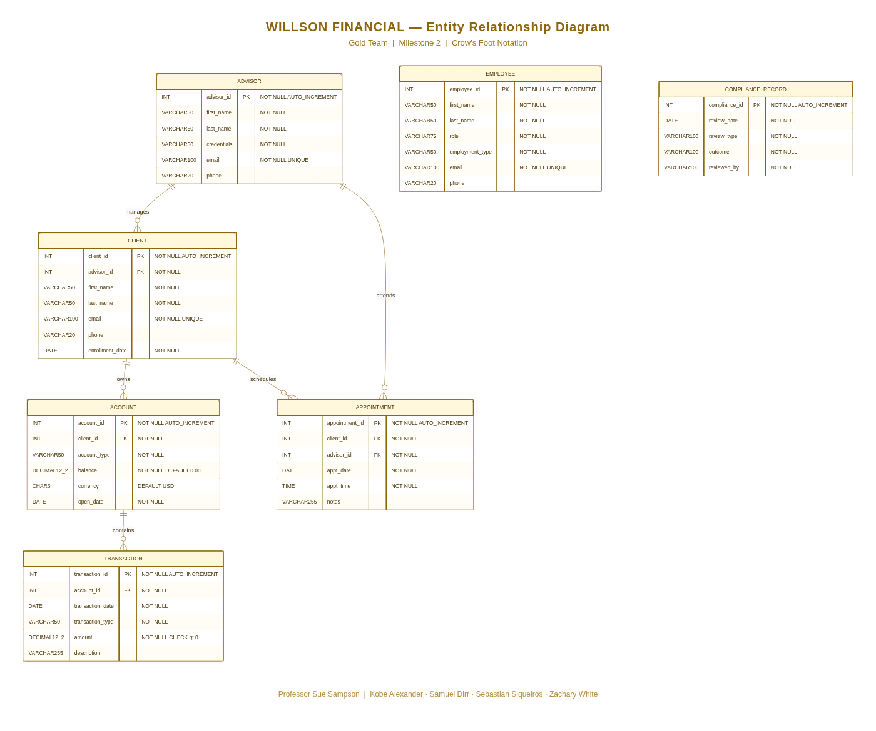
Figure 1 - Willson Financial ERD (Crow's Foot Notation) Gold Team Milestone 2

3NF Compliance Notes
- All non-key attributes depend solely on the primary key of their respective table no partial dependencies exist.
- No transitive dependencies are present; every attribute describes the entity it belongs to directly.
- Repeating groups have been eliminated transactions, accounts, and appointments are each in their own table with FK references.
- COMPLIANCE_RECORD stores reviewed_by as a VARCHAR rather than a FK to EMPLOYEE since reviews may reference external auditors not in the employee list.

Table Creation create_tables.py
The Python script create_tables.py connects to the willson_financial MySQL database and creates all 7 tables in dependency order tables with no foreign key dependencies are created first, followed by tables that reference them. Each table includes appropriate data types, NOT NULL constraints, PRIMARY KEY designations, FOREIGN KEY relationships, and CHECK constraints where applicable.

Script Output Screenshot
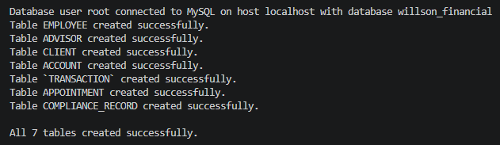
Figure 2 - create_tables.py output: all 7 tables created successfully in willson_financial

Table Creation Order
- EMPLOYEE | no dependencies
- ADVISOR | no dependencies
- CLIENT | references ADVISOR (advisor_id FK)
- ACCOUNT | references CLIENT (client_id FK)
- TRANSACTION | references ACCOUNT (account_id FK)
- APPOINTMENT | references CLIENT and ADVISOR
- COMPLIANCE_RECORD | no dependencies

Data Population insert_records.py
The Python script insert_records.py connects to the willson_financial database and inserts 6 sample records into each of the 7 tables. Client records reflect realistic New Mexico ranchers, farmers, and retirees consistent with the case study background. Jake and Ned Willson are included as the primary advisors. All compliance records are attributed to June Santos, the firm's compliance manager.

Script Output Screenshot
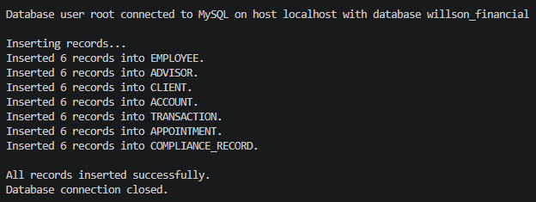
Figure 3 - insert_records.py output: 6 records inserted into each table successfully

Data Display display_tables.py
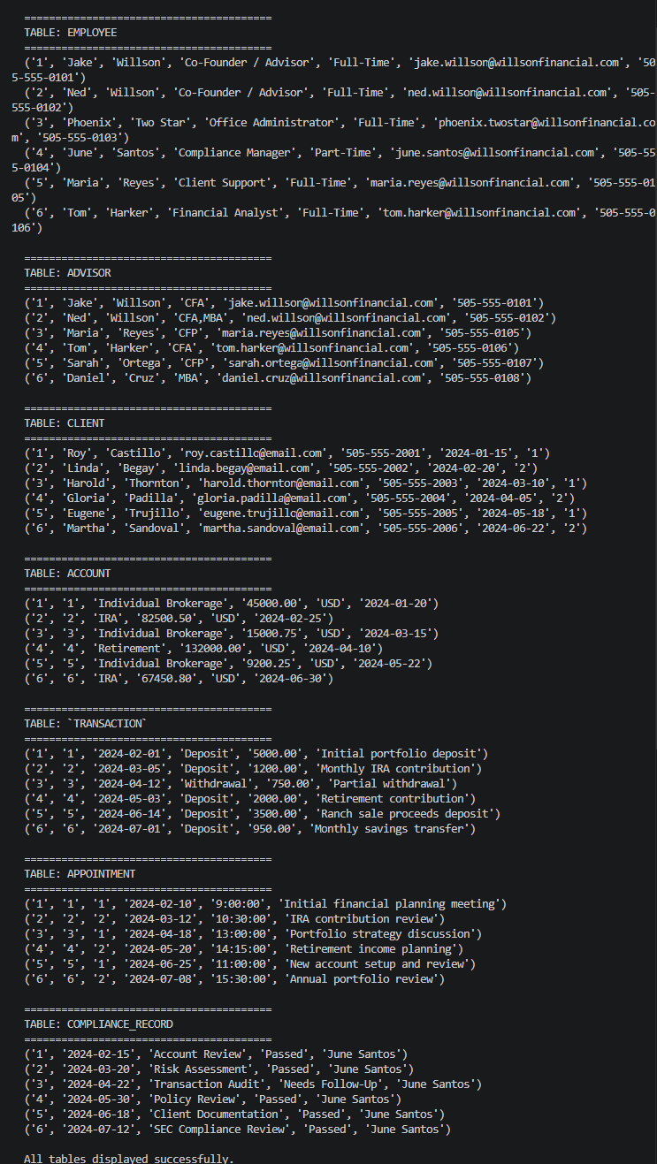
The Python script display_tables.py connects to the willson_financial database and runs a SELECT * query against each of the 7 tables, printing all records to the console. This script serves as verification that all data was inserted correctly and is retrievable from the database.
Script Output Screenshot

Figure 4 - display_tables.py output: all records displayed from all 7 tables

Milestone 2 Deliverables Summary

Deliverable | Status | Notes
Revised ERD (Crow's Foot Notation) | Complete | All 7 entities with full data types and constraints
3NF Compliance Review | Complete | All tables verified for Third Normal Form
create_tables.py | Complete | Creates all 7 tables in correct dependency order
insert_records.py | Complete | 6 records inserted into each table
display_tables.py | Complete | SELECT * run on all 7 tables with screenshot
Word Document | Complete | ERD and all screenshots included
Github Links | Complete | Kobe: https://github.com/Kobea77/csd-310  Sebastian: https://github.com/sebsiqueiros/csd-310  Zach: https://github.com/DevZWhite/CSD310-306J-Database-Development-and-Use  Sam: https://github.com/samdirr/csd-310

Next Steps | Milestone 3 Preview
With the database fully built and populated, Milestone 3 focuses on writing the report queries that answer the core business questions from the Willson Financial case study. There must be a minimum of three reports. Each report requires a description, a Python query script, and a screenshot of the results.

The Three Business Questions to Answer
# | Business Question | Tables / Columns Involved
1 | How many clients have been added for each of the past six months? | CLIENT enrollment_date, COUNT(client_id) GROUP BY month
2 | What is the average amount of assets (in currency) for the entire client list? | ACCOUNT AVG(balance), joined to CLIENT
3 | How many clients have a high number of transactions (more than 10 per month)? | TRANSACTION, ACCOUNT, CLIENT COUNT per client per month, HAVING > 10

Milestone 3 Task Breakdown by Role
Role | Milestone 3 Responsibilities
Reports & Queries Lead | Write all three query scripts in Python. Each script connects to willson_financial, runs the report query, and prints formatted results to the console. Capture a screenshot of each report output.
Data & Population Lead | Verify the sample data supports all three reports. Add additional transaction records if needed to ensure Report 3 (high-volume clients) returns meaningful results.
Database Architect | Review query results against the ERD to confirm joins and relationships are correct. Confirm the schema supports all report requirements without modification.
Documentation & Presentation Lead | Write the description for each report in the Milestone 3 Word document. Compile all screenshots and format the final submission.

Milestone 3 Deliverables Checklist
- Python script(s) for all three report queries
- Report 1 Monthly client growth: clients added per month for the past six months
- Report 2 Average assets: average account balance across all clients
- Report 3 High-transaction clients: clients with more than 10 transactions in a month
- Screenshot of each report's console output
- Word documents with our group name, members, report descriptions, and screenshots (probably following this same system)

Note: The sample data currently contains 6 transactions total (one per account). To produce a meaningful result for Report 3, the Data & Population Lead should add additional transaction records so at least one client exceeds 10 transactions in a single month before running the query.

