Start Zookeeper

Start Kafka Server

Create a topic

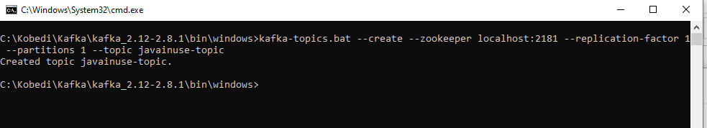
Topic created in Kafka Server

Create a Producer

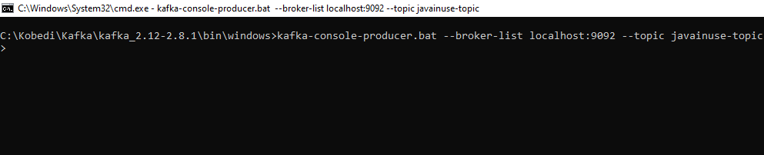
Send a message
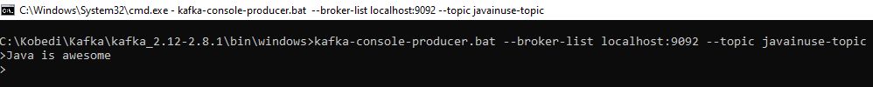

Create a Consumer

Producing and Consuming

