**Create – Applications From Ideas  
Written Response Submission Template**

Please see [Assessment Overview and Performance Task Directions for Student](https://apcentral.collegeboard.org/pdf/ap-csp-student-task-directions.pdf?course=ap-computer-science-principles) for the task directions and recommended word counts.

**Program Purpose and Development**

2a)

|  |
| --- |
| The language we used was C#. The program was meant to be a fun and short platformer. The video showed the start screen, death scene, and win screen and also showed how the player moves and interacts with the enemies using a sword to attack. |

2b)

|  |
| --- |
| My independent problem was with the jumping mechanic when I was creating the code. No matter how many times I created new ways of adressing the problem, the character just wouldn't jump. I worked on this for many days and I finally found out it was a problem in the engine not the code. Another problem was when we were creating a second enemy that would shoot at the player. We did not have enough scope for our project because this turned out much more difficult then we expected. In the end, we had to scrap it to submit our project on time. |

2c)

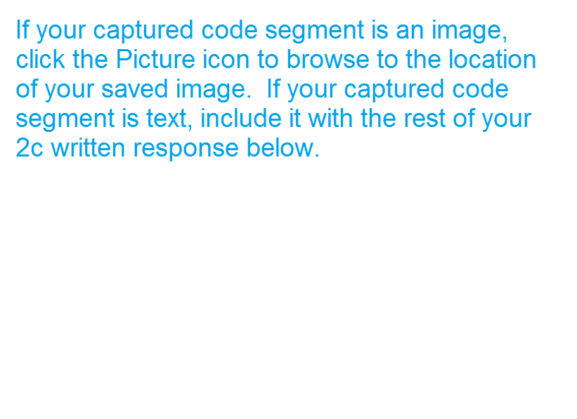

|  |
| --- |
|  |

2d)



  
  
  