**Create – Applications From Ideas  
Written Response Submission Template**

Please see [Assessment Overview and Performance Task Directions for Student](https://apcentral.collegeboard.org/pdf/ap-csp-student-task-directions.pdf?course=ap-computer-science-principles) for the task directions and recommended word counts.

**Program Purpose and Development**

2a)

|  |
| --- |
| The programming language we use is C#. We used that for a total of 6 scripts. We made this game for entertainment puroses and we even enjoyed trying to speedrun our own game. The game is a platformer. The video we made illustrates the functions of the game and how it works including switching the screens with buttons including a main menu button and retry button. We also had a sword that could attack enemies. The video also shows the player conpleteing the game and getting the "You WIn" screen. |

2b)

|  |
| --- |
| When we started our project one of the early problems we had were with jumping. A big problem that I personally had was occasionally the player would jump really high for an unknown reasons and I doubled the length of the level and redesigned it so when it happens, it could be a little bit of luck to help the player get over some of the tougher objects to get over or platforms to get on. For our second problem which we both had, was not being able to figure out how to get an enemy to shoot. We just removed him from the game. |

2c)

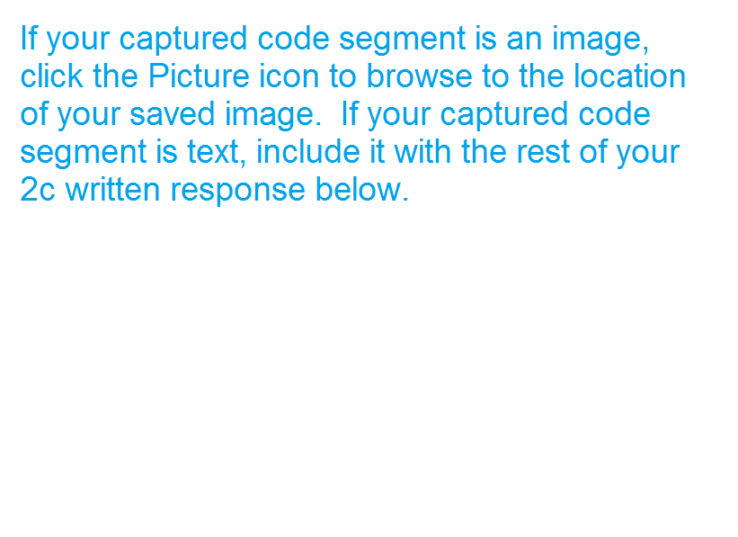

|  |
| --- |
|  |

2d)



  
  
  