CSIS1275-02
JAVA Assignment 4 ( ) Fall 2017
Due date: Nov. 30th/ 2017
You can do this assignment with one partner, in which case, hand in one piece of work with both your names on it.

Create a stand-alone Java Application using Java Swing components and layout managers, call it ComicBuy.java, that will allow customers to select a rare comic to purchase. It should have the following functionality and layout :

Main Screen
The initial main screen is as shown on the next page.

Layout and font

Ensure that the layout of the main screen remains the same, whatever the size of the application (i.e. use layout managers)

The font for the comic publishers and comic image title is “Comic Sans Ms”, bolded and in italics. The rest is either Arial or Helvetical. Note some are bolded and in italics, but some may not. Use your own judgment on the exact font sizes, but the comic publishers, stock and price labels are all a bit larger.

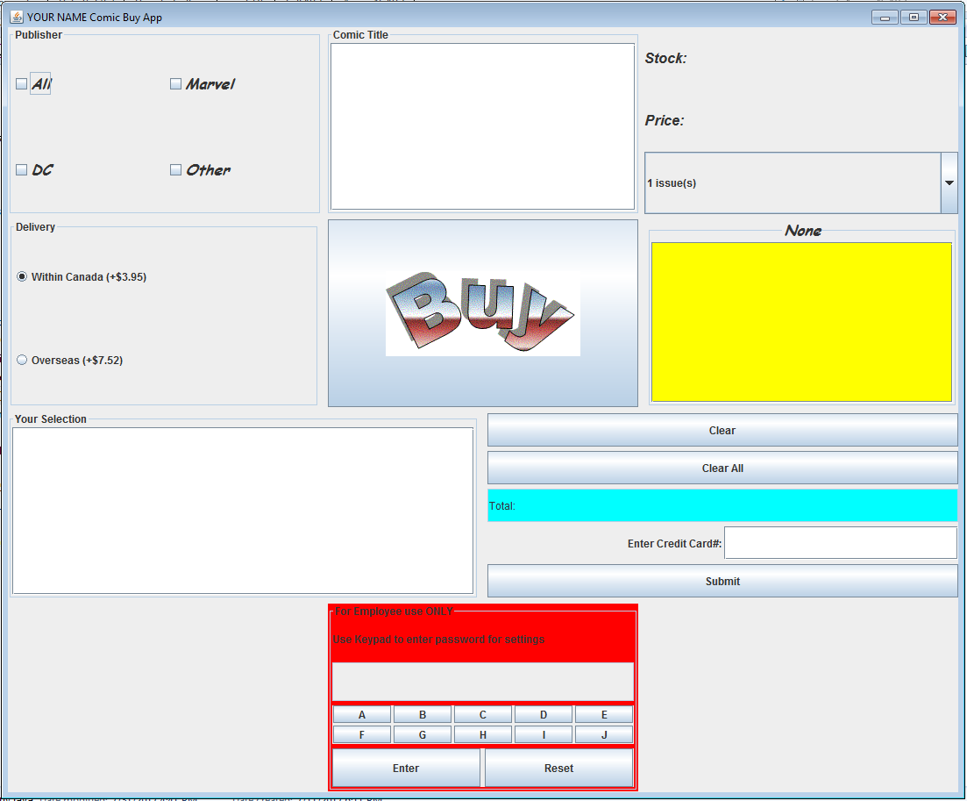
Please replace YOUR NAME with your lastname at the top of the application.

Functionality
- 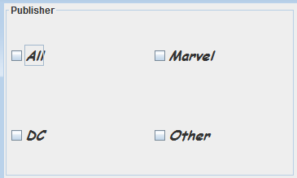 The user first clicks the Publisher’s checkbox. The “All” Checkbox will display all comic titles available, in the “Comic Title” JList box. The other checkboxes will display comic titles published by their respective companies (i.e. clicking on the “Marvel” checkbox will display only the “Marvel comic titles etc..). The “Other” checkbox is for comic titles NOT from either “DC” or “Marvel”. You can of course have both “DC” and “Other” checkbox selected, in which case it will display DC comic titles and any other comic titles published by companies not from “Marvel or DC” (but in this case DC titles are displayed as well)

Note, clicking on the “All” checkbox should deselect all the other checkboxes. On the other hand clicking on the other checkboxes should deselect the “All” checkbox.

Below shows some possible scenarios:

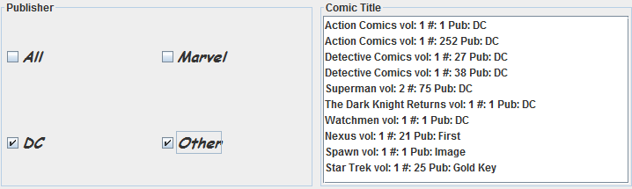

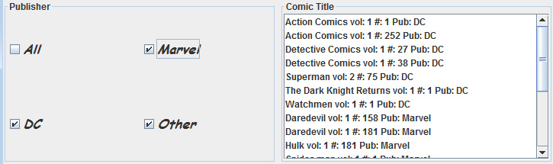 (this example is equivalent to the user clicking on the “All” checkbox.

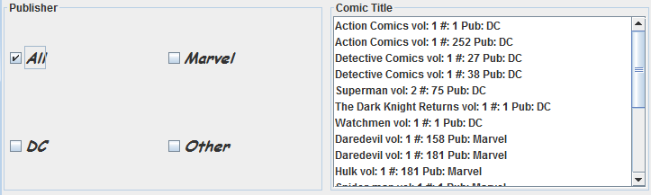 (Note, here that as soon as the user clicks on the “All” checkbox, then the other checkboxes should be deselected)

Note in all cases, DC titles comes first, then Marvel, then Other

- Assuming the “All” checkbox was selected, the user can now select from the “Comic Title” JList box which title he or she wants to purchase. As soon as the user selects a title, the respective Stock and price/issue is displayed in the “Stock” and “Price” JLabels. For example below shows that this title has “7” issues available at a price of $382.91 per issue.
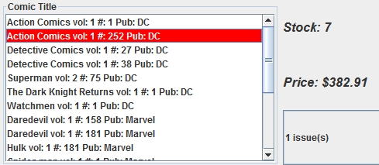

Note, also the colour schemes. When clicking on “DC” titles the colour is white on red. For Marvel titles it is white on blue, and “Other” is black on yellow. If the stock level for that comic is 0, then the Stock JLabel will have a RED background, i.e. 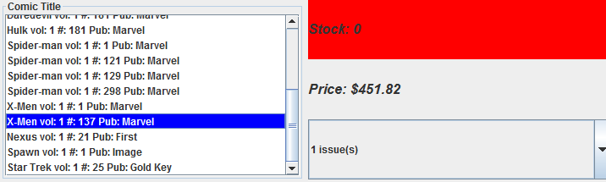. DO NOT FORGET to reset the colour back to the current default background colour, if the stock level is greater than 0.

Referring back to , when the users clicks on the comic title, besides displaying the stock and price, it should also display the cover of the comic book (WITH SCROLLBAR) and also the title at the top (AND is CENTERED) , i.e:

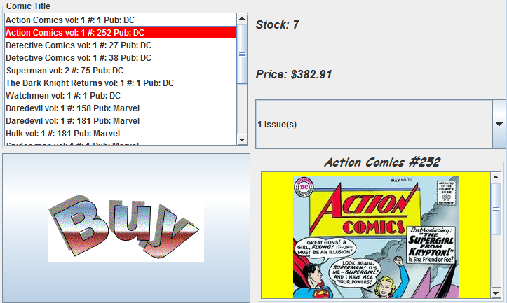

In addition, when the user hovers the mouse over the image, it should display what was so special about this issue, i.e.:

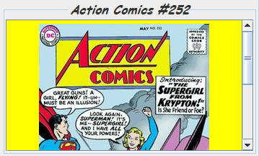 (Before and after mouse hover)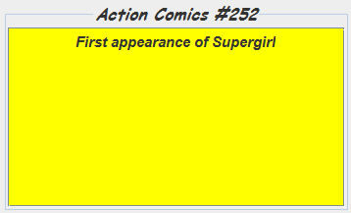

Note, if NO comic title was selected, then the following is the default screen and title , i.e.:
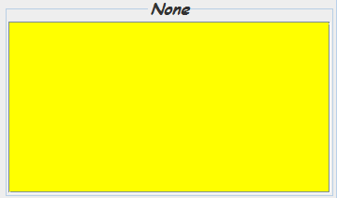

- The user can now select the number of issues to buy from the “Issues” JComboBox, which will have the following pull-down selections:.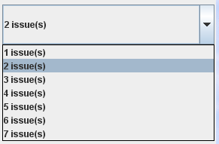

- Assuming there are enough number of issues to satisfy the order, the user can now select whether to deliver within Canada or overseas i.e.: 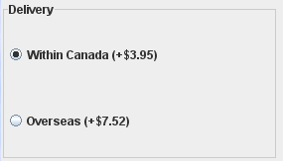 Note, “Within Canada” is the default.
- The user than clicks the Buy button  (JButton with image). If everything is fine, then it will display in the JList box 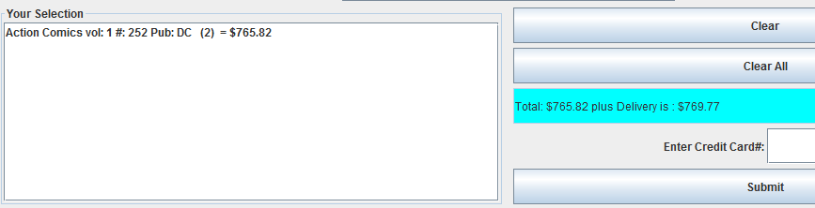 The total appears as shown in the total JTextField (It should also have a cyan background and is READ ONLY). Here, the total plus the delivery charge, which is within Canada is $769.77. If the user now decides that it should be delivered overseas, then by clicking the “Overseas” JRadioButton, the new total is now: 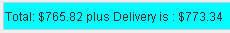. (Note, this delivery charge is a one time payment applied at the end). The new stock number for this title should automatically appear above, i.e.: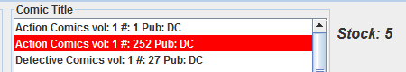 (remember there were 7 issues available for that title, and the user has chosen to buy 2, so 5 issues are left)

- The user can purchase more than one title of course. The user can select as many comic titles to buy (as long as there is stock available) i.e:
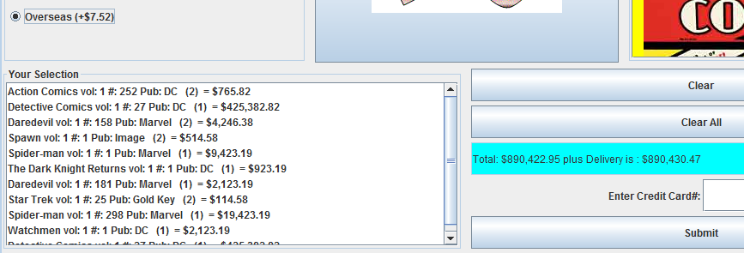 The total amount accrued so far (plus the one time delivery charge) is then displayed in the total JTextField next to it. This basically keeps a running total (i.e. as soon as a new title is added, the new totals are displayed)

- The user can now if he/she so wish, enter the credit card number (NOT an actual one of course) and click the submit button, i.e.: 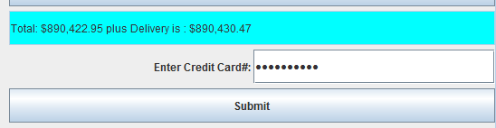 (Note the credit card field must be a JPasswordField)

A warning box appears, i.e.: 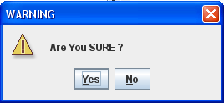 If the user clicks “Yes” then 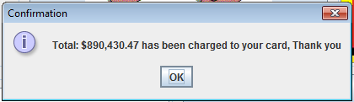 appears. Clicking on “Ok” will clear the Comics Selected JList box, Total and the credit card field, i.e.: 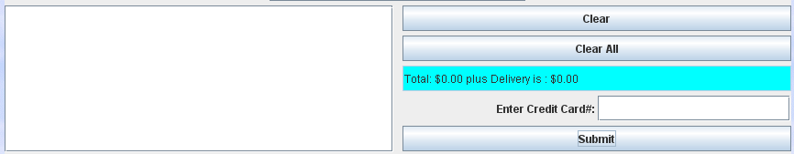

If the No button or close button is clicked, then NO action is taken (assuming the customer wants to purchase more).

If there are NO comics selected for purchasing, but the customer still clicks on the “Submit” button, then after the usual “ Are You Sure Yes/No”dialog box, it should display 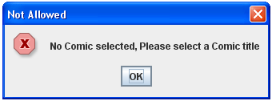.

If user clicks “Submit” and there are comics selected for purchasing but did NOT enter a credit number, then after the usual “ Are You Sure Yes/No” dialog box, it should display 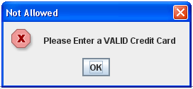.

Not Enough to Buy

- If the user tries to purchase a comic title with NO stock available, then after clicking the “Buy” button, the following dialog box should appear:
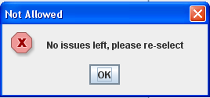

- If the user tries to buy more issues than there are available, i.e:
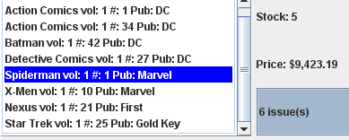. Here there are only 5 issues available for this title, but the user tries to buy 6 issues. The following dialog box should then appear: 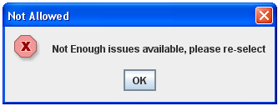

Clear and Clear All Button

The Comic Selected JList Box is single-selectable, i.e. 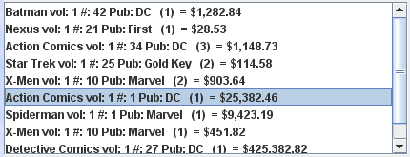. Here the user can remove any of his/her selections before actually buying the comic. Once the comic to remove is selected, the user can click the button, in which case the selection will be deleted from the JList box with the Total JTextField updated i.e. the amount should be reduced. 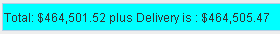 to 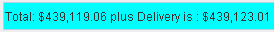, i.e. it should keep a running total. NOTE, if the user continues to clear every selection in the Movie Selected JList box, then the total eventually should be 0.00, i.e. 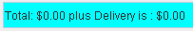. (the delivery charge is also 0.00 as there is nothing bought) NOTE, if you now click on either delivery radio button, the totals should still be .

ALSO, as soon as the “Clear” button is clicked, the number of comics should be updated, i.e. in this case, as the user wants to remove 1 issue of Action Comics #1, then as soon as “Clear” is clicked, the stock for that title should be replenished by 1, i.e. if you were to click on Action Comics #1 from the Comic Ttile JList box, it should show 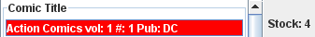

If the Clear button was clicked BUT NO comic selected, then the following error box should appear.
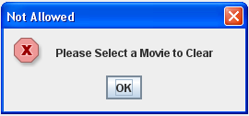.

If the button is clicked then a warning box such as is displayed. If user clicks on Yes button, then ALL the comics selected will be deleted from the Comic Selected JList Box, with $0.00 displayed in the Total JTextField. ALSO make sure the comic stock for those titles have all been replenishe.

If the No button or close button is clicked, then NO action is taken.

Update
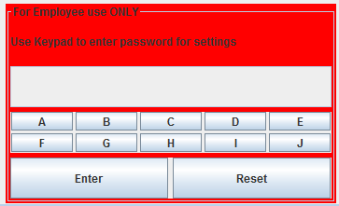
This is an alphabetic keypad, where employees can enter a password by clicking on the keypad 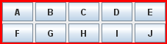 (i.e. NOT entering on the keyboard). If the button is clicked and the correct password was entered, then it will go into the Movie Update window (please see next page for details).

When clicking the password on the keypad, make sure that it is masked out i.e.. The password can be any number of characters, which I leave up to you. You can “hardcode” the password into the program. If user enters the wrong password, then the following error box should appear: 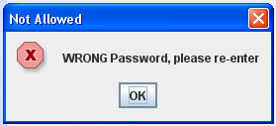 .

The  merely clears the password field (just in case you entered the wrong password and want to restart).

Upon entering the correct password it should first uncheck the Publisher checkboxes, clear the Comic title JList box , clear the Stock/Price/ JLabels and revert the comic cover image and title back to it’s default i.e.:
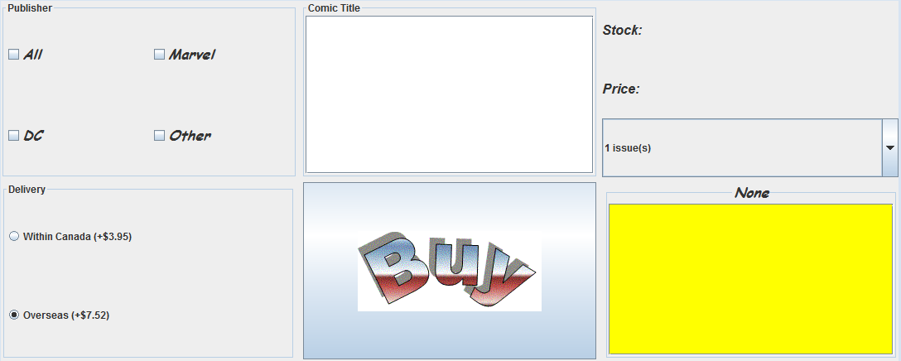

then the following Comic Update window appears (see next section).

Comic Update Window (Save this part as UpdateFrame.java)
Upon entering the correct password, this will generate a window with the following layout and components.
Note, this window is resizable BUT the layout should remain the SAME, whatever the size of the window, i.e. use Layout Managers.

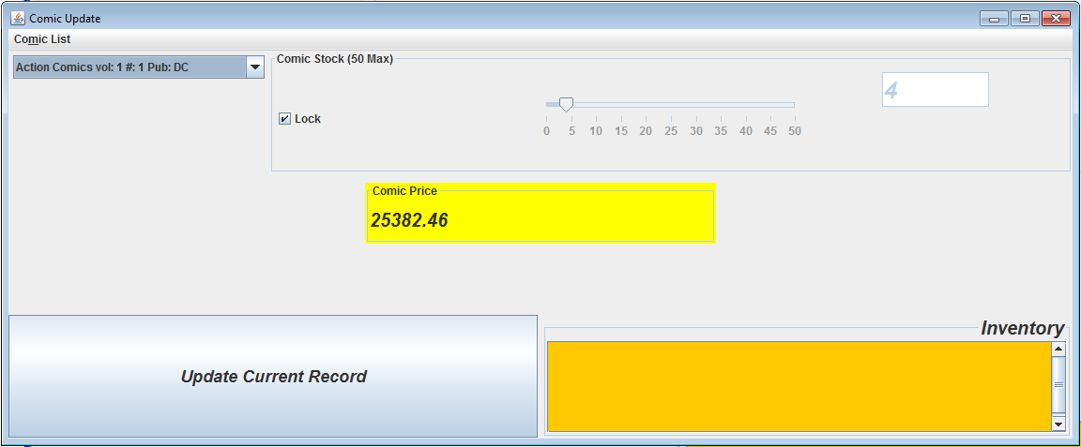

Comic Inventory JTextArea, with scrollbar

Functionality

Here the user can change the Comic title stock and it’s price. The user first select the comic from the Comic Title pull down box, i.e. 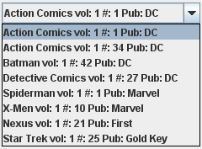. The current comic title details i.e. it’s stock and price, will be displayed in their respective components, i.e. 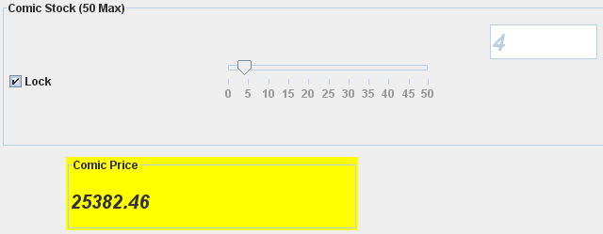
JTextField

The user can change the stock for the comic title by first unchecking the “Lock” check box. Then the user can either enter the new stock value into the textfield or by dragging the JSlider. Please note, that the maximum is 50, so even if you manually enter more than 50, the value of 50 should be displayed. A stock of “0” is the minimum.

If the user manually enters “25” and then presses the <Enter> key in the Stock JTextField (You can use your own judgement on the text size), then the JSlider should automatically go to 25 on the JSlider i.e.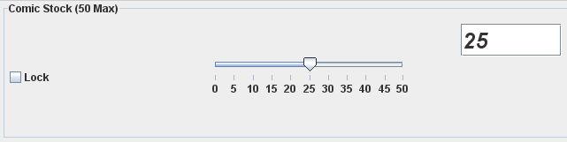

If the user manually drags the JSlider, then the JTextField should automatically display the new value as you drag along.

Once the “Lock” checkbox is checked again, then the JSlider and the corresponding JTextField will NOT be selectable.

The price of this comic title can be changed by entering directly into the comic price JTextField.

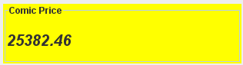 (Note, it has a yellow background. You can use your own judgement on the text size). HOWEVER if the user accidentally enters more that 2 decimal places, i.e. he or she enters 45.7892, then it will round to 45.79 and that will be the price displayed in the text box and used in subsequent calculations.(Hint: first convert to double, use DecimalFormat twoDecimal = new DecimalFormat("0.00"); to round to 2 decimal places and then resave back.
Once you are satisfied with all changes made to this ONE comic title, then the 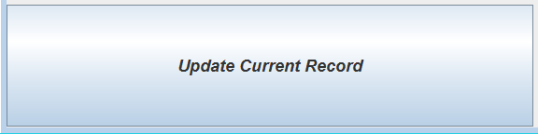 button MUST be clicked. The following confirmation dialog box should appear 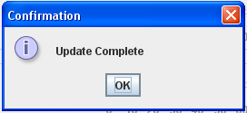. Note, the changes made here, MUST then be reflected in the previous main screen (see page 15).

Comic List Menu
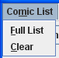
This should have the above selections and corresponding mnemonics.
- If the user selects Full List , then it should display in the Comic inventory JTextArea, a full list of all the comics and their current stock i.e. 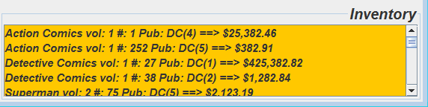 (Note, the font is Helvetica, bolded, italics at 14pt) AND HAVE a scrollbar available . Notice also the title has a larger font size and is RIGHT-ALIGNED
- If the user selects Clear , then it simply clears Comic inventory JTextArea

Exiting Comic Update
- Ensure also the following buttons  do work with this window.

Note: It is important that when the user exits from this Comic Update screen and returns back to the main application, the following are blank.

The user MUST then go through the steps as listed on page 1, to see the comic titles and their new stock/prices.

Classes
You must create at least 2 classes to start off with. These classes are in “ComicInfo.java” which will be given to you.

What to Hand in
- Front cover page with your name, course, assignment number, instructor’s name and due date
- Hardcopy of the program listing
- Zip up and Save your java source files and image files as csis1275_02Assign4F2017YourName.zip and either File Submission (Blackboard) or give to instructor with USB.
4. The password for the Comic Update.
MARKS WILL BE LOST IF ANY OF THE ABOVE IS NOT MET OR IF THE FILES ARE NOT READABLE OR PROGRAM NOT COMPLIABLE OR IF THIS IS NOT YOUR OWN WORK.

