horizontal line

**Akadémia SOVY - 1. N**

Monika JAŠŠOVÁ

Miloš KOČAN

Patrik PATINÁK

Project: 

# DESCRIPTION

Android application providing notification on upcoming waste collection date in the city of Košice, Slovakia; locations of large-capacity containers being present there for certain time; general information on waste management.

# GIT

<https://github.com/Kocarik/Triedenie-Odpadu-Kosice>

# FUNCTIONS

## Notifications

User inputs his address and number of days in advance he wants to be notified on upcoming collection. Application shows notification on defined date and time with information which waste type (glass, paper or plastics and metal) collection is upcoming.

## Information on Waste Management

Description of what belongs into different waste type bags and what does not.

## Map of Containers

Locations of large-capacity containers shown on Google map as in example below.

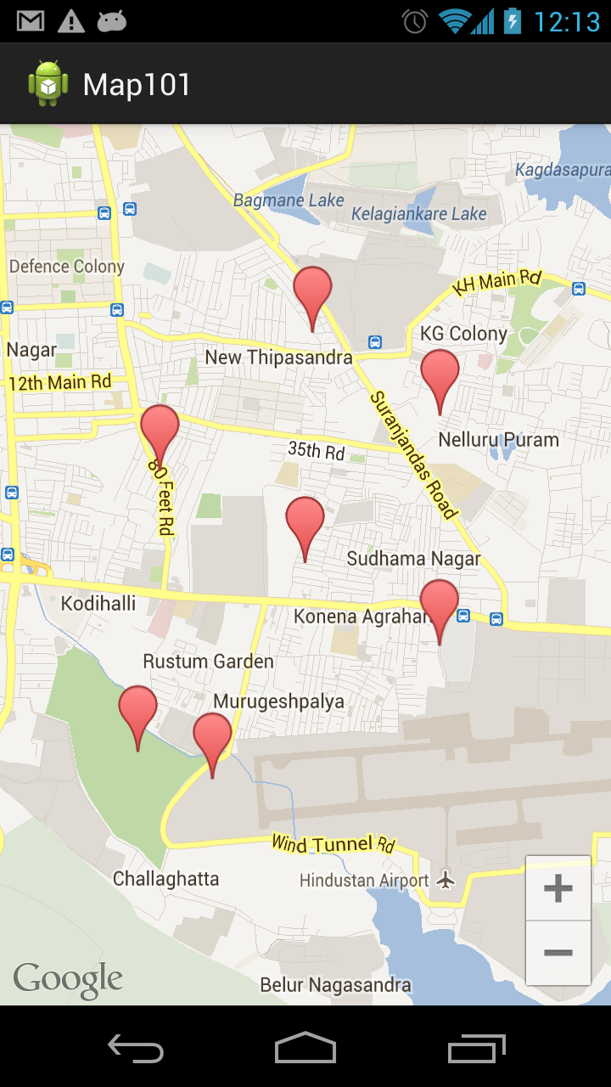

# MAIN ACTIVITY DESIGN

Sketch:

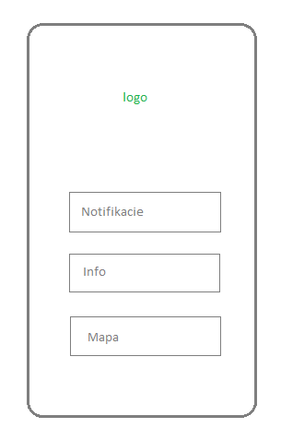

Eventual outcome: Application logo and buttons leading to other activities.

