**SWITCHING FROM AZURE TO HEROKU**

Moving from Azure to Heroku for Loop use is pretty straight-forward. The basic sets you’ll take are:

1. Creating a Heroku account

2. Updating your cgm-remote-monitor repo in GitHub

3. Deploying a new NS site to Heroku

4. Updating Config Vars

**HEROKU ACCOUNT SET-UP**

1. Create an account at Heroku (<https://www.heroku.com>) and choose the Primary Development Language to be Node.js when you create your account. You’re going to use a free account, but you will still need to enter credit card information for your account setup. If you aren’t prompted automatically to enter billing information, go to your account settings.

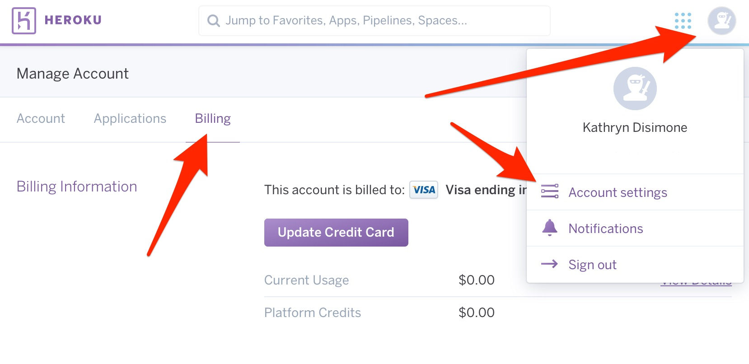

**GITHUB SET-UP**

* If don’t already have a GitHub account and cgm-remote-monitor repo, follow steps 1-3 below, and then skip to step 5.
* If you already have a GitHub account and cgm-remote-monitor repo, start at step 4.

1. Create an account at GitHub (<https://github.com>)

2. Go to <https://github.com/nightscout/cgm-remote-monitor>

3. Click the “Fork” button in the upper right corner

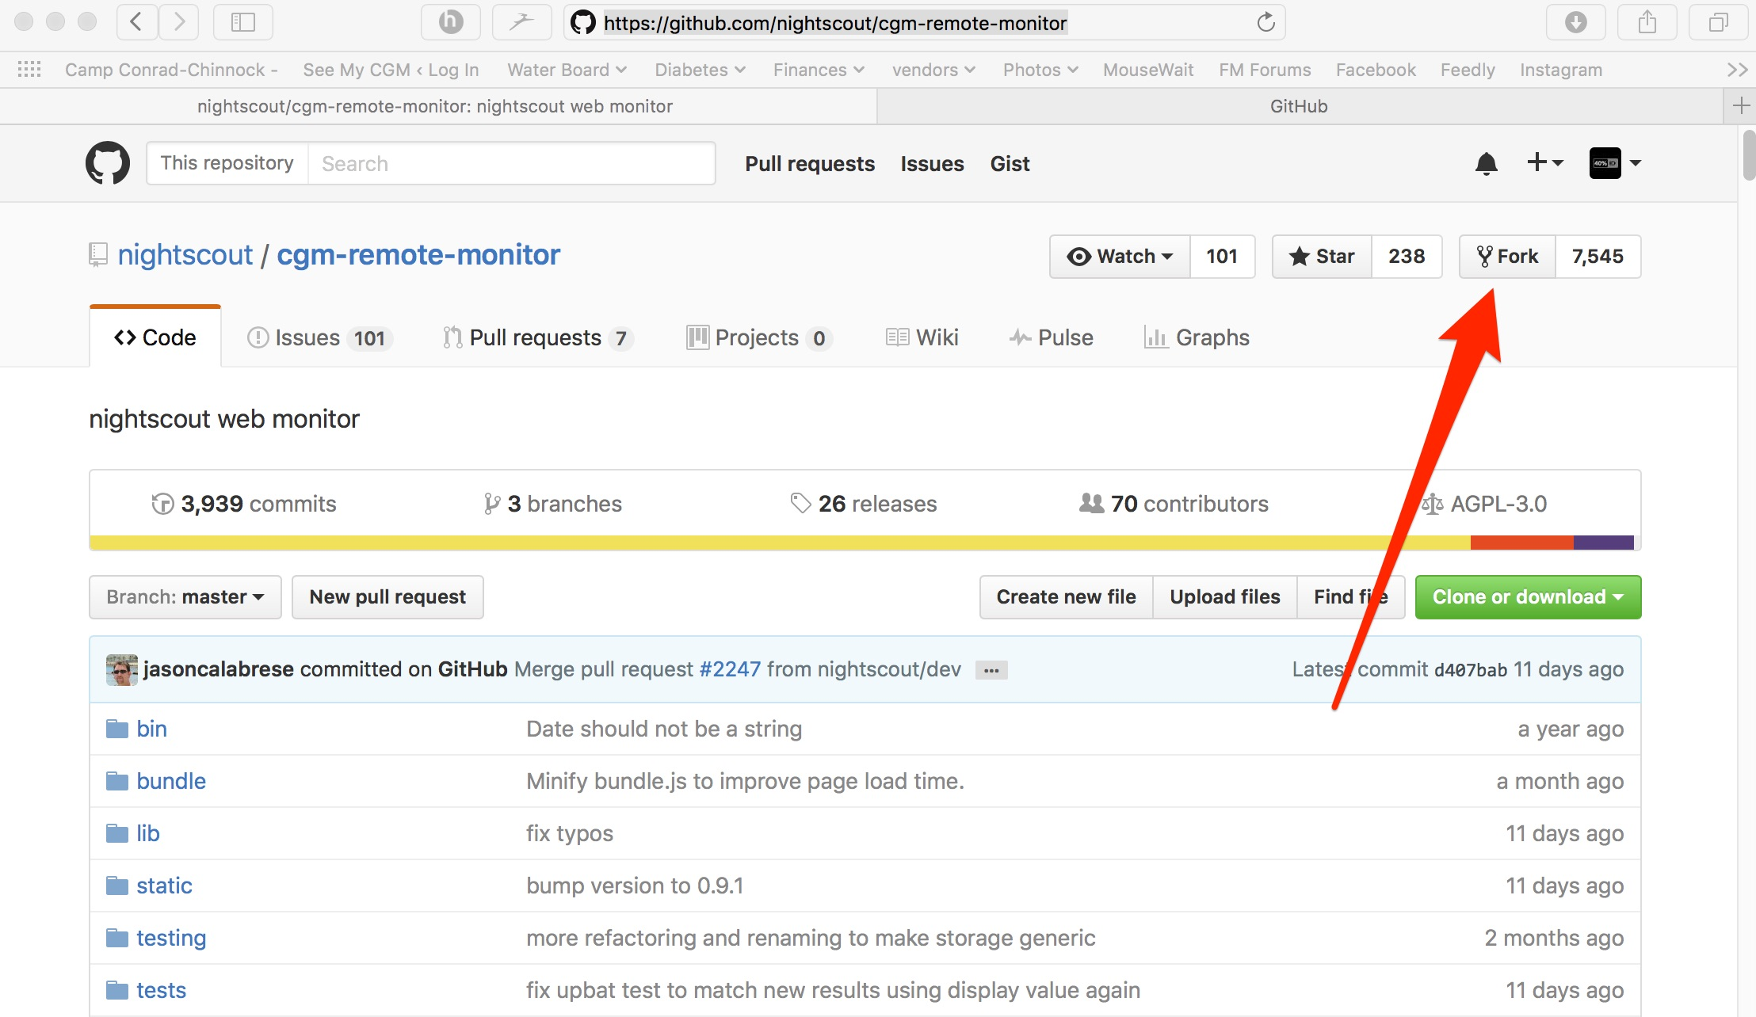

4. Update your cgm-remote-monitor repo by using these links (replace “yourgithubname” with your actual GitHub user name) to start an update:

**NIGHTSCOUT MASTER BRANCH**

https://github.com/yourgithubname/cgm-remote-monitor/compare/master…nightscout:master

**NIGHTSCOUT DEV BRANCH**

https://github.com/yourgithubname/cgm-remote-monitor/compare/dev…nightscout:dev

Remember, updating one branch does NOT update the other branches in the repository. You need to do this for each branch specifically and separately.

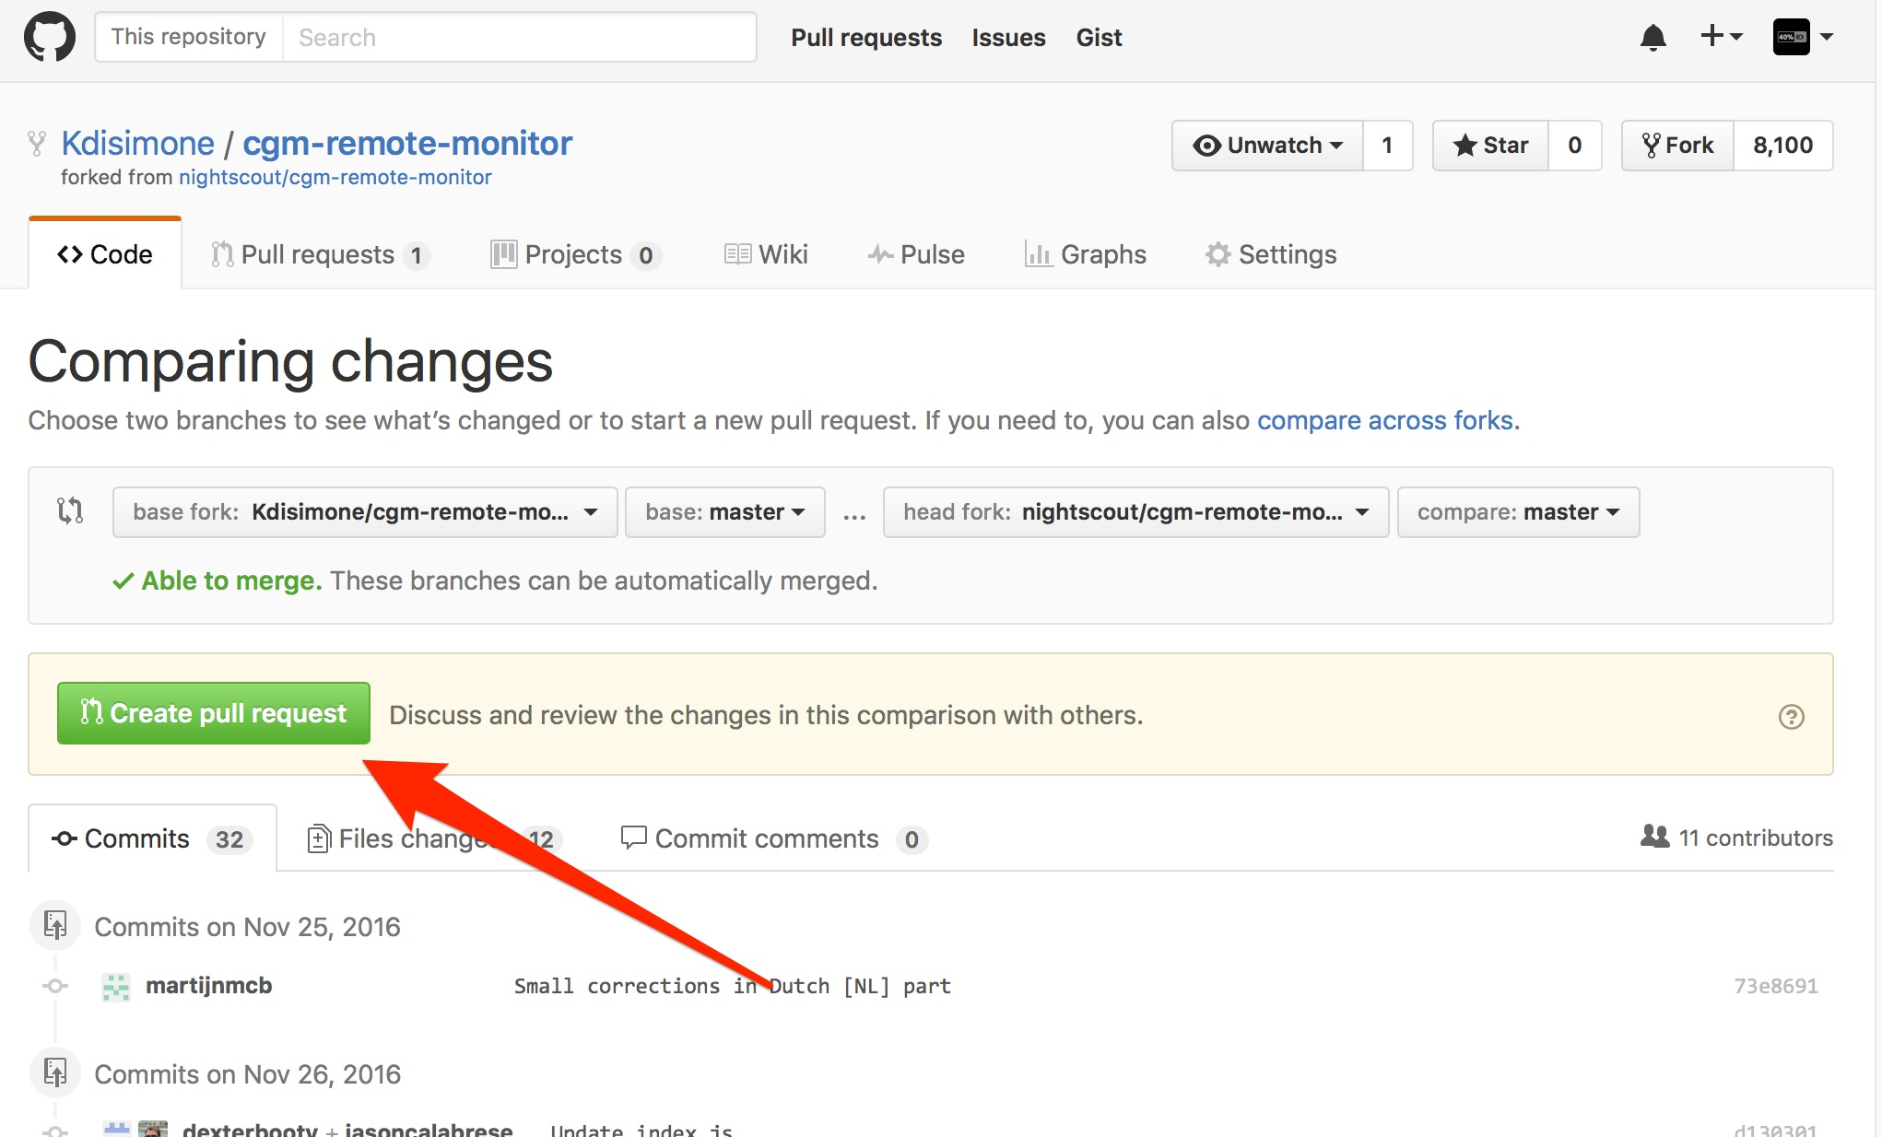Make sure your name is in the base fork and the author’s name is in the head fork. If you used the direct URLs in the previous section, you shouldn’t have any problems. Click the green “Create Pull Request”

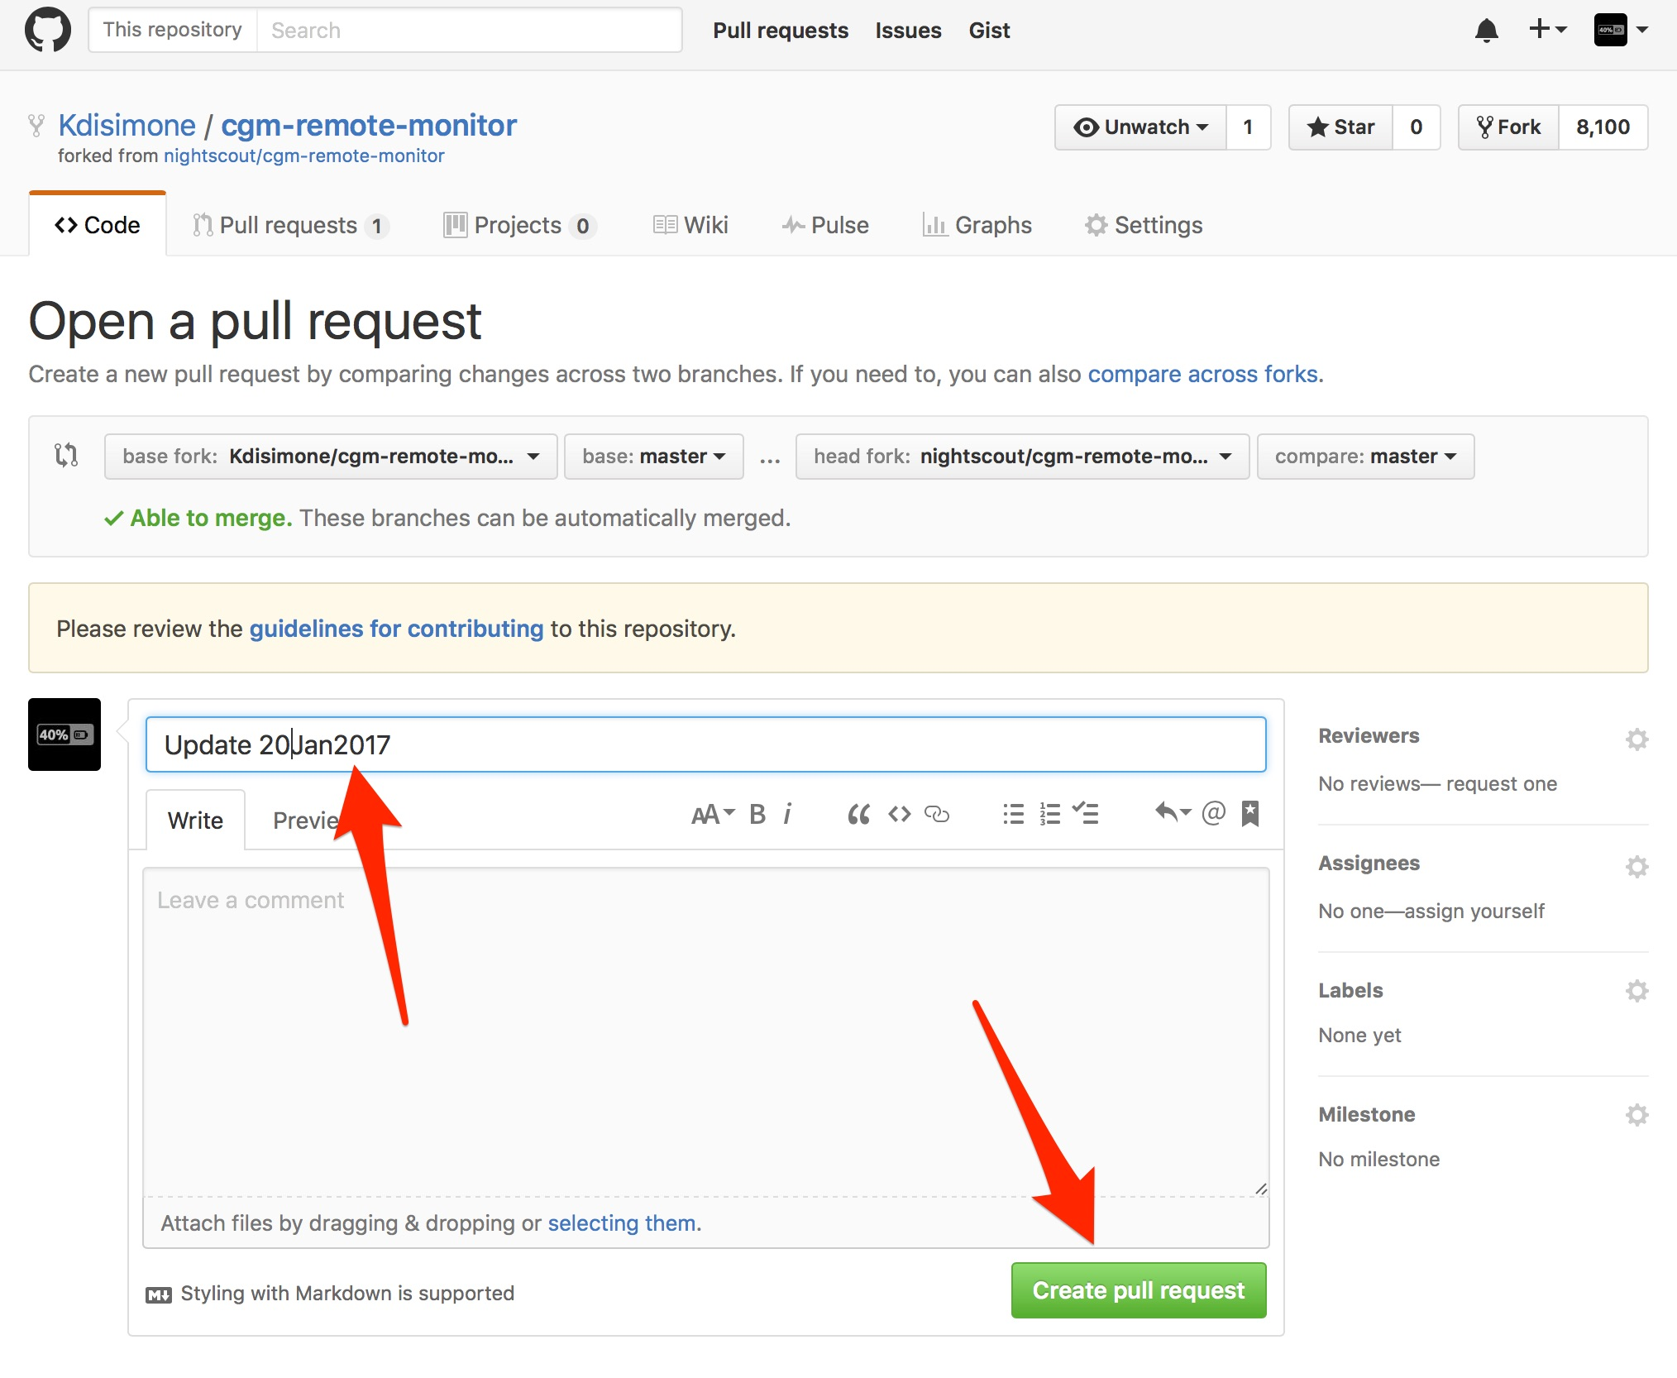Give the Pull Request a name, any name. Click “Create Pull Request” then, scroll down and click the green “Merge Pull Request”. Then click the green “Confirm Merge”. There you just updated your selected branch.

5. Find the main page of your repo’s code by clicking on the “code” tab.

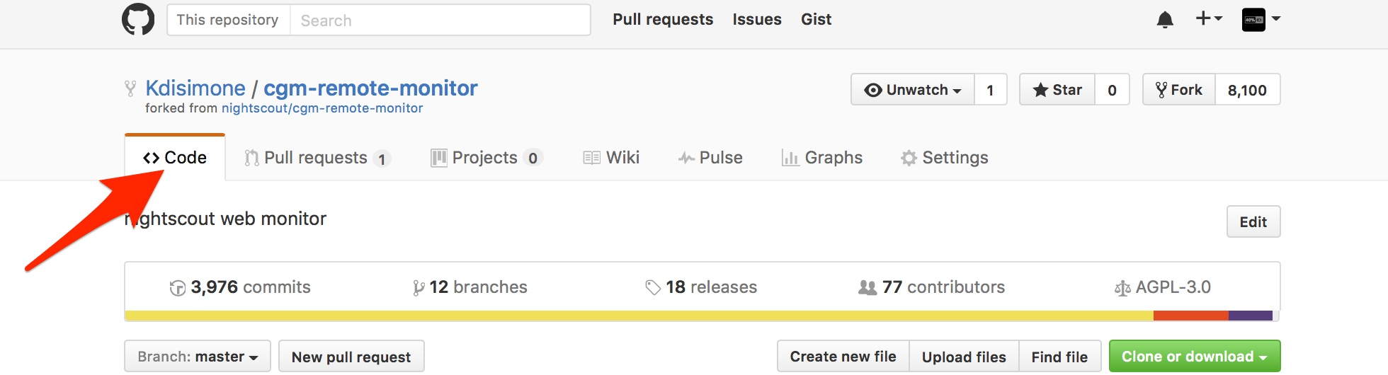

Scroll down until you see the purple “deploy to Heroku” button. Click that button.

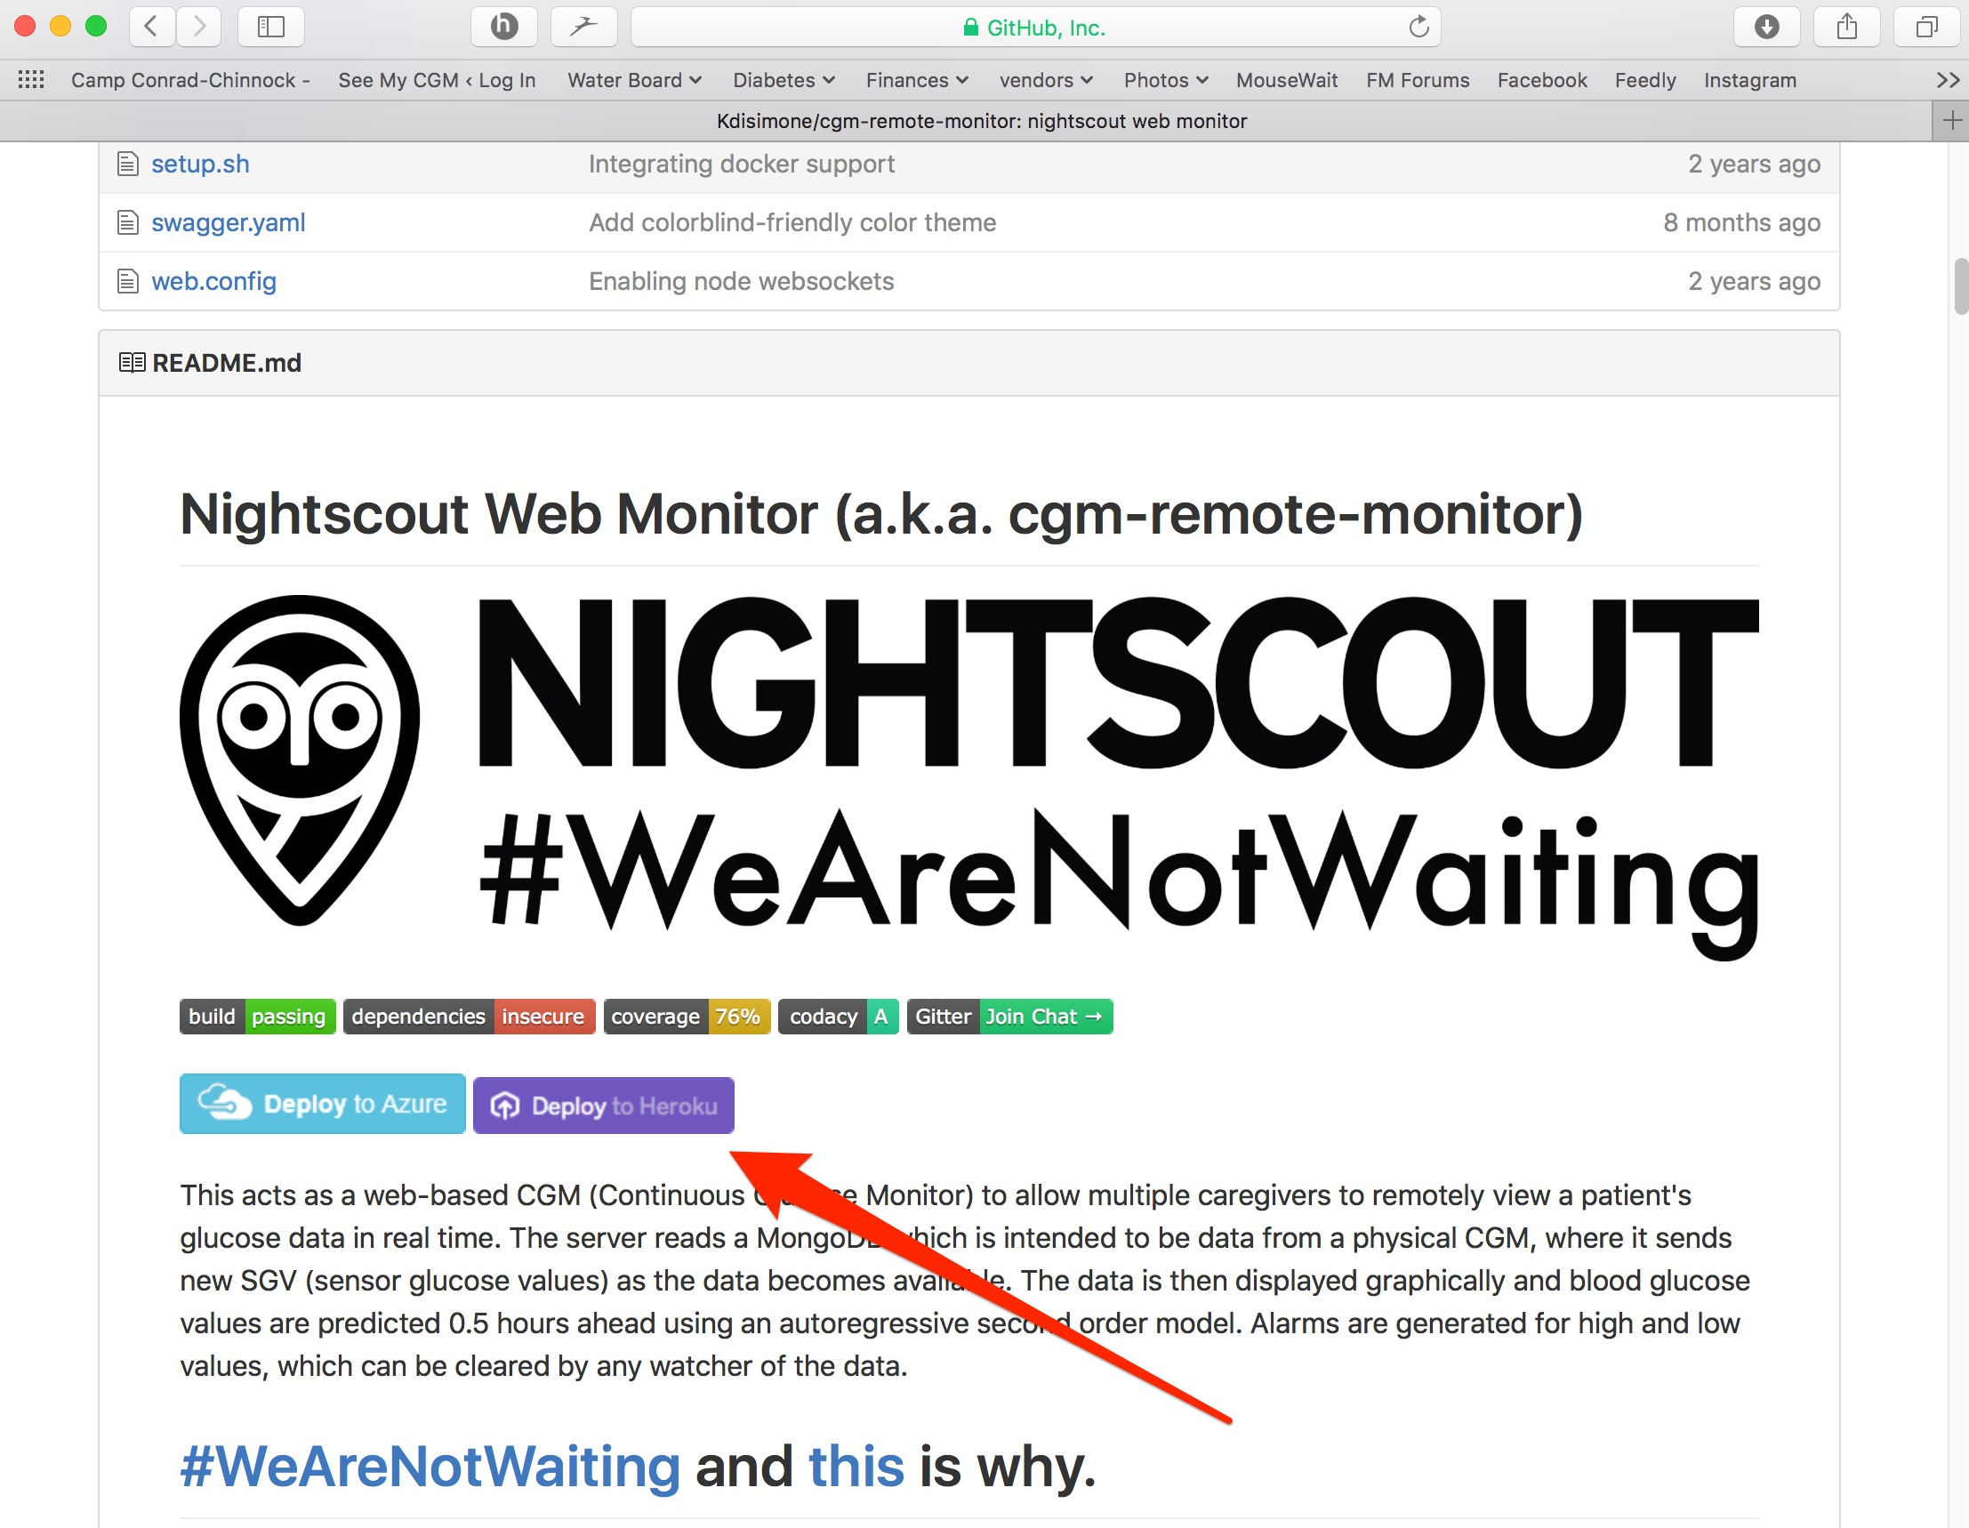

6. Give your app a name, this will be the prefix of your NS site’s URL.

For example, https://yourappname.herokuapp.com

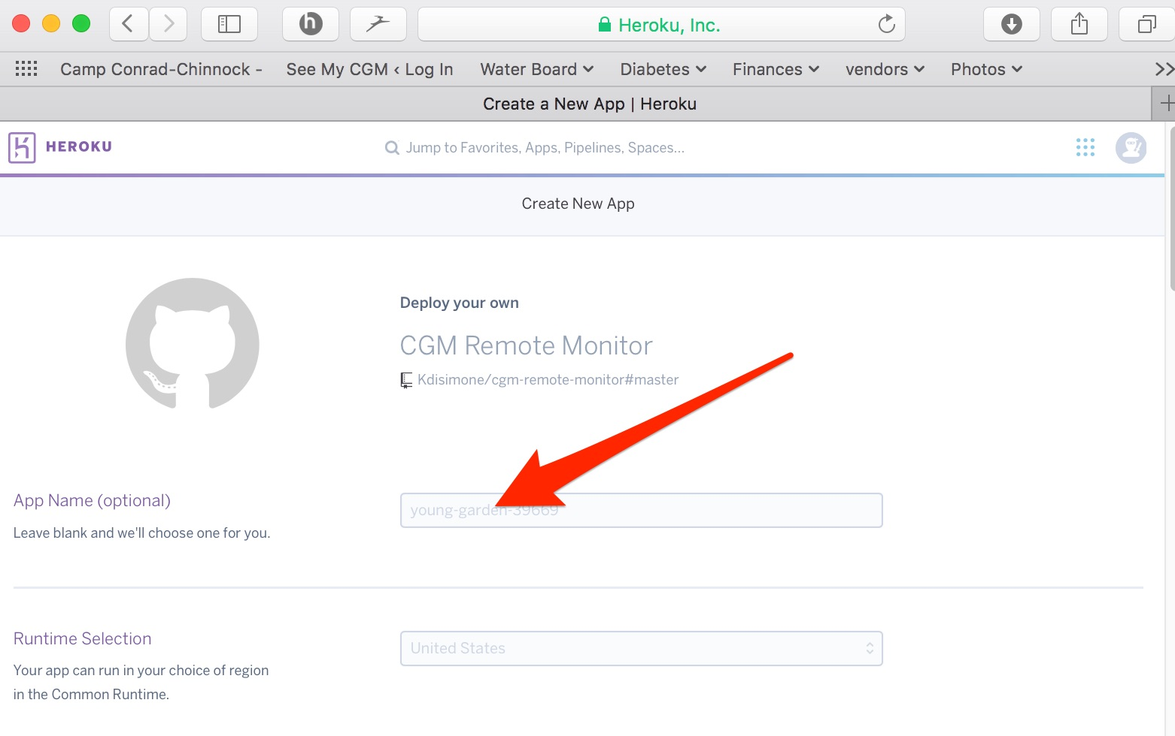

7. Continue to fill out the information lines in the “Config Variables” Section of that page.

API_SECRET: Create your own API_SECRET…this is like the password to your NS site. Please write it down somewhere safe or commit it to memory, you will be using it in the future.­­

DISPLAY_UNITS: mg/dl or mmol

ENABLE: bridge loop pump iob cob basal careportal

(enter all of the ENABLE words, without commas. Just a single space between each word. Make sure autocorrect does not add space between careportal. If you have other NS plugins that you’d also like to enable, add them on this same line now. Such as alexa, boluscalc, bwp, etc. )

DISABLE: Leave blank

ALARM_TYPES: simple

BG_HIGH: enter the numeric value of BG you’d like as an high urgent alarm (Red urgent alert).

BG_TARGET TOP: enter the numeric value of the top of your target BG or the value you’d like NS to start to alert you to high BG values (Yellow warning alert)

BG_TARGET_BOTTOM: enter the numeric value of the bottom of your target BG or the value you’d like NS to start to alert you to low BG values (Yellow warning alert)

BG_LOW: enter the numeric value of the BG you’d like as an urgent low alarm (Red urgent alert)

PUSHOVER lines can be left blank for now. See PUSHOVER section if you want to integrate PUSHOVER notifications with NS later.

CUSTOM_TITLE: This will be the text displayed in the upper left part of the NS website

THEME: colors (default is so plain…change it to colors ☺)

SHOW_RAWBG: never

BRIDGE_USER_NAME: Enter your Dexcom Share Account login name

BRIDGE_PASSWORD: Enter your Dexcom Share Account password

The remaining variables can be left at their default values.

8. Click the purple Deploy button at the bottom of screen

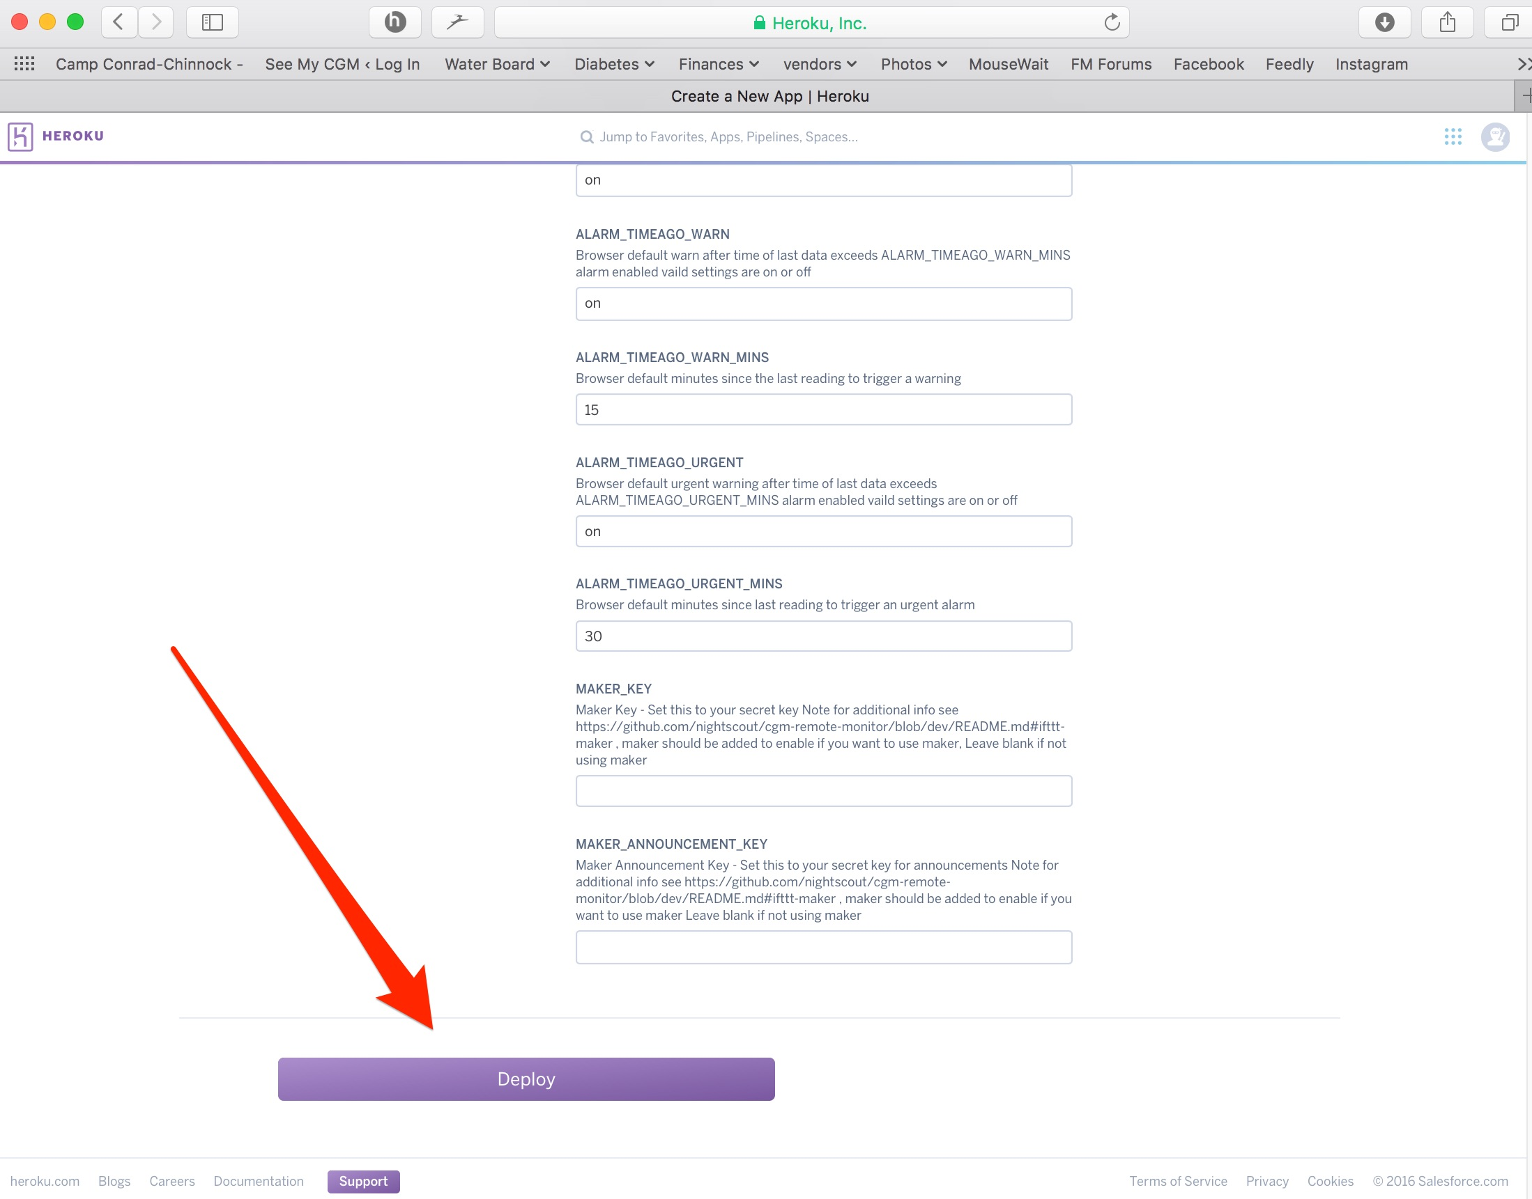

9. Wait a little bit while Heroku builds your NS app. You’ll see some text scroll by in the Build App box, and then finally, you will have a message that the NS app was successfully deployed.

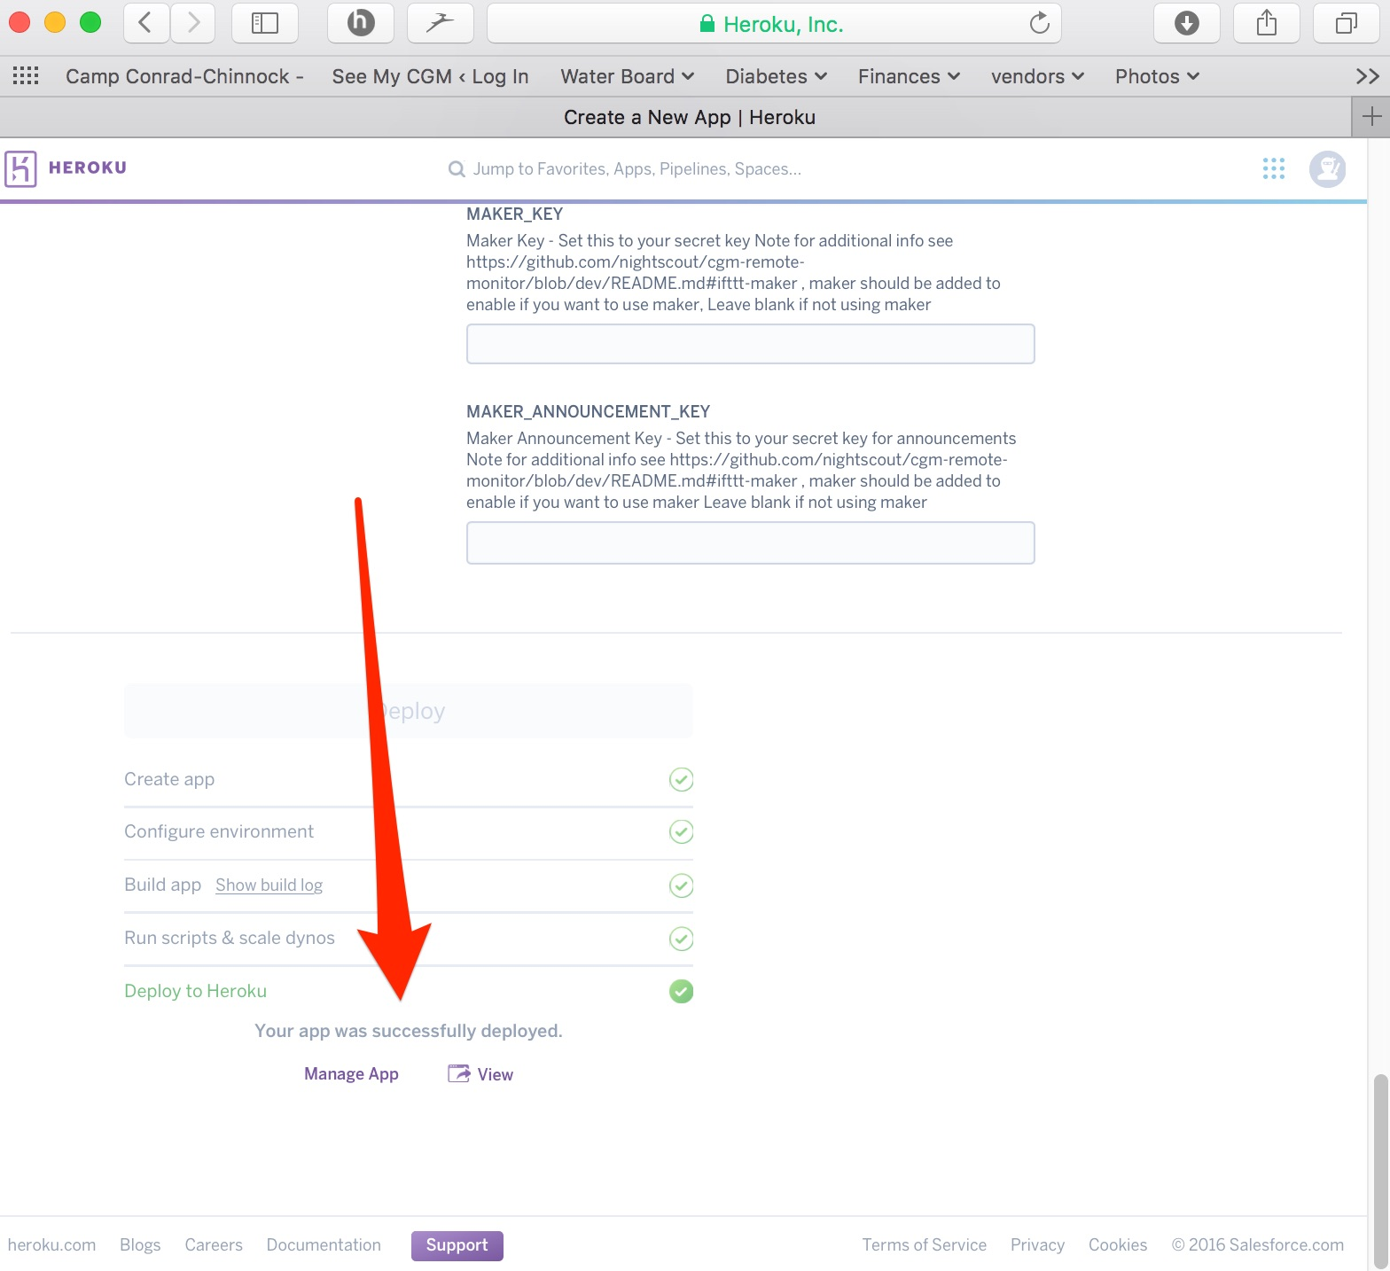

10. You can verify your site’s successful build by clicking View (you should see black site with a profile warning), but we have a few more settings to add before your NS site is really done.

11. Go to the “settings” tab near the top of the screen on your Heroku app.

12. Click on “Reveal Config Vars”. Scroll down the bottom of the Config Vars lines until you find the last blank one. You are going to add several additional lines of config vars for Loop use; some are required for Loop, others are optional.

**REQUIRED LINES**

DEVICESTATUS_ADVANCED: true

PUMP_FIELDS: battery reservoir clock status

SHOW_FORECAST: loop

SHOW_PLUGINS: loop pump cob iob

**OPTIONAL LINES**

**The lines related to alerts for pump reservoir and pump battery levels**

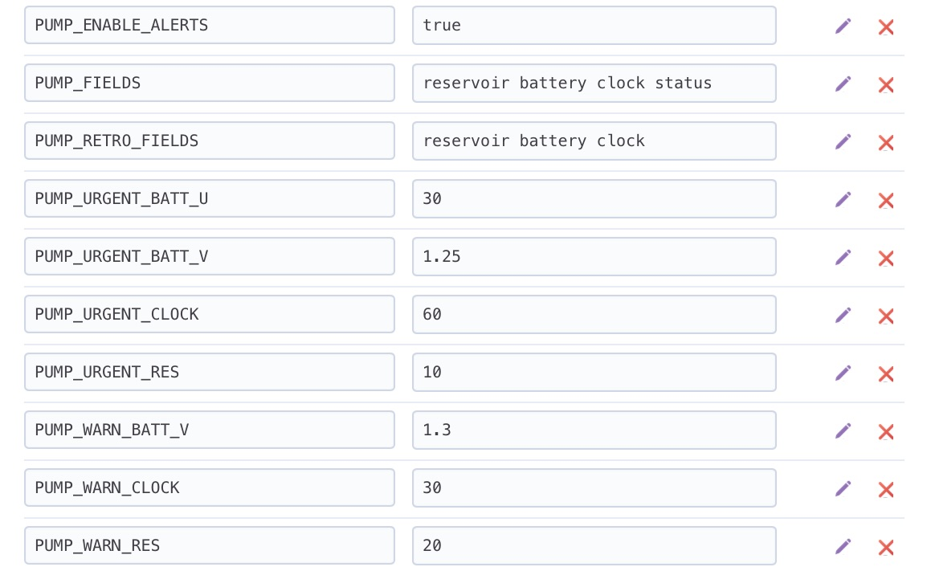

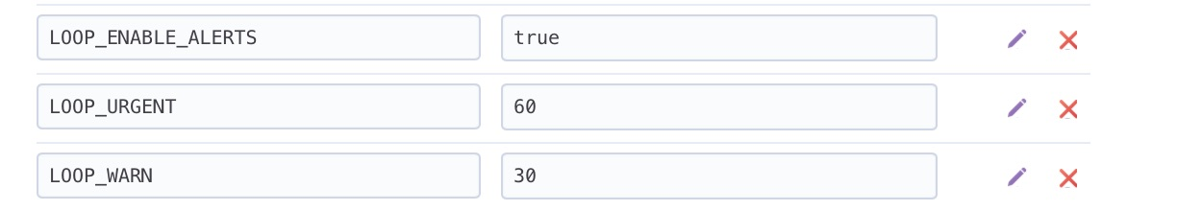**The lines related to Loop alerts**

Finally, if you’d like to seamlessly keep all your old Azure NS data showing in your new Heroku NS site, you’ll need to copy and paste your old MONGODB string from your Azure site. Find it in either Application Settings or Connection strings in Azure and then go to Heroku’s MONGODB_URI line. Replace the content with your copied string from Azure. Double check that your Azure collection used the “entries” name…if it doesn’t, then you will need to update that in Heroku to match as well.

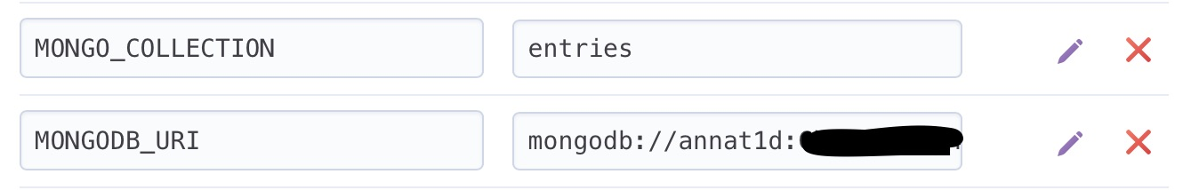

13. Click on “Open App” in the top right corner of your Heroku site.

14. Follow the prompts for settings up a NS profile (Profile Editor can be found in your NS site’s settings by clicking on the three horizontal lines in the upper right corner of your NS site)

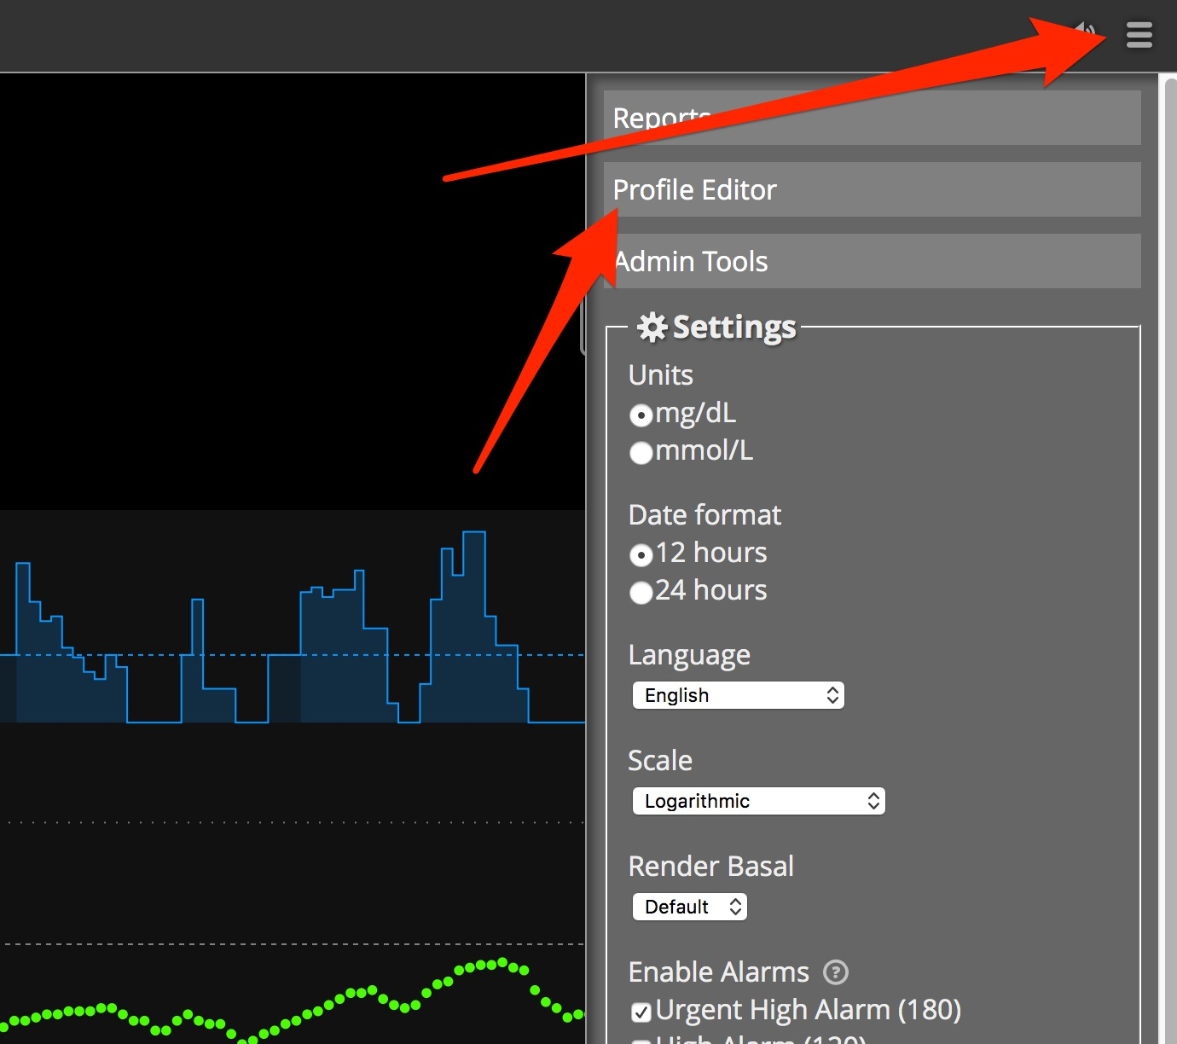

15. You do not have to enter all the information in the Profile if you are using Loop (since loop will be providing the information for IOB and COB rather than letting NS calculate them), but you do have to fill out the Basal Profile and TimeZone at a minimum in order to have your temp basals properly display. Click Save when you have entered the information. You will be prompted to “authenticate”, if it is the first time you’ve used the device to make changes in your profile. Click on the Authenticate link and enter your API_SECRET to complete the authentication.

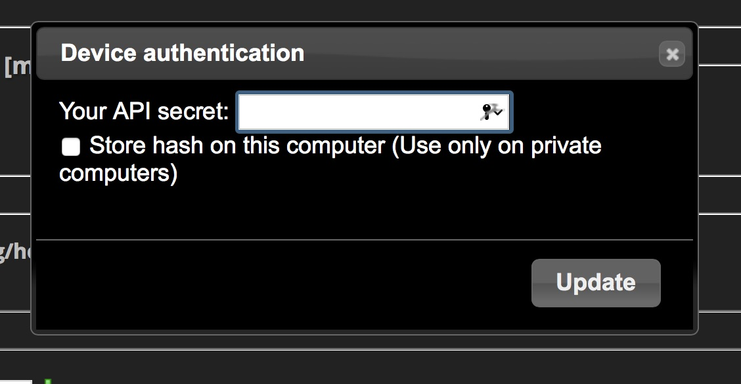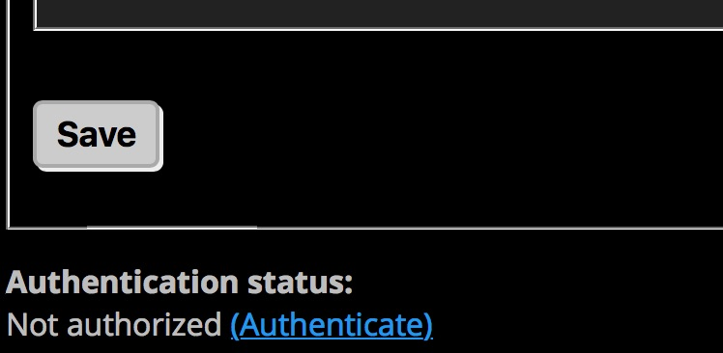

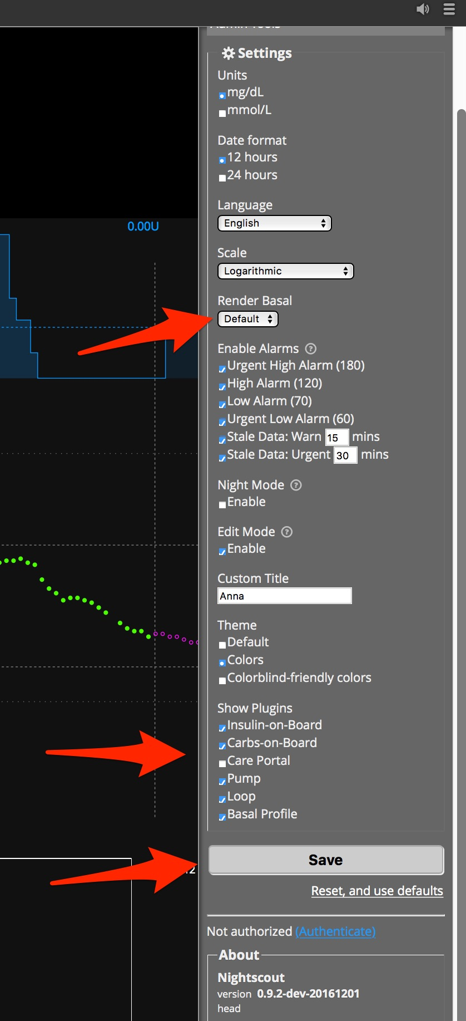16. Finally, go back to your NS site. Click on the settings (those three horizontal lines in upper right corner). Now check that your basal render is selected to either default or icicle (personal preference for how the temp basals show as blue lines in NS site), check the boxes that you’d like pills showing for info on your NS site in the SHOW PLUGINS, and then press save.

Your NIGHTSCOUT site is all set-up. Congrats!