What drives fly-tipping in England and Wales
Findings from official council counts, FixMyStreet reports and councils' own incident records, 2012/13 to 2024/25
October 2026. Data behind every chart: fly_tipping_story_data.xlsx. Code and full results: github.com/kochal/litter.

In brief
- Recorded fly-tipping per person in England rose 62% between 2012/13 and 2024/25. In the 223 councils with no sudden change in how they record, it rose 43%, and the bigger the load, the faster it grew: lorry-sized dumps rose 149%.
- Closing recycling centres did not measurably raise fly-tipping. Nine different tests found no clear effect, although a small effect where a closure adds 3 minutes or more to the drive cannot be ruled out.
- Who lives nearby matters more. Areas with more private renting have more dumped household waste such as black bags and bulky items; areas with more households without a car have more builders' waste and lorry-sized dumps.
- Most fly-tipping is at the kerb: 83% of recorded incidents are on highways, footpaths, council land and back alleys, and 0.3% on farmland.
- Changes in renting and car ownership do not explain why fly-tipping rose. More people moving home explains roughly a quarter to a third of the rise; most of it points to causes that changed for the whole country at once.

Contents
1. Fly-tipping has risen, and most of the real rise is in bigger loads
2. Closing recycling centres did not measurably raise fly-tipping
3. Who lives nearby matters more: private renting and car ownership
4. This is mostly kerbside fly-tipping, not countryside dumping
5. Changes in renting and car ownership do not explain the rise, but more people moving home explains part of it
6. Methodology
How to read the numbers. Results are given as percentage changes in fly-tipping per resident, comparing places or years that differ in one thing and are otherwise alike. "+45% per 10 percentage points of households without a car" means that an area where 30% of households have no car is expected to have about 45% more fly-tipping per resident than an otherwise similar area where 20% have no car. Each estimate comes with a likely range (95% confidence interval); if the range includes 0%, the data cannot tell the effect apart from no effect. The drivers are:
- Drive time to the tip: minutes by car from where residents live to the nearest household waste recycling centre, along the road network.
- Private renting: the share of households renting from a private landlord (Census 2021).
- No car: the share of households without a car or van (Census 2021).
- Deprivation: the share of households deprived in two or more of the Census's four dimensions (employment, education, health and housing).
- Moving rate: how many residents moved into or out of the council area in a year, from elsewhere in the UK or abroad, per 100 residents (ONS population estimates).
- Street-cleaning spending: what a council spends a year on street cleaning, which includes clearing fly-tips, per resident, in 2024/25 prices (councils' revenue outturn returns, adjusted with the consumer prices index).

1. Fly-tipping has risen, and most of the real rise is in bigger loads
We analysed the official counts of all 318 councils in England (296) and Wales (22): 13.2 million incidents from 2012/13 to 2024/25. Recorded fly-tipping per person in England rose 62%, from 13.2 to 21.5 incidents per 1,000 people a year.
Part of that rise is councils recording more, not people dumping more. We looked for councils whose recorded numbers doubled or halved within a year or two, and checked those years for signs of a recording change: a new reporting app, crews logging everything they find, a change in how the council says it records. 73 councils had such a jump, 41 of them with signs of a recording change (for example Camden doubled after launching a reporting app in 2018). In the other 223 councils, whose numbers changed only gradually, recorded fly-tipping per person rose 43%.
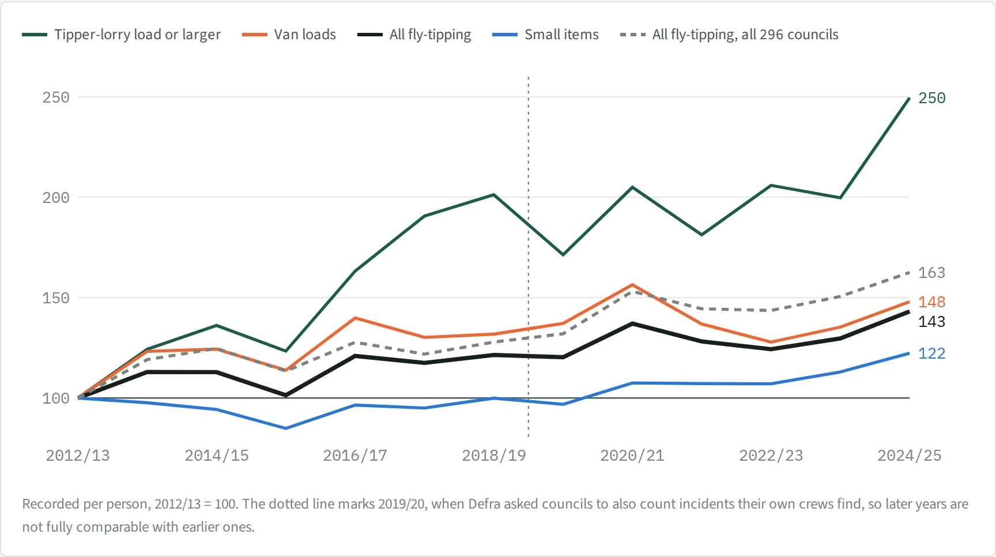
Figure 1. Recorded fly-tipping per person by size of load, England (2012/13 = 100). Lines by size of load are for the 223 councils whose numbers changed only gradually; the dashed line is all 296 councils. The dotted line marks 2019/20, when Defra asked councils to also count incidents their own crews find. Data: workbook sheet 1 Trend.
Size of load (223 councils with no sudden jump) | Per 1,000 people, 2012/13 | 2024/25 | Change
Small items (single bag, single item, car-boot load) | 7.7 | 9.4 | +22%
Van loads (small van or transit van) | 5.8 | 8.5 | +48%
Tipper-lorry load or larger | 0.32 | 0.80 | +149%
All fly-tipping | 13.5 | 19.4 | +43%

The bigger the load, the faster it grew. Lorry-sized dumps are hard to miss and were recorded before and after any change in recording, so their rise is the clearest sign of a real increase. Wales rose 34%, almost all of it since 2019. From 2019/20 Defra also asked councils to count the incidents their own crews find, so figures from then on are not fully comparable with earlier years.

2. Closing recycling centres did not measurably raise fly-tipping
Between 2012 and 2024, 973 of 35,664 neighbourhoods (2.7%) ended up at least 3 minutes' drive further from their nearest recycling centre, mostly because a centre closed. We tested whether that, or living far from a centre in general, leads to more fly-tipping. Before testing we accounted for four things:
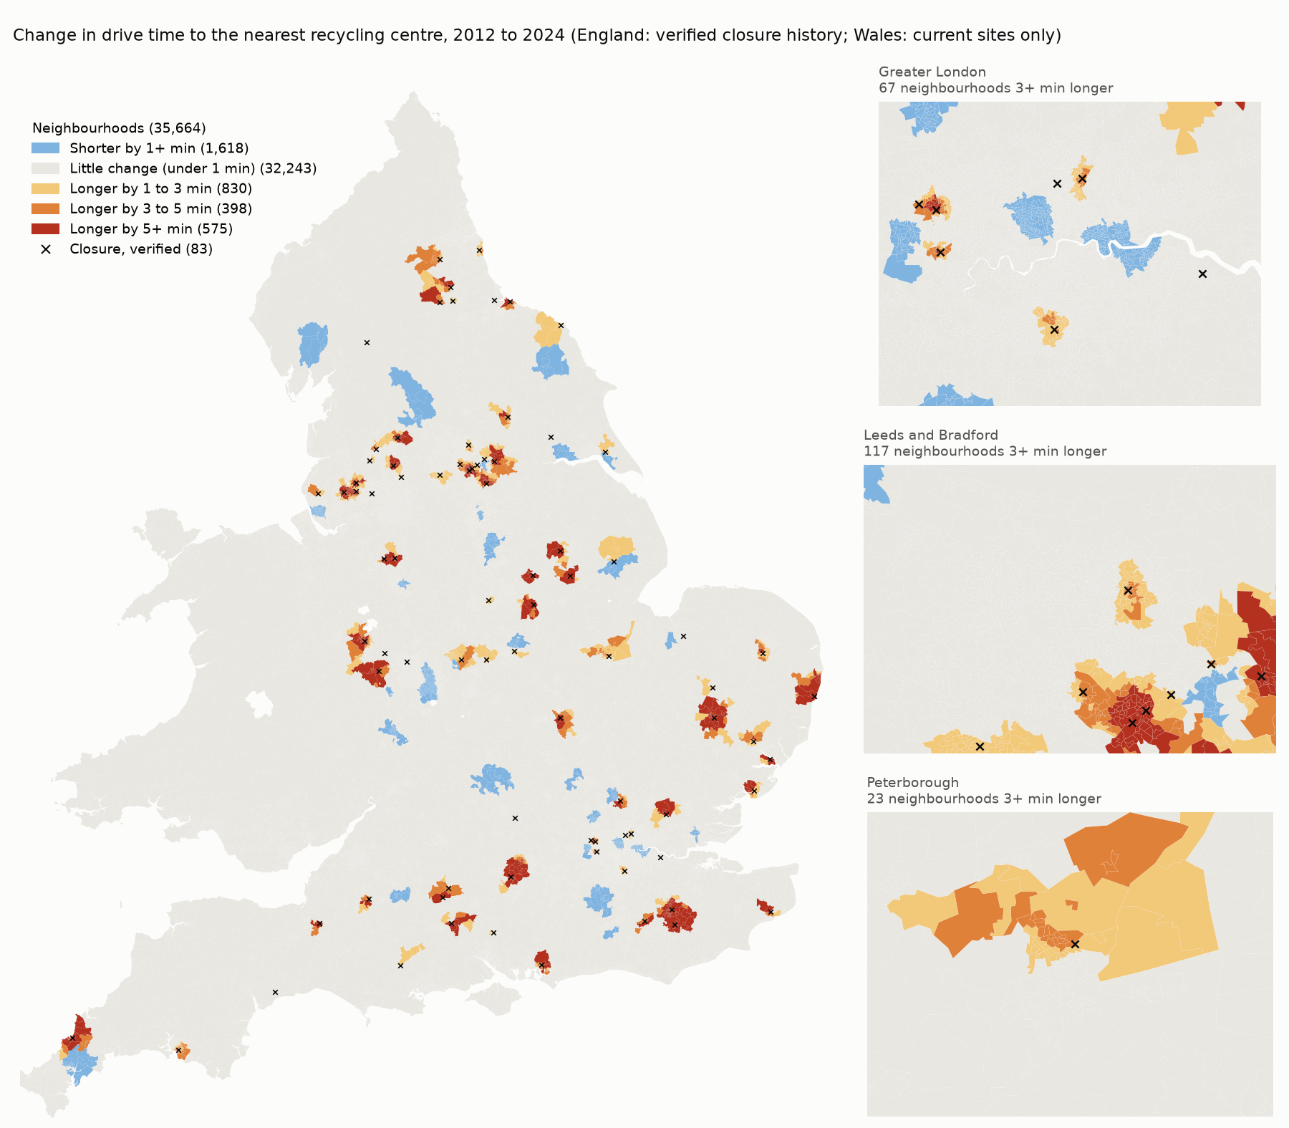
Figure 2. Change in drive time to the nearest recycling centre, 2012 to 2024, for 35,664 neighbourhoods; 973 are at least 3 minutes further away. Crosses mark the 83 verified closures. Wales is shown with its current centres only. Data: drive_time_change_lsoa.parquet and recycling_centres.parquet.
- False closures. Many "closures" in the Environment Agency's site records were not real. We checked all 256 sites that appear or disappear in those records against archived council websites, merged 35 duplicate records and checked the biggest cases by hand. Of 166 apparent closures, 83 remained.
- Differences in recording between councils, by comparing areas only within the same council and year.
- Who lives there: private renting, car ownership, density and whether an area is rural.
- A few heavy-reporting places dominating, by also giving every closure equal weight.
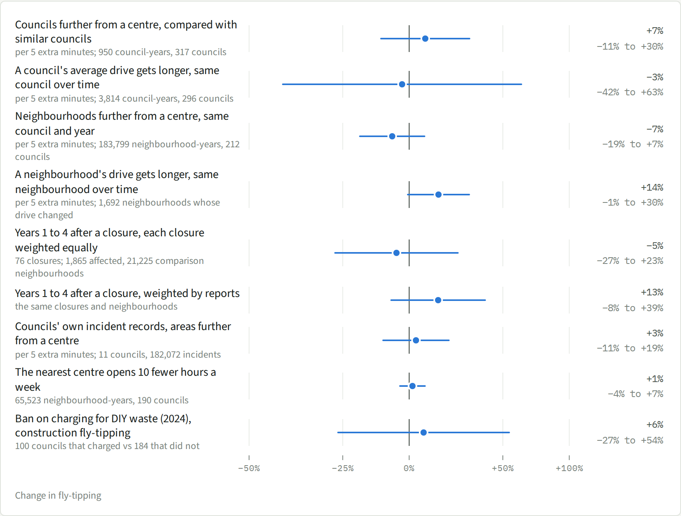
Figure 3. Every test of access to recycling centres: change in fly-tipping per resident, with its likely range (95% confidence interval). The number of observations is under each test. Data: workbook sheet 2 Access tests.
We also found no drive time beyond which fly-tipping jumps. Taken one by one, the 57 closures with enough reports for their own estimate show rises and falls about equally often; the typical closure was followed by no change (+2%).
One result points the other way: where a closure added 3 minutes or more, reports were 28% higher in the following years (+7% to +53%, 985 neighbourhoods). Each correction to the closure records has made the estimated effect of closures smaller, and this result has not yet been checked for dependence on a few closures. Taken together, the data rule out large effects of access to recycling centres on fly-tipping, but cannot rule out a small one where access gets much worse.

3. Who lives nearby matters more: private renting and car ownership
Two characteristics of residents explain more of the pattern than distance does, and they go with different kinds of fly-tipping. Comparing councils with similar deprivation, density and access, per 10 percentage points more households:
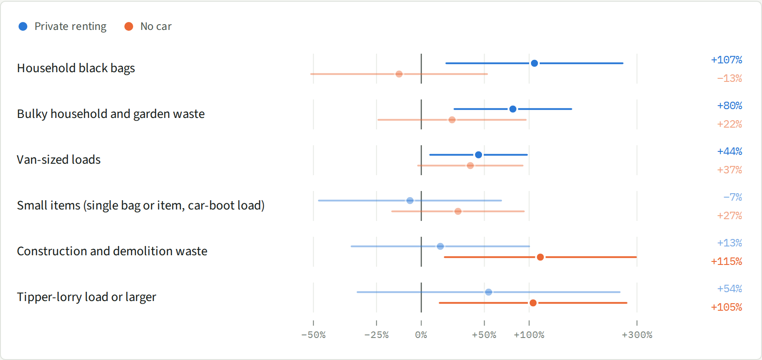
Figure 4. Change in fly-tipping per 10 percentage points more households renting privately (blue) or without a car or van (orange), by kind of fly-tipping. Comparing councils with similar deprivation, density and access: 950 council-years from 317 councils, 2022/23 to 2024/25. Faded values: the likely range includes no change. Data: workbook sheet 3 Renting and no car.
- Private renting goes with household clear-outs: black bags and bulky items, typically van-sized loads, not single small items. This fits waste left behind when tenants move out and rooms are cleared.
- Households without a car go with the biggest loads: builders' rubble and lorry-sized dumps. People without a car cannot take building waste or large items to a tip themselves.
Both links hold when we compare neighbourhoods inside the same council and year, where the way councils record fly-tipping cancels out: per 10 percentage points, +15% for private renting and +23% for no car (183,799 neighbourhood-years, 674,572 FixMyStreet reports, 212 councils). They also hold in twelve councils' own records of where incidents were found (about 379,000 incidents, including those crews find themselves): more fly-tipping with more car-less households in 10 of the 12 councils, and with more private renting in most.
Within neighbourhoods, bags are left close to home: they rise with private renting (+22%) and car-less households (+24%) in the neighbourhood itself, not in the surrounding area. Bulky items and builders' waste also rise next to areas with a lot of private renting (+59% to +123% per 10 points in the surrounding 8 km).

4. This is mostly kerbside fly-tipping, not countryside dumping
Recorded fly-tipping happens overwhelmingly in streets: 38% on highways, 18% on footpaths, 17% on council land and 9% in back alleys, together 83% of incidents in 2022/23 to 2024/25. Private and residential land accounts for 1.3% and farmland for 0.3%. In FixMyStreet, where a report says where the waste was, 64% describe a doorstep, pavement or street and 36% an out-of-the-way place such as a layby, field or verge. Bags (69%) and bulky items (70%) are mostly at the kerb; builders' waste is split evenly (52%).
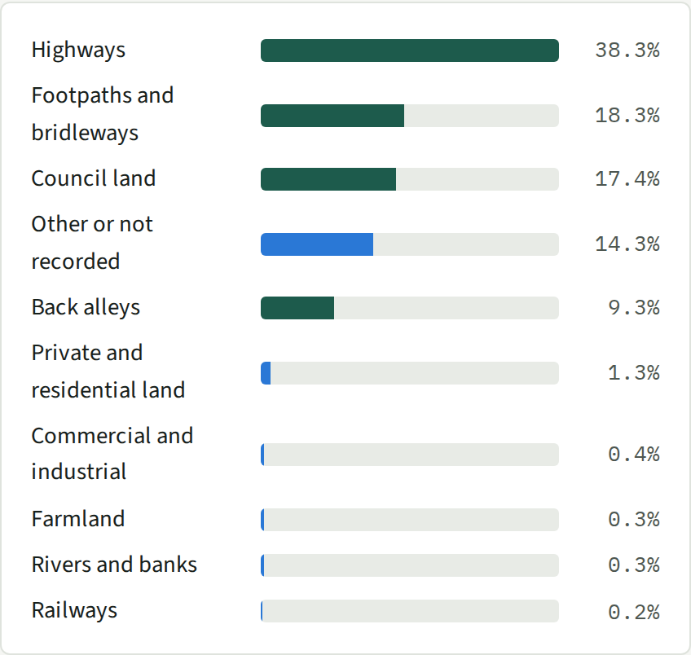
Figure 5. Type of land where fly-tipping was recorded, official council counts, England and Wales, 2022/23 to 2024/25 (3,624,424 incidents). Street-type land in green. Data: workbook sheet 4a Type of land.
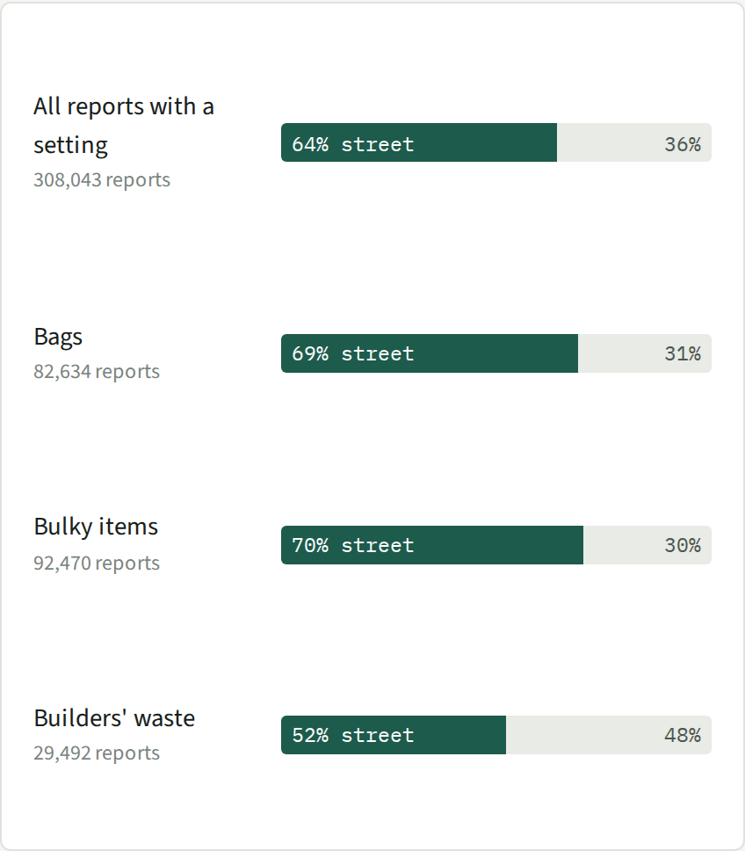
Figure 6. FixMyStreet reports whose text says where the waste was (308,043 reports): a doorstep, pavement or street, or an out-of-the-way place such as a layby, field or verge. Data: workbook sheet 4b Street or out of way.
The drivers explain the kerbside dumping. Private renting goes with fly-tipping in back alleys (+135% per 10 points) and on private and residential land (+128%); car-less households go with back-alley fly-tipping (+118%), but not with dumping on farmland (+9%, likely range −60% to +197%). Inside the same council, rural neighbourhoods report about as much fly-tipping per resident as urban ones.
The limits: countryside dumping is badly under-recorded. Farmers usually clear waste on their land themselves, so it rarely reaches council records (IECR estimates about 108,000 such incidents a year in England), and few people report rural dumping on FixMyStreet. Part of the growth in lorry-sized loads may be dumped in the countryside. Our findings explain kerbside fly-tipping; they say little about what drives countryside dumping.

5. Changes in renting and car ownership do not explain the rise, but more people moving home explains part of it
Between the 2011 and 2021 Censuses, the share of households renting privately rose and the share without a car fell (318 councils on 2025 boundaries):
Share of households | 2011 | 2021 | Change, points
Renting privately, England | 16.8% | 20.5% | +3.6
No car or van, England | 25.8% | 23.5% | −2.3
Renting privately, Wales | 14.1% | 17.0% | +2.8
No car or van, Wales | 22.9% | 19.4% | −3.5

Using the council comparisons from part 3, more renting should have raised fly-tipping by about 6% and fewer car-less households should have lowered it by about 5%. The two roughly cancel out, so together they predict almost no change.
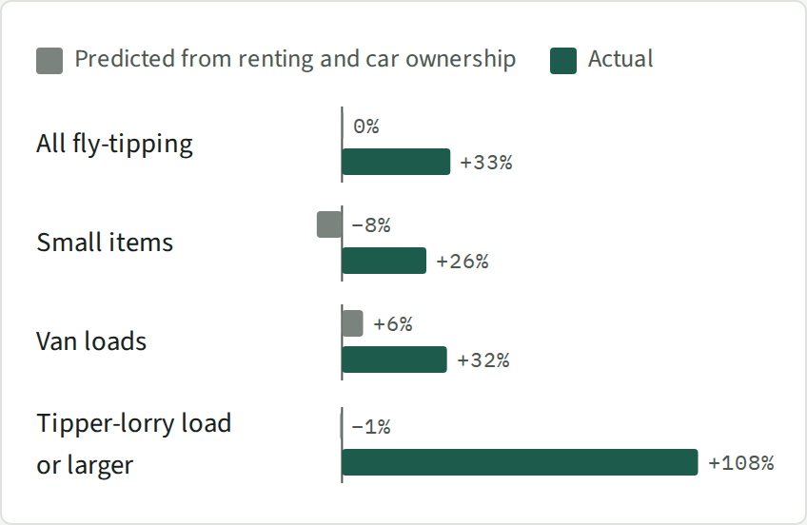
Figure 7. Change in recorded fly-tipping per person in England between 2012/13 to 2014/15 and 2022/23 to 2024/25 (296 councils), against the change predicted from the Census shifts in renting and car ownership. Data: workbook sheet 5a Predicted vs actual.
Councils where renting grew fastest, or where car ownership changed most, did not see faster growth in fly-tipping (294 councils; 222 with no sudden jump in recording). The rise happened almost everywhere, which points to causes that changed for all councils at once. We looked at three:
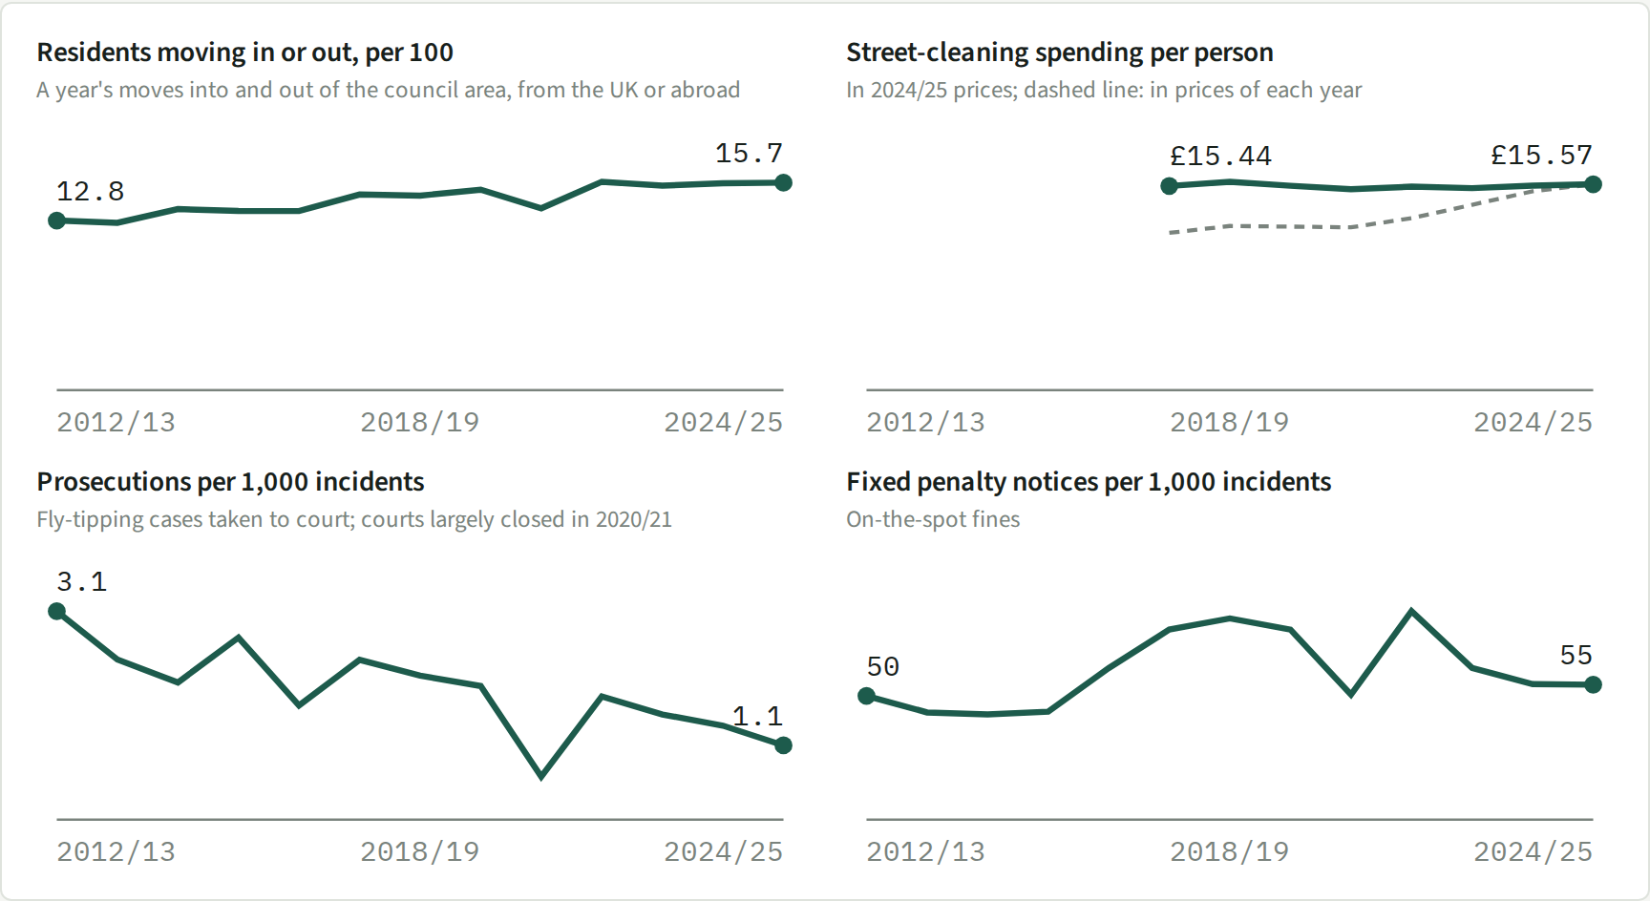
Figure 8. Other things that changed over the same years, England, 296 councils: residents moving into or out of their council area, street-cleaning spending per person (from 2017/18), prosecutions and fixed penalty notices per 1,000 incidents. Data: workbook sheet 5c Other factors by year.
- More people moving home goes with more fly-tipping. The share of residents moving into or out of their council area in a year rose from 12.8 to 15.7 in every 100 (England, 2012/13 to 2024/25). When a council's moving rate rises by 5 in every 100, its fly-tipping rises 16% in councils with no sudden jump in recording (likely range +1% to +34%; 222 councils, 2,875 council-years) and 22% in all councils (0% to +48%; 295 councils, 3,814 council-years). The link is clearest for van-sized loads (+20%, +1% to +43%), which fits clear-outs at moving time. Applied to the national rise in moving, this accounts for about 8% to 11% more fly-tipping, roughly a quarter to a third of the rise. Because each council is compared with itself, fixed differences between councils cannot explain this, but other things that changed at the same time could. Between councils, places with more moving do not record more fly-tipping once renting is allowed for, because the two go together.
- Spending on street cleaning did not fall. Per person, in 2024/25 prices, councils spent £15.44 in 2017/18 and £15.57 in 2024/25 (£11.90 and £15.57 in prices of each year). Councils that cut spending saw slightly more of the largest loads: 8% more if spending halves (+4% to +13%; 212 councils, 1,694 council-years), with no clear change for smaller loads. Because spending held steady nationally, it cannot explain the rise.
- Prosecutions did not keep up. Councils prosecuted 2,170 fly-tipping cases in 2012/13 and 1,377 in 2024/25 while incidents nearly doubled: from 3.1 to 1.1 prosecutions per 1,000 incidents. Fixed penalty notices roughly kept pace (50 per 1,000 incidents in 2012/13, 55 in 2024/25, peaking at 84 in 2021/22). A falling chance of being prosecuted fits the growth in large, deliberate dumps, but we cannot test it as a cause, because more incidents on their own push the prosecution rate down.
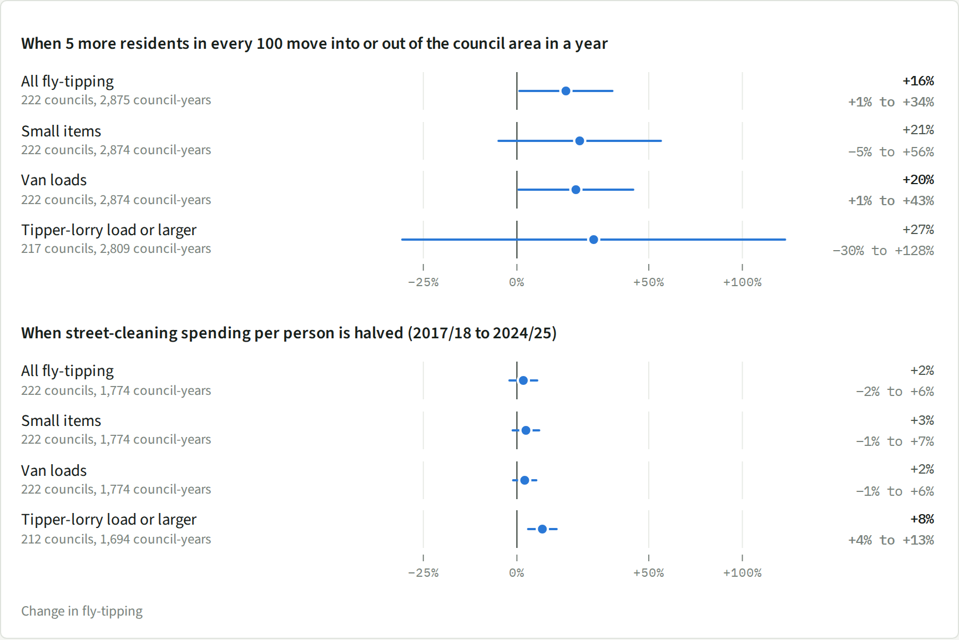
Figure 9. Each council compared with itself over time: change in fly-tipping when its moving rate rises by 5 in every 100 residents, or its street-cleaning spending per person is halved, after allowing for changes common to all councils each year. Councils with no sudden jump in recording; the number of councils and council-years is under each row. Data: workbook sheet 5d Same council over time.
What remains unexplained. Most of the rise, and especially the more than doubling of lorry-sized loads, is not explained by anything we can measure council by council. The likely candidates changed for the whole country at once: the cost of getting rid of waste legally, unlicensed waste collectors advertising online, and enforcement. One hint: lorry-sized dumps grew faster in councils with many households without a car (48% more growth per decade per 10 percentage points, +9% to +101%; 296 councils, 3,709 council-years), which would fit a growing trade in illegal collection for people who cannot get to a tip themselves. In the 223 councils with no sudden jump in recording the estimate is similar (+51%) but too uncertain to rule out no change (−10% to +154%), so it is suggestive only.

6. Methodology
Data.
Source | What it records | Size
Official council counts (Defra, StatsWales) | Yearly totals per council, by waste type, size of load and type of land; no locations | 13.2 million incidents, 318 councils, 2012/13 to 2024/25
FixMyStreet (mySociety) | Public reports with an exact location; waste type read from the report text | 904,027 reports, 2012 to 2025
Councils' own incident records | Where each incident the council dealt with was found | about 379,000 incidents, 12 councils
Environment Agency and Natural Resources Wales site records | Recycling centre locations by year | 845 centres
Archived council websites (Internet Archive) | Which centres were really open, their opening hours, booking and DIY charges | 12,524 pages from 316 council websites
OS Open Roads, Census 2021 | Road network for drive times; renting, car ownership, deprivation | 35,672 neighbourhoods
Census 2011 (Nomis KS402EW, KS404EW) | Renting and car ownership ten years earlier | 318 councils on 2025 boundaries
ONS population estimates | Residents and moves into and out of each council area | 318 councils, 2012 to 2024
Council revenue outturn (RO5), ONS consumer prices index | Street-cleaning spending, in 2024/25 prices | 296 councils, 2017/18 to 2024/25
Enforcement actions in the official counts | Prosecutions and fixed penalty notices | 296 councils, 2012/13 to 2024/25

A neighbourhood is an ONS Lower Layer Super Output Area, home to about 1,500 to 1,700 people.
Comparisons. Each question was tested in more than one way:
- Council against council: do councils with longer drives, more renting or fewer cars record more fly-tipping than otherwise similar councils?
- Neighbourhood against neighbourhood, inside a council and year: this removes differences in how councils record incidents and how much residents use FixMyStreet.
- The same place over time: when a council's or neighbourhood's drive time changes, does its fly-tipping change compared with places whose access did not?
- Closure by closure: neighbourhoods that lost their nearest centre against nearby neighbourhoods that did not, from four years before to four years after.
Models. All estimates come from Poisson regressions of counts with a population offset, so results are changes in fly-tipping per resident; likely ranges are 95% confidence intervals with errors clustered by council or waste authority.
Recording changes. A council's step change is a recorded rate that doubles or halves within a year or two and stays there, by more than three times its usual year-to-year variation. Signs that it is a recording change: small items becoming a much larger share; total incidents jumping while large loads do not; FixMyStreet reports in the council tripling; or a change in its recording basis. The largest steps were checked against council papers and local news.
Why it has risen (part 5). Three tests:
- Did the places change? The national change in each Census share times the council comparisons in part 3 gives the predicted change. For example, councils with 10 percentage points more private renting have about 18% more fly-tipping per resident; renting rose 3.6 points, so renting alone predicts about 6% more. This is compared with the actual change between 2012/13 to 2014/15 and 2022/23 to 2024/25.
- Did fly-tipping grow faster where renting grew faster? Each council's growth against its change in renting and car ownership, allowing for 2021 levels, deprivation and region, weighted by population. Also: whether the gap between high- and low-renting, car-owning and deprived councils widened year by year.
- Did anything else change in the same council at the same time? Each council compared with itself over time, after removing the change common to all councils each year, for the moving rate and for street-cleaning spending. Prosecutions and fines are shown as a trend only, because more incidents on their own lower the number per incident.
Every test was run in all councils and in the councils with no sudden jump in recording, and by size of load. Code: src/composition_change.py.
What the data cannot do. Official counts measure recording as well as dumping. FixMyStreet captures the incidents members of the public choose to report through one website, about 1 in 20 of those councils record. Countryside dumping is under-recorded in both. Renting and car ownership come from the 2011 and 2021 Censuses, so changes are measured over one ten-year step. Comparing a council with itself over time removes fixed differences between councils, but not other changes that happened at the same time.
Contains Environment Agency information © Environment Agency and/or database right. Contains OS data © Crown copyright and database right. Contains public sector information licensed under the Open Government Licence v3.0 (Defra, Welsh Government, ONS, Natural Resources Wales, MHCLG). FixMyStreet reports from mySociety's public Open311 service. Only aggregate results are shown.

