『Maple Bus 1.0』Peripheral
Hardware Specifications

Dreamcast Controller

Rev 1.00

Issued by
Sega Enterprises, Inc.
CS Development and Production Dep't, Second Division

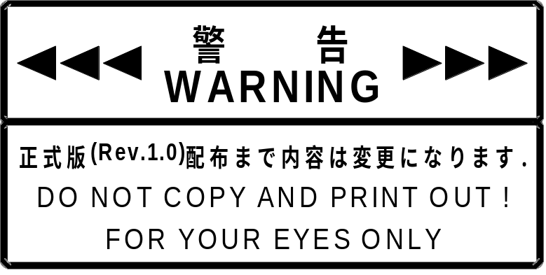

Revision：
1.00 1998/05/21 Initial release

Contents:

1 Dreamcast Controller Function Conditions 4
1.1 Dreamcast Controller Definition 4
1.2 Function Outline 4
1.3 Configuration Details 4
2 Dreamcast Controller Function Operation 7
3 Device ID 7
3.1 Maple Bus1.0 Device ID Configuration 7
4 Data Format 8
4.1 Read Format 8
4.2 Dreamcast Controller Function Information 9
4.3 Type 9
4.4 Fixed Device Status 9
4.5 Free Device Status 10
5 Remarks 11

Dreamcast Controller Function Conditions

Dreamcast Controller Definition
The Dreamcast Controller is an input type man/machine interface corresponding to the Maple Bus 1.0 Standard Specifications. It belongs to the function type "FT0: Controller".

Function Outline
Among the items included in the "FT0: Controller" specification, the Dreamcast Controller provides the following functions:
• Digital arrow keys: Ra, La, Da, Ua
• Digital buttons: A, B, C, X, Y, Z, Start
• Analog key: A3(Xa), A4(Ya)
• Analog lever: A1(AR), A2(AL)

Configuration Details
This section gives a detailed description of Dreamcast Controller function elements.

① Digital arrow key A: Ra, La, Da, Ua
These digital keys (buttons) have two states: push/release (= ON/OFF).
Ra and La as well as Da and Ua are arranged as symmetrical pairs. The Ra and La buttons are at the ends of a straight line (X axis), and the Da and Ua buttons are at the ends of another straight line (Y axis) crossing the X axis at a right angle. Ra is fo right side or right direction, La for left side or left direction, Da for down side or down direction or user near side, and Ua for up side or up direction or user far side.
The values are "pushed" = "0", "released" = "1".
ON key data for three or more keys may not be generated simultaneously.
The keys are intended mainly for use with the left hand.

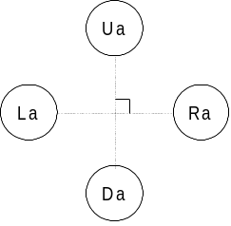
Fig. 1-1 Digital cross-key A button arrangement

② Digital buttons: A, B, X, Y, Start
These digital keys (buttons) have two states: push/release (= ON/OFF).
Simultaneous ON for multiple keys (buttons) must be detectable.
The values are "pushed" = "0", "released" = "1".

③ Analog key: A3(Xa),A4(Ya)
The analog key produces a value that changes linearly with the amount of movement from the initial position. The initial position is taken as 80h (origin). The value range is 00h (minimum) to FFh (maximum, in 01h units. From the key position, decreasing values are taken as the minus direction and increasing values as the plus direction. The key moves in these tw directions.
When the force on the key is removed, it centers itself automatically, returning to the initial (origin) position. A3 and A4 express the Xa axis and Ya axis, which are operated with the left hand.

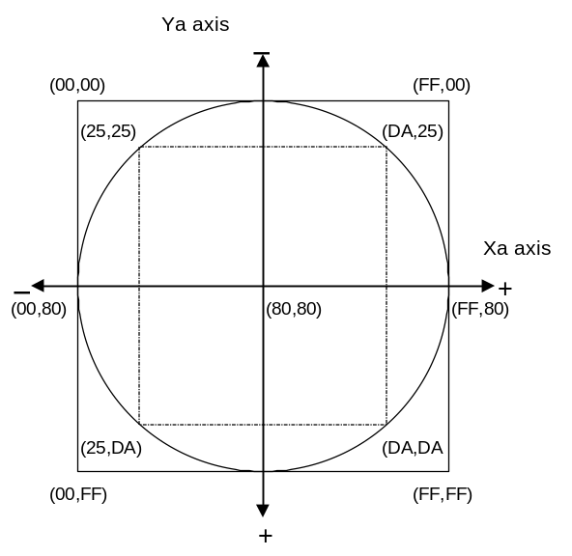
Fig. 1-2 Analog key data range

④ Analog lever: A1(AR), A2(AL)
The analog lever produces a value that changes linearly with the amount of movement from the initial position.
The initial position is taken as 00h (origin). The value range is 00h (minimum) to FFh (maximum, in 01h units. From the key position, decreasing values are taken as the minus direction and increasing values as the plus direction. The key moves in these tw directions, but from the initial (origin) position, it moves only in one direction.
When the force on the key is removed, it centers itself automatically, returning to the initial (origin) position. A1 mainly expresses the R axis and A2 the R axis. The R axis is moved with the left hand and the L axis with the right hand.
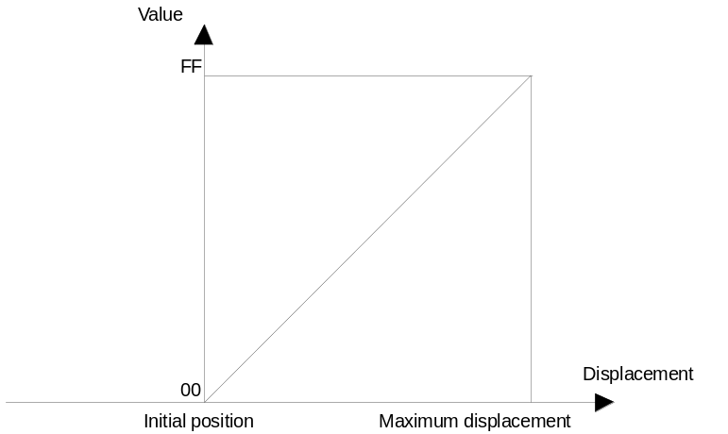

Fig. 1-3 Analog lever data range

Dreamcast Controller Function Operation
Function operation follows the "FT₀: Controller" specification.

Device ID
The device ID corresponds to the Maple Bus 1.0 Standard Specifications. The table below shows the memory image on the host.

Maple Bus1.0 Device ID Configuration
The configuration uses 16 bytes (128 bit).

bit | 7 | 6 | 5 | 4 | 3 | 2 | 1 | 0
1st Data | 0 | 0 | 0 | 0 | 0 | 0 | 0 | 0
2nd Data | 0 | 0 | 0 | 0 | 0 | 0 | 0 | 0
3rd Data | 0 | 0 | 0 | 0 | 0 | 0 | 0 | 0
4th Data | 0 | 0 | 0 | 0 | 0 | 0 | 0 | 1
5th Data | 0 | 0 | 0 | 0 | 0 | 0 | 0 | 0
6th Data | 0 | 0 | 0 | 0 | 1 | 1 | 1 | 1
7th Data | 0 | 0 | 0 | 0 | 0 | 1 | 1 | 0
8th Data | 1 | 1 | 1 | 1 | 1 | 1 | 1 | 0
9th Data | 0 | 0 | 0 | 0 | 0 | 0 | 0 | 0
10th Data | 0 | 0 | 0 | 0 | 0 | 0 | 0 | 0
11th Data | 0 | 0 | 0 | 0 | 0 | 0 | 0 | 0
12th Data | 0 | 0 | 0 | 0 | 0 | 0 | 0 | 0
13th Data | 0 | 0 | 0 | 0 | 0 | 0 | 0 | 0
14th Data | 0 | 0 | 0 | 0 | 0 | 0 | 0 | 0
15th Data | 0 | 0 | 0 | 0 | 0 | 0 | 0 | 0
16th Data | 0 | 0 | 0 | 0 | 0 | 0 | 0 | 0
Fig. 3-1 Device ID
1st - 4th data: Peripheral function type (FT)
5th - 8th data: Function definition block for 1st function (FD1)
9th - 12th data: Function definition block for 2nd function (FD2)
13th - 16th data: Function definition block for 3rd function (FD3)

① FT₀ - FT₃₁: Function type
Indicates the function type implemented by the peripheral. There are a total of 32 function types.

② FD₃₁ - FD₀: Function definition block
These blocks define the various elements that make up a function.

Data Format
This section describes the Dreamcast Controller data format.
The notation uses the memory image on the host.

Read Format
The key data format for reading data from the Dreamcast Controller function is shown below. The data format size is 8 bytes.

bit | 7 | 6 | 5 | 4 | 3 | 2 | 1 | 0
1st Data | Ra | La | Da | Ua | Start | A | B | 1
2nd Data | 1 | 1 | 1 | 1 | 1 | X | Y | 1
3rd Data | A1₇ | A1₆ | A1₅ | A1₄ | A1₃ | A1₂ | A1₁ | A1₀
4th Data | A2₇ | A2₆ | A2₅ | A2₄ | A2₃ | A2₂ | A2₁ | A2₀
5th Data | A3₇ | A3₆ | A3₅ | A3₄ | A3₃ | A3₂ | A3₁ | A3₀
6th Data | A4₇ | A4₆ | A4₅ | A4₄ | A4₃ | A4₂ | A4₁ | A4₀
7th Data | 1 | 0 | 0 | 0 | 0 | 0 | 0 | 0
8th Data | 1 | 0 | 0 | 0 | 0 | 0 | 0 | 0
Fig. 4-1 Read format

Key data description
1st: Digital button data (ON = "0", OFF = "1")
2nd: Digital button data (ON = "0", OFF = "1")
3rd: Analog axis 1 (A1) data. AR axis of analog lever.
4th: Analog axis 2 (A2) data. AL axis of analog lever.
5th: Analog axis 3 (A3) data. Xa axis of analog key.
6th: Analog axis 4 (A4) data. Ya axis of analog key.
7th: Analog axis 5 (A5) data. Not used. Set to "80h" (midpoint).
8th: Analog axis 6 (A6) data. Not used. Set to "80h" (midpoint).

Dreamcast Controller Function Information
This section describes device-specific information (device status).

Type
Fixed Device Status
This refers to 112 bytes of device status information data with a fixed format, comprising required information.

Free Device Status
This refers to a maximum of 40 bytes of device-specific status information that can be allocated freely.

Fixed Device Status
The Fixed Device Status area must include all the items listed below.

① Device ID
Size: 16 bytes
Description: Function type "FT₀" only
1st function definition
2nd function definition: None
3rd function definition: None
Data: 00h-00h-00h-01h-00h-0Fh-06h-FEh-00h-00h-00h-00h-00h-00h-00h-00h

② Country specification
Size: 1 byte
Description: For all countries
Data: FFh

③ Connection method
Size: 1 byte
Description: Expansion socket 1, upstream connection
Expansion socket 2, upstream connection
Data: 00h

④ Model name
Size: 30 bytes
Description: ASCII string "Dreamcast Controller"
Remaining slots to be padded with spaces (20h).
⑤ License
Size: 60 bytes
Description: ASCII string "Produced By or Under License From SEGA ENTERPRISES,LTD."
Remaining slots to be padded with spaces (20h).

⑥ Standby current consumption
Size: 2 bytes
Description: 43.0 mA
Data: 01h-AEh

⑦ Maximum current consumption
Size: 2 bytes
Description: 50 mA
Data: 01h-F4h

Free Device Status
The Free Device Status area can include information about developers, designers, and programmers or any other information. The host can obtain this information by issuing the "All Device Request" command.

For the Dreamcast Controller, the following 40 bytes of data should be included.
"Version 1.000,1998/05/11,315-6125-AB".
"Analog Module: The 4th Edition. 05/08"

Remarks

