"Maple Bus 1.0"
Peripheral Hardware Specifications
Microphone Device
(Sound Input Peripheral)
Revision 1.02

Issued by
Sega Enterprises, Inc.
CS Development and Production Dep't, Second Division

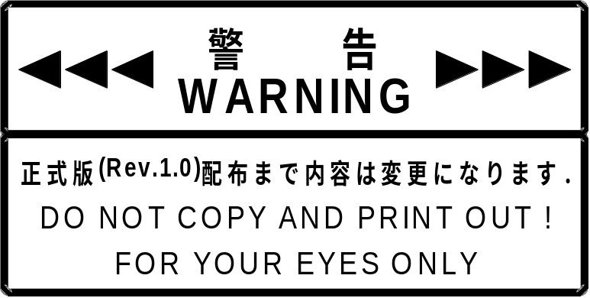
Revision History
Rev 0.1 1997/12/16 Preliminary Specifications

Rev 0.2 1997/12/25 Long swap of all data in 4 byte units

Rev 0.3 1998/1/5 Partial change of sampling data send format
Partial deletion of subcommand 1
→ Get_Sampling_Rate,Get_Sampling_Bit

Rev 0.4 1998/1/11 Deleted AGC subcommand
Added Test_Mode subcommand
SIP block diagram changed

Rev 0.41 1998/1/17 Long swap of frame start 12 byte in 4 byte units
Added EXTU_BIT subcommand
Errata correction, p. 8: "Command Type Unknown"
Added Test_Mode subcommand function
Added 19 SIP data usage bit

Rev 0.42 1998/1/26 Changed frame configuration in actual transmission
Partially changed EXTU_BIT subcommand specification
Added subcommand table explanation

Rev 0.8 1998/3/31 Errata correction μ-Low → μ-Law

Rev 0.9 1998/5/14 Changed support for power connection time hard reset and other commands
Added information for SIP. 2.7.7
Specifications for 3 send/receive sequence
1998/5/18 Revision of various expressions
Confirmation of tentative items excluding microphone specifications
Changed Figure 1.1 and Table 1.1 to specifications for finished product
Deleted description for SET 4 version in 2.7.8
1998/11/11 Added sampling buffer capacity
Revised 2.7.7 SIP information
Added 3.3 "Note Regarding Acquisition of Sampling Data"
Added 3.4 "Buffers for 14 bit Sampling and 8 bit Sampling"

Rev1.0 1999/04/05 Added 3.6 "Operation when two expansion devices are connected to the same port"

Rev1.01 1999/06/11 2.7.7. Current consumption, maximum current consumption changed from
300 mA to 30.0 mA

Rev1.02 1999/11/24 Revised sampling frequency in 1.2 "Sound Input, Sampling, and Other
Functions" and added allowable sampling time.
CONTENTS
1 SIP (Sound Input Peripheral) Outline 4
1.1 SIP Function Outline 4
1.2 Sound Input, Sampling, and Other Functions 4
1.3 Hardware Configuration 5
2 Command Description 7
2.1 Basic SIP Commands 7
2.2 Precautions for Basic SIP Commands 8
2.2.1 Device Kill 8
2.2.2 Limitations for "Transmit Again" Command From Host 8
2.2.3 Power-On 8
2.3 Error Detection When Receiving Commands From Host (SIP Internal Specification) 9
2.3.1 Parity Error Detected 9
2.3.2 Buffer Overflow Detected 9
2.3.3 Out-of-Range Data Detected 9
2.3.4 Function Type Error Detected 9
2.4 First SIP Function Definition Block (Command List) 10
2.5 Second and Third SIP Function Definition Block 10
2.6 Description of FT₄_Control 11
2.7 Subcommands 12
2.7.1 Get_Sampling_Data Subcommand 12
2.7.2 Basic_Control Subcommand 14
2.7.3 AMP_Control Subcommand 16
2.7.4 EXTU_BIT Subcommand 17
2.7.5 Test_Mode Subcommand 18
2.7.6 Data Transfer Command To Send Sampling Data 19
2.7.7 SIP Information 21
2.7.8 SIP Sampling Data Transmission Format 22
3 Hardware characteristics 25
3.1 Interval for Identifying Destination AP Upon Frame Receipt 25
3.2 Interval When The Frame Cannot Be Received 25
3.3 Note Regarding Acquisition of Sampling Data 26
3.4 Buffers for 14 bit Sampling and 8 bit Sampling 27
3.5 Resetting SIP 27
3.6 Operation When Two Expansion Devices are Connected to the Same Port 28

SIP (Sound Input Peripheral) Outline

SIP Function Outline
The Sound Input Peripheral (abbreviated SIP) for new-generation games uses analog sound (normally voice) input via a microphone. Sampling is performed to convert the input into digital data which are then transferred to the host.
This peripheral conforms to the "Maple Bus" Standard Specifications, belonging to function type "FT₄".
Currently, the planned function specifications are as follows.

• Sampling frequency 8.0854 kHz ± 0.5% kHz / 11.02557 kHz ± 0.5%
• Quantization: 14 bit linear / 8 bit μ-Law CODEC
• Communication with host uses the LM-Bus.
• Transfer rate is 1.94 Mbps maximum.
• Commands sent from host can be used to control gain, select sampling frequency, start/stop sampling, etc.

Sound Input, Sampling, and Other Functions
① ADC
• Sampling principle: Differential comparator
• Sampling rate: 8.0854 kHz ± 0.5% kHz / 11.02557 kHz ± 0.5%, switchable by command
• Quantization: 14 bit linear / 8 bit μ-Law CODEC, switchable by command
• Data format: 16 bit (effective digit number 14 bits), 2's complement
• Dynamic range: 70 dB or better
② AMP: -15 to +16dB, adjustable by command (1dB step)
③ LPF: 5th switching capacity filter
④ Microphone: Electret condenser microphone (S/N60dB or better, sensitivity about -40dB, omnidirectional)
⑤ Sampling buffer: 240 x 14 bits or 240 x 8 bits
⑥ Allowable sampling time: At 8 kHz Approx. 30.0 ms (NTSC, approx. 1.8INT minute)
At 11.025 kHz Approx. 21.0 ms (NTSC, approx. 1.3INT minute)

Hardware Configuration
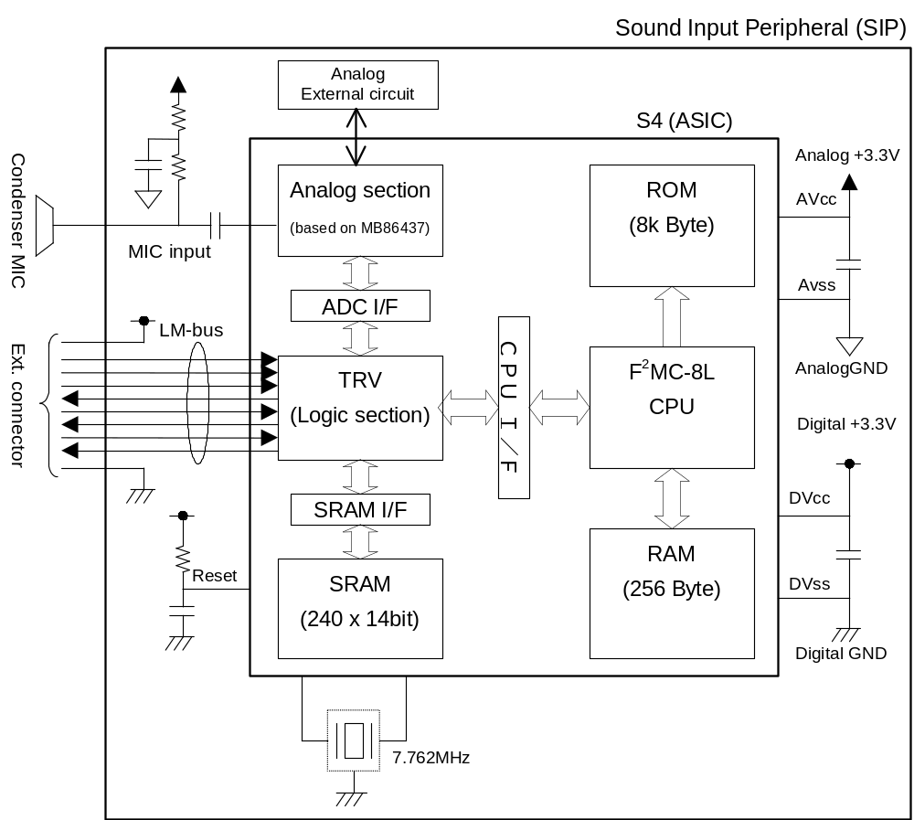
Fig. 1-1 SIP hardware configuration
Table 1-1 Table 1-1 SIP IC (S4) pin function
Pin No. | Designation | I/O | Analog/  Degital | Function | Note
1 | P21 | I/O | D | Test pin (HAKX) | Open
2 | P20 | I/O | D | Test pin (BUFC) | Open
3 to 6 | P17-P14 | I/O | D | Test pin
7 | Vcc | P | D | Power supply (digital)
8 | X1 | C | D | Clock pin
9 | X0 | C | D | Clock pin
10 | Vss | P | D | Digital GND
11-14 | P13-P10 | I/O | D | Test pin | Open
15-22 | P07-P00 | I/O | D | Test pin | Open
23-25 | TMODE0-2 | I | D | Test mode select pin | Fixed low
26 | PVD3 | P | A | Power supply (analog)
27 | PVD1 | P | A | Power supply (analog)
28 | HVD | - | A | AVcc/2 pin
29 | PVS1 | P | A | Analog GND
30 | SG | - | A | Analog reference voltage output pin
31 | MIP | - | A | MIC AMP input pin (+)
32 | MIM | - | A | MIC AMP input pin (-)
33 | MOUT | - | A | MIC AMP output pin
34 | PVD2 | P | A | Power supply (analog)
35 | BBO | - | A | Electric volume output pin
36 | LPFI | - | A | LPF input AMP input (+)
37 | LPFM | - | A | LPF input AMP input (-)
38 | LPFO | - | A | LPF output pin
39 | ADI | - | A | ADC input AMP input (+)
40 | ADM | - | A | ADC input AMP input (-)
41 | PVS2 | P | A | Analog GND
42 | PVS3 | P | A | Analog GND
43 | TESI0 | I | D | Test mode select pin | Fixed high
44 | TESI1 | I | D | Test mode select pin | Fixed low
45-47 | TESO0-2 | O | D | Test status output pin
48 | Vss | P | D | Digital GND
49 | Presetn | I | D | Reset pin
50 | ID0 | I | D | LM-Bus
51 | SDCKB_O | O | D | LM-Bus
52 | SDCKB_I | I | D | LM-Bus
53 | ID1 | I | D | LM-Bus
54 | SDCKA_O | O | D | LM-Bus
55 | SDCKA_I | I | D | LM-Bus
56 | SDCKA EN | O | D | LM-Bus
57-58 | MD0-1 | I | D | CPU op. mode pin | Fixed low
59 | P27 | I/O | D | Test pin (ALE) | Open
60 | P26 | I/O | D | Test pin (RDX) | Open
61 | P25 | I/O | D | Test pin (WRX) | Open
62 | P24 | I/O | D | Test pin (CLK) | Open
63 | P23 | I/O | D | Test pin (RDY) | Fixed high
64 | P22 | I/O | D | Test pin (HRQ) | Open

Command Description

Basic SIP Commands
SIP supports the following commands. When a command other than those listed below is received, SIP returns the message "Command Unknown".

Table 2-1 Supported commands (Preliminary)
 | Command code | Command | Size | Expected return value
Host command | 01H | Device Request | 00H | Device Status
Host command | 02H | All Status Request | 00H | Device All Status
Host command | 03H | Device Reset | 00H | Device Reply
Host command | 04H | Device Kill | 00H | Device Reply
Host command | 0FH | FT₄_Control | 02H - Pending | See subcommands
Host command | FCH | Transmit Again | 00H | As required

 | Command code | Command | Size | Expected return value
Device (extended) command | 05H | Device Status | 1CH | [none]
Device (extended) command | 06H | Device All Status | 3FH | [none]
Device (extended) command | 07H | Device Reply | 00H | [none]
Device (extended) command | 08H | Data Transfer | 01H - FFH | [none]
Device (extended) command | FEH | Function Type Unknown | 00H | [none]
Device (extended) command | FDH | Command Unknown | 00H | [none]

The above commands conform to the "Maple Bus 1.0" standard specifications.
Please refer to the "Maple Bus 1.0" documentation for details.

Precautions for Basic SIP Commands

Device Kill
When this command is received, there will be no more response to the host until a hardware reset occurs, followed by a "Device Request" command.

Limitations for "Transmit Again" Command From Host
In response to the "Get Sampling Data" command from the host, the SIP sends sampling data to the host, using the "Data Transfer" command. After transmission to the host is completed, the SIP does not retain the sampling data. Therefore the "Transmit Again" command is prohibited after the "Get Sampling Data" command.
* When "Transmit_Again" is received under the above conditions, SIP does not guarantee the contents of the response data.

Power-On
• Device_Request
After power has been switched on, no response is returned if a parity error or data overflow occurs when the first "Device Request" is received.
• Hard reset
After power has been switched on, if a hard reset is received before the first "Device Request", SIP accepts the hard reset and returns to the default configuration.
• Other commands
After power has been switched on, no command other than hardware reset will be accepted until the first "Device Request" has been received.

Error Detection When Receiving Commands From Host (SIP Internal Specification)
* "Receiving commands" here refers to the condition when the AP has established that a command addressed to itself has been received.

Parity Error Detected
When a parity error is detected while a command is received from the host, the frame is not reliable, and no command response is sent to the host.

Buffer Overflow Detected
When a buffer overflow (when the receive frame is 12 bytes or greater) is detected while a command is received from the host, the command will not be recognized by the SIP. Therefore the response "Command Unknown" will be sent to the host.

Out-of-Range Data Detected
When a setting value such as "AMP_Control" is sent to the SIP and the value is out of range, the response "Command Unknown" will be sent to the host.

Function Type Error Detected
When a command (frame) comprising a different function type is received, the response "Function Type Unknown" will be sent to the host.

First SIP Function Definition Block (Command List)
The first SIP function definition block is shown below.

Table 2-2 First SIP function definition block
Bit | Corresponding subcommand | Setting value | Bit | Corresponding subcommand | Setting value
FD1₃₁ | Reserved | 0 | FD1₁₅ | Reserved | 0
FD1₃₀ | Reserved | 0 | FD1₁₄ | Reserved | 0
FD1₂₉ | Reserved | 0 | FD1₁₃ | Reserved | 0
FD1₂₈ | Reserved | 0 | FD1₁₂ | Reserved | 0
FD1₂₇ | Reserved | 0 | FD1₁₁ | Reserved | 0
FD1₂₆ | Reserved | 0 | FD1₁₀ | Reserved | 0
FD1₂₅ | Reserved | 0 | FD1₉ | Reserved | 0
FD1₂₄ | Reserved | 0 | FD1₈ | Reserved | 0
FD1₂₃ | Reserved | 0 | FD1₇ | Reserved | 0
FD1₂₂ | Reserved | 0 | FD1₆ | Reserved | 0
FD1₂₁ | Reserved | 0 | FD1₅ | Reserved | 0
FD1₂₀ | Reserved | 0 | FD1₄ | Reserved | 0
FD1₁₉ | Reserved | 0 | FD1₃ | EXTU_BIT | 1
FD1₁₈ | Reserved | 0 | FD1₂ | AMP_GAIN | 1
FD1₁₇ | Reserved | 0 | FD1₁ | Basic_Control | 1
FD1₁₆ | Reserved | 0 | FD1₀ | Get_Sampling_Data | 1

Table 2-3 First SIP function definition block
Bit | 7 | 6 | 5 | 4 | 3 | 2 | 1 | 0
5th Data | 0 | 0 | 0 | 0 | 0 | 0 | 0 | 0
6th Data | 0 | 0 | 0 | 0 | 0 | 0 | 0 | 0
7th Data | 0 | 0 | 0 | 0 | 0 | 0 | 0 | 0
8th Data | 0 | 0 | 0 | 0 | 1 | 1 | 1 | 1

Second and Third SIP Function Definition Block
The second and third SIP function definition block is "00h".

Description of FT₄_Control
SIP supports the Maple-Bus standard "FT₄_Control" command. The frame is shown below.
Note: The frame shown here represents the configuration in actual communication.

Table 2-4 FT₄_Control frame
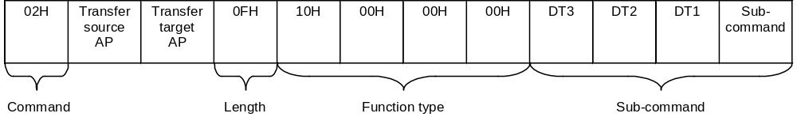

The setting values for the various SIP functions are specified with subcommands, as shown on the next page.

Subcommands
Note: The subcommand table is assumed to be stored in the work RAM of the host. The left side is low-order address and the right side the high-order address.

Get_Sampling_Data Subcommand
Function: Used by host to request sampling data and set AMP gain.
Issue privilege: Host

Table 2-5 Get_Sampling_Data subcommand
Subcommand | DT1 | DT2 | DT3
01H | 00H - 1FH | 00H | 00H

DT1: Set AMP gain
Setting values between 20H and FFH are not accepted. In this case, the current value is maintained.

Table 2-6 Parameters and gain (preliminary)
Parameter | AMP gain
00H | -15
01H | -14
02H | -13
03H | -12
04H | -11
05H | -10
06H | -9
07H | -8
08H | -7
09H | -6
0AH | -5
0BH | -4
0CH | -3
0DH | -2
0EH | -1
0FH | 0 (default)
10H | +1
11H | +2
12H | +3
13H | +4
14H | +5
15H | +6
16H | +7
17H | +8
18H | +9
19H | +10
1AH | +11
1BH | +12
1CH | +13
1DH | +14
1EH | +15
1FH | +16

DT2: Set to 00H.
DT3: Set to 00H.

Response: See description of sampling data in the Data Transfer command section of " Basic SIP SCommands".

Basic_Control Subcommand
Function: Sets the following functions.
• Start/stop sound sampling
• Select sampling frequency
• Select sampling bit count
Issue privilege: Host

Table 2-7 Basic_Control subcommand
Subcommand | DT1 | DT2 | DT3
02H | See below | 00H | 00H

DT1:

Bit | 7 | 6 | 5 | 4 | 3 | 2 | 1 |  | 0
DT1 | Sampling | 0 | 0 | 0 | Sampling frequency |  |  | Quantization

• Sampling:
Setting this bit to "1" starts sampling. Setting the bit to "0" stops sampling.
• Sampling frequency:
The following four settings are available for the sampling frequency.

Setting value | Setting level
00 | 11.025 kHz
01 | 8 kHz
10 | Not used (No change)
11 | Not used (No change)

Under the SIP standard, "00" selects a sampling frequency of 11.025 kHz and "01" selects a sampling frequency of 8 kHz. If other values ("10" - "11") are received, the current sampling frequency setting is maintained.
• Quantization:
The following four settings are available for the sampling bit rate (quantization).

Setting value | Setting level
00 | 14 bit
01 | 8 bit
10 | Not used (No change)
11 | Not used (No change)

For SIP, "00" selects 14-bit sampling and "01" selects 8-bit sampling. If other values ("10" - "11") are received, the current quantization setting is maintained.

DT2: 00H
DT3: 00H
* For SIP, set "Reserved" items to "00H".

Response: Standard Maple Bus "Device Reply" is sent.

Note:
As shown below, the sampling frequency and quantization settings may not be changed while sampling is in progress.
Stop the sampling temporarily.

① To cause SIP to perform sampling at 14 bit, 11 kHz, the following subcommand is sent.

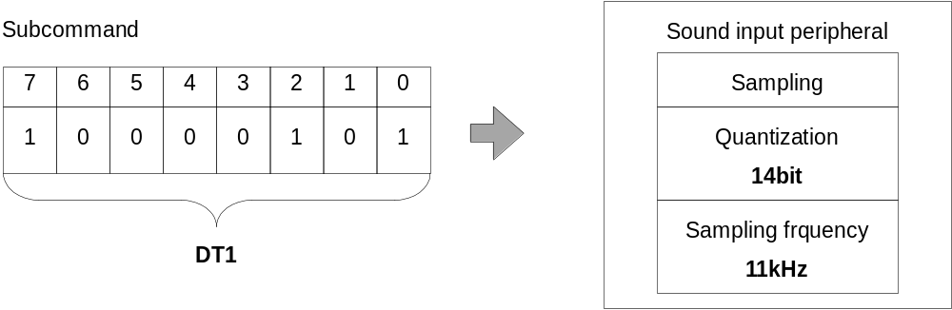

To change the setting, send the command as shown below. This will stop sampling and then change the quantization and sampling frequency setting.

② Change DT1 bit 7 in the subcommand shown in ① to "0" (stop sampling), and change the quantization and sampling frequency settings.

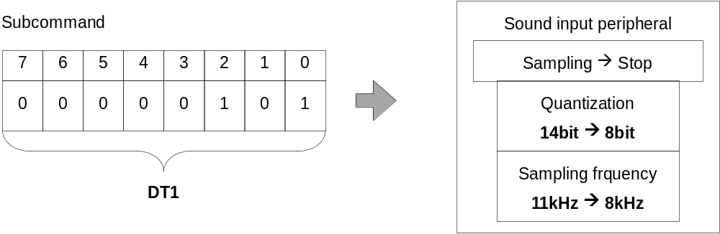

The change can also be made using the command as shown below. In this case, the quantization setting and sampling frequency setting are changed and then sampling starts.

③ If the SIP setting is 14 bit / 11 kHz and sampling is currently stopped, the command below changes the settings to 8 bit / 8 kHz and starts sampling.

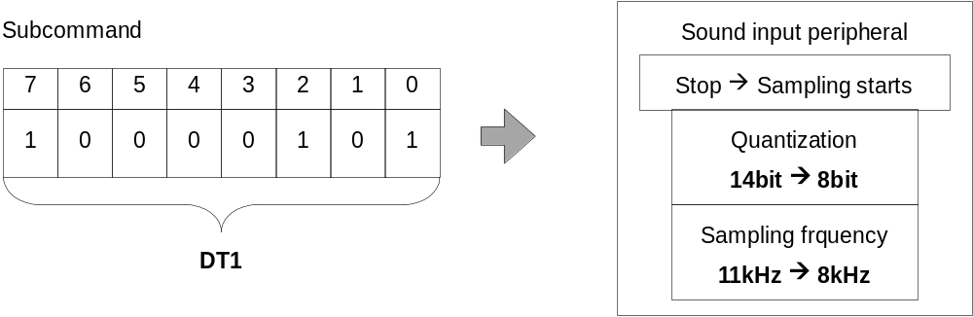

AMP_Control Subcommand
Function: Sets the sound input AMP gain.
Issue privilege: Host

Table 2-8 AMP_Control subcommand
Subcommand | DT1 | DT2 | DT3
03H | See below | 00H | 00H

DT1: AMP gain setting value

Table 2-9 Parameters and gain (preliminary)
Parameter | AMP gain
00H | -15
01H | -14
02H | -13
03H | -12
04H | -11
05H | -10
06H | -9
07H | -8
08H | -7
09H | -6
0AH | -5
0BH | -4
0CH | -3
0DH | -2
0EH | -1
0FH | 0 (default)
10H | +1
11H | +2
12H | +3
13H | +4
14H | +5
15H | +6
16H | +7
17H | +8
18H | +9
19H | +10
1AH | +11
1BH | +12
1CH | +13
1DH | +14
1EH | +15
1FH | +16

DT2: 00H
DT3: 00H

Response: Standard Maple Bus "Device Reply" is sent.

EXTU_BIT Subcommand
Function: Specifies the expansion method for data sampled at the "14bit_Linear" setting.
Under the SIP specification, the lower 2 bits of data sampled with 14-bit linear sampling are expanded for sending to the host.

Table 2-10 Sampling data format
Bit | 15 | 14 | 13 |  | 12 | 11 | 10 | 9 | 8 | 7 | 6 | 5 | 4 | 3 |  | 2 | 1 |  | 0
D | MSB |  |  | sampling data |  |  |  |  |  |  |  |  |  |  | LSB |  |  | * |  | *

Issue privilege: Host

Table 2-11 EXTU_BIT subcommand
Subcommand | DT1 | DT2 | DT3
04H | See below | 00H | 00H

DT1: See table below

Setting value | Expansion
00H | Lower 2 bits are set to "00".
01H | 2 LSB are copied to "**"
02H | Lower 2 bits are set to "10".
03H | Use prohibited
... | .....
FFH | Use prohibited
* If an out-of-range value (03H - FFH) is received, the current setting is maintained.
In this case, the SIP returns the "Command Unknown" response.

DT2: 00H
DT3: 00H

* While sampling is in progress, the SIP will not accept this command and will return the "Command Unknown" response. Be sure to stop sampling before issuing the command.

Response: Standard Maple Bus "Device Reply" is sent.

Test_Mode Subcommand
Function: Can be used in various formats for accessory equipment of the sound input peripheral (FT₄).
This is a test command designed to be used for debugging. It should not be used in an application.
Issue privilege: Host

Table 2-12 Test_Mode subcommand
Subcommand | DT1 | DT2 | DT3
FCH | 00H | 00H | 00H

Response: Maple Bus standard "Data Transfer" is sent. The first 12 bytes of the frame are the same as for sampling data, followed by data as shown in the table below.

Send sequence | Register
1 | CREG0
2 | CREG1
3 | CREG2
4 | SCREG
5 | ADCREG0
6 | ADCREG1
7 | SDSREG
8 | LREG
9 | Receive command
10 | ERROR point
11 | 00H
12 | ERROR yes/no

Data Transfer Command To Send Sampling Data
Note: The frame shown here represents the configuration in actual communication.

Function: Transfer of sampling data currently stored by the sound input peripheral.
Issue privilege: Device, extended device

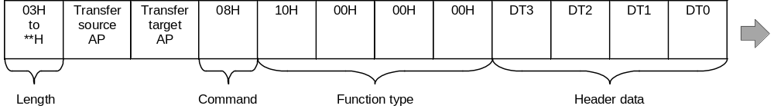

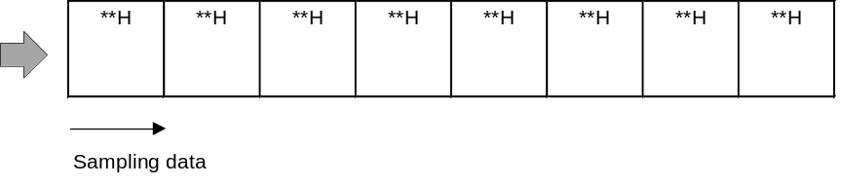

Regarding the sampling data sequence, please refer to the section "SIP Sampling Data Send Format".

If no sampling was carried out and a request for sampling data is received from the host, the frame shown below (no sampling data) is sent.

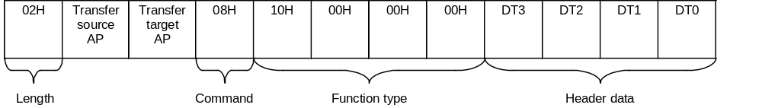
FT₄ data: When sampling data are sent, the frame is assembled as shown in the above illustration.

DT0 | DT1 | DT2 | DT3
FT₄ status | AMP setting value | 00H | Sampling count

• Sampling count: Number of times sampling has been carried out.
• AMP setting value: Currently selected input gain.
• FT₄ status: Shown below

BIT | 7 | 6 | 5 | 4 | 3 | 2 | 1 | 0
NAME | 0 | SBFOV | 0 | 14LSB1 | 14LSB0 | SMPL | μ-Law | Fs

SBFOV: Sampling data buffer overflow condition (0: normal, 1: overflow)
14LSB1,0: Linear sampling data expansion method flag
SMPL: Sampling operation start (0: stop, 1: Execute sampling)
μ-Law: CODEC conversion (0: 14 bit Linear, 1: 8 bit μ-Law CODEC)
Fs: Sampling frequency setting (0:11.025 kHz, 1: 8.0 kHz)

* Refer to 3.3 "Note Regarding Acquisition of Sampling Data" for further information about SBOFV.

SIP Information
The following describes the information sent by "Device Status" and "Device All Status".
(The Device All Status dumped by Codescape is used as an example.)

addr | +0 | +1 | +2 | +3 | +4 | +5 | +6 | +7 | +8 | +9 | +A | +B | +C | +D | +E | +F |  | ascii
000000 | 06 | 00 | 01 | 47 | 00 | 00 | 00 | 10 | 00 | 00 | 00 | 0F | 00 | 00 | 00 | 00 |  | ...G..................SoundInput Peripheral (S.I.P.) Produced By or Under License From SEGA ENTER PRISES,LTD.  ,.,.Version 1.000,1998/05/22,315-6182  S4(SegaSoundSamplingSystem)/Sampling Rate11.0257or8.085kHz/Bit14or8bit/NTSC only/Consumer Deveropment & Mamufacturing DIV.CSPD2-3
000010 | 00 | 00 | 00 | 00 | 03 | 01 | 53 | 6F | 75 | 6E | 64 | 49 | 6E | 70 | 75 | 74
000020 | 50 | 65 | 72 | 69 | 70 | 68 | 65 | 72 | 61 | 6C | 20 | 28 | 53 | 2E | 49 | 2E
000030 | 50 | 2E | 29 | 20 | 50 | 72 | 6F | 64 | 75 | 63 | 65 | 64 | 20 | 42 | 79 | 20
000040 | 6F | 72 | 20 | 55 | 6E | 64 | 65 | 72 | 20 | 4C | 69 | 63 | 65 | 6E | 73 | 65
000050 | 20 | 46 | 72 | 6F | 6D | 20 | 53 | 45 | 47 | 41 | 20 | 45 | 4E | 54 | 45 | 52
000060 | 50 | 52 | 49 | 53 | 45 | 53 | 2C | 4C | 54 | 44 | 2E | 20 | 20 | 20 | 20 | 20
000070 | 2C | 01 | 2C | 01 | 56 | 65 | 72 | 73 | 69 | 6F | 6E | 20 | 31 | 2E | 30 | 30
000080 | 30 | 2C | 31 | 39 | 39 | 38 | 2F | 30 | 35 | 2F | 32 | 32 | 2C | 33 | 31 | 35
000090 | 2D | 36 | 31 | 38 | 32 | 20 | 20 | 20 | 20 | 20 | 20 | 20 | 53 | 34 | 28 | 53
0000A0 | 65 | 67 | 61 | 53 | 6F | 75 | 6E | 64 | 53 | 61 | 6D | 70 | 6C | 69 | 6E | 67
0000B0 | 53 | 79 | 73 | 74 | 65 | 6D | 29 | 2F | 53 | 61 | 6D | 70 | 6C | 69 | 6E | 67
0000C0 | 52 | 61 | 74 | 65 | 31 | 31 | 2E | 30 | 32 | 35 | 37 | 6F | 72 | 38 | 2E | 30
0000D0 | 38 | 35 | 6B | 48 | 7A | 2F | 42 | 69 | 74 | 31 | 34 | 6F | 72 | 38 | 62 | 69
0000E0 | 74 | 2F | 4E | 54 | 53 | 43 | 20 | 6F | 6E | 6C | 79 | 2F | 43 | 6F | 6E | 73
0000F0 | 75 | 6D | 65 | 72 | 20 | 44 | 65 | 76 | 65 | 72 | 6F | 70 | 6D | 65 | 6E | 74
000100 | 20 | 26 | 20 | 4D | 61 | 6D | 75 | 66 | 61 | 63 | 74 | 75 | 72 | 69 | 6E | 67
000110 | 20 | 44 | 49 | 56 | 2E | 43 | 53 | 50 | 44 | 32 | 2D | 33 | 20 | 20 | 20 | 20

Device ID: 00000010 0000000F 00000000 00000000
Destination: 03 (North American region, Japan region)
Connection direction: 01 (connector direction down)
Product name: SoundInputPeripheral_(S.I.P.)_
License: Produced_By_or_Under_License_From_SEGA_ENTERPRISES,
LTD._____
Standby current consumption: 012C (30.0mA)
Maximum current consumption: 012C (30.0mA)
Version: Version 1.000
Release date: 1998/05/22
Parts No.: 315-6182
Free Device Status: S4(SegaSoundSamplingSystem)/SamplingRate11.0257or8.085
kHz/Bit14or8bit/NTSC_only/Consumer_Deveropment_&_Mamufacturing_DIV.CSPD2-3____

SIP Sampling Data Transmission Format
• The number of quantification bits for SIP is 14 bits when linear and 8 bits when using CODEC compression.
• The 2 least significant bits of linear data are complemented and sent as 16 bits of data (see Fig. 2-1).
(LSB 2 bit complementation is specified by the subcommand "EXTU_BIT". See Table 2-13 for details.)
• When CODEC compression is used, the data length for 1 sampling is 8 bits (see Fig. 2-2).
μ-Law CODEC decoding must be done by the host. See specification G.711 regarding μ-Law CODEC compression/decompression.
• Information regarding the amount of sampling data, sampling frequency, and linear/compression is included in the header.

Fig. 2-1 Linear sampling data transmission format
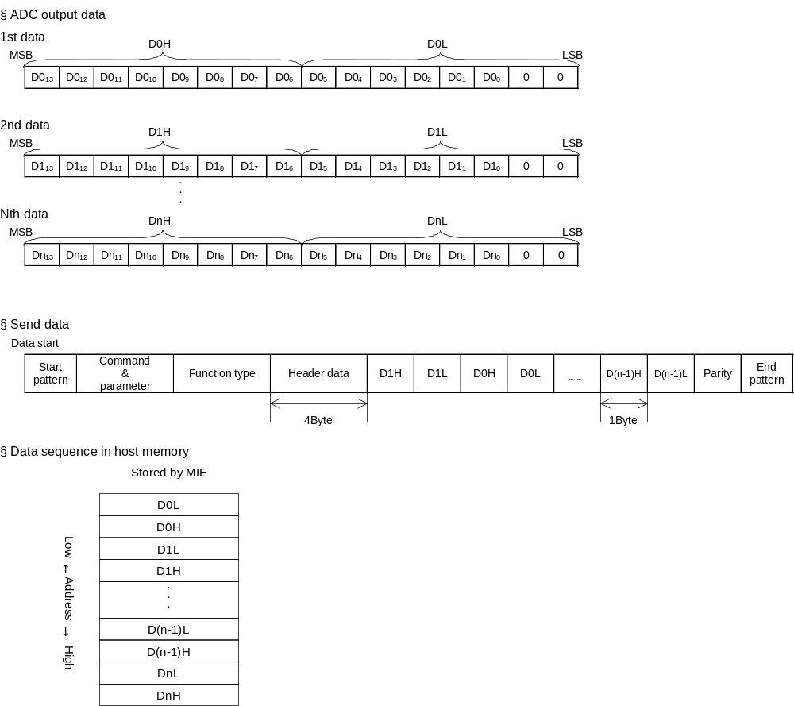
Fig. 2-2 Sampling data send format for CODEC compression (SET4 implementation)
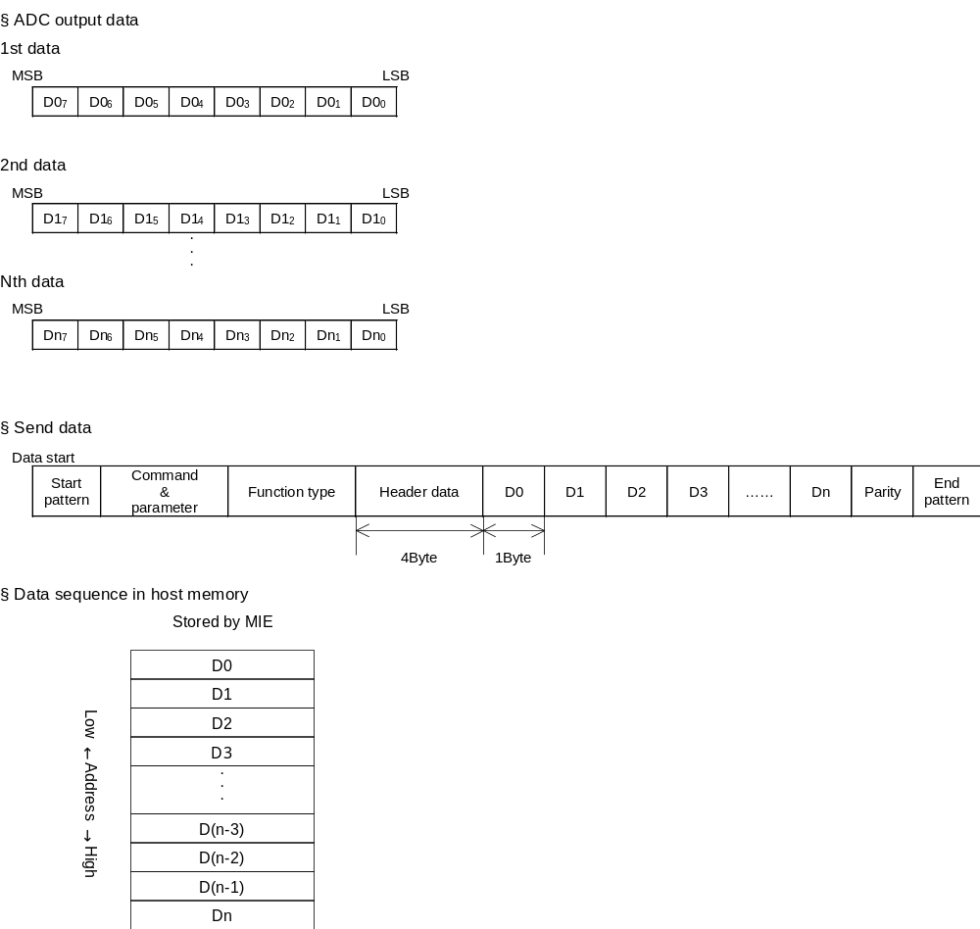
Table 2-13 How playback data differs depending on the method used to compliment the lower 2 bits
ADC output  (simulated 3 bit resolution) | Ideal data  (simulated 5 bit resolution) | Data after bit complimentation
ADC output  (simulated 3 bit resolution) | Ideal data  (simulated 5 bit resolution) | ① Fill with 0 | ② Copy LSB 2 bit | ③ Fill with 10
011 | 01111 |  | 01111
011 | 01110 |  |  | 01110
011 | 01101
011 | 01100 | 01100
010 | 01011
010 | 01010 |  | 01010 | 01010
010 | 01001
010 | 01000 | 01000
001 | 00111
001 | 00110 |  |  | 00110
001 | 00101 |  | 00101
001 | 00100 | 00100
000 | 00011
000 | 00010 |  |  | 00010
000 | 00001
000 | 00000 | 00000 | 00000
111 | 11111 |  | 11111
111 | 11110 |  |  | 11110
111 | 11101
111 | 11100 | 11100
110 | 11011
110 | 11010 |  | 11010 | 11010
110 | 11001
110 | 11000 | 11000
101 | 10111
101 | 10110 |  |  | 10110
101 | 10101 |  | 10101
101 | 10100 | 10100
100 | 10011
100 | 10010 |  |  | 10010
100 | 10001
100 | 10000 | 10000 | 10000

The effect of bit complementation on data quality
Method ① Linearity: GOOD Range usage efficiency: NG Symmetricality: NG
Method ② Linearity: NG Range usage efficiency: GOOD Symmetricality: GOOD
Method ③ Linearity: GOOD Range usage efficiency: NG Symmetricality: GOOD

Hardware characteristics

Interval for Identifying Destination AP Upon Frame Receipt
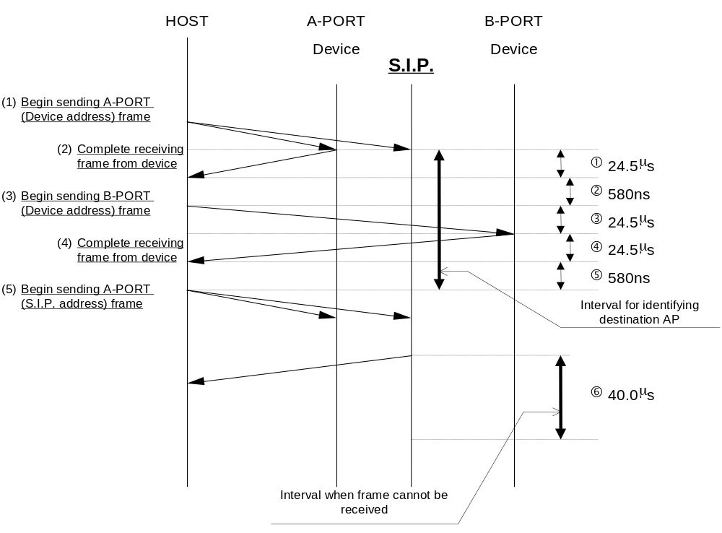
Fig. 3-1

As shown in the figure above, specifications determine that the interval for identifying the destination AP for SIP. is less than 74.66μs.

* The values used in the above figure are the measured values for SET4_F2 at the present stage.
Also, the processing time for the device in this figure is 0 seconds (minimum value).

Interval When The Frame Cannot Be Received
After frame transmission, the S.I.P. ignores all frames for a period of 40μs except for a hard reset from the host.

Note Regarding Acquisition of Sampling Data
SIP. uses the "Basic_Control" command to initiate sampling. After sampling is initiated, sampling data begins to get stored in the buffer. The buffer will become full in approximately 1.3 V-INT, so it is necessary to use the "Get_Sampling_Data" command to send the data to the host before this happens. The timing for sampling at 11kHz is shown in the figure below.
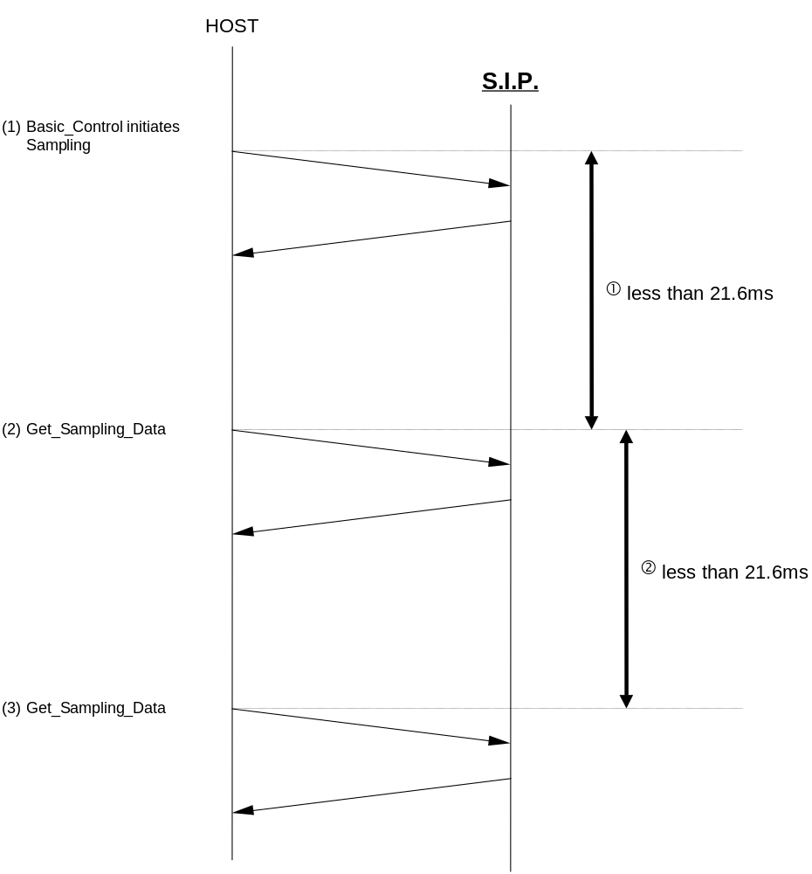

If the interval for ① or ② becomes greater than 21.6ms, the DT0_6bit_SBFOV header data for the response frame becomes "1". After SIP. sends this response frame to the host, SBFOV reverts to "0". Accordingly, if the host next sends the "Get_Sampling_Data" command within 21.6ms, the DT0_6bit_SBFOV header data for the response frame from SIP. will be "0".

* When sampling is done a 8kHz, ① and ② are both less than 30.0ms.

Buffers for 14 bit Sampling and 8 bit Sampling
The buffer can store data for up to 240 samplings. The following figure shows how the buffer is used.
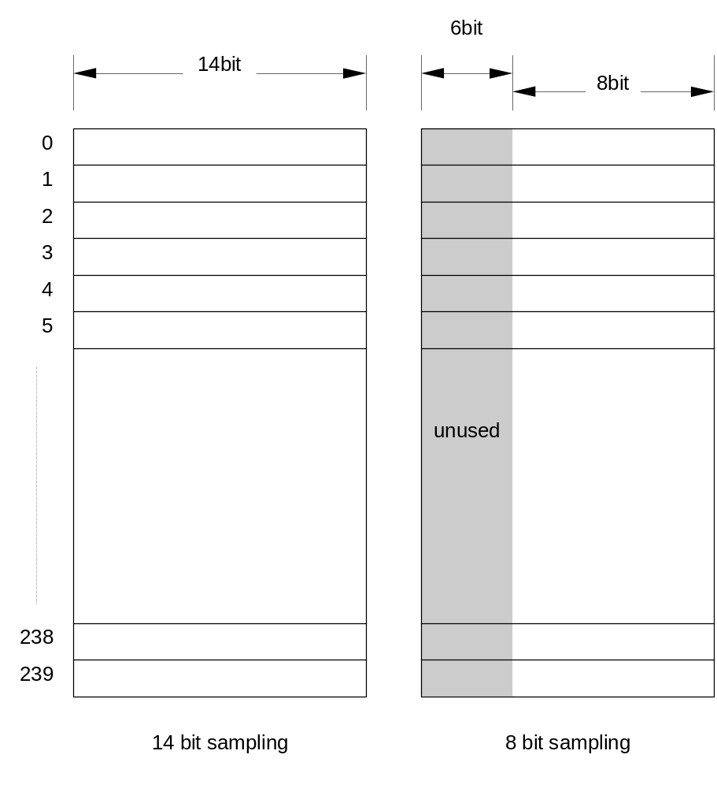

Resetting SIP
A soft reset can be done using the reset button in the case of the development unit, and the controller in the case of Dreamcast. When these resets are performed, the CLX2 in the development unit or in Dreamcast does not automatically send the "Device_Reset" command to peripheral.
If, in the course of SIP. sampling, the development unit CLX2 or Dreamcast CLX2 is reset, even if sampling is initiated with "Basic_Control" after sending "Device_Request", SIP. is continuing sampling, and "Command_Unknown" is returned.
If "Command_Unknown" is returned in response to "Basic_Control", sampling should be re-initiated with "Basic_Control after it has first been stopped with "Basic_Control".

Operation When Two Expansion Devices are Connected to the Same Port
When an SIP is operating while connected to a controller that supports connection of multiple devices (as of 1999/03/31, this is only the standard controller), the operation status of that SIP may change if an expansion unit is connected to the same controller.
To avoid SIP operation with incorrect settings, it must be reset from the SIP library as shown below whenever any other expansion unit is connected to the same controller.

Resetting SIP
① Send a Software Reset command to the SIP.
② Send a Device Request to the SIP (to exit reset status).
③ Send the sub command Extu Control to the SIP.
④ Send the sub command Basic Control to the SIP (starts operation settings and sampling).

* It is not necessary to reset the SIP if the default setting of EXTU_BIT is adequate.

