"Maple Bus 1.0"
Peripheral Hardware Specifications
Dreamcast Gun
Revision 0.61

Produced by:
CS Hardware DIV. 2
SEGA Enterprises Ltd.

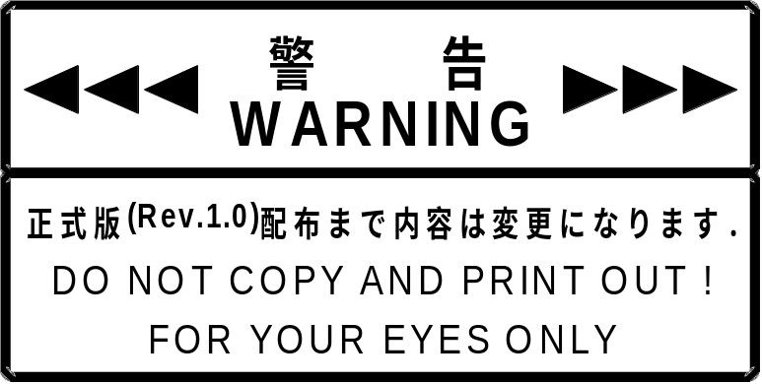
Revision:
10/16-'98 0.50 Preliminary Specifications
10/20-'98 0.55 Changed the name from "Dreamcast Gun" to "Dreamcast Gun."
Added section 4.1, "Read Format."
Changed section 6.2, "Fixed Device Status."
Changed other phrasing.
10/21-'98 0.60 Added section 2.2, "Operation as a Light Gun."
Added section 5, "Support Commands."
6/21-'99 0.61 Added section 7.2, "Fixed Device Status," item (2), "Region Codes."
Added section 7.3, "Contents of Fixed Device Status."
CONTENTS:
1 OVERVIEW 1
1.1 Overview of Dreamcast Gun 1
1.2 Definition of Dreamcast Gun 1
1.3 Function elements 1
1.4 Detailed description of constituent elements 1
2 OPERATION 2
2.1 Operation as a controller 2
2.2 Operation as a Light-Gun 2
3 DEVICE ID 3
3.1 Configuration of the “Maple Bus 1.0” device ID 3
3.2 Function types 4
3.3 Function definition blocks 4
4 DATA FORMAT 5
4.1 Read format 5
5 SUPPORT COMMANDS 7
5.1 Control commands 7
5.2 Error commands 12
6 PROTOCOL FLOW 14
6.1 Confirming connections in the initial state 14
6.2 SDCKB exclusive mode 15
7 Dreamcast Gun INFORMATION 16
7.1 Types 16
7.2 Fixed Device Status 16
7.3 Free Device Status 17
8 AFTERWORD 18

OVERVIEW
This chapter gives an overview of Dreamcast Gun, the gun-type controller for Dreamcast, the new generation game machine.

Overview of Dreamcast Gun
Dreamcast Gun is a scangun-type controller. It is equipped with direction buttons and an expansion slot, enabling new ways of playing that were hitherto not possible.

Definition of Dreamcast Gun
Dreamcast Gun conforms to the "Maple Bus 1.0" Standard Specifications and is equipped with the following functions.
1) "FT₀:Controller Function"
2) "FT₇:Light-Gun Function"
For a detailed description of each function type, refer to the corresponding function type specifications.

Function elements
Allocation of the function elements of the Dreamcast Gun is as follows.
FT₀:Controller Function
･ Digital direction buttons: Ra, La, Ua, Da
･ Digital buttons: A, B, Start
FT₇:Light-Gun Function
･ Function for use in the SDCKB exclusive mode: the signal output from the sensor element is used as a timing signal.

Detailed description of constituent elements
This section provides details on the various elements of the functions that are used with the Dreamcast Gun.

○ Controller function
Digital buttons: A, B, START, Ra, La, Ua, Da
These are digital type buttons which obtain 2 values: push and release. They detect multiple data simultaneously.
However, the direction buttons can sense only a maximum of two neighboring buttons being pushed simultaneously.
The values obtained are: push = '0'
release = '1'
○ Light-Gun function
SDCKB exclusive mode
If the SDCKB exclusive enable pattern is received from the host, the Maple-Bus Serial Data Clock B (SDCKB) is monopolized between the falling and the rising edges of Serial Data Clock A (SDCKA).
During this interval, a signal is generated by the light sensor element, and is latched on to the Host's HV counter.

OPERATION
This section explains operation as a Dreamcast Gun function.

Operation as a controller
The Dreamcast Gun controller function conforms to "FT₀: Controller Function" operation.

• Key scan
It is a requirement that the digital keys (buttons) are always being updated. There should always be a good response to data requests from the host. Accordingly, key scan should always be performed and held key data should always be retained in the newest condition. When there is a request from the host, the retained data should be in the condition to be sent. Since there is no order of priority for key scan, all the keys (buttons) should be concurrently readable.
• Optimization, conditions
a) For the cross keys, no more than 3 keys (buttons) must be ON at the same time (key data must not be generated).
b) The cross keys U and D, R and L must not be ON at the same time (key data must not be generated).
c) The simultaneous ON statuses of multiple digital buttons must detectable.
d) When two or more keys (buttons) are simultaneously pressed, keys (buttons) that are not pressed must not come ON (key data must not be generated).

Operation as a Light-Gun
The Dreamcast Gun Light-Gun function conforms to "FT₇: Light-Gun" operation.

• SDCKB exclusive mode support
If the SDCKB exclusive enable pattern is received from the host, the Maple-Bus Serial Data Clock B (SDCKB) is monopolized between the falling and the rising edges of Serial Data Clock A (SDCKA).
During this interval, a signal is generated by the light sensor element, and is latched on to the Host's HV counter.
• Optimization, conditions
The Dreamcast Gun may not always strike the location at which it is aimed, depending on the precision with which the lens and optical elements have been attached, errors in the lens receptor area, delay in the monitor display, and other problems. Therefore, applications must apply a type of offset compensation. If this compensation is applied in the vertical direction, an area at the bottom of the monitor screen will become impossible to hit. Therefore, applications should also be designed so that targets are not displayed in the bottom 30 lines of the monitor screen.

DEVICE ID
In accordance with the device ID definition in the “Maple Bus 1.0” Standard Specifications.
The notation is that of the host’s memory image.

Configuration of the “Maple Bus 1.0” device ID
The device ID consists of 16 bytes (128 bits). The configuration is as shown in Table 3.1.

Table 3-1 Configuration of the device ID
bit | 7 | 6 | 5 | 4 | 3 | 2 | 1 | 0
1st Data | FT₃₁ | FT₃₀ | FT₂₉ | FT₂₈ | FT₂₇ | FT₂₆ | FT₂₅ | FT24
2nd Data | FT₂₃ | FT₂₂ | FT₂₁ | FT₂₀ | FT₁₉ | FT₁₈ | FT₁₇ | FT16
3rd Data | FT₁₅ | FT₁₄ | FT₁₃ | FT₁₂ | FT₁₁ | FT₁₀ | FT₉ | FT8
4th Data | FT₇ | FT₆ | FT₅ | FT₄ | FT₃ | FT₂ | FT₁ | FT₀
5th Data | FD1₃₁ | FD1₃₀ | FD1₂₉ | FD1₂₈ | FD1₂₇ | FD1₂₆ | FD1₂₅ | FD1₂₄
6th Data | FD1₂₃ | FD1₂₂ | FD1₂₁ | FD1₂₀ | FD1₁₉ | FD1₁₈ | FD1₁₇ | FD1₁₆
7th Data | FD1₁₅ | FD1₁₄ | FD1₁₃ | FD1₁₂ | FD1₁₁ | FD1₁₀ | FD1₉ | FD1₈
8th Data | FD1₇ | FD1₆ | FD1₅ | FD1₄ | FD1₃ | FD1₂ | FD1₁ | FD1₀
9th Data | FD2₃₁ | FD2₃₀ | FD2₂₉ | FD2₂₈ | FD2₂₇ | FD2₂₆ | FD2₂₅ | FD2₂₄
10th Data | FD2₂₃ | FD2₂₂ | FD2₂₁ | FD2₂₀ | FD2₁₉ | FD2₁₈ | FD2₁₇ | FD2₁₆
11th Data | FD2₁₅ | FD2₁₄ | FD2₁₃ | FD2₁₂ | FD2₁₁ | FD2₁₀ | FD2₉ | FD2₈
12th Data | FD2₇ | FD2₆ | FD2₅ | FD2₄ | FD2₃ | FD2₂ | FD2₁ | FD2₀
13th Data | FD3₃₁ | FD3₃₀ | FD3₂₉ | FD3₂₈ | FD3₂₇ | FD3₂₆ | FD3₂₅ | FD3₂₄
14h Data | FD3₂₃ | FD3₂₂ | FD3₂₁ | FD3₂₀ | FD3₁₉ | FD3₁₈ | FD3₁₇ | FD3₁₆
15th Data | FD3₁₅ | FD3₁₄ | FD3₁₃ | FD3₁₂ | FD3₁₁ | FD3₁₀ | FD3₉ | FD3₈
16th Data | FD3₇ | FD3₆ | FD3₅ | FD3₄ | FD3₃ | FD3₂ | FD3₁ | FD3₀

FT : Function type the peripheral is equipped with.
FD1 : 1st function definition block.
FD2 : 2nd function definition block.
FD3 : 3rd function definition block.

① FT₃₁～FT₀: Function type
Defines the type of function the peripheral is equipped with.
There are 32 function types altogether.

② FD₃₁～FD₀: Function definition block
These blocks define the individual elements constituting the function.
(1 peripheral can be equipped with 3 different functions)

Function types
The function types (FT) within the device ID are as follows.
Dreamcast Gun has a controller function and a Light-Gun function.

Table 3-2 Dreamcast Gun function type
bit | 7 | 6 | 5 | 4 | 3 | 2 | 1 | 0
1st Data | 0 | 0 | 0 | 0 | 0 | 0 | 0 | 0
2nd Data | 0 | 0 | 0 | 0 | 0 | 0 | 0 | 0
3rd Data | 0 | 0 | 0 | 0 | 0 | 0 | 0 | 0
4th Data | 1 | 0 | 0 | 0 | 0 | 0 | 0 | 1

Function definition blocks
Because the Light-Gun function only supports SDCKB exclusive mode, function definition does not take place within the function definition blocks. Therefore, as Table 3.3 shows, the configuration is all '0's.
The following paragraph defines the controller function and the Light-Gun function. The Light-Gun function elements are defined in the 1st function definition block, and the controller function elements are defined in the 2nd function definition block. Also, because Light-Gun has no 3rd function, the 3rd function definition block is all '0's.

Table 3-3 1st function definition block (Light-Gun function)
bit | 7 | 6 | 5 | 4 | 3 | 2 | 1 | 0
1st Data | 0 | 0 | 0 | 0 | 0 | 0 | 0 | 0
2nd Data | 0 | 0 | 0 | 0 | 0 | 0 | 0 | 0
3rd Data | 0 | 0 | 0 | 0 | 0 | 0 | 0 | 0
4th Data | 0 | 0 | 0 | 0 | 0 | 0 | 0 | 0

'0' indicates fixed 0.

Table 3-4 2nd function definition block (Controller function)
bit | 7 | 6 | 5 | 4 | 3 | 2 | 1 | 0
1st Data | 0 | 0 | 0 | 0 | 0 | 0 | 0 | 0
2nd Data | 0 | 0 | 0 | 0 | 0 | 0 | 0 | 0
3rd Data | 0 | 0 | 0 | 0 | 0 | 0 | 0 | 0
4th Data | 1 | 1 | 1 | 1 | 1 | 1 | 1 | 0

'0' indicates fixed 0.

DATA FORMAT
To get key data from the Dreamcast Gun, issue the command to the Controller function. The Light Gun function does not have a data format.

Read format
This is the key data format of Dreamcast Gun. When the host transmits Get Condition, the controller returns data according to the data format. The command is Data Transfer.

Table 4-1 Get Condition
Data Address | Data | Setting example | Description
+0000h | Command code | 09h | Specifies Get Condition.
+0001h | Destination AP | 20h | Specifies device of port A.
+0002h | Origin AP | 00h | Send from Port A.
+0003h | Data size | 01h | Data size is 4 bytes.
+0004h | Function type | 00h | The function type specifies the controller.
+0005h |  | 00h
+0006h |  | 00h
+0007h |  | 01h

Table 4-2 Data Transfer
Data Address | Data | Setting example | Description
+0000h | Command code | 08h | Specifies Get Condition.
+0001h | Destination AP | 00h | Specifies device of port A.
+0002h | Origin AP | 30h | Send from Port A.
+0003h | Data size | 03h | Data size is 12 bytes.
+0004h | Function type | 00h | The function type specifies the controller.
+0005h |  | 00h
+0006h |  | 00h
+0007h |  | 01h
+0008h | Read format | FFh | For details on the data that is stored here, refer to Table 4-3.
+0009h |  | FFh
+000Ah |  | 00h
+000Bh |  | 80h
+000Ch |  | 80h
+000Dh |  | 80h
+000Eh |  | 80h
+000Fh |  | 80h

The size of the data format is 8 bytes.
Table 4-3 Read Format
bit | 7 | 6 | 5 | 4 | 3 | 2 | 1 | 0
1st Data | Ra | La | Da | Ua | Start | A | B | 1
2nd Data | 1 | 1 | 1 | 1 | 1 | 1 | 1 | 1
3rd Data | 1 | 1 | 1 | 1 | 1 | 1 | 1 | 1
4th Data | 1 | 1 | 1 | 1 | 1 | 1 | 1 | 1
5th Data | 1 | 0 | 0 | 0 | 0 | 0 | 0 | 0
6th Data | 1 | 0 | 0 | 0 | 0 | 0 | 0 | 0
7th Data | 1 | 0 | 0 | 0 | 0 | 0 | 0 | 0
8th Data | 1 | 0 | 0 | 0 | 0 | 0 | 0 | 0

Description of key data

1st Data: Digital button data. (ON = 0, OFF = 1)
2nd Data: Fixed at FFh.
3rd Data: Fixed at FFh.
4th Data: Fixed at FFh.
5th Data: Fixed at 80h.
6th Data: Fixed at 80h.
7th Data: Fixed at 80h.
8th Data: Fixed at 80h.

SUPPORT COMMANDS
This chapter describes the commands specified in the "Maple Bus 1.0" Standard Specifications which are supported by Dreamcast Gun.
If commands other than the following are sent, the function will return an error.
The concrete operations of the controller function of each command are also described.

Control commands
Device Request
Issuing right : Host
Command code : 01h
Data size : 00h
Data field : none
Expected return value : [Device Status]
Description : This command requests [Device Status] from the device connected to the destination AP. It is also used to check port connection. After initialization of the function, the device does not respond to other commands until this command is sent. The LM-Bus is also disconnected from the expansion device so that the expansion device operation is stopped.
Order of operation : (1) Receives command.
(2) Checks connection of each expansion device
(3) If connected, connects to corresponding LM-Bus
(4) Based on this result, the AP of originating device is created and returned to the host.

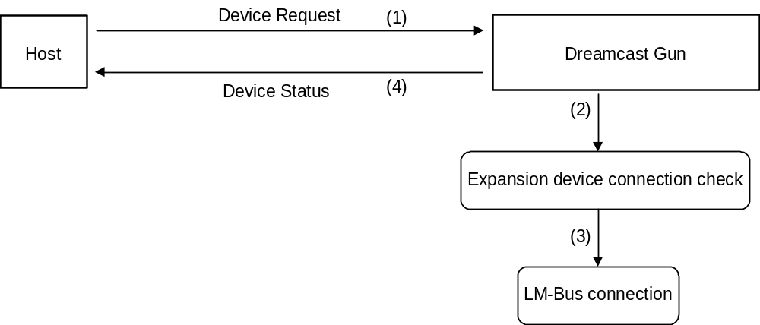
Fig. 5-1 Device Request
All Status Request
Issuing right : Host
Command code : 02h
Data size : 00h
Data field : none
Expected return value : [Device All Status]
Description : This command requests all device statuses (both Fixed Device Status and Free Device Status) from the device connected to the destination AP.

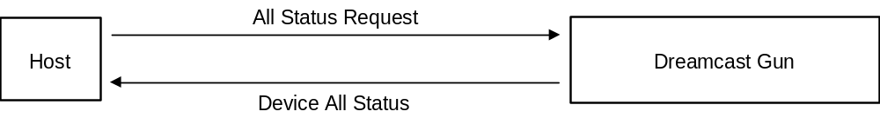
Fig. 5-2 All Status Request

Device Reset
Issuing right : Host
Command code : 03h
Data size : 00h
Data field : none
Expected return value : [Device Reply]
Description : This command enables the device specified by the destination AP to be initialized.
Order of operation : (1) [Device Reply] returned.
(2) Initialization.

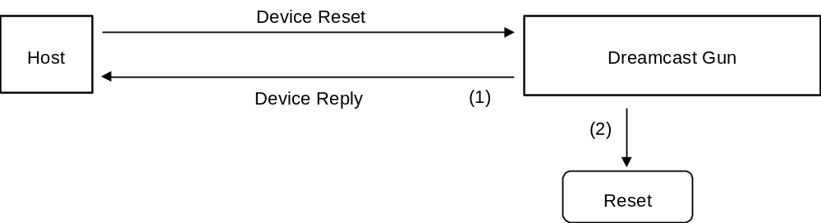
Fig. 5-3 Device Reset
Device Kill
Issuing right : Host
Command code : 04h
Data size : 00h
Data field : none
Expected return value : [Device Reply]
Description : Operation by the peripheral specified by the destination AP is not recognized. The function stands by in standby power consumption mode, and no commands can be received.
To start operation, a hard reset must be performed, or the power should be turned off and operation then started again.
When the Light-Gun function (the device) receives the Device Kill command, the ID0 and ID1 of the LM-Bus are reversed, the expansion device is reset, and the LM-Bus disconnected.
Order of operation : (1) LM-Bus reset and disconnected from the Maple-Bus
(2) [Device Reply] returned.
(3) Operation terminated.

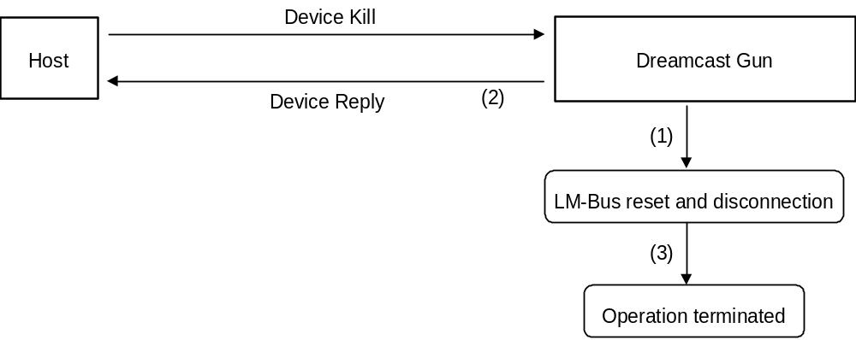
Fig. 5-4 Device Kill

Device Status
Issuing right : Device
Command code : 05h
Data size : 1Ch (28)
Data field : Device ID : 16 bytes
Destination code : 1 byte
Connection direction : 1 byte
Product name : 30 bytes
License : 60 bytes
Standby current consumption : 2 bytes
Maximum current consumption : 2 bytes
Description : This command returns Fixed Device Status data in response to [Device Request] from the host.
Device All Status
Issuing right : Device
Command code : 06h
Data size : 1Ch + (n/4)
Data field : Fixed Device Status : 112 bytes
Device ID : 16 bytes
Destination code : 1 byte
Connection direction : 1 byte
Product name : 30 bytes
License : 60 bytes
Standby current consumption : 2 bytes
Maximum current consumption : 2 bytes
Free Device Status : n bytes

Device Reply
Issuing right : Device
Command code : 07h
Data size : 00h
Data field : none
Description : Used as a response.

Data Transfer
Issuing right : Controller function
Command code : 08h
Data size : 03h
Data field : Function type : 4 bytes
Specifies the controller (00-00-00-01h).
Read format : 8 bytes
Expected return value : none
Description : This command is used to receive Get Condition from the host and when the controller’s read format should be returned.

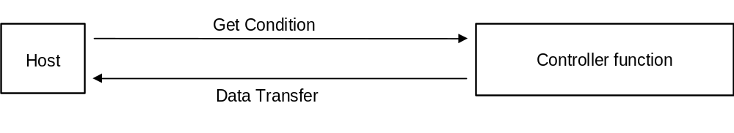
Fig. 5-5 Data Transfer
Table 5-1 Data transmission to host (host’s memory image)
Data Address | Data | Setting example | Description
+0000 | Command code | 08h | Specifies Data Transfer.
+0001 | Destination AP | 00h | Specifies device of port A.
+0002 | Origin AP | 20h | No expansion device
+0003 | Data size | 03h | Data size is 12 bytes.
+0004 | Function type | 00h | The function type specifies
+0005 |  | 00h | the controller.
+0006 |  | 00h
+0007 |  | 01h
+0008 | Read format | FFh | According to the controller format,
+0009 |  | FFh | the controller’s data is stored. The
+000a |  | 00h | blocks to be used have been
+000b |  | 00h | declared already by the device ID.
+000c |  | 80h
+000d |  | 80h
+000e |  | 80h
+000f |  | 80h

Get Condition
Issuing right : Host
Command code : 09h
Data size : 01h
Data field : Function type : 4 bytes
Specifies the controller (00-00-00-01h).
Expected return value : [Data Transfer]
Description : This command requests the physical status (buttons, keys, lever statuses) of the controller function.
Used when the Dreamcast Gun key data should be read.

Fig. 5-6 Get Condition

Table 5-2 Data transmission from host (memory image)
Data Address | Data | Setting example | Description
+0000 | Command code | 09h | Specifies Get Condition.
+0001 | Destination AP | 20h | Specifies device of port A.
+0002 | Origin AP | 00h | Send from Port A.
+0003 | Data size | 01h | Data size is 4 bytes.
+0004 | Function type | 00h
+0005 |  | 00h | The function type specifies the controller.
+0006 |  | 00h
+0007 |  | 01h

Error commands
The error command types supported by the Light-Gun function number only 4.

Transmit Again
Issuing right : Host, Light-Gun function
Command code : FCh
Data size : 00h
Data field : none
Description : This command is used to request that data be transmitted again when the data contained some kind of error. However, the data from the Light-Gun is constantly updated. Therefore, there is no guarantee that the contents of the Light-Gun read data will be returned in the case of an error.
Possible causes : (1) Parity error was generated.
(2) Data overflowed.
(3) Data became jumbled during communication.
(4) Others
Remedies : Send again (maximum of 3 times; subsequent attempts are processed as Time out).

Command Unknown
Issuing right : Light-Gun function
Command code : FDh
Data size : 00h
Data field : none
Description : This command is returned when the Light-Gun function does not support the command sent.
Possible causes : (1) Mistaken specification of command.
(2) Data is written incorrectly.
(3) Data of device ID is jumbled.
(4) Data became jumbled during communication.
Remedies : (1) Specify command correctly.
(2) Write data correctly.
(3) Resend Device Request to obtain device ID.
(4) Send again (maximum of 3 times; subsequent attempts are processed as Time out).
Function Type Unknown
Issuing right : Peripheral
Command code : FEh
Data size : 00h
Data field : none
Description : This command is returned when a function type other than the Light-Gun function is sent.
Possible causes : (1) Mistaken specification of function type.
(2) Data is written incorrectly.
(3) Data of device ID is jumbled.
(4) Data became jumbled during communication.
Remedies : (1) Specify function type correctly.
(2) Write data correctly.
(3) Resend Device Request to obtain device ID.
(4) Send again (maximum of 3 times; subsequent attempts are processed as Time out).

PROTOCOL FLOW
This chapter explains the basic transmission protocols used for the host and Dreamcast Gun.

Confirming connections in the initial state
The initial state resulting from power being supplied, hot connect-disconnect, or Device Kill, accepts only Device Request.

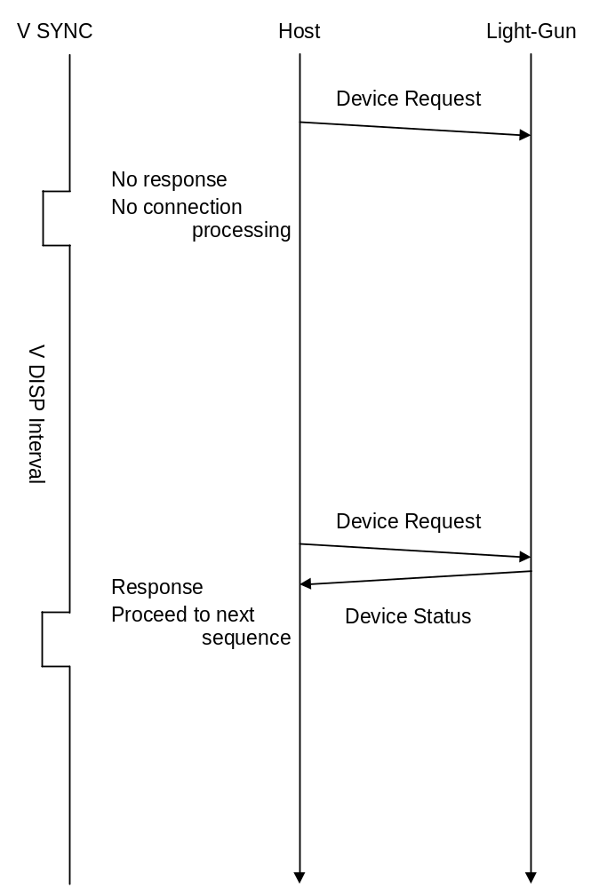
Fig. 6-7 Default configuration connection check

SDCKB exclusive mode

This section describes the order of monopolizing the SDCKB. The SDCKB is only monopolized when On is detected from the trigger.

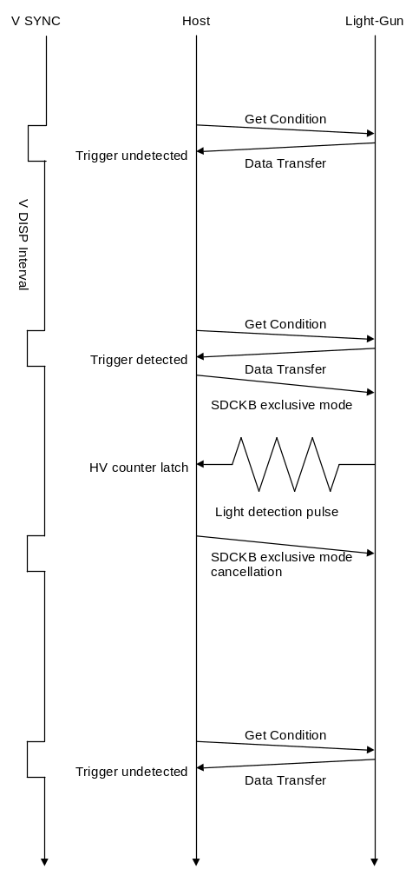
Fig. 6-8 SDCKB monopolization order

Dreamcast Gun INFORMATION
This chapter explains device-specific information (device statuses).
Data is recorded as is in order to prevent device statuses from being rewritten or erased.
* The details of the Fixed Device Status are pending.

Types
Fixed Device Status
This is a set form of device status that must be designated. It consists of a 112 byte format.
Operation and connection cannot be guaranteed unless all items are designated.

Free Device Status
This device status can be freely used by the individual devices.
The volume is a maximum of 908 bytes.

Fixed Device Status
The Fixed Device Status must designate all of the following items.

① Device ID
Capacity : 16 bytes
Description : Function type "FT₀", "FT₇"
1st function definision Light-Gun function definition
2nd function definision Ua, Da, Ra, La, A, B, Start
3rd function definision None
Data :

② Destination
Capacity : 1 bytes
Description : Worldwide
There are two types: one for North America, and one for "worldwide."
Data : FFh
North America: 01h/Worldwide: FFh

③ Connection direction
Capacity : 1 byte
Description : Expantion socket Downward
Data : 01h

④ Product name
Capacity : 30 bytes
Description : This designates "Dreamcast Gun" in English or romaji.
A space code (20h)is inserted for unused space.

⑤ License
Capacity : 60 bytes
Description : This designates the product license.
"Produced By or Under License From SEGA ENTERPRISES,LTD" is designated.
A space code (20h)is inserted for unused space.

⑥ Standby current consumption
Capacity : 60 bytes
Description : 22.0mA
Data : 00h-DCh

⑦ Maximum current consumption
Capacity : 2 bytes
Description : 30.0mA
Data : 01h-2Ch

Free Device Status
The Free Device Status area is available for product planners, developers, designers and programmers to enter any information they wish. The host obtains this status by the All Device Request.
The Free Device Status for Dreamcast Gun is
"Version 1.000,1998/09/16,315-6125-AG ,U,D,L,R,S,A,B Key & Scanning Line".

The contents of the Free Device Status differ, depending on the region:
• Worldwide
“Version 1.000,1998/09/16,315-6125-AG ,U,D,L,R,S,A,B Key & Scanning Line”

• North America
"Version 1.010,1999/04/26,315-6211-AN ,U,D,L,R,S,A,B Key & Scanning Line Amp."

AFTERWORD
Until the official version (Rev. 1.0) is distributed, contents will be modified to a small or large extent.

