『Maple Bus 1.0』Peripheral
Hardware Specifications

Arcade Stick

Revision 0.90

Issued by
Sega Enterprises, Inc.
CS Development and Production Dep't, Second Division

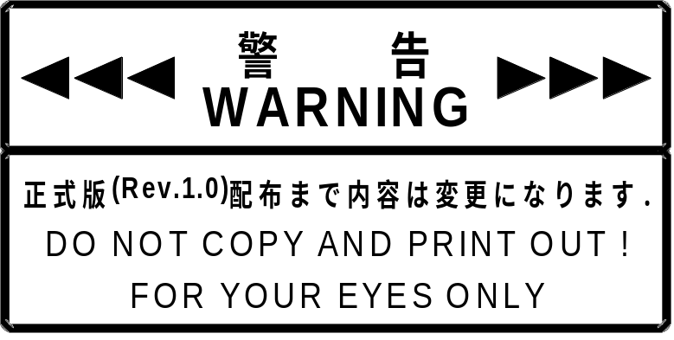

Revision：
0.90 1998/06/02 Initial release

* Additions and changes from the previous version are marked with for additions and for deletions.

Contents:

1. Arcade Stick Function Conditions 4
1.1. Arcade Stick Function Definition 4
1.2. Function Outline 4
1.3. Configuration Details 4
2. Arcade Stick Function Operation 5
3. Device ID 6
3.1. Arcade Stick Device ID Configuration 6
4. Data Format 7
4.1. Read Format 7
4.2. Write Format 7
5. Arcade Stick Function Information 8
5.1. Type 8
5.2. Fixed Device Status 8
5.3. Free Device Status 9
6. Remarks 10

Arcade Stick Function Conditions

Arcade Stick Function Definition

The Arcade Stick function is an input type man/machine interface corresponding to the Maple Bus 1.0 Standard Specifications. It belongs to the function type "FT₀: Controller".

Function Outline

Among the items included in the "FT₀: Controller" specification, the Arcade Stick provides the following functions:

• Digital arrow keys: Ra, La, Da, Ua
• Digital buttons: A, B, C, X, Y, Z, Start

Configuration Details

This section gives a detailed description of Arcade Stick function elements.

① Digital arrow keys: Ra, La, Da, Ua
These digital keys (buttons) have two states: push/release (= ON/OFF).
Ra and La as well as Da and Ua are arranged as symmetrical pairs. The Ra and La buttons are at the ends of a straight line (X axis), and the Da and Ua buttons are at the ends of another straight line (Y axis) crossing the X axis at a right angle. Ra is fo right side or right direction, La for left side or left direction, Da for down side or down direction or user near side, and Ua for up side or up direction or user far side.
The values are "pushed" = "0", "released" = "1".
ON key data for three or more keys may not be generated simultaneously.
The keys are intended mainly for use with the left hand.

。

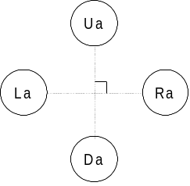
Fig. 1.1 Digital cross-key button arrangement

② Digital buttons: A, B, C, X, Y, Z, Start
These digital keys (buttons) have two states: push/release (= ON/OFF).
Button arrangement is not specified.
Simultaneous ON for multiple keys (buttons) must be detectable.
The values are "pushed" = "0", "released" = "1".

Arcade Stick Function Operation
Function operation follows the "FT₀: Controller" specification.

① Key scan
Key data for the digital keys (buttons) are updated continuously.
When the host requests data, these must be provided at all times with good response.
There is no key scan priority assignment; all keys (buttons) can be read simultaneously.

② Optimization conditions
a) No more than two cross-key buttons may be ON at the same time (key data are not generated for more keys).
b) Cross-key buttons U and D or L and R may not be ON at the same time (key data are not generated).
c) Multiple digital buttons may be ON at the same time.
d) While two or more keys (buttons) are pushed simultaneously, other keys (buttons) may not go ON (key data are not generated).
e) A key chatter prevention method is provided.

③ Expansion socket
One expansion socket is present.

Device ID
The device ID corresponds to the Maple Bus 1.0 Standard Specifications. The table below shows the memory image on the host.

Arcade Stick Device ID Configuration
The configuration uses 16 bytes (128 bit).

Bit | 7 | 6 | 5 | 4 | 3 | 2 | 1 | 0
1st Data | 0 | 0 | 0 | 0 | 0 | 0 | 0 | 0
2nd Data | 0 | 0 | 0 | 0 | 0 | 0 | 0 | 0
3rd Data | 0 | 0 | 0 | 0 | 0 | 0 | 0 | 0
4th Data | 0 | 0 | 0 | 0 | 0 | 0 | 0 | 1
5th Data | 0 | 0 | 0 | 0 | 0 | 0 | 0 | 0
6th Data | 0 | 0 | 0 | 0 | 0 | 0 | 0 | 0
7th Data | 0 | 0 | 0 | 0 | 0 | 1 | 1 | 1
8th Data | 1 | 1 | 1 | 1 | 1 | 1 | 1 | 1
9th Data | 0 | 0 | 0 | 0 | 0 | 0 | 0 | 0
10th Data | 0 | 0 | 0 | 0 | 0 | 0 | 0 | 0
11th Data | 0 | 0 | 0 | 0 | 0 | 0 | 0 | 0
12th Data | 0 | 0 | 0 | 0 | 0 | 0 | 0 | 0
13th Data | 0 | 0 | 0 | 0 | 0 | 0 | 0 | 0
14th Data | 0 | 0 | 0 | 0 | 0 | 0 | 0 | 0
15th Data | 0 | 0 | 0 | 0 | 0 | 0 | 0 | 0
16th Data | 0 | 0 | 0 | 0 | 0 | 0 | 0 | 0
Fig. 3.1 Device ID
FT: Peripheral function type (1st - 4th data)
FD1: Function definition block for 1st function (5th - 8th data)
FD2 Function definition block for 2nd function (9th - 12th data)
FD3: Function definition block for 3rd function (13th - 16th data)

① FT₀ - FT₃₁: Function type
Indicates the function type implemented by the peripheral.
There are a total of 32 function types.

② FD₃₁ - FD₀: Function definition block
These blocks define the various elements that make up a function.

Data Format
This section describes the Arcade Stick data format.
The notation uses the memory image on the host.

Read Format
The key data format for reading data from the Arcade Stick function is shown below.
The data format size is 8 bytes.

Bit | 7 | 6 | 5 | 4 | 3 | 2 | 1 | 0
1st Data | Ra | La | Da | Ua | Start | A | B | C
2nd Data | 1 | 1 | 1 | 1 | 1 | X | Y | Z
3rd Data | 0 | 0 | 0 | 0 | 0 | 0 | 0 | 0
4th Data | 0 | 0 | 0 | 0 | 0 | 0 | 0 | 0
5th Data | 1 | 0 | 0 | 0 | 0 | 0 | 0 | 0
6th Data | 1 | 0 | 0 | 0 | 0 | 0 | 0 | 0
7th Data | 1 | 0 | 0 | 0 | 0 | 0 | 0 | 0
8th Data | 1 | 0 | 0 | 0 | 0 | 0 | 0 | 0
Fig. 4.1 Read format

Key data description
1st: Digital button data (ON = "0", OFF = "1")
2nd: Digital button data (ON = "0", OFF = "1")
3rd: Analog axis 1 (A1) data. "00h" when there are no data.
4th: Analog axis 2 (A2) data. "00h" when there are no data.
5th: Analog axis 3 (A3) data. "80h" at midpoint.
6th: Analog axis 4 (A4) data. "80h" at midpoint.
7th Analog axis 5 (A5) data. "80h" at midpoint.
8th: Analog axis 6 (A6) data. "80h" at midpoint.

Write Format
There is no write format for writing data to the Arcade Stick function because the Arcade Stick function is a read-only device.

Arcade Stick Function Information
This section describes device-specific information (device status). The device status must be stored in such a way that device status data cannot be changed or erased.

Type
Fixed Device Status
This refers to 112 bytes of device status information data with a fixed format, comprising required information. Correct connection and operation are only assured if all items are properly recorded.
Free Device Status
This refers to a maximum of 908 bytes of device-specific status information that can be allocated freely.

Fixed Device Status
The Fixed Device Status area must include all the items listed below.

① Device ID
Size: 16 bytes (00000001000007FF0000000000000000)
Description: Specifies the device ID of the Arcade Stick function.
FT: Controller
FD1: Ra, Da, Ua, La, S, A, B, C, X, Y, Z
FD2: None
FD3: None

② Country specification
Size: 1 byte (FFh)
Description: For all countries

③ Connection method
Size: 1 byte (00h), upstream connection

④ Model name
Size: 30 bytes
Description: ASCII string "Arcade Stick"
Remaining slots to be padded with spaces (20h).

⑤ License
Size: 60 bytes
Description: ASCII string "Produced By or Under License From SEGA ENTERPRISES,LTD."
Remaining slots to be padded with spaces (20h).

⑥ Standby current consumption
Size: 2 bytes
Description: Indicates the current consumption of the unit in paused condition, in 0.1 mA units (hexadecimal notation). Because this is 30 mA for the Arcade Stick, the item is denoted as 01-2C h.
⑦ Maximum current consumption
Size: 2 bytes
Description: Indicates the maximum current consumption of the unit, in 0.1 mA units (hexadecimal notation). Because this is 40 mA for the Arcade Stick, the item is denoted as 01-90 h.

Free Device Status
The Free Device Status area can include information about developers, designers, and programmers or any other information. The host can obtain this information by issuing the "All Device Request" command. If it is to be used by an application, the data orering sequence must be taken into consideration. Include following ASCII string:

"Version 1.000,1998/05/25,315-6125- AC".

Remarks

