『Maple Bus 1.0』Peripheral
Hardware Specifications

105 Key Keyboard for Italy

Revision 1.11

Issued by
Sega Enterprises, Inc.
CS Development and Production Dep't, Second Division

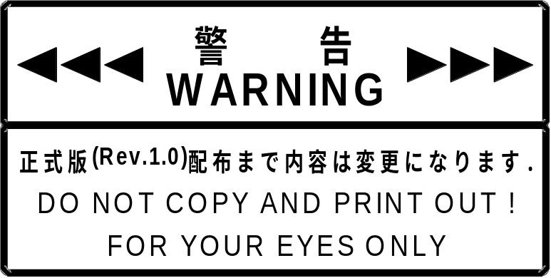

Revision：
0.50 1999/05/17 First release
1.00 1999/06/07 Added Key scan code
1.10 1999/06/21 Changed the specifications for the device ID keyboard language from UK to Italy
1.11 1999/06/24 Modified the position of [ € ] (the Euro) appearing in Fig. 4.1, “Keyboard layout,” and
Fig. 4.3, “Keyboard List,” and deleted

Note:
Windows 95 does not support the new EU currency unit in Euro font.
In Windows 95, characters are displayed differently. (This has been confirmed for versions A, B, and C of Windows 95. Later versions are unverified.)
Windows NT 4.0 Workstation SP4 and Windows 98 are supported.
An update program must be downloaded from the Microsoft site in order for this software to display normally in Windows 95.

contents
1 The Keyboard 4
1.1 Keyboard Functions 4
1.2 Outline of Operation 4
1.3 Keyboard Language, Keyboard Type 4
1.4 Function Outline 4
2 Device ID 5
2.1 Italy AT 105 Key Keyboard Device ID Configuration 5
3 Data Format 6
3.1 Write Format 6
3.2 Read Format 7
4 Key Scan Codes 11
5 Keyboard Function Information 15
5.1 Type 15
5.2 Fixed Device Status 15
5.3 Free Device Status 16
6 Remarks 16

The Keyboard

Keyboard Functions
The Keyboard function is an input type man/machine interface serving for input and editing of characters and numerals, and for control of screen operations. This peripheral conforms to the "Maple Bus" Standard Specifications, belonging to function type " FT₆".

Outline of Operation

(1) Key scan
Keys are scanned constantly and data on key status is kept up to date in order to enable good response to requests from the host on the status of keys.

(2) Optimization and conditions
a) When no keys are pressed, simultaneous depression of up to three keys can be detected.
b) If three or more keys are being pressed, up to three additional keys can be detected provided that they are combinations that do not result in sneak current. However, if sneak current is produced, and error code results for that key and all subsequent keys pressed.
c) If a seventh key is pressed while six keys are already being pressed under the conditions given in b) above, an error code results for all further keyboard functions.
d) If sneak current results when more than three keys are pressed simultaneously, an error code is sent for all further keyboard functions.
e) If two or more keys are pressed simultaneously while two or more other keys are already being pressed, an error code is sent for all further keyboard functions, even if the combination of keys pressed does not produce a sneak current.

(3) Restrictions
Key repeat (intermittent output of a key scan code when a key is held down) cannot be set by keyboard function.
When key repeat is required, the repeat rate and initial repeat delay must be set by the host in software.

Keyboard Language, Keyboard Type

The keyboard applicable to these specifications is “Italy AT 105 Key Keyboard.”

Function Outline

See Fig. 4-1, Keyboard layout.

Device ID
The device ID corresponds to the Maple Bus 1.0 Standard Specifications. The table below shows the memory image on the host.

Italy AT 105 Key Keyboard Device ID Configuration

The configuration uses 16 bytes (128 bit).

bit | 7 | 6 | 5 | 4 | 3 | 2 | 1 | 0
1st Data | 0 | 0 | 0 | 0 | 0 | 0 | 0 | 0
2nd Data | 0 | 0 | 0 | 0 | 0 | 0 | 0 | 0
3rd Data | 0 | 0 | 0 | 0 | 0 | 0 | 0 | 0
4th Data | 0 | 1 | 0 | 0 | 0 | 0 | 0 | 0
5th Data | 0 | 0 | 0 | 0 | 0 | 1 | 1 | 0
6th Data | 0 | 0 | 0 | 0 | 0 | 1 | 1 | 0
7th Data | 0 | 0 | 0 | 0 | 0 | 0 | 0 | 0
8th Data | 1 | 0 | 0 | 0 | 0 | 0 | 0 | 0
9th Data | 0 | 0 | 0 | 0 | 0 | 0 | 0 | 0
10th Data | 0 | 0 | 0 | 0 | 0 | 0 | 0 | 0
11th Data | 0 | 0 | 0 | 0 | 0 | 0 | 0 | 0
12th Data | 0 | 0 | 0 | 0 | 0 | 0 | 0 | 0
13th Data | 0 | 0 | 0 | 0 | 0 | 0 | 0 | 0
14th Data | 0 | 0 | 0 | 0 | 0 | 0 | 0 | 0
15th Data | 0 | 0 | 0 | 0 | 0 | 0 | 0 | 0
16th Data | 0 | 0 | 0 | 0 | 0 | 0 | 0 | 0
Fig. 2-1 Device ID
FT : Peripheral function type
FD1 : Function definition block for 1st function
FD2 : Function definition block for 2nd function
FD3 : Function definition block for 3rd function

(1) FT₀ - FT₃₁: Function type
Indicates the function type implemented by the peripheral. There are a total of 32 function types.

(2) FD₃₁ - FD₀: Function definition block
These blocks define the various elements that make up a function.

Data Format

This section describes the Keyboard function data format.
The notation uses the memory image on the host.

Write Format

The format for writing Keyboard function data is shown below. When the host sends write data with "Set Condition", the keyboard returns a "Device Reply" for normal end or an error code for abnormal end.

bit | 7 | 6 | 5 | 4 | 3 | 2 | 1 | 0
1st Data | LD₇ | LD₆ | LD₅ | LD₄ | LD₃ | LD₂ | LD₁ | LD₀
2nd Data | 0 | 0 | 0 | 0 | 0 | 0 | 0 | 0
3rd Data | 0 | 0 | 0 | 0 | 0 | 0 | 0 | 0
4th Data | 0 | 0 | 0 | 0 | 0 | 0 | 0 | 0
Fig. 3-1 Write format

Write format description
1st : LD LED setting
2nd : W1 Reserved = 00h
3rd : W2 Reserved = 00h
4th : W3 Reserved = 00h

LED setting
LD | Mapping | Lit | Out
0 | Num Lock | 1 | 0
1 | Caps Lock | 1 | 0
2 | Scroll Lock | 1 | 0
3 | Reserved | 1 | 0
4 | Reserved | 1 | 0
5 | Kana | 1 | 0
6 | Power | 1 | 0
7 | Shift | 1 | 0
Fig. 3-2 LED information bit
When set to ON (lit), the state is maintained until set to OFF (out).
With keyboard specifications, LD₇-LD₀ is normally “00h” because all LEDs are unavailable.

Read Format

The format for reading data from the Keyboard function is shown below. When the host sends a "Get Condition", the keyboard returns the "Data Transfer".
The data format size is 8 bytes.

bit | 7 | 6 | 5 | 4 | 3 | 2 | 1 | 0
1st Data | M₇ | M₆ | M₅ | M₄ | M₃ | M₂ | M₁ | M₀
2nd Data | LD₇ | LD₆ | LD₅ | LD₄ | LD₃ | LD₂ | LD₁ | LD₀
3rd Data | KC1₇ | KC1₆ | KC1₅ | KC1₄ | KC1₃ | KC1₂ | KC1₁ | KC1₀
4th Data | KC2₇ | KC2₆ | KC2₅ | KC2₄ | KC2₃ | KC2₂ | KC2₁ | KC2₀
5th Data | KC3₇ | KC3₆ | KC3₅ | KC3₄ | KC3₃ | KC3₂ | KC3₁ | KC3₀
6th Data | KC4₇ | KC4₆ | KC4₅ | KC4₄ | KC4₃ | KC4₂ | KC4₁ | KC4₀
7th Data | KC5₇ | KC5₆ | KC5₅ | KC5₄ | KC5₃ | KC5₂ | KC5₁ | KC5₀
8th Data | KC6₇ | KC6₆ | KC6₅ | KC6₄ | KC6₃ | KC6₂ | KC6₁ | KC6₀
Fig. 3-3 Read format

Read format description
1st : Change key bit
2nd : LED information
3rd : Key scan code array #1
4th : Key scan code array #2
5th : Key scan code array #3
6th : Key scan code array #4
7th : Key scan code array #5
8th : Key scan code array #6

Change key bit
M | Mapping |  | Down |  | Up
0 | Left Control | 1 |  | 0
1 | Left Shift | 1 |  | 0
2 | Left Alt | 1 |  | 0
3 | S1 | 1 |  | 0
4 | Right Control | 1 |  | 0
5 | Right Shift | 1 |  | 0
6 | Right Alt | 1 |  | 0
7 | S2 | 1 |  | 0
Fig. 3-4 Change key bit
Example: [Control] + [Alt]
Normal '00000000' (00h)
Left ｢Alt｣ Down '00000100' (04h)
Right ｢Control｣ Down '00010100' (14h)

LED information
LD | Mapping | Lit | Out | Default
0 | Num Lock | 1 | 0 | 0
1 | Caps Lock | 1 | 0 | 0
2 | Scroll Lock | 1 | 0 | 0
3 | Reserved | 1 | 0 | 0
4 | Reserved | 1 | 0 | 0
5 | Kana | 1 | 0 | 0
6 | Power | 1 | 0 | 0
7 | Shift | 1 | 0 | 0
Fig. 3-5 LED information bit

Key scan code array for simultaneous key depression
When a key on the keyboard is pressed, the key scan code (see "5. Key code") is placed in the array. The array holds up to six key scan codes. When seven or more keys are pressed, a rollover error is generated.

Key input | Change key | Array #1 | Array #2 | Array #3 | Array #4 | Array #5 | Array #6 | Description
No input | 00h | 00h | 00h | 00h | 00h | 00h | 00h
Changed key input  Right [Alt] “down” | 40h | 00h | 00h | 00h | 00h | 00h | 00h | Changed key only is updated
First key input  [Q] “down” | 40h | 04h | 00h | 00h | 00h | 00h | 00h | Array is left-aligned
Second key input  [H] “down” | 40h | 04h | 0Bh | 00h | 00h | 00h | 00h
Third key input  [I] “down” | 40h | 04h | 0Bh | 0Ch | 00h | 00h | 00h
Fourth key input  [M] “down” | 40h | 04h | 0Bh | 0Ch | 10h | 00h | 00h
Change key input  Left [Shift] “down” | 42h | 04h | 0Bh | 0Ch | 10h | 00h | 00h | Changed key only is updated
Fifth key input  [O] “down” | 42h | 04h | 0Bh | 0Ch | 10h | 12h | 00h
Sixth key input  [T] “down” | 42h | 04h | 0Bh | 0Ch | 10h | 12h | 17h
Seventh key input  [A] “down” | 42h | 01h | 01h | 01h | 01h | 01h | 01h | Seventh key was pressed. Rollover error generated.
First key input released  [Q] “up” | 42h | 0Bh | 0Ch | 10h | 12h | 17h | 00h | Array is left-aligned
Second key input released  [H] + [M] “up” | 42h | 0Ch | 12h | 17h | 00h | 00h | 00h
Changed key input released  Right [Alt] “up” | 02h | 0Ch | 12h | 17h | 00h | 00h | 00h | Changed key only is updated
First key input released  [I] “up” | 02h | 12h | 17h | 00h | 00h | 00h | 00h
First key input released  Second key input  [O] “up” +  [Y] “down” | 02h | 17h | 1Ch | 00h | 00h | 00h | 00h | Array is aligned with priority to "up"
First key input released  [T] “up” | 02h | 1Ch | 00h | 00h | 00h | 00h | 00h
Changed key input released  Left [Shift] “up” | 00h | 1Ch | 00h | 00h | 00h | 00h | 00h | Changed key only is updated
First key input released  [Y] “up” | 00h | 00h | 00h | 00h | 00h | 00h | 00h | No key pressed
Fig. 3-6 Operation example (no sneak current is produced)

Sneak current phenomenon
Depending on the key position and timing, pressing three or more keys can lead to a condition where the keyboard circuitry cannot respond accurately, producing a false key scan code output. This is called sneak current. When it occurs, the keyboard products a rollover error.

Key status | Change key | Array #1 | Array #2 | Array #3 | Array #4 | Array #5 | Array #6 | Description
Normal | 00h | 00h | 00h | 00h | 00h | 00h | 00h
Right [Alt] down | 40h | 00h | 00h | 00h | 00h | 00h | 00h | Changed key only is updated
[Q] down | 40h | 04h | 00h | 00h | 00h | 00h | 00h | Array is left-aligned
[W] down | 40h | 04h | 1Dh | 00h | 00h | 00h | 00h
[P] down | 40h | 04h | 1Dh | 01h | 01h | 01h | 01h | Sneak current occurs. Rollover error is generated.
Fig. 3-7 Sneak current condition

Key Scan Codes
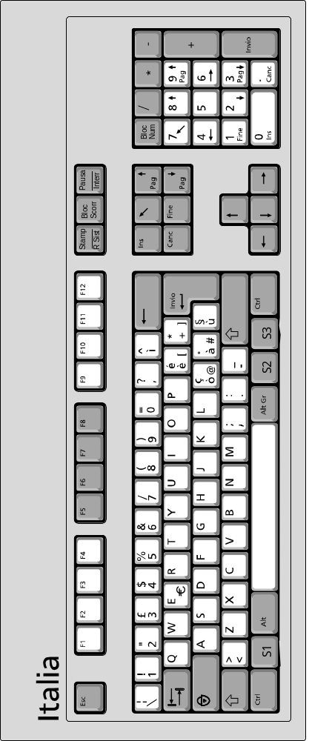
Fig. 4-1 Keyboard layout
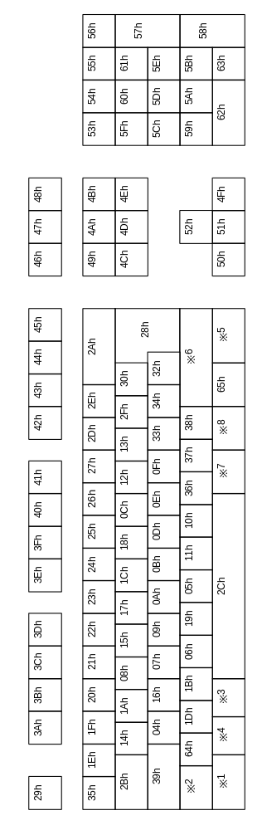
Fig. 4-2 Key scan code

code | code |  | code | code
DEC | HEX | Italian 105K | DEC | HEX | Italian 105K
0 | 00h | No Event Indicated | 56 | 38h | Keyboard [-], [_]
1 | 01h | Error Roll Over | 57 | 39h | Keyboard [Caps Lock]
4 | 04h | Keyboard [a], [A] | 58 | 3Ah | Keyboard [F1]
5 | 05h | Keyboard [b], [B] | 59 | 3Bh | Keyboard [F2]
6 | 06h | Keyboard [c], [C] | 60 | 3Ch | Keyboard [F3]
7 | 07h | Keyboard [d], [D] | 61 | 3Dh | Keyboard [F4]
8 | 08h | Keyboard [e], [E], [ € ](Euro) | 62 | 3Eh | Keyboard [F5]
9 | 09h | Keyboard [f], [F] | 63 | 3Fh | Keyboard [F6]
10 | 0Ah | Keyboard [g], [G] | 64 | 40h | Keyboard [F7]
11 | 0Bh | Keyboard [h], [H] | 65 | 41h | Keyboard [F8]
12 | 0Ch | Keyboard [i], [I] | 66 | 42h | Keyboard [F9]
13 | 0Dh | Keyboard [j], [J] | 67 | 43h | Keyboard [F10]
14 | 0Eh | Keyboard [k], [K] | 68 | 44h | Keyboard [F11]
15 | 0Fh | Keyboard [l], [L] | 69 | 45h | Keyboard [F12]
16 | 10h | Keyboard [m], [M] | 70 | 46h | Keyboard [Stamp]
17 | 11h | Keyboard [n], [N] | 71 | 47h | Keyboard [Bloc Scorr]
18 | 12h | Keyboard [o], [O] | 72 | 48h | Keyboard [Pausa]
19 | 13h | Keyboard [p], [P] | 73 | 49h | Keyboard [Ins]
20 | 14h | Keyboard [q], [Q] | 74 | 4Ah | Keyboard [?]
21 | 15h | Keyboard [r], [R] | 75 | 4Bh | Keyboard [Pag↑]
22 | 16h | Keyboard [s], [S] | 76 | 4Ch | Keyboard [Canc]
23 | 17h | Keyboard [t], [T] | 77 | 4Dh | Keyboard [Fine]
24 | 18h | Keyboard [u], [U] | 78 | 4Eh | Keyboard [Pag↓]
25 | 19h | Keyboard [v], [V] | 79 | 4Fh | Keyboard [→]
26 | 1Ah | Keyboard [w], [W] | 80 | 50h | Keyboard [←]
27 | 1Bh | Keyboard [x], [X] | 81 | 51h | Keyboard [↓]
28 | 1Ch | Keyboard [y], [Y] | 82 | 52h | Keyboard [↑]
29 | 1Dh | Keyboard [z], [Z] | 83 | 53h | Keypad [Broc Num]
30 | 1Eh | Keyboard [1], [!] | 84 | 54h | Keypad [/]
31 | 1Fh | Keyboard [2], ["] | 85 | 55h | Keypad [*]
32 | 20h | Keyboard [3], [£] | 86 | 56h | Keypad [-]
33 | 21h | Keyboard [4], [$] | 87 | 57h | Keypad [+]
34 | 22h | Keyboard [5], [%] , [ € ](Euro) | 88 | 58h | Keypad [Invio]
35 | 23h | Keyboard [6], [&] | 89 | 59h | Keypad [1], [Fine]
36 | 24h | Keyboard [7], [/] | 90 | 5Ah | Keypad [2], [↓]
37 | 25h | Keyboard [8], [(] | 91 | 5Bh | Keypad [3], [Pag↓]
38 | 26h | Keyboard [9], [)] | 92 | 5Ch | Keypad [4], [←]
39 | 27h | Keyboard [0], [=] | 93 | 5Dh | Keypad [5]
40 | 28h | Keyboard [Invio](Enter) | 94 | 5Eh | Keypad [6], [→]
41 | 29h | Keyboard [ESC] | 95 | 5Fh | Keypad [7], [?]
42 | 2Ah | Keyboard [Delete](BS) | 96 | 60h | Keypad [8], [↑]
43 | 2Bh | Keyboard [Tab] | 97 | 61h | Keypad [9], [Pag↑]
44 | 2Ch | Keyboard [Spacebar] | 98 | 62h | Keypad [0], [Ins]
45 | 2Dh | Keyboard ['], [?] | 99 | 63h | Keypad [.], [Canc]
46 | 2Eh | Keyboard [i], [^] | 100 | 64h | keyboard [<], [>]
47 | 2Fh | Keyboard [è], [é], [[] | 101 | 65h | keyboard [S3]
48 | 30h | Keyboard [+], [*], []] | *224 | E0h | Keyboard L[Control]
49 | 31h | Not Use | *225 | E1h | Keyboard L[Shift]
50 | 32h | keyboard [ù], [§] | *226 | E2h | Keyboard L[Alt]
51 | 33h | Keyboard [ò], [ç], [@] | *227 | E3h | Keyboard [S1]
52 | 34h | Keyboard [à], [°], [#] | *228 | E4h | Keyboard R[Control]
53 | 35h | Keyboard [\], [|] | *229 | E5h | Keyboard R[Shift]
54 | 36h | Keyboard [,], [;] | *230 | E6h | Keyboard R[Alt]
55 | 37h | Keyboard [.], [:] | *231 | E7h | Keyboard [S2]
Fig. 4-3 Keyboard List

The following key codes exist in addition to those shown in Fig. 4-2.

00h: No operation
01h: Rollover error

The 2nd data of the keys marked *1 (Left Control), *2 (Left Shift), *3 (Left Alt), *4 (S1), *5 (Right Control), *6 (Right Shift), *7 (Right Alt), and *8 (S2) is handled as the change key bit, so no key codes are returned for the 3rd to 8th data.

For a detailed explanation of character input methods, please refer to the software (IME) specifications.

Keyboard Function Information

This section describes device-specific information (device status). The device status must be stored in such a way that device status data cannot be changed or erased.

Type

Fixed Device Status
This refers to 112 bytes of device status information data with a fixed format, comprising required information. Correct connection and operation are only assured if all items are properly recorded.
Free Device Status
This refers to a maximum of 908 bytes of device-specific status information that can be allocated freely.

Fixed Device Status

The Fixed Device Status area must include all the items listed below.
(1) Device ID
Size : 16 bytes (00000040-06060080-00000000-00000000)
Description : Specify peripheral device ID.

(2) Country specification
Size : 1Byte (08h)
Description : Only available in the Europe region.

(3) Connection method
Size : 1byte(00h)
Description : Connects to the expansion device and records the direction of the expansion socket.
Becomes “00h” when the expansion device is not connected to the keyboard.

(4) Model name
Size : 30 bytes
Description : “Keyboard” in hankaku characters.
Remaining slots to be padded with spaces (20h).

(5) License
Size : 60 bytes
Description : “Produced By or Under License From SEGA ENTERPRISES,LTD.”
in hankaku characters. Remaining slots to be padded with spaces (20h).

(6) Standby current consumption
Size : 2 bytes
Description : Indicates the current consumption of the unit in paused condition (During minimum power consumption), in 0.1 mA units (hexadecimal notation).
Contains 01-2Ch since power consumption for the 105 Key Keyboard for Italy w is
30 mA.

(7) Maximum current consumption
Size : 2Byte
Description : Indicates the maximum current consumption of the unit, in 0.1 mA units (hexadecimal notation).
Contains 01-90h since power consumption for the 105 Key Keyboard for Italy w is
40 mA

Free Device Status

The Free Device Status area can include information about developers, designers, and programmers or any other information. The host can obtain this information by issuing the "All Device Request" command. If it is to be used by an application, the data orering sequence must be taken into consideration.

"Version 1.010,1999/04/27,315-6211-AM ," in hankaku characters.

Remarks

