“Maple Bus 1.0” Peripheral
Hard Ware Specifications

Racing Controller

Revision 0.90

Produced by:
CS Development and Production Department, Second Division
SEGA Enterprises Ltd.



Revision:
0.90 September 4, 1998 First distribution

* Additions and changes from the previous version are marked with for additions and for deletions.
CONTENTS:

1. Racing Controller Function Conditions 4
1.1. Racing Controller function definitions 4
1.2. Function elements 4
1.3. Detailed description of constituent elements 4
2. Racing Controller Function Operations 6
3. Device ID 7
3.1. Configuration of the Racing Controller device ID 7
3.1.1 In the case of steering only 7
3.1.2 In the case of steering + accelerator/brake unit 8
4. Data Formats 9
4.1. Read format 9
4.1.1 In the case of steering only 9
4.1.2 In the case of steering + accelerator/brake unit 10
4.2. Write format 10
5. Racing Controller Function Information 11
5.1. Types 11
5.2. Fixed Device Status 11
5.3. Free Device Status 12
6. Afterword 13

Racing Controller Function Conditions

Racing Controller function definitions
Indicates the man-machine-interface of the input form.
It must conform to the “Maple Bus 1.0” Standard Specifications and be affiliated with the “FT₀:Controller”.

Function elements
The Racing Controller comprises the following elements from among the function elements that can be defined by the FT₀:Controller function.
- Digital direction keys A : Da,Ua (Layout: Da:- (minus) buttons, Ua:+ (plus) buttons)
- Digital buttons : A, B, Start
- Analog key : A3 (When turned to the left, digital La is also output. When turned to the right, digital Ra is also output)
- Analog levers : A1, A2, A5, A6 (However, A5 and A6 are only valid when the accelerator/brake unit is connected.)

Detailed description of constituent elements
Each of the Racing Controller function elements is describe in detail in the following.
- Digital direction keys A : Ra, La, Da, Ua
Da, Ua are 2-value press/release (= ON/OFF) digital type keys (buttons).
Ra and La discern that digital is ON, when the analog key’s threshold values (La: 40h, Ra: BEh) are exceeded.
Virtually, Ra and La and Da and Ua form counterparts, respectively, The straight line (X-axis) on which Ra and La are placed at the respective endpoints intersects with the other straight line (Y-axis) on which the Da and Ua are placed at the respective endpoints. The keys (buttons) are arranged on the X-Y surface formed by these straight lines.
The way the keys (buttons) are arranged and the directions of movement are as follows: Ra is on the right side, right direction, La is on the left side, left direction, Da is at the bottom, downward direction and toward the viewer, Ua is at the top, upward direction and away from the viewer.
The values are pressed (exceeding the threshold value) = ‘0’, released (not exceeding the threshold value) = ’1’.
The controller must not generate the key data of more than 3 keys (buttons) at the same time.

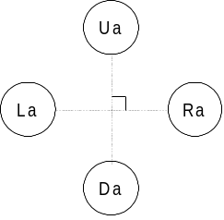
Fig. 1.1 Button layout of digital cross keys A

- Digital buttons : A, B, Start
These are 2-value press/release (= ON/OFF) digital type keys (buttons).
The button arrangement is optional.
The controller must be able to detect whether multiple keys (buttons) are ON at the same time.
The values are: pressed = ’0’, released = ’1’.
- Analog keys : A3
These are analog type keys where the value detected in accordance with the distance the key is moved from its initial position changes linearly.
The value at the key’s initial position is 80h, and the value changes in 01h units from the minimum value 00h to the maximum value FFh.
In relation to the key position, the direction in which the value decreases is the minus direction, and the direction in which the value increases is the plus direction.
The key should be able to move in these two directions.
When the load applied to move the key is released, the centering of the key should be performed automatically so that the key returns to the initial position.
A3 indicates the Xa axis and is operated with both hands.
When turned to the left, La of the digital key is also output when the analog data becomes smaller than 40h.
When turned to the right, Ra of the digital key is also output when the analog data becomes larger than BEh.

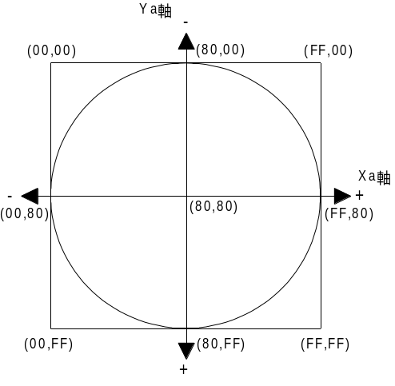
Ya-axis
Xa-axis
Fig. 1.2 Data range of analog key

- Analog levers : A1, A2, A5, A6 (however, A5 and A6 are only valid when the accelerator/brake unit is connected.)
These are analog type levers where the value detected in accordance with the distance the lever is moved from its initial position changes linearly.
The value at the lever’s initial position is 00h, and the value changes in 01h units from the minimum value 00h to the maximum value FFh.
In relation to the lever’s initial position, the lever only moves in the plus direction in which the value increases.
When the load applied to move the lever is released, the lever should automatically return to its initial position.
In general, A1 indicates the R-axis and A2 indicates the L-axis. The R-axis is operated with the right hand and the L-axis with the left hand.
Use of only one axis at a time should also be possible.

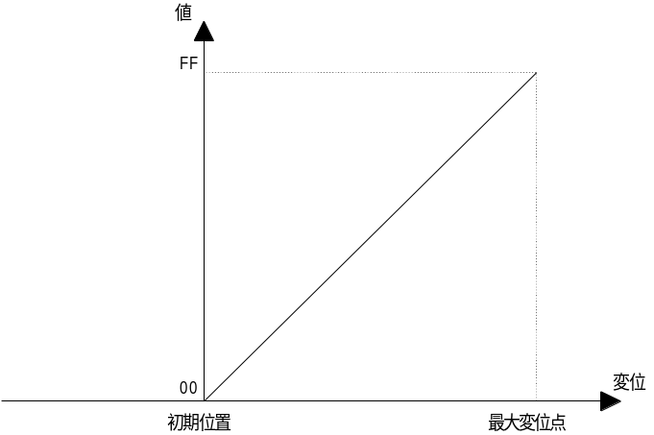
Value
Change
Maximum change
Intial position
Fig. 1.3 Data range of analog lever

Racing Controller Function Operations
The controller should be manufactured in accordance with the operation of the FT₀:Controller functions.
- Key scan
It is a requirement that the data (key data) of the digital keys (buttons) and analog keys are updated constantly.
There should always be a good response to data requests from the host.
Since there is no order of priority for key scan, all the keys (buttons) should be concurrently readable.

- A/D conversion
In a controller using analog data, A/D conversion should be performed to convert the analog quantities to digital quantities.
The A/D conversion accuracy is not a question but there should be 8 bits per axis for the key data.
The maximum total time for A/D conversion of all analog keys should be less than 1 msec which is the Time Out time.

- Optimization, conditions
- For the cross keys, no more than 3 keys (buttons) must be ON at the same time (key data must not be generated).
- The cross keys U and D, R and L must not be ON at the same time (key data must not be generated).
- The simultaneous ON statuses of multiple digital buttons must be detectable.
- When two or more keys (buttons) are simultaneously pressed, keys (buttons) that are not pressed must not come ON (key data must not be generated).
- When the analog key is at the center position (initial position), the key data value must not fluctuate while the key is not touched.
- When the analog lever is at the initial position, the key data value must not fluctuate while the lever is not touched.
- When the analog key or analog lever is at the maximum changed positions, the key data value must indicate the maximum value.
- No matter where the analog key is located inside the operation range, the key must return to the center position when the key is released.

Device ID
In accordance with the device ID definition in the “Maple Bus 1.0” Standard Specifications.
The notation is that of the host’s memory image.

Configuration of the Racing Controller device ID

In the case of steering only
The device ID consists of 16 bytes (128 bits).
Bit | 7 | 6 | 5 | 4 | 3 | 2 | 1 | 0
1st Data | 0 | 0 | 0 | 0 | 0 | 0 | 0 | 0
2nd Data | 0 | 0 | 0 | 0 | 0 | 0 | 0 | 0
3rd Data | 0 | 0 | 0 | 0 | 0 | 0 | 0 | 0
4th Data | 0 | 0 | 0 | 0 | 0 | 0 | 0 | 1
5th Data | 0 | 0 | 0 | 0 | 0 | 0 | 0 | 0
6th Data | 0 | 0 | 0 | 0 | 0 | 1 | 1 | 1
7th Data | 0 | 0 | 0 | 0 | 0 | 0 | 0 | 0
8th Data | 1 | 1 | 1 | 1 | 1 | 1 | 1 | 0
9th Data | 0 | 0 | 0 | 0 | 0 | 0 | 0 | 0
10th Data | 0 | 0 | 0 | 0 | 0 | 0 | 0 | 0
11th Data | 0 | 0 | 0 | 0 | 0 | 0 | 0 | 0
12th Data | 0 | 0 | 0 | 0 | 0 | 0 | 0 | 0
13th Data | 0 | 0 | 0 | 0 | 0 | 0 | 0 | 0
14th Data | 0 | 0 | 0 | 0 | 0 | 0 | 0 | 0
15th Data | 0 | 0 | 0 | 0 | 0 | 0 | 0 | 0
16th Data | 0 | 0 | 0 | 0 | 0 | 0 | 0 | 0
Fig. 3.1 Device ID
FT : Designates type of function that the peripheral is equipped with. (1st to 4th Data)
FD1 : Designates the function definition block of the first function. (5th to 8th Data)
FD2 : Designates the function definition block of the second function. (9th to 12th Data)
FD3 : Designates the function definition block of the third function. (13th to 16th Data)

- FT₀-FT₃₁ : Function type
Designates the function that the peripheral is equipped with.
There are 32 function types altogether.

- FD1₃₁-FD1₀ : Function definition block
This is for the block defining the individual elements that constitute the function.

In the case of steering + accelerator/brake unit
The device ID consists of 16 bytes (128 bits).
Bit | 7 | 6 | 5 | 4 | 3 | 2 | 1 | 0
1st Data | 0 | 0 | 0 | 0 | 0 | 0 | 0 | 0
2nd Data | 0 | 0 | 0 | 0 | 0 | 0 | 0 | 0
3rd Data | 0 | 0 | 0 | 0 | 0 | 0 | 0 | 0
4th Data | 0 | 0 | 0 | 0 | 0 | 0 | 0 | 1
5th Data | 0 | 0 | 0 | 0 | 0 | 0 | 0 | 0
6th Data | 0 | 0 | 1 | 1 | 0 | 1 | 1 | 1
7th Data | 0 | 0 | 0 | 0 | 0 | 0 | 0 | 0
8th Data | 1 | 1 | 1 | 1 | 1 | 1 | 1 | 0
9th Data | 0 | 0 | 0 | 0 | 0 | 0 | 0 | 0
10th Data | 0 | 0 | 0 | 0 | 0 | 0 | 0 | 0
11th Data | 0 | 0 | 0 | 0 | 0 | 0 | 0 | 0
12th Data | 0 | 0 | 0 | 0 | 0 | 0 | 0 | 0
13th Data | 0 | 0 | 0 | 0 | 0 | 0 | 0 | 0
14th Data | 0 | 0 | 0 | 0 | 0 | 0 | 0 | 0
15th Data | 0 | 0 | 0 | 0 | 0 | 0 | 0 | 0
16th Data | 0 | 0 | 0 | 0 | 0 | 0 | 0 | 0
Fig. 3.1 Device ID
FT : Designates type of function that the peripheral is equipped with. (1st to 4th Data)
FD1 : Designates the function definition block of the first function. (5th to 8th Data)
FD2 : Designates the function definition block of the second function. (9th to 12th Data)
FD3 : Designates the function definition block of the third function. (13th to 16th Data)

- FT₀-FT₃₁ : Function type
Designates the function that the peripheral is equipped with.
There are 32 function types altogether.

- FD1₃₁-FD1₀ : Function definition block
This is for the block defining the individual elements that constitute the function.

Data Formats
Racing Controller function data formats are explained in the following.
The notation is that of the host’s memory image.

Read format
This is the key data format when the Racing Controller function data are read.

In the case of steering only
The data format size is 8 bytes.

Bit | 7 | 6 | 5 | 4 | 3 | 2 | 1 | 0
1st Data | Ra | La | Da | Ua | Start | A | B | 1
2nd Data | 1 | 1 | 1 | 1 | 1 | 1 | 1 | 1
3rd Data | A1₇ | A1₆ | A1₅ | A1₄ | A1₃ | A1₂ | A1₁ | A1₀
4th Data | A2₇ | A2₆ | A2₅ | A2₄ | A2₃ | A2₂ | A2₁ | A2₀
5th Data | A3₇ | A3₆ | A3₅ | A3₄ | A3₃ | A3₂ | A3₁ | A3₀
6th Data | 1 | 0 | 0 | 0 | 0 | 0 | 0 | 0
7th Data | 1 | 0 | 0 | 0 | 0 | 0 | 0 | 0
8th Data | 1 | 0 | 0 | 0 | 0 | 0 | 0 | 0
Fig. 4.1 Read format

Key data explanation
1st : Digital button data. (ON = ‘0’, OFF =‘1’)
2nd : Digital button data. (ON = ‘0’, OFF = ‘1’)
3rd : Analog axis 1 (A1) data.
4th : Analog axis 2 (A2) data.
5th : Analog axis 3 (A3) data.
6th : Analog axis 4 (A4) data. As there is no analog data, this becomes the midpoint “80h”.
7th : Analog axis 5 (A5) data. As there is no analog data, this becomes the midpoint “80h”.
8th : Analog axis 6 (A6) data. As there is no analog data, this becomes the midpoint “80h”.

In the case of steering + accelerator/brake unit
The data format size is 8 bytes.

Bit | 7 | 6 | 5 | 4 | 3 | 2 | 1 | 0
1st Data | Ra | La | Da | Ua | Start | A | B | 1
2nd Data | 1 | 1 | 1 | 1 | 1 | 1 | 1 | 1
3rd Data | A1₇ | A1₆ | A1₅ | A1₄ | A1₃ | A1₂ | A1₁ | A1₀
4th Data | A2₇ | A2₆ | A2₅ | A2₄ | A2₃ | A2₂ | A2₁ | A2₀
5th Data | A3₇ | A3₆ | A3₅ | A3₄ | A3₃ | A3₂ | A3₁ | A3₀
6th Data | 1 | 0 | 0 | 0 | 0 | 0 | 0 | 0
7th Data | A5₇ | A5₆ | A5₅ | A5₄ | A5₃ | A5₂ | A5₁ | A5₀
8th Data | A6₇ | A6₆ | A6₅ | A6₄ | A6₃ | A6₂ | A6₁ | A6₀
Fig. 4.1 Read format

Key data explanation
1st : Digital button data. (ON = ‘0’, OFF =‘1’)
2nd : Digital button data. (ON = ‘0’, OFF = ‘1’)
3rd : Analog axis 1 (A1) data.
4th : Analog axis 2 (A2) data.
5th : Analog axis 3 (A3) data.
6th : Analog axis 4 (A4) data. As there is no analog data, this becomes the midpoint “80h”.
7th : Analog axis 5 (A5) data.
8th : Analog axis 6 (A6) data.

Write format
There is no write format for writing data to the Racing Controller function.
Racing Controller functions are read only.

Racing Controller Function Information
This chapter explains information about specific devices (device statuses).
To prevent device statuses from being rewritten or erased, the data are recorded as they are.

Types
Fixed Device Status
This is a set form of device status, consisting of 112 bytes in all, that must be designated.
Unless all items are designated, operation and connection are not guaranteed.
Free Device Status
The individual devices can use this status freely. The maximum capacity is 908 bytes.

Fixed Device Status
All of the following items must be designated for the Fixed Device Status.

- Device ID
(1) – 1 In the case of steering only
Capacity : 16 bytes (00000001000700FE0000000000000000)
Explanation : Indicates the Racing Controller function’s device ID.
FT : Controller
FD1 : Ra, Da, Ua, La, S, A, B, A1, A2, A3
FD2 : None
DF3 : None

(1) – 2 In the case of steering + accelerator/brake unit
Capacity : 16 bytes (00000001003700FE0000000000000000)
Description : Indicates the Racing Controller function’s device ID.
FT : Controller
FD1 : Ra, Da, Ua, La, S, A, B, A1, A2, A3, A5, A6
FD2 : None
DF3 : None

- Destination
Capacity : 1 byte (FFh)
Description : Common worldwide

- Connection direction
Capacity : 1 byte (00h) upper direction

- Product name
Capacity : 30 bytes
Description : Designates “Racing Controller” in half-width characters.
A space code (20h) is inserted for unused space.
- License
Capacity : 60 bytes
Description : Designates “Produced By or Under License From SEGA ENTERPRISES,LTD.” in half-width characters. A space code (20h) is inserted for unused space.

- Standby current consumption
Size : 2 bytes
Description : Standby current consumption for temporary stop, in units of 0.1 mA, is designated in hexadecimal notation.
As the Racing Controller is 44 mA , please enter as 01-B8h.

- Maximum current consumption
Size : 2 bytes
Description : Maximum current consumption, in units of 0.1 mA, is designated in hexadecimal notation.
As the Racing Controller is 55 mA , please enter as 02-26h.

Free Device Status
The Free Device Status area is available for product planners, developers, designers and programmers to enter any information they wish. The host obtains this status by the All Device Request.
When used with application software, it is necessary to consider the data layout, etc.

“Version 1.000,1998/08/19,315-6125-AE , : Indicates a space

Enter in half-width characters.

Afterword
Until the official version (Rev. 1.0) is distributed, contents will be modified to a small or large extent.

