"Maple Bus 1.0" Peripheral
Hardware Specifications

Fishing Controller

Rev 0.80

Issued by
Sega Enterprises, Inc.
CS Development and Production Dep't, Second Division

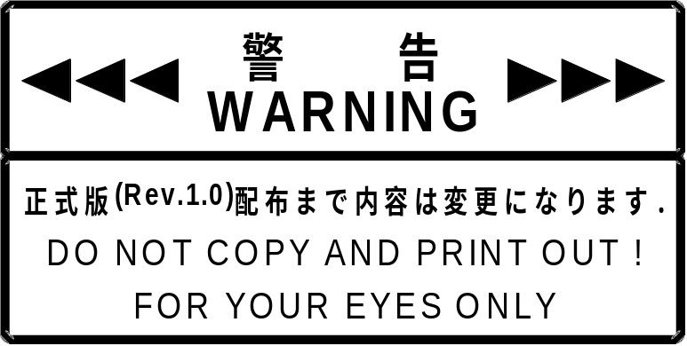
Revision:
0.60 1998/10/09 Preview Version
0.61 1998/10/14 Preview Version 2
Assigned FT₈: Vibration Function to LM-BUS No.5.
Setting the direction of rotation for vibration source No.1 is not possible.
0.70 1998/10/16 First edition
0.71 1998/11/20 Revision
The number of vibrations that can be set simultaneously was changed from two to one.
[Set Condition] command restriction
(An error results if two are set simultaneously.)
0.72 1998/12/11 Revision
In section 1.4, "Detailed description of constituent elements"
Fig. 1.1 Changed the range of the analog key data.
Added description of analog key output data characteristics.
Fig. 1.2 Changed the acceleration sensor sensitivity access and the range of the data.
Changed the analog XYZ coordinate data for maximum impact.
In section 2.2, "Vibration Operation"
Added description of problem with single-pulse convergent/single-pulse divergent vibration after automatic vibration has stopped, and a method for avoiding that problem.
In section 4.3.1, "Rotation Setting"
Added description of problem with single-pulse convergent/single-pulse divergent vibration after automatic vibration has stopped, and a method for avoiding that problem.
0.80 1999/02/10 Revision
Added "Creating Applications that Support the Fishing Controller."

Contents:

1. Overview 5
1.1 Overview of the Fishing Controller 5
1.2 Fishing Controller definitions 5
1.3 Function elements 5
1.4 Detailed description of constituent elements 6
2. FISHING CONTROLLER OPERATION 11
2.1 Operation as controller 11
2.2 Vibration operation 12
3. Device ID 13
3.1 Configuration of the "Maple Bus 1.0" device ID 13
4. DATA FORMATS 15
4.1 Read format 15
4.2 Vibration source information 17
4.3 Vibration setting 18
4.3.1 Rotation settings 18
4.3.2 Simultaneous rotation setting 19
4.3.3 Rotation stop settings 19
4.4 Checking the vibration settings while vibration is in progress 20
4.5 Automatic vibration stop time setting 21
4.6 Checking the automatic vibration stop time setting 23
4.7 Setting and checking a custom vibration waveform 23
5. FISHING CONTROLLER INFORMATION 24
5.1 Types 24
5.2 Fixed Device Status 24
5.3 Free Device Status 25
6. AFTERWORD 26

Creating Applications that Support the Fishing Controller

- The Fishing Controller does not include an expansion slot similar to that found the standard controller, etc. If it is necessary to save data from a game in progress, connect a controller and a memory card to the open controller port.
- If the Fishing Controller is used with software that does not support the Fishing Controller, the controller may not operate correctly due to differences in the assignment of function keys.
- Using the vibration function on the Fishing Controller consumes an extremely large amount of current.
A maximum of only two Fishing Controllers should be used simultaneously. If three or more controllers are connected to controller ports, use only the two that have the highest priority, and keep the remaining controllers in the standby state. This also applies to other peripherals, such as the Purupuru Pack, that consume a large amount of current.
- The Fishing Controller can be operated in many different ways for different applications. Therefore, the instruction manual that is provided with the Fishing Controller does not contain a detailed description of the operation of the Fishing Controller. Each application should include instructions on how to use the Fishing Controller with that application.

Overview

This section describes the Fishing Controller, a peripheral for Sega's next-generation game machine, Dreamcast.

Overview of the Fishing Controller

The Fishing Controller is an I/O man-machine interface that has a reel mechanism (a necessity for any fishing game), uses an acceleration detector to implement the casting action, and uses an eccentric motor to allow the user to "feel" a fishing taking and pulling on the line.

Fishing Controller definitions

The Fishing Controller conforms with the Maple Bus 1.0 Standard Specifications, and supports the following functions:

- FT₀: Controller Function
- FT₈: Vibration Function

For details, refer to the appropriate specifications.

Function elements

The Fishing Controller has a vibration function as an expanded function.
The Fishing Controller is assigned to FT₀ as a device, and the vibration function is assigned to FT₈ as an internally connected expansion device.
Function elements defined in each of these are as follows.

- Device
FT₀: Controller Function
- Digital buttons : A,B,X,Y,Start
- Analog keys : A3,A4 (A3 and A4 are also output as digital direction keys Ra, La, Ua, and Da)
- Analog xyz axises : A2,A5,A6 (A2, A5, and A6 output the acceleration sensor Z, X, and Y coordinates, respectively)
- Analog lever : A1 (Reel handle output)

- Expansion device
FT₈: Vibration Function
- Vibration on source number : 2
(Number of vibration sources that can be concurrently selected. : 1)

- The expansion device is connected to LM-BUS No.5. (This connection is a fixed connection.)

Detailed description of constituent elements

Each of the Fishing Controller function elements is describe in detail in the following.

- Controller function

- Digital buttons :A,B,X,Y,Start
These are 2-value press/release (= ON/OFF) digital type keys (buttons).
The controller must be able to detect whether multiple keys (buttons) are ON at the same time.
The values are: press = ‘0’, release = ‘1’.

- Analog keys :A3(Xa),A4(Ya)
These are analog type keys where the value detected in accordance with the distance the key is moved from its initial position changes linearly.
The value at the key’s initial position is 80h (home position), and the value changes in 01h units from the minimum value 00h to the maximum value FFh.
In relation to the key position, the direction in which the value decreases is the minus direction, and the direction in which the value increases is the plus direction.
The key should be able to move in these two directions.
When the load applied to move the key is released, the centering of the key should be performed automatically so that the key returns to the initial position (home position).
A3 and A4 represent the Xa axis and the Ya axis, and are operated by the left hand.
If the Xa axis or the Ya axis exceeds its threshold value, the ON signal for the corresponding digital direction key is output.
If the Xa axis (Ya axis) is moved from the center to the left (up) and the analog data decreases below 30h, the ON signal is output for the digital key La (Ua). When the control is moved back to the center and the analog data exceeds 40h, the OFF signal is output for the digital key La (Ua).
Conversely, if the control is moved to the right (down) and the analog data exceeds D0h, the ON signal is output for the digital key Ra (Da). When the control is moved back to the center and the analog data decreases C0h, the OFF signal is output for the digital key Ra (Da). The digital key data is output in order to maintain compatibility when performing menu operations in OS mode on the Dreamcast. From the standpoint of key operability, using the digital data that is output by these keys in a game is inappropriate. Use only the analog key data in applications.
Ya axis
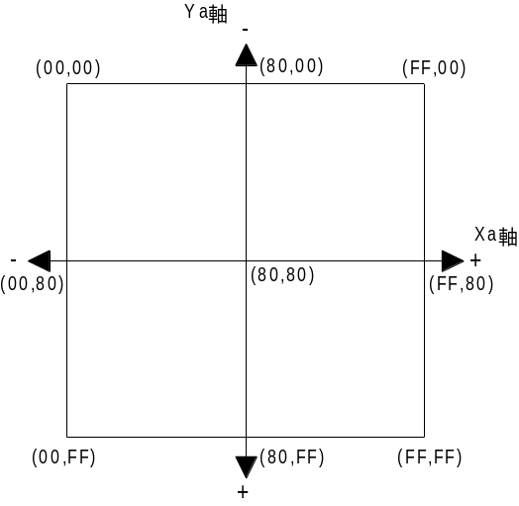

Xa axis

Fig. 1.1 Data range of analog key
!Caution!
As a result of the construction of the analog keys, the data range when the key is centered is extremely large. In order to avoid problems on the file management screen when the controller is connected to the Dreamcast, compensation is applied so that the coordinate data definitely returns to the center (i.e., 80h is output). (This is blind area processing for the center return area.)
The end result is that the correlation between the absolute position of the key and the data is slightly loose. Specifically, the locus indicated by the operation of the key in the response area will differ from the coordinate locus in the data.
The calculations involved in polar coordinate conversion are not precise due to limitations of the firmware, since a pseudo-calculation method based on slope has been adopted. The symptoms of this imprecision especially manifest themselves when performing an operation in which the coordinate data for either the X axis or the Y axis is fixed and the other axis changes. This can result in an awkward feel when operating the controller. However, in regards to the amount of change versus radial lines that extend from the center, the data that is output tracks the amount of key movement in a very linear manner, resulting in a natural feel.
Therefore, this characteristic imprecision can be avoided by always handling key data in terms of direction and speed of movement from a position, rather than using absolute coordinates.
The characteristics curve is as described below.
In the compensation processing, the 360-degree field is divided into 8 sections of 45 degrees each. The slope (X/Y) is derived from the X and Y data relative to the center of the 45-degree region (80h, 80h); the calculated slope is then fitted to the 73-step slope, and the X and Y coordinates that correspond to the blind area in each 45-degree sector are subtracted.
In areas (1), (4), (5), and (8), the above calculation is performed, compensation is applied for that individual quadrant, and the result is output. In areas (2), (3), (6), and (7), the X and Y coordinate values are switched for each other, a calculation similar to that for area (1) is performed, compensation is applied for that individual quadrant, X and Y are switched with each other again, and the result is output.
90°（80h,00h）

(2)
(3)

(1)
(4)
0°（FFh,80h）
180°（00h,80h）
Blind area
(5)
(7)

(6)
(7)

270°（80h,FFh）

Fig. 2.2 Compensation Area Divisions
Y axis fixed X axis fixed
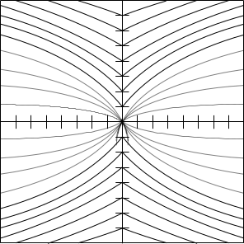
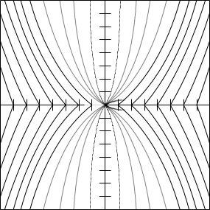

Fig. 3.3 Output Characteristics After Analog Key Data Output

- Analog XYZ coordinates: A2(Z),A5,(X),A6(Y)

Forces applied to the controller are detected by an acceleration sensor that expresses separate components for each of the three axes, X, Y, and Z.
In the X, Y, and Z axes, the acceleration sensor outputs a value of 80 ± 8H (home position) when they are in the static state (± 0G), and in each of the sensitivity axes X, Y, and Z, the sensor outputs a value of F0h or greater for the maximum force (+10G) applied in the positive direction (solid line) and a value of 11h or less for the maximum force (-10G) applied in the negative direction (dotted line). There will also be variations in the output characteristics among individual acceleration sensor elements.

The following diagram indicates the mounting position of the acceleration sensor on the controller, and the direction of each of the sensitivity axes X, Y, and Z.
In this case, from the perspective of the player who is operating the controller (indicated by the arrow):
X coordinate sensitivity axis : Right is positive, left is negative
Y coordinate sensitivity axis : Down is positive, up is negative
Z coordinate sensitivity axis : Forward is positive, backward is negative
The surface on which the analog direction key is located correspond to the "up" direction.
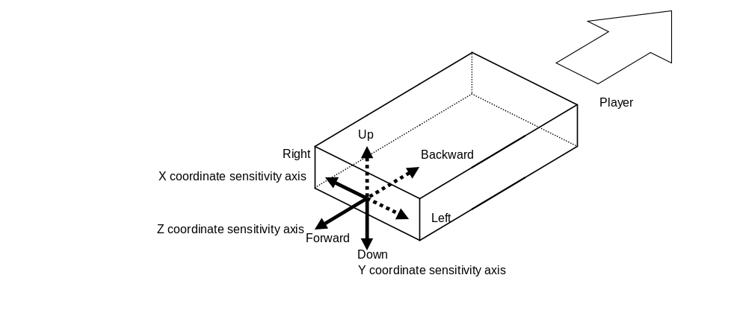
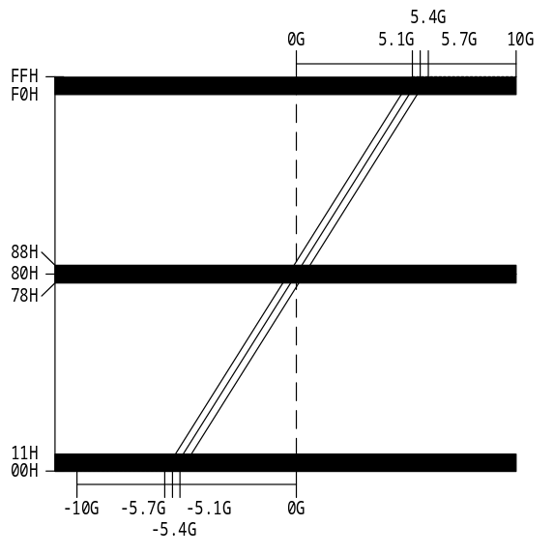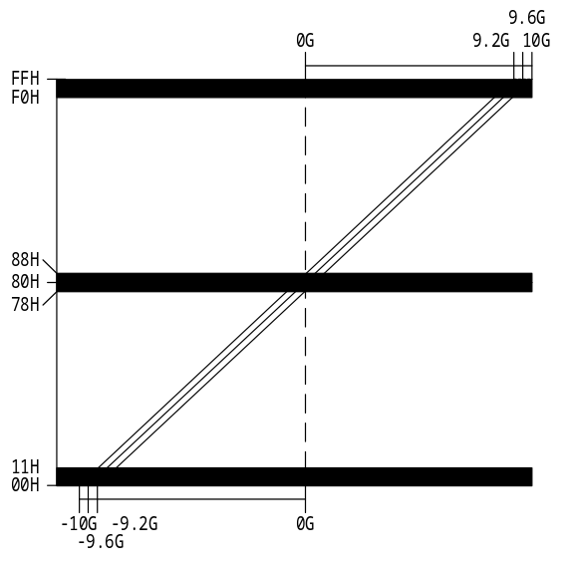
Fig. 4.4 Acceleration Sensor Sensitivity Axes and Data Ranges

- Analog lever :A1
This is an analog lever that converts the value detected by the amount of change from the lever's initial position (home position) into a linear value. In the Fishing Controller, the rotational speed of the reel handle is output as a linear value. When stopped, the value is 00h. The value can range from a minimum of 00h to a maximum of FFh, according to the rotational speed, and changes in 01h increments.
The maximum value is reaches at 360rpm.
The data is updated every 100ms (6 Int). The previous data is retained between updates.

- Vibration function

There are two vibration sources installed in the Fishing Controller.
The details for each of these elements are described below.

- Vibration sources : 1 VN='0001'
Vibration source position : Front VP='00'
The Vibration axis of Vibration source : None VD='00'
Variable vibration intensity setting : Variable over 8 steps PF=’1’
Continuous vibration : Possible CV='1'
Direction setting : Not possible PD='0'
Arbitrary vibration waveform : Not possible OWF='0'

Vibration attribute flag : Specifies the maxi and min values VA='0000'
Minimum settable vibration frequency: Fmin='00h'（0.5Hz）
Maximum settable vibration frequency: Fmax='0Fh'（8.0Hz）

- Vibration sources : 1 VN='0010'
Vibration source position : Back VP='01'
The Vibration axis of Vibration source : None VD='00'
Variable vibration intensity setting : Fixed PF=’0’
Continuous vibration : Possible CV='1'
Direction setting : Not possible PD='0'
Arbitrary vibration waveform : Not possible OWF='0'

Vibration attribute flag : Disabled to set the number
of the vibration VA='1111'

FISHING CONTROLLER OPERATION

The following describes the Fishing Controller operation.

Operation as controller

The operation of the Fishing Controller conforms with the operation of the "FT₀: Controller" function.

- Key scan
It is a requirement that the data (key data) of the digital keys (buttons) and analog keys are always being updated.
There can always be a good response to data requests from the host.
Since there is no order of priority for key scan, all the keys (buttons) should be concurrently readable.

- Generation of acceleration data for three axes
The acceleration sensor elements that are mounted in the Fishing Controller convert the force (acceleration) that is applied to the Fishing Controller in three axes into a change in analog signals that the Fishing Controller then outputs. The data for each of the three axes (X, Y, and Z) is expressed through 8-bit values.

- Reel handle data generation
The Fishing Controller detects rotation of the handle by means of a photo-interrupter, and outputs the count per unit of time as analog data. When the handle is stopped, the data that is output is 00h; at approximately 360rpm (six times per second), the value FFh is output. The Fishing Controller does not detect the direction of rotation.

- Optimization, conditions
- The simultaneous ON statuses of multiple digital buttons must detectable.
- When two or more buttons are simultaneously pressed, buttons that are not pressed must not come ON (key data must not be generated).

Vibration operation

The vibration source that is built into the Fishing Controller conforms with FT₈: Vibration operation.

- Single-pulse vibration operation
This setting can be made for both vibration sources No.1 and No.2.
This is a "vibration" that consists of just a single pulse.
Once that single pulse ends, vibration stops.

- Continuous vibration operation
This setting can be made for both vibration sources No.1 and No.2.
During this operation, the vibration pulse is repeated on the set cycle.
Vibration continues until either the vibration stop instruction is received or the automatic vibration stop time is reached.

- Convergent (divergent) vibration
This setting can only be made for vibration source No.1.
Convergent and divergent vibration cannot both be set simultaneously.
This setting can be made with continuous vibration. "Convergent vibration" means that the vibration starts out string, and then gradually becomes weak. When the vibration stops, it becomes strong again. This process repeats.
If continuous vibration was set, then convergent or divergent vibration continues until either the vibration stop instruction is received or the automatic vibration stop time is reached.
Once vibration has been completed, vibration stops.
* However, if vibration has stopped at the automatic vibration stop time, subsequent single-pulse convergent/divergent vibration will not function normally because the automatic stop flag is not cleared. Therefore, all motor control should be set so that there is plenty of excess time built into the automatic vibration stop time setting, and always stop vibration by setting the intensity to "0" so that the automatic vibration stop function is never triggered.
Abnormal operation after automatic vibration stops can be avoided by issuing the "Device Reset" command.

- Vibration auto-stop time
This setting can be made for both vibration sources No.1 and No.2.
This function is available only when continuous vibration is being used.
Once this time elapses from the time when vibration starts, vibration automatically stops.
The stop time can be set for each vibration source independently.

- Custom vibration waveform
It is not possible to set a custom vibration waveform for either vibration source No.1 or vibration source No.2.

Device ID

In accordance with the device ID definition in the “Maple Bus 1.0” Standard Specifications.
The notation is that of the host’s memory image.

Configuration of the "Maple Bus 1.0" device ID

With the Fishing Controller, there are separate device IDs for the device and for the internally connected expansion device.

The device ID consists of 16 bytes (128 bits).
1st Data -4th Data : Designates type of function that the peripheral is equipped with. (FT)
5st Data -8th Data FD1 : Designates the function definition block of the first function. (FD1)
9st Data -12th Data FD2 : Designates the function definition block of the second function. (FD2)
13st Data -16th Data FD3 : Designates the function definition block of the third function. (FD3)

- FT₀-FT₃₁ : Function type
Designates the function that the peripheral is equipped with.
There are 32 function types altogether.

- FD1₃₁-FD1₀ : Function definition block
This is for the block defining the individual elements making up the function.

- "FT₀: Controller Function" is assigned to the device.

bit | 7 | 6 | 5 | 4 | 3 | 2 | 1 | 0
1st Data | 0 | 0 | 0 | 0 | 0 | 0 | 0 | 0
2nd Data | 0 | 0 | 0 | 0 | 0 | 0 | 0 | 0
3rd Data | 0 | 0 | 0 | 0 | 0 | 0 | 0 | 0
4th Data | 0 | 0 | 0 | 0 | 0 | 0 | 0 | 1
5th Data | 0 | 0 | 0 | 0 | 0 | 0 | 0 | 0
6th Data | 0 | 0 | 1 | 1 | 1 | 1 | 1 | 1
7th Data | 0 | 0 | 0 | 0 | 0 | 1 | 1 | 0
8th Data | 1 | 1 | 1 | 1 | 1 | 1 | 1 | 0
9th Data | 0 | 0 | 0 | 0 | 0 | 0 | 0 | 0
10th Data | 0 | 0 | 0 | 0 | 0 | 0 | 0 | 0
11th Data | 0 | 0 | 0 | 0 | 0 | 0 | 0 | 0
12th Data | 0 | 0 | 0 | 0 | 0 | 0 | 0 | 0
13th Data | 0 | 0 | 0 | 0 | 0 | 0 | 0 | 0
14th Data | 0 | 0 | 0 | 0 | 0 | 0 | 0 | 0
15th Data | 0 | 0 | 0 | 0 | 0 | 0 | 0 | 0
16th Data | 0 | 0 | 0 | 0 | 0 | 0 | 0 | 0
Fig. 3.1 Device IDs for Devices

- "FT₈: Vibration Function" is assigned to the expansion device.

bit | 7 | 6 | 5 | 4 | 3 | 2 | 1 | 0
1st Data | 0 | 0 | 0 | 0 | 0 | 0 | 0 | 0
2nd Data | 0 | 0 | 0 | 0 | 0 | 0 | 0 | 0
3rd Data | 0 | 0 | 0 | 0 | 0 | 0 | 0 | 1
4th Data | 0 | 0 | 0 | 0 | 0 | 0 | 0 | 0
5th Data | 0 | 0 | 0 | 0 | 0 | 0 | 1 | 0
6th Data | 0 | 0 | 0 | 0 | 0 | 0 | 0 | 1
7th Data | 0 | 0 | 0 | 0 | 0 | 0 | 0 | 0
8th Data | 0 | 0 | 0 | 0 | 0 | 0 | 0 | 0
9th Data | 0 | 0 | 0 | 0 | 0 | 0 | 0 | 0
10th Data | 0 | 0 | 0 | 0 | 0 | 0 | 0 | 0
11th Data | 0 | 0 | 0 | 0 | 0 | 0 | 0 | 0
12th Data | 0 | 0 | 0 | 0 | 0 | 0 | 0 | 0
13th Data | 0 | 0 | 0 | 0 | 0 | 0 | 0 | 0
14th Data | 0 | 0 | 0 | 0 | 0 | 0 | 0 | 0
15th Data | 0 | 0 | 0 | 0 | 0 | 0 | 0 | 0
16th Data | 0 | 0 | 0 | 0 | 0 | 0 | 0 | 0
Fig. 3.2 Device IDs for Expansion Devices

DATA FORMATS

The Fishing Controller function data formats are explained in the following.
The notation is that of the host’s memory image.

Read format

This is the format for key data in the Fishing Controller.
When the host transmits Get Condition, the Fishing Controller returns data according to the data format.
The command is Data Transfer.

Data Address | Data | Setting example | Description
+0000h | Command code | 09h | Specifies Get Condition.
+0001h | Destination AP | 20h | Specifies device of port A.
+0002h | Origin AP | 00h | Port A
+0003h | Data size | 01h | Data size is 4 bytes.
+0004h | Function type | 00h | The function type specifies the controller.
+0005h | Function type | 00h | The function type specifies the controller.
+0006h | Function type | 00h | The function type specifies the controller.
+0007h | Function type | 01h | The function type specifies the controller.
Fig. 4.1 "Get Condition" Data transmission from host

Data Address | Data | Setting example | Description
+0000h | Command code | 08h | Specifies Data Transfer
+0001h | Destination AP | 00h | Port A
+0002h | Origin AP | 30h | Specifies device of port A.
+0003h | Data size | 03h | Data size is 12 byte
+0004h | Function type | 00h | The function type specifies the controller.
+0005h | Function type | 00h | The function type specifies the controller.
+0006h | Function type | 00h | The function type specifies the controller.
+0007h | Function type | 01h | The function type specifies the controller.
+0008h | Read format | FFh | For details on the data that is stored here, refer to Fig. 4.3.
+0009h | Read format | FFh
+000Ah | Read format | 00h
+000Bh | Read format | 80h
+000Ch | Read format | 80h
+000Dh | Read format | 80h
+000Eh | Read format | 80h
+000Fh | Read format | 80h
Fig. 4.2 "Data Transfer" Data transmission from host

The data format size is 8 bytes.

bit | 7 | 6 | 5 | 4 | 3 | 2 | 1 | 0
1st Data | Ra | La | Da | Ua | Start | A | B | 1
2nd Data | 1 | 1 | 1 | 1 | 1 | X | Y | 1
3rd Data | A1₇ | A1₆ | A1₅ | A1₄ | A1₃ | A1₂ | A1₁ | A1₀
4th Data | A2₇ | A2₆ | A2₅ | A2₄ | A2₃ | A2₂ | A2₁ | A2₀
5th Data | A3₇ | A3₆ | A3₅ | A3₄ | A3₃ | A3₂ | A3₁ | A3₀
6th Data | A4₇ | A4₆ | A4₅ | A4₄ | A4₃ | A4₂ | A4₁ | A4₀
7th Data | A5₇ | A5₆ | A5₅ | A5₄ | A5₃ | A5₂ | A5₁ | A5₀
8th Data | A6₇ | A6₆ | A6₅ | A6₄ | A6₃ | A6₂ | A6₁ | A6₀
Fig. 4.3 Read format

Key data explanation
1st : Digital button data. (ON = ‘0’, OFF =‘1’)
2nd : Digital button data. (ON = ‘0’, OFF = ‘1’)
3rd : Analog axis 1 (A1) data. Reel handle.
4th : Analog axis 2 (A2) data. Acceleration sensor Z axis.
5th : Analog axis 3 (A3) data. Analog key Xa axis.
6th : Analog axis 4 (A4) data. Analog key Ya axis.
7th : Analog axis 5 (A5) data. Acceleration sensor X axis.
8th : Analog axis 6 (A6) data. Acceleration sensor Y axis.

Vibration source information

This gets the vibration source information and characteristics.

Data Address | Data | Setting example | Description
+0000h | Command code | 0Ah | Specifies Get Media Info
+0001h | Destination AP | 10h | Port A LM-BUS No.5
+0002h | Origin AP | 00h | Port A
+0003h | Data size | 02h | Data size is 8 byte
+0004h | Function type | 00h | The function type specifies the vibration.
+0005h | Function type | 00h | The function type specifies the vibration.
+0006h | Function type | 01h | The function type specifies the vibration.
+0007h | Function type | 00h | The function type specifies the vibration.
+0008h | VN | 02h | Specifies Vibration Source  No.2
+0009h | Phase | 00h | Fixed value
+000Ah | Block No. | 0000h | Fixed value
+000Bh | Block No. | 0000h | Fixed value
Fig. 4.4 Example of Getting Vibration Source Information
Before making the vibration settings, this command must be used to get the vibration source information.
An error results if the vibration source number (VN) is greater than the number indicated by FD.
In the above example, vibration source No.2 is specified; to specify vibration source No.1, change VN to "01h".

The return data is shown below.

Data Address | Data | Setting example | Description
+0000h | Command code | 08h | Specifies Data Transfer
+0001h | Destination AP | 00h | Port A
+0002h | Origin AP | 10h | Port A LM-BUS No.5
+0003h | Data size | 02h | Data size is 8 byte
+0004h | Function type | 00h | The function type specifies the vibration.
+0005h | Function type | 00h | The function type specifies the vibration.
+0006h | Function type | 01h | The function type specifies the vibration.
+0007h | Function type | 00h | The function type specifies the vibration.
+0008h | Vibration source  information Vset0 | 24h | Vibration source No.2,  posterior, no vibration axis
+0009h | Vset1 | 4Fh | Fixed, continuous,  not directional，not possible
+000Ah | Fm0 | 00h | Fixed value
+000Bh | Fm1 | 00h | Fixed value
Fig. 4.5 Example of Vibration Source Information

Vibration setting

Rotation settings

An example of rotation settings are shown below.

Data Address | Data | Setting example | Description
+0000h | Command code | 0Eh | Specifies Set Condition
+0001h | Destination AP | 10h | Port A LM-BUS No.5
+0002h | Origin AP | 00h | Port A
+0003h | Data size | 02h | Data size is 8 byte
+0004h | Function type | 00h | The function type specifies the vibration.
+0005h | Function type | 00h | The function type specifies the vibration.
+0006h | Function type | 01h | The function type specifies the vibration.
+0007h | Function type | 00h | The function type specifies the vibration.
+0008h | Vibration setting CTRL | 11h | Vibration source No.1,  continuous vibration
+0009h | POW | 70h | Strength +7
+000Ah | Freq | 0Fh | Vibration frequency 20Hz
+000Bh | Inc | 00h | No vibration gradient
Fig. 4.6 Example of Rotation Settings

With this command, vibration source No.1 continues to rotate in the forward direction for the period of time set for continuous rotation.

If the stop command (intensity: 0) is issued, braking is applied to the rotation.

- Neither vibration source No.1 nor 2 permits setting of the rotation direction. Even if reverse rotation is set, the motor rotates in the forward direction.
- The vibration intensity of vibration source No.2 is constant. An error results if convergent or divergent vibration is set for vibration source No.2.
- If single-pulse convergent/divergent vibration has been set, and the stop command (intensity: 0) is not set before vibration stops automatically, subsequent single-pulse convergent/divergent vibration will not be performed correctly.
Abnormal operation can be avoided by issuing the "Device Reset" command.

Simultaneous rotation setting

The Fishing Controller does not permit simultaneous rotation setting. If the setting command is issued, the "Transmit Again" error is generated.

Rotation stop settings

An example of rotation stop settings for vibration sources No.1 and No.2 is shown below.

Data Address | Data | Setting example | Description
+0000h | Command code | 0Eh | Specifies Set Condition
+0001h | Destination AP | 10h | Port A LM-BUS No.5
+0002h | Origin AP | 00h | Port A
+0003h | Data size | 02h | Data size is 8 byte
+0004h | Function type | 00h | The function type specifies the vibration.
+0005h | Function type | 00h | The function type specifies the vibration.
+0006h | Function type | 01h | The function type specifies the vibration.
+0007h | Function type | 00h | The function type specifies the vibration.
+0008h | Vibration setting CTRL₁ | 10h | Vibration source No.1,  no continuous vibration
+0009h | POW₁ | 00h | Strength 0
+000Ah | Freq₁ | 00h | Fixed value
+000Bh | Inc₁ | 00h | Fixed value
Fig. 4.7 Example of Rotation Stop Settings

This command stops rotation for vibration source No.1.
This command is also used to apply braking to a vibration source.
This command stops the rotation of vibration sources No.1 and No.2 independently.

- As long as the strength is set to "0," any settings that are made for continuous vibration, frequency (Freq), or vibration gradient (Inc) are ignored.

Checking the vibration settings while vibration is in progress

An example of checking the current vibration settings for the vibration source is shown below.

Data Address | Data | Setting example | Description
+0000h | Command code | 09h | Specifies Get Condition
+0001h | Destination AP | 10h | Port A LM-BUS No.5
+0002h | Origin AP | 00h | Port A
+0003h | Data size | 01h | Data size is 4 byte
+0004h | Function type | 00h | The function type specifies the vibration.
+0005h | Function type | 00h | The function type specifies the vibration.
+0006h | Function type | 01h | The function type specifies the vibration.
+0007h | Function type | 00h | The function type specifies the vibration.
Fig. 4.8 Example of Checking the Current Vibration Settings

This command can be used to check the current vibration settings for vibration sources No.1 and No.2.
The data returned by this command is the vibration settings that were set with the previous [Set Condition] command.

Automatic vibration stop time setting

An example of the automatic vibration stop time setting is shown below.

Data Address | Data | Setting example | Description
+0000h | Command code | 0Ch | Specifies Block Write
+0001h | Destination AP | 10h | Port A LM-BUS No5
+0002h | Origin AP | 00h | Port A
+0003h | Data size | 03h | Data size is 12 byte
+0004h | Function type | 00h | The function type specifies the vibration.
+0005h | Function type | 00h | The function type specifies the vibration.
+0006h | Function type | 01h | The function type specifies the vibration.
+0007h | Function type | 00h | The function type specifies the vibration.
+0008h | VN | 00h | Specifies the automatic  vibration stop time
+0009h | Phase | 00h | Fixed value
+000Ah | Block No. | 0000h | Fixed value
+000Bh | Block No. | 0000h | Fixed value
+000Ch | ASR | 0006h | Specifies Vibration Source  No.1  Specifies Vibration Source  No.2
+000Dh | ASR | 0006h
+000Eh | AST 1 | 13h | Time setting (5.0)
+000Fh | AST-2 | 27h | Time setting (10.0)
Fig. 4.9 Example of Automatic Vibration Stop Time Setting

This command can change the automatic vibration stop time setting.
In the example, the automatic vibration stop time for vibration source No.1 is set to 5 seconds, and the automatic vibration stop time for vibration source No.2 is set to 10 seconds.

The details of the AST setting are shown below.

Auto-stop time | AST | AST₇ | AST₆ | AST₅ | AST₄ | AST₃ | AST₂ | AST₁ | AST₀
0.25 Sec | 00h | 0 | 0 | 0 | 0 | 0 | 0 | 0 | 0
0.50 Sec | 01h | 0 | 0 | 0 | 0 | 0 | 0 | 0 | 1
0.75 Sec | 02h | 0 | 0 | 0 | 0 | 0 | 0 | 1 | 0
1.00 Sec | 03h | 0 | 0 | 0 | 0 | 0 | 0 | 1 | 1
: | : | : | : | : | : | : | : | : | :
5.00 Sec | 13h | 0 | 0 | 0 | 1 | 0 | 0 | 1 | 1
: | : | : | : | : | : | : | : | : | :
10.0 Sec | 27h | 0 | 1 | 1 | 0 | 0 | 1 | 1 | 1
: | : | : | : | : | : | : | : | : | :
30.0 Sec | 77h | 0 | 1 | 1 | 1 | 0 | 1 | 1 | 1
: | : | : | : | : | : | : | : | : | :
60.0 Sec | EFh | 1 | 1 | 1 | 0 | 1 | 1 | 1 | 1
: | : | : | : | : | : | : | : | : | :
64.0 Sec | FFh | 1 | 1 | 1 | 1 | 1 | 1 | 1 | 1
Fig. 4.10 Bit Configuration of the Automatic Vibration Stop Time Setting

Checking the automatic vibration stop time setting

An example of checking the automatic vibration stop time setting is shown below.

Data Address | Data | Setting example | Description
+0000h | Command code | 0Bh | Specifies Block Read
+0001h | Destination AP | 10h | Port A LM-BUS No.5
+0002h | Origin AP | 00h | Port A
+0003h | Data size | 02h | Data size is 8 byte
+0004h | Function type | 00h | The function type specifies the vibration.
+0005h | Function type | 00h | The function type specifies the vibration.
+0006h | Function type | 01h | The function type specifies the vibration.
+0007h | Function type | 00h | The function type specifies the vibration.
+0008h | VN | 00h | Specifies the automatic  vibration stop time
+0009h | Phase | 00h | Fixed value
+000Ah | Block No. | 0000h | Fixed value
+000Bh | Block No. | 0000h | Fixed value
Fig. 4.11 Example of Checking the Automatic Vibration Stop Time Setting

This command can be used to check the current automatic vibration stop time setting.
The data that is returned by this command is the data that was set by the previous [Block_Write] command.

Setting and checking a custom vibration waveform

This product does not permit the setting or checking of a custom vibration waveform.
If the setting command is issued, a "Transmit Again" error is generated.

FISHING CONTROLLER INFORMATION

This chapter explains information about specific devices (device statuses).

Types

Fixed Device Status
This is a set form of device status, consisting of 112 bytes in all, that must be designated.

Free Device Status
The individual devices can use this status freely. It consists of 40 bytes.

Fixed Device Status

The following information is recorded in the Fixed Device Status.
With the Fishing Controller, there are certain instances where different information is recorded for the device and the expansion device.
These distinctions are identified as follows:
- Device Information that is recorded only for the device
- Expansion device Information that is recorded only for the expansion device
- Device and expansion device Information that is recorded for both the device and the expansion device

- Device ID
- Device
Capacity : 16bytes
Description : Function type "FT₀"
Function definition 1st Ua,Da,Ra,La,A,B,X,Y,Start,A1,A2,A3,A4,A5,A6
Function definition 2nd None
Function definition 3rd None
Data : 00h-00h-00h-01h -00h-3Fh-06h-FEh -00h-00h-00h-00h -00h-00h-00h-00h

- Expantion device
Capacity : 16bytes
Description : Function type "FT₈"
Function definition 1st Vibration source :2
Number of vibration sources that can be concurrently
selected :1
Function definition 2nd None
Function definition 3rd None
Data : 00h-00h-01h-00h -02h-01h-00h-00h -00h-00h-00h-00h -00h-00h-00h-00h

- Destination
- Device • Expantion device
Capacity : 1byte
Description : Worldwide
Data : FFh

- Connection direction
- Device • Expantion device
Capacity : 1byte
Description : Expantion device Upward
Data : 00h

- Product name
- Device • Expantion device
Size : 30bytes
Description : " Dreamcast Fishing Controller " in hankaku characters.
A space code (20h) is inserted for unused space.

- License
- Device • Expantion device
Size : 60bytes
Description : Generally, it designates
"Produced By or Under License From SEGA ENTERPRISES,LTD."
A space code (20h) is inserted for unused space.

- Standby current consumption
- Device • Expantion device
Size : 2bytes
Description : 60.0mA
Data : 02h-58h

- Maximum current consumption
- Device • Expantion device
Size : 2bytes
Description : 240mA
Data : 09h-60h

Free Device Status

The host obtains this status by the All Device Request.
The following 40 bytes of data are recorded in this status.

In the Fishing Controller, the following 40 bytes of data are recorded for both the device and expansion device:
"Version 1.003,1998/12/01,315-6125-AJ , "
" "

AFTERWORD
Until the official version (Rev. 1.0) is distributed, contents will be modified to a small or large extent.

