"Maple Bus 1.0"
Peripheral Hardware Specifications
Dreameye Microphone Device

Revision 0.41

Issued by
Sega Enterprises, Inc.
CS Development and Production Dep't, CS Research and Development Division

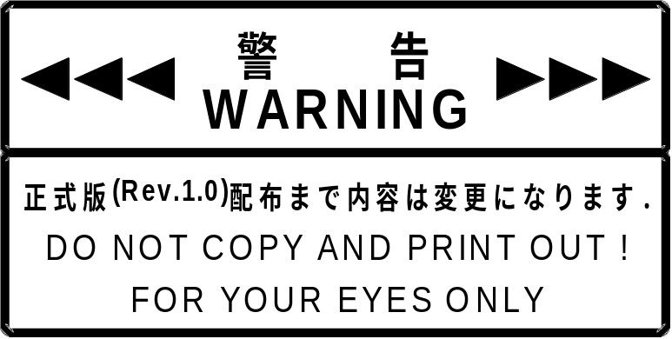
Revision History
Rev 0.1 2000/2/16 Preliminary Specifications

Rev 0.2 2000/2/17 Added Volume_Mode and Clock_Change responses.

Rev 0.3 2000/2/20 Changed name from S.I.P. to Dreameye Microphone Device.

Rev 0.4 2000/3/2 Added an explanation of Device All Status.

Rev 0.41 2000/3/27 Corrected 04h → 05h for the Volume_Mode subcommand.
Corrected the range of setting values for the Volume_Mode subcommand.

CONTENTS
1 Dreameye Microphone Device (Provisional Name) Outline 4
1.1 Function Outline 4
1.2 Sound Input, Sampling, and Other Functions 4
1.3 Hardware Configuration 5
2 Command Description 7
2.1 Basic Dreameye Microphone Device Commands 7
2.2 Precautions for Basic Dreameye Microphone Device Commands 8
2.2.1 Device Kill 8
2.2.2 Limitations for "Transmit Again" Command From Host 8
2.2.3 Power-On 8
2.3 Error Detection When Receiving Commands From Host (Dreameye Microphone Device Internal Specification) 9
2.3.1 Parity Error Detected 9
2.3.2 Buffer Overflow Detected 9
2.3.3 Out-of-Range Data Detected 9
2.3.4 Function Type Error Detected 9
2.4 First Dreameye Microphone Device Function Definition Block (Command List) 10
2.5 Second and Third Dreameye Microphone Device Function Definition Block 10
2.6 Description of FT₄_Control 11
2.7 Subcommands 12
2.7.1 Get_Sampling_Data Subcommand 12
2.7.2 Basic_Control Subcommand 14
2.7.3 AMP_Control Subcommand 17
2.7.4 EXTU_BIT Subcommand 18
2.7.5 Volume_Mode Subcommand 19
2.7.6 Test_Mode Subcommand 20
2.7.7 Data Transfer Command To Send Sampling Data 21
2.7.8 SIP Information 23
2.7.9 Dreameye Microphone Device Sampling Data Transmission Format 24
3 Hardware characteristics 27
3.1 Interval for Identifying Destination AP Upon Frame Receipt 27
3.2 Interval When The Frame Cannot Be Received 27
3.3 Note Regarding Acquisition of Sampling Data 28
3.4 Buffers for 14 bit Sampling and 8 bit Sampling 29
3.5 Resetting Dreameye Microphone Device 29
3.6 Operation When Two Expansion Devices are Connected to the Same Port 30

Dreameye Microphone Device (Provisional Name) Outline

Function Outline
Dreameye Microphone Device (provisional name) is highly compatible with microphone device standards.
This peripheral conforms to the "Maple Bus" Standard Specifications, belonging to function type "FT₄".
Currently, the planned function specifications are as follows.

• Sampling frequency 8.000 kHz ± 150ppm / 10.909090 kHz ± 150ppm
（Primary frequency 7.68MHz ・7680000 / 960 = 8000 ・7680000 / 704 = 10.909090....）
• Quantization: 14 bit linear / 8 bit μ-Law CODEC
• Communication with host uses the LM-Bus.
• Transfer rate is 1.94 Mbps maximum. ←To be confirmed
• Commands sent from host can be used to control gain, select sampling frequency, start/stop sampling, etc.

Sound Input, Sampling, and Other Functions
① ADC
• Sampling principle: Differential comparator
• Sampling rate: 8.000 kHz ± 150 ppm / 10.909090 kHz ± 150ppm, switchable by command
• Quantization: 14 bit linear / 8 bit μ-Law CODEC, switchable by command
• Data format: 16 bit (effective digit number 14 bits), 2's complement
• Dynamic range: 65 dB or better
② Internal electronic volume: -15 to +16dB, adjustable by command (1dB step)
③ LPF: 5th switching capacity filter
④ Microphone: Electret condenser microphone (S/N60dB or better, sensitivity about -40dB, omnidirectional)
⑤ Sampling buffer: 240 x 14 bits or 240 x 8 bits
⑥ Allowable sampling time: At 8 kHz Approx. 30.0 ms (NTSC, approx. 1.8INT minute)
At 11.025 kHz Approx. 21.0 ms (NTSC, approx. 1.3INT minute)

Hardware Configuration
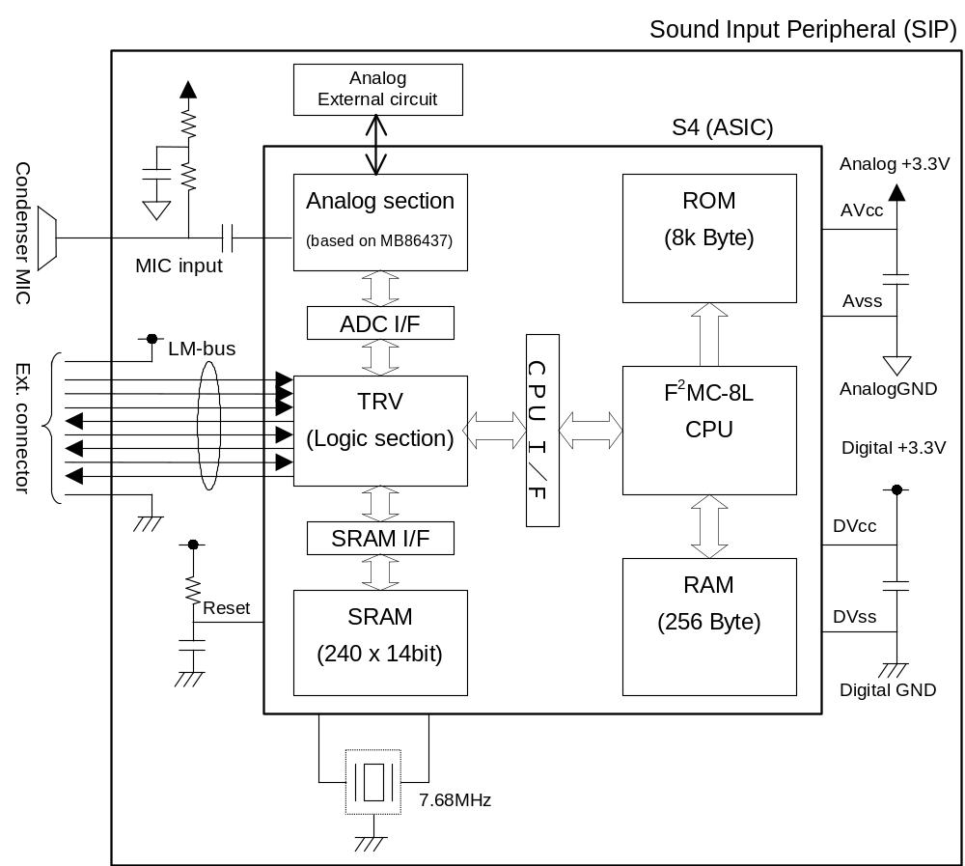
Fig. 1-1 Dreameye Microphone Device hardware configuration
Table 1-1 Dreameye Microphone Device IC (S4) pin function
Pin No. | Designation | I/O | Analog/  Degital | Function | Note
1 | P21 | I/O | D | Test pin (HAKX) | Open
2 | P20 | I/O | D | Test pin (BUFC) | Open
3 to 6 | P17-P14 | I/O | D | Test pin
7 | Vcc | P | D | Power supply (digital)
8 | X1 | C | D | Clock pin
9 | X0 | C | D | Clock pin
10 | Vss | P | D | Digital GND
11-14 | P13-P10 | I/O | D | Test pin | Open
15-22 | P07-P00 | I/O | D | Test pin | Open
23-25 | TMODE0-2 | I | D | Test mode select pin | Fixed low
26 | PVD3 | P | A | Power supply (analog)
27 | PVD1 | P | A | Power supply (analog)
28 | HVD | - | A | AVcc/2 pin
29 | PVS1 | P | A | Analog GND
30 | SG | - | A | Analog reference voltage output pin
31 | MIP | - | A | MIC AMP input pin (+)
32 | MIM | - | A | MIC AMP input pin (-)
33 | MOUT | - | A | MIC AMP output pin
34 | PVD2 | P | A | Power supply (analog)
35 | BBO | - | A | Electric volume output pin
36 | LPFI | - | A | LPF input AMP input (+)
37 | LPFM | - | A | LPF input AMP input (-)
38 | LPFO | - | A | LPF output pin
39 | ADI | - | A | ADC input AMP input (+)
40 | ADM | - | A | ADC input AMP input (-)
41 | PVS2 | P | A | Analog GND
42 | PVS3 | P | A | Analog GND
43 | TESI0 | I | D | Test mode select pin | Fixed high
44 | TESI1 | I | D | Test mode select pin | Fixed low
45-47 | TESO0-2 | O | D | Test status output pin
48 | Vss | P | D | Digital GND
49 | Presetn | I | D | Reset pin
50 | ID0 | I | D | LM-Bus
51 | SDCKB_O | O | D | LM-Bus
52 | SDCKB_I | I | D | LM-Bus
53 | ID1 | I | D | LM-Bus
54 | SDCKA_O | O | D | LM-Bus
55 | SDCKA_I | I | D | LM-Bus
56 | SDCKA EN | O | D | LM-Bus
57-58 | MD0-1 | I | D | CPU op. mode pin | Fixed low
59 | P27 | I/O | D | Test pin (ALE) | Open
60 | P26 | I/O | D | Test pin (RDX) | Open
61 | P25 | I/O | D | Test pin (WRX) | Open
62 | P24 | I/O | D | Test pin (CLK) | Open
63 | P23 | I/O | D | Test pin (RDY) | Fixed high
64 | P22 | I/O | D | Test pin (HRQ) | Open

Command Description

Basic Dreameye Microphone Device Commands
Dreameye Microphone Device supports the following commands. When a command other than those listed below is received, SIP returns the message "Command Unknown".

Table 2-1 Supported command list
 | Command code | Command | Size | Expected return value
Host command | 01H | Device Request | 00H | Device Status
Host command | 02H | All Status Request | 00H | Device All Status
Host command | 03H | Device Reset | 00H | Device Reply
Host command | 04H | Device Kill | 00H | Device Reply
Host command | 0FH | FT₄_Control | 02H - Pending | See subcommands
Host command | FCH | Transmit Again | 00H | As required

 | Command code | Command | Size | Expected return value
Device (extended) command | 05H | Device Status | 1CH | [none]
Device (extended) command | 06H | Device All Status | 3FH | [none]
Device (extended) command | 07H | Device Reply | 00H | [none]
Device (extended) command | 08H | Data Transfer | 01H - FFH | [none]
Device (extended) command | FEH | Function Type Unknown | 00H | [none]
Device (extended) command | FDH | Command Unknown | 00H | [none]

The above commands conform to the "Maple Bus 1.0" standard specifications.
Please refer to the "Maple Bus 1.0" documentation for details.

Precautions for Basic Dreameye Microphone Device Commands

Device Kill
When this command is received, there will be no more response to the host until a hardware reset occurs, followed by a "Device Request" command.

Limitations for "Transmit Again" Command From Host
In response to the "Get Sampling Data" command from the host, the Dreameye Microphone Device sends sampling data to the host, using the "Data Transfer" command. After transmission to the host is completed, the Dreameye Microphone Device does not retain the sampling data. Therefore the "Transmit Again" command is prohibited after the "Get Sampling Data" command.
* When "Transmit_Again" is received under the above conditions, Dreameye Microphone Device does not guarantee the contents of the response data.

Power-On
• Device_Request
After power has been switched on, no response is returned if a parity error or data overflow occurs when the first "Device Request" is received.
• Hard reset
After power has been switched on, if a hard reset is received before the first "Device Request", Dreameye Microphone Device accepts the hard reset and returns to the default configuration.
• Other commands
After power has been switched on, no command other than hardware reset will be accepted until the first "Device Request" has been received.

Error Detection When Receiving Commands From Host (Dreameye Microphone Device Internal Specification)
* "Receiving commands" here refers to the condition when the AP has established that a command addressed to itself has been received.

Parity Error Detected
When a parity error is detected while a command is received from the host, the frame is not reliable, and no command response is sent to the host.

Buffer Overflow Detected
When a buffer overflow (when the receive frame is 12 bytes or greater) is detected while a command is received from the host, the command will not be recognized by the Dreameye Microphone Device. Therefore the response "Command Unknown" will be sent to the host.

Out-of-Range Data Detected
When a setting value is sent to the Dreameye Microphone Device and the value is out of range, the response "Command Unknown" will be sent to the host.

Function Type Error Detected
When a command (frame) comprising a different function type is received, the response "Function Type Unknown" will be sent to the host.

First Dreameye Microphone Device Function Definition Block (Command List)
The first Dreameye Microphone Device function definition block is shown below.

Table 2-2 First Dreameye Microphone Device function definition block
Bit | Corresponding subcommand | Setting value | Bit | Corresponding subcommand | Setting value
FD1₃₁ | Reserved | 0 | FD1₁₅ | Reserved | 0
FD1₃₀ | Reserved | 0 | FD1₁₄ | Reserved | 0
FD1₂₉ | Reserved | 0 | FD1₁₃ | Reserved | 0
FD1₂₈ | Reserved | 0 | FD1₁₂ | Reserved | 0
FD1₂₇ | Reserved | 0 | FD1₁₁ | Reserved | 0
FD1₂₆ | Reserved | 0 | FD1₁₀ | Reserved | 0
FD1₂₅ | Reserved | 0 | FD1₉ | Reserved | 0
FD1₂₄ | Reserved | 0 | FD1₈ | Reserved | 0
FD1₂₃ | Reserved | 0 | FD1₇ | Reserved | 0
FD1₂₂ | Reserved | 0 | FD1₆ | Prohibited (fixed) | 0
FD1₂₁ | Reserved | 0 | FD1₅ | Volume_Mode | 0
FD1₂₀ | Reserved | 0 | FD1₄ | Reserved | 0
FD1₁₉ | Reserved | 0 | FD1₃ | EXTU_BIT | 1
FD1₁₈ | Reserved | 0 | FD1₂ | AMP_GAIN | 1
FD1₁₇ | Reserved | 0 | FD1₁ | Basic_Control | 1
FD1₁₆ | Reserved | 0 | FD1₀ | Get_Sampling_Data | 1

Table 2-3 First Dreameye Microphone Device function definition block
Bit | 7 | 6 | 5 | 4 | 3 | 2 | 1 | 0
5th Data | 0 | 0 | 0 | 0 | 0 | 0 | 0 | 0
6th Data | 0 | 0 | 0 | 0 | 0 | 0 | 0 | 0
7th Data | 0 | 0 | 0 | 0 | 0 | 0 | 0 | 0
8th Data | 0 | 0 | 1 | 1 | 1 | 1 | 1 | 1

By using Device_All_Status to confirm the above information, you can determine what type of subcommand is compatible with each peripheral device belonging to FT₄. If you use a subcommand that is not compatible, the message Command_Unknown is returned.

Example: When sending a Volume_Mode subcommand to the microphone device (the 1st function defined block = 0Fh)
→Since the subcommand is not compatible, the message Command_Unknown is returned.

Further, it is prohibited to use FD1₅. Please ignore this bit.

Second and Third Dreameye Microphone Device Function Definition Block
The second and third Dreameye Microphone Device function definition block is "00h".

Description of FT₄_Control
Dreameye Microphone Device supports the Maple-Bus standard "FT₄_Control" command. The frame is shown below.
Note: The frame shown here represents the configuration in actual communication.

Table 2-4 FT₄_Control frame
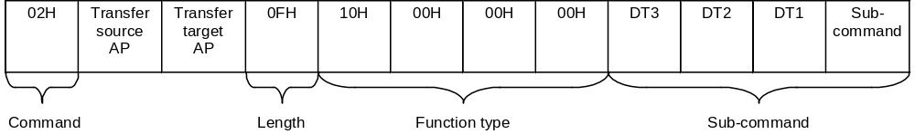

The setting values for the various Dreameye Microphone Device functions are specified with subcommands, as shown on the next page.

Subcommands
Note: The subcommand table is assumed to be stored in the work RAM of the host. The left side is low-order address and the right side the high-order address.

Get_Sampling_Data Subcommand
Function: Used by host to request sampling data and set AMP gain.
Issue privilege: Host

Table 2-5 Get_Sampling_Data subcommand
Subcommand | DT1 | DT2 | DT3
01H | 00H - 1FH | 00H | 00H

DT1: Set AMP gain
Setting values between 20H and FFH are not accepted. In this case, the current value is maintained.

Table 2-6 Parameters and gain (preliminary)
Parameter | AMP gain
00H | -15
01H | -14
02H | -13
03H | -12
04H | -11
05H | -10
06H | -9
07H | -8
08H | -7
09H | -6
0AH | -5
0BH | -4
0CH | -3
0DH | -2
0EH | -1
0FH | 0 (default)
10H | +1
11H | +2
12H | +3
13H | +4
14H | +5
15H | +6
16H | +7
17H | +8
18H | +9
19H | +10
1AH | +11
1BH | +12
1CH | +13
1DH | +14
1EH | +15
1FH | +16

DT2: Set to 00H.
DT3: Set to 00H.

Response: See description of sampling data in the Data Transfer command section of " Basic SIP SCommands".

Basic_Control Subcommand
Function: Sets the following functions.
• Start/stop sound sampling
• Select sampling frequency
• Select sampling bit count
Issue privilege: Host

Table 2-7 Basic_Control subcommand
Subcommand | DT1 | DT2 | DT3
02H | See below | 00H | 00H

DT1:

Bit | 7 | 6 | 5 | 4 | 3 | 2 | 1 | 0
DT1 | Sampling | 0 | 0 | 0 | Sampling frequency |  | Quantization

• Sampling:
Setting this bit to "1" starts sampling. Setting the bit to "0" stops sampling.
• Sampling frequency:
The following four settings are available for the sampling frequency.

Setting value | Setting level
00 | 11.025 kHz
01 | 8 kHz
10 | Not used (No change)
11 | Not used (No change)

Under the Dreameye Microphone Device standard, "00" selects a sampling frequency of 11.025 kHz and "01" selects a sampling frequency of 8 kHz. If other values ("10" - "11") are received, the current sampling frequency setting is maintained.
• Quantization:
The following four settings are available for the sampling bit rate (quantization).

Setting value | Setting level
00 | 14 bit
01 | 8 bit
10 | Not used (No change)
11 | Not used (No change)

For Dreameye Microphone Device, "00" selects 14-bit sampling and "01" selects 8-bit sampling. If other values ("10" - "11") are received, the current quantization setting is maintained.

DT2: 00H
DT3: 00H
* For Dreameye Microphone Device, set "Reserved" items to "00H".

Response: Standard Maple Bus "Device Reply" is sent.

Note:
As shown below, the sampling frequency and quantization settings may not be changed while sampling is in progress.
Stop the sampling temporarily.

① To cause Dreameye Microphone Device to perform sampling at 14 bit, 11 kHz, the following subcommand is sent.

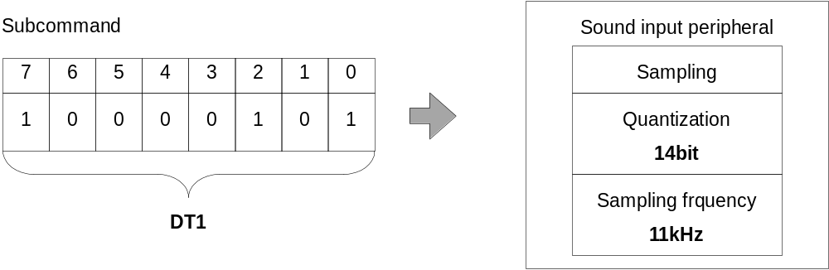

To change the setting, send the command as shown below. This will stop sampling and then change the quantization and sampling frequency setting.

② Change DT1 bit 7 in the subcommand shown in ① to "0" (stop sampling), and change the quantization and sampling frequency settings.

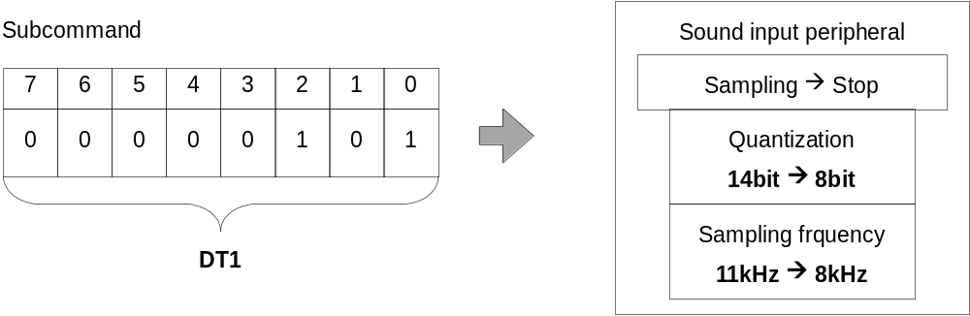

The change can also be made using the command as shown below. In this case, the quantization setting and sampling frequency setting are changed and then sampling starts.

③ If the Dreameye Microphone Device setting is 14 bit / 11 kHz and sampling is currently stopped, the command below changes the settings to 8 bit / 8 kHz and starts sampling.

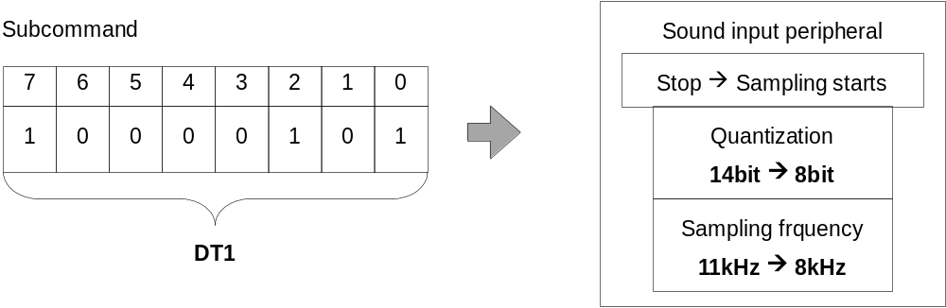

AMP_Control Subcommand
Function: Sets the sound input AMP gain.
Issue privilege: Host

Table 2-8 AMP_Control subcommand
Subcommand | DT1 | DT2 | DT3
03H | See below | 00H | 00H

DT1: AMP gain setting value

Table 2-9 Parameters and gain (preliminary)
Parameter | AMP gain
00H | -15
01H | -14
02H | -13
03H | -12
04H | -11
05H | -10
06H | -9
07H | -8
08H | -7
09H | -6
0AH | -5
0BH | -4
0CH | -3
0DH | -2
0EH | -1
0FH | 0 (default)
10H | +1
11H | +2
12H | +3
13H | +4
14H | +5
15H | +6
16H | +7
17H | +8
18H | +9
19H | +10
1AH | +11
1BH | +12
1CH | +13
1DH | +14
1EH | +15
1FH | +16

DT2: 00H
DT3: 00H

Response: Standard Maple Bus "Device Reply" is sent.

EXTU_BIT Subcommand
Function: Specifies the expansion method for data sampled at the "14bit_Linear" setting.
Under the Dreameye Microphone Device specification, the lower 2 bits of data sampled with 14-bit linear sampling are expanded for sending to the host.

Table 2-10 Sampling data format
Bit | 15 | 14 | 13 | 12 | 11 | 10 | 9 | 8 | 7 | 6 | 5 | 4 | 3 |  | 2 | 1 |  | 0
D | MSB |  | sampling data |  |  |  |  |  |  |  |  |  |  | LSB |  |  | * |  | *

Issue privilege: Host

Table 2-11 EXTU_BIT subcommand
Subcommand | DT1 | DT2 | DT3
04H | See below | 00H | 00H

DT1: See table below

Setting value | Expansion
00H | Lower 2 bits are set to "00".
01H | 2 LSB are copied to "**"
02H | Lower 2 bits are set to "10".
03H | Use prohibited
... | .....
FFH | Use prohibited
* If an out-of-range value (03H - FFH) is received, the current setting is maintained.
In this case, the Dreameye Microphone Device returns the "Command Unknown" response.

DT2: 00H
DT3: 00H

* While sampling is in progress, the Dreameye Microphone Device will not accept this command and will return the "Command Unknown" response. Be sure to stop sampling before issuing the command.

Response: Standard Maple Bus "Device Reply" is sent.

Volume_Mode Subcommand
Function: Changes the reference for the amplification rate.
Issue privilege: Host
Table 2-2 Volume_Mode Subcommand
Subcommand | DT1 | DT2 | DT3
05H | See below | 00H | 00H

DT1：
Setting value | Setting level
00H | +30dB
01H | +12dB
02H | Not used (No change)
... | ....
FFH | Not used (No change)
* If an out-of-range value (03H - FFH) is received, the current setting is maintained.
In this case, the Dreameye Microphone Device returns the "Command Unknown" response.

Response: Standard Maple Bus "Device Reply" is sent.

Test_Mode Subcommand
Function: Can be used in various formats for accessory equipment of the sound input peripheral (FT₄).
This is a test command designed to be used for debugging. It should not be used in an application.
Issue privilege: Host

Table 2-12 Test_Mode subcommand
Subcommand | DT1 | DT2 | DT3
FCH | 00H | 00H | 00H

Response: Maple Bus standard "Data Transfer" is sent. The first 12 bytes of the frame are the same as for sampling data, followed by data as shown in the table below.

Send sequence | Register
1 | CREG0
2 | CREG1
3 | CREG2
4 | SCREG
5 | ADCREG0
6 | ADCREG1
7 | SDSREG
8 | LREG
9 | Receive command
10 | ERROR point
11 | 00H
12 | ERROR yes/no

Data Transfer Command To Send Sampling Data
Note: The frame shown here represents the configuration in actual communication.

Function: Transfer of sampling data currently stored by the sound input peripheral.
Issue privilege: Device, extended device

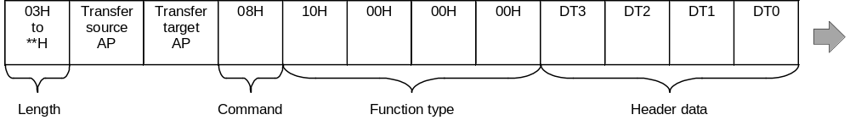

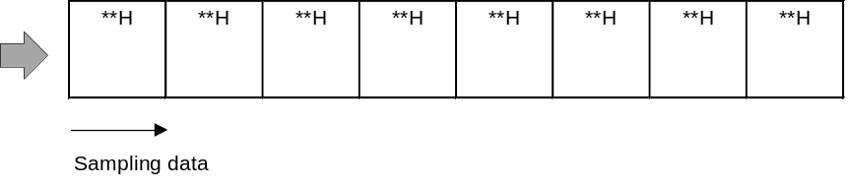

Regarding the sampling data sequence, please refer to the section "Dreameye Microphone Device Sampling Data Send Format".

If no sampling was carried out and a request for sampling data is received from the host, the frame shown below (no sampling data) is sent.

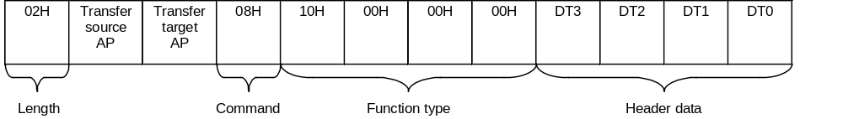
FT₄ data: When sampling data are sent, the frame is assembled as shown in the above illustration.

DT0 | DT1 | DT2 | DT3
FT₄ status | AMP setting value | 00H | Sampling count

• Sampling count: Number of times sampling has been carried out.
• AMP setting value: Currently selected input gain.
• FT₄ status: Shown below

BIT | 7 | 6 | 5 | 4 | 3 | 2 | 1 | 0
NAME | 0 | SBFOV | 0 | 14LSB1 | 14LSB0 | SMPL | μ-Law | Fs

SBFOV: Sampling data buffer overflow condition (0: normal, 1: overflow)
14LSB1,0: Linear sampling data expansion method flag
SMPL: Sampling operation start (0: stop, 1: Execute sampling)
μ-Law: CODEC conversion (0: 14 bit Linear, 1: 8 bit μ-Law CODEC)
Fs: Sampling frequency setting (0:11.025 kHz, 1: 8.0 kHz)

* Refer to 3.3 "Note Regarding Acquisition of Sampling Data" for further information about SBOFV.

SIP Information
The following describes the information sent by "Device Status" and "Device All Status".
(The Device All Status dumped by Codescape is used as an example.)

addr +0 +1 +2 +3 +4 +5 +6 +7 +8 +9 +A +B +C +D +E +F ascii
000000 06 00 02 47 00 00 00 10 00 00 00 3F 00 00 00 00 ...G.......?....
000010 00 00 00 00 0F 01 4D 69 63 44 65 76 69 63 65 20 ......MicDevice
000020 66 6F 72 20 44 72 65 61 6D 65 79 65 20 20 20 20 for Dreameye
000030 20 20 20 20 50 72 6F 64 75 63 65 64 20 42 79 20 Produced By
000040 6F 72 20 55 6E 64 65 72 20 4C 69 63 65 6E 73 65 or Under License
000050 20 46 72 6F 6D 20 53 45 47 41 20 45 4E 54 45 52 From SEGA ENTER
000060 50 52 49 53 45 53 2C 4C 54 44 2E 20 20 20 20 20 PRISES,LTD.
000070 2C 01 2C 01 56 65 72 73 69 6F 6E 20 31 2E 30 30 ,.,.Version 1.00
000080 30 2C 32 30 30 30 2F 30 32 2F 32 34 2C 33 31 35 0,2000/02/24,315
000090 2D 36 31 38 32 41 20 20 20 20 20 20 53 34 31 28 -6182A S41(
0000A0 53 65 67 61 53 6F 75 6E 64 53 61 6D 70 6C 69 6E SegaSoundSamplin
0000B0 67 53 79 73 74 65 6D 29 2F 53 61 6D 70 6C 69 6E gSystem)/Samplin
0000C0 67 52 61 74 65 31 30 2E 39 30 39 30 6F 72 38 2E gRate10.9090or8.
0000D0 30 30 30 6B 48 7A 2F 42 69 74 31 34 6F 72 38 62 000kHz/Bit14or8b
0000E0 69 74 2F 4E 54 53 43 2F 50 41 4C 2F 43 6F 6E 73 it/NTSC/PAL/Cons
0000F0 75 6D 65 72 20 44 65 76 65 72 6F 70 6D 65 6E 74 umer Deveropment
000100 20 26 20 4D 61 6D 75 66 61 63 74 75 72 69 6E 67 & Mamufacturing
000110 20 44 49 56 2E 43 53 52 44 20 20 20 20 20 20 20 DIV.CSRD

Device ID: 00000010 0000003F 00000000 00000000
Destination: 0F (North America, Japan, Asia, Europe)
Connection direction: 01 (connector direction down)
Product name: MicDevice for Dreameye_______
License: Produced_By_or_Under_License_From_SEGA_ENTERPRISES,
LTD._____
Standby current consumption: 012C (30.0mA)
Maximum current consumption: 012C (30.0mA)
Version: Version 1.000
Release date: 2000/02/24
Parts No.: 315-6182A
Free Device Status: S41(SegaSoundSamplingSystem)/SamplingRate10.9090or
8.000kHz/Bit14or8bit/NTSC/PAL/Consumer Deveropment
& Mamufacturing DIV.CSRD_______

Dreameye Microphone Device Sampling Data Transmission Format
• The number of quantification bits for Dreameye Microphone Device is 14 bits when linear and 8 bits when using CODEC compression.
• The 2 least significant bits of linear data are complemented and sent as 16 bits of data (see Fig. 2-1).
(LSB 2 bit complementation is specified by the subcommand "EXTU_BIT". See Table 2-13 for details.)
• When CODEC compression is used, the data length for 1 sampling is 8 bits (see Fig. 2-2).
μ-Law CODEC decoding must be done by the host. See specification G.711 regarding μ-Law CODEC compression/decompression.
• Information regarding the amount of sampling data, sampling frequency, and linear/compression is included in the header.

Fig. 2-1 Linear sampling data transmission format
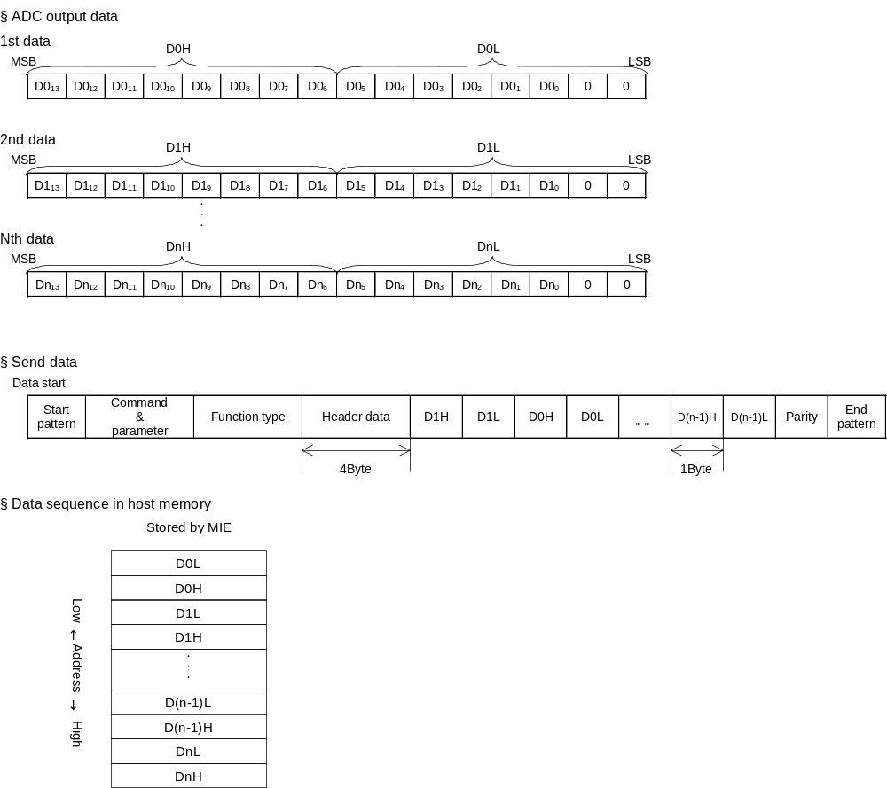
Fig. 2-2 Sampling data send format for CODEC compression (SET4 implementation)
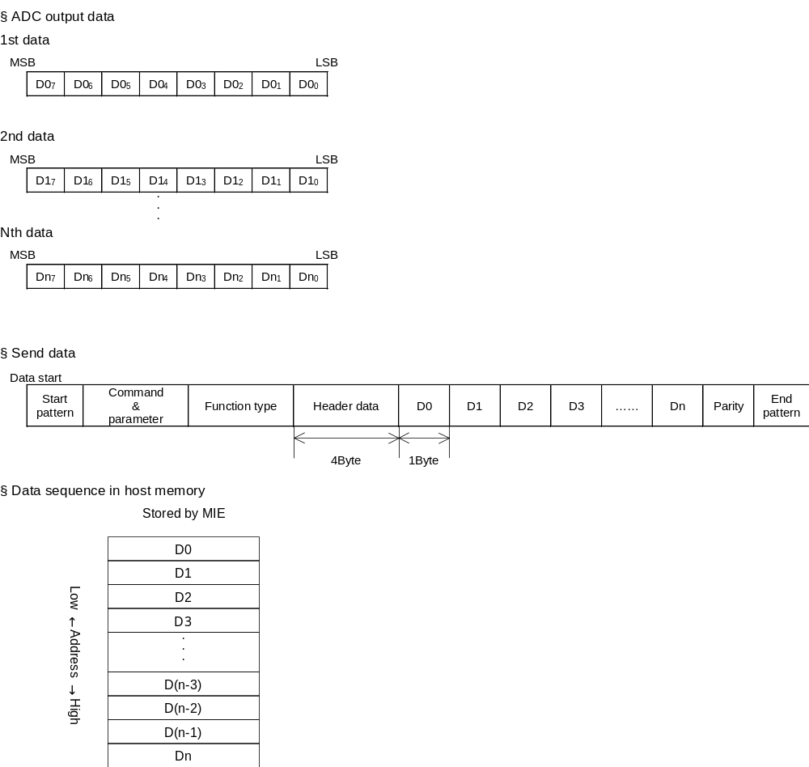
Table 2-13 How playback data differs depending on the method used to compliment the lower 2 bits
ADC output  (simulated 3 bit resolution) | Ideal data  (simulated 5 bit resolution) | Data after bit complimentation
ADC output  (simulated 3 bit resolution) | Ideal data  (simulated 5 bit resolution) | ① Fill with 0 | ② Copy LSB 2 bit | ③ Fill with 10
011 | 01111 |  | 01111
011 | 01110 |  |  | 01110
011 | 01101
011 | 01100 | 01100
010 | 01011
010 | 01010 |  | 01010 | 01010
010 | 01001
010 | 01000 | 01000
001 | 00111
001 | 00110 |  |  | 00110
001 | 00101 |  | 00101
001 | 00100 | 00100
000 | 00011
000 | 00010 |  |  | 00010
000 | 00001
000 | 00000 | 00000 | 00000
111 | 11111 |  | 11111
111 | 11110 |  |  | 11110
111 | 11101
111 | 11100 | 11100
110 | 11011
110 | 11010 |  | 11010 | 11010
110 | 11001
110 | 11000 | 11000
101 | 10111
101 | 10110 |  |  | 10110
101 | 10101 |  | 10101
101 | 10100 | 10100
100 | 10011
100 | 10010 |  |  | 10010
100 | 10001
100 | 10000 | 10000 | 10000

The effect of bit complementation on data quality
Method ① Linearity: GOOD Range usage efficiency: NG Symmetricality: NG
Method ② Linearity: NG Range usage efficiency: GOOD Symmetricality: GOOD
Method ③ Linearity: GOOD Range usage efficiency: NG Symmetricality: GOOD

Hardware characteristics

Interval for Identifying Destination AP Upon Frame Receipt
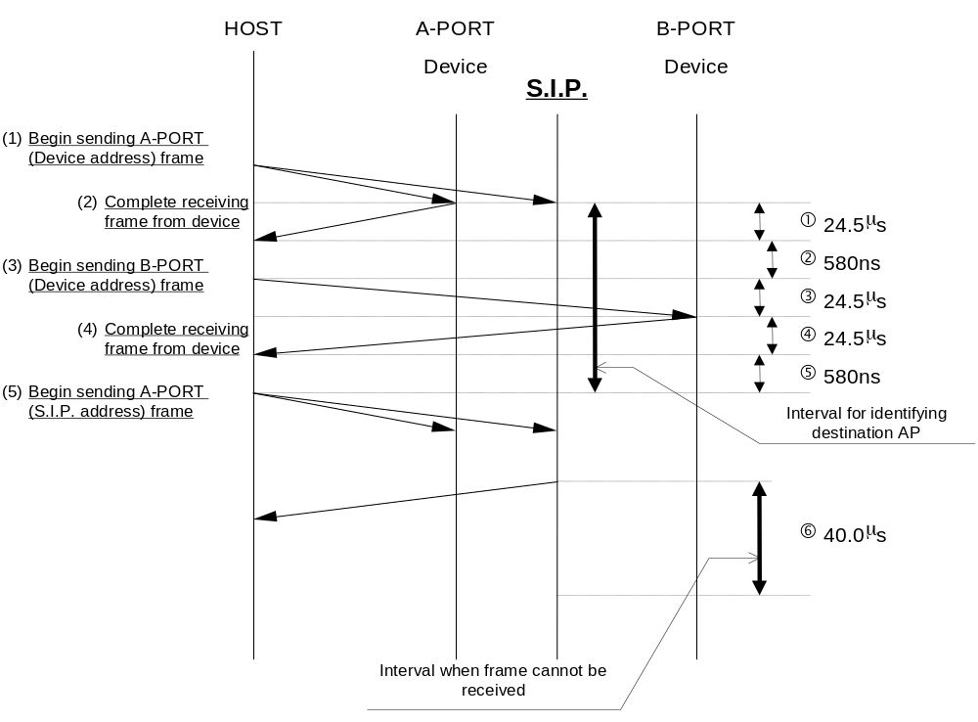
Fig. 3-1

As shown in the figure above, specifications determine that the interval for identifying the destination AP for Dreameye Microphone Device is less than 74.66μs.

* The values used in the above figure are the measured values for SET4_F2 at the present stage.
Also, the processing time for the device in this figure is 0 seconds (minimum value).

Interval When The Frame Cannot Be Received
After frame transmission, the S.I.P. ignores all frames for a period of 40μs except for a hard reset from the host.

Note Regarding Acquisition of Sampling Data
Dreameye Microphone Device uses the "Basic_Control" command to initiate sampling. After sampling is initiated, sampling data begins to get stored in the buffer. The buffer will become full in approximately 1.3 V-INT, so it is necessary to use the "Get_Sampling_Data" command to send the data to the host before this happens. The timing for sampling at 11kHz is shown in the figure below.
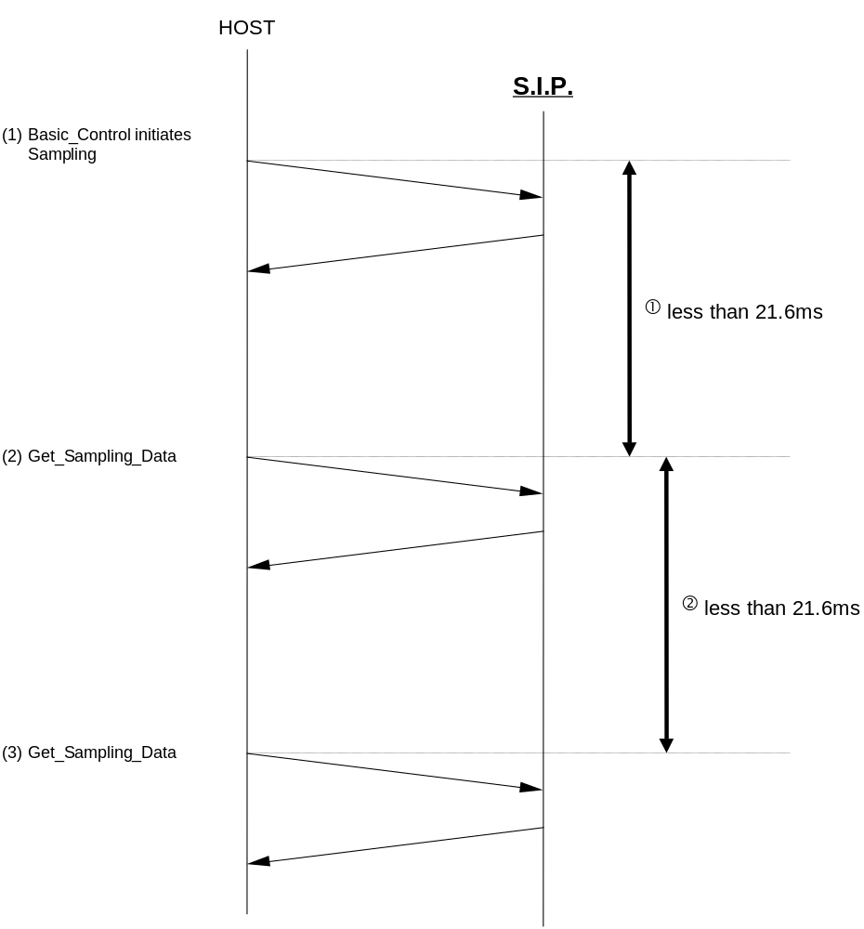

If the interval for ① or ② becomes greater than 21.6ms, the DT0_6bit_SBFOV header data for the response frame becomes "1". After Dreameye Microphone Device sends this response frame to the host, SBFOV reverts to "0". Accordingly, if the host next sends the "Get_Sampling_Data" command within 21.6ms, the DT0_6bit_SBFOV header data for the response frame from Dreameye Microphone Device will be "0".

* When sampling is done a 8kHz, ① and ② are both less than 30.0ms.

Buffers for 14 bit Sampling and 8 bit Sampling
The buffer can store data for up to 240 samplings. The following figure shows how the buffer is used.
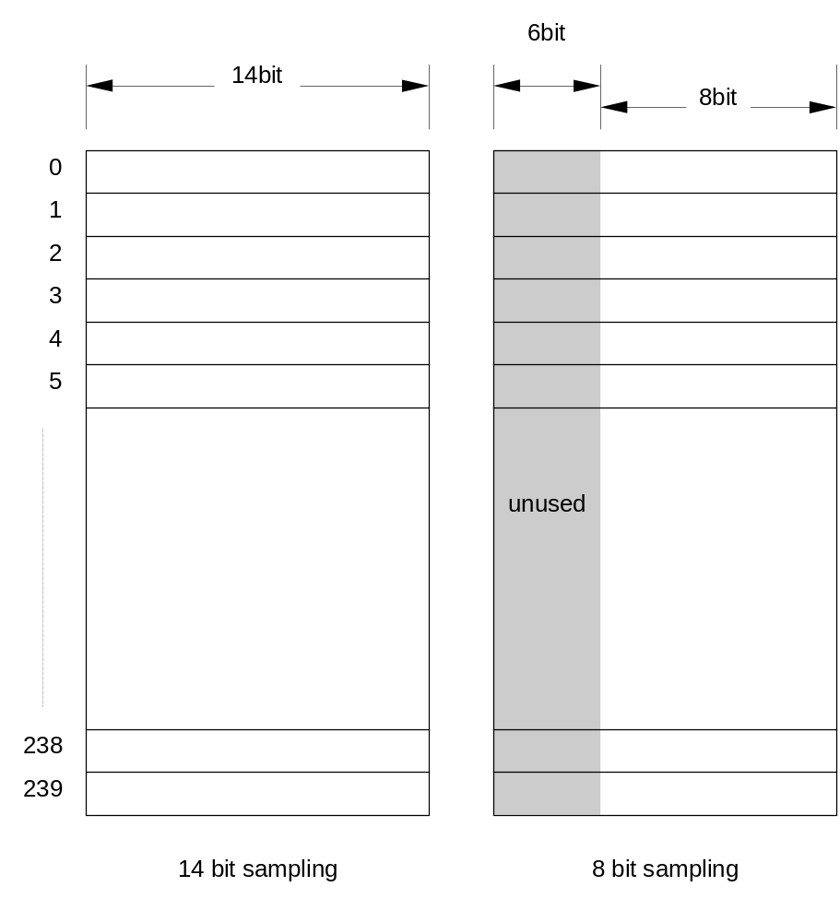

Resetting Dreameye Microphone Device
A soft reset can be done using the reset button in the case of the development unit, and the controller in the case of Dreamcast. When these resets are performed, the CLX2 in the development unit or in Dreamcast does not automatically send the "Device_Reset" command to peripheral.
If, in the course of Dreameye Microphone Device sampling, the development unit CLX2 or Dreamcast CLX2 is reset, even if sampling is initiated with "Basic_Control" after sending "Device_Request", Dreameye Microphone Device is continuing sampling, and "Command_Unknown" is returned.
If "Command_Unknown" is returned in response to "Basic_Control", sampling should be re-initiated with "Basic_Control after it has first been stopped with "Basic_Control".

Operation When Two Expansion Devices are Connected to the Same Port
When an Dreameye Microphone Device is operating while connected to a controller that supports connection of multiple devices (as of 1999/03/31, this is only the standard controller), the operation status of that Dreameye Microphone Device may change if an expansion unit is connected to the same controller.
To avoid SIP operation with incorrect settings, it must be reset from the Dreameye Microphone Device library as shown below whenever any other expansion unit is connected to the same controller.

Resetting Dreameye Microphone Device
① Send a Software Reset command to the Dreameye Microphone Device.
② Send a Device Request to the Dreameye Microphone Device (to exit reset status).
③ Send the sub command Extu Control to the Dreameye Microphone Device.
④ Send the sub command Basic Control to the Dreameye Microphone Device (starts operation settings and sampling).

* It is not necessary to reset the Dreameye Microphone Device if the default setting of EXTU_BIT is adequate.

