“Maple Bus 1.0”
Function Type Specifications

FT₀ : Controller Function

Revision 0.90

Produced by:
CS Hardware DIV.2
SEGA Enterprises Ltd.

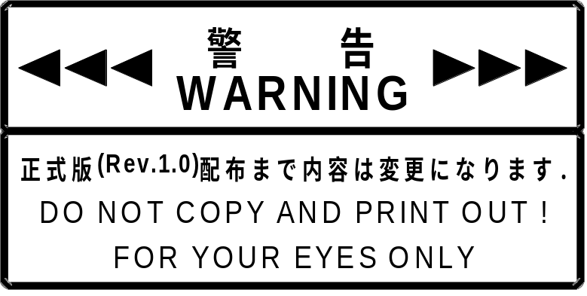

Revisions:

0.80 January 20 1998 First distribution
0.81 January 30 1998 When the standard controller buttons were altered, it was ascertained that the existing device ID (function definition block) could not be used for definitions. Accordingly, the function definition block was changed.
0.90 May 20 1998 Fixed the LM-Bus reset undefined duration.
Described buttons and key data not to be used.
Added connection direction information to the Free Device Status.
Other corrections.

* For items affected by the latest revisions and previous revisions, added items are set off by , and deleted items are set off by .

CONTENTS

1 CONTROLLER FUNCTION CONDITIONS 4
1.1 Controller function definitions 4
1.2 Function elements 4
1.3 Detailed description of constituent elements 5
1.4 Recommended operation systems 7
2 CONTROLLER FUNCTION OPERATION 8
2.1 Operation as device 8
2.2 Operation as controller 9
3 Device ID 10
3.1 Configuration of the “Maple Bus 1.0” device ID 10
3.2 Function types 11
3.3 Function definition block 11
4 DATA FORMATS 12
4.1 Read format 12
4.2 Write format 12
5 SUPPORTED COMMANDS 13
5.1 Control command 13
5.2 Error Commands 19
6 CONTROLLER FUNCTION INFORMATION 21
6.1 Types 21
6.2 Fixed Device Status 21
6.3 Free Device Status 22
7 AFTERWORD 23

CONTROLLER FUNCTION CONDITIONS

Controller function definitions
The controller function should be able to control all application software and indicate the input form of the man-machine interface.
- There are no restrictions on external view, but there should be compatibility with control of any product.
- It is an absolute condition that it is equipped with the minimum function constituent elements.
- It must conform to the “Maple Bus 1.0” Standard Specifications.

Function elements
Controller function elements are as follows:
- Digital direction keys A : Ra,La,Da,Ua
- Digital direction keys B : Rb,Lb,Db,Ub
- Digital buttons : A,B,C,D,X,Y,Z,Start
- Analog keys : A3,A4,A5,A6
- Analog levers : A1,A2

It is an absolute condition that the controller is equipped with the following elements.
- Digital direction keys A : Ra,La,Da,Ua
- Digital buttons : A,B,Start
If these elements are missing, it cannot be regarded as a controller.
Accordingly, the controller can have the following features.
- Have two systems for 4-direction (8-direction) operation.
- Buttons can be freely organized within the range of seven buttons.
- The analog system control has up to six axes.
- Two analog X-Y axes systems.

Detailed description of constituent elements
Each of the controller function elements is describe in detail in the following.
- Digital direction keys A : Ra,La,Da,Ua
These are 2-value press/release (= ON/OFF) digital type keys (buttons).
Ra and La, Da and Ua form counterparts. The straight line (X-axis) on which Ra and La are placed at the respective endpoints intersects with the other straight line (Y-axis) on which the Da and Ua are placed at the respective endpoints. The keys (buttons) are arranged on the X-Y surface composed by these straight lines. The way the keys (buttons) are arranged and the directions of movement are as follows: Ra is on the right side, right direction, La is on the left side, left direction, Da is at the bottom, downward direction and toward the viewer, Ua is at the top, upward direction and away from the viewer.
The values are press= ‘0’, release= ‘1’.
The controller must not generate the key data of more than 3 keys (buttons) at the same time.
These direction keys are primarily for left-hand operation.
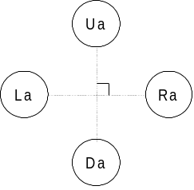
Fig. 1.1 Button layout of digital cross keys A
- Digital direction keys B : Rb,Lb,Db,Ub
These are 2-value press/release (= ON/OFF) digital type keys (buttons).
Rb and Lb, Db and Ub form counterparts. The straight line (X-axis) on which Rb and Lb are placed at the respective endpoints intersects with the other straight line (Y-axis) on which the Db and Ub are placed at the respective endpoints. The keys (buttons) are arranged on the X-Y surface composed by these straight lines.
The way the keys (buttons) are arranged and the directions of movement are as follows: Rb is on the right side, right direction, Lb is on the left side, left direction, Db is at the botton, downward direction and toward the viewer, Ub is at the top, upward direction and away from the viewer.
These direction keys are primarily for right-hand operation.
The values are: press = ‘0’, release = ‘1’.
The controller must not generate the key data of more than 3 keys (buttons) at the same time.
* The principle of use should be so that the digital direction keys A have priority in use while the digital direction keys B act as additional direction keys.
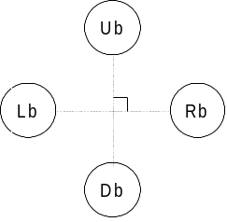
Fig. 1.2 Button layout of digital cross keys B
- Digital button : A,B,C,D,X,Y,Z,Start
These are 2-value press/release (= ON/OFF) digital type keys (buttons).
The button arrangement is optional.
The controller must be able to detect whether multiple keys (buttons) are ON at the same time.
The values are: press = ‘0’, release = ‘1’.

- Analog keys : A3,A4,A5,A6
These are analog type keys where the value detected in accordance with the distance the key is moved from its initial position changes linearly.
The value at the key’s initial position is 80h, and the value changes in 01h units from the minimum value 00h to the maximum value FFh.
In relation to the key position, the direction in which the value decreases is the minus direction, and the
direction in which the value increases is the plus direction.
The key should be able to move in these two directions.
When the load applied to move the key is released, the centering of the key should be performed automatically so that the key returns to the initial position.
In general, A3 and A4 indicate the Xa-axis and Ya-axis, and A5 and A6 indicate the Xb-axis and Yb-axis. The (Xa,Ya) system is operated with the left hand while the (Xb,Yb) system is operated with the right hand.
Use of only one axis at a time should also be possible.
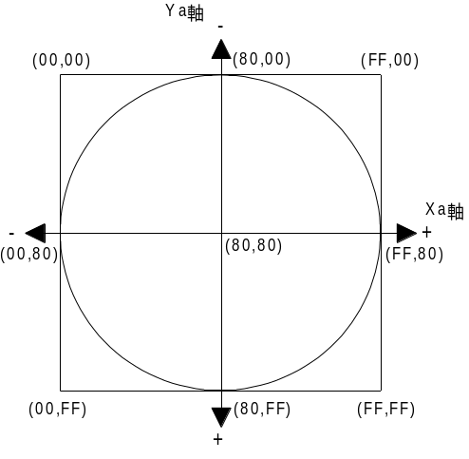
Ya-axis
Xa-axis
Fig. 1.3 Data range of analog key
- Analog levers : A1,A2
These are analog type levers where the value detected in accordance with the distance the lever is moved from its initial position changes linearly.
The value at the lever’s initial position is 00h, and the value changes in 01h units from the minimum value 00h to the maximum value FFh.
In relation to the lever position, the direction in which the value decreases is the minus direction, and the direction in which the value increases is the plus direction.
The lever should be able to move in these two directions but from the initial position it should only be able to move in one direction.
When the load applied to move the lever is released, the lever should automatically return to its initial position.
In general, A1 indicates the R-axis and A2 indicates the L-axis. The R-axis is operated with the right hand and the L-axis with the left hand.
Use of only one axis at a time should also be possible.
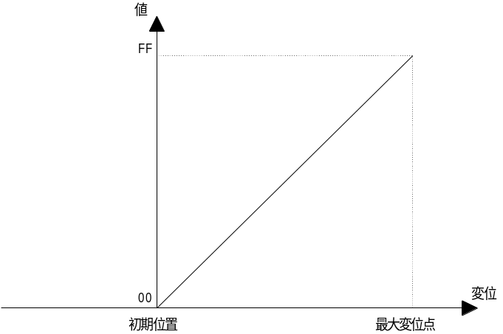
Value
Position change
Maximum position change
Intial position
Fig. 1.4 Data range of analog lever

Recommended operation systems
To maintain operation system compatibility between products with controller functions, recommended operation systems are described in the following.
There is a chance that the configuration of the digital buttons may change.
- Controller with minimum constituents Digital direction keys A, digital buttons (A,B,Start)
(Essential operation system)

- Controller with standard constituents Digital direction keys A, digital buttons (A,B,X,Y,Strat)
Analog X-Y axis (A3, A4), analog levers (A1, A2)

- W cross-key controller Digital direction keys A, digital direction keys B
Digital button (A, B, X, Y Start)

- W analog controller Analog X-Y axis A (A3, A4), analog X-Y axis B (A5, A6)
Analog levers (A1, A2), digital buttons (A, B, C, Start)

- JOY-STICK Digital direction keys A, digital buttons (A, B, C, D, X, Y, Z, Start)
- Analog JOY-STICK Digital direction keys A, digital buttons (A, B, C, X, Y, Z, Start)
Analog X-Y axis (A3, A4), analog levers (A1, A2)

- W Analog JOY-STICK Digital direction keys A, digital direction keys B
Analog X-Y axis A (A3, A4), analog X-Y axis B (A5, A6)
Digital buttons (A, B, C, X, Y, Z, Start)

- Handle controller Analog X axis A (A3), analog levers (A1, A2)
Digital direction key A, digital buttons (A, B, Strat)

- W JOY-STICK Digital direction keys A, Digital direction keys B
Digital buttons (A, B, C, X, Y, Z, Start)

CONTROLLER FUNCTION OPERATION
The following describes the controller function operation in the case of operation as device and operation as controller.
The controller should be manufactured in accordance with the operation of these functions.

Operation as device
- Initialization
Initializes the registers, RAM, etc. to be used.
Resets MIE and clears all flags and TRBF.
MIE is set to the receive condition.
The LM-Bus is completely disconnected and is set so that data does not flow to expansion devices.
The ID0, ID1 of the LM-Bus are set as the reverse of the Bus No.’s setting values.

- LM-Bus control
The LM-Bus remains as it is until it receives a [Device Request].
When it receives the first [Device Request] after initialization, it reverses the ID0, ID1 of the LM-Bus and returns them to the set values.
At the same, it also requests reset of expansion devices.
If it detects a ‘1’ on ID2 for each LM-Bus, the expansion device is connected, so it connects that LM-Bus to the Maple-Bus.
It reads the current status of the connected LM-Bus and reflects the [Device Status], which is the reply to the [Device Request] in the AP.
If a ‘0’ is detected on the ID2 of each LM-Bus, the expansion device is not physically connected, so that LM-Bus is disconnected from the Maple-Bus.
This check of ID2 is conducted every time a command is received from the host.

- Down Stream Time Out
The device is always detecting the Maple-Bus’ Down Stream Time Out (except during [Device Kill]).
A Time Out is when there is no change for more than 1 ms in either the SDCKA or SDCKB.
Detection begins when the start pattern is received (RXB = ‘1’) and continues until the end when the end pattern is received (RFB = ‘1’).
In case of Time Out, the following processing starts.

Process-ing order | Device | Expansion Device
1 | Resets | Normal operation
2 | There is a chance that ID0,1 will become indefinite during resetting. (the period is within  5ms 300us (provisional)) | Normal operation  ID0, ID1 are not reversed, so they don’t initialize.
3 | Reversed from the ID0, ID1 from before initialization. (Initialization) | ID0, ID1 are reversed so they are initialized. (LM-Bus reset)
4 | Waits for [Device Request]. | Resets (Initializes.)
5 | Normal operation | Waits for [Device Request].
6 | Normal operation | Normal operation
Fig. 2.1 Time Out processing sequence
- Up Stream Time Out
If an abnormal condition occurs in the MIE or the Maple-Bus when sending from a device to the host (Up Stream) it may not be able to get out of the transmission condition.
In this case, the host will detect a Time Out and perform a hard reset. However, because the device is transmitting, it will not receive the reset pattern.
Therefore, the expected time of transmission completion is calculated by the device which sent the data and if the transmission condition continues for longer than that time it resets the MIE (Time Out processing).

Operation as controller
- Key scan
It is a requirement that the data (key data) of the digital keys (buttons) and analog keys are always being updated.
There should always be a good response to data requests from the host.
Accordingly, key scan should always be performed and held key data should always be retained in the newest condition.
When there is a request from the host, the retained data should be in the condition to be sent.
Since there is no order of priority for key scan, all the keys (buttons) should be concurrently readable.
- A/D conversion
In a controller using analog data, A/D conversion should be performed to convert the analog quantities to digital quantities.
The A/D conversion accurracy is not a question but there should be 8 bits per axis for the key data.
The maximum total time for A/D conversion of all analog keys should be less than 1 msec which is the Time Out time .
- Optimization, conditions
- For the cross keys, no more than 3 keys (buttons) must be ON at the same time (key data must not be generated).
- The cross keys U and D, R and L must not be On at the same time (key data must not be generated).
- The simultaneous ON statuses of multiple digital buttons must detectable.
- When two or more keys (buttons) are simultaneously pressed, keys (buttons) that are not pressed must not come ON (key data must not be generated).
- When the analog key is at the center position (initial position), the key data value must not fluctuate while the key is not touched.
- When the analog lever is at the initial position, the key data value must not fluctuate while the lever is not touched.
- When the analog key or analog lever is at the maximum changed positions, the key data value must be the maximum value or the minimum value.
- No matter where the analog key is located inside the operation range, the key must return to the center position when the key is released.
- Initialization
Indicates the key data value after power is supplied (reset processing).
Digital direction keys and digital buttons have absolute values that will depend on the key (button) condition at that time.
Analog keys and analog levers will be as follows depending on the device.
- The key (lever) position at that time becomes the initial position.
- For keys and levers with decided absolute initial positions, the key (lever) position at that time becomes the key data.
- Undefined until the key (lever) comes to the decided position.

Device ID
In accordance with the device ID definition in the “Maple Bus 1.0” Standard Specifications.
The notation is that of the host’s memory image.

Configuration of the “Maple Bus 1.0” device ID
The device ID consists of 16 bytes (128 bits).

Bit | 7 | 6 | 5 | 4 | 3 | 2 | 1 | 0
1st Data | FT₃₁ | FT₃₀ | FT₂₉ | FT₂₈ | FT₂₇ | FT₂₆ | FT₂₅ | FT₂₄
2nd Data | FT₂₃ | FT₂₂ | FT₂₁ | FT₂₀ | FT₁₉ | FT₁₈ | FT₁₇ | FT₁₆
3rd Data | FT₁₅ | FT₁₄ | FT₁₃ | FT₁₂ | FT₁₁ | FT₁₀ | FT₉ | FT₈
4th Data | FT₇ | FT₆ | FT₅ | FT₄ | FT₃ | FT₂ | FT₁ | FT₀
5th Data | FD1₃₁ | FD1₃₀ | FD1₂₉ | FD1₂₈ | FD1₂₇ | FD1₂₆ | FD1₂₅ | FD1₂₄
6th Data | FD1₂₃ | FD1₂₂ | FD1₂₁ | FD1₂₀ | FD1₁₉ | FD1₁₈ | FD1₁₇ | FD1₁₆
7th Data | FD1₁₅ | FD1₁₄ | FD1₁₃ | FD1₁₂ | FD1₁₁ | FD1₁₀ | FD1₉ | FD1₈
8th Data | FD1₇ | FD1₆ | FD1₅ | FD1₄ | FD1₃ | FD1₂ | FD1₁ | FD1₀
9th Data | FD2₃₁ | FD2₃₀ | FD2₂₉ | FD2₂₈ | FD2₂₇ | FD2₂₆ | FD2₂₅ | FD2₂₄
10th Data | FD2₂₃ | FD2₂₂ | FD2₂₁ | FD2₂₀ | FD2₁₉ | FD2₁₈ | FD2₁₇ | FD2₁₆
11th Data | FD2₁₅ | FD2₁₄ | FD2₁₃ | FD2₁₂ | FD2₁₁ | FD2₁₀ | FD2₉ | FD2₈
12th Data | FD2₇ | FD2₆ | FD2₅ | FD2₄ | FD2₃ | FD2₂ | FD2₁ | FD2₀
13th Data | FD3₃₁ | FD3₃₀ | FD3₂₉ | FD3₂₈ | FD3₂₇ | FD3₂₆ | FD3₂₅ | FD3₂₄
14th Data | FD3₂₃ | FD3₂₂ | FD3₂₁ | FD3₂₀ | FD3₁₉ | FD3₁₈ | FD3₁₇ | FD3₁₆
15th Data | FD3₁₅ | FD3₁₄ | FD3₁₃ | FD3₁₂ | FD3₁₁ | FD3₁₀ | FD3₉ | FD3₈
16th Data | FD3₇ | FD3₆ | FD3₅ | FD3₄ | FD3₃ | FD3₂ | FD3₁ | FD3₀
Fig. 3.1 Configuration of device ID
FT : Designates type of function that the peripheral is equipped with.
FD1 : Designates the function definition block of the first function.
FD2 : Designates the function definition block of the second function.
FD3 : Designates the function definition block of the third function.

- FT₀-FT₃₁ : Function type
Designates the function that the peripheral is equipped with.
There are 32 function types altogether.

- FD1₃₁-FD1₀ : Function definition block
This is for the block defining the individual elements making up the function.

Function types
The function types (FT) within the device ID are as follows.
The controller function is FT₀=‘1’.

Bit | 7 | 6 | 5 | 4 | 3 | 2 | 1 | 0
1st Data | FT₃₁ | FT₃₀ | FT₂₉ | FT₂₈ | FT₂₇ | FT₂₆ | FT₂₅ | FT₂₄
2nd Data | FT₂₃ | FT₂₂ | FT₂₁ | FT₂₀ | FT₁₉ | FT₁₈ | FT₁₇ | FT₁₆
3rd Data | FT₁₅ | FT₁₄ | FT₁₃ | FT₁₂ | FT₁₁ | FT₁₀ | FT₉ | FT₈
4th Data | FT₇ | FT₆ | FT₅ | FT₄ | FT₃ | FT₂ | FT₁ | 1
Fig. 3.2 Controller function types

Function definition block
Indicates the function definition block (FD) within the device ID.
The controller definition block specifies the constituent elements of the function to be used.
The definition method sets the division of the data format’s read format.

Bit | 7 | 6 | 5 | 4 | 3 | 2 | 1 | 0
1st Data | 0 | 0 | 0 | 0 | 0 | 0 | 0 | 0
2nd Data | 0 | 0 | RB₂₁ | RB₂₀ | RB₁₉ | RB₁₈ | RB₁₇ | RB₁₆
3rd Data | RB₁₅ | RB₁₄ | RB₁₃ | RB₁₂ | RB₁₁ | RB₁₀ | RB₉ | RB₈
4th Data | RB₇ | RB₆ | RB₅ | RB₄ | RB₃ | RB₂ | RB₁ | RB₀
Fig. 3.3 Controller function definition block
RB: Read format division block
‘0’ indicates fixed 0.

Read format blocks are divided as shown in the figure below.
Details on the read format are explained in the next chapter.
In correspondence with Fig. 3-3, set the bits to ‘1’ for the blocks to be used, and ‘0’ for the blocks not used.
Unused blocks are ignored by the Function Libraries.

bit | 7 | 6 | 5 | 4 | 3 | 2 | 1 | 0
1st Data | RB₇ | RB₆ | RB₅ | RB₄ | RB₃ | RB₂ | RB₁ | RB₀
2nd Data | RB₁₅ | RB₁₄ | RB₁₃ | RB₁₂ | RB₁₁ | RB₁₀ | RB₉ | RB₈
3rd Data | RB₁₆
4th Data | RB₁₇
5th Data | RB₁₈
6th Data | RB₁₉
7th Data | RB₂₀
8th Data | RB₂₁
Fig. 3.4 Block division for data format

DATA FORMATS
The controller function data formats are explained in the following.
The notation is that of the host’s memory image.

Read format
This is the key data format when the controller function data are read.
When the host transmits Get Condition, the controller returns data according to the data format. The command is Data Transfer.
The data format size is 8 bytes.
The key data block to be used from these key data is defined by the function definition block.

bit | 7 | 6 | 5 | 4 | 3 | 2 | 1 | 0
1st Data | Ra | La | Da | Ua | Start | A | B | C
2nd Data | Rb | Lb | Db | Ub | D | X | Y | Z
3rd Data | A1₇ | A1₆ | A1₅ | A1₄ | A1₃ | A1₂ | A1₁ | A1₀
4th Data | A2₇ | A2₆ | A2₅ | A2₄ | A2₃ | A2₂ | A2₁ | A2₀
5th Data | A3₇ | A3₆ | A3₅ | A3₄ | A3₃ | A3₂ | A3₁ | A3₀
6th Data | A4₇ | A4₆ | A4₅ | A4₄ | A4₃ | A4₂ | A4₁ | A4₀
7th Data | A5₇ | A5₆ | A5₅ | A5₄ | A5₃ | A5₂ | A5₁ | A5₀
8th Data | A6₇ | A6₆ | A6₅ | A6₄ | A6₃ | A6₂ | A6₁ | A6₀
Fig. 4.1 Read format

Key data explanation
1st : Digital button data. (ON = ‘0’, OFF =‘1’)
2nd : Digital button data. (ON = ‘0’, OFF = ‘1’)
3rd : Analog axis 1 (A1) data.
4th : Analog axis 2 (A2) data.
5th : Analog axis 3 (A3) data.
6th : Analog axis 4 (A4) data.
7th : Analog axis 5 (A5) data.
8th : Analog axis 6 (A6) data.
The data of an unused button is fixed at ‘1’.
The data of an unused analog axis become the origin of the axis.

Write format
There is no write format for writing data to the controller functions.
Controller functions are read only.

SUPPORTED COMMANDS
The commands supported by the controller function among the commands specified in the “Maple Bus 1.0” Standard Specifications are described here.
If other commands than the following are sent, the controller function will return an error.
The concrete operations of the controller function for each command are also described.

Control command
Device Request
Issuing right : Host
Command code : 01h
Data size : 00h
Data field : none
Expected return value : [Device Status]
Description : Requests controller function of destination AP to return Device Status.
This command is also used to check port connection.
Following initialization of the function and until this command is sent, the controller function does not respond to other commands.
The LM-Bus is also disconnected for the expansion device so that the expansion device operation is stopped.
Order of operation (1) Receives command.
(2) Checks connection of each expansion device.
(3) If connected, connects to corresponding LM-Bus.
(4) Based on this result, the AP of originating device is created and returned to the host.

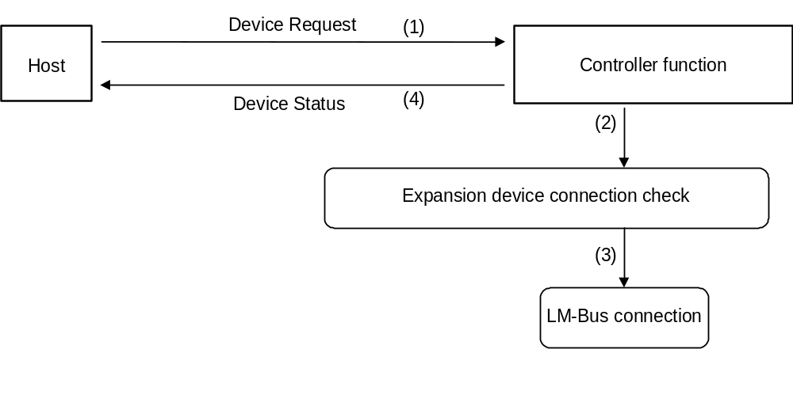
Fig. 5.1 Device Request

All Status Request
Issuing right : Host
Command code : 02h
Data size : 00h
Data field : none
Expected return value : [Device All Status]
Description : Requests controller function of destination AP to return all device statuses (both Fixed Device Status and Free Device Status).
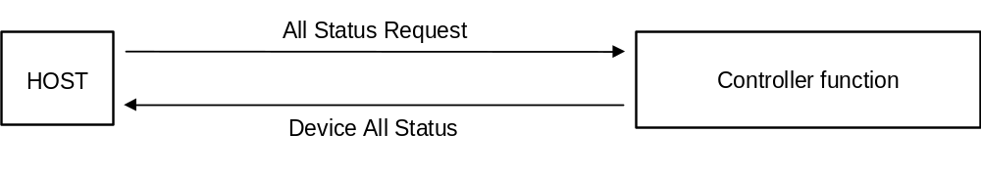
Fig. 5.2 All Status Request

Device Reset
Issuing right : Host
Command code : 03h
Data size : 00h
Data field : none
Expected return value : [Device Reply]
Description : Controller functions specified by the destination AP can be initialized.
Order of operation : (1) [Device Reply] returned.
(2) Initialization

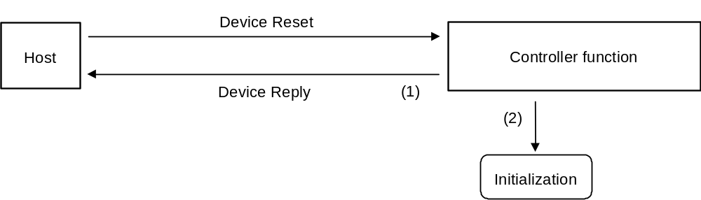
Fig. 5.3 Device Reset

Device Kill
Issuing right : Host
Command code : 04h
Data size : 00h
Data field : none
Expected return value : [Device Reply]
Description : Operation is recognized for the controller function specified by destination AP.
The function stands by in standby power consumption mode (minimum power consumption) and no commands can be received.
To start operation, a hard reset must be performed or the power should be turned off and then operation should be started again.
When the controller function which is a device receives the Device Kill command, the ID0,1 of the LM-Bus are reversed, expansion device is reset and the LM-Bus is disconnected.
Order of operation : (1) LM-Bus is reset and disconnected from the Maple-Bus.
(2) [Device Reply] returned.
(3) Operation terminated.

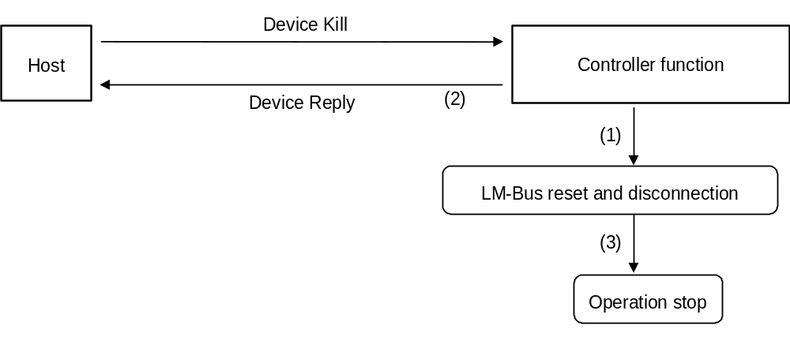
Fig. 5.4 Device Kill

Device Status
Issuing right : Controller function
Command code : 05h
Data size : 1Ch (28)
Data field : Device ID : 16 bytes
Destination code : 1 byte
Connection direction : 1 byte
Product name : 30 1bytes
License : 60 bytes
Standby current consumption : 2 bytes
Maximum current consumption : 2 bytes
Description : In response to the Device Request from the host, Fixed Device Status data is returned.

Device All Status
Issuing right : Controller function
Command code : 06h
Data size : 1Ch+(n/4)
Data field : Fixed Device Status : 112 bytes
Device ID : 16 bytes
Destination code : 1 byte
Connection direction : 1 byte
Product name : 30 1byte
License : 60byte
Standby current consumption : 2 bytes
Maximum current consumption : 2 bytes
Free Device Status : n byte
Description : In response to the All Status Request from the host, both Fixed Device Status and Free Device Status are returned.

Device Reply
Issuing right : Controller function
Command code : 07h
Data size : 00h
Data field : none
Description : Used as response.

Get Condition
Issuing right : Host
Command code : 09h
Data size : 01h
Data field : Function type : 4 bytes
Specifies the controller (00-00-00-01h).
Expected return value : [Data Transfer]
Description : This command requests the physical status (buttons, keys, lever statuses) of the controller function.
Used when the controller data should be read.

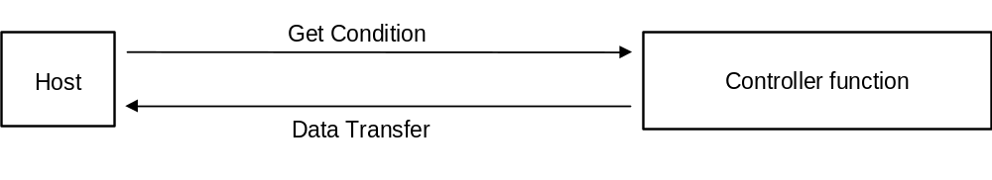
Fig. 5.5 Get Condition

Data Address | Data | Setting example | Description
+0000 | Command code | 09h | Specifies Get Condition.
+0001 | Destination AP | 20h | Specifies device of port A.
+0002 | Origin AP | 00h | Send from Port A.
+0003 | Data size | 01h | Data size is 4 bytes.
+0004 | Function type | 00h
+0005 |  | 00h | The function type specifies the controller.
+0006 |  | 00h
+0007 |  | 01h
Fig. 5.6 Data transmission from host (memory image)

Data Transfer
Issuing right : Controller function
Command code : 08h
Data size : 03h
Data field : Function type : 4 bytes
Specifies the controller (00-00-00-01h).
Reset format : 8 bytes
Expected return value : none
Description : This command is used to receive Get Condition from the host and when the controller’s read format should be returned.

Fig. 5.7 Data Transfer

Data Address | Data | Setting example | Description
+0000 | Command code | 08h | Specifies Data Transfer.
+0001 | Destination AP | 00h | Specifies device of port A.
+0002 | Origin AP | 20h | No expansion device
+0003 | Data size | 03h | Data size is 12 bytes.
+0004 | Function type | 00h | The function type specifies
+0005 |  | 00h | the controller.
+0006 |  | 00h
+0007 |  | 01h
+0008 | Read format | FFh | According to the controller format,
+0009 |  | FFh | the controller’s data is stored. The
+000a |  | 00h | blocks to be used have been
+000b |  | 00h | declared already by the device ID.
+000c |  | 80h
+000d |  | 80h
+000e |  | 80h
+000f |  | 80h
Fig. 5.8 Data transmission to host (host’s memory image)

Error Commands
The controller function supports only 3 types of error commands.

Function Type Unknown
Issuing right : Controller function
Command code : FEh
Data size : 00h
Data field : none
Description : This command is returned when the sent function type is other than a controller.

Possible causes : (1) Mistaken specification of function type
(2) Data written incorrectly.
(3) Data of device ID jumbled.
(4) Data became jumbled during communication.

Remedies : (1) Specify function type correctly.
(2) Write data correctly.
(3) Resend Device Request to obtain device ID.
(4) Try sending again (maximum of three times; subsequent tries are processed as Time Out).

Command Unknown
Issuing right : Controller function
Command code : FDh
Data size : 00h
Data field : none
Description : This command is returned when the sent command is not supported by the controller function.

Possible causes : (1) Mistaken specification of function type
(2) Data written incorrectly.
(3) Data of device ID jumbled.
(4) Data became jumbled during communication.

Remedies : (1) Specify function type correctly.
(2) Write data correctly.
(3) Resend Device Request to obtain device ID.
(4) Try sending again (maximum of three times; subsequent tries are processed as Time Out).

Transmit Again
Issuing right : Host, controller function
Command code : FCh
Data size : 00h
Data field : none
Description : This command is used to request that the data be transmitted again when the data contained some kind of error.
However, since the controller is always updating the data, it is not always that the returned contents are identical with the contents of the controller’s read data when the error occurred.

Possible causes : (1) Parity error was generated.
(2) Data overflowed.
(3) Data became jumbled during communication.
(4) Others

Remedy : Try sending again (maximum of three times; subsequent tries are processed as Time Out).

CONTROLLER FUNCTION INFORMATION
This chapter explains information about specific devices (device statuses).
To prevent device statuses from being rewritten or erased, the data is recorded as is.

Types
Fixed Device Status
This is a set form of device status, consisting of 112 bytes in all, that must be designated.
Unless all items are designated, operation and connection are not guaranteed.

Free Device Status
The individual devices can use this status freely. It consists of 908 912 bytes.

Fixed Device Status
The Fixed Device Status has the following items, all of which must be designated.
- Device ID
Capacity : 16 bytes
Description : Indicates the controller function’s device ID.
If there is another function besides the controller, this must also be specified. (Maximum 2 types)
- Destination
Capacity : 1 byte
Description : Indicates product destination (sales region).

Bit | 7 | 6 | 5 | 4 | 3 | 2 | 1 | 0
Data | DES₇ | DES₆ | DES₅ | DES₄ | DES₃ | DES₂ | DES₁ | DES₀
Fig. 6.1 Configuration of setting bits for destination
Destination | Setting bit
North American region | DES₀=‘1’
Japan region | DES₁=‘1’
Asia region | DES₂=‘1’
European region | DES₃=‘1’
Reserved region 1 | DES₄=‘1’
Reserved region 2 | DES₅=‘1’
Reserved region 3 | DES₆=‘1’
Reserved region 4 | DES₇=‘1’
Fig. 6.2 Setting bits for destination
Worldwide : DES=‘11111111’=FFh
Except for special device types, the controller function is generally the same worldwide.

(3) Connection direction
Capacity : 1 byte
Description : Information differs for devices and expansion devices.
Device :
Indicates the direction of the expansion socket for expansion devices.
For details, refer to “Maple Bus 1.0” Standard Specifications.

(4)(3) Product name Size : 30 1 bytes
Description : Designates the product name in English or romaji. Either full-width or half-width characters can be used.
A space code (20h) is inserted for unused space.

(5)(4) License
Size : 60 bytes
Description : Designates the license.
Generally, it designates “Produced By or Under License From SEGA ENTERPRISES,LTD.”
A space code (20h) is inserted for unused space.

(6)(5) Standby current consumption
Size : 2 bytes
Description : Standby current consumption for temporary stop, in units of 0.1 mA, is designated in hexadecimal notation.
For example, 10.5 mA is designated by 00-69h.

(7)(6) Maximum current consumption
Size : 2 bytes
Description : Maximum current consumption, in units of 0.1 mA, is designated in hexadecimal notation.
For example, 127.9 mA is designated by 04-FFh.

Free Device Status
The Free Device Status area is available for product planners, developers, designers and programmers to enter any information they wish. The host obtains this status by the All Device Request.
For details, see “Maple Bus 1.0” Standard Specifications.

AFTERWORD
Until the official version (Rev. 1.0) is distributed, contents will be modified to a small or large extent.

