Maple Bus 1.0
Function Type Specifications
FT₂B/W LCD Function
Revision 0.81

Created by:
Second Development Department
CD Development and Production Division
Sega Enterprises

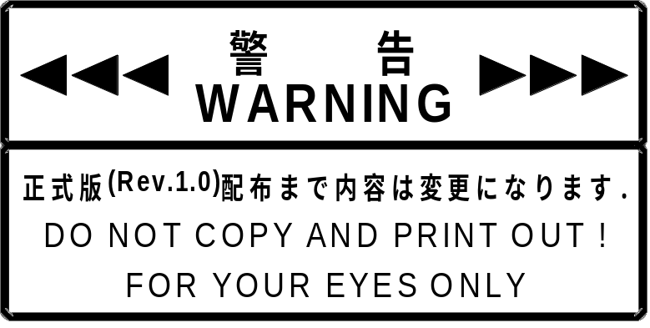
The contents of this document may change before distribution of the formal release (Rev. 1.0).
DO NOT COPY AND PRINT OUT!
FOR YOUR EYES ONLY

Revision

10/14/97 0.70 Preview Version
2/10/98 0.80 Title change
Added definition of B/W LCD function
Added B/W LCD function control
Amended specifications of the function definition block
Added LCD number (PT) specifications
Changed access number (WA) specifications
Changed specifications for data arrangement (H/V) and added diagrams 2.5 ~ 2.10
Changed B/W (Fig.2.11)
Amended specifications for the Get_Media_Info command
Added LCD number (PT) specifications
Added diagrams 3.4, 3.5
Changed specifications for Block_Write command
Changed specifications for LCD Data capacity
Added specifications for function error codes
Added Device_Reply command
Added LCD_Error command
Added warnings for data creation (Chapter 4)
Added specifications for protocol flow
Added flow diagram for LCD display processing (Fig.5.2)
3/31/98 0.81 Added operations during function initialization
Changed Block No. which can be specified for the Block_Write command
Added Set_Condition command
Added method for adjusting the contrast using the same command
Edited the LCD_Error command
Changed error operations and responses to errors
Added information regarding gradual conversion of image data
Deleted data transmission during contrast adjustment
Added information regarding data transmission between LCDs with different gradations
Changed the layout

Contents:

1 Overview of B/W LCD
1.1 Definition of B/W LCD Functions
1.2 Restrictions on B/W LCD Functions
1.3 Operation during Initialization
2 Device ID
2.1 Composition of Device IDs
2.2 Function Types
2.3 Function Definition Blocks 6
3 Warnings for LCD Data Creation
3.1 If the LCD Matrix Size is not a Multiple of 8
3.2 If the LCD Gradation Exceeds 2 Gradations
3.2.1 Definition of Gradation
3.2.2 Plain and Block Arrangement
3.2.3 Gradation Conversion
4 Commands
4.1 Control Commands
4.1.1 Get_Media_Info
4.1.2 Block_Write
4.1.3 Set_Condition
4.1.4 Device Reply
4.1.5 Data Transfer
4.1.6 Device Request
4.1.7 All Status Request
4.1.8 Device Reset
4.1.9 Device Kill
4.1.10 Device Status
4.1.11 Device All Status
4.2 Error Commands
4.2.1 Function Type Unknown
4.2.2 Command Unknown
4.2.3 Transmit Again
4.2.4 LCD Error
5 Protocol Flow
5.1 Overview of Transmission Protocols
5.2 Processing Flow of LCD Display
5.3 Processing Flow of Get_Media_Info
5.4 Processing Flow of Block_Write
6 Afterword

Overview of B/W LCD

Definition of B/W LCD Function
The "B/W LCD" contains a reflective, monochrome liquid crystal display with functions for output of simple images. The B/W LCD function must fulfill the following requirements.

- The monochrome dot matrix liquid crystal display must be on the surface of the unit and the user must be able to confirm the screen's status. There are no other restrictions on the outer appearance
- The B/W LCD function must adhere to the "Maple Bus 1.0" Standard Specifications.

It will be possible to display game subscreens and messages using the B/W LCD Function.
For example, by displaying specific information to each user, it will be possible to create game software of a more strategic nature.

Restrictions on B/W LCD Functions
The following are restrictions on the B/W LCD Function

- LCD dot number X axis direction Y axis direction
- Gradation Only gradations of 2,4, 8, 16 can be set
- The LCD display speed will change depending on the block size during data transmission and the number of transmissions.
The data to be displayed on the LCD will be displayed when all of the data is complete.
- Backlighting controls Not supported.

Operation during Initialization
The B/W LCD Function will operate as follows during initialization.

- LCD Display LCD Display is turned off. In addition, the memory area for image data is cleared.
- Contrast The contrast brightness setting is returned to its initial value.

Moreover, the above settings are applicable when the power is turned on and in the case of a reset.

Device ID

The ID conforms to the Device ID prescribed in the "Maple Bus 1.0" Standard Specifications.
The notation indicates the host's memory image.

Composition of Device IDs
According to "Maple Bus 1.0", Device IDs are structured as shown below.

bit | 7 | 6 | 5 | 4 | 3 | 2 | 1 | 0
1st Data | FT₃₁ | FT₃₀ | FT₂₉ | FT₂₈ | FT₂₇ | FT₂₆ | FT₂₅ | FT₂₄
2nd Data | FT₂₃ | FT₂₂ | FT₂₁ | FT₂₀ | FT₁₉ | FT₁₈ | FT₁₇ | FT₁₆
3rd Data | FT₁₅ | FT₁₄ | FT₁₃ | FT₁₂ | FT₁₁ | FT₁₀ | FT₉ | FT₈
4th Data | FT₇ | FT₆ | FT₅ | FT₄ | FT₃ | FT₂ | FT₁ | FT₀
5th Data | FD1₃₁ | FD1₃₀ | FD1₂₉ | FD1₂₈ | FD1₂₇ | FD1₂₆ | FD1₂₅ | FD1₂₄
6th Data | FD1₂₃ | FD1₂₂ | FD1₂₁ | FD1₂₀ | FD1₁₉ | FD1₁₈ | FD1₁₇ | FD1₁₆
7th Data | FD1₁₅ | FD1₁₄ | FD1₁₃ | FD1₁₂ | FD1₁₁ | FD1₁₀ | FD1₉ | FD1₈
8th Data | FD1₇ | FD1₆ | FD1₅ | FD1₄ | FD1₃ | FD1₂ | FD1₁ | FD1₀
9th Data | FD2₃₁ | FD2₃₀ | FD2₂₉ | FD2₂₈ | FD2₂₇ | FD2₂₆ | FD2₂₅ | FD2₂₄
10th Data | FD2₂₃ | FD2₂₂ | FD2₂₁ | FD2₂₀ | FD2₁₉ | FD2₁₈ | FD2₁₇ | FD2₁₆
11th Data | FD2₁₅ | FD2₁₄ | FD2₁₃ | FD2₁₂ | FD2₁₁ | FD2₁₀ | FD2₉ | FD2₈
12th Data | FD2₇ | FD2₆ | FD2₅ | FD2₄ | FD2₃ | FD2₂ | FD2₁ | FD2₀
13th Data | FD3₃₁ | FD3₃₀ | FD3₂₉ | FD3₂₈ | FD3₂₇ | FD3₂₆ | FD3₂₅ | FD3₂₄
14th Data | FD3₂₃ | FD3₂₂ | FD3₂₁ | FD3₂₀ | FD3₁₉ | FD3₁₈ | FD3₁₇ | FD3₁₆
15th Data | FD3₁₅ | FD3₁₄ | FD3₁₃ | FD3₁₂ | FD3₁₁ | FD3₁₀ | FD3₉ | FD3₈
16th Data | FD3₇ | FD3₆ | FD3₅ | FD3₄ | FD3₃ | FD3₂ | FD3₁ | FD3₀
Fig. 2.1 Device ID
FT: Indicates the peripheral device's function type.
FD1: First function definition block.
FD2: Second function definition block.
FD3: Third function definition block.

- FT₃₁ ~ FT₀: Function type
Indicates the function implemented by the peripheral device.
A total of 32 types of functions are defined.

- FD₃₁ ~ FD₀ Function definition block
This is the block which defines the individual elements which make up the function.
(One peripheral device can have up to three different functions.)

Function Types
Indicates the function type (FT) within the Device ID.
The B/W LCD Function's function type is defined as FT₂='1'.

bit | 7 | 6 | 5 | 4 | 3 | 2 | 1 | 0
1st Data | FT₃₁ | FT₃₀ | FT₂₉ | FT₂₈ | FT₂₇ | FT₂₆ | FT₂₅ | FT₂₄
2nd Data | FT₂₃ | FT₂₂ | FT₂₁ | FT₂₀ | FT₁₉ | FT₁₈ | FT₁₇ | FT₁₆
3rd Data | FT₁₅ | FT₁₄ | FT₁₃ | FT₁₂ | FT₁₁ | FT₁₀ | FT₉ | FT₈
4th Data | FT₇ | FT₆ | FT₅ | FT₄ | FT₃ | 1 | FT₁ | FT₀
Fig. 2.2 B/W LCD Function Type
For example, in the case of a peripheral device which only implements the B/W LCD Function, the function type is defined as FT='00h-00h-00h-04h'.
Also, in the case of peripheral devices which implement other functions, the function type corresponding to each function has its bit set to '1'.

Function Definition Block
Indicates the function definition block within the Device ID.
The function definition block is a 32 bit data table specific to each function. The elements which make up each function and the methods of data transmission and receipt are determined by this data.

The structure of the B/W LCD Function's function definition block is as shown below.

bit | 7 | 6 | 5 | 4 | 3 | 2 | 1 | 0
1st Data | PT₇ | PT₆ | PT₅ | PT₄ | PT₃ | PT₂ | PT₁ | PT₀
2nd Data | BB₇ | BB₆ | BB₅ | BB₄ | BB₃ | BB₂ | BB₁ | BB₀
3rd Data | WA₃ | WA₂ | WA₁ | WA₀ | 0 | 0 | 0 | 0
4th Data | H/V₁ | H/V₀ | B/W | FD₄ | FD₃ | FD₂ | FD₁ | FD₀
Fig. 2.3 Structure of the B/W LCD function definition block
PT: Number of LCDs
Can be set from 1 to 256.

Number of LCDs = (PT+1)
(Except for unusual cases, '00h' (LCD number = 1) is the value which is normally used)

BB: Number of bytes during Block transmission
It is the number of bytes which are transmitted in one block transmission.
It can be set between 32 and 8192 bytes

The number of bytes in 1 block = (BB+1) ´ 32 [byte]

WA: Number of accesses to Block Write
Sets the number of accesses needed to Write 1 Block of data.
The number of accesses can be set from 1 to 15 times.
The data amount of 1 access is calculated by dividing the capacity of 1 Block by the number of accesses.

Number of accesses = WA [times]
Capacity of 1 access = 1 Block capacity  WA [byte]
(WA = 0 cannot be set)

H/V: Specifies whether the LCD data rows are horizontal or vertical.
Except for unusual cases, H/V = '00' is the value which is normally used.

Data Rows | H/V₁ | H/V₀
Horizontal 1 | 0 | 0
Horizontal 2 | 0 | 1
Vertical 1 | 1 | 0
Vertical 2 | 1 | 1
Fig. 2.4 Values of H/V
Examples of H/V settings and LCD data arrangement are shown below.
(For more information about the LCD matrix size (dX, dY) used in the example, please refer to Chapter 3.1.)

Example 1: H/V = '00' (LCD data 16 bytes, LCD matrix size dX=31, dY=3)
Horizontal LCD dot size dX+1
Data size (dX+1)/8
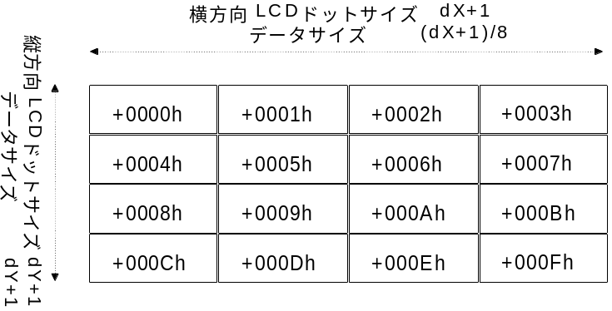
Vertical LCD dot size dY+1
Data size dY+1
Fig. 2.5 H/V = '00' Data arrangement

Example 2: H/V = '01' (LCD data 16 bytes, LCD matrix size dX=31, dY=3)
Horizontal LCD dot size dX+1
Data size (dX+1)/8
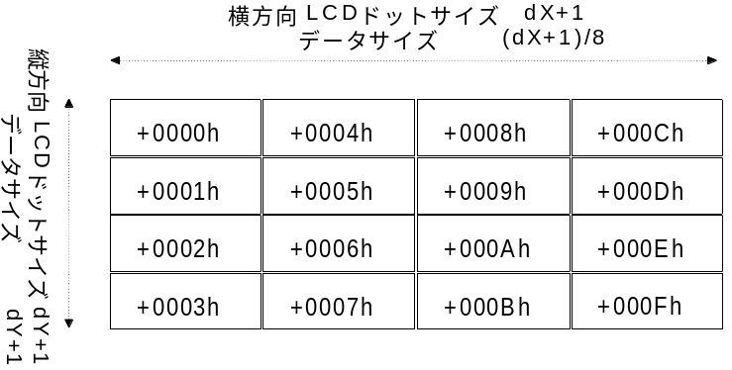
Vertical LCD dot size dY+1
Data size dY+1
Fig. 2.6 H/V = '01' Data arrangement

Example 3: H/V = '10' (LCD data 16 bytes, LCD matrix size dX=7, dY=15)
Horizontal LCD dot size dX+1
Data size dX+1
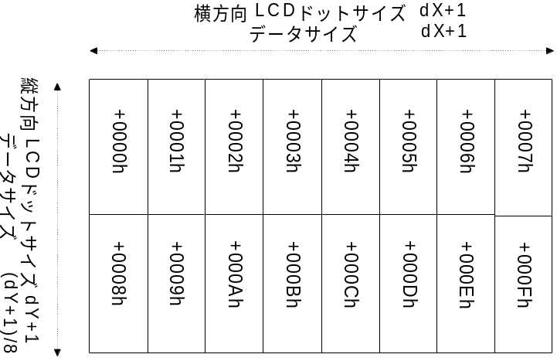
Vertical LCD dot size dY+1
Data size (dY+1)/8
Fig. 2.7 H/V = '10' Data arrangement

Example 4: H/V = '11' (LCD data 16 bytes, LCD matrix size dX=7, dY=15)
Horizontal LCD dot size dX+1
Data size dX+1
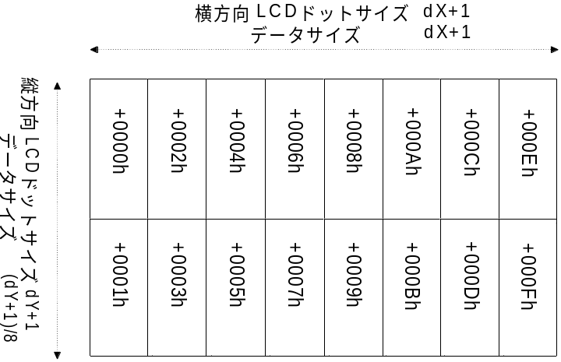
Vertical LCD dot size dY+1
Data size (dY+1)/8
Fig. 2.8 H/V = '11' Data arrangement

The relationship between the data direction and the LCD dot position is shown below.
Horizontal LCD dot size dX+1
Data size (dX+1)/8
Vertical LCD dot size dY+1
Data size dY+1
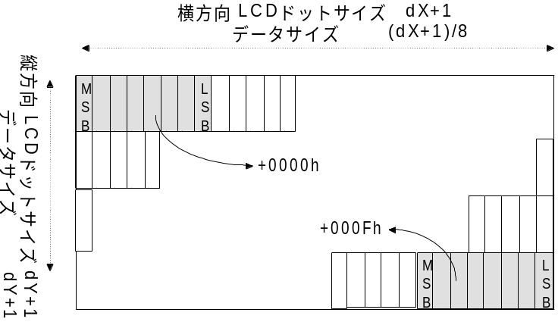
Fig. 2.9 Horizontal Data Rows (in comparison to LCD Panel)
Horizontal LCD dot size dX+1
Data size dX+1
Vertical LCD dot size dY+1
Data size (dY+1)/8
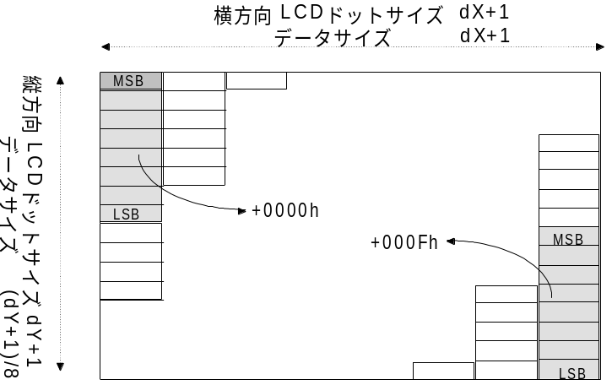
Fig. 2.10 Vertical Data Rows (in comparison to LCD Panel)

B/W: Specifies Normally Black or Normally White.

Normally | B/W
White | 0
Block | 1
Fig. 2.11 Values of B/W
Normally White: LCD Data = '0' is White and LCD Data = '1' is Black
Normally Black: LCD Data = '1' is White and LCD Data = '0' is Black
Except for unusual cases, B/W='0' is used.

FD: Reserved
The fixed value of '0' is used.

Warnings for LCD Data Creation

This section gives examples of things to be careful of when creating LCD data.

If the LCD Matrix Size is not a Multiple of 8
Basically, 1 LCD dot is 1 bit of data and the LCD dots are managed in 1 byte units.
Therefore, if the LCD matrix size is not a multiple of 8, the excess data will be ignored.

Ex.1 Horizontal Data Row (H/V='00','01')
If the X axis dot size is not a multiple of 8, the data outside of the LCD matrix will be ignored.
Data outside of the Y axis matrix will not be generated.
X Axis Direction
X Axis Direction
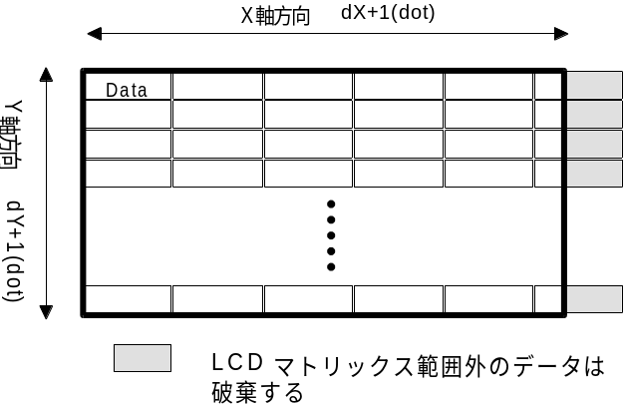
Y Axis Direction
Data outside of the LCD matrix will be ignored
Fig. 3.1 H/V = '00', '01'

Ex.2 Vertical Data Row (H/V='10','11')
If the Y axis dot size is not a multiple of 8, the data outside of the LCD matrix will be ignored.
Data outside of the X axis matrix will not be generated.

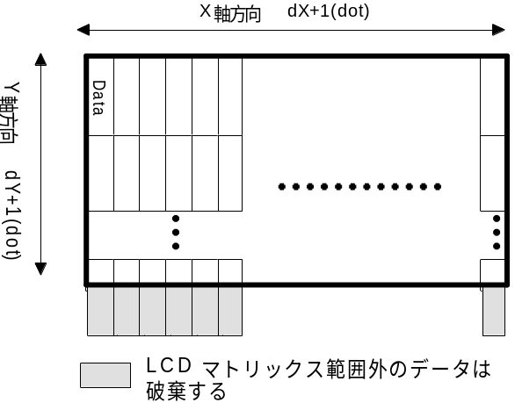
Data outside of the LCD matrix will be ignored
Y Axis Direction
Fig. 3.2 H/V = '10', '11'

If the LCD Gradation Exceeds 2 Gradations
This section gives examples to explain the data structure of the LCD image when the LCD Gradation Exceeds 2 Gradations.
Moreover, a "Plane" is defined as the "LCD image data when the LCD gradation is 1 bit/dot".

Definition of Gradation
Ex. LCD which can be set to 16 levels of gradation
When setting 16 gradations of data, 1 dot requires 4 bits of data. (The media information's TE is '111h')
Therefore, the LCD data becomes 4 Planes of data as shown below.

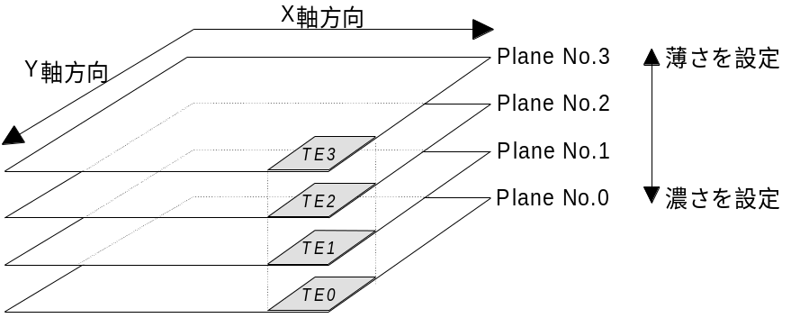
Set lightness
Set darknes
Y Axis
X Axis

Fig. 3.3 LCD Data Structure
The figure above shows the data structure of an LCD image with 16 possible gradation settings.
The gray area in the figure (TE3~TE0) represents a specific coordinate (x, y) on the LCD.
When viewing the LCD, the layers of the Planes are placed on top of each other.
The gradation of the point shown at the coordinate (x,y) on the LCD is calculated with the following formula.

TE( x , y ) = TE0  8 + TE1  4 + TE2  2 + TE3

If (TE0, TE1, TE2, TE3) = (1,0,1,0) then,

TE( x , y ) = 1  8 + 0  4 + 1  2 + 0 = 10'Ah'

In addition, the data actually written on the Plane has a '1' at the Plane 0,2 coordinate (x,y) and a '0' at the Plane 1,3 coordinate (x,y).

On LCD's with gradation other than 16, there are Planes for expressing only that gradation.
2 Gradations: Plane 0
4 Gradations: Plane 0, 1
8 Gradations: Plane 0, 1, 2

Plain and Block Arrangement
This section explains the arrangement of data sent to and from the B/W LCD Function.

The data size of one Plane is different in comparison with the LCD matrix size, but the data size needed for one Plane and the size of one Block are matched by the peripheral device (B/W LCD Function).

The figure below shows the relationship between image data and the Block in the B/W LCD Function which supports 16 gradations.
The data size of one Plane and one Block are the same.

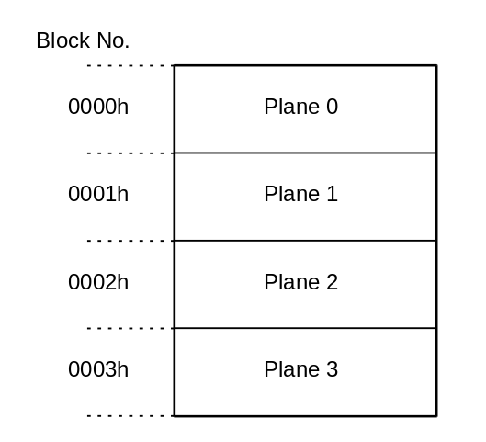
Fig. 3.4 Arrangement of image data
Because the Plane's data size is the same as one screen of LCD data with 2 gradations, it is determined solely by the LCD's matrix size.

The data size of one plane is as follows,
Plane data size = (dX+1)  (dY+1)  8 [byte]

The maximum data size of one Plane according to the above formula is
Plane data size (Max) = (255+1)  (255+1)  8
= 8192 [byte]
Thus, the maximum data size is 8192 bytes.

The maximum data size of one Block is prescribed at 8192 bytes.
(Refer to "2.3 Function Definition Blocks")

Therefore, one Plane can be stored in one Block regardless of the data size.

Gradation Conversion
This section discusses the situation where image data with a specific gradation is sent to a B/W LCD Function with a different gradation.
The following two things can occur when image data is sent to a B/W LCD Function with a different gradation.

- If the data is sent to a function with an LCD gradation lower than that of the image data

The method for sending data to an LCD function with a lower gradation is shown below.

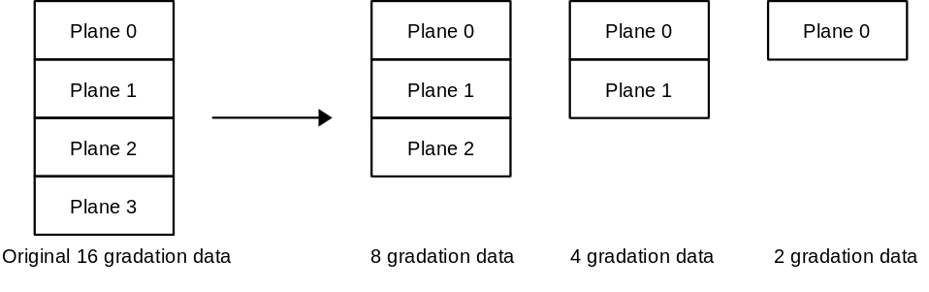

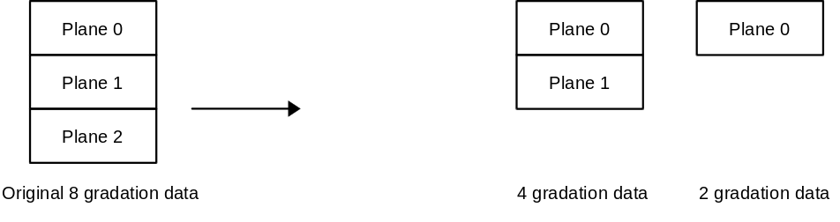

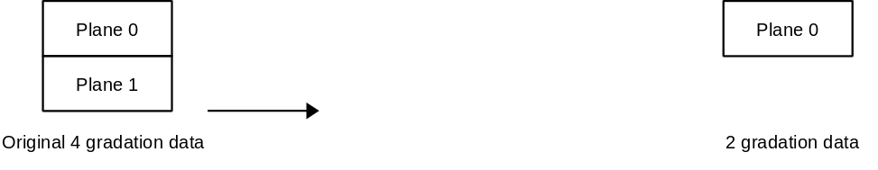

Fig. 3.5 Sending image data to an LCD Function with a lower gradation
When image data is sent to an LCD function with low gradation, the data transmission is canceled in order from the highest data (data indicating the lightness of the darkness) Plane No. according to the difference in gradation.

For example, when data with 16 gradations is sent to an LCD function with 2 gradations, the transmission of 3 Planes (Plane No. 3,2,1) worth of data is canceled in order from the highest Plane No.
If the Plane No. 3,2,1 data (Block No. 3,2,1) is sent, it will result in an [LCD Error].

The LCD function will only display the Plan No. data which was sent.

- If the data is sent to a function with an LCD gradation higher than that of the image data

The method for sending data to an LCD function with a higher gradation is shown below.

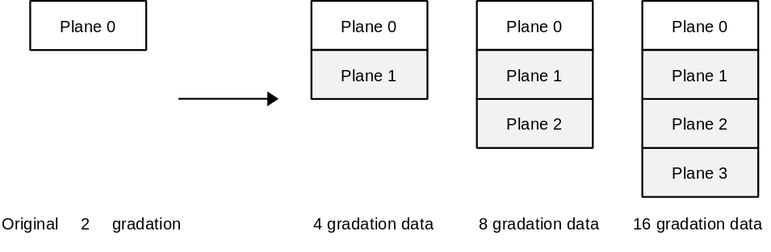

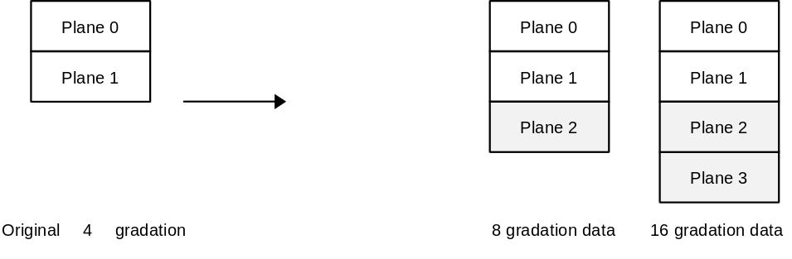

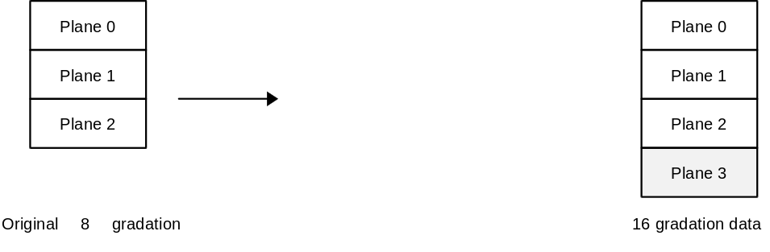

Fig. 3.6 Sending image data to an LCD Function with a higher gradation
When image data is sent to an LCD Function with a higher gradation, it sends "Dummy Plane data" for the difference in gradation. The Dummy Plane data is all '00h'. (grayed out area in figure)
For example, if 2 gradation data is send to an LCD function of 16 gradation, then Dummy Plane data is added to the Planes 1,2,3 of the original data and sent.
The LCD function displays the received data (including Dummy data) on the LCD.

The Plane No.'s used for each gradation is shown below (Planes being used = 'O')

Gradation after data conversion | PlaneNo.3 | Plane No.2 | Plane No.1 | Plane No.0
2 Gradations |  |  |  | O
4 Gradations |  |  | O | O
8 Gradations |  | O | O | O
16 Gradations | O | O | O | O

Fig. 3.7 Number of Planes used for image data after gradation conversion

Commands

This section lists the commands in the "Maple Bus 1.0" Standard Specifications which are supported by the B/W LCD function.
All settings examples assume connection to Port A and LM-Bus No. 1.

Control Commands

Get_Media_Info
Issuing authority: Host
Command code: 0Ah
Data size: 02h (8byte)
Data: Function type: 4byte
PT: 1byte
Fixed value: 3byte
Expected return value: [Data Transfer]
Description: This command is for receiving media information necessary for issuing other commands to the B/W LCD.
Example commands are shown below.

Data address | Data | Setting | Description
+0000h | Command code | 0Ah | Specifies [Get_Media_Info]
+0001h | Transfer destination AP | 01h | Expansion Device (LM-Bus No. 1)
+0002h | Transfer source AP | 00h | Port A
+0003h | Data size | 02h | Data size is 8 bytes
+0004h | Function type | 00h | Function type specifies [B/W LCD]
+0005h |  | 00h
+0006h |  | 00h
+0007h |  | 04h
+0008h | PT | 00h | Specifies the LCD No.
+0009h | Fixed value | 00h | Uses fixed value of '00h'
+000Ah |  | 00h
+000Bh |  | 00h
Fig. 4.1 Example of Get_Media_Info Commands
PT: LCD Number
Specifies which LCD to access since 1 to 256 LCDs can be accessed at once on the same peripheral device.
Number of LCDs = (PT+1)
(Except for unusual cases, '00h' (LCD number = 1) is the value which is normally used)

Because each LCD has its own specific media information, it is necessary to issue this command to each LCD.

When the B/W LCD function receives this command, it sends the media information shown in fig. 4.2 to the host via [Data Transfer].
For more information about [Data Transfer], please refer to "4.1.5 Data Transfer".

Data address | Data | Setting | Description
+0000h | Command code | 08h | Specifies [Data Transfer]
+0001h | Transfer destination AP | 00h | Port A
+0002h | Transfer source AP | 01h | Expansion Device (LM-Bus No.1)
+0003h | Data size | 02h | Data size is 8 bytes
+0004h | Function type | 00h | Function type specifies [B/W LCD]
+0005h |  | 00h
+0006h |  | 00h
+0007h |  | 04h
+0008h    +000Bh | Media information |  | Refer to Fig. 4.3
Fig. 4.2 Replies to the Get_Media_Info command
The following figure shows the details of the media information

bit | 7 | 6 | 5 | 4 | 3 | 2 | 1 | 0
1st Data | dX₇ | dX₆ | dX₅ | dX₄ | dX₃ | dX₂ | dX₁ | dX₀
2nd Data | dY₇ | dY₆ | dY₅ | dY₄ | dY₃ | dY₂ | dY₁ | dY₀
3rd Data | TE₃ | TE₂ | TE₁ | TE₀ | CT₃ | CT₂ | CT₁ | CT₀
4th Data | RE₇ | RE₆ | RE₅ | RE₄ | RE₃ | RE₂ | RE₁ | RE₀
Fig. 4.3 Composition of Media Information

dX: 1byte Number of X Axis dots Number of dots = (dX+1) 1~256dot
dY: 1byte Number of Y Axis dots Number of dots = (dY+1) 1~256dot
TE: 4bit Gradation (bit/dot) Refer to Fig. 4.5
CT: 4bit Contrast 0~15 Gradations (0 is no contrast adjustment)
RE: 8bit Reserved area, uses '0'

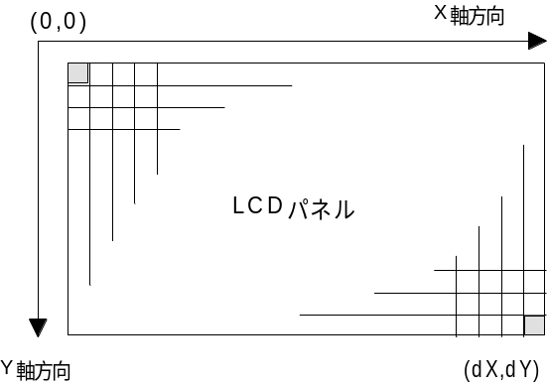
LCD Panel
Y Axis
X Axis

Fig. 4.4 Direction of the LCD Dot Matrix Coordinates

The figure below shows the gradation (TE) setting values.
Moreover, TE specifies how many planes are used to show the gradation.
For more information on Planes, please refer to Chapter 3.2.

TE₃ | TE₂ | TE₁ | TE₀ | Gradation | No. of Planes Used
0 | 0 | 0 | 1 | 2 gradations | 1
0 | 0 | 1 | 1 | 4 gradations | 2
0 | 1 | 1 | 1 | 8 gradations | 3
1 | 1 | 1 | 1 | 16 gradations | 4
Fig. 4.5 Gradation (TE) setting values

Block_Write
Issuing authority: Host
Command code: 0Ch
Data size: 02h + n (8byte + n  4 byte)
Data: Function type: 4byte
PT: 1byte
Phase: 1byte
Block No.: 2byte
LCD Data: n  4byte
Description: This command tells the B/W LCD function to write in (Block transfer) the data into the specified Block No. (Plane).
The figure below contains examples of commands.

Data address | Data | Setting | Description
+0000h | Command code | 0Ch | Specifies [Block_Write]
+0001h | Transfer destination AP | 01h | Expansion Device (LM-Bus No.1)
+0002h | Transfer source AP | 00h | Port A
+0003h | Data size | 02h + n
+0004h | Function type | 00h | Expansion Device (LM-Bus No.1)
+0005h |  | 00h
+0006h |  | 00h
+0007h |  | 04h
+0008h | PT | 00h | Specifies LCD No.
+0009h | Phase |  | Specifies Phase
+000Ah | Block No. |  | Specifies the Block No. (Plane) to Write to
+000Bh
+000Ch   | Write Data |  | LCD Data  n × 4 byte
Fig. 4.6 Examples of Block_Write commands

If one screen of data cannot be written in one access (WA2), then the screen data is divided by the number of WA and sent. Phase is used to indicate the sequential number of the divided data.

Ex.) 1 screen of 512 bytes of data is written 3 times. (WA=3)
This, the data amount of one access is 171 bytes.
In this case, a total of 513 bytes of data is sent in 3 accesses, but the one extra Block (above 512 bytes) is filled with '00h'.
(On the third access, the 171st byte of data is '00h'.)

Phase must be issue consecutively starting from '00h' and continuing '01h', '02h', '03h', ....
If another command is issued during the Block_Write Phase or if the Phase value is not issued continuously, an [LCD Error] is returned. Data is not written into that Block (Plane).

In order to indicate the Plane, the Block No. value has a range from '0000h' to '0003h'.

LCD Data capacity = (dx+1)  (dy+1)  (No. of Planes)  8 [byte]

Capacity of 1 access = LCD Data capacity  WA [byte]

Set_Condition
Issuing authority: Host
Command code: 0Eh
Data size: 02h (8byte)
Data: Function type: 4byte
PT: 1byte
Contrast increase/decrease value: 1byte
Reserved: 2byte
Description: Command which specifies the physical status of the B/W LCD Function.
This command is used by the B/W LCD Function to adjust the LCD contrast value and to acquire the current contrast value.

Data address | Data | Setting | Description
+0000h | Command code | 0Eh | Specifies [Set_Condition]
+0001h | Transfer destination AP | 01h | Expansion Device (LM-Bus No.1)
+0002h | Transfer source AP | 00h | Port A
+0003h | Data size | 02h | Data size is 8 bytes
+0004h | Function type | 00h | Function type specifies [B/W LCD]
+0005h |  | 00h
+0006h |  | 00h
+0007h |  | 04h
+0008h | PT | 00h | Specifies LCD No.
+0009h | Contrast increase/decrease value |  | See below
+000Ah | Reserved | 00h | Fixed value
+000Bh |  | 00h
Fig. 4.7 Examples of Commands for Adjusting Contrast
Contrast automatically changes the LCD brightness at the B/W LCD Function, so there is no need for the host to change the LCD data being displayed.
Contrast is performed on the entire LCD screen.

Contrast increase/decrease values are specified as follows.
Increase contrast (darken): Contrast increase/decrease value = '01h'
Decrease contrast (lighten): Contrast increase/decrease value = '80h'
To reset the contrast: Contrast increase/decrease value = '00h'
To acquire the contrast value: Contrast increase/decrease value = 'FFh'

If the contrast value exceeds the LCD's set range (CT), or if a value other than those above is specified, it will result in an [LCD Error].

When the B/W LCD receives this command, the following data is returned to the host via [Data Transfer].

Data address | Data | Setting | Description
+0000h | Command code | 08h | Specifies [Data Transfer]
+0001h | Transfer destination AP | 00h | Port A
+0002h | Transfer source AP | 01h | Expansion Device (LM-Bus No.1)
+0003h | Data size | 02h | Data size is 8 bytes
+0004h | Function type | 00h | Function type specifies [B/W LCD]
+0005h |  | 00h
+0006h |  | 00h
+0007h |  | 04h
+0008h | PT | 00h | Specifies LCD No.
+0009h | CT | 0xh | Contrast value
+000Ah | Reserved | 00h | Fixed value
+000Bh |  | 00h
Fig. 4.8 Replies to Set_Condition command
Contrast value: Returns the Contrast value after the execution of the Set_Condition command.
The upper 4 bits are fixed at '0'.

Device Reply
Issuing authority: Host
Command code: 07h
Data size: 00h
Data: none
Description: This command is returned to the host after the host command has successfully completed within the function.
Used for the Block_Write reply.
Examples of this command are shown below.

Data address | Data | Setting | Description
+0000h | Command code | 07h | Specifies [Device Reply]
+0001h | Transfer destination AP | 00h | Port A
+0002h | Transfer source AP | 01h | Expansion Device (LM-Bus No.1)
+0003h | Data size | 00h | Data size is 0 bytes
Fig. 4.9 Example of Device Reply Commands

Data Transfer
Issuing authority: B/W LCD Function
Command code: 08h
Data size: For [Get_Media_Info]: 02h
For [Set_Condition]: 02h
Data: For [Get_Media_Info]
Function type: 4byte
Media information: 4byte
For [Set_Condition]
Function type: 4byte
PT: 1byte
CT: 1byte
Reserved ('00h'): 2byte
Description: Returns data in response to a request from the host.
In the case of [Get_Media_Info], the Media information is returned. For more details, please refer to "4.1.1 Get_Media_Info".
In the case of [Set_Condition], the contrast data is returned.
Examples of the command are shown below.

Data address | Data | Setting | Description
+0000h | Command code | 08h | Specifies [Data Transfer]
+0001h | Transfer destination AP | 00h | Port A
+0002h | Transfer source AP | 01h | Expansion Device (LM-Bus No.1)
+0003h | Data size | 02h
+0004h | Function type | 00h | Function type specifies [B/W LCD]
+0005h |  | 00h
+0006h |  | 00h
+0007h |  | 04h
+0008h    +000Bh | Data |  | Data
Fig. 4.10 Examples of Data_Transfer Commands

Device Request
Issuing authority: Host
Command code: 01h
Data size: 00h
Data: none
Expected return value: [Device Status]
Description: This command requests a [Device Status] from the transfer destination AP's peripheral device.
After the initialization of the function, the B/W LCD will not respond to any other commands until this command is received.
Examples of the command are shown below.

Data address | Data | Setting | Description
+0000h | Command code | 01h | Specifies [Device Request]
+0001h | Transfer destination AP | 01h | Expansion Device (LM-Bus No.1)
+0002h | Transfer source AP | 00h | Port A
+0003h | Data size | 00h | Data size is 0 bytes
Fig. 4.11 Examples of Device Request commands

All Status Request
Issuing authority: Host
Command code: 02h
Data size: 00h
Data Area: none
Expected return value: [Device All Status]
Description: Requests the transfer destination AP's peripheral device to provide the device status (both Fixed and Free Device Status) of all devices.
Examples of the command are shown below.

Data address | Data | Setting | Description
+0000h | Command code | 02h | Specifies [All Status Request]
+0001h | Transfer destination AP | 01h | Expansion Device (LM-Bus No.1)
+0002h | Transfer source AP | 00h | Port A
+0003h | Data size | 00h | Data size is 0 bytes
Fig. 4.12 Examples of the All Status Request command

Device Reset
Issuing authority: Host
Command code: 03h
Data size: 00h
Data Area: none
Expected return value: [Device Reply]
Order of operation: (1) Return [Device Reply]
(2) Initializes
Description: Can initialize the peripheral device specified by the transfer destination AP.
When initializing, the LCD screen is cleared.
Examples of the command are shown below.

Data address | Data | Setting | Description
+0000h | Command code | 03h | Specifies [Device Reset]
+0001h | Transfer destination AP | 01h | Expansion Device (LM-Bus No.1)
+0002h | Transfer source AP | 00h | Port A
+0003h | Data size | 00h | Data size is 0 bytes
Fig. 4.13 Examples of the Device Reset command

Device Kill
Issuing authority: Host
Command code: 04h
Data size: 00h
Data Area: none
Expected return value: [Device Reply]
Order of operation: (1) Return [Device Reply]
(2) Halts operation
Description: Does not permit operation of peripheral device specified by the transfer destination AP.
After the function clears the LCD, it waits on standby using consumption current and will not receive any command.
To resume operation, it is necessary to perform a hard reset or shut off the power and restart.
Examples of the command are shown below.

Data address | Data | Setting | Description
+0000h | Command code | 04h | Specifies [Device Reset]
+0001h | Transfer destination AP | 01h | Expansion Device (LM-Bus No.1)
+0002h | Transfer source AP | 00h | Port A
+0003h | Data size | 00h | Data size is 0 bytes
Fig. 4.14 Examples of the Device Kill command

Device Status
Issuing authority: Peripheral device
Command code: 05h
Data size: 1Ch (28)
Data Area: Device ID: 16Byte
Regional code: 1Byte
Product name: 31Byte
License: 60Byte
Standby consumption current: 2Byte
Maximum consumption current: 2Byte
Description: Returns the Fixed Device Status in response to the [Device Request] from the host.
Examples of the command are shown below.

Data address | Data | Setting | Description
+0000h | Command code | 05h | Specifies [Device Status]
+0001h | Transfer destination AP | 00h | Port A
+0002h | Transfer source AP | 01h | Expansion Device (LM-Bus No.1)
+0003h | Data size | 1Ch | Data size is 112 bytes
+0004h    +0013h | Device ID |  | Specifies the Device ID
+0014h | Regional code |  | Specifies the Regional code
+0015h    +0033h | Product name |  | Specifies the Product name
+0034h    +006Fh | License |  | Specifies the License
+0070h | Standby consumption current |  | Specifies the Standby consumption current
+0071h
+0072h | Maximum consumption current |  | Specifies the Maximum consumption current
+0073h
Fig. 4.15 Examples of the Device Status command

Device All Status
Issuing authority: Peripheral device
Command code: 06h
Data size: 1Ch + n
Data Area: Fixed Device Status: 112Byte
Device ID: 16Byte
Regional code: 1Byte
Product name: 31Byte
License: 60Byte
Standby consumption current: 2Byte
Maximum consumption current: 2Byte
Free Device Status: n  4Byte
Description: Returns both the Fixed Device Status and Free Device Status in response to the [All Status Request] from the host.

Error Commands

Function Type Unknown
Issuing authority: Peripheral device
Command code: FEh
Data size: 00h
Data Area: none
Description: Returned when the function type sent is not in the peripheral device.
Possible causes: (1) Function type specification is incorrect.
(2) Data statement is incorrect.
(3) Device ID data is corrupt.
(4) Data corruption occurred during transmission.
Solutions: (1) Correct the Function type specification.
(2) Correct the Data statement.
(3) Resend the [Device Request] and receive the Device ID.
(4) Receive the function type again. (Up to a maximum of three times, more than that will cause a Time Out)

Command Unknown
Issuing authority: B/W LCD Function
Command code: FDh
Data size: 00h
Data Area: none
Description: Returned when the command which was sent is not supported by the B/W LCD Function.
Possible causes: (1) Command specification is incorrect.
(2) Data statement is incorrect.
(3) Device ID data is corrupt.
(4) Data corruption occurred during transmission.
Solutions: (1) Correct the Command specification.
(2) Correct the Data statement.
(3) Resend the [Device Request] and receive the Device ID.
(4) Receive the command again. (Up to a maximum of three times, more than that will cause a Time Out)

Transmit Again
Issuing authority: Host, B/W LCD Function
Command code: FCh
Data size: 00h
Data Area: none
Description: If an error occurs in data which is sent, this command requests that the data be sent once again.
Possible causes: (1) Parity error occurred.
(2) The data overflowed.
(3) Data corruption occurred during transmission.
(4) Other
Solutions: Resend the data. (Up to a maximum of three times, more than that will cause a Time Out)

LCD Error
Issuing authority: B/W LCD Function
Command code: FAh
Data size: 01h
Data: Function error code: 4byte
Description: This command is returned to the host when an error occurs in processing (when a series of commands is processed over several instances, it is considered as one process) a command received from the host.
Examples of the command are shown below.

Data address | Data | Setting | Description
+0000h | Command code | FAh | Specifies [LCD Error]
+0001h | Transfer destination AP | 00h | Port A
+0002h | Transfer source AP | 01h | Expansion Device (LM-Bus No.1)
+0003h | Data size | 01h | Data size is 4 bytes
+0004h | Function error code |  | Refer to fig. 4.17
+0005h
+0006h
+0007h
Fig. 4.16 Examples of the LCD Error command

The details of the Function Error Codes are shown below.

bit | 7 | 6 | 5 | 4 | 3 | 2 | 1 | 0
1st Data | FE₃₁ | FE₃₀ | FE₂₉ | FE₂₈ | FE₂₇ | FE₂₆ | FE₂₅ | FE₂₄
2nd Data | FE₂₃ | FE₂₂ | FE₂₁ | FE₂₀ | FE₁₉ | FE₁₈ | FE₁₇ | FE₁₆
3rd Data | FE₁₅ | FE₁₄ | FE₁₃ | FE₁₂ | FE₁₁ | FE₁₀ | FE₉ | FE₈
4th Data | FE₇ | FE₆ | FE₅ | FE₄ | FE₃ | FE₂ | FE₁ | FE₀
Fig. 4.17 Function Error Codes

Items with an error have a '1' and those without an error have a '0'.

The descriptions of the errors are as follows.
If the error is not fixed by the host's response, then it will be disconnected or a user message will be displayed.

FE₀ : PT Error
Error description: The LCD indicated by the specified PT does not exist.
Function operation: All of the data at the time of the error is rejected.
Host response: The data is resent (up to a maximum of three times)

FE₁ : Phase Error
Error description: The Phase+1 value exceeds the WA value. (Block_Write execution)
Counted a Phase value other than +1. (ex: Phase : 0  2  1)
Function operation: All of the data at the time of the error is rejected.
Host response: The data is resent (up to a maximum of three times)
The data is resent by Block transfer from Phase = 0.

FE₂ : Block Error
Error description: The specified Block (Plane) does not exist.
Function operation: All of the data at the time of the error is rejected.
Host response: The data is resent (up to a maximum of three times)

FE₃ : Write Error
Error description: The data is not properly written into the function's image memory.
Function operation: The incorrect data is written into memory, but it does not delete the data.
Therefore, the incorrect screen is displayed on the LCD.
Host response: The data is resent (up to a maximum of three times)
Or, the next screen is sent.

FE₄ : Length Error
Error description: The LCD data capacity and the size of the data sent do not match.
Function operation: The data is displayed using the actual LCD data capacity.
Therefore, the incorrect screen is displayed on the LCD.
Host response: The data is resent (up to a maximum of three times)

FE₅ : Contrast Error
Error description: The contrast value has exceeded the range of the LCD settings or the setting method is incorrect.
Function operation: The contrast value is changed so that it does not exceed the range.
Host response: None.

FE₃₁ : Undefined Error
Error description: An undefined error occurred.
Function operation: All of the data (Block) at the time of the error is rejected.
Host response: The data is resent (up to a maximum of three times)

Errors other than those above are reserved.

Protocol Flow

Overview of Transmission Protocols
The figure below shows the fundamental protocols between the host and the B/W LCD.

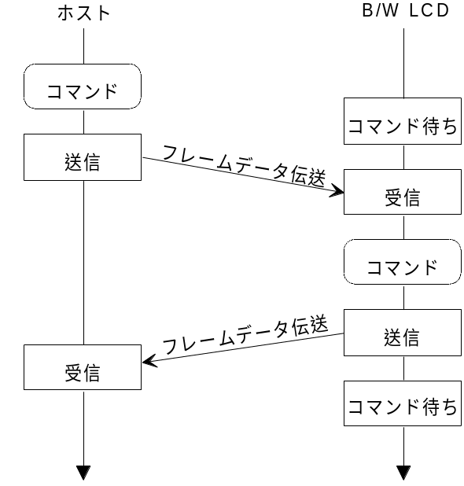
Awaiting command
Awaiting command
Frame data trans.
Frame data trans.
Command
Transmission
Reception
Command
Transmission
Reception
Host
B/W LCD

Fig. 5.1 Overview of Transmission Protocols

Processing Flow of LCD Display
The following diagram shows the overall flow of LCD display.
For more information about the processing flow of acquisition of LCD parameters and transmission of image data, please refer to "Get_Media_Info Processing Flow" and "Block_Write Processing Flow".

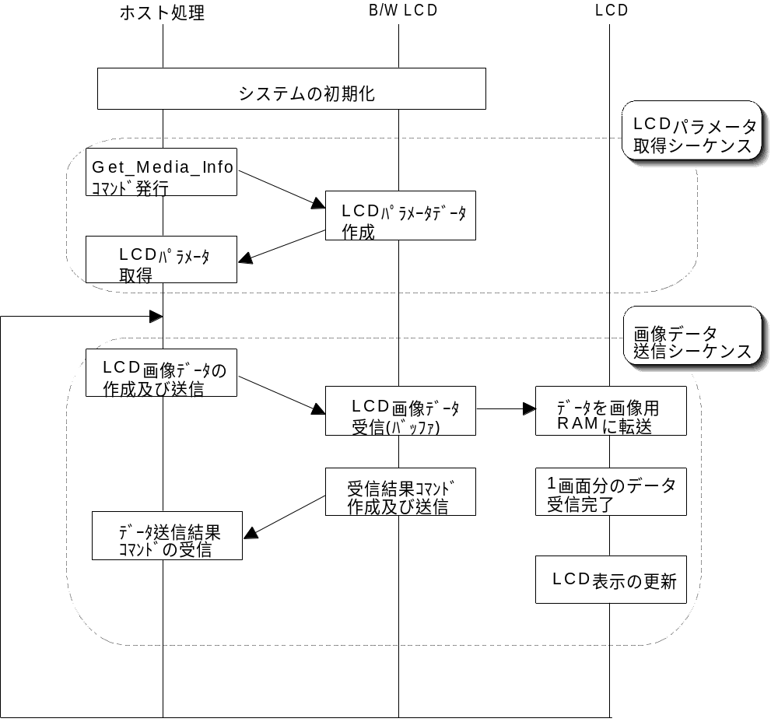
Creation and Transmission
of LCD image dataa
Reception of data transmission results command
Creation and Transmission of reception results command
Reception of 1 screen of data complete
LCD display is
changed
LCD parameter
acquisition
Reception of LCD
image data (buffer)
Data transferred to
image RAM
Image data
transmission sequence
LCD parameter data created
Issue Get_Media_Info command
LCD parameter
acquisition sequence
System initialization
Host Processing B/W LCD LCD

Fig. 5.2 Processing Flow of LCD Display

Processing Flow of Get_Media_Info
The following diagram shows the overall flow of the Get_Media_Info processing.

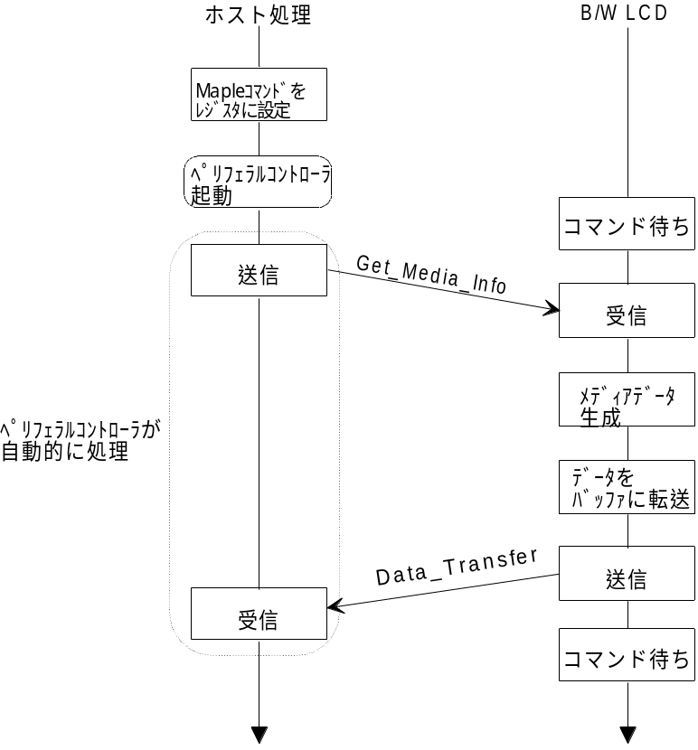
Data_Transfer
Get_Media_Info
Transmission
Reception
Automatically processed by the peripheral controller
Media data
created
Transfer data
to buffer
Transmission
Reception
Await command
Await command
Startup peripheral controller
Maple command set in register
Host processing B/W LCD
Fig. 5.3 Processing Flow of Get_Media_Info

Processing Flow of Block_Write
The following diagram shows the overall flow of the Block_Write processing.

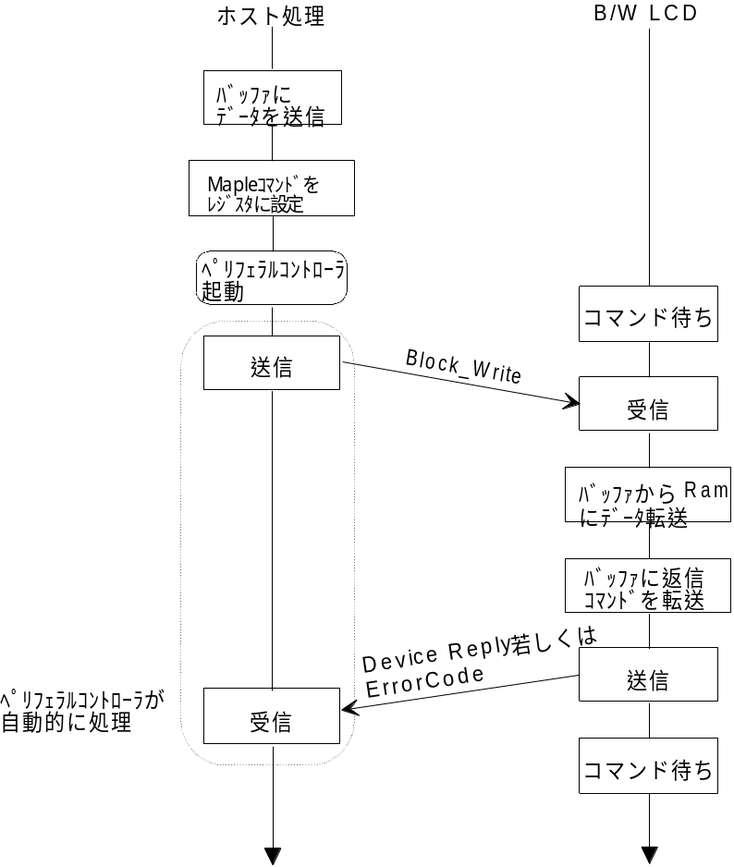
Block_Write
Device Reply or Error Code
Transmission
Reception
Automatically processed by the peripheral controller
Data transferred
from buffer to RAM
Send return
command to buffer
Transmission
Reception
Await command
Await command
Startup peripheral controller
Maple command set in register
Transmit data
to buffer
Host processing B/W LCD

Fig. 5.4 Processing Flow of Block_Write

Afterword

The contents of these specifications are subject to change in part or in whole until the formal version is issued (Rev. 1.0).

