"Maple Bus 1.0"
Function Type Specifications
FT₄ : Audio input device Function
Revision 1.0

Produced by
CS Hardware Division 2
Sega Enterprises, Inc.

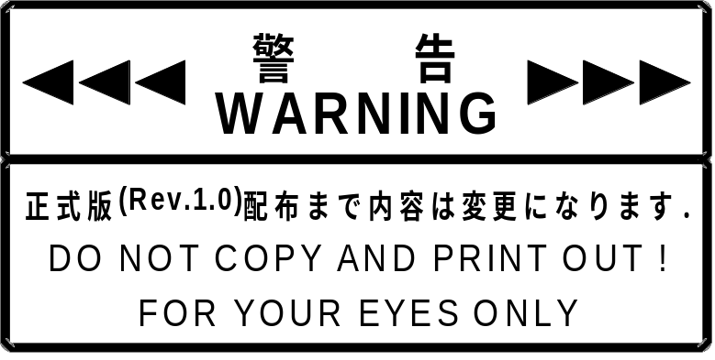
Revision:
Rev0.1 1997/12/17 Preliminary Specifications
Rev0.3 1998/01/05 Partial change of Get_Sampling_Date subcommand
Header data detail change for DataTransfer command to send Sampling data
Rev0.4 1998/01/11 Deleted AGC subcommand
Added Test_Mode subcommand
Rev0.41 1998/01/17 Changed send frame of all commands
Added EXTU_BIT subcommand
Partially changed Test_Mode function description
Rev0.42 1998/01/26 Changed specifications title page and format
Changed command frame configuration to actual transmission
Added description to subcommand table
Rev0.8 1998/03/31 Errata correction, p. 12
μ-Low → μ-Law
Revised description of function definition block
Rev0.9 1998/11/11 Ammended EXTU subcommand
Rev1.0 2000/03/15 Added 3.1.5 Volume_Mode Subcommand.
Added 2.2, Explanation of 1st Function Definition Block.
Added 2.3, Explanation of 2nd and 3rd Function Definition Blocks.
Added explanation of subcommand 06H, p. 7.
CONTENTS:
1 Audio Input Device Outline 4
1.1 Audio Input Device Definition 4
1.2 Basic Functions Definition 4
1.3 Special Functions 4
2 Audio Input Device ID Setting 5
2.1 Function Type 5
2.2 1st function definition block (command list) 5
2.3 2nd, 3rd Function Definition Blocks of the Dreameye Mike Device 6
3 Audio Input Device Command Configuration 7
3.1 Audio Input Device Subcommands 8
3.1.1 Get_Sampling_Data Subcommand 8
3.1.2 Basic_Control Subcommand 9
3.1.3 AMP_Control Subcommand 10
3.1.4 EXTU_BIT Subcommand 11
3.1.5 Volume_Mode Subcommand 12
3.1.6 Test_Mode Subcommand (Preliminary) 12
3.1.7 DataTransfer Command To Send Sampling Data 13

Audio Input Device Outline

Audio Input Device Definition

The audio input device serves to send digital data to the new-generation game machine (hereafter called "host"), based on the Maple Bus specifications. The audio input device performs this function according to the following two methods:

• Analog data (audio) are converted into digital data and sent to host without further processing
• Analog data (audio) are analyzed by the device, and the result only is sent to the host, using a special format

* At this point, specifications for devices using the second method are not finalized. The current document therefore excludes this method from the definition of basic functions and treats it as a special function.
* As of Mar 15, 2000, application peripherals are the mike device and the Dreameye mike device.

Basic Functions Definition

The audio input device for the new-generation game machine (belonging to FT₄ of the Maple Bus specifications) is defined by the following basic functions.

• A/D conversion capability using specified sampling frequency and quantization.
→ Sampling frequency and quantization can be specified in up to four steps.
• Memory capacity to store a minimum of 1.3 INT worth of sampling data (digital data). (preliminary)

There is a possibility that the above basic functions may be handled as special functions in future.

Special Functions

Audio input devices for the new-generation game machine with functions to improve voice recognition, generate sampling data, perform automatic volume adjustment, etc. may be developed in future. A protocol for "Audio Input Devices With Special Functions" corresponding to the Maple Bus specifications allows for a maximum of 32 special (expanded) functions.

Audio Input Device ID Setting

Function Type

The audio input device belongs to the function type FT₄, which is defined as shown in the table below.

Table 2-1 Function types
bit | 7 | 6 | 5 | 4 | 3 | 2 | 1 | 0
1st Data | Undefined | Undefined | Undefined | Undefined | Undefined | Undefined | Undefined | Undefined
2nd Data | Undefined | Undefined | Undefined | Undefined | Undefined | Undefined | Undefined | Undefined
3rd Data | Undefined | Undefined | Undefined | Undefined | Undefined | Undefined | Undefined | Undefined
4th Data | Undefined | Undefined | Undefined | 1 | Undefined | Undefined | Undefined | Undefined

1st function definition block (command list)

The components of the 1st function definition block for the Dreameye mike device are as follows.

Table 2-2 1st function definition block for the Dreameye mike device
Bit | Corresponding subcommand | Setting value | Bit | Corresponding subcommand | Setting value
FD1₃₁ | Reserved | 0 | FD1₁₅ | Reserved | 0
FD1₃₀ | Reserved | 0 | FD1₁₄ | Reserved | 0
FD1₂₉ | Reserved | 0 | FD1₁₃ | Reserved | 0
FD1₂₈ | Reserved | 0 | FD1₁₂ | Reserved | 0
FD1₂₇ | Reserved | 0 | FD1₁₁ | Reserved | 0
FD1₂₆ | Reserved | 0 | FD1₁₀ | Reserved | 0
FD1₂₅ | Reserved | 0 | FD1₉ | Reserved | 0
FD1₂₄ | Reserved | 0 | FD1₈ | Reserved | 0
FD1₂₃ | Reserved | 0 | FD1₇ | Reserved | 0
FD1₂₂ | Reserved | 0 | FD1₆ | Reserved | 0
FD1₂₁ | Reserved | 0 | FD1₅ | Use prohibited (fixed) | 1
FD1₂₀ | Reserved | 0 | FD1₄ | Volume_Mode | 1
FD1₁₉ | Reserved | 0 | FD1₃ | EXTU_BIT | 1
FD1₁₈ | Reserved | 0 | FD1₂ | AMP_GAIN | 1
FD1₁₇ | Reserved | 0 | FD1₁ | Basic_Control | 1
FD1₁₆ | Reserved | 0 | FD1₀ | Get_Sampling_Data | 1

Table 2-3 1st function definition block
Bit | 7 | 6 | 5 | 4 | 3 | 2 | 1 | 0
5th Data | 0 | 0 | 0 | 0 | 0 | 0 | 0 | 0
6th Data | 0 | 0 | 0 | 0 | 0 | 0 | 0 | 0
7th Data | 0 | 0 | 0 | 0 | 0 | 0 | 0 | 0
8th Data | 0 | 0 | * | * | * | * | * | *

The subcommands supported by peripherals belonging to FT₄ can be determined by checking the above information with Device_All_Status. If an unsupported subcommand is used, Command_Unknown is returned.

Example: When the Volume_Mode subcommand is sent to the mike device (1st function definition block = 0Fh), Command_Unknown is returned because the subcommand is not supported.

2nd, 3rd Function Definition Blocks of the Dreameye Mike Device
The 2nd and 3rd function definition blocks of the Dreameye mike device are both 00H.

Audio Input Device Command Configuration

The illustration below shows the frame configuration for commands sent by the host to the audio input device. (Start and end patterns are omitted.)
Note that the frame shown here represents the configuration in actual data transfer.

Table 3-1 Dedicated commands for audio input device
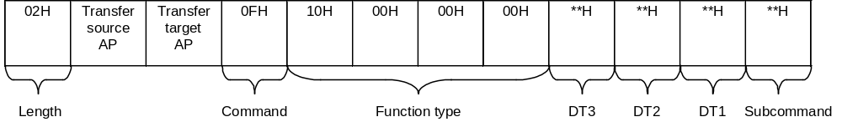

The function of the audio input device is determined by the "subcommand," "DT1", "DT2", and "DT3". Available subcommands are listed below.

Table 3-2 Subcommands
Issue privilege | Subcommand name | Subcommand | Response
Host | Undefined | 00H | Command Unknown
Host | Get_Sampling_Data | 01H | Data Transfer
Host | Basic_Control | 02H | Device Reply
Host | AMP_GAIN | 03H | Device Reply
Host | EXTU_BIT | 04H | Device Reply
Host | Volume_Mode | 05H | Device Reply
Host | Use prohibited | 06H | -
Host | Undefined | 07H - FBH | Undefined
Audio input device (preliminary) | Test_Mode | FCH | Data Transfer
Audio input device (preliminary) | Undefined | FEH | -
Audio input device (preliminary) | Undefined | FFH | -

* Up to 32 audio input device subcommand types can be registered. Subcommands from the host therefore range from 00H to 1FH.
* Various audio input devices will have different special functions. Therefore the host must obtain the 1st function definition block (device function subcommand list) from the audio input device connected with the "Device_Request".
* Use of subcommand 06H is not permitted. Do not send subcommand 06H even if the FD1₅ bit of the 1st function definition block has been set to “1” with Device_Status for a peripheral device belonging to FT₄. This bit will not be allocated to new functions in any FT₄ peripheral devices to be developed in the future.

Audio Input Device Subcommands

In this document, a string that is returned by the audio input device in response to a command sent from the host is called "response". The subcommand table is assumed to be stored in the work RAM of the host. The left side is low-order address and the right side the high-order address.

Get_Sampling_Data Subcommand

Function: Used by host to request sampling data and set AMP gain.
Issue privilege: Host

Table 3-3 Get_Sampling_Data subcommand
Subcommand | DT1 | DT2 | DT3
01H | AMP gain value | Reserved | Reserved

DT1: AMP gain setting
DT2: Reserved
DT3: Reserved

Response: See "DataTransfer Command To Send Sampling Data "

Basic_Control Subcommand

Function: Sets the following functions.
• Start/stop sound sampling
• Select sampling frequency
• Select sampling bit count
Issue privilege: Host

Table 3-4 Basic_Control subcommand
Subcommand | DT1 | DT2 | DT3
02H | See below | Reserved | Reserved

DT1:

bit | 7 | 6 | 5 | 4 | 3 | 2 | 1 |  | 0
DT1 | Sampling | 0 | 0 | 0 | Sampling frequency |  |  | Quantization

Sampling:
Setting this bit to "1" starts sampling. Setting the bit to "0" stops sampling.
Sampling frequency:
The following four settings are available for the sampling frequency.

Setting value | Setting level
00 | LEVEL0
01 | LEVEL1
10 | LEVEL2
11 | LEVEL3

Quantization:
The following four settings are available for the sampling bit rate (quantization).

Setting value | Setting level
00 | LEVEL0
01 | LEVEL1
10 | LEVEL2
11 | LEVEL3

DT2: Reserved
DT3: Reserved

Response: Standard Maple Bus "Device Reply" is sent.

AMP_Control Subcommand

Function: Sets the sound input AMP gain value.
Issue privilege: Host

Table 3-5 AMP_Control subcommand
Subcommand | DT1 | DT2 | DT3
03H | See below | Reserved | Reserved

DT1: AMP gain setting value

bit | 7 | 6 | 5 | 4 | 3 | 2 | 1 | 0
 | 256 possible settings from 00H - FFH

DT2: Reserved
DT3: Reserved

Response: Standard Maple Bus "Device Reply" is sent.

EXTU_BIT Subcommand

Function: Sampling data can be expanded in devices belonging to FT₄.
The method used or expanding sampling data is specified using this command.

Table 3-6 Sampling data format
bit | 15 | 14 | 13 | 12 | 11 | 10 | 9 | 8 | 7 | 6 | 5 | 4 | 3 |  | 2 | 1 |  | 0
D | MSB |  | Sampling data |  |  |  |  |  |  |  |  |  |  | LSB |  |  | * |  | *

Issue Privilege: Host

Table 3-7 EXTU_BIT subcommand
Subcommand | DT1 | DT2 | DT3
04H | See below | 00H | 00H

DT1: See table below

Setting value | Expansion contents
00H | Lower 2 bits are set at "00"
01H | LSB 2 bits are copied to "**"
02H | Lower 2 bits are set at "10"
03H | Use prohibited
... | .....
FFH | Use prohibited
* If out-of-range values 03H - FFH are received, existing setting values are retained.
In this case, the SIP returns the "Command Unknown" response.

DT2: 00H
DT3: 00H

Response: Standard Maple Bus "Device Reply" is sent.

Volume_Mode Subcommand

Function:
• Changes the amplification reference.
Issue privilege: Host
Table 3-8 Volume_Mode subcommand
Subcommand | DT1 | DT2 | DT3
04H | See below | 00H | 00H

DT1:
Setting value | Setting
00H | +30dB
01H | +12dB
02H | Reserved (status maintained)
... | ....
FFH | Reserved (status maintained)
* If out-of-range values 03H - FFH are received, existing setting values are retained.
In this case, the SIP returns the "Command Unknown" response.

Response: Standard Maple Bus "Device Reply" is sent.

Test_Mode Subcommand (Preliminary)

Function: Test mode for debugging. For information on the format, see the specifications for each device. The command is designed to be used only for debugging. It may not be used in an application.
Issue privilege: Host

Table 3-9 Test_Mode subcommand
Subcommand | DT1 | DT2 | DT3
FCH | Reserved | Reserved | Reserved

DT1: Reserved
DT2: Reserved
DT3: Reserved

Response: Standard Maple Bus "Data Transfer" is sent.

DataTransfer Command To Send Sampling Data

Function: Transfer of sampling data currently stored by audio input device.
Issue privilege: Device, extended device
* Note that the frame shown here represents the configuration in actual data transfer.

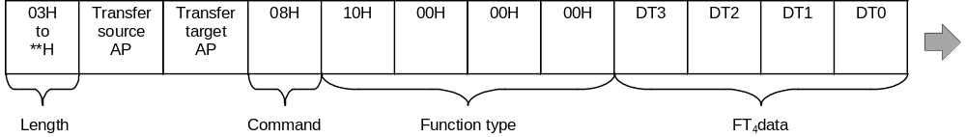

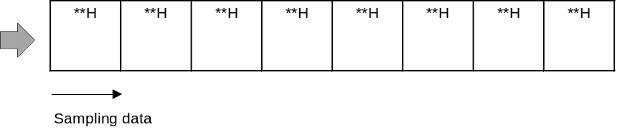

If no sampling was carried out and a request for sampling data is received from the host, the frame shown below (no sampling data) is sent.

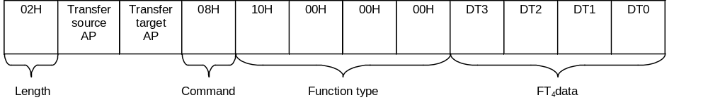

Response: When FT₄ data (sampling data) are sent, the frame is assembled as shown in the above illustration.

DT0 | DT1 | DT2 | DT3
FT₄ status | AMP setting value | For expansion | Sampling count

• Sampling count: Number of times sampling has been carried out.
• AMP setting value: Currently selected input gain.
• FT₄ status: Shown below

BIT | 7 | 6 | 5 | 4 | 3 | 2 | 1 | 0
NAME | EX_BIT | SBFOV | 0 | 14LSB1 | 14LSB0 | SMPL | μ-Law | Fs

EX_BIT: Expansion bit for new functions. When this bit is "1", the connected peripheral incorporates another function besides the basic functions. "DT2" comprises the status data for the new function. Details are still pending.
SBFOV: Sampling data buffer overflow condition (0: normal, 1: overflow)
14LSB1,0: Linear sampling data expansion method flag
SMPL: Sampling operation start (0: stop, 1: Execute sampling)
μ-Law: CODEC conversion (0: 14 bit linear, 1: 8 bit μ-Law CODEC)
Fs: Sampling frequency setting (0:11.025 kHz, 1: 8.0 kHz)

