“Maple Bus 1.0”
Function Type Specifications

FT₆ : Keyboard

Revision 0.90

Issued by
Sega Enterprises, Inc.
CS Development and Production Dep't, Second Division

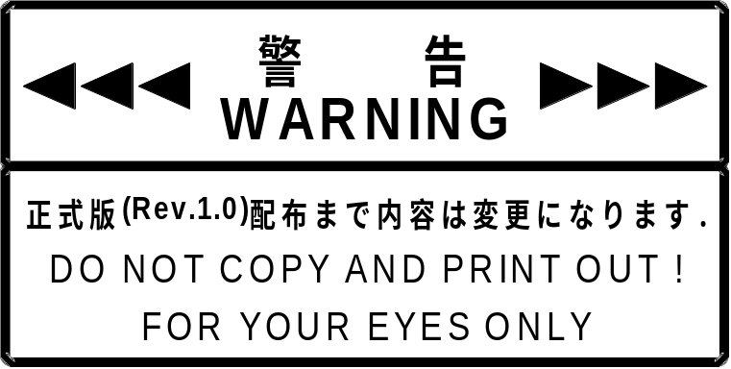

Revision history
0.75 1998/04/19
0.78 1998/05/25 Contents of Free Device Status revised, and unifying information added.
Added description of the characters that can be used for Fixed Device Status and Free Device Status.
0.80 1998/06/10 Chart for explaining Function key features partly revised.
84-, 85-, 87-, 88-key added to recommended operating system.
Keyboard language setting contents changed.
Keyboard type (87-key, 88-key) added.
Wraparound contents partly changed.
Caution added to explanation of the handling of the henka-key’s key code.
0.82 1998/08/20 Key code tables divided into US, UK and JPN tables.
0.90 1999/04/30 Display location of diagram numbers unified under diagrams.
Keyboard items extensively revised.
Left Win, right Win, and application key designations changed to special keys S1, S2, and S3.

Contents

1. Keyboard Function Conditions 4
1.1 Keyboard Function Definition 4
1.2 Function Outline 4
1.3 Configuration Details 5
1.4 Recommended Configurations 7
2. Keyboard Function Operation 8
2.1 Device Operation 8
2.2 Keyboard Operation 9
3. Device ID 10
3.1 Maple Bus 1.0 Device ID Configuration 10
3.2 Function Type 11
3.3 Function Definition Block 11
4. Data Format 14
4.1 Write Format 14
4.2 Read Format 15
4.3 Key Scan Codes (US, UK JP) 18
5. Supported Commands 26
5.1 Control Commands 26
5.1.1 Device Request 26
5.1.2 All Status Request 27
5.1.3 Device Reset 27
5.1.4 Device Kill 28
5.1.5 Device Status (Note: In Maple Bus Rev. 0.81 data sizes will be changed.) 28
5.1.6 Device All Status (Note: In Maple Bus Rev. 0.81 data sizes will be changed.) 29
5.1.7 Device Reply 29
5.1.8 Get Condition 30
5.1.9 Data Transfer 31
5.1.10 Set Condition 32
5.2 Error Commands 33
5.2.1 Function Type Unknown 33
5.2.2 Command Unknown 33
5.2.3 Transmit Again 34
6. Keyboard Function Information 35
6.1 Type 35
6.2 Fixed Device Status 35
6.3 Free Device Status 38
7. Usable Characters 39
8. Remarks 40

1. Keyboard Function Conditions

1.1 Keyboard Function Definition
The Keyboard function is an input type man/machine interface serving for input and editing of characters and numerals, and for control of screen operations. It provides
(1) External shape is not prescribed, but operation must be compatible with every product.
(2) The minimum function complement must be provided.
(3) The Keyboard function must comply to the Maple Bus 1.0 Standard Specifications.

1.2 Function Outline
The Keyboard function elements are listed below.
- Alphanumeric keys :A - Z, 0 - 9
- Symbol keys :- ^ \ @ [ ] : ; . / \ ! " # $ % & ' ( ) ~ | ` { + * } < > ? _ ,
- Function keys :F1 - F24
- Editing keys :Tab, Backspace, Space, CapsLock, Insert, Delete, Home, End, PageUp, PageDown, PrintScreen, ScrollLock, Pause, Enter, Esc, Hankaku/Zenkaku, Muhenkan, Zenkouho Henkan (jikouho), Katakana Hiragana, Stop, Again, Undo, Cut, Copy, Paste, Find, Alternate, Ease, Cancel, Clear, Prior, Return, Separator, Out, Open, Clear/Again, CrSel/Props, ExSel, SysReq, Power, Mute, Volume Up, Volume Down
- Cursor keys : ← ↑ → ↓
- Control keys :Ctr, Alt, Shift
- Numeric keypad :0 - 9, NumLock, Enter . / + - * , =
- Special keys :S1,S2,S3
- Error code :No operation, rollover error, POST Fail, undefined error

*Composition of elements may vary according to language.

The minimum required elements for the Keyboard function are as follows.
- Alphanumeric keys :A - Z, 0 - 9
- Symbol keys : - ^ \ @ [ ] : ; . / \ ! " # $ % & ' ( ) ~ | ` { + * } < > ? _ ,
- Function keys :F1 - F6
- Editing keys :Tab, Backspace, Space, CapsLock, Enter, Esc
- Cursor keys :← ↑ → ↓
- Control keys :Ctr, Alt, Shift
- Error code :Rollover error

Unless these elements are provided, a function cannot be defined as Keyboard function.

1.3 Configuration Details
This section gives a detailed description of Keyboard function elements.
(1) Alpha keys, symbol keys: A - Z, - ^ \ @ [ ] : ; . / \ ! " # $ % & ' ( ) = ~ | ` { + * } < > ? _ ,
These are digital keys that take only two states: pressed/not pressed (ON/OFF). When pressed, the corresponding key scan code is output. The corresponding letter (A - Z), numeral (0 - 9), or symbol is displayed on the screen. To input the symbol printed i the top left corner of the key (for example ` { + * } etc.), the Shift key must be held down while pressing the key.

(2) Function keys: F1 – F24
These are digital keys that take only two states: pressed/not pressed (ON/OFF). When pressed, the corresponding key scan code is output and a function assigned to the key (such as displaying help) is executed.

(3) Editing keys: Tab, Backspace, Space, CapsLock, Insert, Delete, Home, End, PageUp, PageDown, PrintScreen, ScrollLock, Pause, Enter, Esc, NumLock, Hankaku/Zenkaku, Muhenkan, Zenkouho Henkan (jikouho), Katakana Hiragana, etc.
These are digital keys that take only two states: pressed/not pressed (ON/OFF). When pressed, the corresponding key scan code is output. These keys perform auxiliary functions when creating a document with the alphanumeric keys and symbol keys. Some repreentative functions are listed below in Table 1.3.1.
Editing key | Function Example
Space | Inserts a blank (space). Also uses as conversion.
Tab | Moves the cursor to a position defined by the word processing software.
CapsLock | Fixes the alpha keys A - Z to output only capitals (same as when Shift key is pressed).
Insert | Toggles the word processing software between overwrite mode and insert mode.
Delete | Deletes the character at the cursor without changing the cursor position.
Home | Moves the cursor to the home position.
End | Moves the cursor to the end of the line.
PageUp | Scrolls one screen up in word processing software.
PageDown | Scrolls one screen down in word processing software.
PrintScreen | Saves the current display contents as an image in the buffer.
ScrollLock | Serves as locking key, for example to keep the cursor position while scrolling.
Enter | Confirms an input or inserts a line feed/carriage return.
Esc | Cancels a command or other input before it has been confirmed.
NumLock | Toggles the numeric keypad ON and OFF.
BackSpace | Deletes the character before the cursor.
Hankaku/Zenkaku | Switches between zenkaku (dual-byte) and hankaku (single-byte) characters in Japanese input. Also activates the kanji mode.
Muhenkan | Enters characters without conversion in Japanese input.
Zenkouho Henkan (jikouho) | Displays a list of henkan (conversion) candidates for kana-to-kanji conversion.
Katakana Hiragana | Toggles between katakana and hiragana in Japanese input for word processing software etc.
Fig. 1-1 Editing key function example

(4) Cursor keys: ← ↑ → ↓
These are digital keys that take only two states: pressed/not pressed (ON/OFF). When pressed, the corresponding key scan code is output. The keys serve to move the cursor in the indicated direction.

(5) Control keys: Ctr, Alt, Shift
These are digital keys that take only two states: pressed/not pressed (ON/OFF). When pressed, the corresponding key scan code is output. Some function examples are listed below in Table 1.3.2.

Control key | Function example
Ctrl | Used in conjunction with other keys for shortcuts etc.
Alt | Used mainly as a menu key. Also used in conjunction with other keys for shortcuts etc.
Shift | Used to switch between lower case and upper case and to input symbols
Fig. 1-2 Control key function example

(6) Numeric keypad: 0 - 9, NumLock, Enter . / + - *
These are digital keys that take only two states: pressed/not pressed (ON/OFF). When pressed, the corresponding key scan code is output. The keys serve for numeric input, equation input, etc.

(7) Special keys: S1,S2,S3
These are digital keys that take only two states, pressed or not pressed (ON/OFF). When pressed (ON), the corresponding key code is output. Used to display the operating system Start menu, etc.

(8) Error code
This function is provided to deal with keyboard errors. It is not associated with a physical key. When seven or more keys are pressed simultaneously or when a sneak current has occurred, an error code is returned to the host.

1.4 Recommended Configurations
To ensure compatibility among Keyboard function products, the following configurations are recommended.

(1) 84-key keyboard USA keyboard with no ten keypad.

(2) 85-key keyboard UK keyboard with no ten keypad.

(3) 87-key keyboard 84-key keyboard + Special keys (S1, S2, S3)

(4) 88-key keyboard 85-key keyboard + Special keys (S1, S2, S3)

(5) 89-key keyboard Japanese keyboard with no ten key pad.

(6) 92-key keyboard 89-key keyboard + Special keys (S1, S2, S3)

(7) 101-key keyboard USA AT keyboard

(8) 102-key keyboard UK AT keyboard

(9) 104-key keyboard 101-key keyboard + Special keys (S1, S2, S3)

(10) 105-key keyboard 102-key keyboard + Special keys (S1, S2, S3)

(11) 106-key keyboard Japanese AT keyboard

(12) 109-key keyboard 106-key keyboard + Special keys (S1, S2, S3)

2. Keyboard Function Operation
This section explains the operation of the Keyboard function as a device, and as a keyboard. The keyboard is controlled according to these functions.

2.1 Device Operation
(1) Initialization
Sets the used registers, RAM, etc. to the initial state.
MIE is reset and all flags and TRBF are cleared.
MIE is set to the receive condition.

(2) Downstream Timeout
The device (except for Device Kill) constantly detects the downstream timeout condition of the Maple Bus. When there is no state transition on either SDCKA or SDCKB for 1 ms or more, timeout is detected. Detection starts when the start pattern is received(RXB = '1'), and ends when the end pattern is received. (RFB = '1').
When timeout is detected, the following processing steps are carried out.

Processing steps | Device
1 | Reset
2 | Wait for [Device Request]
3 | Normal operation
Fig. 2-1 Timeout processing sequence

(3) Upstream Timeout
When sending data to the host (upstream), an error in MIE or the Maple Bus may result the inability to normally recover from the send condition. In such a case, the host will detect a timeout and carry out a hardware reset, but the device will not accept he reset pattern because it is still in the send state.
Therefore the device is made to calculate the estimated send time from the data size and enter into timeout processing (MIE reset) when that period is exceeded.

2.2 Keyboard Operation
(1) Key scan
All key readout data (key scan codes) must be constantly updated, so that any data request from the host can be processed with quick response. Latest key scan data are therefore kept in memory, ready to be returned to the host immediately when needed. Allkeys are scanned simultaneously, with no priority.

(2) LEDs
The keyboard LEDs can be controlled either by the host or by the Keyboard function. When controlled by the host, the ON condition is maintained until an OFF command is received. When reset is performed, all LEDs are turned OFF.

(3) Optimization conditions
a) Simultaneous key press patterns must be detected.
b) Maximum number of simultaneous key-press readout is six.
c) When seven or more keys are pressed simultaneously, the Keyboard function generates an error.
d) When two or more keys are pressed and a sneak current has occurred, the Keyboard function generates an error.

(4) Restrictions
Key repeat (continuous output of a key scan code when a key is held down) cannot be set at the Keyboard function. When key repeat is required, the repeat rate and initial repeat delay must be set by the host in software.

(5) Default state
All LEDs are out.

3. Device ID
The device ID corresponds to the Maple Bus 1.0 Standard Specifications. The table below shows the memory image on the host.

3.1 Maple Bus 1.0 Device ID Configuration
The configuration uses 16 bytes (128 bit).

bit | 7 | 6 | 5 | 4 | 3 | 2 | 1 | 0
1st Data | FT₃₁ | FT₃₀ | FT₂₉ | FT₂₈ | FT₂₇ | FT₂₆ | FT₂₅ | FT₂₄
2nd Data | FT₂₃ | FT₂₂ | FT₂₁ | FT₂₀ | FT₁₉ | FT₁₈ | FT₁₇ | FT₁₆
3rd Data | FT₁₅ | FT₁₄ | FT₁₃ | FT₁₂ | FT₁₁ | FT₁₀ | FT₉ | FT₈
4th Data | FT₇ | FT₆ | FT₅ | FT₄ | FT₃ | FT₂ | FT₁ | FT₀
5th Data | FD1₃₁ | FD1₃₀ | FD1₂₉ | FD1₂₈ | FD1₂₇ | FD1₂₆ | FD1₂₅ | FD1₂₄
6th Data | FD1₂₃ | FD1₂₂ | FD1₂₁ | FD1₂₀ | FD1₁₉ | FD1₁₈ | FD1₁₇ | FD1₁₆
7th Data | FD1₁₅ | FD1₁₄ | FD1₁₃ | FD1₁₂ | FD1₁₁ | FD1₁₀ | FD1₉ | FD1₈
8th Data | FD1₇ | FD1₆ | FD1₅ | FD1₄ | FD1₃ | FD1₂ | FD1₁ | FD1₀
9th Data | FD2₃₁ | FD2₃₀ | FD2₂₉ | FD2₂₈ | FD2₂₇ | FD2₂₆ | FD2₂₅ | FD2₂₄
10th Data | FD2₂₃ | FD2₂₂ | FD2₂₁ | FD2₂₀ | FD2₁₉ | FD2₁₈ | FD2₁₇ | FD2₁₆
11th Data | FD2₁₅ | FD2₁₄ | FD2₁₃ | FD2₁₂ | FD2₁₁ | FD2₁₀ | FD2₉ | FD2₈
12th Data | FD2₇ | FD2₆ | FD2₅ | FD2₄ | FD2₃ | FD2₂ | FD2₁ | FD2₀
13th Data | FD3₃₁ | FD3₃₀ | FD3₂₉ | FD3₂₈ | FD3₂₇ | FD3₂₆ | FD3₂₅ | FD3₂₄
14th Data | FD3₂₃ | FD3₂₂ | FD3₂₁ | FD3₂₀ | FD3₁₉ | FD3₁₈ | FD3₁₇ | FD3₁₆
15th Data | FD3₁₅ | FD3₁₄ | FD3₁₃ | FD3₁₂ | FD3₁₁ | FD3₁₀ | FD3₉ | FD3₈
16th Data | FD3₇ | FD3₆ | FD3₅ | FD3₄ | FD3₃ | FD3₂ | FD3₁ | FD3₀
Fig. 3-1 Device ID

FT : Peripheral function type
FD1 : Function definition block for 1st function
FD2 : Function definition block for 2nd function
FD3 : Function definition block for 3rd function

(1) FT₀ - FT₃₁: Function type
Indicates the function type implemented by the peripheral. There are a total of 32 function types.

(2) FD₃₁ - FD₀: Function definition block
These blocks define the various elements that make up a function.

3.2 Function Type
The function type (FT) is indicated in the device ID. FT for the keyboard function is FT₆ = '1'.

bit | 7 | 6 | 5 | 4 | 3 | 2 | 1 | 0
1st Data | FT₃₁ | FT₃₀ | FT₂₉ | FT₂₈ | FT₂₇ | FT₂₆ | FT₂₅ | FT₂₄
2nd Data | FT₂₃ | FT₂₂ | FT₂₁ | FT₂₀ | FT₁₉ | FT₁₈ | FT₁₇ | FT₁₆
3rd Data | FT₁₅ | FT₁₄ | FT₁₃ | FT₁₂ | FT₁₁ | FT₁₀ | FT₉ | FT₈
4th Data | FT₇ | 1 | FT₅ | FT₄ | FT₃ | FT₂ | FT₁ | FT₀
Fig. 3-2 Keyboard function type

For example, a peripheral device which incorporates only the Keyboard function will have the function type FT = '00-00-00-40h'.
A device incorporating also other functions will have the bit corresponding to the other function types set to '1'.

3.3 Function Definition Block
The function definition block in the device ID is shown below. For the keyboard, it specifies the implemented function configuration.

bit | 7 | 6 | 5 | 4 | 3 | 2 | 1 | 0
1st Data | KL₇ | KL₆ | KL₅ | KL₄ | KL₃ | KL₂ | KL₁ | KL₀
2nd Data | KT₇ | KT₆ | KT₅ | KT₄ | KT₃ | KT₂ | KT₁ | KT₀
3rd Data | LD₇ | LD₆ | LD₅ | LD₄ | LD₃ | LD₂ | LD₁ | LD₀
4th Data | LDON | FD₆ | FD₅ | FD₄ | FD₃ | FD₂ | FD₁ | FD₀
Fig. 3-3 Keyboard function definition block

KL : Keyboard language 1 byte
KT : Keyboard type 1 byte
LD : LED type 1 byte
LDON : LED control 1 bit
FD : Reserved

(1) KL: Keyboard language

Keyboard language | KL
*1 | 00h
Japan | 01h
America (US) | 02h
England (UK) | 03h
Germany | 04h
France | 05h
Italy | 06h
Spain | 07h
Sweden | 08h
Switzerland | 09h
Holland | 0Ah
Portugal | 0Bh
Latin America | 0Ch
Canadian French | 0Dh
Russia | 0Eh
China | 0Fh
Korea | 10h
Reserved | 11h∼FFh
Fig. 3-4 keyboard language setting

*1: Prohibited setting
Example: The Japanese keyboard is KL = '01h'.
Note: For new language types, KL = '11h - FFh' will be used.

(2) KT: Keyboard type

Keyboard type | KT
*2 | 00h
89-key | 01h
92-key | 02h
101-key | 03h
102-key | 04h
104-key | 05h
105-key | 06h
106-key | 07h
109-key | 08h
87-key | 09h
88-key | 0Ah
Reserved | 0Bh∼80h
Reserved for unusual types | 81h∼FFh
Fig. 3-5 Keyboard type setting

*2: Prohibited setting
Example: The 89-key keyboard is KT = '01h'.
Note: The reserved setting is for other keyboards that are available on the market (such as a 128-key keyboard) and for keyboards to be developed in house. For these,
KT = '0Bh - 80h' is used. Within this definition, new and unusual keys can be accommodated by sing the reserved setting KT = '81h - FFh'.

(3) LD: LED type
LD | Mapping | Yes | No
0 | Num Lock | 1 | 0
1 | Caps Lock | 1 | 0
2 | Scroll Lock | 1 | 0
3 | Reserved | 1 | 0
4 | Reserved | 1 | 0
5 | Kana | 1 | 0
6 | Power | 1 | 0
7 | Shift | 1 | 0
Fig. 3-6 LED type setting

(4) LDON: LED control
Determines whether the keyboard LED ON/OFF state is controlled by the host or the Keyboard function.

LED ON/OFF control | LDON
Host | 0
Keyboard function | 1
Fig. 3-7 LDON setting

When set to be controlled by the Keyboard function, the host disregards the LD setting.

(5) FD: Reserved
Fixed to '0'.

4. Data Format
This section describes the Keyboard function data format.
The notation uses the memory image on the host.

4.1 Write Format
The format for writing Keyboard function data is shown below. When the host sends write data with "Set Condition", the keyboard returns a "Device Reply" for normal end or an error code for abnormal end.

bit | 7 | 6 | 5 | 4 | 3 | 2 | 1 | 0
1st Data | LD₇ | LD₆ | LD₅ | LD₄ | LD₃ | LD₂ | LD₁ | LD₀
2nd Data | W1₇ | W1₆ | W1₅ | W1₄ | W1₃ | W1₂ | W1₁ | W1₀
3rd Data | W2₇ | W2₆ | W2₅ | W2₄ | W2₃ | W2₂ | W2₁ | W2₀
4th Data | W3₇ | W3₆ | W3₅ | W3₄ | W3₃ | W3₂ | W3₁ | W3₀
Fig. 4-1 Write format

Write format description
1st : LD LED setting
2nd : W1 Reserved = 00h
3rd : W2 Reserved = 00h
4th : W3 Reserved = 00h

LED setting
LD | Mapping | Lit | Out
0 | Num Lock | 1 | 0
1 | Caps Lock | 1 | 0
2 | Scroll Lock | 1 | 0
3 | Reserved | 1 | 0
4 | Reserved | 1 | 0
5 | Kana | 1 | 0
6 | Power | 1 | 0
7 | Shift | 1 | 0
Fig. 4-2 LED information bit

When set to ON (lit), the state is maintained until set to OFF (out).

4.2 Read Format
The format for reading data from the Keyboard function is shown below. When the host sends a "Get Condition", the keyboard returns the "Data Transfer".
The data format size is 8 bytes.

bit | 7 | 6 | 5 | 4 | 3 | 2 | 1 | 0
1st Data | M₇ | M₆ | M₅ | M₄ | M₃ | M₂ | M₁ | M₀
2nd Data | LD₇ | LD₆ | LD₅ | LD₄ | LD₃ | LD₂ | LD₁ | LD₀
3rd Data | KC1₇ | KC1₆ | KC1₅ | KC1₄ | KC1₃ | KC1₂ | KC1₁ | KC1₀
4th Data | KC2₇ | KC2₆ | KC2₅ | KC2₄ | KC2₃ | KC2₂ | KC2₁ | KC2₀
5th Data | KC3₇ | KC3₆ | KC3₅ | KC3₄ | KC3₃ | KC3₂ | KC3₁ | KC3₀
6th Data | KC4₇ | KC4₆ | KC4₅ | KC4₄ | KC4₃ | KC4₂ | KC4₁ | KC4₀
7th Data | KC5₇ | KC5₆ | KC5₅ | KC5₄ | KC5₃ | KC5₂ | KC5₁ | KC5₀
8th Data | KC6₇ | KC6₆ | KC6₅ | KC6₄ | KC6₃ | KC6₂ | KC6₁ | KC6₀
Fig. 4-3 Read format

Read format description
1st : Change key bit
2nd : LED information
3rd : Key scan code array #1
4th : Key scan code array #2
5th : Key scan code array #3
6th : Key scan code array #4
7th : Key scan code array #5
8th : Key scan code array #6

Change key bit
M | Mapping |  | Down |  | Up
0 | Left Control | 1 |  | 0
1 | Left Shift | 1 |  | 0
2 | Left Alt | 1 |  | 0
3 | Left GUI | 1 |  | 0
4 | Right Control | 1 |  | 0
5 | Right Shift | 1 |  | 0
6 | Right Alt | 1 |  | 0
7 | S2 | 1 |  | 0
Fig. 4-4 Change key bit

Example: [Control] + [Alt]
Normal '00000000' (00h)
Left [Alt] down '00000100' (04h)
Right [Control] down '00010100' (14h)

LED information
LD | Mapping | Lit | Out
0 | Num Lock | 1 | 0
1 | Caps Lock | 1 | 0
2 | Scroll Lock | 1 | 0
3 | Reserved | 1 | 0
4 | Reserved | 1 | 0
5 | Kana | 1 | 0
6 | Power | 1 | 0
7 | Shift | 1 | 0
Fig. 4-5 LED information bit

Key scan code array
When a key on the keyboard is pressed, the key scan code (see Fig. 4.3) is placed in the array. The array holds up to six key scan codes. When seven or more keys are pressed, a rollover error is generated.

Key status | Change key | Array #1 | Array #2 | Array #3 | Array #4 | Array #5 | Array #6 | Description
Normal | 00h | 00h | 00h | 00h | 00h | 00h | 00h
Right [Alt] down | 40h | 00h | 00h | 00h | 00h | 00h | 00h | Changed key only is updated
[A] down | 40h | 04h | 00h | 00h | 00h | 00h | 00h | Array is left-aligned
[H] down | 40h | 04h | 0Bh | 00h | 00h | 00h | 00h
[I] down | 40h | 04h | 0Bh | 0Ch | 00h | 00h | 00h
[M] down | 40h | 04h | 0Bh | 0Ch | 10h | 00h | 00h
Left [Shift] down | 42h | 04h | 0Bh | 0Ch | 10h | 00h | 00h | Changed key only is updated
[O] down | 42h | 04h | 0Bh | 0Ch | 10h | 12h | 00h
[T] down | 42h | 04h | 0Bh | 0Ch | 10h | 12h | 17h
[Q] down | 42h | 01h | 01h | 01h | 01h | 01h | 01h | Seventh key was pressed. Rollover error generated.
[A] up | 42h | 0Bh | 0Ch | 10h | 12h | 17h | 00h | Array is left-aligned
[H] + [M] up | 42h | 0Ch | 12h | 17h | 00h | 00h | 00h
Right [Alt] up | 02h | 0Ch | 12h | 17h | 00h | 00h | 00h | Changed key only is updated
[I] up | 02h | 12h | 17h | 00h | 00h | 00h | 00h
[O] up + [Y] down | 02h | 17h | 1Ch | 00h | 00h | 00h | 00h | Array is aligned with priority to "up"
[T] up | 02h | 1Ch | 00h | 00h | 00h | 00h | 00h
Left [Shift] up | 00h | 1Ch | 00h | 00h | 00h | 00h | 00h | Changed key only is updated
[Y] up | 00h | 00h | 00h | 00h | 00h | 00h | 00h | No key pressed
Fig. 4-6 Operation example

Sneak current phenomenon
Depending on the key position and timing, pressing three or more keys can lead to a condition where the keyboard circuitry cannot respond accurately, producing a false key scan code output. This is called sneak current. When it occurs, the keyboard producs a rollover error.

Key status | Change key | Array #1 | Array #2 | Array #3 | Array #4 | Array #5 | Array #6 | Description
Normal | 00h | 00h | 00h | 00h | 00h | 00h | 00h
Right [Alt] down | 40h | 00h | 00h | 00h | 00h | 00h | 00h | Changed key only is updated
[A] down | 40h | 04h | 00h | 00h | 00h | 00h | 00h | Array is left-aligned
[Z] down | 40h | 04h | 1Dh | 00h | 00h | 00h | 00h
[P] down | 40h | 0401h | 1D01h | 01h | 01h | 01h | 01h | Sneak current occurs. Rollover error is generated.
Fig. 4-7 Sneak current condition

The sneak current condition is illustrated below.

A
C
B
A
C
B

D
D

[A] key ON [B], [C], [D] key ON
Fig. 4-8 Sneak current principle

When three adjacent keys are pressed as shown in Fig. 4.2.6, the current flow becomes as indicated by the arrows, causing detection of a non-existent keypress (key [A]).

4.3 Key Scan Codes (US, UK JP)
Mapping differs according to language. For details, refer to “Maple Bus 1.0”, Peripheral Hardware Specifications for each keyboard.

Key scan code |  | Key mapping and usage | Keyboard type
Decimal | Hex | Key mapping and usage | 89  JP | 92  JP | 101  US | 102  UK & others | 104  US | 105  UK & others | 106  JP | 109  JP
0 | 00h | No operation⁹ | O | O | O | O | O | O | O | O
1 | 01h | Rollover error ⁹ | O | O | O | O | O | O | O | O
2 | 02h | POST Fail ⁹ | O | O | O | O | O | O | O | O
3 | 03h | Undefined error ⁶ | O | O | O | O | O | O | O | O
4 | 04h | Keyboard [a], [A]⁴ | O | O | O | O | O | O | O | O
5 | 05h | Keyboard [b], [B] | O | O | O | O | O | O | O | O
6 | 06h | Keyboard [c], [C]⁴ | O | O | O | O | O | O | O | O
7 | 07h | Keyboard [d], [D] | O | O | O | O | O | O | O | O
8 | 08h | Keyboard [e], [E] | O | O | O | O | O | O | O | O
9 | 09h | Keyboard [f], [F] | O | O | O | O | O | O | O | O
10 | 0Ah | Keyboard [g], [G] | O | O | O | O | O | O | O | O
11 | 0Bh | Keyboard [h], [H] | O | O | O | O | O | O | O | O
12 | 0Ch | Keyboard [i], [I] | O | O | O | O | O | O | O | O
13 | 0Dh | Keyboard [j], [J] | O | O | O | O | O | O | O | O
14 | 0Eh | Keyboard [k], [K] | O | O | O | O | O | O | O | O
15 | 0Fh | Keyboard [l], [L] | O | O | O | O | O | O | O | O
16 | 10h | Keyboard [m], [M]⁴ | O | O | O | O | O | O | O | O
17 | 11h | Keyboard [n], [N] | O | O | O | O | O | O | O | O
18 | 12h | Keyboard [o], [O]⁴ | O | O | O | O | O | O | O | O
19 | 13h | Keyboard [p], [P]⁴ | O | O | O | O | O | O | O | O
20 | 14h | Keyboard [q], [Q]⁴ | O | O | O | O | O | O | O | O
21 | 15h | Keyboard [r], [R] | O | O | O | O | O | O | O | O
22 | 16h | Keyboard [s], [S]⁴ | O | O | O | O | O | O | O | O
23 | 17h | Keyboard [t], [T] | O | O | O | O | O | O | O | O
24 | 18h | Keyboard [u], [U] | O | O | O | O | O | O | O | O
25 | 19h | Keyboard [v], [V] | O | O | O | O | O | O | O | O
26 | 1Ah | Keyboard [w], [W]⁴ | O | O | O | O | O | O | O | O
27 | 1Bh | Keyboard [x], [X]⁴ | O | O | O | O | O | O | O | O
28 | 1Ch | Keyboard [y], [Y] ⁴ | O | O | O | O | O | O | O | O
29 | 1Dh | Keyboard [z], [Z]⁴ | O | O | O | O | O | O | O | O
30 | 1Eh | Keyboard [1], [!]⁴ | O | O | O | O | O | O | O | O
31 | 1Fh | Keyboard [2], [@]⁴ | O | O | O | O | O | O | O | O
32 | 20h | Keyboard [3], [#]⁴ | O | O | O | O | O | O | O | O
33 | 21h | Keyboard [4], [$]⁴ | O | O | O | O | O | O | O | O
34 | 22h | Keyboard [5], [%]⁴ | O | O | O | O | O | O | O | O
35 | 23h | Keyboard [6], [^]⁴ | O | O | O | O | O | O | O | O
Fig. 4-9 Key scan codes (1)

Key scan code |  | Key mapping and usage | Keyboard type
Decimal | Hex | Key mapping and usage | 89  JP | 92  JP | 101  US | 102  UK & others | 104  US | 105  UK & others | 106  JP | 109  JP
36 | 24h | Keyboard [7], [&]⁴ | O | O | O | O | O | O | O | O
37 | 25h | Keyboard [8], [*]⁴ | O | O | O | O | O | O | O | O
38 | 26h | Keyboard [9], [(]⁴ | O | O | O | O | O | O | O | O
39 | 27h | Keyboard [0], [)]⁴ | O | O | O | O | O | O | O | O
40 | 28h | Keyboard [Return] (Enter)⁵ | O | O | O | O | O | O | O | O
41 | 29h | Keyboard [Esc] | O | O | O | O | O | O | O | O
42 | 2Ah | Keyboard [Delete] (Backspace)¹³ | O | O | O | O | O | O | O | O
43 | 2Bh | Keyboard [Tab] | O | O | O | O | O | O | O | O
44 | 2Ch | Keyboard [Spacebar] | O | O | O | O | O | O | O | O
45 | 2Dh | Keyboard [-], [_]⁴ | O | O | O | O | O | O | O | O
46 | 2Eh | Keyboard [=], [+] ⁴ | O | O | O | O | O | O | O | O
47 | 2Fh | Keyboard [[], [{]⁴ | O | O | O | O | O | O | O | O
48 | 30h | Keyboard []], [}]⁴ | O | O | O | O | O | O | O | O
49 | 31h | Keyboard [\], [|] |  |  | O |  | O
50 | 32h | Keyboard Non-US #, [~] ² | O | O | O | O | O | O | O | O
51 | 33h | Keyboard [;], [:] ⁴ | O | O | O | O | O | O | O | O
52 | 34h | Keyboard['], ["]⁴ | O | O | O | O | O | O | O | O
53 | 35h | Keyboard Grave Accent, Tilde⁴ | O | O | O | O | O | O | O | O
54 | 36h | Keyboard [,], [<]⁴ | O | O | O | O | O | O | O | O
55 | 37h | Keyboard[. ], [>]⁴ | O | O | O | O | O | O | O | O
56 | 38h | Keyboard [/], [?]⁴ | O | O | O | O | O | O | O | O
57 | 39h | Keyboard [Caps Lock]¹¹ | O | O | O | O | O | O | O | O
58 | 3Ah | Keyboard [F1] | O | O | O | O | O | O | O | O
59 | 3Bh | Keyboard [F2] | O | O | O | O | O | O | O | O
60 | 3Ch | Keyboard [F3] | O | O | O | O | O | O | O | O
61 | 3Dh | Keyboard [F4] | O | O | O | O | O | O | O | O
62 | 3Eh | Keyboard [F5] | O | O | O | O | O | O | O | O
63 | 3Fh | Keyboard [F6] | O | O | O | O | O | O | O | O
64 | 40h | Keyboard [F7] | O | O | O | O | O | O | O | O
65 | 41h | Keyboard [F8] | O | O | O | O | O | O | O | O
66 | 42h | Keyboard [F9] | O | O | O | O | O | O | O | O
67 | 43h | Keyboard [F10] | O | O | O | O | O | O | O | O
68 | 44h | Keyboard [F11] | O | O | O | O | O | O | O | O
69 | 45h | Keyboard [F12] | O | O | O | O | O | O | O | O
70 | 46h | Keyboard [Print Screen]¹ | O | O | O | O | O | O | O | O
71 | 47h | Keyboard [Scroll Lock]¹¹ | O | O | O | O | O | O | O | O
72 | 48h | Keyboard [Pause]¹ | O | O | O | O | O | O | O | O
73 | 49h | Keyboard [Insert]¹ | O | O | O | O | O | O | O | O
74 | 4Ah | Keyboard [Home]¹ | O | O | O | O | O | O | O | O
Fig. 4-10 Key scan codes (2)

Key scan code |  | Key mapping and usage | Keyboard type
Decimal | Hex | Key mapping and usage | 89  JP | 92  JP | 101  US | 102  UK & others | 104  US | 105  UK & others | 106  JP | 109  JP
75 | 4Bh | Keyboard [Page Up]¹ | O | O | O | O | O | O | O | O
76 | 4Ch | Keyboard [Delete Forward]^{1,14} | O | O | O | O | O | O | O | O
77 | 4Dh | Keyboard [End]¹ | O | O | O | O | O | O | O | O
78 | 4Eh | Keyboard [Page Down]¹ | O | O | O | O | O | O | O | O
79 | 4Fh | Keyboard [→]¹ | O | O | O | O | O | O | O | O
80 | 50h | Keyboard [←]¹ | O | O | O | O | O | O | O | O
81 | 51h | Keyboard [↓]¹ | O | O | O | O | O | O | O | O
82 | 52h | Keyboard [↑]¹ | O | O | O | O | O | O | O | O
83 | 53h | Numeric keypad [Num Lock], [Clear]¹¹ |  |  | O | O | O | O | O | O
84 | 54h | Numeric keypad [/] 1¹ |  |  | O | O | O | O | O | O
85 | 55h | Numeric keypad [*] |  |  | O | O | O | O | O | O
86 | 56h | Numeric keypad [-] |  |  | O | O | O | O | O | O
87 | 57h | Numeric keypad [+] |  |  | O | O | O | O | O | O
88 | 58h | Numeric keypad [Enter]⁵ |  |  | O | O | O | O | O | O
89 | 59h | Numeric keypad [1], [End] |  |  | O | O | O | O | O | O
90 | 5Ah | Numeric keypad [2], [↓] |  |  | O | O | O | O | O | O
91 | 5Bh | Numeric keypad [3], [Page Down] |  |  | O | O | O | O | O | O
92 | 5Ch | Numeric keypad [4], [←] |  |  | O | O | O | O | O | O
93 | 5Dh | Numeric keypad [5] |  |  | O | O | O | O | O | O
94 | 5Eh | Numeric keypad [6], [→] |  |  | O | O | O | O | O | O
95 | 5Fh | Numeric keypad [7], [Home] |  |  | O | O | O | O | O | O
96 | 60h | Numeric keypad [8], [↑] |  |  | O | O | O | O | O | O
97 | 61h | Numeric keypad [9], [Page Up] |  |  | O | O | O | O | O | O
98 | 62h | Numeric keypad [0], [Insert] |  |  | O | O | O | O | O | O
99 | 63h | Numeric keypad [.], [Delete] |  |  | O | O | O | O | O | O
100 | 64h | Keyboard Non-US #, [|]² |  |  |  | O |  | O | O | O
101 | 65h | Keyboard [S3]¹⁰ |  | O |  |  | O | O |  | O
102 | 66h | Keyboard [Power]⁹
103 | 67h | Numeric keypad [=]
104 | 68h | Keyboard [F13]
105 | 69h | Keyboard [F14]
106 | 6Ah | Keyboard [F15]
107 | 6Bh | Keyboard [F16]
108 | 6Ch | Keyboard [F17]
109 | 6Dh | Keyboard [F18]
110 | 6Eh | Keyboard [F19]
111 | 6Fh | Keyboard [F20]
112 | 70h | Keyboard [F21]
113 | 71h | Keyboard [F22]
114 | 72h | Keyboard [F23]
Fig. 4-11 Key scan codes (3)

Key scan code |  | Key mapping and usage | Keyboard type
Decimal | Hex | Key mapping and usage | 89  JP | 92  JP | 101  US | 102  UK & others | 104  US | 105  UK & others | 106  JP | 109  JP
115 | 73h | Keyboard [F24]
116 | 74h | Keyboard [Execute]
117 | 75h | Keyboard [Help]
118 | 76h | Keyboard [Menu]
119 | 77h | Keyboard [Select]
120 | 78h | Keyboard [Stop]
121 | 79h | Keyboard [Again]
122 | 7Ah | Keyboard [Undo]
123 | 7Bh | Keyboard [Cut]
124 | 7Ch | Keyboard [Copy]
125 | 7Dh | Keyboard [Paste]
126 | 7Eh | Keyboard [Find]
127 | 7Fh | Keyboard [Mute]
128 | 80h | Keyboard [Volume Up]
129 | 81h | Keyboard [Volume Down]
130 | 82h | Keyboard [Caps Lock] fixed¹²
131 | 83h | Keyboard [Num Lock] fixed ¹²
132 | 84h | Keyboard [Scroll Lock] fixed ¹²
133 | 85h | Numeric keypad Comma ²⁷
134 | 86h | Numeric keypad Equal sign ²⁹
135 | 87h | International Keyboard 1^{15,28} | O | O |  |  |  |  | O | O
136 | 88h | International Keyboard 2¹⁶ | O | O |  |  |  |  | O | O
137 | 89h | International Keyboard 3¹⁷ | O | O |  |  |  |  | O | O
138 | 8Ah | International Keyboard 4¹⁸ | O | O |  |  |  |  | O | O
139 | 8Bh | International Keyboard 5¹⁹ | O | O |  |  |  |  | O | O
140 | 8Ch | International Keyboard 6²⁰
141 | 8Dh | International Keyboard 7²¹
142 | 8Eh | International Keyboard 8²²
143 | 8Fh | International Keyboard 9²²
144 | 90h | Keyboard by language 1²⁵
145 | 91h | Keyboard by language 2²⁶
146 | 92h | Keyboard by language 3
147 | 93h | Keyboard by language 4
148 | 94h | Keyboard by language 5
149 | 95h | Keyboard by language 6⁸
150 | 96h | Keyboard by language 7⁸
151 | 97h | Keyboard by language 8⁸
152 | 98h | Keyboard by language 9⁸
Fig. 4-12 Key scan codes (4)

Key scan code |  | Key mapping and usage | Keyboard type
Decimal | Hex | Key mapping and usage | 89  JP | 92  JP | 101  US | 102  UK & others | 104  US | 105  UK & others | 106  JP | 109  JP
153 | 99h | Keyboard [Alternate Erase] ⁷
154 | 9Ah | Keyboard [Sys Req/Attention]¹
155 | 9Bh | Keyboard [Cancel]
156 | 9Ch | Keyboard [Clear]
157 | 9Dh | Keyboard [Prior]
158 | 9Eh | Keyboard [Return]
159 | 9Fh | Keyboard [Separator]
160 | A0h | Keyboard [Out]
161 | A1h | Keyboard [Oper]
162 | A2h | Keyboard [Clear/Again]
163 | A3h | Keyboard [CrSel/Props]
164 | A4h | Keyboard [ExSel]
165 | A5h | Reserved
166 | A6h | Reserved
167 | A7h | Reserved
168 | A8h | Reserved
169 | A9h | Reserved
170 | AAh | Reserved
171 | ABh | Reserved
172 | ACh | Reserved
173 | ADh | Reserved
174 | AEh | Reserved
175 | AFh | Reserved
176 | B0h | Reserved
177 | B1h | Reserved
178 | B2h | Reserved
179 | B3h | Reserved
180 | B4h | Reserved
181 | B5h | Reserved
182 | B6h | Reserved
183 | B7h | Reserved
184 | B8h | Reserved
185 | B9h | Reserved
186 | BAh | Reserved
187 | BBh | Reserved
188 | BCh | Reserved
189 | BDh | Reserved
190 | BEh | Reserved
Fig. 4-13 Key scan codes (5)

Key scan code |  | Key mapping and usage | Keyboard type
Decimal | Hex | Key mapping and usage | 89  JP | 92  JP | 101  US | 102  UK & others | 104  US |  | 105  UK & others |  | 106  JP |  | 109  JP
191 | BFh | Reserved
192 | C0h | Reserved
193 | C1h | Reserved
194 | C2h | Reserved
195 | C3h | Reserved
196 | C4h | Reserved
197 | C5h | Reserved
198 | C6h | Reserved
199 | C7h | Reserved
200 | C8h | Reserved
201 | C9h | Reserved
202 | CAh | Reserved
203 | CBh | Reserved
204 | CCh | Reserved
205 | CDh | Reserved
206 | CEh | Reserved
207 | CFh | Reserved
208 | D0h | Reserved
209 | D1h | Reserved
210 | D2h | Reserved
211 | D3h | Reserved
212 | D4h | Reserved
213 | D5h | Reserved
214 | D6h | Reserved
215 | D7h | Reserved
216 | D8h | Reserved
217 | D9h | Reserved
218 | DAh | Reserved
219 | DBh | Reserved
220 | DCh | Reserved
221 | DDh | Reserved
222 | DEh | Reserved
223 | DFh | Reserved
224 | E0h | Keyboard Left [Control] *3 | O | O | O | O | O | O |  | O |  | O
225 | E1h | Keyboard Right [Shift] *3 | O | O | O | O | O | O |  | O |  | O
226 | E2h | Keyboard Left [Alt] *3 | O | O | O | O | O | O |  | O |  | O
227 | E3h | Keyboard Left [S1]^{10,23} *3 |  | O |  |  | O | O |  |  |  | O
228 | E4h | Keyboard Right [Control] *3 | O | O | O | O | O | O |  | O |  | O
229 | E5h | Keyboard Right [Shift] *3 | O | O | O | O | O | O |  | O |  | O
230 | E6h | Keyboard Right [Alt] *3 | O | O | O | O | O | O |  | O |  | O
231 | E7h | Keyboard Right [S3]^{10,24} *3 |  | O |  |  | O | O |  |  |  | O
Fig. 4-14 Key scan codes (6)

Key scan code |  | Key mapping and usage | Keyboard type
Decimal | Hex | Key mapping and usage | 89  JP | 92  JP | 101  US | 102  UK & others | 104  US | 105  UK & others |  | 106  JP |  | 109  JP
232 | E8h | Reserved
233 | E9h | Reserved
234 | EAh | Reserved
235 | EBh | Reserved
236 | ECh | Reserved
237 | EDh | Reserved
238 | EEh | Reserved
239 | EFh | Reserved
240 | F0h | Reserved
241 | F1h | Reserved
242 | F2h | Reserved
243 | F3h | Reserved
244 | F4h | Reserved
245 | F5h | Reserved
246 | F6h | Reserved
247 | F7h | Reserved
248 | F8h | Reserved
249 | F9h | Reserved
250 | FAh | Reserved
251 | FBh | Reserved
252 | FCh | Reserved
253 | FDh | Reserved
254 | FEh | Reserved
255 | FFh | Reserved
Fig. 4-15 Key scan codes (7)

#3 These keys are treated as 2nd data henka-key bits in the read format. The key code is not returned for the 3rd to 8th data of the read format.
Notes:
- Key scan codes do not change also when [Control], [Alt], [Shift], or [Num Lock] is pressed. Pressing these keys does not generate an additional key scan code.
- Mapping differs depending on the keyboard language. Normally, the following keys are mapped.
US:\| Belg:μ`￡ FrCa:<}> Dan:’* Dutch:<> Fren:*μ Ger:#’ Ital:ù§ LatAm:}`]
Nor:,* Span:}Ç Swed:,* Swiss:$￡ UK:#~
- Mapping differs according to keyboard language. Normally, the following keys are mapped.
Belg:<\> Frca:《º》 Dan:<\> Dutch:]|[ Fren:<> Ger:<|> Ital:<> LatAm:<>
Nor:<> Span:<> Swed:<|> Swiss:<\> UK:\| Brazil:\|
- Mapping for other language performed at the host.
- The keyboard Enter key and the numeric keypad Enter key generate a different key scan code.
- Ordinarily located near the left [Shift] key on 102 Key Keyboards.
- Example, the Erase-Eaze™ key
- Reserved for language-specific functions, such as FEP, IME, etc.
- Reserved for standard keyboard state or keyboard error. Available as keyboard array, but does not correspond to physical key being pressed.
- Special key 3. The key top may change depending on keyboard specifications.
- Functions as non-fixed key.
- Functions as fixed key. Use as a toggle button to support older equipment is possible, but use as a non-fixed key is recommended.
- Moves cursor one position back and erases characters one at a time.
- Erases characters without moving cursor position.
15-20. Used on Japanese keyboards.
21.1 Changes between the 1-byte and 2-byte modes.
22. Undefined. Reserved for FEPs of other languages.
23. Special key 1. Key top may change depending on keyboard specifications.
24. Special key 2. Key top may change depending on keyboard specifications.
25. Key for switching between Hangul and English. Used on the Korean keyboard.
26. Hanja change key. Used on the Korean keyboard.
27. Used as the period key [.] on the Brazilian keyboard. This may be obvious, but please note the precise key mapping for each language under the system software.
28.
29. Used with the AS/400 keyboard.
AT-109 NEC PC-98

15.
＿

ろ
＿ ｜

＼ ろ

かな

カタカナ
ひら
がな
｜
￥
＿
｜ 「

￥ ＿

，

ＮＦＥＲ

無変換

ＸＦＥＲ
前候補

変換

16.

17.

18.

19.

20.

5. Supported Commands
Within the framework of commands defined by the Maple Bus 1.0 Standard Specifications, the commands supported by the Keyboard function are listed below. When the Keyboard function receives a command other than one of those listed, it returns an error.
This section also describes the operation of the Keyboard function in response to the command.

5.1 Control Commands
5.1.1 Device Request
Issue privilege :Host
Command code :01h
Data size :00h
Data area :None
Expected return value :[Device Status]
Description :This command requests the [Device Status] information from the Keyboard function specified as transfer target AP.
The command is also used for connection check of the various ports. After initialization, the Keyboard function does not respond to any command before this command is received.

Operation sequence :(1) Receive command.
(2) Generate transfer target AP and return to host.

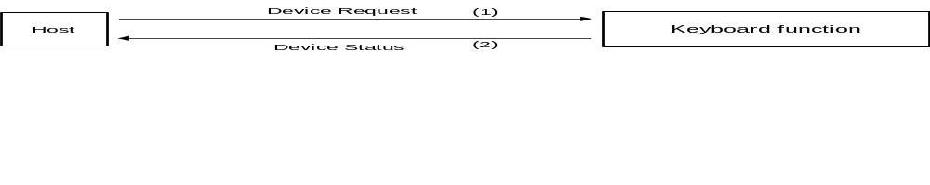
Fig. 5-1 Device Request

5.1.2 All Status Request
Issue privilege :Host
Command code :02h
Data size :00h
Data area :None
Expected return value : [Device All Status]
Description :This command requests the entire device status information (Fixed Device Status and Free Device Status) from the Keyboard function specified as transfer target AP.

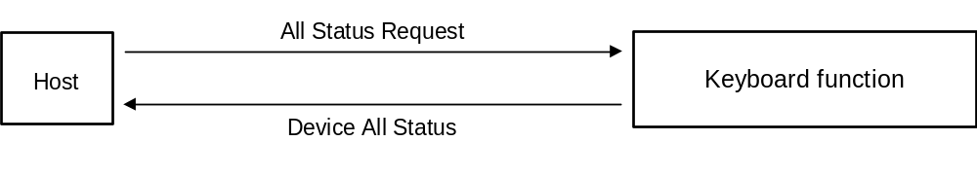
Fig. 5-2 All Status Request

5.1.3 Device Reset
Issue privilege :Host
Command code :03h
Data size :00h
Data area :None
Expected return value : [Device Reply]
Description :This command initializes the Keyboard function specified as transfer target AP.
Operation sequence :(1) Return [Device Reply].
(2) Initialize.

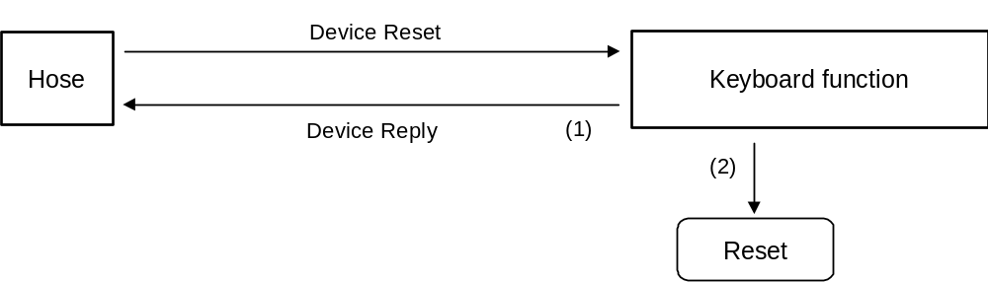
Fig. 5-3 Device Reset

5.1.4 Device Kill
Issue privilege :Host
Command code :04h
Data size :00h
Data area :None
Expected return value : [Device Reply]
Description :This command disables operation of the Keyboard function specified as transfer target AP. The function goes into standby current consumption mode and does not accept any further commands. To reactivate the function, a hardware rest or power off/on cycle is required.
Operation sequence :(1) Return [Device Reply].
(2) Stop operation.

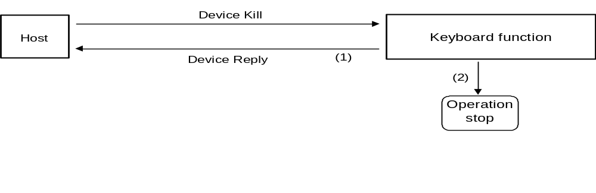
Fig. 5-4 Device Kill

5.1.5 Device Status (Note: In Maple Bus Rev. 0.81 data sizes will be changed.)
Issue privilege :Peripheral device
Command code :05h
Data size :1Ch (28)
Data area :Device ID: 16 bytes
Country code: 1 byte
Product name: 30 bytes
License: 60 bytes
Standby current consumption: 2 bytes
Maximum current consumption: 2 bytes
Description :Returns Fixed Device Status data in response to [Device Request] from host.

5.1.6 Device All Status (Note: In Maple Bus Rev. 0.81 data sizes will be changed.)
Issue privilege :Peripheral device
Command code :06h
Data size :1Ch +(n/4)
Data area :Fixed Device Status: 112 bytes
Device ID: 16 bytes
Country code: 1 byte
Product name: 30 bytes
License: 60 bytes
Standby current consumption: 2 bytes
Maximum current consumption: 2 bytes
Free Device Status: (n x 4) bytes
Description :Returns Fixed Device Status and Free Device Status data in response to [All Status Request] from host.

5.1.7 Device Reply
Issue privilege :Peripheral device
Command code :07h
Data size :00h
Data area :None
Description :Used as reply.

5.1.8 Get Condition
Issue privilege :Host
Command code :09h
Data size :01h
Data area :Function type :4 bytes
Specifies keyboard (00-00-00-40h)
Expected return value :[Data Transfer]
Description :Requests physical status of Keyboard function (button, key, lever status). Used when reading keyboard data.

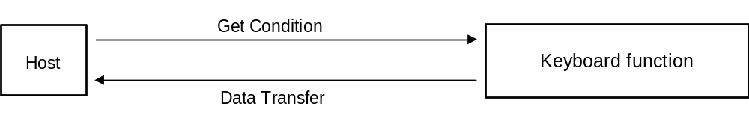
Fig. 5-5 Get Condition

Data Address | Data | Setting example | Setting example description
+0000 | Command code | 09h | Specifies [Get Condition]
+0001 | Transfer target AP | 20h | Specifies port A device
+0002 | Transfer source AP | 00h | Send from port A
+0003 | Data size | 01h | Data size is 4 bytes
+0004 | Function type | 00h | Function type is specified
+0005 |  | 00h | as "keyboard".
+0006 |  | 00h
+0007 |  | 40h

Fig. 5-6 Host [Get Condition] send data (memory image)

5.1.9 Data Transfer
Issue privilege :Keyboard function
Command code :08h
Data size :03h
Data area :Function type :4 bytes
Specifies keyboard (00-00-00-40h)
Read format :8 bytes
Expected return value :None
Description :Used when a [Get Condition] command is received from the host and the keyboard returns read format information.

Fig. 5-7 Data Transfer

Data Address | Data | Setting example | Setting example description
+0000 | Command code | 08h | Specifies [Data Transfer]
+0001 | Transfer target AP | 00h | Specifies port A
+0002 | Transfer source AP | 20h | No expansion device
+0003 | Data size | 03h | Data size is 12 bytes
+0004 | Function type | 00h | Function type is specified
+0005 |  | 00h | as "keyboard".
+0006 |  | 00h
+0007 |  | 40h
+0008 | Read format | 00h
+0009 |  | 00h
+000A |  | 00h
+000B |  | 00h
+000C |  | 00h
+000D |  | 00h
+000E |  | 00h
+000F |  | 00h

Fig. 5-8 Host [Data Transfer] send data (memory image)

5.1.10 Set Condition
Issue privilege :Host
Command code :0Eh
Data size :02h
Data area :Function type :4 bytes
Specifies keyboard (00-00-00-40h)
Write format: :4 bytes
Expected return value :[Device Reply]
Description :Specified according to the physical configuration of the Keyboard function. Controls the ON/OFF status of LEDs on the keyboard.

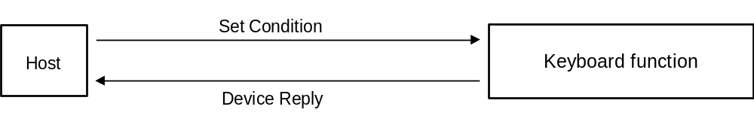
Fig. 5-9 Set Condition

Data Address | Data | Setting example | Setting example description
+0000 | Command code | 0Eh | Specifies [Set Condition]
+0001 | Transfer target AP | 00h | Specifies port A
+0002 | Transfer source AP | 20h | No expansion device
+0003 | Data size | 02h | Data size is 8 bytes
+0004 | Function type | 00h | Function type is specified
+0005 |  | 00h | as "keyboard".
+0006 |  | 00h
+0007 |  | 40h
+0008 | Write format | 00h | LED setting
+0009 |  | 00h
+000A |  | 00h
+000B |  | 00h
Fig. 5-10 Host [Set Condition] send data (memory image)

5.2 Error Commands
The Keyboard function supports the following three error commands.

5.2.1 Function Type Unknown
Issue privilege :Peripheral device
Command code :FEh
Data size :00h
Data area :None
Description :Returned when a function type other than "keyboard" is specified in received data.
Possible causes :(1) Wrong function type specification
(2) Wrong data content
(3) Corrupted Device ID
(4) Communication error has corrupted data

Remedy :(1) Specify correct function type
(2) Specify data correctly
(3) Use [Device Request] once more to obtain Device ID
(4) Resend (up to 3 times, afterwards same processing as for timeout)

5.2.2 Command Unknown
Issue privilege :Peripheral device
Command code :FDh
Data size :00h
Data area :None
Description :Returned when a command not supported by the Keyboard function was received.

Possible causes :(1) Wrong command specification
(2) Wrong data content
(3) Corrupted Device ID
(4) Communication error has corrupted data

Remedy :(1) Specify correct command
(2) Specify data correctly
(3) Use [Device Request] once more to obtain Device ID
(4) Resend (up to 3 times, afterwards same processing as for timeout)

5.2.3 Transmit Again
Issue privilege :Host, peripheral device
Command code :FCh
Data size :00h
Data area :None
Description :Returned when an error was detected in received data and data should be sent once more. However, because the keyboard constantly updates its data, the resent keyboard read data may not be the same as the previously sent data.

Possible causes :(1) Parity error has occurred
(2) Data overflow
(3) Communication error has corrupted data
(4) Other cause

Remedy :Resend (up to 3 times, afterwards same processing as for timeout)

6. Keyboard Function Information
This section describes device-specific information (device status). The device status must be stored in such a way that device status data cannot be changed or erased.

6.1 Type
Fixed Device Status
This refers to 112 bytes of device status information data with a fixed format, comprising required information. Correct connection and operation are only assured if all items are properly recorded.
Free Device Status
This refers to a maximum of 908912 bytes of device-specific status information that can be allocated freely.

6.2 Fixed Device Status
The Fixed Device Status area must include all the items listed below.

(1) Device ID
Size :16 bytes
Description :Specifies the function definition. For details, refer to chapter 3.

(2) Country specification
Size :1 byte
Description :Specifies the destination (marketing) region.

bit | 7 | 6 | 5 | 4 | 3 | 2 | 1 | 0
data | DES₇ | DES₆ | DES₅ | DES₄ | DES₃ | DES₂ | DES₁ | DES₀
Fig. 6-1 Country specification bit

Area | Setting bit
North America | DES₀=‘1’
Japan | DES₁=‘1’
Asia except Japan | DES₂=‘1’
Europe | DES₃=‘1’
Reserved area 1 | DES₄=‘1’
Reserved area 2 | DES₅=‘1’
Reserved area 3 | DES₆=‘1’
Reserved area 4 | DES₇=‘1’
Fig. 6-2 Country specification bit

Worldwide: DES = '11111111' = FFh
The country specification and the keyboard language are not necessarily identical.

(3) Connection method
Size :1 byte
Description :For device:
Indicates orientation of expansion socket for connection of expansion device.
For expansion device:
Indicates orientation of connector for connection to device.

bit | 7 | 6 | 5 | 4 | 3 | 2 | 1 | 0
data | SD4₁ | SD4₀ | SD3₁ | SD3₀ | SD2₁ | SD2₀ | SD1₁ | SD1₀
Fig. 6-3 Connection method bit configuration

- Device
Specifies expansion socket orientation.
Non-installed sockets are indicated by '00'.

Orientation | SDx₁ | SDx₀
Top | 0 | 0
Bottom | 0 | 1
Left | 1 | 0
Right | 1 | 1
Fig. 6-4 Socket orientation setting
X = 1 - 4: socket number

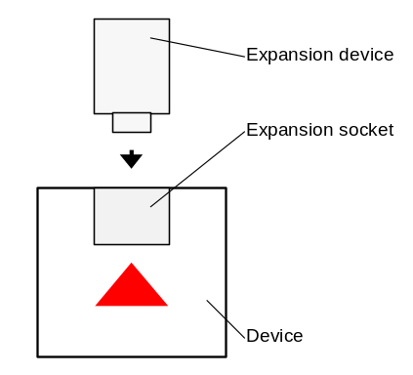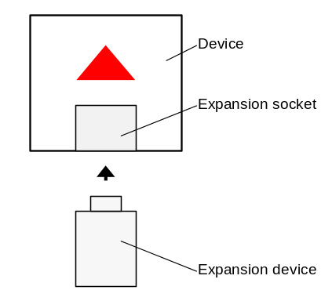
Fig. 6-5 Socket orientation (top) Fig. 6-6 Socket orientation (bottom)

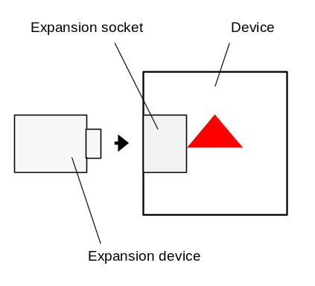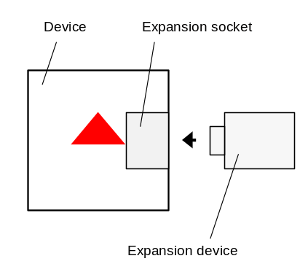
Fig. 6-7 Socket orientation (left) Fig. 6-8 Socket orientation (right)

- Expansion device
Specifies connector orientation.

Bit | 7 | 6 | 5 | 4 | 3 | 2 | 1 | 0
Top facing | 0 | 0 | 0 | 0 | 0 | 0 | 0 | 0
Bottom facing | 0 | 0 | 0 | 0 | 0 | 0 | 1 | 0
Left facing | 0 | 0 | 0 | 0 | 0 | 1 | 0 | 0
Right facing | 0 | 0 | 0 | 0 | 1 | 0 | 0 | 0
Fig. 6-9 Connector orientation setting

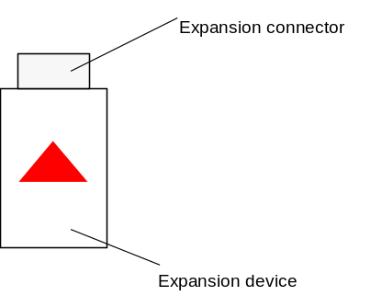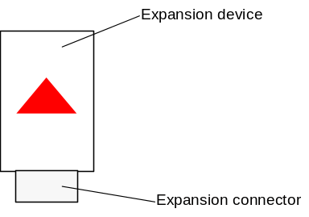
Fig. 6-10 Connector orientation (top) Fig. 6-11 Connector orientation (bottom)

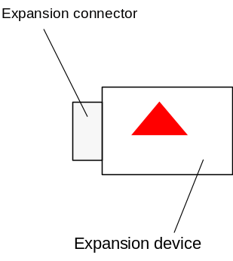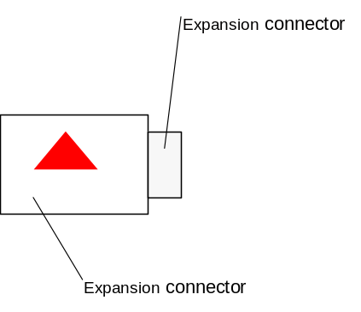

Fig. 6-12 Connector orientation (left) Fig. 6-13 Connector orientation (right)

(4) Model name
Size :30 bytes
Description :ASCII string describing the model
Remaining slots to be padded with spaces (20h).
The product name must be registered in advance.

(5) License
Size :60 bytes
Description :ASCII string. Normally "Produced By or Under License From SEGA ENTERPRISES,LTD."
Remaining slots to be padded with spaces (20h).

(6) Standby current consumption
Size :2 bytes
Description :Indicates the current consumption of the unit in paused condition (During minimum power consumption), in 0.1 mA units (hexadecimal notation). For example, 10.5 mA would be 00- 69h.

(7) Maximum current consumption
Size :2 bytes
Description :Indicates the maximum current consumption of the unit, in 0.1 mA units (hexadecimal notation). For example, 127.9 mA would be 04-FFh.

6.3 Free Device Status
The Free Device Status area can include information about developers, designers, and programmers or any other information. The host can obtain this information by issuing the "All Device Request" command. If it is to be used by an application, the data ordering sequence must be taken into consideration.

Unless there are special reasons for not doing so, the following 40 bytes of information should first be entered.

Versions (ROM, logic, etc.) :13 bytes E.g., “Version 1.000”
Recommended: The version orthography as shown in the example, three digits following the decimal point, and the first release is 1.000.
Release date :10 bytes E.g., “1998/05/11”
Recommended: Year in four digits, month in two digits, and day in two digits.
IC parts number :14 bytes E.g., “315-6125-AB ”
Recommended: Enter space (20h) in the empty area.
Each item should be separated by “,”.
Example: “Version 1.000,1998/05/11,315-6125-AB ,”

7. Usable Characters
The characters that can be used for Fixed Device Status and Device Status are described here.

The characters indicated in the following ASCII code diagram can be used.
Use of the items marked (P.) (= Prohibited) in the diagram is prohibited becomes the control code and characters differ depending on the country.
Use of characters beyond '80h' of the ASCII code is also prohibited.

Character code |  | Lower 4 bits
 |  | 0h | 1h | 2h | 3h | 4h | 5h | 6h | 7h | 8h | 9h | Ah | Bh | Ch | Dh | Eh | Fh
Up-per  4 bits | 0h | (P.) | (P.) | (P.) | (P.) | (P.) | (P.) | (P.) | (P.) | (P.) | (P.) | (P.) | (P.) | (P.) | (P.) | (P.) | (P.)
Up-per  4 bits | 1h | (P.) | (P.) | (P.) | (P.) | (P.) | (P.) | (P.) | (P.) | (P.) | (P.) | (P.) | (P.) | (P.) | (P.) | (P.) | (P.)
Up-per  4 bits | 2h | Space | ! | " | (P.) | (P.) | % | & | ' | ( | ) | * | + | , | - | . | /
Up-per  4 bits | 3h | 0 | 1 | 2 | 3 | 4 | 5 | 6 | 7 | 8 | 9 | : | ; | < | = | > | ?
Up-per  4 bits | 4h | (P.) | A | B | C | D | E | F | G | H | I | J | K | L | M | N | O
Up-per  4 bits | 5h | P | Q | R | S | T | U | V | W | X | Y | Z | (P.) | (P.) | (P.) | (P.) | _
Up-per  4 bits | 6h | (P.) | A | b | c | d | e | f | g | h | i | j | k | l | m | n | o
Up-per  4 bits | 7h | p | Q | r | s | t | u | v | w | x | Y | z | (P.) | (P.) | (P.) | (P.) | (P.)
Fig. 7-1 ASCII code table

Example: A is '41h' and g is '67h'.

8. Remarks
Contents subject to major or minor changes until release of final (distribution) version (Rev. 1.0).

