"Maple Bus 1.0"
Function Type Specifications
FT₇：Light-Gun Function
Revision 0.85

Produced by:
CS Hardware DIV. 2
SEGA Enterprises Ltd.

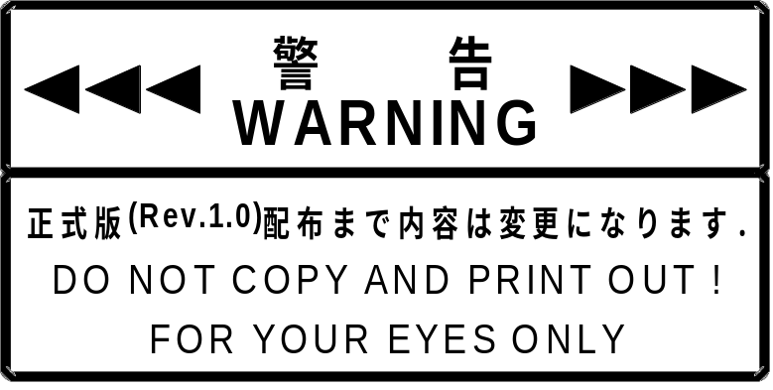
Revision:
8/8-'98 0.50 Preliminary Specifications
8/14-'98 0.70 Added 6.PROTOCOL FLOW
8/21-'98 0.75 Supports only SDCKB exclusive mode. Button data is obtained with the controller function.
8/28-'98 0.80 Added 1.2 Characteristics and limitations of the Light-Gun function.
10/19'-98 0.85 Changed various expressions.
CONTENTS:
1 LIGHT-GUN FUNCTION CONDITIONS 1
1.1 Definition of Light-Gun function 1
1.2 Characteristics and limitations of the Light-Gun function 1
1.3 Default configuration for the Light-Gun function 1
2 LIGHT-GUN FUNCTION OPERATION 2
2.1 Operation as a device 2
2.2 Operation as a Light-Gun 3
3 DEVICE ID 4
3.1 Configuration of the device ID 4
3.2 Function types 5
3.3 Function definition block 5
4 DATA FORMAT 6
5 SUPPORT COMMANDS 7
5.1 Control commands 7
5.2 Error commands 11
6 PROTOCOL FLOW 13
6.1 Confirming connections in the initial state 13
6.2 SDCKB exclusive mode 14
7 LIGHT-GUN FUNCTION INFORMATION 15
7.1 Types 15
7.2 Fixed Device Status 15
7.3 Free Device Status 16
8 AFTERWORD 17

LIGHT-GUN FUNCTION CONDITIONS

Definition of Light-Gun function

The Light-Gun function detects the light from a scan line with the light sensor element and uses this signal to latch the Dreamcast HV counter, thus specifying the gun point position. The Light-Gun function must satisfy the following conditions.

① The Light-Gun function must be equipped with an internal light sensor element, and must be able to latch the Dreamcast HV counter with the light sensor element's signal.
② The Light-Gun function must be able to switch from the Maple-Bus signal mode to the SDCKB exclusive mode, in order to reduce the time delay from light detection until the HV counter is latched.
③ The Light-Gun function must conform to the "Maple Bus 1.0" Standard Specifications

Characteristics and limitations of the Light-Gun function

The Light-Gun function has the following characteristics and limitations.

① The host must produce a white flash of up to 75% brightness (RGB value of 0Ch or less) on the monitor screen when the trigger is pulled in order for the light detection element to generate the signal which enables it to latch on to the HV counter. (Data for the trigger and other buttons is obtained by accessing the controller function.)
② Normally, access to other functions can take 1V-INT (16msec), but when using SDCKB exclusive mode, about 14msec of the display interval is used as the light sensor element's light reception time. Thus it becomes necessary to access other functions in the remaining time of about 2msec. Accordingly, peripherals which handle large volumes of data such as Visual Memory and Mike Device (preliminary names) can only be used in game scenes where SDCKB exclusive mode is not used.
③ Resolution depends on the monitor mode being used.

Default configuration for the Light-Gun function

The default configuration for the Light-Gun function are as follows.

･ Problems such as a lack of precision in attaching the light sensor or the lens at the front of the Light-Gun may result in missing the place the Light-Gun is aimed at. (Alignment adjustment is necessary according to the application being used.)

LIGHT-GUN FUNCTION OPERATION

This section explains operation as a Light-Gun function device and operation as a Light-Gun.
The Light-Gun should be produced in accordance with the operation of these functions.

Operation as a device

① Initialization
Initializes the registers and the RAM, etc, to be used.
Resets the MIE and clears all flags and TRBF.
MIE is set to the receive condition.
The LM-Bus is completely disconnected and configured so that data does not flow to expansion devices.
The ID0, ID1 of the LM-Bus are set to the reverse of the Bus No. setting values.

② LM-Bus control
The LM-Bus is left as it is until the Light-Gun function receives a [Device Request].
When the Light-Gun function receives the first [Device Request] after initialization, it reverses the ID0, ID1 of the LM-Bus and returns them to the specified values. At the same time, it also requests the expansion devices to reset.
The Light-Gun function checks the ID2 of each LM-Bus. If it detects a '1', the expansion device is connected, and the function connects that LM-Bus to the Maple-Bus.
It reads the current status of the connected LM-Bus and reflects this to the origin AP for [Device Status], which is the reply to [Device Request].
If, when the ID2 of each LM-Bus is checked, a '0' is detected, the expansion device is not physically connected, and that LM-Bus is disconnected from the Maple-Bus. This ID2 check is conducted every time a command is received from the host.

③ Down Stream Time Out
The device is constantly detecting the Maple-Bus' Down Stream Time Out (except during [Device Kill]). In case of Time Out, the following processing starts.

Table 2-1 Time Out processing sequence
Processing order | Device | Expansion device
1 | Resets. | Normal operation
2 | During resetting, ID0 and ID1 may possible become undefined.  (Time is 300us or less (preliminary)) | Normal operation  ID0 and ID1 are not reversed, so Reset is not performed.
3 | ID0 and ID1 are reversed in relation to their condition before Reset.  (Initialization) | ID0 and ID1 are reversed, so Reset is performed. (LM-Bus Reset)
4 | [Device Request] is carried. | Reset (Initialization)
5 | Normal operation | [Device Request] is carried.
6 | Normal operation | Normal operation
④ Up Stream Time Out
If an abnormal condition occurs in the MIE or the Maple-Bus when sending from a device to the host (Up Stream), they may not be able to get out of the transmission condition. In this case, the host will detect a Time Out and perform a hard reset. However, because the device is transmitting, it will not receive the reset pattern.
Therefore, based on the size of the transmission, the expected time of transmission completion is calculated by the device which sent the data, and if the transmission condition continues for longer than that time, it resets the MIE (Time Out processing).

Operation as a Light-Gun

･ SDCKB exclusive mode support
If the SDCKB exclusive enable pattern is received from the host, the Maple-Bus Serial Data Clock B (SDCKB)is monopolized between the falling and the rising edges of Serial Data Clock A (SDCKA).
During this interval, a signal is generated by the light sensor element, and is latched on to the Host's HV counter.
Time Out is not detected during SDCKB exclusive mode.

DEVICE ID

The device ID is defined based on the Maple-Bus specifications and consists of the function type, the 1st function definition block, 2nd function definition block, and 3rd function definition block.

Configuration of the device ID

The device ID consists of 16 bytes (128 bits). The configuration is as shown in Table 3.1.

Table 3-2 Configuration of the device ID
bit | 7 | 6 | 5 | 4 | 3 | 2 | 1 | 0
1st Data | FT₃₁ | FT₃₀ | FT₂₉ | FT₂₈ | FT₂₇ | FT₂₆ | FT₂₅ | FT₂₄
2nd Data | FT₂₃ | FT₂₂ | FT₂₁ | FT₂₀ | FT₁₉ | FT₁₈ | FT₁₇ | FT₁₆
3rd Data | FT₁₅ | FT₁₄ | FT₁₃ | FT₁₂ | FT₁₁ | FT₁₀ | FT₉ | FT₈
4th Data | FT₇ | FT₆ | FT₅ | FT₄ | FT₃ | FT₂ | FT₁ | FT₀
5th Data | FD1₃₁ | FD1₃₀ | FD1₂₉ | FD1₂₈ | FD1₂₇ | FD1₂₆ | FD1₂₅ | FD1₂₄
6th Data | FD1₂₃ | FD1₂₂ | FD1₂₁ | FD1₂₀ | FD1₁₉ | FD1₁₈ | FD1₁₇ | FD1₁₆
7th Data | FD1₁₅ | FD1₁₄ | FD1₁₃ | FD1₁₂ | FD1₁₁ | FD1₁₀ | FD1₉ | FD1₈
8th Data | FD1₇ | FD1₆ | FD1₅ | FD1₄ | FD1₃ | FD1₂ | FD1₁ | FD1₀
9th Data | FD2₃₁ | FD2₃₀ | FD2₂₉ | FD2₂₈ | FD2₂₇ | FD2₂₆ | FD2₂₅ | FD2₂₄
10th Data | FD2₂₃ | FD2₂₂ | FD2₂₁ | FD2₂₀ | FD2₁₉ | FD2₁₈ | FD2₁₇ | FD2₁₆
11th Data | FD2₁₅ | FD2₁₄ | FD2₁₃ | FD2₁₂ | FD2₁₁ | FD2₁₀ | FD2₉ | FD2₈
12th Data | FD2₇ | FD2₆ | FD2₅ | FD2₄ | FD2₃ | FD2₂ | FD2₁ | FD2₀
13th Data | FD3₃₁ | FD3₃₀ | FD3₂₉ | FD3₂₈ | FD3₂₇ | FD3₂₆ | FD3₂₅ | FD3₂₄
14h Data | FD3₂₃ | FD3₂₂ | FD3₂₁ | FD3₂₀ | FD3₁₉ | FD3₁₈ | FD3₁₇ | FD3₁₆
15th Data | FD3₁₅ | FD3₁₄ | FD3₁₃ | FD3₁₂ | FD3₁₁ | FD3₁₀ | FD3₉ | FD3₈
16th Data | FD3₇ | FD3₆ | FD3₅ | FD3₄ | FD3₃ | FD3₂ | FD3₁ | FD3₀

FT : Function type the peripheral is equipped with.
FD1 : 1st function definition block.
FD2 : 2nd function definition block.
FD3 : 3rd function definition block.

① FT₃₁～FT₀: Function type
Defines the type of function the peripheral is equipped with.
There are 32 function types altogether.

② FD₃₁～FD₀: Function definition block
These blocks define the individual elements constituting the function.
(1 peripheral can be equipped with 3 different functions)

Function types

The function types (FT) within the device ID are as follows.
For the Light-Gun function, FT₇="1".

Table 3-2 Light-Gun function type
bit | 7 | 6 | 5 | 4 | 3 | 2 | 1 | 0
1st Data | FT₃₁ | FT₃₀ | FT₂₉ | FT₂₈ | FT₂₇ | FT₂₆ | FT₂₅ | FT₂₄
2nd Data | FT₂₃ | FT₂₂ | FT₂₁ | FT₂₀ | FT₁₉ | FT₁₈ | FT₁₇ | FT₁₆
3rd Data | FT₁₅ | FT₁₄ | FT₁₃ | FT₁₂ | FT₁₁ | FT₁₀ | FT₉ | FT₈
4th Data | 1 | FT₆ | FT₅ | FT₄ | FT₃ | FT₂ | FT₁ | FT₀

Function definition block

Because the Light-Gun function only supports SDCKB exclusive mode, function definition does not take place within the function definition block. Therefore, as Table 3-3 shows, the configuration is all '0's.

Table 3-3 Light-Gun function definition block (Light-Gun function)
bit | 7 | 6 | 5 | 4 | 3 | 2 | 1 | 0
1st Data | 0 | 0 | 0 | 0 | 0 | 0 | 0 | 0
2nd Data | 0 | 0 | 0 | 0 | 0 | 0 | 0 | 0
3rd Data | 0 | 0 | 0 | 0 | 0 | 0 | 0 | 0
4th Data | 0 | 0 | 0 | 0 | 0 | 0 | 0 | 0

'0' indicates fixed 0.

DATA FORMAT

The Light-Gun function has no data format.
The Dreamcast Gun is equipped with a cross key and buttons, but when button data is requested, the command is issued to the controller function (FT₀).
Refer to "Maple-Bus 1.0" Peripheral Hardware Specifications AFLAC for details.

SUPPORT COMMANDS

This chapter describes the commands specified in the "Maple Bus 1.0" Standard Specifications which are supported by the Light-Gun function.
If commands other than the following are sent, the Light-Gun function will return an error.
The concrete operations of Light-Gun function for each command are also described.

Control commands

Device Request
Issuing right : Host
Command code : 01h
Data size : 00h
Data field : none
Expected return value : [Device Status]
Description : This command requests [Device Status] from the device connected to the destination AP. It is also used to check port connection. After initialization of the function, the device does not respond to other commands until this command is sent. The LM-Bus is also disconnected from the expansion device so that the expansion device operation is stopped.
Order of operation : (1) Receives command.
(2) Checks connection of each expansion device
(3) If connected, connects to corresponding LM-Bus
(4) Based on this result, the AP of originating device is created and returned to the host.

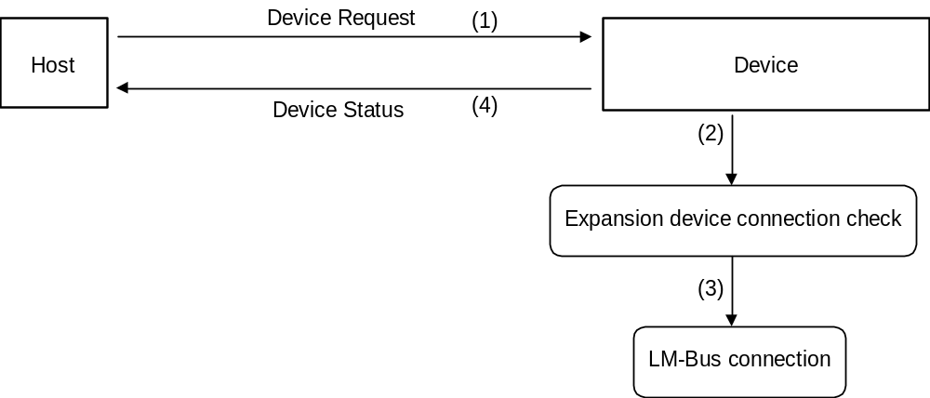
Fig. 5-1 Device Request
All Status Request
Issuing right : Host
Command code : 02h
Data size : 00h
Data field : none
Expected return value : [Device All Status]
Description : This command requests all device statuses (both Fixed Device Status and Free Device Status) from the device connected to the destination AP.

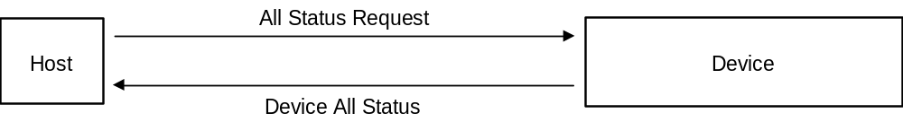
Fig. 5-2 All Status Request

Device Reset
Issuing right : Host
Command code : 03h
Data size : 00h
Data field : none
Expected return value : [Device Reply]
Description : This command enables the device specified by the destination AP to be initialized.
Order of operation : (1) [Device Reply] returned.
(2) Initialization.

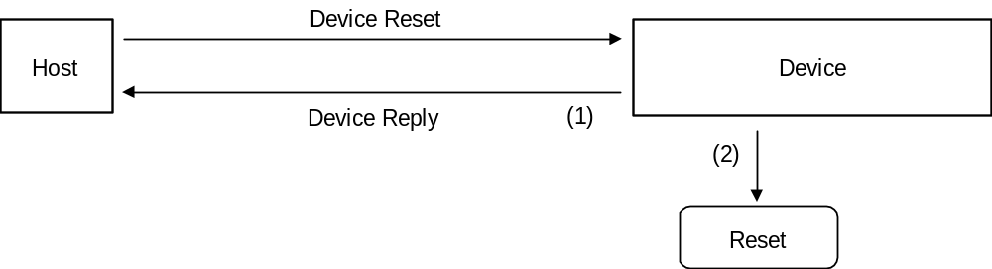
Fig. 5-3 Device Reset
Device Kill
Issuing right : Host
Command code : 04h
Data size : 00h
Data field : none
Expected return value : [Device Reply]
Description : Operation by the peripheral specified by the destination AP is not recognized. The function stands by in standby power consumption mode, and no commands can be received.
To start operation, a hard reset must be performed, or the power should be turned off and operation then started again.
When the Light-Gun function (the device) receives the Device Kill command, the ID0 and ID1 of the LM-Bus are reversed, the expansion device is reset, and the LM-Bus disconnected.
Order of operation : (1) LM-Bus reset and disconnected from the Maple-Bus
(2) [Device Reply] returned.
(3) Operation terminated.

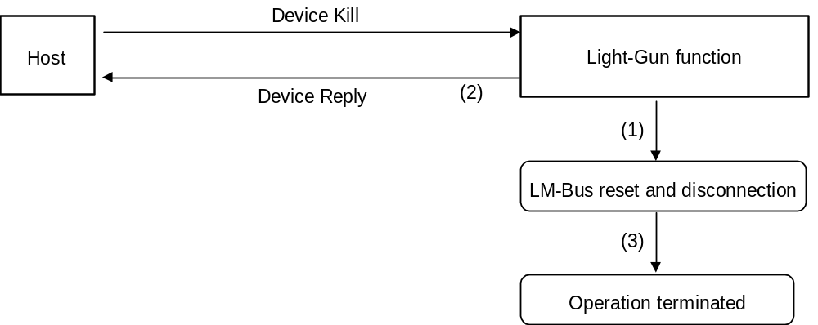
Fig. 5-4 Device Kill

Device Status
Issuing right : Light-Gun function
Command code : 05h
Data size : 1Ch (28)
Data field : Device ID : 16 bytes
Destination code : 1 byte
Connection direction : 1 byte
Product name : 30 bytes
License : 60 bytes
Standby current consumption : 2 bytes
Maximum current consumption : 2 bytes
Description : This command returns Fixed Device Status data in response to [Device Request] from the host.
Device All Status
Issuing right : Light-Gun function
Command code : 06h
Data size : 1Ch + (n/4)
Data field : Fixed Device Status : 112 bytes
Device ID : 16 bytes
Destination code : 1 byte
Connection direction : 1 byte
Product name : 30 bytes
License : 60 bytes
Standby current consumption : 2 bytes
Maximum current consumption : 2 bytes
Free Device Status : n bytes

Device Reply
Issuing right : Light-Gun function
Command code : 07h
Data size : 00h
Data field : none
Description : Used as a response.

Error commands

The error command types supported by the Light-Gun function number only 4.

Transmit Again
Issuing right : Host, Light-Gun function
Command code : FCh
Data size : 00h
Data field : none
Description : This command is used to request that data be transmitted again when the data contained some kind of error. However, the data from the Light-Gun is constantly updated. Therefore, there is no guarantee that the contents of the Light-Gun read data will be returned in the case of an error.
Possible causes : (1) Parity error was generated.
(2) Data overflowed.
(3) Data became jumbled during communication.
(4) Others
Remedies : Send again (maximum of 3 times; subsequent attempts are processed as Time out).

Command Unknown
Issuing right : Light-Gun function
Command code : FDh
Data size : 00h
Data field : none
Description : This command is returned when the Light-Gun function does not support the command sent.
Possible causes : (1) Mistaken specification of command.
(2) Data is written incorrectly.
(3) Data of device ID is jumbled.
(4) Data became jumbled during communication.
Remedies : (1) Specify command correctly.
(2) Write data correctly.
(3) Resend Device Request to obtain device ID.
(4) Send again (maximum of 3 times; subsequent attempts are processed as Time out).
Function Type Unknown
Issuing right : Peripheral
Command code : FEh
Data size : 00h
Data field : none
Description : This command is returned when a function type other than the Light-Gun function is sent.
Possible causes : (1) Mistaken specification of function type.
(2) Data is written incorrectly.
(3) Data of device ID is jumbled.
(4) Data became jumbled during communication.
Remedies : (1) Specify function type correctly.
(2) Write data correctly.
(3) Resend Device Request to obtain device ID.
(4) Send again (maximum of 3 times; subsequent attempts are processed as Time out).

PROTOCOL FLOW

This chapter explains the basic transmission protocols used for the host and the Light-Gun function.

Confirming connections in the initial state

The initial state resulting from power being supplied, hot connect-disconnect, or Device Kill, accepts only Device Request.

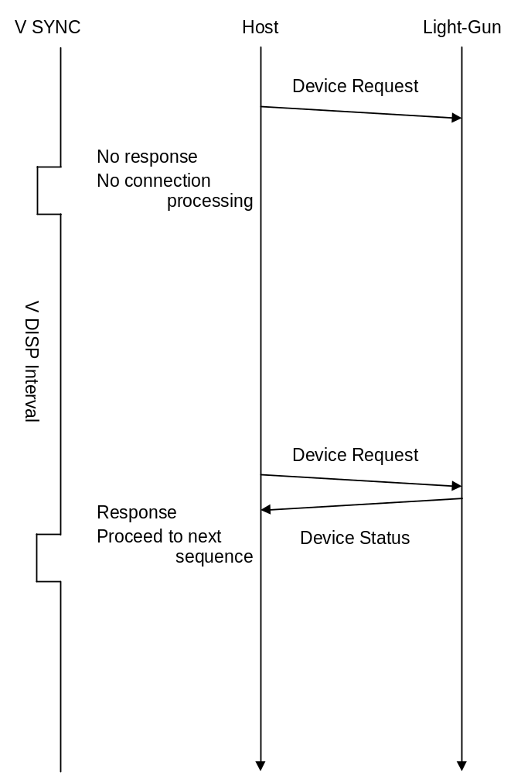
Fig. 6-5 Default configuration connection check

SDCKB exclusive mode

This section describes the order of monopolizing the SDCKB. The SDCKB is only monopolized when On is detected from the trigger.

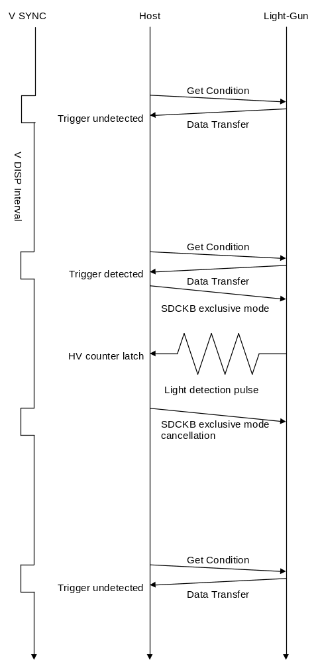
Fig. 6-6 SDCKB monopolization order

LIGHT-GUN FUNCTION INFORMATION

This chapter explains device-specific information (device statuses).
Data is recorded as is in order to prevent device statuses from being rewritten or erased.
The details of the Fixed Device Status are pending.

Types

Fixed Device Status
This is a set form of device status that must be designated. It consists of a 112 byte format.
Operation and connection cannot be guaranteed unless all items are designated.

Free Device Status
This device status can be freely used by the individual devices.
The volume is a maximum of 908 bytes.

Fixed Device Status

The Fixed Device Status must designate all of the following items.

① Device ID
Capacity : 16 bytes
Description : This indicates the device ID of the Light-Gun function.
This also indicates any functions apart from the Light-Gun function, should there be any.

② Destination
Capacity : 16 bytes
Description : This indicates the product destination (sales region).

Table 7-3 Configuration of setting bits for destination
bit | 7 | 6 | 5 | 4 | 3 | 2 | 1 | 0
data | DES₇ | DES₆ | DES₅ | DES₄ | DES₃ | DES₂ | DES₁ | DES₀

Table 7-4 Setting bits for destination
Destination | Setting bit
North American region | DES₀=‘1’
Japan region | DES₁=‘1’
Asia region | DES₂=‘1’
European region | DES₃=‘1’
Reserved region 1 | DES₄=‘1’
Reserved region 2 | DES₅=‘1’
Reserved region 3 | DES₆=‘1’
Reserved region 4 | DES₇=‘1’
③ Connection direction
Capacity : 1 byte
Description : This information differs for devices and expansion devices.
Devices: This information indicates the direction of the expansion socket for expansion devices.
For a detailed description, refer to the "Maple Bus 1.0" Standard Specifications.

④ Product name
Capacity : 30 bytes
Description : This designates the product name in English or romaji.
One byte characters are used.
A space code (20h)is inserted for unused space.

⑤ License
Capacity : 60 bytes
Description : This designates the product license.
"Produced By or Under License From SEGA ENTERPRISES,LTD" is designated.
A space code (20h)is inserted for unused space.

⑥ Standby current consumption
Capacity : 2 bytes
Description : The current consumption for temporary stop condition is designated in hexadecimal notation in units of 0.1mA.
For example, 10.5mA is written as 00-69h.

⑦ Maximum current consumption
Capacity : 2 bytes
Description : The maximum current consumption is designated in hexadecimal notation in units of 0.1mA.
For example, 127.9mA is written as 04-FFh.

Free Device Status

The Free Device Status area is available for product planners, developers, designers and programmers to enter any information they wish. The host obtains this status by the All Device Request.
When using this area for application software, it must support data parallelism.
For a detailed description, refer to the "Maple Bus 1.0" Standard Specifications.

AFTERWORD

Until the official version (Rev. 1.0) is distributed, contents will be modified to a small or large extent.

