"Maple Bus 1.0"
Function Type Specifications
FT₈:Vibration Function
Revision 0.80

Produced by:
CS Hardware DIV. 2
SEGA Enterprises Ltd.

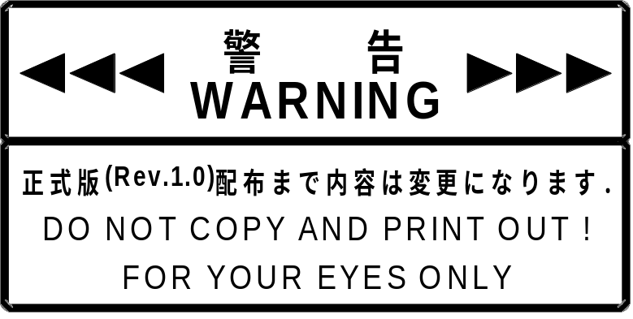
Revision:
1998/09/03 0.51 Preview Version
1998/09/16 0.60 Preview Version 2
1998/09/23 0.70 First distribution
1998/10/05 0.80 Added conditions for Convergent and divergent setting function
Added conditions for vibration auto-stop function
Added conditions for normal configuration for vibration settings
Added settings for arbitrary waveform vibration settings
Added other revisions

* For items affected by the latest revisions and previous revisions, added items are set off by , and deleted items are set off by .
CONTENTS:
1 OVERVIEW OF VIBRATION FUNCTIONS 5
1.1 Definition of vibration functions 5
1.2 Characteristics and limitations of vibration functions 5
1.3 Default configuration for vibration functions 5
2 DEVICE ID 6
2.1 Configuration of the device ID 6
2.2 Function types 7
2.3 Function definition blocks 7
3 VIBRATION SOURCE SETTINGS INFORMATION 8
4 VIBRATION SPECIFICATIONS 12
4.1 Vibration position 12
4.2 Vibration axes 13
4.3 Continuous vibration 13
4.4 Vibration waveforms 14
4.4.1 Normal configuration 14
4.4.2 When arbitrary vibration frequency waveforms may be specified 15
4.5 Convergent and divergent setting function 16
4.6 Vibration auto-stop function 17
5 VIBRATION SETTINGS 18
5.1 Normal configuration 18
5.2 Arbitrary waveform settings 22
5.3 Vibration auto-stop settings 25
6 COMMANDS 27
6.1 Control commands 27
6.1.1 Get Media Info 27
6.1.2 Set Condition 29
6.1.3 Get Condition 30
6.1.4 Block_Write 32
6.1.5 Block_Read 34
6.1.6 Data Transfer 37
6.1.7 Device Reply 37
6.1.8 Device Request 38
6.1.9 All Status Request 38
6.1.10 Device Reset 39
6.1.11 Device Kill 39
6.1.12 Device Status 40
6.1.13 Device All Status 41
6.2 Error commands 42
6.2.1 Function Type Unknown 42
6.2.2 Command Unknown 42
6.2.3 Transmit Again 43
7 PROTOCOL FLOW 44
7.1 Processing flow for Get Media Info 44
7.2 Processing flow for vibration settings 45
7.3 Processing flow for arbitrary waveform settings 46
7.4 Processing flow for vibration auto-stop time settings 47
7.5 Processing flow for reading normal configuration 48
7.6 Processing flow for reading arbitray waveform settings and vibration auto-stop time settings 49
8 Afterword 50

OVERVIEW OF VIBRATION FUNCTIONS

Definition of vibration functions

Vibration functions are functions able to vibrate and rock, and generate vibrations within objects installed in a device.
Vibration functions must satisfy the following conditions.

① Vibration functions must be able to generate vibration. There are no other restrictions on external view.
② They must conform to the "Maple Bus 1.0" Standard Specifications.

Characteristics and limitations of vibration functions

Vibration functions have the following characteristics and limitations.

①Vibration intensity can be specified as fixed or adjustable to 8 levels.
② Vibration frequency settings may be fixed, non-settable, or a linear variable with a specified maximum and minimum.
③Vibration sources can be allocated to 4 positions: front, back, left and right.
④ Vibration direction may be specified as X axis direction, Y axis direction, Z axis direction, and No direction. Also, + directions and - directions may be specified for each of these.
⑤ The maximum number of vibration sources is 15.
⑥ Vibration functions allow configuration of continuous vibration, single-pulse vibration, convergent vibration, and divergent vibration.
⑦ If no re-configuration is performed within a fixed time after a vibration is specified, vibration will stop automatically. Automatic stop can be specified for each vibration source.

Default configuration for vibration functions

The default settings for vibration functions are as follows.

① Vibration is stopped.
② Vibration auto-stop time is specified to 5.0 seconds.

DEVICE ID

Conforms with the device ID definition in the "Maple Bus 1.0" Standard Specifications.
The notation is that of the host's memory image.

Configuration of the device ID

The device ID is defined in "Maple Bus 1.0" as the following configuration.

bit | 7 | 6 | 5 | 4 | 3 | 2 | 1 | 0
1st Data | FT₃₁ | FT₃₀ | FT₂₉ | FT₂₈ | FT₂₇ | FT₂₆ | FT₂₅ | FT₂₄
2nd Data | FT₂₃ | FT₂₂ | FT₂₁ | FT₂₀ | FT₁₉ | FT₁₈ | FT₁₇ | FT₁₆
3rd Data | FT₁₅ | FT₁₄ | FT₁₃ | FT₁₂ | FT₁₁ | FT₁₀ | FT₉ | FT₈
4th Data | FT₇ | FT₆ | FT₅ | FT₄ | FT₃ | FT₂ | FT₁ | FT₀
5th Data | FD1₃₁ | FD1₃₀ | FD1₂₉ | FD1₂₈ | FD1₂₇ | FD1₂₆ | FD1₂₅ | FD1₂₄
6th Data | FD1₂₃ | FD1₂₂ | FD1₂₁ | FD1₂₀ | FD1₁₉ | FD1₁₈ | FD1₁₇ | FD1₁₆
7th Data | FD1₁₅ | FD1₁₄ | FD1₁₃ | FD1₁₂ | FD1₁₁ | FD1₁₀ | FD1₉ | FD1₈
8th Data | FD1₇ | FD1₆ | FD1₅ | FD1₄ | FD1₃ | FD1₂ | FD1₁ | FD1₀
9th Data | FD2₃₁ | FD2₃₀ | FD2₂₉ | FD2₂₈ | FD2₂₇ | FD2₂₆ | FD2₂₅ | FD2₂₄
10th Data | FD2₂₃ | FD2₂₂ | FD2₂₁ | FD2₂₀ | FD2₁₉ | FD2₁₈ | FD2₁₇ | FD2₁₆
11th Data | FD2₁₅ | FD2₁₄ | FD2₁₃ | FD2₁₂ | FD2₁₁ | FD2₁₀ | FD2₉ | FD2₈
12th Data | FD2₇ | FD2₆ | FD2₅ | FD2₄ | FD2₃ | FD2₂ | FD2₁ | FD2₀
13th Data | FD3₃₁ | FD3₃₀ | FD3₂₉ | FD3₂₈ | FD3₂₇ | FD3₂₆ | FD3₂₅ | FD3₂₄
14th Data | FD3₂₃ | FD3₂₂ | FD3₂₁ | FD3₂₀ | FD3₁₉ | FD3₁₈ | FD3₁₇ | FD3₁₆
15th Data | FD3₁₅ | FD3₁₄ | FD3₁₃ | FD3₁₂ | FD3₁₁ | FD3₁₀ | FD3₉ | FD3₈
16th Data | FD3₇ | FD3₆ | FD3₅ | FD3₄ | FD3₃ | FD3₂ | FD3₁ | FD3₀
Fig. 2.1 Device ID

FT : Designates type of function that the peripheral is equipped with.
FD1 : First function definition block.
FD2 : Second function definition block.
FD3 : Third function definition block.

① FT₃₁～FT₀: Function type
Designates the function that the peripheral is equipped with.
There are 32 function types altogether.

② FD₃₁～FD₀: Function definition block
This is for the block defining the individual elements making up the function.
(1 peripheral can be equipped with 3 different functions)

Function types

The function types (FT) within the device ID are as follows.
Function types for vibration functions are defined by FT₈ = '1'.

bit | 7 | 6 | 5 | 4 | 3 | 2 | 1 | 0
1st Data | FT₃₁ | FT₃₀ | FT₂₉ | FT₂₈ | FT₂₇ | FT₂₆ | FT₂₅ | FT₂₄
2nd Data | FT₂₃ | FT₂₂ | FT₂₁ | FT₂₀ | FT₁₉ | FT₁₈ | FT₁₇ | FT₁₆
3rd Data | FT₁₅ | FT₁₄ | FT₁₃ | FT₁₂ | FT₁₁ | FT₁₀ | FT₉ | 1
4th Data | FT₇ | FT₆ | FT₅ | FT₄ | FT₃ | FT₂ | FT₁ | FT₀
Fig. 2.2 Function types for vibration functions

For example, in peripherals equipped with only vibration functions, function types are defined by FT='00-00-01-00h'.
Also, in peripherals equipped with other functions, the bit for function types corresponding to the installed functions is '1'.

Function definition blocks

Indicates the function definition block (FD) within the device.
Function definition blocks are function-specific 32 bit data tables for each function. Each function's constituent elements, data transfer method, etc, are determined based on this data.

The following figure shows the configuration for the function definition blocks for vibration functions.

bit | 7 | 6 | 5 | 4 | 3 | 2 | 1 | 0
1st Data | VN₇ | VN₆ | VN₅ | VN₄ | VN₃ | VN₂ | VN₁ | VN₀
2nd Data | SE₇ | SE₆ | SE₅ | SE₄ | SE₃ | SE₂ | SE₁ | SE₀
3rd Data | Res₁₅ | Res₁₄ | Res₁₃ | Res₁₂ | Res₁₁ | Res₁₀ | Res₉ | Res₈
4th Data | Res₇ | Res₆ | Res₅ | Res₄ | Res₃ | Res₂ | Res₁ | Res₀
Fig. 2.3 Vibration function definition block configuration

VN : Vibration source number
Indicates the number of vibration sources
The 4 upper bits are fixed at '0', and the number of vibration sources is represented by the 4 lower bits.
The number of vibration sources is 1～15 ('1h'～'Fh'). '0' setting is not permitted.

SE : Number of vibration sources that can be concurrently selected.
Indicates the number of vibration sources which can be concurrently specified to generate vibration.
The 4 upper bits are fixed at '0', and the number of vibration sources is represented by the 4 lower bits.
The number of vibration sources is 1～15 ('1h'～'Fh').
'0' setting is not permitted. The settings must conform to SE≦VN.

Res : Reserved bits
Used as '0'.

VIBRATION SOURCE SETTINGS INFORMATION

Indicates the settings information for each vibration source. This information is obtained with Get Media Info command.
The settings information for each vibration source uses 4 bytes.

bit | 7 | 6 | 5 | 4 | 3 | 2 | 1 | 0
VSet0 | VN₃ | VN₂ | VN₁ | VN₀ | VP₁ | VP₀ | VD₁ | VD₀
VSet1 | PF | CV | PD | OWF | VA₃ | VA₂ | VA₁ | VA₀
Fm0 | to be added
Fm1
Fig. 3.4 Configuration of Vibration source settings information

VN : Vibration source No.
Indicates the number of vibration sources.
The number of vibration sources is 1～15 ('1h'～'Fh').
'0h' is not permitted.

VP : Vibration source position
Indicates the position where the vibration source is installed.

Position | VP₁ | VP₀
Front | 0 | 0
Back | 0 | 1
Left | 1 | 0
Right | 1 | 1
Fig. 3.5 Bit configuration for vibration source position

VD : Vibration source vibration axis.
Indicates the axis (direction) the vibration source vibrates along.

Vibration axis | VD₁ | VD₀
none | 0 | 0
X axis direction | 0 | 1
Y axis direction | 1 | 0
Z axis direction | 1 | 1
Fig. 3.6 Bit configuration for vibration source vibration direction

PF : Setting of variable vibration intensity
Indicates if the intensity of the vibration source is variable.

Setting of variable vibration intensity | PF
fixed | 0
variable to 8 levels | 1
Fig. 3.7 Bit configuration for variable vibration intensity setting
CV : Vibration source continuous vibration flag
Indicates if a specified vibration can continue until the next setting command.

Continuous setting | CV
Not possible | 0
Possible | 1
Fig. 3.8 Bit configuration for source continuous vibration setting flag

PD : Vibration source direction setting flag
Indicates if + directions and - directions are settable.
If +/- settings are not permitted, the setting is specified as + direction. Even if - direction is specified, it is treated as + direction.

direction setting | PD
Not possible | 0
Possible | 1
Fig. 3.9 Bit configuration for vibration source intensity setting flag

OWF : Arbitrary vibration waveform flag
Indicates if the arbitrary vibration waveform can be selected.

Waveform setting | OWF
Not possible | 0
Possible | 1
Fig. 3.10 Bit configuration for arbitrary waveform setting flag
VA : Vibration attribute flag
Information following this attribute changes according.
The 3 kinds of VA settings are '0000','0001','1111'. All others are reserved.

When VA='0000'.
Represents the maximum and minimum vibration frequency values.

bit | 7 | 6 | 5 | 4 | 3 | 2 | 1 | 0
Fm0 | Fmin₇ | Fmin₆ | Fmin₅ | Fmin₄ | Fmin₃ | Fmin₂ | Fmin₁ | Fmin₀
Fm1 | Fmax₇ | Fmax₆ | Fmax₅ | Fmax₄ | Fmax₃ | Fmax₂ | Fmax₁ | Fmax₀
Fig. 3.11 Vibration source setting information configuration when VA='0000'

Fmin : Minimum settable vibration frequency
Represents the minimum settable vibration frequency for the vibration source.
The settable vibration frequency range is 0.5～128Hz("00h"～"FFh").
The frequency represented here must conform to Fmin<Fmax.

Fmax: Maximum settable vibration frequency
Represents the maximum settable vibration frequency for the vibration source.
The settable vibration frequency range is 0.5～128Hz("00h"～"FFh").
The frequency represented here must conform to Fmin<Fmax.

The vibration source controls the frequency from Fmin to Fmax in 0.5Hz units.
The vibration frequency F is represented by the following formula.
F=(Fm+1)/2 [Hz]

When VA='0001'.
Represents a fixed frequency.

bit | 7 | 6 | 5 | 4 | 3 | 2 | 1 | 0
Fm0 | Ffix₇ | Ffix₆ | Ffix₅ | Ffix₄ | Ffix₃ | Ffix₂ | Ffix₁ | Ffix₀
Fm1 | Dum₇ | Dum₆ | Dum₅ | Dum₄ | Dum₃ | Dum₂ | Dum₁ | Dum₀
Fig. 3.12 Vibration source setting information configuration when VA='0001'

Ffix : Fixed frequency
Represents the settable frequency of the vibration source.
Settable vibration frequency is 0.5～128Hz("00h"～"FFh").

Dum : Dummy data
Is specified to '00h'.

The source only vibrates at the Ffix vibration frequency.
Vibration frequency F is represented by the following formula.
F=(Fm+1)/2 [Hz]
When VA='1111'.
Represents that the vibration frequency cannot be specified.

bit | 7 | 6 | 5 | 4 | 3 | 2 | 1 | 0
Fm0 | Dum₁₅ | Dum₁₄ | Dum₁₃ | Dum₁₂ | Dum₁₁ | Dum₁₀ | Dum₉ | Dum₈
Fm1 | Dum₇ | Dum₆ | Dum₅ | Dum₄ | Dum₃ | Dum₂ | Dum₁ | Dum₀
Fig. 3.13 Vibration source setting information configuration when VA='1111'

Dum : Dummy data
Is specified to '00h'.

VIBRATION SPECIFICATIONS

This chapter explains about the "vibration source" which generates vibration.
The maximum number of vibration sources which may be allocated is to 4 15.

Vibration position

Represents the position where the vibration source is installed.
Vibration sources may be installed in 4 locations: front，back，left，and right.

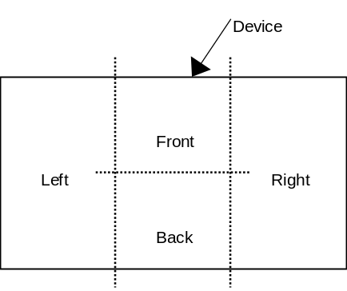
Fig. 4.14 Vibration position

Position is defined The position in which the player normally uses the device is used as the standard when defining position.
It is possible to install more than one vibration source in 1 position.
Vibration position refers to the place to which the vibration source is allocated, not the place where the player senses the vibration.

Vibration axes

The 4 vibration source vibration axes are No direction, X axis direction，Y axis direction，and Z axis direction.
The No direction axis is specified in cases of vibration sources where the direction of the vibration generated is not clearly defined (for example, rotary vibration such as generated by a vibration motor).
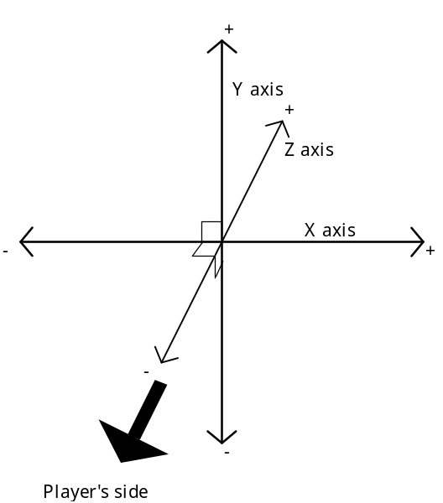
Fig. 4.15 Vibration axes

X axis direction : Indicates vibration of a left-right direction in relation to the player.
The right direction is the + direction, and the left direction is the - direction.
Y axis direction : Indicates vibration of an up-down direction in relation to the player.
The up direction is the + direction, and the down direction is the - direction.
Z axis direction : Indicates vibration of a front-back direction in relation to the player.
The front direction is the + direction, and the back direction is the - direction.

These + and - directions correspond to the + and - directions of the vibration waveform.
Multiple vibration sources may be specified for the same direction in 1 vibration position.

Continuous vibration

Indicates the condition where a vibration specified with 1 command continues until the next setting is sent.
If continuous vibration is not configured, the vibration is stopped after 1 cycle (1 arbitrary waveform).
If continuous vibration is configured, the vibration auto-stop function comes into operation.
Can be specified for each vibration source.

■ In cases of vibration sources where continuous vibration can be specified, the CV corresponding to the vibration source setting information is '1'.
■ To stop vibration, either CNT='0' should be specified, or the intensity should be specified as '0'.

Vibration waveforms

This section explains about the waveforms for controlling vibration sources.
To stop vibration, intensity should be specified to 0 (-0).

Normal configuration

Vibration waveforms are generated by the intensity and frequency settings.
The following figure illustrates an example of a waveform generated under normal configuration.

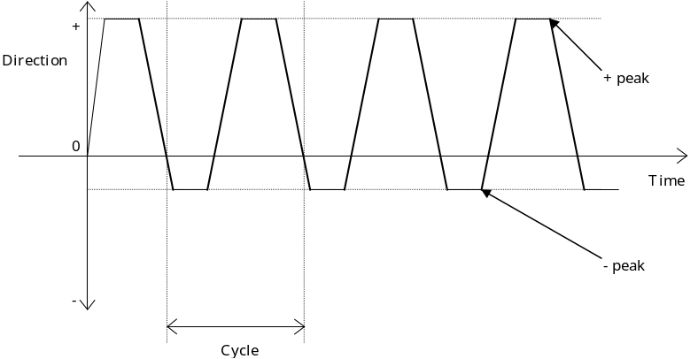
Fig. 4.16 Outline of a vibration waveform under normal configuration

The + peaks and the - peaks in the figure indicate that it is possible to specify the intensity in those directions based on the + peak values and the - peak values, when direction can be specified (when PD='1').
When there is no axis direction (when VD='00'), the + peak represents forward rotation, and the - peak represents backward rotation.

In cases where the + peak value is 1 or more at the time vibration is started, vibration starts from the + direction.

■ When no axis direction is specified (when VD='00'), the + peak value and the - peak value cannot be specified concurrently. Concurrent configuration results in an error.
■ If the variable intensity setting is fixed (PF='0'), specifying the intensity to 8 different levels still results in vibration at the fixed intensity.

When arbitrary vibration frequency waveforms may be specified

The following figure illustrates a common vibration waveform generated by a vibration source which can be arbitrarily specified to generate waveforms (OWF='1').
Vibration must be able to be specified according to normal configuration in addition to arbitrary waveforms.

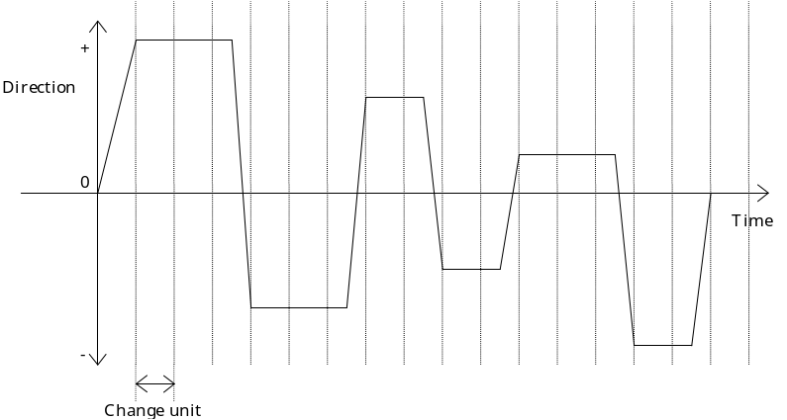
Fig. 4.17 Outline of waveform when arbitrary vibration waveforms can be specified.

The method for specifying waveforms consists of specifying the intensity of the change units.
Intensity can be specified to 8 levels, including +, -, and 0.
+: +0～+7, -: -0～-7 (+0 and -0 are the same intensity)
The change unit is 10ms.

If waveform is re-specified during vibration based on an arbitrary waveform, the vibration stops temporarily, then starts again with the re-specified waveform.

■ If continuous vibration is specified, the previously specified vibration waveform is repeated.
■ If the variable intensity setting is fixed (PF='0'), specifying the intensity to 8 different levels still results in vibration at the fixed intensity.

Convergent and divergent setting function

This function automatically changes vibration intensity at a specified time.

The vibration converges or diverges in the specified cycle.
Intensity is changed once for each specified cycle (vibration frequency). After the intensity reaches 0 or the maximum intensity, vibration stops.

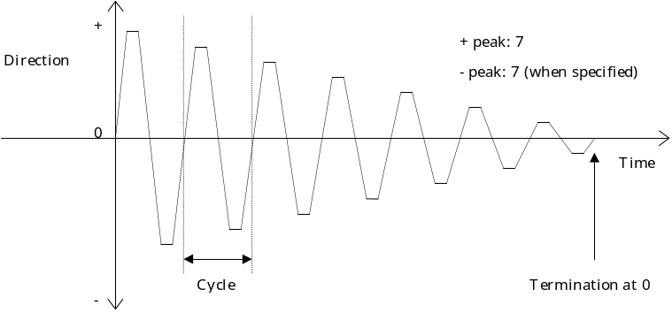
Fig. 4.18 Outline of waveform when convergence is specified.

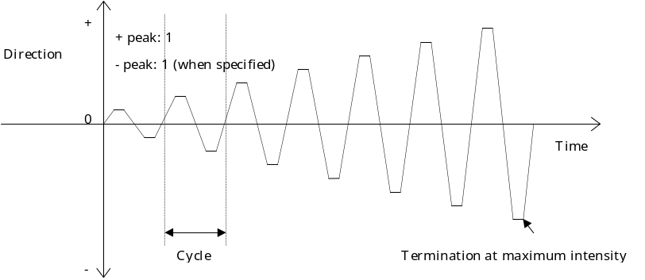
Fig. 4.19 Outline of waveform when divergence is specified.

Settings should select either convergence or divergence.
If both are specified, an error occurs.
Both convergence and divergence can be specified to be continuous.

■ The initial + peak value and - peak value, convergence or divergence, and the change cycle are specified for the waveform.
The + peak value and the - peak value can be different.
In the case of convergence, vibration stops when either the + peak or the - peak equals 0. In the case of divergence, vibration stops when either the + peak or the - peak equals 7.

■ When direction is specified to No direction (VD='00'), + peaks and - peaks cannot be specified at the same time.
If they are specified at the same time, an error occurs.
Also, the vibration converges or diverges on only one side, either the + side or the - side.

■ When the variable intensity setting is fixed (PF='0'), this function will not operate. If it is selected, an error will occur.

■ The next vibration can be specified during convergent vibration and divergent vibration. In this case, the vibration converging or diverging stops, and the specified vibration will start.

Vibration auto-stop function

This function automatically stops a vibration after the vibration has continued for a specified time, in order to avoid unforeseen operation of the vibration due to an accident or a reset when using continuous vibration.
It is also used when using continuous vibration for a specific time.

It is possible to specify the auto-stop time separately for each vibration source.
If the time settings are changed during a continuous vibration, the new settings come into effect with the next vibration setting.

The period until vibration stops is measured from the time data was last specified.

The period until vibration stops can be specified from 0.25 seconds up to 64 seconds, in 0.25 second units.
The default setting value is 5.0 seconds.

For this setting time, the transmission of the stop signal is produced in 0.25 second units. Cessation of the actual vibration takes longer than this.
Also, variation in the timing of the stop signal transmissions is within a ±0.25 second range.

This function cannot be stopped or disabled.

VIBRATION SETTINGS

This chapter explains about the method for specifying vibrations.

Normal configuration

4 bytes are used for each vibration source when speciying vibrations.

Indicates vibration instructions.

bit | 7 | 6 | 5 | 4 | 3 | 2 | 1 | 0
CTRL | VN₃ | VN₂ | VN₁ | VN₀ | Res₂ | Res₁ | Res₀ | CNT
POW | INH | Ppow₂ | Ppow₁ | Ppow₀ | EXH | Mpow₂ | Mpow₁ | Mpow₀
Freq | Freq₇ | Freq₆ | Freq₅ | Freq₄ | Freq₃ | Freq₂ | Freq₁ | Freq₀
Inc | Inc₇ | Inc₆ | Inc₅ | Inc₄ | Inc₃ | Inc₂ | Inc₁ | Inc₀
Fig. 5.20 vibration instructions

VN : Vibration source No.
Indicates the number of vibration sources.
The number of vibration sources is 1～15 ('1h'～'Fh').
'0h' may not be specified. Specifying '0h' results in an error.

Res : Reserved bits
Used as '0'.Reserved bits

CNT : Continuous vibration setting bits
The continuous vibration flag for the continuous setting information must be specified at '1'.
If specified when CV='0', an error results.
Also, CNT should be specified at '0'when stopping vibration.

Continuous vibration | CNT
No (STOP) | 0
Yes (START) | 1
Fig. 5.21 Bit configuration for continuous vibration setting
INH : Convergent vibration setting bit
Configured when generating convergent vibration.
Cannot be specified concurrently with divergent vibration setting bit.
Concurrent configuration results in an error.

Convergent vibration | INH
No | 0
Yes | 1
Fig. 5.22 Bit configuration for convergent vibration setting

■ If specified when the setting of variable intensity is fixed (PF='0'), an error results.

Ppow : Forward direction (+ direction) intensity setting bit
Configures the intensity of vibration in the forward direction (+ direction).

Intensity | Ppow₂ | Ppow₁ | Ppow₀
+7 | 1 | 1 | 1
+6 | 1 | 1 | 0
+5 | 1 | 0 | 1
+4 | 1 | 0 | 0
+3 | 0 | 1 | 1
+2 | 0 | 1 | 0
+1 | 0 | 0 | 1
+0 | 0 | 0 | 0
Fig. 5.23 Bit configuration for forward direction intensity setting

If specified at '+0', vibration is stopped.
A '+7' setting produces the strongest vibration.

■ When the variable intensity setting is fixed (PF='0'), settings of +1～+7 only produce the same fixed vibration intensity.

■ If specified at "+0", continuous vibration can be stopped.
EXH : Divergent vibration setting bit
Configured when generating divergent vibration.
Cannot be specified concurrently with convergent vibration setting bit.
Concurrent configuration results in an error.

Divergent vibration | EXH
No | 0
Yes | 1
Fig. 5.24 Bit configuration for divergent vibration setting

■ If specified when the setting of variable intensity is fixed (PF='0'), an error results.

Mpow:Backward direction (- direction) intensity setting bit
Configures the initial intensity of vibration in the backward direction (- direction).

Intensity | Mpow₂ | Mpow₁ | Mpow₀
-7 | 1 | 1 | 1
-6 | 1 | 1 | 0
-5 | 1 | 0 | 1
-4 | 1 | 0 | 0
-3 | 0 | 1 | 1
-2 | 0 | 1 | 0
-1 | 0 | 0 | 1
-0 | 0 | 0 | 0
Fig. 5.25 Bit configuration for backward direction intensity setting

If specified at '+0', vibration is stopped.
A '-7' setting results in extremely strong vibration.

■ When the variable intensity setting is fixed (PF='0'), settings of +1～+7 result in the same fixed vibration intensity.

■ When the vibration source's direction setting flag is direction non-settable (PD='0'), a - direction setting is treated as a + direction. In such a case, if there is a setting value for the + direction, this - direction setting value is ignored.

■ If specified at "+0", continuous vibration can be stopped.
Freq : Vibration frequency setting bit
Configures the vibration frequency.
In a non-settable vibration frequency is configured, an error results.
When the vibration frequency cannot be specified (when VA='1111h'), an arbitrary value is used.
When the vibration frequency is fixed (when VA='1111h'), it becomes the specified frequency. (Any value apart from the fixed value is ignored.)

Inc : Vibration inclination period setting bit
Specifies the vibration inclination period.
Is specified when either convergence or divergence is used. When convergence and divergence are not used, the arbitrary value "00h" is used.
1 convergent (or 1 divergent) vibration is completed in the period specified in Inc.
Is specified when Freq ≧ Inc.
All other settings result in an error.

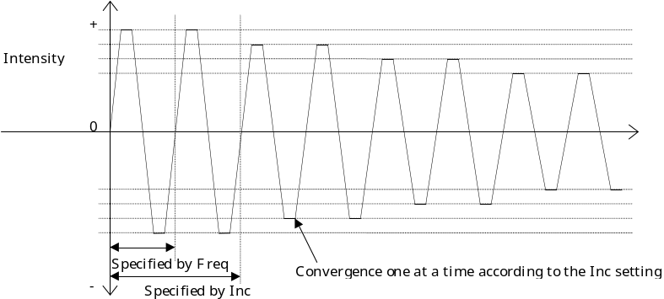
Fig. 5.26 Outline of waveform for convergent setting

The example illustrated in the above figure has a setting of Inc="02h".
Setting muct be Inc=1～255("00h"～"FFh").
Specifying Inc="00h" when convergence or divergence are selected results in an error.

Arbitrary waveform settings

The method for specifying waveforms consists of specifying the intensity of the vibration for the unit of change.
The time unit is 10ms.
The data specified for WF must be a 4 byte unit.

bit | 7 | 6 | 5 | 4 | 3 | 2 | 1 | 0
WF | Cont | 0WFE | 0 | 0 | Dir | Pow₂ | Pow₁ | Pow₀
Fig. 5.27 Bit configuration for arbitrary vibration waveform settings

Cont : Continuous vibration setting bit
Can only be specified with the 1st Data from the arbitrary waveform settings. If specified with data from the 2nd Data or after (10ms or later), the setting is ignored. Data from the 2nd Data or after is specified as '0'.
It cannot be set if the continuous vibration flag (CV) of FD of the vibration source corresponded by it is '1'.
If CV='0' is specified, an error results.

Continuous vibration | Cont
No | 0
Yes | 1
Fig. 5.28 Bit configuration for continuous vibration settings

WFE : Setting data termination bit
Is specified as '1' when the last data for WF is sent.
Data sent after this is ignored.

Settings completed | WFE
Continuation | 0
Termination | 1
Fig. 5.29 Bit configuration for setting data termination

Dir : Intensity direction setting bit
Specifies the direction of the vibration intensity.

Vibration direction | Dir
+ direction | 0
- direction | 1
Fig. 5.1030 Bit configuration for intensity direction settings

■ When the vibration source's direction setting flag is direction non-settable (PD='0'), a - direction setting is treated as + direction.
Pow : Vibration intensity setting bit
The + and - parts of the intensity setting represent the direction of the vibration.
If the intensity is specified as +0 or -0, vibration stops.
An intensity of 1 is the weakest. An intensity of 7 is the strongest.

Intensity | Dir | Pow₂ | Pow₁ | Pow₀
+7 | 0 | 1 | 1 | 1
+6 | 0 | 1 | 1 | 0
+5 | 0 | 1 | 0 | 1
+4 | 0 | 1 | 0 | 0
+3 | 0 | 0 | 1 | 1
+2 | 0 | 0 | 1 | 0
+1 | 0 | 0 | 0 | 1
+0 | 0 | 0 | 0 | 0
-0 | 1 | 0 | 0 | 0
-1 | 1 | 0 | 0 | 1
-2 | 1 | 0 | 1 | 0
-3 | 1 | 0 | 1 | 1
-4 | 1 | 1 | 0 | 0
-5 | 1 | 1 | 0 | 1
-6 | 1 | 1 | 1 | 0
-7 | 1 | 1 | 1 | 1
Fig. 5.1131 Bit configuration for Vibration intensity setting

■ When the variable intensity setting is fixed (PF='0'), settings of +1～+7 or -1～-7 result in the same fixed vibration intensity.
Setting example:
Continuous vibration: Yes

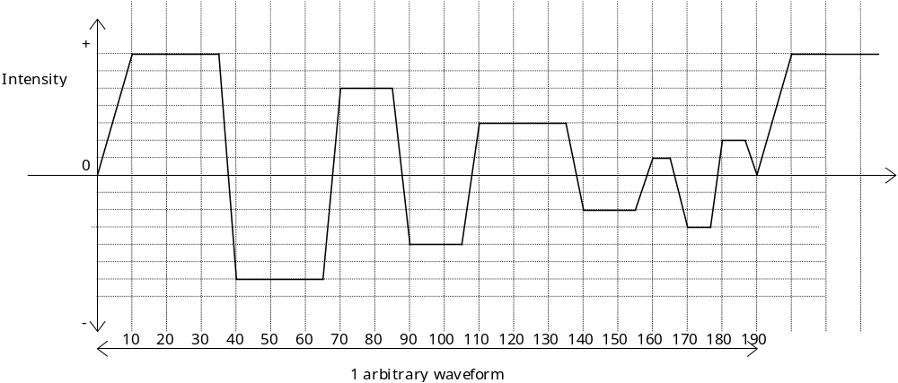
Fig. 5.1232 Example of arbitrary vibration waveform settings (waveform)

Data | Change point [ms] | WF | Cont | 0WFE | 0 | 0 | Dir | Pow₂ | Pow₁ | Pow₀
1st Data | 0 | 80h | 1 | 0 | 0 | 0 | 0 | 0 | 0 | 0
2nd Data | 10 | 07h | 0 | 0 | 0 | 0 | 0 | 1 | 1 | 1
3rd Data | 20 | 07h | 0 | 0 | 0 | 0 | 0 | 1 | 1 | 1
4th Data | 30 | 07h | 0 | 0 | 0 | 0 | 0 | 1 | 1 | 1
5th Data | 40 | 0Eh | 0 | 0 | 0 | 0 | 1 | 1 | 1 | 0
6th Data | 50 | 0Eh | 0 | 0 | 0 | 0 | 1 | 1 | 1 | 0
7th Data | 60 | 0Eh | 0 | 0 | 0 | 0 | 1 | 1 | 1 | 0
8th Data | 70 | 05h | 0 | 0 | 0 | 0 | 0 | 1 | 0 | 1
9th Data | 80 | 05h | 0 | 0 | 0 | 0 | 0 | 1 | 0 | 1
10th Data | 90 | 0Ch | 0 | 0 | 0 | 0 | 1 | 1 | 0 | 0
11th Data | 100 | 0Ch | 0 | 0 | 0 | 0 | 1 | 1 | 0 | 0
12th Data | 110 | 03h | 0 | 0 | 0 | 0 | 0 | 0 | 1 | 1
13th Data | 120 | 03h | 0 | 0 | 0 | 0 | 0 | 0 | 1 | 1
14th Data | 130 | 03h | 0 | 0 | 0 | 0 | 0 | 0 | 1 | 1
15th Data | 140 | 0Ah | 0 | 0 | 0 | 0 | 1 | 0 | 1 | 0
16th Data | 150 | 0Ah | 0 | 0 | 0 | 0 | 1 | 0 | 1 | 0
17th Data | 160 | 01h | 0 | 0 | 0 | 0 | 0 | 0 | 0 | 1
18th Data | 170 | 0Bh | 0 | 0 | 0 | 0 | 1 | 0 | 1 | 1
19th Data | 180 | 02h | 0 | 0 | 0 | 0 | 0 | 0 | 1 | 0
20th Data | 190 | 00h | 0 | 01 | 0 | 0 | 0 | 0 | 0 | 0
Fig. 5.1333 Example of arbitrary vibration waveform settings (data)

Vibration auto-stop settings

The vibration auto-stop settings are as follows.

bit | 7 | 6 | 5 | 4 | 3 | 2 | 1 | 0
ASR | ASR₁₅ | ASR₁₄ | ASR₁₃ | ASR₁₂ | ASR₁₁ | ASR₁₀ | ASR₉ | ASR₈
ASR | ASR₇ | ASR₆ | ASR₅ | ASR₄ | ASR₃ | ASR₂ | ASR₁ | 0
Fig. 5.1434 Bit configuration for vibration auto-stop time revision

ASR : Vibration auto-stop time revision bit
Revises the settings for vibration auto-stop time
ASR₁～ASR₁₅ correspond to Vibration Source -1～Vibration Source -15 respectively.

Vibration auto-stop time revision | ASR
Does not revise | 0
Revises | 1
Fig. 5.1535 Bit configuration for vibration auto-stop time revision

The function ignores any specification sent for a vibration source not installed in the function.
If a revision is sent during continuous vibration, the revision is reflected beginning with the next vibration.

After specifying ASR, AST is specified in the vibration sources to be revised in order beginning from the vibration source with the smallest number.

bit | 7 | 6 | 5 | 4 | 3 | 2 | 1 | 0
AST | AST₇ | AST₆ | AST₅ | AST₄ | AST₃ | AST₂ | AST₁ | AST₀
Fig. 5.1636 Bit configuration for vibration auto-stop time settings
AST : Vibration auto-stop time setting bit
Specifies the auto-stop time.
Default value is 5.0 seconds. May be specified to a maximum of 64.0 seconds in 0.25 increments.

auto-stop time | AST | AST₇ | AST₆ | AST₅ | AST₄ | AST₃ | AST₂ | AST₁ | AST₀
0.25 seconds | 00h | 0 | 0 | 0 | 0 | 0 | 0 | 0 | 0
0.50 seconds | 01h | 0 | 0 | 0 | 0 | 0 | 0 | 0 | 1
0.75 seconds | 02h | 0 | 0 | 0 | 0 | 0 | 0 | 1 | 0
1.00 seconds | 03h | 0 | 0 | 0 | 0 | 0 | 0 | 1 | 1
: | : | : | : | : | : | : | : | : | :
5.00 seconds | 13h | 0 | 0 | 0 | 1 | 0 | 0 | 1 | 1
: | : | : | : | : | : | : | : | : | :
10.0 seconds | 27h | 0 | 1 | 1 | 0 | 0 | 1 | 1 | 1
: | : | : | : | : | : | : | : | : | :
30.0 seconds | 77h | 0 | 1 | 1 | 1 | 0 | 1 | 1 | 1
: | : | : | : | : | : | : | : | : | :
60.0 seconds | EfEFh | 1 | 1 | 1 | 0 | 1 | 1 | 1 | 1
: | : | : | : | : | : | : | : | : | :
64.0 seconds | FFh | 1 | 1 | 1 | 1 | 1 | 1 | 1 | 1
Fig. 5.1737 Bit configuration for vibration auto-stop time settings

ASR and AST must be sent together as a 4 byte unit.
If ASR and AST combined cannot produce a 4 byte unit, the dummy data '00h' is added to form a 4 byte unit.

COMMANDS

The commands supported by the vibration functions among the commands specified in the "Maple Bus 1.0" Standard Specifications are described here.
Setting examples are all presented as being connected to the LM-Bus No.1 via Port A.

Control commands

Get Media Info

Issuing right : Host
Command code : 0Ah
Data size : 02h (4 bytes)
Data field : Function type : 4 bytes
VN : 4 bytes (3 bytes are Dummy)
Expected return value : [Data Transfer]
Description : Requests function type media information for the vibration source number specified in VN.
When dealing with vibration functions, this command is for obtaining vibration media information.
A variety of settings are specified based on this media information.
If VN='00h' is specified, the error message [Transmit Again] is returned.

Data Address | Data | Setting example | Description
+0000h | Command code | 0E0Ah | Specifies Set Condition Get Media Info
+0001h | Destination AP | 01h | Expansion device (LM-Bus No.1)
+0002h | Origin AP | 00h | Port A
+0003h | Data size | 02h | Data size is 8 bytes
+0004h | Function type | 00h | The function type specifies the vibration.
+0005h | Function type | 00h | The function type specifies the vibration.
+0006h | Function type | 01h | The function type specifies the vibration.
+0007h | Function type | 00h | The function type specifies the vibration.
+0008h | VN | 01h | Specifies Vibration Source -1
+0009h | Dummy | 00h | Fixed value
+000Ah | Dummy | 00h | Fixed value
+000Bh | Dummy | 00h | Fixed value
Fig. 6.38 Example of Get Media Info command

The reply from the function is [Data Transfer].
If there is an error in the settings, [Transmit Again] is returned.
Data returned is as shown in the following figure.

Data Address | Data | Setting example | Description
+0000h | Command code | 08h | Specifies Data Transfer.
+0001h | Destination AP | 00h | Port A
+0002h | Origin AP | 01h | Expansion device (LM-Bus No.1)
+0003h | Data size | 0302h | Data size is 12 8 bytes
+0004h | Function type | 00h | The function type specifies the vibration.
+0005h | Function type | 00h | The function type specifies the vibration.
+0006h | Function type | 01h | The function type specifies the vibration.
+0007h | Function type | 00h | The function type specifies the vibration.
+0008h | VSet0 |  | Vibration source setting information specified in VN
+0009h | VSet1 |  | Vibration source setting information specified in VN
+000Ah | Fm0 |  | Vibration source setting information specified in VN
+000Bh | Fm1 |  | Vibration source setting information specified in VN
Fig. 6.39 Example of reply command for Get Media Info

Set Condition

Issuing right : Host
Command code : 0Eh
Data size : 1+n/4h (4+n bytes)
Data field : Function type : 4 bytes
Vibration settings : n byte
Expected return value : [Device Reply]
Description : Specifies the physical status of the function.
When dealing with vibration functions, this command is used to specify the vibration.

Data Address | Data | Setting example | Description
+0000h | Command code | 0Eh | Specifies Set Condition.
+0001h | Destination AP | 01h | Expansion device (LM-Bus No.1)
+0002h | Origin AP | 00h | Port A
+0003h | Data size | 1+n/4h | Data size is 4+n bytes
+0004h | Function type | 00h | The function type specifies the vibration.
+0005h | Function type | 00h | The function type specifies the vibration.
+0006h | Function type | 01h | The function type specifies the vibration.
+0007h | Function type | 00h | The function type specifies the vibration.
+0008h | CTRL i |  | Vibration Source -i settings
+0009h | POW i |  | Vibration Source -i settings
+000Ah | Freq i |  | Vibration Source -i settings
+000Bh | Inc i |  | Vibration Source -i settings
: | : | : | :
+0008h+n-3 | CTRL j |  | Vibration Source -j settings
+0008h+n-2 | POW j |  | Vibration Source -j settings
+0008h+n-1 | Freq j |  | Vibration Source -j settings
+0008h+n | Inc j |  | Vibration Source -j settings
Fig. 6.40 Example of Set Condition command

For a detailed description of these settings, see "5 VIBRATION SETTINGS".
The reply from the function is [Device Reply].
If there is an error in the settings, [Transmit Again] is returned.
Setting specification begins from the vibration source with the smallest number. (i<j)
The number of vibration sources to be specified must be SE (in the function definition block) or less.

Get Condition

Issuing right : Host
Command code : 09h
Data size : 01h
Data field : Function type :4 bytes
Expected return value : [Data Transfer]
Description : Requests the physical status of the function.
When dealing with vibration functions, this command is used to obtain the settings of the current vibration.

Data Address | Data | Setting example | Description
+0000h | Command code | 09h | Specifies Get Condition.
+0001h | Destination AP | 01h | Expansion device (LM-Bus No.1)
+0002h | Origin AP | 00h | Port A
+0003h | Data size | 01h | Data size is 4 bytes
+0004h | Function type | 00h | The function type specifies the vibration.
+0005h | Function type | 00h | The function type specifies the vibration.
+0006h | Function type | 01h | The function type specifies the vibration.
+0007h | Function type | 00h | The function type specifies the vibration.
Fig. 6.41 Example of Get Condition command

Data read with the [Get Condition] command is sent by the [Data Transfer] command.
In vibration functions, this becomes the vibration source settings data.
This command makes it possible to send, at one instance, the data for all the vibration sources.
Data returned is as shown in the following figure.

Data Address | Data | Setting example | Description
+0000h | Command code | 08h | Specifies Data Transfer.
+0001h | Destination AP | 00h | Port A
+0002h | Origin AP | 01h | Expansion device (LM-Bus No.1)
+0003h | Data size | 1+n/4h | Data size is 4+n byte
+0004h | Function type | 00h | The function type specifies the vibration.
+0005h | Function type | 00h | The function type specifies the vibration.
+0006h | Function type | 01h | The function type specifies the vibration.
+0007h | Function type | 00h | The function type specifies the vibration.
+0008h | CTRL i |  | Vibration Source -i settings
+0009h | POW i |  | Vibration Source -i settings
+000Ah | Freq i |  | Vibration Source -i settings
+000Bh | Inc i |  | Vibration Source -i settings
: | : | : | :
+0008h+(n-3) | CTRL j |  | Vibration Source -j settings
+0008h+(n-2) | POW j |  | Vibration Source -j settings
+0008h+(n-1) | Freq j |  | Vibration Source -j settings
+0008h+n | Inc j |  | Vibration Source -j settings
Fig. 6.42 Example of reply command for Get Condition

For vibration source setting data, see "5 VIBRATION SETTINGS".
Setting specification begins from the vibration source with the smallest number. (i<j)

Block_Write

Issuing right : Host
Command code : 0Ch
Data size : 04h (16 bytes) 2+n/4h (8+n bytes)
Data : Function type : 4 bytes
VN : 1 byte
Phase : 1 byte
Block No. : 2 bytes
Write data : n bytes
Expected return value : [Device Reply]
Description : In response to the vibration function, this command records (writes) data in the specified vibration source. It is used to specify arbitrary waveforms and vibration auto-stop time.
In vibration functions, Phase='00h' ,Block No. ='0000h' are fixed values. VN for each vibration source is '01h'～'0Fh' for Vibration Source -1～Vibration Source -15, respectively.
An example of this command is illustrated in the following figure.

Data Address | Data | Setting example | Description
+0000h | Command code | 0Ch | Specifies Block_Write.
+0001h | Destination AP | 01h | Expansion device (LM-Bus No.1)
+0002h | Origin AP | 00h | Port A
+0003h | Data size | 2+n/4h | Data size is 8+n bytes
+0004h | Function type | 00h | The function type specifies the vibration.
+0005h | Function type | 00h | The function type specifies the vibration.
+0006h | Function type | 01h | The function type specifies the vibration.
+0007h | Function type | 00h | The function type specifies the vibration.
+0008h | VN | 01h | When specifying Vibration Source -1
+0009h | Phase | 00h | Fixed value
+000Ah | Block No. | 0000h | Fixed value
+000Bh | Block No. | 0000h | Fixed value
+000Ch | WF1 |  | Arbitrary waveform data
+000Dh | WF2
+000Eh | WF3
+000Fh | WF4
: | : | : | :
+000Bh+n | WFn
Fig. 6.43 Example of Block_Write command sent to vibration source

WF must be a 4 byte unit.
Also, when specifying vibration auto-stop time, VN is '00h'.

Data Address | Data | Setting example | Description
+0000h | Command code | 0Ch | Specifies Block_Write.
+0001h | Destination AP | 01h | Expansion device (LM-Bus No.1)
+0002h | Origin AP | 00h | Port A
+0003h | Data size | 2+n/4 | Data size is 8+n bytes
+0004h | Function type | 00h | The function type specifies the vibration.
+0005h | Function type | 00h | The function type specifies the vibration.
+0006h | Function type | 01h | The function type specifies the vibration.
+0007h | Function type | 00h | The function type specifies the vibration.
+0008h | VN | 00h | When specifying vibration auto-stop time
+0009h | Phase | 00h | Fixed value
+000Ah | Block No. | 0000h | Fixed value
+000Bh | Block No. | 0000h | Fixed value
+000Ch | ASR |  | Vibration auto-stop time revision bit
+000Dh | ASR |  | Vibration auto-stop time revision bit
+000Eh | AST I |  | Vibration Source -i time settings
: | : | : | :
+000Dh+n | AST j |  | Vibration Source -j time settings
Fig. 6.44 Example of Block_Write command sent to vibration auto-stop time

For the arbitrary vibration setting values, see "5 VIBRATION SETTINGS".
If the command is processed by the function (as is normal), [Device Reply] is returned. If an error occurs, [Transmit Again] is returned.
If any value other than VN='00h' is specified when arbitrary waveforms are cannot be specified, the error command [Transmit Again] is returned.

AST is specified so that i<j.

Block_Read

Issuing right : Host
Command code : 0Bh
Data size : 02h (8 bytes)
Data : Function type : 4 bytes
VN : 1 byte
Phase : 1 byte
Block No. : 2 bytes
Expected return value : [Data Transfer]
Description : In response to the function, this command requests the data of the specified vibration source (VN). It is used to read the settings for both current arbitrary waveforms in the vibration source and auto-stop time.
In vibration functions, Phase='00h' ,Block No. ='0000h' are fixed values. VN for each vibration source is '01h'～'0Fh' for Vibration Source -1～Vibration Source -15, respectively.
An example of this command is illustrated in the following figure.

Data Address | Data | Setting example | Description
+0000h | Command code | 0Bh | Specifies Block_Read.
+0001h | Destination AP | 01h | Expansion device (LM-Bus No.1)
+0002h | Origin AP | 00h | Port A
+0003h | Data size | 02h | Data size is 8 bytes
+0004h | Function type | 00h | The function type specifies the vibration.
+0005h | Function type | 00h | The function type specifies the vibration.
+0006h | Function type | 01h | The function type specifies the vibration.
+0007h | Function type | 00h | The function type specifies the vibration.
+0008h | VN | 01h | When specifying Vibration Source -1
+0009h | Phase | 00h | Fixed value
+000Ah | Block No. | 0000h | Fixed value
+000Bh | Block No. | 0000h | Fixed value
Fig. 6.45 Example of Block_Read command

For a detailed description of these settings, see "5 VIBRATION SETTINGS".
If values for Phase and Block No. are other than '00h' and '0000h' respectively, the error command [Transmit Again] is returned.
If any value other than VN='00h' is specified when arbitrary waveforms are cannot be specified, the error command [Transmit Again] is returned.
Data read with the [Block_Read] command can be sent by the [Data Transfer] command.
Data returned is as shown in the following figure.

Data Address | Data | Setting example | Description
+0000h | Command code | 08h | Specifies Data Transfer.
+0001h | Destination AP | 00h | Port A
+0002h | Origin AP | 01h | Expansion device (LM-Bus No.1)
+0003h | Data size | 2+n/4 | Data size is 8+n bytes
+0004h | Function type | 00h | The function type specifies the vibration.
+0005h | Function type | 00h | The function type specifies the vibration.
+0006h | Function type | 01h | The function type specifies the vibration.
+0007h | Function type | 00h | The function type specifies the vibration.
+0008h | VN | 01h | When specifying Vibration Source -1
+0009h | Phase | 00h | Fixed value
+000Ah | Block No. | 0000h | Fixed value
+000Bh | Block No. | 0000h | Fixed value
+000Ch | WF1 |  | Arbitrary waveform data
+000Dh | WF2
+000Eh | WF3
+000Fh | WF4
: | : | :
+000Bh+n | WFn
Fig. 6.46 Example of reply command for Block_Read sent to vibration source

For the arbitrary vibration setting values, see "5 VIBRATION SETTINGS".

The data written with the [Block Write] command is returned in the sent form. This becomes the returned data.
When dealing with vibration auto-stop time, VN is '00h'.

Data Address | Data | Setting example | Description
+0000h | Command code | 0C08h | Specifies Block_Write Data Transfer.
+0001h | Destination AP | 01h | Expansion device (LM-Bus No.1)
+0002h | Origin AP | 00h | Port A
+0003h | Data size | 2+n/4 | Data size is 8+n bytes
+0004h | Function type | 00h | The function type specifies the vibration.
+0005h | Function type | 00h | The function type specifies the vibration.
+0006h | Function type | 01h | The function type specifies the vibration.
+0007h | Function type | 00h | The function type specifies the vibration.
+0008h | VN | 00h | When specifying vibration auto-stop time
+0009h | Phase | 00h | Fixed value
+000Ah | Block No. | 0000h | Fixed value
+000Bh | Block No. | 0000h | Fixed value
+000Ch | ASR |  | Vibration auto-stop time revision bit
+000Dh | ASR |  | Vibration auto-stop time revision bit
+000Eh | AST i |  | Vibration Source -i time settings
: | : | : | :
+000Dh+n | AST j |  | Vibration Source -j time settings
Fig. 6.47 Example of reply command for Block_Read sent to vibration auto-stop time settings

The data written with the [Block Write] command is returned. This becomes the returned data.

AST is specified so that i<j.

Data Transfer

Issuing right : Vibration function
Command code : 08h
Data size : 01h + n/4 (4 bytes + n bytes)
Data : Function type : 4 bytes
Data : n byte
Description : Returns data in response to a request from the host.
An example of this command is illustrated in the following figure.

Data Address | Data | Setting example | Description
+0000h | Command code | 08h | Specifies Data Transfer.
+0001h | Destination AP | 00h | Port A
+0002h | Origin AP | 01h | Expansion device (LM-Bus No.1)
+0003h | Data size | 1 + n/4h | Data sixe is 4+n bytes
+0004h | Function type | 00h | The function type specifies the vibration.
+0005h | Function type | 00h | The function type specifies the vibration.
+0006h | Function type | 01h | The function type specifies the vibration.
+0007h | Function type | 00h | The function type specifies the vibration.
+0008h  ～ | Data
Fig. 6.48 Example of Data_Transfer command

Device Reply

Issuing right : Vibration function
Command code : 07h
Data size : 00h
Data : none
Description : This command is returned to the host as a reply command when a command from the host has been successfully completed in the function.
An example of this command is illustrated in the following figure.

Data Address | Data | Setting example | Description
+0000h | Command code | 07h | Specifies Device Reply.
+0001h | Destination AP | 00h | Port A
+0002h | Origin AP | 01h | Expansion device (LM-Bus No.1)
+0003h | Data size | 00h | Data size is 0 bytes
Fig. 6.49 Example of Device Reply command

Device Request

Issuing right : Host
Command code : 01h
Data size : 00h
Data : none
Expected return value : [Device Status]
Description : Requests [Device Status] from the destination AP's peripheral.
After initialization, the vibration function does not respond to any other commands until this command is sent.
An example of this command is illustrated in the following figure.

Data Address | Data | Setting example | Description
+0000h | Command code | 01h | Specifies Device Request.
+0001h | Destination AP | 01h | Expansion device (LM-Bus No.1)
+0002h | Origin AP | 00h | Port A
+0003h | Data size | 00h | Data size is 0 bytes
Fig. 6.50 Example of Device Request command

All Status Request

Issuing right : Host
Command code : 02h
Data size : 00h
Data field : none
Expected return value : [Device All Status]
Description : Requests all device statuses (both Fixed Device Status and Free Device Status) from the destination AP's peripheral.
An example of this command is illustrated in the following figure.

Data Address | Data | Setting example | Description
+0000h | Command code | 02h | Specifies All Status Request.
+0001h | Destination AP | 01h | Expansion device (LM-Bus No.1)
+0002h | Origin AP | 00h | Port A
+0003h | Data size | 00h | Data size is 0 bytes
Fig. 6.51 Example of All Status Request command

Device Reset

Issuing right : Host
Command code : 03h
Data size : 00h
Data field : none
Expected return value : [Device Reply]
Order of operation : (1) [Device Reply] returned.
(2) Initialization.
Description : Peripherals specified by the destination AP can be initialized.
Vibration is stopped and settings are cleared.
An example of this command is illustrated in the following figure.

Data Address | Data | Setting example | Description
+0000h | Command code | 03h | Specifies Device Reset.
+0001h | Destination AP | 01h | Expansion device (LM-Bus No.1)
+0002h | Origin AP | 00h | Port A
+0003h | Data size | 00h | Data size is 0 bytes
Fig. 6.52 Example of Device Reset command

Device Kill

Issuing right : Host
Command code : 04h
Data size : 00h
Data field : none
Expected return value : [Device Reply]
Order of operation : (1) [Device Reply] returned.
(2) Operation terminated.
Description : Operation by the peripheral specified by the destination AP is not recognized.
Vibration terminates.
The function stands by in standby power consumption mode, and no commands can be recieved.
To start operation, a hard reset must be performed, or the power should be turned off and then operation should be started again.
An example of this command is illustrated in the following figure.

Data Address | Data | Setting example | Description
+0000h | Command code | 04h | Specifies Device Kill.
+0001h | Destination AP | 01h | Expansion device (LM-Bus No.1)
+0002h | Origin AP | 00h | Port A
+0003h | Data size | 00h | Data size is 0 bytes
Fig. 6.53 Example of Device Kill command

Device Status

Issuing right : Peripheral
Command code : 05h
Data size : 1Ch
Data field : Device ID : 16 bytes
Destination code : 1 byte
Product name : 31 bytes
License : 60 bytes
Standby current consumption : 2 bytes
Maximum current consumption : 2 bytes
Description : Returns Fixed Device Status data in response to [Device Request] from the host.
An example of this command is illustrated in the following figure.

Data Address | Data | Setting example | Description
+0000h | Command code | 05h | Specifies Device Status.
+0001h | Destination AP | 00h | Port A
+0002h | Origin AP | 01h | Expansion device (LM-Bus No.1)
+0003h | Data size | 1Ch | Data size is 112 bytes
+0004h  ～  +0013h | Device ID |  | Specifies the Device ID
+0014h | Destination code |  | Specifies the destination code.
+0015h  ～  +0033h | Product name |  | Specifies the product name.
+0034h  ～  +006Fh | License |  | Specifies the license.
+0070h | Standby current consumption |  | Specifies the standby current consumption.
+0071h | Standby current consumption |  | Specifies the standby current consumption.
+0072h | Maximum current consumption |  | Specifies the maximum current consumption.
+0073h | Maximum current consumption |  | Specifies the maximum current consumption.
Fig. 6.54 Example of Device Status command

Device All Status

Issuing right : Peripheral
Command code : 06h
Data size : 1Ch + n/4
Data field : Fixed Device Status : 112 bytes
Device ID : 16 bytes
Destination code : 1 byte
Product name : 31 bytes
License : 60 bytes
Standby current consumption : 2 bytes
Maximum current consumption : 2 bytes
Free Device Status : n bytes
Description : Returns both Fixed Device Status and Free Device Status in response to [All Status Request] from the host.

Error commands

Function Type Unknown

Issuing right : Peripheral
Command code : FEh
Data size : 00h
Data field : none
Description : This command is returned when the peripheral is not equipped with the function type sent.
Possible causes : (1) Mistaken specification of function type.
(2) Data is written incorrectly.
(3) Data of device ID is jumbled.
(4) Data became jumbled during communication.
Remedies : (1) Specify function type correctly.
(2) Write data correctly.
(3) Resend Device Request to obtain device ID.
(4) Try sending again (maximum of 3 times; subsequent tries are processed as Time out).

Command Unknown

Issuing right : Vibration function
Command code : FDh
Data size : 00h
Data field : none
Description : This command is returned when the vibration function does not support the command sent.
Possible causes : (1) Mistaken specification of command.
(2) Data is written incorrectly.
(3) Data of device ID is jumbled.
(4) Data became jumbled during communication.
Remedies : (1) Write command correctly.
(2) Write data correctly.
(3) Resend Device Request to obtain device ID.
(4) Try sending again (maximum of 3 times; subsequent tries are processed as Time out).

Transmit Again

Issuing right : Host，Vibration function
Command code : FCh
Data size : 00h
Data field : none
Description : This command is used to request that the data be transmitted again when the data contained some kind of error.
Possible causes : (1) Parity error wwas generated.
(2) Data overflowed.
(3) Data became jumbled during communication.
(4) Settings are incorrect.
(5) Others
Remedies : Try sending again (maximum of 3 times; subsequent tries are processed as Time out).

PROTOCOL FLOW

The following diagram illustrates a outline of the basic transmission protocol between host and vibration function.
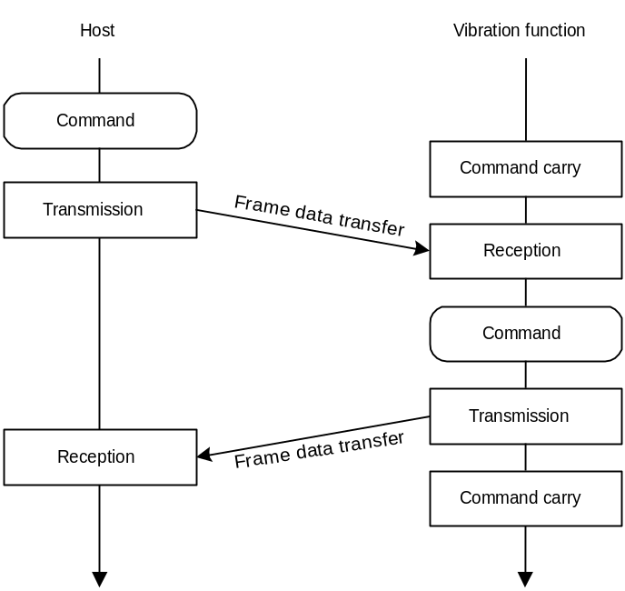
Fig. 7.55 Diagram of transmission protocol

Processing flow for Get Media Info

The following diagram illustrates the processing flow for Get Media Info.
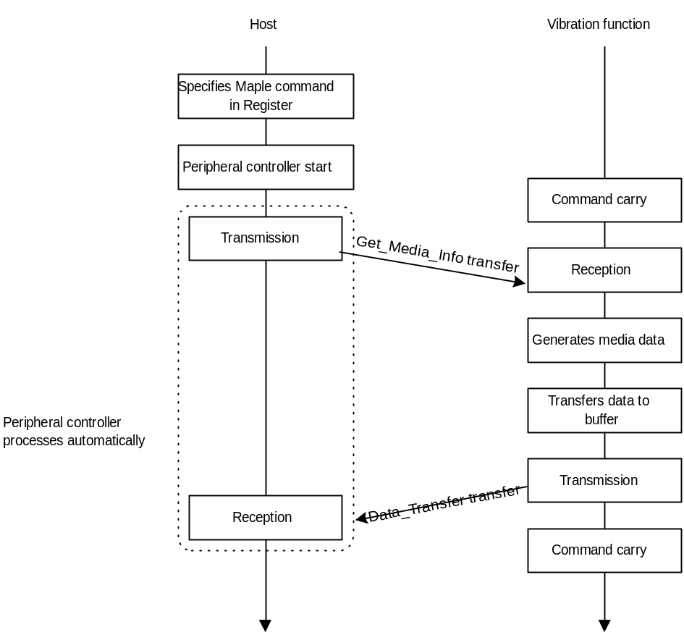
Fig. 7.56 Diagram of processing flow for Get Media Info

Processing flow for vibration settings

The following diagram illustrates the processing flow for vibration settings.

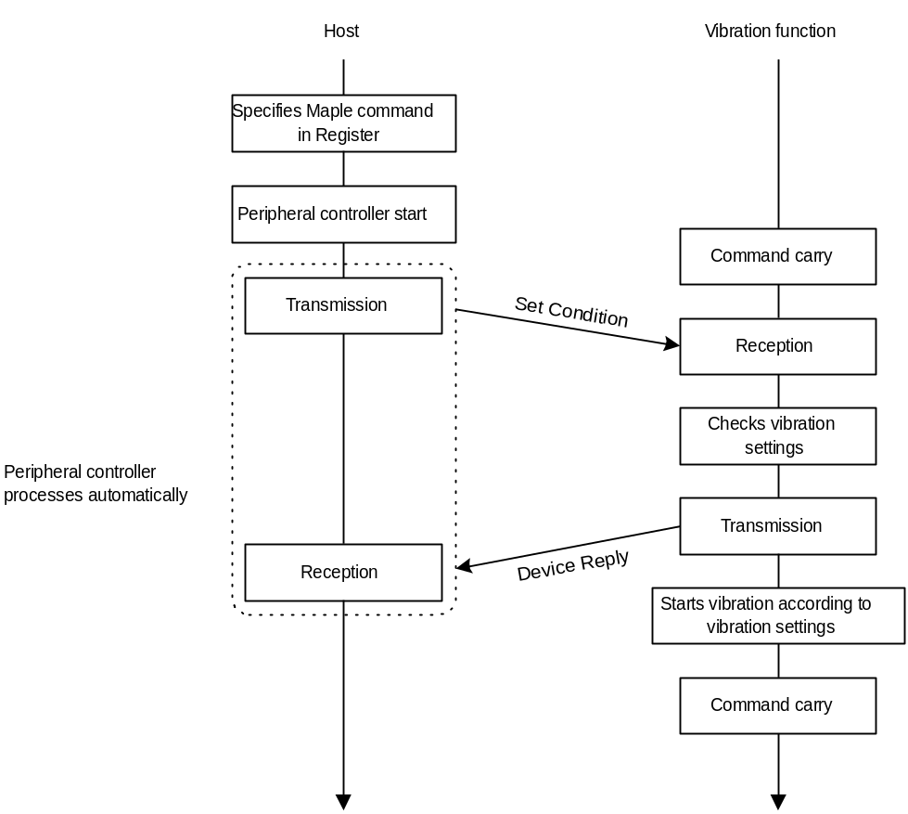
Fig. 7.57 Diagram of processing flow for vibration settings

Processing flow for arbitrary waveform settings

The following diagram illustrates the processing flow for arbitrary waveform settings.

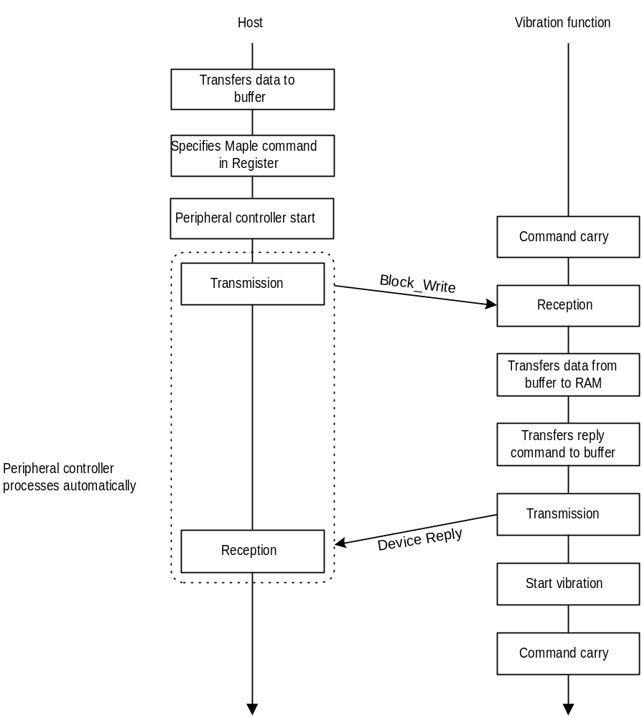
Fig. 7.58 Diagram of processing flow for arbitrary waveform settings

Processing flow for vibration auto-stop time settings

The following diagram illustrates the processing flow for vibration auto-stop time settings.

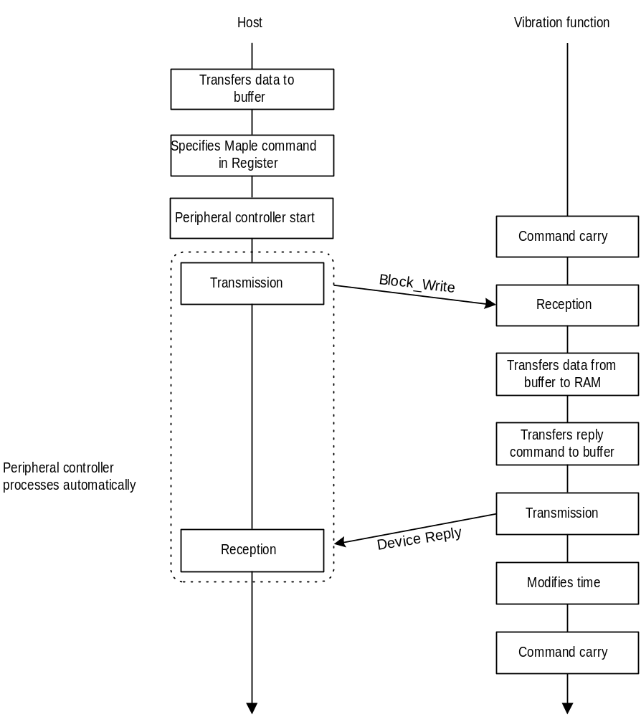
Fig. 7.59 Diagram of processing flow for vibration auto-stop time settings

Processing flow for reading normal configuration

The following diagram illustrates the processing flow for reading normal configuration.

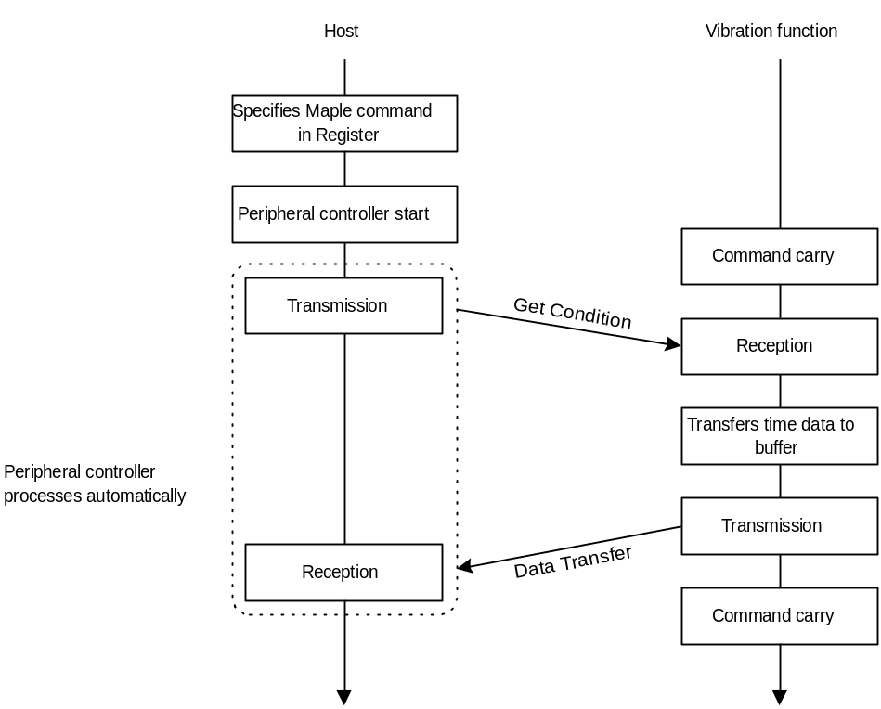
Fig. 7.60 Diagram of processing flow for reading normal configuration

Processing flow for reading arbitray waveform settings and vibration auto-stop time settings

The following diagram illustrates the processing flow for reading arbitray waveform settings and vibration auto-stop time settings.

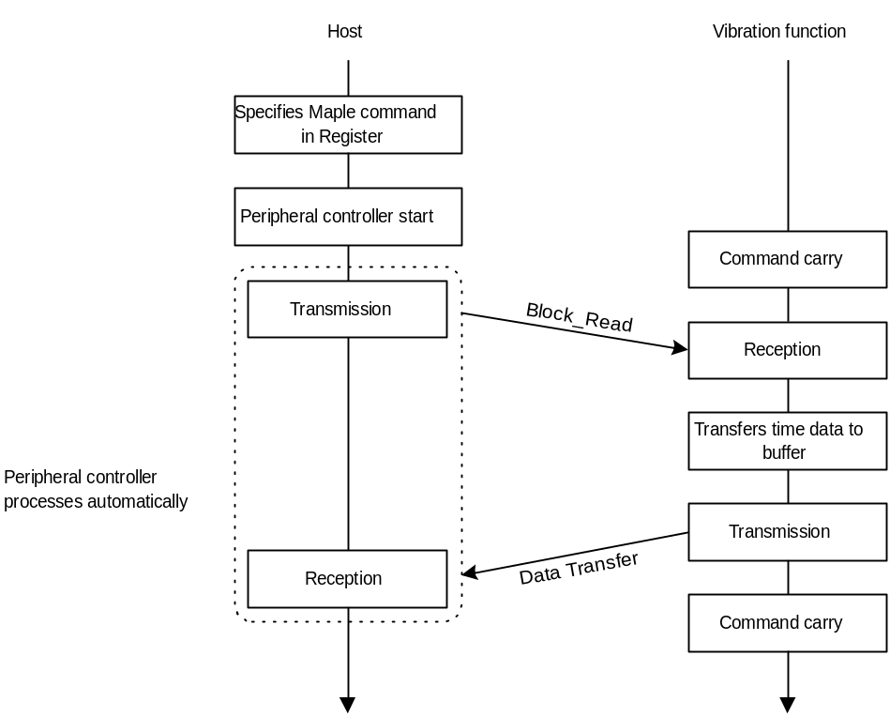
Fig. 7.61 Diagram of processing flow for reading arbitray waveform settings and
vibration auto-stop time settings

Afterword

Until the official version (Rev. 1.0) is distributed, contents will be modified to a small or large extent.

