『Maple Bus 1.0』Peripheral
Hardware Specifications

Ascii Mission Stick

Rev 1.00

Produced by:
CS Hardware DIV.2
SEGA Enterprises Ltd.

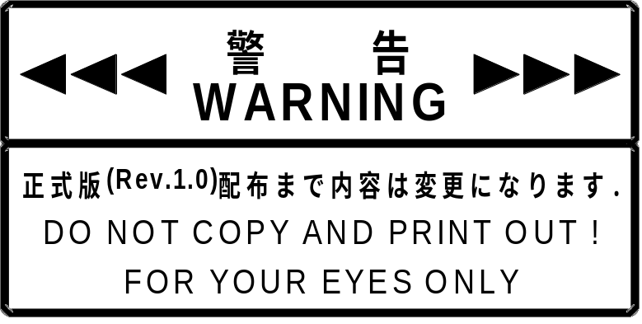

Revision：
1.00 March 2 1999 First issue

CONTENTS

1 Ascii Mission Stick FUNCTION CONDITIONS 4
1.1 Ascii Mission Stick function definitions 4
1.2 Function Elements 4
1.3 Detailed Description of Constituent Elements 5
2 Ascii Mission Stick Function Operation 8
3 Device ID 8
3.1 Configuration of the “Maple Bus 1.0” device ID 8
4 DATA FORMATS 9
4.1 Read format 9
4.2 Ascii Mission Stick･Function Information 10
4.3 Types 10
4.4 Fixed Device Status 10
4.5 Free Device Status 11
5 Afterword 12

Ascii Mission Stick FUNCTION CONDITIONS

Ascii Mission Stick Function Definitions

Indicates the input form of the man-machine interface.
It conforms to the “Maple Bus 1.0” Standard Specifications and belongs to Function Type "FT₀：Controller ".

Function Elements

Function elements defined by the function type "FT0" and used by the Ascii Mission Stick are as follow:
・Digital direction keys A: Ra,La,Da,Ua
・Digital buttons : A,B,X,Y,Start
・Analog keys: A3(Xa),A4(Ya)
・Analog levers: A1(AR),A2(AL)

In addition, the following elements are included with the Ascii Mission Stick as elements not defined by function type.
- Digital buttons: 1,2,3
- Function setting switches: 4 types for A, B, X, Y
- Key allocation setting switches: 3 types for 1, 2, 3

Detailed Description of Constituent Elements

In this section, each function element used by the Ascii Mission Stick is described in detail.

(1) Digital direction keys A: Ra,La,Da,Ua
These are 2-value press/release (= ON/OFF) digital type keys (buttons).
Ra and La, Da and Ua form counterparts. The straight line (X-axis) on which Ra and La are placed at the respective endpoints intersects with the other straight line (Y-axis) on which the Da and Ua are placed at the respective endpoints. The keys (buttons) are arranged on the X-Y surface composed by these straight lines. The way the keys (buttons) are arranged and the directions of movement are as follows: Ra is on the right side, right direction, La is on the left side, left direction, Da is at the bottom, downward direction and toward the viewer, Ua is at the top, upward direction and away from the viewer.
The values are press= ‘0’, release= ‘1’.
The controller does not create key data for more than 3 keys (buttons) pressed simultaneously.
Digital keys are located in the center of the Ascii Mission Stick controller for operation by either the left or right hand.

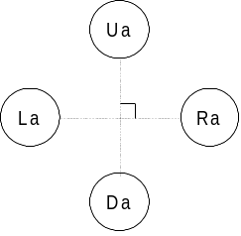
Fig. 1-1 Button layout of digital cross keys A

(2) Digital buttons: A,B,X,Y,Start
These are 2-value press/release (= ON/OFF) digital type keys (buttons).
The controller detects if more than one key (button) is ON at the same time.
Values can be switched among 5 output formats with the function setting switch.
Refer to the function switch section for information about output formats.

(4) Analog keys: A3(Xa),A4(Ya)
These are analog type keys where the value detected in accordance with the distance the key is moved from its initial position changes linearly.
The value at the key’s initial position is 80h (zero position), and the value changes in 01h units from the minimum value 00h to the maximum value FFh.
In relation to the key position, the direction in which the value decreases is the minus direction, and the direction in which the value increases is the plus direction.
When the load applied to move the key is released, the centering of the key should be performed automatically so that the key returns to the initial position. (zero position),

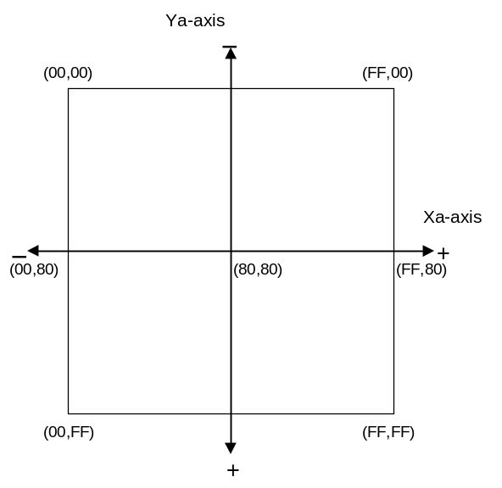
Fig. 1-2 Data range of analog key

(5) Analog levers: A1(AR),A2(AL)
These are analog type levers where the value detected in accordance with the distance the lever is moved from its initial position (zero position) changes linearly.
The value at the lever’s initial position (zero position) is 00h, and the value changes in 01h units from the minimum value 00h to the maximum value FFh.
In relation to the lever position, the direction in which the value decreases is the minus direction, and the direction in which the value increases is the plus direction.
The lever should be able to move in these two directions but from the initial position (zero position) it should only be able to move in one direction.
When the load applied to move the lever is released, the lever should automatically return to its initial position.
In general, A1 indicates the R-axis and A2 indicates the L-axis. The R-axis is operated with the right hand and the L-axis with the left hand.
Use of only one axis at a time should also be possible.
Value
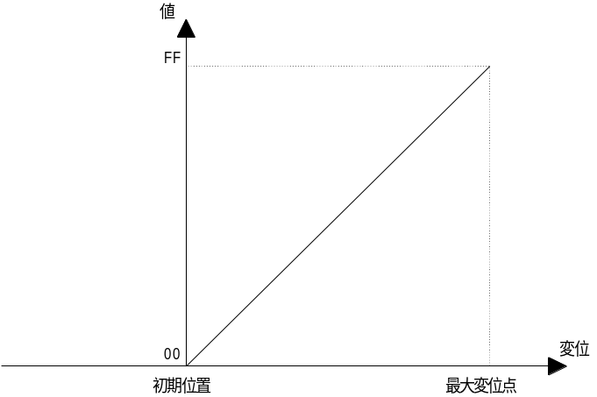
Position change
Maximum position change
Initial position
Fig. 1-3 Data range of analog lever

The following section explains the elements which are not defined by function type.

(1) Digital buttons: 1,2,3
These are 2-value press/release (= ON/OFF) digital type keys (buttons).
The controller detects if more than one key (button) is ON at the same time.
Each key can be allocated to either the A, B, X, or Y function with the key allocation setting switch.
Values can be switched among 5 output formats with the function setting switch.

- Function Setting Switch: 4 types for A, B, X, Y
This switch sets functions, such as continuous shooting, for each key A, B, X, and Y.
With the function setting switch, you can allocate one function for each key from among five types of functions. Functions that can be allocated are shown below.

- Normal (Press = ’0’. Release = ’1’)
- Continuous shooting when pressed, OFF when released
(Press ='continuous shooting'. Release =’1’)
- OFF when pressed, continuous shooting when released
(Press =’1’. Release ='continuous shooting')
- OFF when pressed, ON when released (Press =’1’. Release =’0’)
- ON when pressed, continuous shooting when released
(Press =’0’. Release ='continuous shooting')

(3) Key Allocation Setting Switch: 3 types for 1, 2, 3
This switch allocates the function of either the A, B, X, or Y key to the 1, 2, or 3 key.
One function from among the A, B, X, or Y key can be allocated to the 1, 2, or 3 key.
(It is also possible to set the 1, 2, or 3 key to not be used.)
Values depend on the function setting switch of the allocated key.

Ascii Mission Stick Function Operation

Operation of the Ascii Mission Stick is based on the operation of the "FT₀ Controller".

Device ID

In accordance with the device ID definition in the “Maple Bus 1.0” Standard Specifications.
The notation is that of the host’s memory image.

Configuration of the “Maple Bus 1.0” Device ID

The device ID consists of 16 bytes (128 bits).
bit | 7 | 6 | 5 | 4 | 3 | 2 | 1 | 0
1st Data | 0 | 0 | 0 | 0 | 0 | 0 | 0 | 0
2nd Data | 0 | 0 | 0 | 0 | 0 | 0 | 0 | 0
3rd Data | 0 | 0 | 0 | 0 | 0 | 0 | 0 | 0
4th Data | 0 | 0 | 0 | 0 | 0 | 0 | 0 | 1
5th Data | 0 | 0 | 0 | 0 | 0 | 0 | 0 | 0
6th Data | 0 | 0 | 0 | 0 | 1 | 1 | 1 | 1
7th Data | 0 | 0 | 0 | 0 | 0 | 1 | 1 | 0
8th Data | 1 | 1 | 1 | 1 | 1 | 1 | 1 | 0
9th Data | 0 | 0 | 0 | 0 | 0 | 0 | 0 | 0
10th Data | 0 | 0 | 0 | 0 | 0 | 0 | 0 | 0
11th Data | 0 | 0 | 0 | 0 | 0 | 0 | 0 | 0
12th Data | 0 | 0 | 0 | 0 | 0 | 0 | 0 | 0
13th Data | 0 | 0 | 0 | 0 | 0 | 0 | 0 | 0
14th Data | 0 | 0 | 0 | 0 | 0 | 0 | 0 | 0
15th Data | 0 | 0 | 0 | 0 | 0 | 0 | 0 | 0
16th Data | 0 | 0 | 0 | 0 | 0 | 0 | 0 | 0
Fig. 3-1 Device ID
1st Data～4th Data: Designates type of function that the peripheral is equipped with. (FT)
5th Data～8th Data: Designates the function definition block of the first function. (FD1)
9th Data～12th Data: Designates the function definition block of the second function. (FD2)
13th Data～16th Data: Designates the function definition block of the third function. (FD3)

(1) FT₀-FT₃₁: Function type
Designates the function that the peripheral is equipped with.
There are 32 function types altogether.

(2) FD₃₁～FD₀: Function definition block
This is for the block defining the individual elements making up the function.

DATA FORMATS

The Ascii Mission Stick function data formats are explained in the following.
The notation is that of the host’s memory image.

Read Format

This is the key data format when the Ascii Mission Stick function data are read.
The data format size is 8 bytes.

bit | 7 | 6 | 5 | 4 | 3 | 2 | 1 | 0
1st Data | Ra | La | Da | Ua | Start | A | B | 1
2nd Data | Ra | La | Da | Ua | 1 | X | Y | 1
3rd Data | A1₇ | A1₆ | A1₅ | A1₄ | A1₃ | A1₂ | A1₁ | A1₀
4th Data | A2₇ | A2₆ | A2₅ | A2₄ | A2₃ | A2₂ | A2₁ | A2₀
5th Data | A3₇ | A3₆ | A3₅ | A3₄ | A3₃ | A3₂ | A3₁ | A3₀
6th Data | A4₇ | A4₆ | A4₅ | A4₄ | A4₃ | A4₂ | A4₁ | A4₀
7th Data | 1 | 0 | 0 | 0 | 0 | 0 | 0 | 0
8th Data | 1 | 0 | 0 | 0 | 0 | 0 | 0 | 0
Fig. 4-1 Read format

Key data explanation
1st : Digital button data. (ON = ‘0’, OFF =‘1’)
2nd : Digital button data. (ON = ‘0’, OFF = ‘1’)
3rd : Analog axis 1 (A1) data. Analog lever AR axis.
4th : Analog axis 2 (A2) data. Analog lever AL axis.
5th : Analog axis 3 (A3) data. Analog key Xa axis.
6th : Analog axis 4 (A4) data. Analog key Ya axis.
7th : Analog axis 5 (A5) data. Not used. The midpoint (80h).
8th : Analog axis 6 (A6) data. Not used. The midpoint (80h).

Ascii Mission Stick･Function Information

This chapter explains information about specific devices (device statuses).

Types

Fixed Device Status
This is a set form of device status, consisting of 112 bytes in all, that must be designated.

Free Device Status
The individual devices can use this status freely. It consists of 40 bytes.

Fixed Device Status

Fixed Device Status records the following information.

(1) Device ID
Capacity: 16 bytes
Description: Function type Only "FT₀"
Function Definition 1st Ra,La,Da,Ua,A,B,X,Y,Start,A1,A2,A3,A4
Function Definition 2st None
Function Definition 3st None
Data: 00h-00h-00h-01h-00h-0Fh-06h-FEh-00h-00h-00h-00h-00h-00h-00h-00h

(2) Destination
Capacity: 1byte
Description: worldwide
Data: FFh

(3) Connection direction
Capacity: 1byte
Description: Expansion socket 1 up direction
Expansion socket 2 up direction
Data: 00h

(4) Product name
Capacity: 30byte
Description: Designates "ASCII ANALOG STICK" in half-width characters.
A space code (20h) is inserted for unused space.

(5) License
Size: 60byte
Description: It designates “Produced By or Under License From SEGA ENTERPRISES,LTD.”
A space code (20h) is inserted for unused space.

(6) Standby current consumption
Size: 2byte
Description: 25.0mA
Data: 00h-FAh

(7) Maximum current consumption
Size: 2byte
Description: 50mA
Data: 01h-F4h

Free Device Status

The Free Device Status area is available for product planners, developers, designers and programmers to enter any information they wish. The host obtains this status by the All Device Request.

The following 40-byte data are designated in the Ascii Mission Stick.
“Version 1.000,1998/12/08,315-6125-AL ,”
“ ”

Afterword

Until the official version (Rev. 1.0) is distributed, contents will be modified to a small or large extent.

