“Maple Bus 1.0”
Standard Specification
Revision 0.82

Produced by:
CS Hardware DIV.2
SEGA Enterprises Ltd.

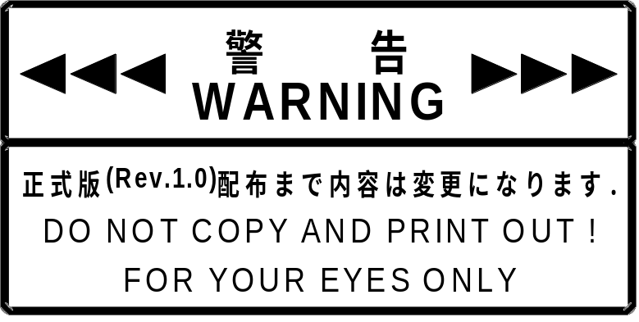

Revisions:
0.7 April 28 1997 First distribution
0.71 May 8 1997 Timing of edge modified. Hardware
ACK non-essential conditions added.
Maximum number of connectable devices changed to 16.
RP renamed AP.
Chapter configuration, chapter titles, and positions of block diagrams changed.
Explanations of hot plugs and other items added.
Major changes made to device registers and operations.
0.71a May 12 1997 Transmission principle, format and reset pattern modified, and ACK pattern eliminated.
Command register's pattern selection bit modified.
Status register's operation modified.
0.72 June 6 1997 Explanations of hot plugs and other items modified and added.
Physical specifications added.
Device status modified.
Device block diagrams changed.
CPU of Maple Bus and MIE interface modified to match Maple Bus specifications.
Maximum number of connectable devices changed to 8.
0.73 July 15 1997 All pages reviewed.
Explanations of concept and frame added.
Maximum frame length changed from 256 Bytes to 1024 Bytes.
Protocol and error processing improved extensively.
Data format added and device ID defined.
Commands and device statuses modified.
Block diagrams of peripheral connections added.
Host internal interface not decided, so explanation moved to separate document.
0.74 July 22 1997 Host internal interface (draft) decided, so included in this manual.
0.75 August 4 1997 Error processing unified.
Data format explanation supplemented.
Command codes and error commands modified.
“Other commands” eliminated.
Numbering of chapters overhauled.
- 76 August 18, 1997 LREG revised and receiving eliminated
Peripheral internal interfaces and registers modified and continuous transmission added
Device ID format type and R/W block declaration changed to function type and definition
block
Distinction between command basis and extension eliminated
0.77 September 4, 1997 Peripheral BFOV register modified
Host internal register modified
Peripheral Time Out process added
- September 29, 1997 Time Out changed to 1.0 ms (provisional)
Time Out process added
Host internal register modified
- October 6, 1997 Device ID changed to 16 Bytes
B/W LCD and storage function type added
Number of peripheral functions increased to 3
Command eliminated and added
- February 3, 1998 Added definition of data direction
Unified data contents with the host memory image
Added errors, device/expansion device processing, AP settings to data transmission item
Changed cutoff check, reset
Changes function type, controller device ID, definition block
Changed contents of peripheral device data buffer
Added LM-Bus description
Changed block diagram
Changed host's register name
Added [Set Condition], [FT Control], [AR Control], [AR Error] commands
Entered values for AC characteristics
Added connector diagram, pin arrangement
0.81 April 13, 1998 Deleted section on host MIE hard trigger
Added AC timing
Changed expansion device connector specifications (12 pins -> 14 pins)
Addition to illegal items
Changed command reference layout
Added expansion socket information to fixed device status
0.82 May 20, 1998 Added device Request description to AP settings
Added description of FD order of priority
Added description of distinction between the commands Device Status and All Status Request
Added connection direction to Device Status and Device All Status
Revised Free Device Status capacity and added unifying information.
Revised the explanation of connection directions of expansion devices
Added description the characters that can be used for Fixed Device Status and Free Device Status
Added other revisions
CONTENTS:
CHAPTER 1 OVERVIEW 8
1.1 Concept of Maple Bus 8
1.1.1 Topology of "Maple Bus 1.0" 8
1.1.2 Layer configuration and communication flow 9
1.1.3 Types of peripherals 11
1.1.4 Definition of Data Direction 11
1.2 Description 12
1.3 Scope of Specification 16
CHAPTER 2 DATA TRANSFER PATTERNS 17
2.1 Overview 17
2.2 Transmission Principle 17
2.2.1 Data pattern formed by SDCKA and SDCKB 17
2.2.2 Information patterns through SDCKA and SDCKB 17
2.3 Transmission Format 18
CHAPTER 3 PROTOCOLS 19
3.1 Overview 19
3.2 Frame Data 20
3.2.1 Frame 20
3.2.2 Command code 20
3.2.3 AP 21
3.2.4 Data size 23
3.3.2 Transmission errors 25
3.3.3 Illegal items 25
3.3.4 Device Processing 26
3.3.5 Expansion Device Processing 26
3.3.6 AP Settings 27
3.4 Connection and Cutoff of Peripherals 28
3.4.1 Host processing 28
3.4.2 Connection check 28
3.4.3 Disconnection check 29
3.5 Reset 30
3.6 Setting of Device ID 31
3.6.1 Definition of device ID 31
3.6.2 Configuration of device ID 31
3.7 Function Data Format and Definition Block 33
3.7.1 Types of peripherals 33
3.7.2 Controller-type function 34
3.7.3 Data format and device ID of standard controller 36
3.7.4 Storage function 37
3.7.5 B/W LCD Function 38
3.7.6 Other functions 39
3.8 Example of Accessing Peripheral 40
3.8.1 Processing after connection 40
3.8.2 Access to function 40
3.9 Exceptional Processing 42
3.9.1 Light-GUN 42
CHAPTER 4 INTERNAL INTERFACE OF HOST 43
4.1 Overview 43
4.2 Register Map 45
4.2.1 DMA command table address register [SB_MDSTAR] 45
4.2.2 DMA enable register [SB_MDEN] 45
4.2.3 DMA start/status register [SB_MDST] 46
4.2.4 System control register [SB_MSYS] 46
4.2.5 Status register 47
4.2.6 Work RAM Area Protection Register [SB_MDAPRO] 48
4.2.7 Send data address counter register 48
4.2.8 Receive data address counter register 49
4.2.9 Receive data base address register 49
4.2.10 Test mode register 50
4.2.11 Test mode data set register 50
4.2.12 Counter test monitor 0 register 51
4.2.13 Counter test monitor 1 register 51
4.2.14 Counter test monitor 2 register 52
4.2.15 Timer test monitor register 52
4.3 Send Data 53
4.3.1 Instructions 53
4.3.2 Receive data store address 55
4.3.3 Output data 55
4.4 Interrupt Register 55
4.5 HV Counter Register 56
4.6 Transfer Sequence 56
4.6.1 Ordinary sequence 56
4.6.2 SDCKB occupy procedure (Light-GUN) 57
4.7 Register Setting Methods (Reference) 58
4.8 Host MIE Block Diagram 59
4.8.1 Block Description 59
CHAPTER 5 INTERNAL INTERFACE OF PERIPHERALS 61
5.1 Overview 61
5.2 Register Configuration 61
5.2.1 Control flag (CFLAG) 61
5.2.2 Data length register (LREG) 63
5.3 Data Buffer 64
5.3.1 Transmission buffer (TRBF) 64
5.4 Data Transfer Procedures 65
5.4.1 Method of receiving data 65
5.4.2 Method of sending data 67
5.4.3 Relationships among flags and communication statuses 69
5.4.4 Error processing 69
5.4.5 LM-Bus 70
5.5 Block Diagram of MIE for Device 71
CHAPTER 6 COMMAND REFERENCE 72
6.1 Control Commands 72
6.1.1 Device Request 72
6.1.2 All Status Request 73
6.1.3 Device Reset 73
6.1.4 Device Kill 74
6.1.5 Device Status 74
6.1.6 Device All Status 75
6.1.7 Device Reply 75
6.1.8 Data Transfer 75
6.1.9 Get Condition 76
6.1.10 Get Media Info 76
6.1.11 Block Read 77
6.1.12 Block Write 77
6.1.13 Get Last Error 78
6.1.14 Set Condition 78
6.1.15 FT₄ Control 79
6.1.16 AR Control 79
6.2 Error Commands 80
6.2.1 Function Type Unknown 80
6.2.2 Command Unknown 80
6.2.3 Transmit Again 81
6.2.4 File Error 81
6.2.5 LCD Error 82
6.2.6 AR Error 82
CHAPTER 7 INFORMATION ABOUT PERIPHERALS 83
7.1 Types 83
7.2 Fixed Device Status 83
7.3 Free Device Status 86
CHAPTER 8 PHYSICAL SPECIFICATIONS OF BUS 88
8.1 DC Characteristics and Specifications (currently under evaluation and study) 88
8.1.1 Specification for ports on host side 88
8.1.2 Specification for ports on device side 88
8.1.3 Cable specification 88
8.2 AC Characteristics 89
8.2.1 Edge timing for SDCKA and SDCKB 89
8.2.2 Transition timing 89
8.2.3 Frame timing 91
8.3 Mechanical Specifications 92
8.3.1 Specifications for ports on host side 92
8.3.2 Shape of the Host Side Maple-Bus Connector 92
8.3.3 Specifications for connectors on device side 93
8.3.4 Shape of the Device Side Maple-Bus Connector 93
8.3.5 Specifications for expansion device connectors 94
8.3.6 Shape of expansion device connectors 95
8.3.7 Cable specifications 96
CHAPTER 9 AFTERWORD 97

CHAPTER 1 OVERVIEW
This chapter explains "Maple Bus", a peripherals interface for new-generation game units (tentative).

1.1 Concept of Maple Bus

1.1.1 Topology of "Maple Bus 1.0"

- Physical connection topology

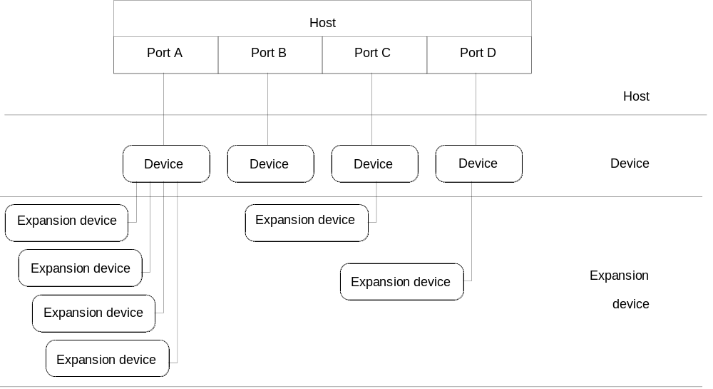
Fig. 1-1 Physical connection topology

Physical connection is of one type: From host to device to expansion. Device There is one host per system.
A host can have a maximum of four ports for connecting peripherals. One device can be connected per port.
A device can be connected to a maximum of four expansion devices for external connections.
The following connections are not supported:
a) Host and expansion device connected directly.
b) Device connected to device.
c) Expansion device connected to device.
d) Expansion device connected to expansion device.
The host and device are connected by the stipulated cable.
(2) Physical connection topology
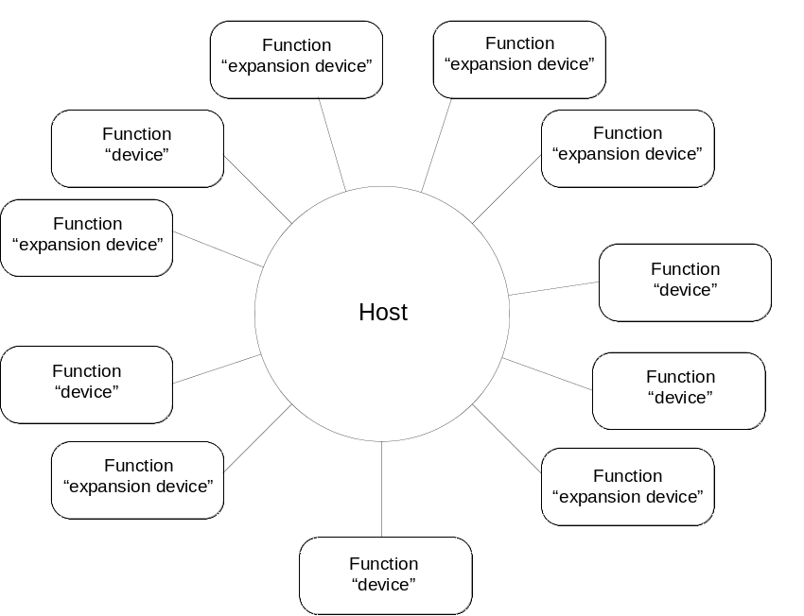
Fig. 1-2 Physical connection topology

The physical connections between each function (device, expansion device) and the host make a star formation with the host at the center.
Signal transmission and reception are managed by the host.

1.1.2 Layer configuration and communication flow

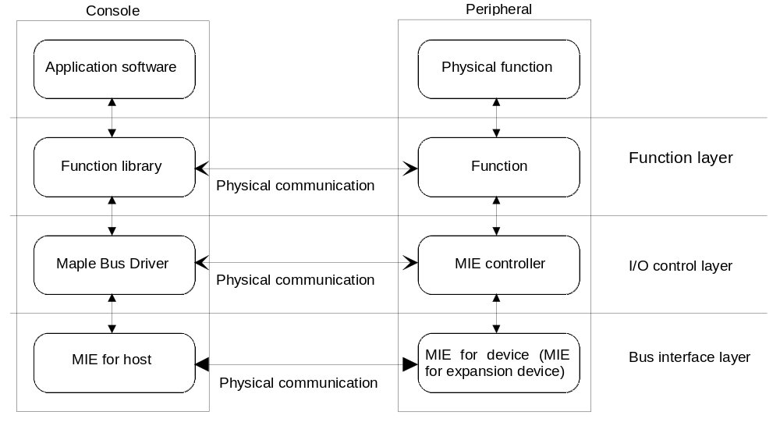
Fig. 1-3 Layer configuration
Function layer
This layer uses the various functions of the peripheral devices and performs data transmission/receiving according to the data format. It specifies and accesses the function type.
Peripheral devices can have a maximum of three functions.

I/O control layer
This layer transmits and receives data in frame units and controls the MIE. It specifies the AP and gains access.

Bus interface layer:
Layer that physically connects the host and the device, and sends and receives signals.

1.1.3 Types of peripherals
Peripherals are classified into the types shown in Fig. 1-4.
Fig. 1-4 Classification of peripherals
Device type | Peripheral type | Examples
Device | Controllers | Standard controller, joy-stick, steering
 | Others | Keyboard, mouse, gun
Expansion device | Controller expansion devices | Audio input, backup memory, gun

Controllers have a standard data format so the they can be used with any application software.
The data format for other devices and expansion devices varies depending on the device, so a function library must be readied for each function.

1.1.4 Definition of Data Direction
Using the host as the starting point, the data flow is defined as shown in the diagram below.
Data flow from the host to devices and expansion devices is called "Down Stream" and the opposite is called "Up Stream".

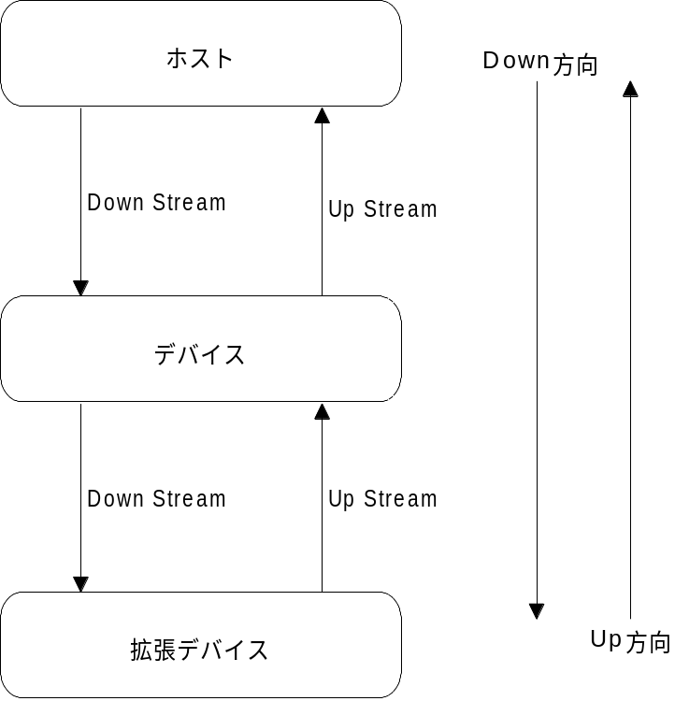
Host
Device
Expansion device
Down direction
Up direction

Fig. 1-5 Direction of Data Flow

In Down Stream flow, data flows from the port specified by the host to all of the devices and expansion devices.
In Up Stream flow, data flows only between the device or expansion device which output the data and the host.

1.2 Description
Serial data and serial bus (Maple-Bus)
"Serial data" is data that is sent sequentially ("in series") one bit at a time.
A "serial bus" is the line (flow) for exchanging data in the form of serial data.
The "Maple-Bus" is the serial bus for Maple Bus. It connects the game unit and peripheral equipment.

Device ID
The device ID is the parameter set assigned to each peripheral to indicate its function.
The device ID consists of 16 bytes that indicate the attributes and function (data format and function elements) of
the peripheral. The device ID can be obtained with the Device Status command.

Port
"Ports" are Maple-Bus terminals for connecting the game unit to peripheral equipment.
Four pins are standard for the ports. These are for the power terminals (VCC, GND) and the data lines (SDCKA, SDCKB).
"Maple-Bus 1.0" supports a maximum of four ports (port A, port B, port C, port D)

Host and functions
The game unit side is called the "host," and the function/s configuring the peripheral to which it is connected is called "function/s".
A function does not refer to the product itself, but rather to the elements making up the product. One product can have multiple functions.
Peripherals are groups of functions, and access from the host is performed in peripheral units. Access to functions is performed by designating the specific function type.
Multiple functions can be used with the one peripheral. However, with Maple Bus 1.0, a maximum of three functions can be used.
Device and expansion device
Peripherals are of two physical types, the "device" and the "expansion device".
The device is connected to the host, and is the peripheral that controls the expansion device.
The expansion device is connected to a device, and is a peripheral that cannot work without a device.
The Maple-Bus that links the device to the expansion device is called the "LM-Bus".
Logically (in terms of the signal), the LM-Bus and the Maple-Bus are the same thing, but physically they are different.
Of the peripherals, devices are generally controllers, and expansion devices are expansions of the controllers.
Only one device can be connected per host port, and one device can manage up to five expansion devices (and up to five LM-Buses).

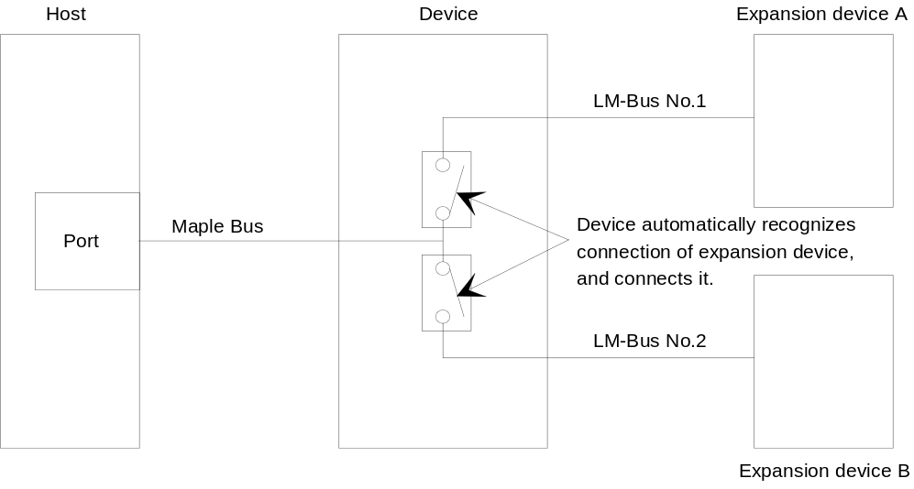
Fig. 1-6 Connection diagram for device and expansion devices

Absolute Position (AP)
So that the device and multiple expansion devices can be accessed directly via the one port, the device and expansion devices are assigned a recognition number where they are connected.
The assigned number is called the Absolute Position (AP).
In "Maple Bus 1.0", the AP is fixed as one byte, made up as follows:
[Maximum of 4 ports (2 bits)] x [Maximum of 6 APs assignable to 1 port (6 bits)) = [1 byte (8 bits)]
The assignable APs are decided according to the connection pattern and the device and expansion devices. (For details, see Chapter 3.) These APs are used for accessing the device and expansion devices.

Commands and parameters
Instead of the conventional fixed data for exchange between host and functions, the appropriate data can be sent and received at the appropriate time and place, and data can be exchanged using specific commands.
Data for a command is called the parameter.
A parameter consists of the AP of the destination device, the AP of the originating device, data size, and data.
"Maple Bus 1.0" supports a maximum of 254 basic commands, and can transfer data of up to 1020 bytes per access.
Frames
Data is transferred in and out of ports in units called "frames". (See Fig. 1.7.)
One frame consists of the start pattern, the command code, the parameter (AP of destination device, AP of originating device, data size, and data), the parity bit, and the end pattern.
One frame is transmitted in one access, and one access is performed within one INT per function.
The MIE (described later) adds and controls the start pattern, parity bit, and end pattern.

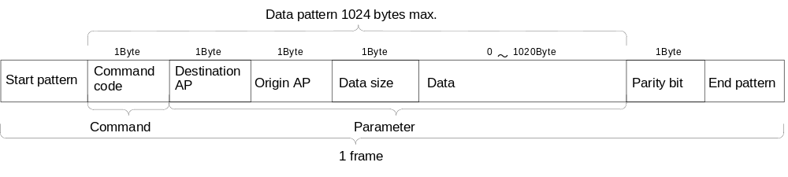
Fig. 1-7 Frame format

The rows of data within the data pattern are determined by the order (array) in which the data are stored in the host's memory.

Acknowledge and Time Out
"Acknowledge" is the response to the command that the host sends to the device or expansion device. After sending a command, the host waits for a certain time for the Acknowledge. If there is no Acknowledge during this time, a "Time Out" occurs. This means that the device is considered as being cut off from the host.
In addition, if a device Times Out during reception, it performs a soft reset.
The time (reply time) until Time Out occurs is 1.0 ms.
In the figure below,
1) The Acknowledge from the device is within the acknowledge time, so is normal.
2) No Acknowledge is received, so a Time Out occurs.
3) The Acknowledge does not occur during the acknowledge time, so a Time Out occurs.
4) The interval between data transmissions has exceeded the acknowledge time, so a Time Out occurs.
The hardware is reset at the port of any peripheral that has had a Time Out.

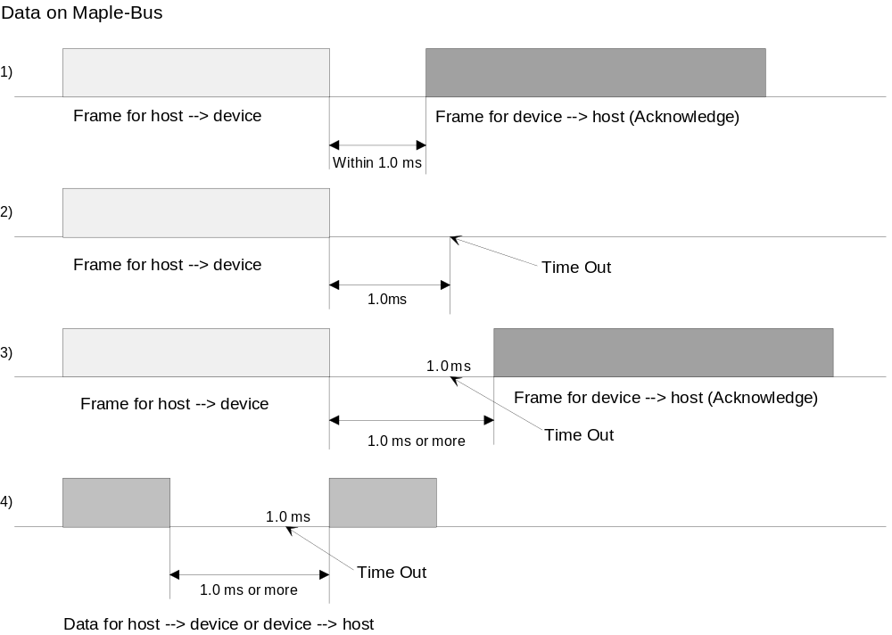
Fig. 1-8 Time Out

Expansion socket
The place where an expansion unit is connected for expanding the controller function is called the
"expansion socket." Expansion devices are connected to expansion sockets.
"Maple Bus 1.0" can have a maximum of four expansion sockets. This is because the correspondence between the
expansion sockets and LM-Buses is performed using the logic of two ID lines.
The number of LM-Buses and number of expansion sockets do not have to be the same.

Maple Bus I/F Engine (MIE)
The MIE is a circuit for converting data for the Maple Bus into serial data and sending and receiving this data
over the Maple-Bus.
All equipment conforming to the Maple Bus specification has an MIE.
The host has a host MIE, the device has a device MIE, and the expansion devices have expansion device MIEs.
The MIE only converts data. For extraction data from the frame, the host uses the Maple Bus Driver (described next),
and the device uses software (firmware) called the MIE controller.

Maple Bus Driver and Function Library
For the host to access a peripheral, it must do so through the "Maple Bus Driver" and "Function Library", which is
software that controls peripherals (devices, expansion devices).
The Maple Bus Driver controls and manages frames. The Function Library performs control by issuing commands to all
types of peripherals (functions), and manages parameters (data formats).
The Maple Bus Driver is of one type for all peripherals. There is a Function Library for each function.
One peripheral device can use up to three Function Libraries which are indicated in the function type.
Device status
All devices and expansion devices used with "Maple Bus" must record their own information according to a
designated format. This device information is called "device status." The device status consists of the management
data, which covers product name, device ID, license, and destination, and the electrical data,
such as current consumption during standby, maximum current consumption, etc.
The device status is used for managing the device library and application software so that, for example, copied
products (judging by their product name or license) can be excluded, and the current for all ports can be
controlled according to the maximum current consumption.

1.3 Scope of Specification
Of the overall processing of Maple Bus, this document sets down the following specifications.
(1) Physical specifications
(2) Interface specifications for the host's MIE and Maple Bus Driver
(3) Interface specifications for the functions and the MIE controller
(4) Specifications for communication protocol
(5) Data format

CHAPTER 2 DATA TRANSFER PATTERNS
This chapter explains the physical data transfer over Maple Bus.

2.1 Overview
Data is transferred using a synchronous serial format.
A total of four cable wires are used, being the power wires (VCC and GND) and the bi-directional data wires (SDCKA and SDCKB).
Data transmission is bi-directional half-duplex, with a maximum transfer rate of 2 Mbps.
The conversion of data patterns into data and the decoding and addition of information patterns are done automatically by the MIE.

2.2 Transmission Principle

2.2.1 Data pattern formed by SDCKA and SDCKB

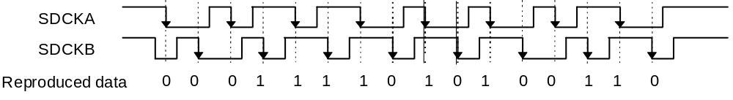
Fig. 2-1 Data pattern

The signals sent by serial data clock A (SDCKA) and serial data clock B (SDCKB) always alternate with the falling edge at the time of transfer of transmission data.
On the receiving side, one falling edge latches the other signal for data. This data is transmitted from the MSB (Most Significant Bit). SDCKA is the clock for starting, and SDCKB is the data.

2.2.2 Information patterns through SDCKA and SDCKB
(1) Synchronous patterns

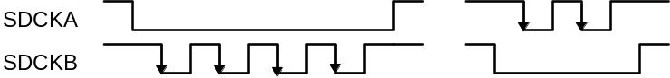
Fig. 2-2 START pattern Fig. 2-3 END pattern

Figure 2-2 shows the synchronous pattern (START) that is transmitted ahead of the data pattern (see Fig. 2-1).
At the receiving side, if four falling edges are detected on the SDCKB line while the SDCKA line is going from falling to rising, the subsequent pattern is decoded as the data pattern.
Figure 2-3 shows the synchronous pattern (END) that designates the end of the data pattern.
On the receiving side, if two falling edges are detected on the SDCKA line while the SDCKB line is going from falling to rising, the end of the data pattern is confirmed and it is treated as ending normally.
(2) SDCKB occupy authorization pattern (light-GUN)

Fig. 2-4 SCKB occupy authorization pattern
On the receiving side, if eight falling edges are detected on the SDCKB line while the SDCKA line is going from falling to rising, the SDCKB line will be occupied from the next falling edge of the SDCKA line until the SDCKA line is rising.
The SDCKB occupy mode must be canceled by the following rising edge of SDCKA.

(3) Reset pattern

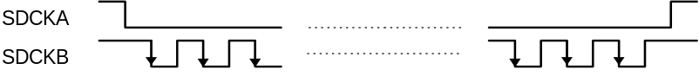
Fig. 2-5 Reset pattern
On the receiving side, if 14 falling edges are detected on the SDCKB line while the SDCKA line is going from falling to rising, reset is performed according to a reset request from the sending side.

2.3 Transmission Format
Data transmission is done in frame units (minimum units).
The frame consists of the START pattern that designates the start of data transmission, the data pattern that can be as long as 1024 bytes, the parity, and the END pattern.
At sending, MIE automatically adds the 8-bit horizontal parity. At receiving, it is erased.

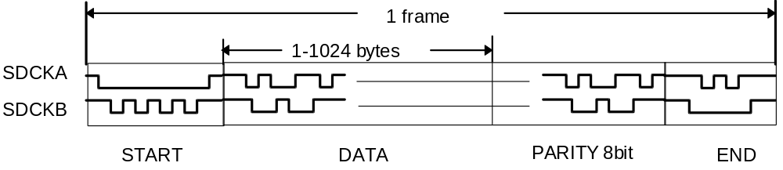
Fig. 2-6 Standard format

CHAPTER 3 PROTOCOLS
This chapter explains the communication protocols between the host and peripherals.
Commands are shown in the text in the form [command_name]. See Chapter 6 for details.

3.1 Overview
All communication between the host and peripherals is in frame units. The host sends instructions to the peripherals in the form of commands and parameters in the frames, and the peripherals respond to these.
In this flow, the host has priority rights for sending commands.

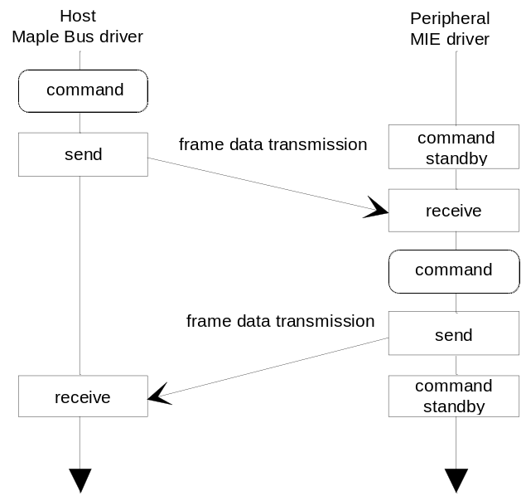
Fig. 3-1 Overview of data transfer
The device and expansion devices can be accessed directly from the host with the same protocol. No intermediate data conversion is required. The AP data necessary for accessing is decided according to the host's connected port, device and expansion socket.
When the device is accessed, the connection status of its expansion devices can be confirmed.
Peripherals can be connected and disconnected even when the host is in operating status.
The host can request the peripherals for their device status so that it can obtain information about them. If no request is made, the peripherals do not start to operate, but remain in standby status.
There are two types of reset for peripherals, the software reset (reset command) and the hardware reset (reset pattern). The software reset can be done for specific peripherals only, but the hardware reset can be done for all peripherals connected to the ports.
Data transmission is done in frame units of 1024 bytes maximum.
One peripheral can use a maximum of three functions. Functions are accessed by specifying their respective function type.
One function can be accessed a maximum of one time during one INT, and one frame of data can be sent per access.
One port cannot be continually accessed. (If continuous access in unavoidable, use the NOP instruction.)

3.2 Frame Data

3.2.1 Frame
One function can be accessed a maximum of one time during one INT. The amount of data that can be transferred per access is one frame for sending, and one frame for receiving.

Data pattern
1024 bytes max.
1 Byte

1 Byte

1 Byte

0 ~ 1020 Byte

1 Byte

start pattern
Command code
Destination AP
Origin AP
Data size
Data
Parity bit
End pattern
1 Byte

Command
Parameter
1 frame

Fig. 3-2 Frame
(1) Start pattern, parity bit, end pattern
These are governed by the data transmission pattern (Chapter 2) and are processed automatically by the MIE.
(2) Data pattern
The data pattern contained in the frame is configured of four-byte units, and is a minimum of four bytes and a maximum of 1024 bytes.
When it consists of the minimum four bytes only, it has just the command code, the destination AP, the origin AP, and the data size (= 00h).
The command code designates the code of the command that instructs the destination peripheral.
The destination AP designates the AP to which the frame is sent. (The host designates APs for the device and expansion device, and the device and expansion devices designate APs for the host's ports).
The origin AP designates the originating equipment's own AP.
Data size designates the transmission data size in units of four bytes.
Transmission data (including the data format, etc.) is stored in 4 byte units.
The order of the rows of data (array) is the order in which it is stored in the host's memory.

3.2.2 Command code
The command code is contained in one byte.

bit | 7 | 6 | 5 | 4 | 3 | 2 | 1 | 0
Data | COM₇ | COM₆ | COM₅ | COM₄ | COM₃ | COM₂ | COM₁ | COM₀
Fig. 3-3 Configuration of command codes
COM₀-COM₇: Command code
These are designated in the range from 01h to FEh. See Chapter 6 for details.

3.2.3 AP
(1) Types of AP
The value of the AP is fixed according to the connection pattern of the device and the expansion devices.
There are two types of AP, the destination AP and the origin AP.
(2) Configuration of AP bits
These are configured in one byte.
Bit | 7 | 6 | 5 | 4 | 3 | 2 | 1 | 0
Data | PO₁ | PO₀ | D/E | LM₄ | LM₃ | LM₂ | LM₁ | LM₀
Fig. 3-4 AP configuration

PO₀, PO₁: Port setting bits
Selection port | PO₁ | PO₀
Port A | 0 | 0
Port B | 0 | 1
Port C | 1 | 0
Port D | 1 | 1
Fig. 3-5 Port setting bits

D/E: Device/expansion device setting bits
Setting device | D/E
Device | 1
Expansion device | 0
Port | 0
Fig. 3-6 Device/expansion device setting bits

LM₀-LM₄: LM-Bus No. setting bits
Destination | LM₄ | LM₃ | LM₂ | LM₁ | LM₀
Device | 0 | 0 | 0 | 0 | 0
Expansion device | Lower table
Port | 0 | 0 | 0 | 0 | 0

LM-Bus No. | Setting bit | Access or connection status | Disconnected status
No.1 | LM₀ | 1 | 0
No.2 | LM₁ | 1 | 0
No.3 | LM₂ | 1 | 0
No.4 | LM₃ | 1 | 0
No.5 | LM₄ | 1 | 0
Fig. 3-7 LM-Bus No. setting bits
When an expansion device is being accessed, only its LM-Bus No. setting bit is set to "1".
When the device responds, the origin AP at the time automatically sets the device AP and the connection status setting bits of the expansion devices on the LM-Buses to OR.
Example:
1) When the device is accessed from port A:
Destination AP = "00100000" (20h) Origin AP = "00000000" (00h)
The acknowledge (expansion devices are connected to the device over LM-Buses No. 1 and 3)
Destination AP = "00000000" (00h) Origin AP = "00100101" (25h)
In the device's AP = "00100000", the origin AP has been OR'ed with the expansion devices' connection statuses
(LM0, LM2 = "1").

2) When the expansion device (LM-Bus No.1) is accessed from port B:
Destination AP = "01000001" (41h) Origin AP = "01000000" (40h)
Acknowledge
Destination AP = "01000000" (40h) Origin AP = "01000001" (41h)

(3) AP value and connection location
Below is a table showing the APs of the device and expansion devices when they are accessed from the host.
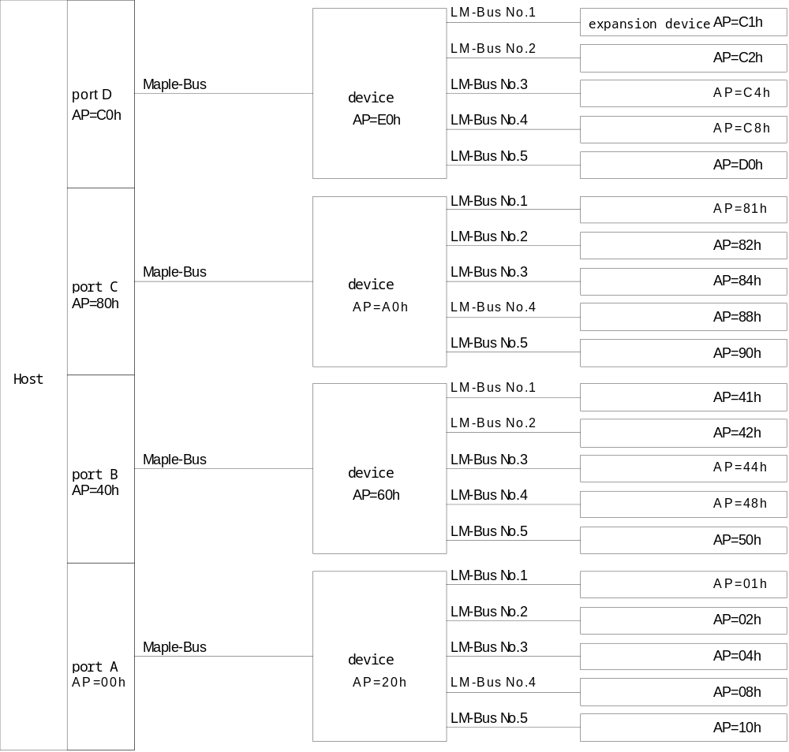
Fig. 3-8 Values of all APs
When the device responds, the origin AP at the time becomes the value of the sum (all OR) of the device's own AP and the connected expansion devices' APs.

3.2.4 Data size
Configured of one byte.

bit | 7 | 6 | 5 | 4 | 3 | 2 | 1 | 0
Data | DS₇ | DS₆ | DS₅ | DS₄ | DS₃ | DS₂ | DS₁ | DS₀
Fig. 3-9 Configuration of data size
DS₀-DS₇: Data size
The data size is designated in four-byte units, from a minimum of 0 bytes to a maximum of 1020 bytes.

bit | 7 | 6 | 5 | 4 | 3 | 2 | 1 | 0
Designated data size | DS₇ | DS₆ | DS₅ | DS₄ | DS₃ | DS₂ | DS₁ | DS₀
0Byte | 0 | 0 | 0 | 0 | 0 | 0 | 0 | 0
4Byte | 0 | 0 | 0 | 0 | 0 | 0 | 0 | 1
8Byte | 0 | 0 | 0 | 0 | 0 | 0 | 1 | 0
： | ： | ： | ： | ： | ： | ： | ： | ：
508Byte | 0 | 1 | 1 | 1 | 1 | 1 | 1 | 1
512Byte | 1 | 0 | 0 | 0 | 0 | 0 | 0 | 0
516Byte | 1 | 0 | 0 | 0 | 0 | 0 | 0 | 1
： | ： | ： | ： | ： | ： | ： | ： | ：
1012Byte | 1 | 1 | 1 | 1 | 1 | 1 | 0 | 1
1016Byte | 1 | 1 | 1 | 1 | 1 | 1 | 1 | 0
1020Byte | 1 | 1 | 1 | 1 | 1 | 1 | 1 | 1
Fig. 3-10 Data size

3.2.5 Data
Transmission data is handled in the size (four-byte units) designated by the data size.

bit | 7 | 6 | 5 | 4 | 3 | 2 | 1 | 0
1st Data | D1₇ | D1₆ | D1₅ | D1₄ | D1₃ | D1₂ | D1₁ | D1₀
2nd Data | D2₇ | D2₆ | D2₅ | D2₄ | D2₃ | D2₂ | D2₁ | D2₀
3rd Data | D3₇ | D3₆ | D3₅ | D3₄ | D3₃ | D3₂ | D3₁ | D3₀
4th Data | D4₇ | D4₆ | D4₅ | D4₄ | D4₃ | D4₂ | D4₁ | D4₀
： | ： | ： | ： | ： | ： | ： | ： | ：
Fig. 3-11 Configuration of data

The contents of the data vary depending on the function. For controllers, for instance, the data contains the controller function type and data format.
3.3 Data Transmission
3.3.1 Request and acknowledge
(1) Request from host
Orders and requests made to devices (functions) are called "commands".
When a command is sent to a device, some kind of command will always be returned.
If a transmission error occurs, the hardware sets an error flag, and error processing is done. For details, see Chapter 4 "Internal Interface of Host".

(2) Acknowledge from device (function)
After connection, the device (function) does not operate until it receives a "Device Request". It always returns some kind of command in response to a command from the host.
The function can receive one command during one INT.

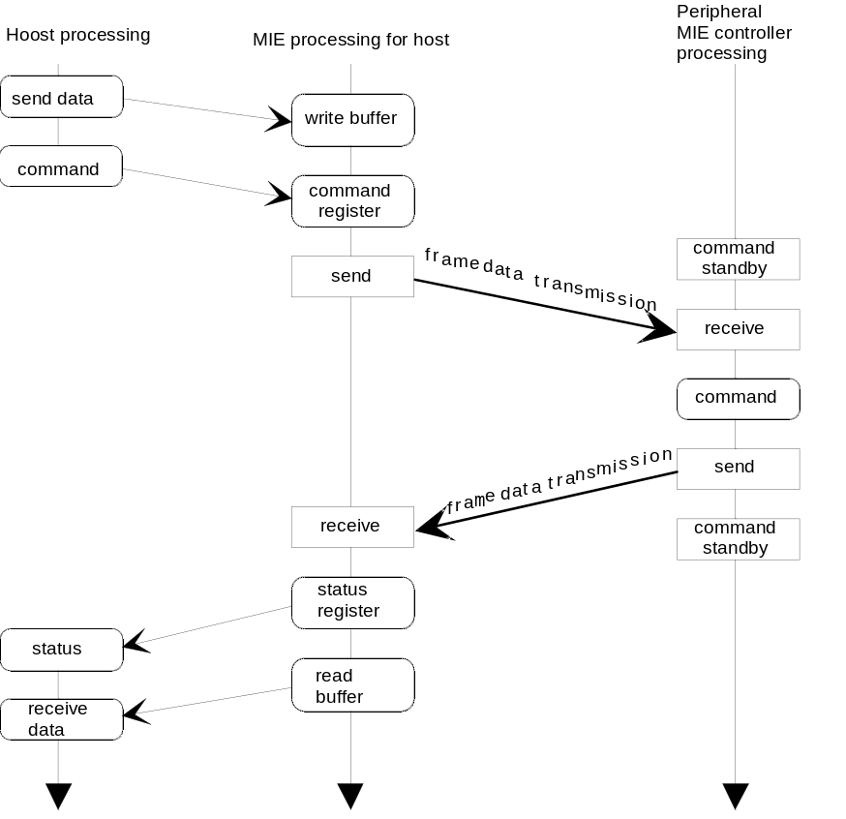
Fig. 3-12 Flow of request and acknowledge

3.3.2 Transmission errors
(1) Types of errors
Errors that can be detected by the hardware are of the following types:
1) Parity errors
Occurs when the parity of the data frame does not agree.
2) Time Out (hardware detection only for the host)
Time Out period has elapsed while the SDCKA and SDCKB lines have maintained a fixed state.
3) Data overflow
Occurs when the send buffer or receive buffer is exceeded
Other errors (such as jumbled data) must be detected with the software.
When a frame is received and a hardware-detectable error occurs, the flags are notified.

(2) Host processing
If a receive error occurs at the host, a resend command is sent by the command that was sent to the device. The resend command is sent a maximum of three times. If an error still occurs, disconnection and error display are processed. The number of resends and the processing method differ according to the application software and library.
Commands which are resent by a device can be received up to three times for each command sent by the host. Anything more than that will be processed as an error.
The error processing consists of opening an interval of 1 INT or more on the port which had the error and sending a hardware reset (reset pattern).
Following that, a [Device Request] is performed if necessary.
In the case of a Time Out, it responds according to "3.4.3 Disconnection Check".

(3) Device processing
When a send error occurs, error processing such as resend is not done.
When a receive error occurs, a resend command can be sent.
If the Time Out occurs when receiving, a software reset is performed.
Time Out detection is performed by the device only. The ID line is used to send the reset signal from the device to the expansion device. (LM-Bus Reset)

(4) Up Stream Time Out
If an abnormal condition occurs in the MIE or the Maple-Bus when sending from a device or extended device to the host and it cannot get out of the transmission condition, the host will detect a Time Out and initiate disconnect processing. However, because the device or expansion device is transmitting, it will not receive the reset pattern. Therefore, the expected time of transmission completion is calculated by the device or expansion device which sent the data and if the transmission condition continues for longer than that time it resets the MIE.
In addition, the transmission time for one period is ended within 1 INT.

3.3.3 Illegal items
When connected to the host, a device cannot access another device directly. It must go via the host without fail.
The device must not use any command that can be issued by the host only.
The same port (regardless of the device, expansion device even if the function is different) cannot be continuously accessed.
If continuous access in unavoidable, use the NOP instruction. (Insert at least 2 NOP instructions between accesses.)
A device or expansion device may not unilaterally send data to the host (only as response).

3.3.4 Device Processing
For information on the LM-Bus, please refer to "5.4.5 LM-Bus".

(1) Initialization
MIE is set to the receive condition.
The LM-Bus is completely cutoff and is set so that data does not flow to expansion devices.
ID0, ID1 of the LM-Bus are the reverse of the Bus No.'s setting values.

(2) LM-Bus Controls
The LM-Bus is free until it receives a [Device Request].
When it receives the first [Device Request] after initialization, it reverses the ID0, ID1 of the LM-Bus and returns them to the set values.
If it detects a '1' on ID2 for each LM-Bus, the expansion device is connected, so it connects that LM-Bus to the Maple-Bus.
It reads the current status of the LM-Bus and reflects the [Device Status], which is the reply to the [Device Request] in the AP.
If a "0" is detected on the ID2 of each LM-Bus, the expansion device is not physically connected, so that LM-Bus is disconnected from the Maple-Bus.
This check of ID2 is conducted every time a command is received from the host.

(3) Down Stream Time Out
The device is always detecting the Maple-Bus' Down Stream Time Out.
It begins detection after resetting.
A Time Out is when there is no change for more than 1 ms in either the SDCKA or SDCKB.
Detection begins when the start pattern is received and continues until the end when the end pattern is received.

3.3.5 Expansion Device Processing
(1) Initialization
MIE is set to the receive condition.
When connected to the LM-Bus, the ID2 is set to '1' (Usually fixed at '1' by a circuit.)
Reads ID0, ID1 and sets the lower 6 bits of its own AP.

(2) ID Controls
When ID0, ID1 both reverse at the same time, it resets as if it were a reset request from a device.
ID0, ID1 detect at a minimum of 1ms intervals (preliminary).

3.3.6 AP Settings
The AP settings of peripheral devices are set at the first [Device Request] after initialization.
Access by the host to the peripheral device uses the peripheral device as the transfer destination and the AP of the host port which outputs the data as the transfer origin.
The peripheral device compares the transfer destination AP sent by the host with its own AP, and if it matches, it recognizes it as data sent to itself and replies to the host.
The AP of this reply is the transfer origin AP (port AP) of the data sent.

However, the AP settings of a peripheral device that is a transfer destination are not defined by the [Device Request].
Consequently, the port setting bit of the peripheral device AP is set arbitrarily by the host side.
(It is recommended to set to the port to be used.)
The peripheral device side compares the lower 6 bits of the transfer destination AP and detects a matching setting.
The peripheral device decides on the AP based on the port setting bit of the transfer destination AP of the [Device Request].

3.4 Connection and Cutoff of Peripherals

3.4.1 Host processing
The host sends a Device Request to the device of each port.
The destination device AP is decided by each port.
The signal does not have to be sent to ports not using application software.
The send interval should be per one INT, and there is no need to send the Device Request after the device responds.

3.4.2 Connection check
(1) Device
When the host sends a Device Request to a port, the device returns the Device Status.
The host recognizes that the device is connected to the port for which the Device Status has been written.
If the device makes no response (Time Out), that port is disconnected.
Time Out is the condition in which no response is made within 1.0 ms of the command being sent.

(2) Expansion device
If the host accesses only the device through the port, it will receive a response (origin AP) from the device, including the connection status of any expansion device connected to that device, so there is no need for all the expansion devices to undergo the connection check that the device undergoes.
Further, when the device is accessed, and the response from the device changes the connection setting bit to "1" for the expansion device that had been disconnected by the origin AP, this means that the expansion device indicated by this setting bit is newly connected.
After the device is accessed, the connection status of the expansion device is known, so a Device Request is also sent to the expansion device and Device Status is waited. If there is no Device Status response (Time Out), that expansion device is disconnected.

(3) Operation of peripherals
As soon as they are connected, all peripherals are in the standby status. They cannot operate as devices, and have only the lower six bits of their own AP.
On receiving the Device Request from the host, the peripheral saves the port to which it is connected and for the first time completes its own AP and starts operation.
The connected port is found from the origin AP of the Device Request.
If another command is received before receiving the Device Request, the peripheral makes no response to the host.
The AP is completed upon the first [Device Request] after connection (after resetting).
The AP does not change on subsequent [Device Requests].

3.4.3 Disconnection check
(1) Device
If there is no response (Time Out) to a command sent to a connected device, the host recognizes this as meaning that the device has been cut off and is disconnected.
The host conducts up to three confirmations of a disconnection.
The host opens up a minimum of a 1INT interval on the disconnected port and performs a hard reset.

(2) Expansion device
If there is no response (Time Out) to a command sent to a connected expansion device, the host recognizes this as meaning that the expansion device has been cut off and is disconnected.
Further, if the host accesses the device, and the response from the device causes the connection setting bit to change to "0" for the expansion device that was connected to the origin AP, the expansion device indicated by that setting bit is cut off, and is indicated as being disconnected.
When a Time Out occurs, the host opens up a minimum of a 1INT interval on the disconnected port and performs a hard reset.
If a disconnect occurs at the device's transfer destination AP, it stops sending without performing a hard reset. The host perceives it as an internal (software) expansion device disconnection.
The order of processing priority puts the confirmation processing at the device's transfer destination AP first and then does the Time Out processing.

(3) Operation of peripherals
Once cut off, power is cut off from all peripherals, so that the stored information on the connection ports is lost. Consequently, even when they are reconnected, peripherals will not start to operate.
When a hard reset is received, the functions will not work if it is not reconnected using a [Device Request].
(Refer to section 3.5 Reset)

3.5 Reset
There are three kinds of reset, the hard reset (reset pattern), the soft reset (reset command), and the LM-Bus reset.
The hard and soft resets are done from the host while the LM-Bus reset is done by a device to an expansion device.

(1) Hard reset
It is a reset done by a reset pattern and it can reset all of the devices and expansion devices on that port.
There are no replies from the devices, etc.
It is used to recover from disconnect (Time Out) processing or [Device Kill].
When a device or expansion device receive a hard reset, it processes in the following order.
(1) Halt normal operations
(2) Disconnect LM-Bus (device only)
(3) Reset MIE
(4) Initialize registers, RAM (location depends on peripheral device)
(5) Wait for [Device Request]

(2) Soft reset
It is a reset done with a reset command and it can initialize specific devices and expansion devices.
[Device Reply] is sent from the device and then the device is initialized.
When a device or expansion device receive a [Device Reset], it processes in the following order.
(1) Halt normal operations
(2) Reset MIE
(3) Initialize registers, RAM (location depends on peripheral device)
(4) Wait for [Device Request]
Even if a device performs a soft reset, Time Out detection continues.

(3) LM-Bus Reset
In the case where a device detects a Down Stream Time Out, it resets the expansion device.
The reset uses the LM-Bus ID0,1 lines to reverse the logic at the same time and send a reset request from the device to the expansion device.
The device and expansion device execute the following processes.

Processing Order | Device | Expansion Device
1 | Initialize | Normal operation
2 | There is a chance that ID0,1 will become indefinite during initialization. (the period is less than 5ms (preliminary)) | Normal operation  ID0, ID1 are not reversed, so they don't initialize.
3 | Reversed from the ID0, ID1 from before initialization (expansion device initialization) | ID0, ID1 are reversed so they are initialized. (LM-Bus reset)
4 | Waits for [Device Request]. | Initializes.
5 | Normal operation | Waits for [Device Request].
6 | Normal operation | Normal operation.
Fig. 3-13 LM-Bus processing sequence
(4) Initialized Locations
With the exception of some functions, variables and contents of RAM and other data stored in the devices and expansion devices are initialized back to the values immediately after turning on the power.
The AP is also initialized, so in the case where it is reused, it is necessary for the host to send a [Device Request].

3.6 Setting of Device ID
The device ID is written in the Fixed Device Status. When a Device Request is received from the host, this causes the device ID to be sent to the host by Device Status.

3.6.1 Definition of device ID
The function type and declarative in the function definition block are registered for the device and expansion devices.
All peripherals always have one device ID and at least one function.

3.6.2 Configuration of device ID
The device ID consists of 16 bytes (128 bits).
Fig. 3-14 Configuration of device ID

bit | 7 | 6 | 5 | 4 | 3 | 2 | 1 | 0
1st Data | FT₃₁ | FT₃₀ | FT₂₉ | FT₂₈ | FT₂₇ | FT₂₆ | FT₂₅ | FT₂₄
2nd Data | FT₂₃ | FT₂₂ | FT₂₁ | FT₂₀ | FT₁₉ | FT₁₈ | FT₁₇ | FT₁₆
3rd Data | FT₁₅ | FT₁₄ | FT₁₃ | FT₁₂ | FT₁₁ | FT₁₀ | FT₉ | FT₈
4th Data | FT₇ | FT₆ | FT₅ | FT₄ | FT₃ | FT₂ | FT₁ | FT₀
5th Data | FD1₃₁ | FD1₃₀ | FD1₂₉ | FD1₂₈ | FD1₂₇ | FD1₂₆ | FD1₂₅ | FD1₂₄
6th Data | FD1₂₃ | FD1₂₂ | FD1₂₁ | FD1₂₀ | FD1₁₉ | FD1₁₈ | FD1₁₇ | FD1₁₆
7th Data | FD1₁₅ | FD1₁₄ | FD1₁₃ | FD1₁₂ | FD1₁₁ | FD1₁₀ | FD1₉ | FD1₈
8th Data | FD1₇ | FD1₆ | FD1₅ | FD1₄ | FD1₃ | FD1₂ | FD1₁ | FD1₀
9th Data | FD2₃₁ | FD2₃₀ | FD2₂₉ | FD2₂₈ | FD2₂₇ | FD2₂₆ | FD2₂₅ | FD2₂₄
10th Data | FD2₂₃ | FD2₂₂ | FD2₂₁ | FD2₂₀ | FD2₁₉ | FD2₁₈ | FD2₁₇ | FD2₁₆
11th Data | FD2₁₅ | FD2₁₄ | FD2₁₃ | FD2₁₂ | FD2₁₁ | FD2₁₀ | FD2₉ | FD2₈
12th Data | FD2₇ | FD2₆ | FD2₅ | FD2₄ | FD2₃ | FD2₂ | FD2₁ | FD2₀
13th Data | FD32₃₁ | FD3₃₀ | FD3₂₉ | FD3₂₈ | FD3₂₇ | FD3₂₆ | FD3₂₅ | FD3₂₄
14th Data | FD3₂₃ | FD3₂₂ | FD3₂₁ | FD3₂₀ | FD3₁₉ | FD3₁₈ | FD3₁₇ | FD3₁₆
15th Data | FD3₁₅ | FD3₁₄ | FD3₁₃ | FD3₁₂ | FD3₁₁ | FD3₁₀ | FD3₉ | FD3₈
16th Data | FD3₇ | FD3₆ | FD3₅ | FD3₄ | FD3₃ | FD3₂ | FD3₁ | FD3₀

FT :Designates type of function that the peripheral is equipped with.
FD1 :Designates the function definition block of the first function.
FD2 :Designates the function definition block of the second function.
FD3 :Designates the function definition block of the third function.
The contents of FD1, FD2, and FD3 vary depending on the function designated by FT.
(1) FT₀-FT₃₁: Function type
Designates the function that the peripheral is equipped with.
There are 32 function types altogether. Each has a set command and data format.
Fig. 3-15 Function type

bit | Function type | bit | Function type
FT₃₁ | Reserved | FT₁₅ | Reserved
FT₃₀ | Reserved | FT₁₄ | Reserved
FT₂₉ | Reserved | FT₁₃ | Reserved
FT₂₈ | Reserved | FT₁₂ | Reserved
FT₂₇ | Reserved | FT₁₁ | Reserved
FT₂₆ | Reserved | FT₁₀ | Reserved
FT₂₅ | Reserved | FT₉ | Reserved
FT₂₄ | Reserved | FT₈ | Reserved
FT₂₃ | Reserved | FT₇ | Reserved
FT₂₂ | Reserved | FT₆ | Keyboard
FT₂₁ | Reserved | FT₅ | AR-Gun
FT₂₀ | Reserved | FT₄ | Audio input
FT₁₉ | Reserved | FT₃ | Timer
FT₁₈ | Reserved | FT₂ | B/W LCD
FT₁₇ | Reserved | FT₁ | Storage
FT₁₆ | Reserved | FT₀ | Controller
Up to three function types can be set on one peripheral device. The function type's setting bit is set to '1'.
The function type indicates the category of the peripheral device's function. Detailed classification and specification is done in the function definition block.
Setting bits have an order or priority, with the highest order bit (FT₃₁) being highest, and the lowest order bit (FT₀) being lowest. Up to three Function Libraries can be set in order of their priority.
The order of priority for function definition blocks is such that FD1 is highest and FD3 is lowest.

(2) FD1₃₁-FD1₀: First function definition block
This is for the block defining the individual elements making up the first function.
The contents vary depending on the function.
See the respective function specifications for details.

(3) FD2₃₁-FD2₀: Second function definition block
This is for the block defining the individual elements making up the second function.
The contents vary depending on the function.
See the respective function specifications for details.

(4) FD3₃₁-FD3₀: Third function definition block
This is for the block defining the individual elements making up the third function.
The contents vary depending on the function.
See the respective function specifications for details.

3.7 Function Data Format and Definition Block
Designates the data format for performing data exchange with peripherals.

3.7.1 Types of peripherals
Peripherals are classified into the types shown in Fig. 3-15.
Fig. 3-16 Classification of peripherals
Device type | Peripheral type | Examples
Device | Controllers | Standard controller, joy-stick, steering
 | Others | Keyboard, mouse, gun
Expansion device | Controller expansion devices | Audio input, gun, backup memory

(1) Controller
The function type is connected to the host's port for use by the controller. The data format is standard so that many applications can be supported. The elements of the controller functions is as follows:
• Digital direction key A ：Ra, La, Da, Ua
• Digital direction key B ：Rb, Lb, Db, Ub
• Digital button ：A, B, C, D, X, Y, Z, Start
• Analog key ：A3, A4, A5, A6
• Analog lever ：A1, A2

Also, the controller peripheral must incorporate the following elements.
• Digital direction key A ：Ra, La, Da, Ua
• Digital button ：A, B, Start
For more details, please refer to FT₀: Controller Function Specifications.

(2) Device = other
This is the peripheral of a device type other than a controller.
The data contents and format, read/write cycle and other items differ according to the peripheral, so it has data formats and Function Libraries corresponding to the various functions.

(3) Expansion device
This peripheral is for expanding the functions of the device.
The data contents and format, read/write cycle and other items differ according to the peripheral, so it has data formats and Function Libraries corresponding to the various functions.

3.7.2 Controller-type function
The function type designates the controller data format and device ID definition block.
For more details, please refer to FT₀: Controller Function Specifications.

(1) Read data format
This format is for reading the controller's data.
The size of the data format is eight bytes.
Fig. 3-17 Controller read format
bit | 7 | 6 | 5 | 4 | 3 | 2 | 1 | 0
1st Data | Ra | La | Da | Ua | Start | A | B | C
2nd Data | Rb | Lb | Db | Ub | D | X | Y | Z
3rd Data | A1₇ | A1₆ | A1₅ | A1₄ | A1₃ | A1₂ | A1₁ | A1₀
4th Data | A2₇ | A2₆ | A2₅ | A2₄ | A2₃ | A2₂ | A2₁ | A2₀
5th Data | A3₇ | A3₆ | A3₅ | A3₄ | A3₃ | A3₂ | A3₁ | A3₀
6th Data | A4₇ | A4₆ | A4₅ | A4₄ | A4₃ | A4₂ | A4₁ | A4₀
7th Data | A5₇ | A5₆ | A5₅ | A5₄ | A5₃ | A5₂ | A5₁ | A5₀
8th Data | A6₇ | A6₆ | A6₅ | A6₄ | A6₃ | A6₂ | A6₁ | A6₀
First :Digital button data (ON = "0", OFF = "1")
Second :Digital button data (ON = "0", OFF = "1")
Third :Analog axis 1 data (value of 00h ←→ FFh).
Fourth :Analog axis 2 data (value of ←→ FFh).
Fifth :Analog axis 3 data (value of 00h ←→ 80h ←→ FFh).
Sixth :Analog axis 4 data (value of 00h ←→ 80h ←→ FFh).
Seventh :Analog axis 5 data (value of 00h ←→ 80h ←→ FFh).
Eighth :Analog axis 6 data (value of 00h ←→ 80h ←→ FFh).

(2) Write data format
There is no format when data is being written to the controller. The data size is zero bytes. Even if data is written, thereis no response.

(3) Function Definition Block
The controller definition block FD divides and designates the elements used in the read format in Fig. 3-16.
Fig. 3-18 Configuration of controller function definition block FD
bit | 7 | 6 | 5 | 4 | 3 | 2 | 1 | 0
1st Data | 0 | 0 | 0 | 0 | 0 | 0 | 0 | 0
2nd Data | 0 | 0 | RB₂₁ | RB₂₀ | RB₁₉ | RB₁₈ | RB₁₇ | RB₁₆
3rd Data | RB₁₅ | RB₁₄ | RB₁₃ | RB₁₂ | RB₁₁ | RB₁₀ | RB₉ | RB₈
4th Data | RB₇ | RB₆ | RB₅ | RB₄ | RB₃ | RB₂ | RB₁ | RB₀
RB: Read format division block

Blocks are divided as shown in the figure below.
Fig. 3-19 Block division for controller read format
bit | 7 | 6 | 5 | 4 | 3 | 2 | 1 | 0
1st Data | RB₇ | RB₆ | RB₅ | RB₄ | RB₃ | RB₂ | RB₁ | RB₀
2nd Data | RB₁₅ | RB₁₄ | RB₁₃ | RB₁₂ | RB₁₁ | RB₁₀ | RB₉ | RB₈
3rd Data | RB₁₆
4th Data | RB₁₇
5th Data | RB₁₈
6th Data | RB₁₉
7th Data | RB₂₀
8th Data | RB₂₁
In correspondence with Fig. 3-17, set the bits to "1" for the blocks to be used, and “0” for the blocks not used. Unused blocks are ignored by the Function Libraries.

3.7.3 Data format and device ID of standard controller
The standard controller has the functions of a controller only. The device ID and data format for the standard controller is shown below.

(1) Device ID
Fig. 3-20 Device ID of standard controller
bit | 7 | 6 | 5 | 4 | 3 | 2 | 1 | 0
1st Data | 0 | 0 | 0 | 0 | 0 | 0 | 0 | 0
2nd Data | 0 | 0 | 0 | 0 | 0 | 0 | 0 | 0
3rd Data | 0 | 0 | 0 | 0 | 0 | 0 | 0 | 0
4th Data | 0 | 0 | 0 | 0 | 0 | 0 | 0 | 1
5th Data | 0 | 0 | 0 | 0 | 0 | 0 | 0 | 0
6th Data | 0 | 0 | 0 | 0 | 1 | 1 | 1 | 1
7th Data | 0 | 0 | 0 | 0 | 0 | 1 | 1 | 0
8th Data | 1 | 1 | 1 | 1 | 1 | 1 | 1 | 0
9th Data | 0 | 0 | 0 | 0 | 0 | 0 | 0 | 0
10th Data | 0 | 0 | 0 | 0 | 0 | 0 | 0 | 0
11th Data | 0 | 0 | 0 | 0 | 0 | 0 | 0 | 0
12th Data | 0 | 0 | 0 | 0 | 0 | 0 | 0 | 0
13th Data | 0 | 0 | 0 | 0 | 0 | 0 | 0 | 0
14th Data | 0 | 0 | 0 | 0 | 0 | 0 | 0 | 0
15th Data | 0 | 0 | 0 | 0 | 0 | 0 | 0 | 0
16th Data | 0 | 0 | 0 | 0 | 0 | 0 | 0 | 0
The device ID is as follows: 00h-00h-00h-01h-00h-0Fh-06h-FEh-00h-00h-00h-00h-00h-00h-00h-00h
Because the controller does not have a second or third function, FD2 and FD3 are all 00h.

(2) Data format
Fig. 3-21 Read format of standard controller
Bit | 7 | 6 | 5 | 4 | 3 | 2 | 1 | 0
1st Data | Ra | La | Da | Ua | Start | A | B | 1
2nd Data | 1 | 1 | 1 | 1 | 1 | X | Y | 1
3rd Data | A1₇ | A1₆ | A1₅ | A1₄ | A1₃ | A1₂ | A1₁ | A1₀
4th Data | A2₇ | A2₆ | A2₅ | A2₄ | A2₃ | A2₂ | A2₁ | A2₀
5th Data | A3₇ | A3₆ | A3₅ | A3₄ | A3₃ | A3₂ | A3₁ | A3₀
6th Data | A4₇ | A4₆ | A4₅ | A4₄ | A4₃ | A4₂ | A4₁ | A4₀
7th Data | 1 | 0 | 0 | 0 | 0 | 0 | 0 | 0
8th Data | 1 | 0 | 0 | 0 | 0 | 0 | 0 | 0
There is no write format.

3.7.4 Storage function
Designates the function type and function definition block for the storage function for the purpose of saving data.
Data other than the function definition (such as total capacity) is obtained by Get Media Info.
For details, see the FT₁ : Storage Function Specifications.
(1) Function type
FT₁ = “1”

- Function definition block
The storage function definition block is shown in Fig. 3-22.
Fig. 3-22 Configuration of the Storage Function Definition Block
bit | 7 | 6 | 5 | 4 | 3 | 2 | 1 | 0
1st Data | PT₇ | PT₆ | PT₅ | PT₄ | PT₃ | PT₂ | PT₁ | PT₀
2nd Data | BB₇ | BB₆ | BB₅ | BB₄ | BB₃ | BB₂ | BB₁ | BB₀
3rd Data | WA₃ | WA₂ | WA₁ | WA₀ | RA₃ | RA₂ | RA₁ | RA₀
4th Data | RM | CRC | FD₅ | FD₄ | FD₃ | FD₂ | FD₁ | FD₀

PT: Number of partitions
Set from 1 to 256
Number of partitions = PT + 1 [partitions]
Normally set to PT=00h.

BB: Number of bytes in one block
Set from 32 bytes to 8192 bytes
Number of bytes in one block = (BB + 1) x 32 [bytes]
Normally set to BB=0Fh (512Byte).

RA: Number of read accesses for one block
Sets the number of times that the data must be accessed to read the data for one block.
The number of accesses is set from 1 to 15 times.
The number of accesses equally divide the capacity of one block. This determines the amount of data for one
access.
Number of accesses = RA [times]
Amount of data for one access = Capacity of one block ÷ RA [bytes]
RA = 0 indicates that there is no read access.

WA: Number of write accesses for one block
Sets the number of times that the data must be accessed to write the data for one block.
The number of accesses is set from 1 to 15 times.
The number of accesses equally divide the capacity of one block . This determines the amount of data for one
access.
Number of accesses = WA [times]
Amount of data for one access = Capacity of one block ÷ WA [bytes]
WA = 0 indicates that there is no write access.

RM: Removable media
Designates whether the media for storing data is removable (FD or flash memory card) or not.

Fig. 3-23 RM values
Media | RM
Fixed | 0
Removable | 1

CRC: CRC flag
This flag indicates whether CRC error correction is used.
0: No error correction 1: Error correction used

FD: Reserved bit
This is a setting bit reserved for future use.
All bits are set to “0”.

3.7.5 B/W LCD Function
Designates the function type and function definition block for the B/W dot-matrix LCD which outputs simple video.
Data for other function definitions (such as resolution) is obtained by Get Media Info.
For details, see the FT₂ : B/W LCD Function Specifications.

(1) Function type
FT₂ = “1”

- Function definition block
The B/W LCD definition block is shown in Fig. 3-24.

Fig. 3-24 Configuration of the B/W LCD Function Definition Block
bit | 7 | 6 | 5 | 4 | 3 | 2 | 1 | 0
1st Data | PT₇ | PT₆ | PT₅ | PT₄ | PT₃ | PT₂ | PT₁ | PT₀
2nd Data | BB₇ | BB₆ | BB₅ | BB₄ | BB₃ | BB₂ | BB₁ | BB₀
3rd Data | WA₃ | WA₂ | WA₁ | WA₀ | 0 | 0 | 0 | 0
4th Data | H/V₁ | H/V₀ | B/W | FD₄ | FD₃ | FD₂ | FD₁ | FD₀

PT: Number of LCDs
Set from 1 to 256
Number of LCDs = PT + 1 [LCDs]

BB: Number of bytes in one block transmission
Set from 32 bytes to 8192 bytes
Number of bytes in one block = (BB + 1) x 32 [bytes]
WA: Number of write accesses for one block
Sets the number of times that the data must be accessed to write the data for one block.
The number of accesses is set from 1 to 15 times.
The number of accesses equally divide the capacity of one block . This determines the amount of data for one
access.
Number of accesses = WA [times]
Amount of data for one access = Capacity of one block ÷ WA [bytes]
WA = 0 indicates that there is no write access.

H/V: Designates whether the LCD data list is horizontal or vertical.

Fig. 3-25 H/V values
Data list | H/V₁ | H/V₀
Horizontal 1 | 0 | 0
Horizontal 2 | 0 | 1
Vertical 1 | 1 | 0
Vertical 2 | 1 | 1

B/W: Designates Normally Black or Normally White.

Fig. 3-26 H/V values
Normally | B/W
White | 0
Black | 1

FD: Reserved bits
Setting bits reserved for future use.
All bits are set to '0'.

3.7.6 Other functions
For details on the data format and function definition block for non-controller functions, see the respective function specifications.

3.8 Example of Accessing Peripheral
This section explains how to access a peripheral, using an example.

3.8.1 Processing after connection
(1) Processing confirms the destination, product name, license, and operating current written in the Device Status; it
also confirms anything that does not match the host's destination, that is not supported by the application, or that cannot be operated by the hardware; if the results are unsuitable, it performs a hard reset or discontinues access.

(2) Processing confirms the function type from the data written in the Device Status. It searches from the
highest-order setting bit and calls up to three of the highest-order Function Libraries.
Then it prepares the necessary data from the function definition block.

(3) If the origin AP value shows that an expansion device is connected, a Device Request is sent to that expansion
device and processing is repeated from (1).

3.8.2 Access to function
After connection, communication with the peripheral begins.
The explanation assumes that the connected peripheral is a standard controller.

(1) The standard controller data is requested.
The command is Get Condition. This command instructs the physical status of the function to respond.
In the controller, this command requests the status of the buttons, keys, and levers.
The recommended interval for sending the command is one INT; faster access is illegal.

Fig. 3-27 Data transmission from host to peripheral device (host's memory image)

Data Address | Data | Setting example | Description
+0000 | Command code | 09h | Specifies Get Condition.
+0001 | Destination AP | 20h | Specifies device of port A.
+0002 | Origin AP | 00h | Send from Port A
+0003 | Data size | 01h | Data size is four bytes.
+0004 | Function type | 00h | The function type indicates the controller.
+0005 |  | 00h | The function type indicates the controller.
+0006 |  | 00h
+0007 |  | 01h
(2) The controller returns data according to the data format. The command is Data Transfer.

Fig. 3-28 Data transmission from peripheral device to host (host's memory image)

Data Address | Data | Setting example | Description
+0000 | Command code | 08h | Specifies Data Transfer.
+0001 | Destination AP | 00h | Specifies device of port A.
+0002 | Origin AP | 20h | No expansion device
+0003 | Data size | 03h | Data size is 12 bytes.
+0004 | Format type | 00h | The function type indicates
+0005 |  | 00h | the controller.
+0006 |  | 00h
+0007 |  | 01h
+0008 | Read format | FFh | According to the controller format,
+0009 |  | FFh | the controller's data is stored. The
+000A |  | 00h | blocks to be used have been
+000B |  | 00h | declared already by the device ID.
+000C |  | 80h
+000D |  | 80h
+000E |  | 80h
+000F |  | 80h

The function type is stored as is when sent from the host. The read format is added according to that function type.
The controller's read format is eight bytes.

3.9 Exceptional Processing
This is special processing provided for equipment where data transfer cannot be controlled by commands.

3.9.1 Light-GUN
1) When the host recognizes that the peripheral has the Light-GUN device ID, it switches the Maple-Bus from ordinary
mode to SDCKB occupy mode when the Light-GUN is used.
The mode cannot be switched from the peripheral.
The host sends the SDCKB occupy pattern. When the port enters SDCKB occupy mode, all peripherals of that port enter SDCKB occupy mode. Only peripherals that operate in SDCKB occupy mode will operate.
If multiple peripherals having a Light-GUN device ID are connected to the one port, a warning message will inform the user, because the quantity connected must be changed to one.

2) To return from SDCKB occupy mode, the host performs cancel processing.
After SDCKB occupy mode ends, the ordinary mode is entered immediately.

3) For the Light-GUN, the peripheral is in SDCKB occupy mode for the duration of the one INT screen rewrite except
for the vertical blanking period (in other words, the period during which the TV screen is being drawn).
When the screen drawing period ends and it is the blanking period, the peripheral switches immediately to ordinary mode, and data transfer can be performed for other peripherals of that port.

4) To support the Light-GUN functions, one function (can be expansion device) is required for the light-receiving elements, and another function (can be expansion device) for the trigger, the direction keys, and the analog keys. This configuration solves the earlier problem where the direction keys could not be used when the Light-GUN was used.
Also, the Light-GUN becomes a separate function, so that it can be connected to other expansion devices.

5) Time Out processing is not performed while in SDCKB occupy mode.

CHAPTER 4 INTERNAL INTERFACE OF HOST
This chapter explains the interface between the Maple Bus Driver and the MIE for the host.

4.1 Overview
The peripheral controller consists of a 32-bit DMA command table address register, DMA enable register, DMA start/status register, system control register, status register, work RAM area protection register, send data address counter register, receive data address counter register, receive data base address register, test mode setting register, test mode data set register, and counter test monitor 0 register, counter test monitor 1 register, counter test monitor 2 register, and a timer test monitor register.

These components are classified in the following way.
• Hardware testing registers
Test mode setting register
Test mode data set register
Counter test monitor 0 register
Counter test monitor 1 register
Counter test monitor 2 register
Timer test monitor register
• Software and hardware debugging registers
Send data address counter register
Receive data address counter register
Receive data base address counter register
• Application registers
DMA command table address register
DMA enable register
DMA start/status register
System control register
Status register
Work RAM area protection register

The basic operation is as follows.
The peripheral controller sets the DMA enable and DMA start register to load the send data from work RAM into the FIFO buffer. The data are specified by the DMA command table address register.

Send data consists of instructions plus received data storage address plus the output data.
Instructions are commands to the peripheral controllers which set completion, output port, transmission data length, etc.

Also, in the case where the instructions do not indicate completion, it will continuously load transmission data in the Work RAM into the send FIFO as soon as the send FIFO becomes empty. (This is done in 32-byte units.)
The receive data store address sets the leading address that stores the receive data.
Output data is the data governed by application protocol, and is actually transmitted to the peripheral (in four-byte units).
Receive data from the peripheral is in four-byte units, and is sent to the Work RAM indicated by the receive data store address as soon as the receive FIFO becomes full (32 bytes).
However, as soon as receive ends, even when the FIFO is not full, receive data is forcibly sent as 32 bytes (valid data plus invalid data).

Also, if a Time Out (1 msec) occurs because a peripheral is not connected or some other reason, a 32-bit ffff_ffffh is written to the leading receive data store address corresponding to the instruction.
If a parity error occurs, a 32-bit ffff_ff00h is written.

When this operation flow ends, the peripheral controller stops operation, and reflects the status in the DMA start/status register.

4.2 Register Map

4.2.1 DMA command table address register [SB_MDSTAR]
Address: 005f_6c04h (Not initialized)
Description: The DMA command table address register is a read/write register consisting of 32 bits.
The constituent elements of this register are bits (Ct31-Ct5) indicating the commands to the peripheral controller, receive data store address, and send data group leading address.
Fig. 4-1 DMA command table address register
Bit | 31 | 30 | 29 | 28 | 27 | 26 | 25 | 24 | 23 | 22 | 21 | 20 | 19 | 18 | 17 | 16
Dir | RW | RW | RW | RW | RW | RW | RW | RW | RW | RW | RW | RW | RW | RW | RW | RW
Ini | - | - | - | - | - | - | - | - | - | - | - | - | - | - | - | -
DATA | Ct₃₁ | Ct₃₀ | Ct₂₉ | Ct₂₈ | Ct₂₇ | Ct₂₆ | Ct₂₅ | Ct₂₄ | Ct₂₃ | Ct₂₂ | Ct₂₁ | Ct₂₀ | Ct₁₉ | Ct₁₈ | Ct₁₇ | Ct₁₆

Bit | 15 | 14 | 13 | 12 | 11 | 10 | 9 | 8 | 7 | 6 | 5 | 4 | 3 | 2 | 1 | 0
Dir | RW | RW | RW | RW | RW | RW | RW | RW | RW | RW | RW | RW | RW | RW | RW | RW
Ini | - | - | - | - | - | - | - | - | - | - | - | 0 | 0 | 0 | 0 | 0
DATA | Ct₁₅ | Ct₁₄ | Ct₁₃ | Ct₁₂ | Ct₁₁ | Ct₁₀ | Ct₉ | Ct₈ | Ct₇ | Ct₆ | Ct₅ | 0 | 0 | 0 | 0 | 0
Dir: Read-write direction W: Write only
R: Read only
Ini: Initial value -: Undetermined
DATA: Name 0: Fixed to 0

4.2.2 DMA enable register [SB_MDEN]
Address: 005f_6c14h (Reset initialized)
Description: The DMA enable register is a read/write register consisting of 32 bits.
The constituent elements of this register are bits (Tn) for selecting send/receive enable and disable.
In enable status, forced termination can be performed by writing a “0”.
Fig. 4-2 DMA enable register
Bit | 31 | 30 | 29 | 28 | 27 | 26 | 25 | 24 | 23 | 22 | 21 | 20 | 19 | 18 | 17 | 16
Dir | RW | RW | RW | RW | RW | RW | RW | RW | RW | RW | RW | RW | RW | RW | RW | RW
Ini | 0 | 0 | 0 | 0 | 0 | 0 | 0 | 0 | 0 | 0 | 0 | 0 | 0 | 0 | 0 | 0
DATA | 0 | 0 | 0 | 0 | 0 | 0 | 0 | 0 | 0 | 0 | 0 | 0 | 0 | 0 | 0 | 0

Bit | 15 | 14 | 13 | 12 | 11 | 10 | 9 | 8 | 7 | 6 | 5 | 4 | 3 | 2 | 1 | 0
Dir | RW | RW | RW | RW | RW | RW | RW | RW | RW | RW | RW | RW | RW | RW | RW | RW
Ini | 0 | 0 | 0 | 0 | 0 | 0 | 0 | 0 | 0 | 0 | 0 | 0 | 0 | 0 | 0 | 0
DATA | 0 | 0 | 0 | 0 | 0 | 0 | 0 | 0 | 0 | 0 | 0 | 0 | 0 | 0 | 0 | Tn
Tn: Send/receive enable selection bit
0: Disable (forced termination of transmission)
1: Enable

4.2.3 DMA start/status register [SB_MDST]
Address: 005f_6c18h (Reset initialized)
Description: The DMA start/status register is a read/write register consisting of 32 bits.
The constituent elements of this register are bits (Ss) for performing software start of transmission.
Also, this bit indicates the send/receive status during reading.

Fig. 4-3 DMA Start/status register
Bit | 31 | 30 | 29 | 28 | 27 | 26 | 25 | 24 | 23 | 22 | 21 | 20 | 19 | 18 | 17 | 16
Dir | RW | RW | RW | RW | RW | RW | RW | RW | RW | RW | RW | RW | RW | RW | RW | RW
Ini | 0 | 0 | 0 | 0 | 0 | 0 | 0 | 0 | 0 | 0 | 0 | 0 | 0 | 0 | 0 | 0
DATA | 0 | 0 | 0 | 0 | 0 | 0 | 0 | 0 | 0 | 0 | 0 | 0 | 0 | 0 | 0 | 0

Bit | 15 | 14 | 13 | 12 | 11 | 10 | 9 | 8 | 7 | 6 | 5 | 4 | 3 | 2 | 1 | 0
Dir | RW | RW | RW | RW | RW | RW | RW | RW | RW | RW | RW | RW | RW | RW | RW | RW
Ini | 0 | 0 | 0 | 0 | 0 | 0 | 0 | 0 | 0 | 0 | 0 | 0 | 0 | 0 | 0 | 0
DATA | 0 | 0 | 0 | 0 | 0 | 0 | 0 | 0 | 0 | 0 | 0 | 0 | 0 | 0 | 0 | Ss
During write During read
Ss: Transmission start bit Ss: Status
0: Invalid 0: Transmission end
1: Transmission software start (w) 1: Transmission in progress

4.2.4 System control register [SB_MSYS]
Address: 005f_6c80h (Reset initialized)
Description: The system control register is a read/write register consisting of 32 bits.
The configuration elements are the Time Out setting bits (To₁₅ - To₀) and the transfer rate setting bits (Dc₃ - Dc₀).
Fig. 4-4 System register
Bit | 31 | 30 | 29 | 28 | 27 | 26 | 25 | 24 | 23 | 22 | 21 | 20 | 19 | 18 | 17 | 16
Dir | RW | RW | RW | RW | RW | RW | RW | RW | RW | RW | RW | RW | RW | RW | RW | RW
Ini | 0 | 0 | 0 | 0 | 0 | 0 | 0 | 0 | 0 | 0 | 0 | 0 | 0 | 0 | 0 | 0
DATA | To₁₅ | To₁₄ | To₁₃ | To₁₂ | To₁₁ | To₁₀ | To₉ | To₈ | To₇ | To₆ | To₅ | To₄ | To₃ | To₂ | To₁ | To₀

Bit | 15 | 14 | 13 | 12 | 11 | 10 | 9 | 8 | 7 | 6 | 5 | 4 | 3 | 2 | 1 | 0
Dir | RW | RW | RW | RW | RW | RW | RW | RW | RW | RW | RW | RW | R | R | R | R
Ini | 0 | 0 | 0 | 0 | 0 | 0 | 0 | 0 | 0 | 0 | 0 | 0 | 0 | 0 | 0 | 0
DATA | 0 | 0 | 0 | 0 | 0 | 0 | Dc₁ | Dc₀ | 0 | 0 | 0 | 0 | 0 | 0 | 0 | 0
To₁₅-To₀: Time Out setting register
Setting time =20ns x T [15:0]
Example: 300 µs = 20ns x 3a98h
1ms = 20ns x c350h
Dc₁-Dc₀: Transfer rate setting bits
Fig. 4-5 Transfer rate setting bits
Transfer rate [bps] | Dc₁ | Dc₀
2M | 0 | 0
1M | 0 | 1
4M (Not Used) | 1 | 0
8M (Not Used) | 1 | 1

4.2.5 Status register
Address: 005f_6c84h (Reset initialized)
Description: The status register is a dedicated read register consisting of 32 bits.
The constituent elements of this register are the bits (Do) for indicating that the peripheral controller is operating (transferring data), bits (Fm2-Fm0) for monitoring the internal block frame counter, bits (St5-St0) that monitor the internal block state counter, and the bits (La3-La0, Lb3-Lb0) for monitoring the input-output lines of each port.
This register is not used in the application since it is a Hardware debugging register.
Fig.4-6 Status register
Bit | 31 | 30 | 29 | 28 | 27 | 26 | 25 | 24 | 23 | 22 | 21 | 20 | 19 | 18 | 17 | 16
Dir | R | R | R | R | R | R | R | R | R | R | R | R | R | R | R | R
Ini | 0 | 0 | 0 | 0 | 0 | 0 | 0 | 0 | 0 | 0 | 0 | 0 | 0 | 0 | 0 | 0
DATA | Do | 0 | 0 | 0 | 0 | Fm₂ | Fm₁ | Fm₀ | 0 | 0 | St₅ | St₄ | St₃ | St₂ | St₁ | St₀

Bit | 15 | 14 | 13 | 12 | 11 | 10 | 9 | 8 | 7 | 6 | 5 | 4 | 3 | 2 | 1 | 0
Dir | R | R | R | R | R | R | R | R | R | R | R | R | R | R | R | R
Ini | 0 | 0 | 0 | 0 | 0 | 0 | 0 | 0 | 0 | 0 | 0 | 0 | 0 | 0 | 0 | 0
DATA | 0 | 0 | 0 | 0 | 0 | 0 | 0 | 0 | La₃ | Lb₃ | La₂ | Lb₂ | La₁ | Lb₁ | La₀ | Lb₀

Do: Judging bit during operation
0: Peripheral controller is not operating (received data is defined).
1: Peripheral controller is operating (received data is not defined, so send data cannot be overwritten).
Fm₂-Fm₀: Internal block frame counter monitor bits
St₅-St₀: Internal block state counter monitor bits

La _{x}: SDCKA line monitor bits
0: Port x SDCKA "Low level"
1: Port x SDCKA "High level"

Lb _{x}: SDCKB line monitor bits
0: Port x SDCKB "Low level"
1: Port x SDCKB "High level"

4.2.6 Work RAM Area Protection Register [SB_MDAPRO]
Address: 005f_6c8ch (Reset Initialized)
Description: The Work RAM Area Protection Register is a 32 bit write only register. It consists of a 16 bit write-in security code, the beginning of the transmission data's accessible range (Ha), and a bit to set the exit (Ta) address.

Fig. 4-7 Work RAM area protection register
Bit | 31 | 30 | 29 | 28 | 27 | 26 | 25 | 24 | 23 | 22 | 21 | 20 | 19 | 18 | 17 | 16
Dir | W | W | W | W | W | W | W | W | W | W | W | W | W | W | W | W
Ini | - | - | - | - | - | - | - | - | - | - | - | - | - | - | - | -
DATA | 0 | 1 | 1 | 0 | 0 | 0 | 0 | 1 | 0 | 1 | 0 | 1 | 0 | 1 | 0 | 1

Bit | 15 | 14 | 13 | 12 | 11 | 10 | 9 | 8 | 7 | 6 | 5 | 4 | 3 | 2 | 1 | 0
Dir | W | W | W | W | W | W | W | W | W | W | W | W | W | W | W | W
Ini | 0 | 1 | 1 | 1 | 1 | 1 | 1 | 1 | 0 | 0 | 0 | 0 | 0 | 0 | 0 | 0
DATA | 0 | Ha₂₆ | Ha₂₅ | Ha₂₄ | Ha₂₃ | Ha₂₂ | Ha₂₁ | Ha₂₀ | 0 | Ta₂₆ | Ta₂₅ | Ta₂₄ | Ta₂₃ | Ta₂₂ | Ta₂₁ | Ta₂₀
Ha: Leading address in the range
Ta: End address in the range

4.2.7 Send data address counter register
Address: 005f_6cf4h (Not initialized)
Description: The send data address counter register is a dedicated read register consisting of 32 bits.
The constituent elements of this register are bits for indicating the send data address point on the Work RAM read by the peripheral controller. This register is not used in the application since it is a debugging register.
Fig. 4-8 Send data address counter register
Bit | 31 | 30 | 29 | 28 | 27 | 26 | 25 | 24 | 23 | 22 | 21 | 20 | 19 | 18 | 17 | 16
Dir | R | R | R | R | R | R | R | R | R | R | R | R | R | R | R | R
Ini | 0 | 0 | 0 | 0 | 1 | - | - | - | - | - | - | - | - | - | - | -
DATA | 0 | 0 | 0 | Sa₂₈ | Sa₂₇ | Sa₂₆ | Sa₂₅ | Sa₂₄ | Sa₂₃ | Sa₂₂ | Sa₂₁ | Sa₂₀ | Sa₁₉ | Sa₁₈ | Sa₁₇ | Sa₁₆

Bit | 15 | 14 | 13 | 12 | 11 | 10 | 9 | 8 | 7 | 6 | 5 | 4 | 3 | 2 | 1 | 0
Dir | R | R | R | R | R | R | R | R | R | R | R | R | R | R | R | R
Ini | - | - | - | - | - | - | - | - | - | - | - | 0 | 0 | 0 | 0 | 0
DATA | Sa₁₅ | Sa₁₄ | Sa₁₃ | Sa₁₂ | Sa₁₁ | Sa₁₀ | Sa₉ | Sa₈ | Sa₇ | Sa₆ | Sa₅ | 0 | 0 | 0 | 0 | 0
Sa: Send data address counter

4.2.8 Receive data address counter register
Address: 005f_6cf8h (Not initialized)
Description: The receive data address counter register is a dedicated read register consisting of 32 bits.
The constituent elements of this register are bits for indicating the receive data address point on the Work RAM read by the peripheral controller. This register is not used in the application since it is a debugging register.
Fig. 4-9 Receive data address counter register
Bit | 31 | 30 | 29 | 28 | 27 | 26 | 25 | 24 | 23 | 22 | 21 | 20 | 19 | 18 | 17 | 16
Dir | R | R | R | R | R | R | R | R | R | R | R | R | R | R | R | R
Ini | - | - | - | - | - | - | - | - | - | - | - | - | - | - | - | -
DATA | 0 | 0 | 0 | Ra₂₈ | Ra₂₇ | Ra₂₆ | Ra₂₅ | Ra₂₄ | Ra₂₃ | Ra₂₂ | Ra₂₁ | Ra₂₀ | Ra₁₉ | Ra₁₈ | Ra₁₇ | Ra₁₆

Bit | 15 | 14 | 13 | 12 | 11 | 10 | 9 | 8 | 7 | 6 | 5 | 4 | 3 | 2 | 1 | 0
Dir | R | R | R | R | R | R | R | R | R | R | R | R | R | R | R | R
Ini | - | - | - | - | - | - | - | - | - | - | - | - | - | - | - | -
DATA | Ra₁₅ | Ra₁₄ | Ra₁₃ | Ra₁₂ | Ra₁₁ | Ra₁₀ | Ra₉ | Ra₈ | Ra₇ | Ra₆ | Ra₅ | Ra₄ | Ra₃ | Ra₂ | Ra₁ | Ra₀
Ra: Receive data address counter

4.2.9 Receive data base address register
Address: 005f_6cfch (Not initialized)
Description: The receive data base address register is a dedicated read register consisting of 32 bits.
The constituent elements of this register are bits for indicating the receive data leading address on the Work RAM read by the peripheral controller. This register is not used in the application since it is a debugging register.

Fig. 4-10 Receive data base address register
Bit | 31 | 30 | 29 | 28 | 27 | 26 | 25 | 24 | 23 | 22 | 21 | 20 | 19 | 18 | 17 | 16
Dir | R | R | R | R | R | R | R | R | R | R | R | R | R | R | R | R
Ini | - | - | - | - | - | - | - | - | - | - | - | - | - | - | - | -
DATA | Ba₃₁ | Ba₃₀ | Ba₂₉ | Ba₂₈ | Ba₂₇ | Ba₂₆ | Ba₂₅ | Ba₂₄ | Ba₂₃ | Ba₂₂ | Ba₂₁ | Ba₂₀ | Ba₁₉ | Ba₁₈ | Ba₁₇ | Ba₁₆

Bit | 15 | 14 | 13 | 12 | 11 | 10 | 9 | 8 | 7 | 6 | 5 | 4 | 3 | 2 | 1 | 0
Dir | R | R | R | R | R | R | R | R | R | R | R | R | R | R | R | R
Ini | - | - | - | - | - | - | - | - | - | - | - | - | - | - | - | -
DATA | Ba₁₅ | Ba₁₄ | Ba₁₃ | Ba₁₂ | Ba₁₁ | Ba₁₀ | Ba₉ | Ba₈ | Ba₇ | Ba₆ | Ba₅ | Ba₄ | Ba₃ | Ba₂ | Ba₁ | Ba₀
Ba: Receive data base address

4.2.10 Test mode register
Address: 005f_6ce0h (Reset Initialized)
Description: The test mode register is a dedicated write register consisting of 32 bits.
The constituent elements of this register are bits (Tm) for switching the IC internal test mode. This register is not used in the application since it is an IC testing register.

Fig. 4-11 Test mode register
Bit | 31 | 30 | 29 | 28 | 27 | 26 | 25 | 24 | 23 | 22 | 21 | 20 | 19 | 18 | 17 | 16
Dir | W | W | W | W | W | W | W | W | W | W | W | W | W | W | W | W
Ini | - | - | - | - | - | - | - | - | - | - | - | - | - | - | - | -
DATA | 0 | 0 | 0 | 0 | 0 | 0 | 0 | 0 | 0 | 0 | 0 | 0 | 0 | 0 | 0 | 0

Bit | 15 | 14 | 13 | 12 | 11 | 10 | 9 | 8 | 7 | 6 | 5 | 4 | 3 | 2 | 1 | 0
Dir | W | W | W | W | W | W | W | W | W | W | W | W | W | W | W | R
Ini | - | - | - | - | - | - | - | - | - | - | - | - | - | - | - | 0
DATA | 0 | 0 | 0 | 0 | 0 | 0 | 0 | 0 | 0 | 0 | 0 | 0 | 0 | 0 | 0 | Tm
Tm: Test mode
0: Normal mode
1: Test mode (valid only when the IC test pin is at “L”.)

4.2.11 Test mode data set register
Address: 005f_6ce4h (Reset Initialized)
Description: The test mode data set register is a dedicated write register consisting of 32 bits.
The constituent elements of this register are test data increment bits (Td) for test mode. This register is not used in the application since it is an IC testing register.

Fig. 4-12 Test mode data set register
Bit | 31 | 30 | 29 | 28 | 27 | 26 | 25 | 24 | 23 | 22 | 21 | 20 | 19 | 18 | 17 | 16
Dir | W | W | W | W | W | W | W | W | W | W | W | W | W | W | W | W
Ini | - | - | - | - | - | - | - | - | - | - | - | - | - | - | - | -
DATA | 0 | 0 | 0 | 0 | 0 | 0 | 0 | 0 | 0 | 0 | 0 | 0 | 0 | 0 | 0 | 0

Bit | 15 | 14 | 13 | 12 | 11 | 10 | 9 | 8 | 7 | 6 | 5 | 4 | 3 | 2 | 1 | 0
Dir | W | W | W | W | W | W | W | W | W | W | W | W | W | W | W | R
Ini | - | - | - | - | - | - | - | - | - | - | - | - | - | - | - | 0
DATA | 0 | 0 | 0 | 0 | 0 | 0 | 0 | 0 | 0 | 0 | 0 | 0 | 0 | 0 | 0 | Td
Td: Test mode
0: Data set
1: Data increment

4.2.12 Counter test monitor 0 register
Address: 005f_6c70h (Reset Initialized)
Description: The counter test mode monitor 0 register is a dedicated read register consisting of 32 bits.
The constituent elements of this register are bits for monitoring the IC internal counter during test mode. This register is not used in the application since it is an IC testing register.

4-13 Counter test monitor 0 register
Bit | 31 | 30 | 29 | 28 | 27 | 26 | 25 | 24 | 23 | 22 | 21 | 20 | 19 | 18 | 17 | 16
Dir | W | W | W | W | W | W | W | W | W | W | W | W | W | W | W | W
Ini | 0 | 0 | 0 | 0 | 0 | 0 | 0 | 0 | 0 | 0 | 0 | 0 | 0 | 0 | 0 | 0
DATA | T₃₁ | T₃₀ | T₂₉ | T₂₈ | T₂₇ | T₂₆ | T₂₅ | T₂₄ | T₂₃ | T₂₂ | T₂₁ | T₂₀ | T₁₉ | T₁₈ | T₁₇ | T₁₆

Bit | 15 | 14 | 13 | 12 | 11 | 10 | 9 | 8 | 7 | 6 | 5 | 4 | 3 | 2 | 1 | 0
Dir | W | W | W | W | W | W | W | W | W | W | W | W | W | W | W | R
Ini | 0 | 0 | 0 | 0 | 0 | 0 | 0 | 0 | 0 | 0 | 0 | 0 | 0 | 0 | 0 | 0
DATA | T₁₅ | T₁₄ | T₁₃ | T₁₂ | T₁₁ | T₁₀ | T₉ | T₈ | T₇ | T₆ | T₅ | T₄ | T₃ | T₂ | T₁ | T₀
T₃₁-T₁₆: 16-bit internal counter
T₁₅-T₀: 16-bit internal counter

4.2.13 Counter test monitor 1 register
Address: 005f_6c74h (Reset Initialized)
Description: The counter test monitor 1 register is a dedicated read register consisting of 32 bits.
The constituent elements of this register are bits for monitoring the IC internal counter during test mode. This register is not used in the application since it is an IC testing register.

Fig. 4-14 Counter test monitor 1 register
Bit | 31 | 30 | 29 | 28 | 27 | 26 | 25 | 24 | 23 | 22 | 21 | 20 | 19 | 18 | 17 | 16
Dir | W | W | W | W | W | W | W | W | W | W | W | W | W | W | W | W
Ini | 0 | 0 | 0 | 0 | 0 | 0 | 0 | 0 | 0 | 0 | 0 | 0 | 0 | 0 | 0 | 0
DATA | T₃₁ | T₃₀ | T₂₉ | T₂₈ | T₂₇ | T₂₆ | T₂₅ | T₂₄ | T₂₃ | T₂₂ | T₂₁ | T₂₀ | T₁₉ | T₁₈ | T₁₇ | T₁₆

Bit | 15 | 14 | 13 | 12 | 11 | 10 | 9 | 8 | 7 | 6 | 5 | 4 | 3 | 2 | 1 | 0
Dir | W | W | W | W | W | W | W | W | W | W | W | W | W | W | W | R
Ini | 0 | 0 | 0 | 0 | 0 | 0 | 0 | 0 | 0 | 0 | 0 | 0 | 0 | 0 | 0 | 0
DATA | T₁₅ | T₁₄ | T₁₃ | T₁₂ | T₁₁ | T₁₀ | T₉ | T₈ | T₇ | T₆ | T₅ | T₄ | T₃ | T₂ | T₁ | T₀
T₃₁-T₁₆: 16-bit internal counter
T₁₅-T₀: 16-bit internal counter

4.2.14 Counter test monitor 2 register
Address: 005f_6c78h (Reset Initialized)
Description: The counter test monitor 2 register is a dedicated read register consisting of 32 bits.
The constituent elements of this register are bits for monitoring the IC internal counter during test mode. This register is not used in the application since it is an IC testing register.

Fig. 4-15 Counter test monitor 2 register
Bit | 31 | 30 | 29 | 28 | 27 | 26 | 25 | 24 | 23 | 22 | 21 | 20 | 19 | 18 | 17 | 16
Dir | W | W | W | W | W | W | W | W | W | W | W | W | W | W | W | W
Ini | 0 | 0 | 0 | 0 | 0 | 0 | 0 | 0 | 0 | 0 | 0 | 0 | 0 | 0 | 0 | 0
DATA | 0 | 0 | 0 | 0 | 0 | T₂₆ | T₂₅ | T₂₄ | T₂₃ | T₂₂ | T₂₁ | T₂₀ | T₁₉ | T₁₈ | T₁₇ | T₁₆

Bit | 15 | 14 | 13 | 12 | 11 | 10 | 9 | 8 | 7 | 6 | 5 | 4 | 3 | 2 | 1 | 0
Dir | W | W | W | W | W | W | W | W | W | W | W | W | W | W | W | R
Ini | 0 | 0 | 0 | 0 | 0 | 0 | 0 | 0 | 0 | 0 | 0 | 0 | 0 | 0 | 0 | 0
DATA | T₁₅ | T₁₄ | T₁₃ | T₁₂ | T₁₁ | T₁₀ | T₉ | T₈ | T₇ | T₆ | T₅ | T₄ | T₃ | T₂ | T₁ | T₀
T₂₆-T₁₆: 11-bit internal register
T₁₅-T₀: 16-bit internal register

4.2.15 Timer test monitor register
Address: 005f_6c7ch (Reset Initialized)
Description: The timer test monitor register is a dedicated read register consisting of 32 bits.
The constituent elements of this register are bits for monitoring the IC internal counter during test mode. This register is not used in the application since it is an IC testing register.

Fig. 4-16 Counter test monitor register
Bit | 31 | 30 | 29 | 28 | 27 | 26 | 25 | 24 | 23 | 22 | 21 | 20 | 19 | 18 | 17 | 16
Dir | W | W | W | W | W | W | W | W | W | W | W | W | W | W | W | W
Ini | 0 | 0 | 0 | 0 | 0 | 0 | 0 | 0 | 0 | 0 | 0 | 0 | 0 | 0 | 0 | 0
DATA | 0 | 0 | 0 | 0 | 0 | 0 | 0 | 0 | 0 | 0 | 0 | 0 | T₁₉ | T₁₈ | T₁₇ | T₁₆

Bit | 15 | 14 | 13 | 12 | 11 | 10 | 9 | 8 | 7 | 6 | 5 | 4 | 3 | 2 | 1 | 0
Dir | W | W | W | W | W | W | W | W | W | W | W | W | W | W | W | R
Ini | 0 | 0 | 0 | 0 | 0 | 0 | 0 | 0 | 0 | 0 | 0 | 0 | 0 | 0 | 0 | 0
DATA | T₁₅ | T₁₄ | T₁₃ | T₁₂ | T₁₁ | T₁₀ | T₉ | T₈ | T₇ | T₆ | T₅ | T₄ | T₃ | T₂ | T₁ | T₀
T₁₉-T₁₆: 4-bit internal counter
T₁₅-T₀: 16-bit internal counter

4.3 Send Data
One unit of send data consists of instructions, the received data storage address, and the output data.
When placed in the Work RAM as instructions plus received data storage address plus output data plus instructions plus received data storage address plus output data ...the peripheral controller executes them in that order.

4.3.1 Instructions
Instructions are 32 bit data which control the peripheral controllers.
They consist of the last bit which indicates the end of instruction execution (Ef), the selection bit for the active port for receiving or sending (Po), the pattern selection bit (Pn), and the output data length (Ln).
If the peripheral controller detects a '1' in the Ef bit, it exits processing on the current instruction. (The Ef bit of the last command of the send data must be set to '1'.)
In the case where [START] is selected on the pattern selection bit, it outputs the output data.
In the case where another pattern is selected, the output data length specification becomes invalid only on the port's information pattern output. (160µsec)
NOP extends the processing by a set amount of time.
In the case where the SDCKB occupy authorization pattern is selected, the Ef bit must be set to '1'.
All subsequent executions except the SDCKB occupy authorization pattern are invalid.
In addition, during the SDCKB occupation period, the peripheral controller outputs negative edges inputted from the SDCKB line as an HV counter latch signal.

Fig. 4-17 Instructions

Bit | 31 | 30 | 29 | 28 | 27 | 26 | 25 | 24 | 23 | 22 | 21 | 20 | 19 | 18 | 17 | 16
Dir | W | W | W | W | W | W | W | W | W | W | W | W | W | W | W | W
Ini | - | - | - | - | - | - | - | - | - | - | - | - | - | - | - | -
DATA | Ef | 0 | 0 | 0 | 0 | 0 | 0 | 0 | 0 | 0 | 0 | 0 | 0 | 0 | Po₁ | Po₀

Bit | 15 | 14 | 13 | 12 | 11 | 10 | 9 | 8 | 7 | 6 | 5 | 4 | 3 | 2 | 1 | 0
Dir | W | W | W | W | W | W | W | W | W | W | W | W | W | W | W | W
Ini | - | - | - | - | - | - | - | - | - | - | - | - | - | - | - | -
DATA | 0 | 0 | 0 | 0 | 0 | Pn₂ | Pn₁ | Pn₀ | Ln₇ | Ln₆ | Ln₅ | Ln₄ | Ln₃ | Ln₂ | Ln₁ | Ln₀

Ef: Last instruction bit
Fig. 4-18 Last instruction bit
Contents | Ef
Execute the next instruction | 0
Exits instructions | 1

Po₁-Po₀: Port selection bits
Fig. 4-19 Port selection bits
Selection port | Po₁ | Po₀
Port A | 0 | 0
Port B | 0 | 1
Port C | 1 | 0
Port D | 1 | 1

Pn₂-Pn₀: Pattern selection bits
Fig. 4-20 Pattern selection bits
Pattern | Pn₂ | Pn₁ | Pn₀
START | 0 | 0 | 0
SDCKB occupy permission | 0 | 1 | 0
RESET | 0 | 1 | 1
SDCKB occupy cancel | 1 | 0 | 0
NOP | 1 | 1 | 1

Ln₇-Ln₀: Send data length selection bits
Fig. 4-21 Send data length selection bits
Send data length | Ln₇ | Ln₆ | Ln₅ | Ln₄ | Ln₃ | Ln₂ | Ln₁ | Ln₀
4 bytes | 0 | 0 | 0 | 0 | 0 | 0 | 0 | 0
8 bytes | 0 | 0 | 0 | 0 | 0 | 0 | 0 | 1
： | ： | ： | ： | ： | ： | ： | ： | ：
512 bytes | 0 | 1 | 1 | 1 | 1 | 1 | 1 | 1
516 bytes | 1 | 0 | 0 | 0 | 0 | 0 | 0 | 0
： | ： | ： | ： | ： | ： | ： | ： | ：
1020 bytes | 1 | 1 | 1 | 1 | 1 | 1 | 1 | 0
1024 bytes | 1 | 1 | 1 | 1 | 1 | 1 | 1 | 1

4.3.2 Receive data store address
The receive data store address is the leading address setting bit (Ra) for storing receive data.
Fig. 4-22 Receive data store address
Bit | 31 | 30 | 29 | 28 | 27 | 26 | 25 | 24 | 23 | 22 | 21 | 20 | 19 | 18 |  | 17 | 16
Dir | － | － | － | － | － | － | － | － | － | － | － | － | － | － |  | － | －
Ini | － | － | － | － | － | － | － | － | － | － | － | － | － | － |  | － | －
DATA | 0 | 0 | 0 | 0 | 1 | Ra₂₆ | Ra₂₅ | Ra₂₄ | Ra₂₃ | Ra₂₂ | Ra₂₁ | Ra₂₀ | Ra₁₉ |  | Ra₁₈ | Ra₁₇ | Ra₁₆

Bit | 15 | 14 | 13 | 12 | 11 | 10 | 9 | 8 | 7 | 6 | 5 | 4 | 3 | 2 | 1 | 0
Dir | － | － | － | － | － | － | － | － | － | － | － | － | － | － | － | －
Ini | － | － | － | － | － | － | － | － | － | － | － | － | － | － | － | －
DATA | Ra₁₅ | Ra₁₄ | Ra₁₃ | Ra₁₂ | Ra₁₁ | Ra₁₀ | Ra₉ | Ra₈ | Ra₇ | Ra₆ | Ra₅ | 0 | 0 | 0 | 0 | 0

4.3.3 Output data
The output data is the data actually sent to the peripheral. The data length must have the size for the output data length set by the instruction (in 32-bit units).

Fig. 4-23 Output data
Bit | 31 | 30 | 29 | 28 | 27 | 26 | 25 | 24 | 23 | 22 | 21 | 20 | 19 | 18 | 17 | 16
Dir | － | － | － | － | － | － | － | － | － | － | － | － | － | － | － | －
Ini | － | － | － | － | － | － | － | － | － | － | － | － | － | － | － | －
DATA | D₃₁ | D₃₀ | D₂₉ | D₂₈ | D₂₇ | D₂₆ | D₂₅ | D₂₄ | D₂₃ | D₂₂ | D₂₁ | D₂₀ | D₁₉ | D₁₈ | D₁₇ | D₁₆

Bit | 15 | 14 | 13 | 12 | 11 | 10 | 9 | 8 | 7 | 6 | 5 | 4 | 3 | 2 | 1 | 0
Dir | － | － | － | － | － | － | － | － | － | － | － | － | － | － | － | －
Ini | － | － | － | － | － | － | － | － | － | － | － | － | － | － | － | －
DATA | D₁₅ | D₁₄ | D₁₃ | D₁₂ | D₁₁ | D₁₀ | D₉ | D₈ | D₇ | D₆ | D₅ | D₄ | D₃ | D₂ | D₁ | D₀

4.4 Interrupt Register
The interrupt-related register is not included in this interface.
Six signals from this interface are connected to the interrupt block. The six signals are shown in the table below.

Fig. 4-24 Interrupt registers
M_dint_n | DMA end (transmission end)
M_voverint_n | Transmission operation extends to V BLANK IN
M_orint_n | Access outside the Work RAM protection area
M_fifoint_n | Data was written to FIFO when the receive FIFO was already in a full state
M_iaint_n | Setting and startup outside the DMA command table address protection area
M_comint_n | Illegal instruction fetch

4.5 HV Counter Register
The HV counter register in Light-Gun mode is not included in this interface.
HV latch signals from this interface are connected to the plotting block. The application reads the HV counter for the plotting block in the V BLANK period.

4.6 Transfer Sequence

4.6.1 Ordinary sequence
The flow for data transfer among the CPU, peripheral controller and peripherals is shown below.

Fig. 4-25 Ordinary sequence
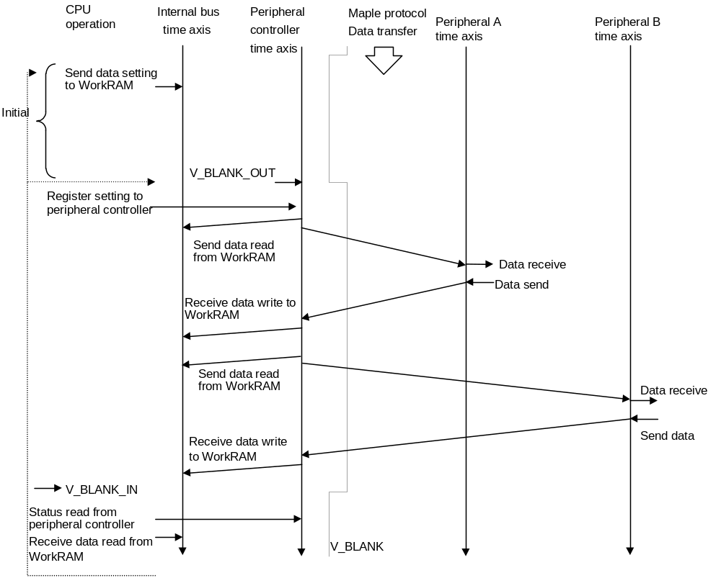

4.6.2 SDCKB occupy procedure (Light-GUN)

Fig. 4-26 SDCKB occupy-cancel procedure
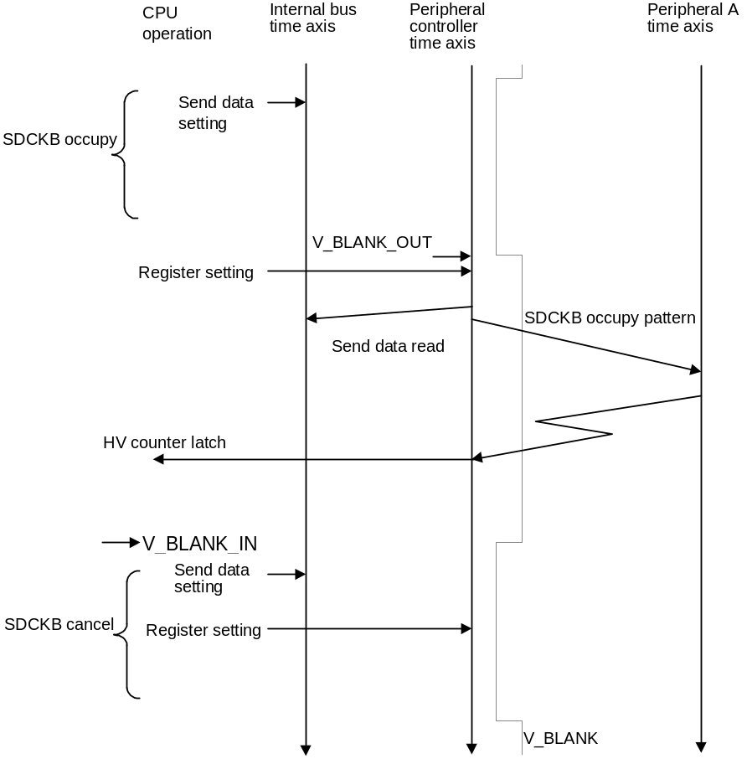

4.7 Register Setting Methods (Reference)
To activate Maple DMA, it is necessary to set DMA CH0 of SH4 to DDT mode.
Address: ffa0_0040h Write data: 0000_8201h
For details, please refer to the section on SH4 DMAC (in the separate specifications document).

Initialization
1. Work RAM area protection register setting
* Address 005f_6c8ch: Write data xxxx_xxxxh
2. System control register setting
* Address 005f_6c80h: Write data 3a98_0000h
Contents Time out: 300 us, transmission rate: 2 Mbps, startup delay: 0

Execution procedure
3. Data settings for Work RAM (DMA command table)
* Address Work RAM area (nnnn_nnnnh): Write data 8000_0000h
Contents 4-byte send data to port A complete
* Address nnnn_nnnn+4h: Write data Work RAM address (mmmm_mmmmh)
Contents Receive data store address (address mmmm_mmmmh)
* Address nnnn_nnnn+8h: Write data xxxx_xxxxh
Contents Transmission data xxxx_xxxxh to port A
4. DMA command table address register setting
* Address 005f_6c04h: Write data nnnn_nnnnh
Contents Leading address in Work RAM storing send data (address nnnn_nnnnh)
5. DMA enable register setting
* Address 005f_6c14h: Write data 0000_0001h
Contents DMA enable
6. DMA start/status register setting
* Address 005f_6c18h: Write data 0000_0001h
Contents DMA startup, transmission start

End Confirm
7. DMA start/status confirm
* Address 005f_6c18h: Read data 0000_0000 (transmission end)
Contents Confirm transmission end
8. Reading receive data in Work RAM
* Address mmmm_mmmmh: Read data xxxx_xxxxh
Contents Reading receive data from port A

4.8 Host MIE Block Diagram

Fig. 4-27 Peripheral controller block diagram
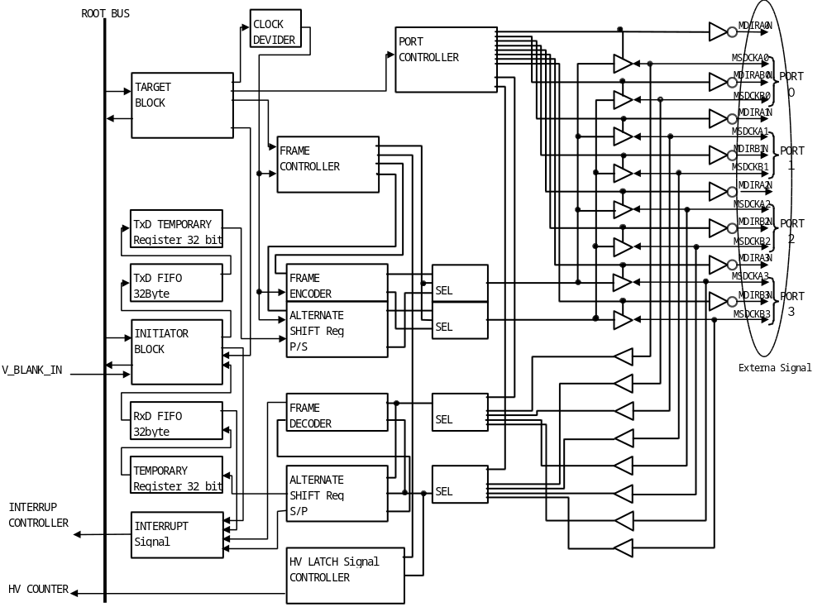

4.8.1 Block Description
(1) Target block
This block operates as the target on the root bus. It consists of a register set which is read or written using 32 bits from the CPU.
(2) Send data temporary register
This register is for holding the 32 bits of send data from the 32-byte send data FIFO.
(3) Send data FIFO
This is a 32-byte FIFO.
(4) Initiator block
This block is for gaining access to the Work RAM which serves as the bus master when the peripheral controller is in operating status.
(5) Receive data FIFO
This is a 32-byte receive data FIFO.
(6) Receive data temporary register
This register is for holding the 32 bits of receive data.
The data is written to the receive data FIFO as soon as the receive data process ends.
(7) Interrupt signal
This is a 1-clock pulse signal sent to the interrupt block.
(8) Clock divider
This is a clock divider block for selecting the send data bit rate.
(9) Frame controller
This block controls the send data frame (start pattern, data pattern, end pattern, etc.)
(10) Frame encoder
This block creates the frame pattern.
(11) Alternate shift register (parallel/serial)
This block converts the parallel send data alternately to two serial lines.
(12) Frame decoder
This block analyzes the receive signal frame.
(13) Alternate shift register (serial/parallel)
This block converts the data coming alternately from two serial lines to parallel.
(14) HV latch signal controller
This block passes the HV latch signal from the serial line to the plotting block HV counter.
(15) Port controller
This is the controller block for the active port serving as the transmission target.

CHAPTER 5 INTERNAL INTERFACE OF PERIPHERALS
This chapter explains the interface for the MIE controller, the device MIE and expansion MIE.
The interface is configured to optimize each peripheral. The global specifications are indicated here.

5.1 Overview
Viewed from the peripheral CPU side, the interface with the MIE consists of a 21-unit control flag (CFLAG) and data length register (LREG), and a 1024-byte maximum transmission buffer (TRBF). The size of TRBF is optimized by the device.

5.2 Register Configuration

5.2.1 Control flag (CFLAG)
(1) Configuration
This is a 21-unit flag for controlling data receiving and sending.

Fig. 5-1 CFLAG configuration
Dir | R/W | R/W | R/W | R/W | R/W | R/W | R/W | R/W | R/W | R/W | R/W
Data | HRES | CTXB | TFB | TXB | BFOV | RFB | ENDP | LMC1 | LMC2 | LMC3 | LMC4
Ini | 0 | 0 | 0 | 0 | 0 | 0 | 0 | 0 | 0 | 0 | 0

Dir | R | R | R | R | R | R | R | R | R | R
Data | RXB | EMP | SDAM | SDBM | PERR | POS | LMM1 | LMM2 | LMM3 | LMM4
Ini | 0 | 0 | - | - | 0 | 0 | - | - | - | -
R/W: Read/Write
R: Read Only
Ini: Initial settings

The flag to be used and registered varies depending on the peripheral.

HRES: Reset pattern receive flag
CTXB: Continue transmission flag
TFB: Transmission complete flag
TXB: Transmission flag
BFOV: Transmission buffer (TRBF) overflow flag
RFB: Receive complete flag
ENDP: End pattern output flag
RXB: Receive flag

EMP: Empty flag
PERR: Parity error flag
POS: SDCKB occupy mode flag
SDAM: SDCKA line monitor (device only)
SDBM: SDCKB line monitor (device only)
LMC1-4: LM-Bus 1-4 connection flag (device only)
LMM1-4: LM-Bus 1-4 connection flag (device only)

(2) Description
RXB changes when data is received.
When data is written to TXB during send or receive operations, the contents of that data cannot be guaranteed.
When TRBF overflows, BFOV is set to "1".
BFOV is cleared to "0" when receive data starts and send data starts.
POS indicates whether the Maple-Bus is in ordinary mode (POS = "0") or SDCKB occupy mode (POS = "1").
When HRES receives the reset pattern it is set to "1", and accelerates MIE controller initialization.
PERR is set to "1" when the parity of the received frame does not match. When normal it is cleared to "0".
ENDP is set to "1" when an end pattern is added to the send data.
When the send data overflows TRBF, the next data is stored in TRBF and is sent by CTXB, not TXB.
When there is no data to be sent to TRBF during send data (empty), EMP is set to "1".
The LMC 1-4 flags indicate the logical connection of LM-Bus 1-4 (='1'), and the logical disconnection (='0').
SDAM, SDBM indicate the status of SDCKA, SDCKB lines. LMM1~LMM4 indicate the status of LM-Bus 1-4's physical connection.
The device's MIE controller looks at the LMM status and if the expansion device is physically connected it sets the LMC to '1', else if it is physically disconnected it sets it to '0'.
The device's MIE controller checks the SDAM, SDBM and checks the Time Out of the data coming from the host.
Time Out processing is performed only by the devices. It is not performed by the expansion devices.

5.2.2 Data length register (LREG)
(1) Configuration
This is a one-byte register for indicating the size of one frame during send data.

Fig. 5-2 Configuration of LREG
Bit | 7 | 6 | 5 | 4 | 3 | 2 | 1 | 0
Dir | R/W | R/W | R/W | R/W | R/W | R/W | R/W | R/W
Data | Ln₇ | Ln₆ | Ln₅ | Ln₄ | Ln₃ | Ln₂ | Ln₁ | Ln₀
Ini | - | - | - | - | - | - | - | -
R/W：Read/Write
Initial status :All bits are undefined.
Ln :Data length 00h≦Ln≦FFh

(2) Description
Fig. 5-3 Data length
Bit | 7 | 6 | 5 | 4 | 3 | 2 | 1 | 0
Data length | Ln₇ | Ln₆ | Ln₅ | Ln₄ | Ln₃ | Ln₂ | Ln₁ | Ln₀
4Byte | 0 | 0 | 0 | 0 | 0 | 0 | 0 | 0
8Byte | 0 | 0 | 0 | 0 | 0 | 0 | 0 | 1
： | ： | ： | ： | ： | ： | ： | ： | ：
512Byte | 0 | 1 | 1 | 1 | 1 | 1 | 1 | 1
516Byte | 1 | 0 | 0 | 0 | 0 | 0 | 0 | 0
： | ： | ： | ： | ： | ： | ： | ： | ：
1020Byte | 1 | 1 | 1 | 1 | 1 | 1 | 1 | 0
1024Byte | 1 | 1 | 1 | 1 | 1 | 1 | 1 | 1
The value of LREG is undefined during data transmission and after receiving data.
Size is specified in units of four bytes.

5.3 Data Buffer

5.3.1 Transmission buffer (TRBF)
(1) Configuration
This is a buffer area for storing one frame of send or receive data.
It can accommodate from four to 1024 bytes in four-byte units.
The area is optimized for each peripheral.
Send and receive operations share this same buffer, which is divided into the command code, destination AP, origin AP, data size, and data fields.
Data is sent or received in order from the first data in Fig. 5-4.
The data is stored in the host memory in the rows of the function's data format.
Fig. 5-4 Configuration of TRBF
Bit | 7 | 6 | 5 | 4 | 3 | 2 | 1 | 0
Dir | R/W | R/W | R/W | R/W | R/W | R/W | R/W | R/W
1st Data | D1₇ | D1₆ | D1₅ | D1₄ | D1₃ | D1₂ | D1₁ | D1₀
2nd Data | D2₇ | D2₆ | D2₅ | D2₄ | D2₃ | D2₂ | D2₁ | D2₀
3rd Data | D3₇ | D3₆ | D3₅ | D3₄ | D3₃ | D3₂ | D3₁ | D3₀
4th Data | D4₇ | D4₆ | D4₅ | D4₄ | D4₃ | D4₂ | D4₁ | D4₀
5th Data | D5₇ | D5₆ | D5₅ | D5₄ | D5₃ | D5₂ | D5₁ | D5₀
6th Data | D6₇ | D6₆ | D6₅ | D6₄ | D6₃ | D6₂ | D6₁ | D6₀
7th Data | D7₇ | D7₆ | D7₅ | D7₄ | D7₃ | D7₂ | D7₁ | D7₀
8th Data | D8₇ | D8₆ | D8₅ | D8₄ | D8₃ | D8₂ | D8₁ | D8₀
： | ： | ： | ： | ： | ： | ： | ： | ：
R/W : Read/Write
Initial value: Undefined
(2) Description of 1st Data - 4th Data
Area for storing command codes, transmission destination AP, transmission origin AP and the data size.
Also, in the case where data greater than TRBF's capacity is sent, it stores the next parameter's data.

(3) Description of fifth and subsequent data
Fields for storing parameter data.
This field stores data only for the number of bytes specified in the data size field.
Contents of subsequent data fields are undefined.

5.4 Data Transfer Procedures

5.4.1 Method of receiving data
The MIE receives data automatically. Once receiving starts, TXB, TFB, RFB and BFOV are cleared to "0".
When RXB is "1", this indicates that the MIE is receiving data. When RXB is "0", this indicates that receiving has finished.
When data receiving ends normally, the data is stored to TRBF, the parity error status is stored to PERR, and "1" is set in RFB (in the case of interrupt processing, a receive signal interrupt is generated here). This completes receive processing.
When RXB and RFB are both "1", this means that a receive error has occurred.
Further, if the receive data exceeds the TRBF capacity, BFOV is set to "1". Receive data will be the amount of the TRBF capacity size from the start of receiving, but will be stored in TRBF.
If the frame data parity does not match, PERR is set to "1". If it is normal, PERR is cleared to "0".

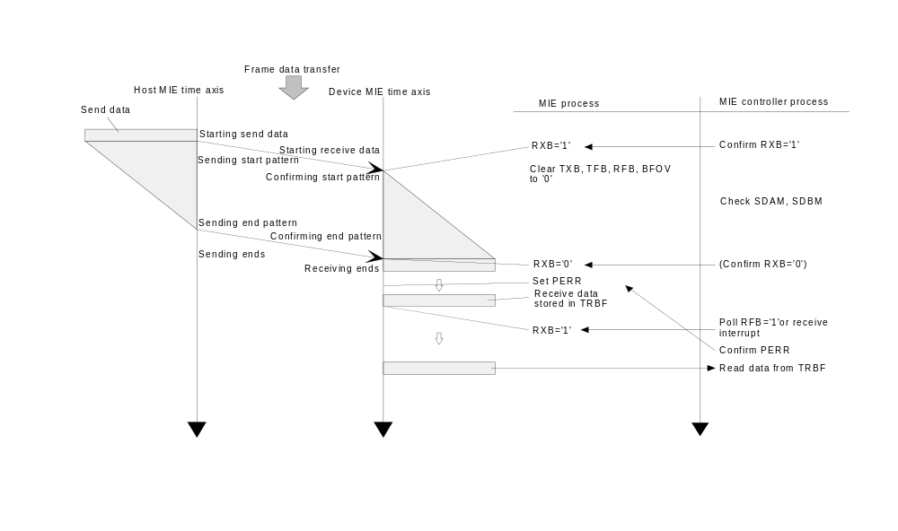
Fig. 5-5 Data receive

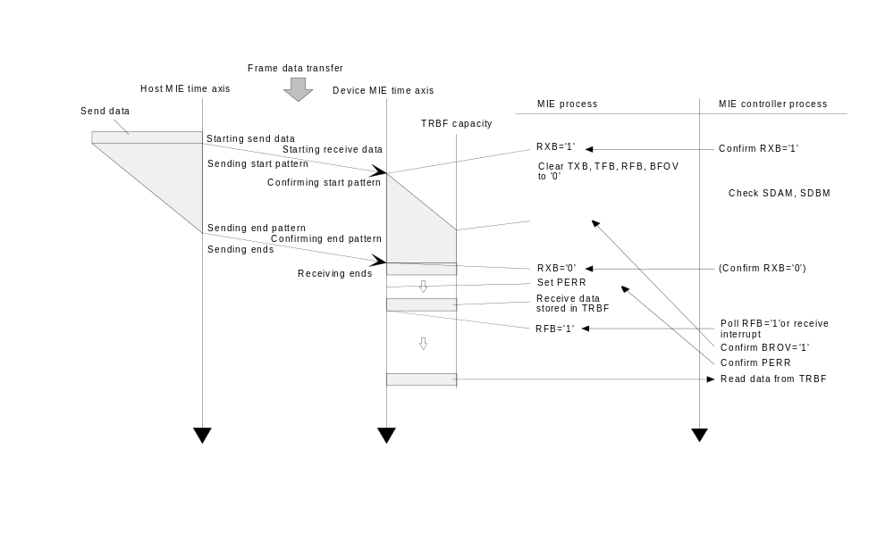

Fig. 5-6 When the received data exceeds the TRBF capacity

5.4.2 Method of sending data
If there is no response within 1.0 ms of a command being sent, the host treats the destination as being disconnected. Hence, a response to the command must be made within this time period.
After writing data (command and parameter) to TRBF, the host sets the send data length to LREG and ENDP= “1”.
When "1" is set in TXB, the Maple-Bus performs output and the quantity of bytes of data specified in LREG are sent.
When TXB becomes "1", MIE clears RXB, RFB, TFB, and BFOV to "0".
When TXB is read but remains "1", this means that data is being sent; when "0", that sending is finished.
When data sending ends normally, TFB is set to "1", and the Maple-Bus automatically enters the input status.
After sending ends, the contents of TRBF are undefined.
When TXB and TFB are both "1", this means that a send error has occurred.
If the LREG capacity is greater than the TRBF capacity, then BFOV is set to “1”, and the entire TRBF data is sent.
It calculates the expected transmission completion time from the transmission data, and if the transmission status continues for more than that amount of time, it performs Up Stream Time Out processing.

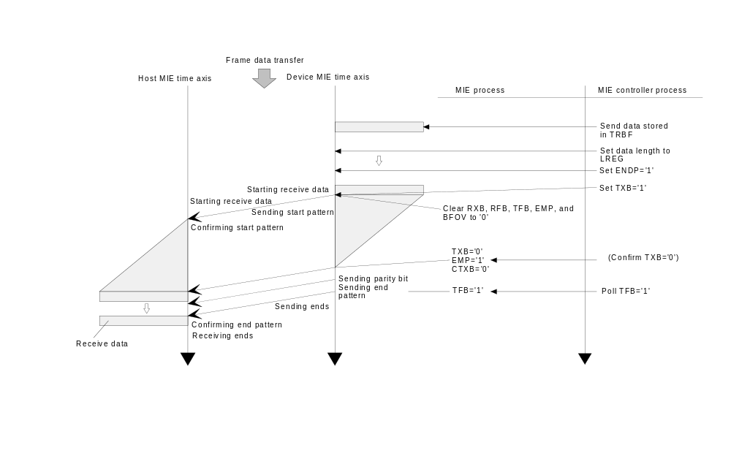
Fig. 5-7 Data send
If the send data exceeds the TRBF capacity, the data is divided into several blocks by the TRBF capacity before being sent.
During split transmission, the first block is TXB and the subsequent blocks send data using CTXB.
Also, if the amount of time between sending one block of data and sending the next block exceeds 1.0 ms, the host will Time Out, so it is necessary to transmit within this time period.
The block size is set to LREG in block units.
All blocks except for the last block are sent by ENDP='0', and no end pattern is added.
When the last block is sent, ENDP='1' and an end pattern is added.

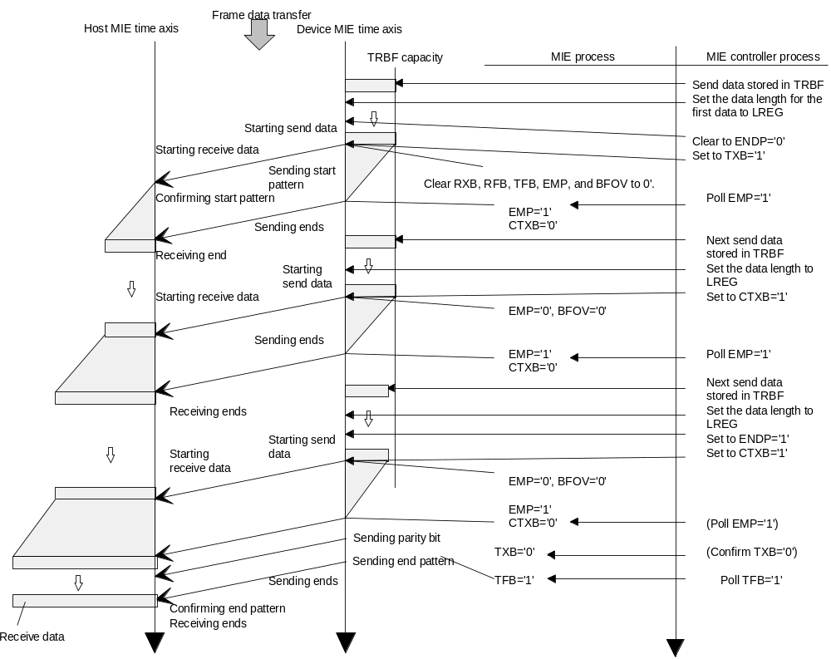
Fig. 5-8 Sending data exceeding the TRBF capacity

5.4.3 Relationships among flags and communication statuses
(1) Status of device flags (during communication with host)
Fig. 5-9 Data is sent to host.
Flags | Sending starts | Sending | Sending ends | Send error
TXB | 1 | 1 | 0 | 1
TFB | 0 | 0 | 1 | 1
RXB | 0 | 0 | 0 | 0
RFB | 0 | 0 | 0 | 0
Fig. 5-10 Data is received from host.
Flags | Receiving | Receiving ends | Received data stored | Receive error
TXB | 0 | 0 | 0 | 0
TFB | 0 | 0 | 0 | 0
RXB | 1 | 1 | 0 | 1
RFB | 0 | 0 | 1 | 1

(2) Status of device flags (when other device communicating with host)

Fig. 5-11 Status of own flags in relation to sending status of other device
Flags | Sending starts | Sending | Sending ends | Send error
TXB | 0 | 0 | 0 | 0
TFB | 0 | 0 | 0 | 0
RXB | 0 | 0 | 0 | 0
RFB | 0 | 0 | 0 | 0

Fig. 5-12 Status of own flags in relation to receive status of other device
Flags | Receiving | Receiving ends | Received data stored | Receive error
TXB | 0 | 0 | 0 | 0
TFB | 0 | 0 | 0 | 0
RXB | 1 | 1 | 0 | 1
RFB | 0 | 0 | 1 | 1

5.4.4 Error processing
A send or receive error is set when an error occurs with the data transfer processing.
Parity errors are set in PERR.
Data overflows during receiving and buffer capacity overflows during sending are set in BFOV.
When an error occurs:
Sending: Processes only Up Stream Time Out errors.
It does not do anything for other errors, it only clears flags.
Receiving: when it is the data transmission destination: can transmit a resend command to the host.
when another is the data transmission destination: clears own flag.
in the case of a Time Out: Performs Down Stream Time Out processing (LM-Bus reset).

5.4.5 LM-Bus
The LM-Bus data line is made up of the two Maple-Bus bi-directional data line (SDCKA, SDCKB) signals which have been separated into signal lines for each direction in the device MIE, and the ID line for the socket controller.

The serial data line is split up in the MIE as shown below.

Host

Expansion Device
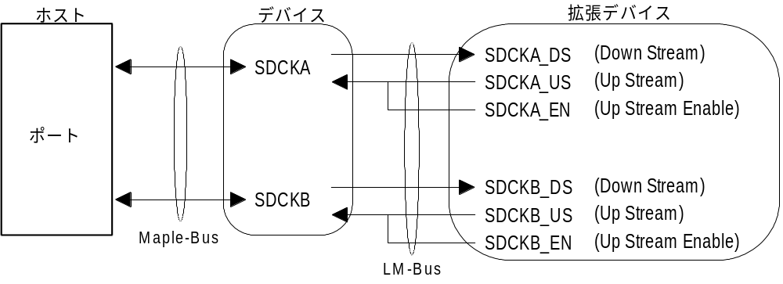
Port

Fig. 5-13 LM-Bus serial data line

The ID line is set as follows.
Table 5-14 LM-Bus ID Settings
ID0 |  | ID1 |  | Expansion socket (LM-Bus)
0 | 0 |  | No.1
1 | 0 |  | No.2
0 | 1 |  | No.3
1 | 1 |  | No.4

ID2 is used for confirming if the expansion socket is connected.

For details about the operation, please refer to "5.5 Block Diagram of MIE for Device".

5.5 Block Diagram of MIE for Device
The figure below is a block diagram of the MIE interior.

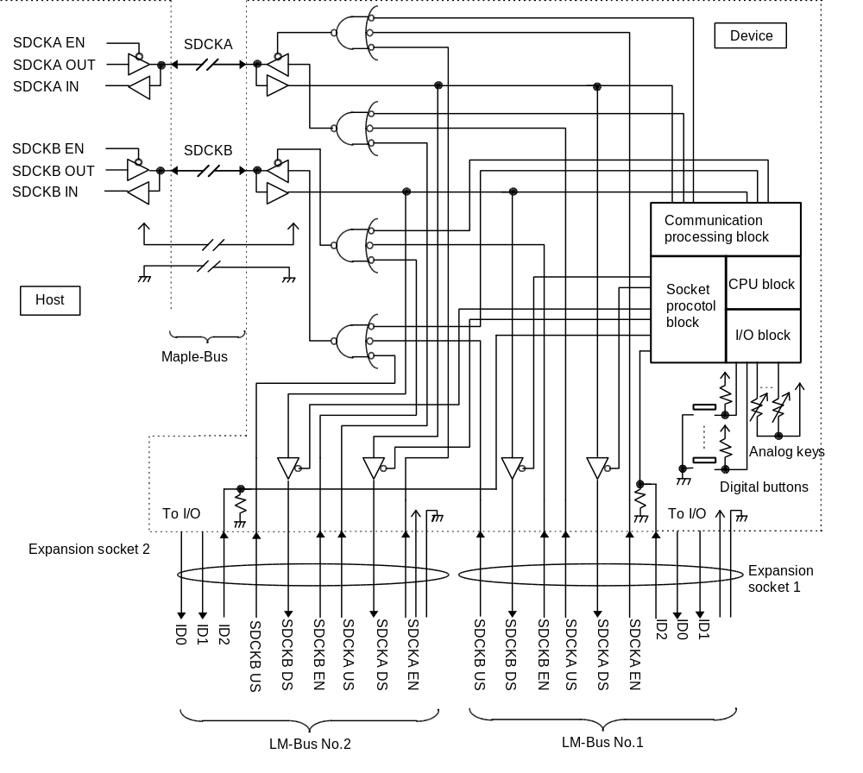
Fig. 5-15 Block diagram of MIE for device (when there are two LM-Buses)
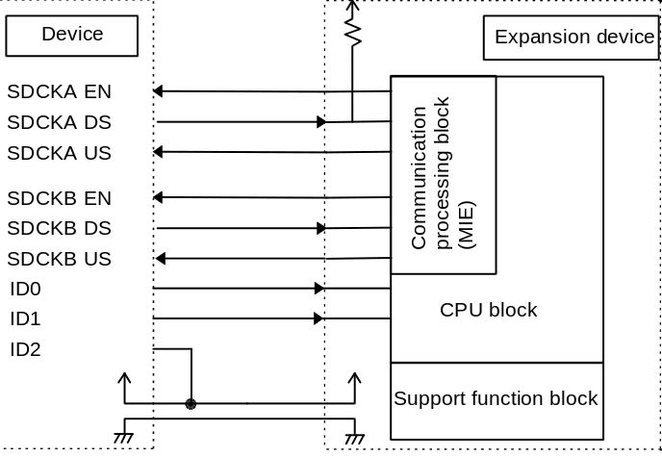
Fig. 5-16 Block diagram of MIE for expansion device

For more details, please refer to the peripheral device's MIE specifications.

CHAPTER 6 COMMAND REFERENCE
This chapter explains the specific commands.
Up to 254 command codes can be used, from 01h through FEh. 00h and FFh cannot be used. These codes mean "Data cannot be guaranteed owing to communication error".

6.1 Control Commands
Mainly, control commands use the command codes from 01h through DFh.
These commands are for controlling the sending and receiving of data.
The various Function Libraries must not have different commands for the same command codes.
Before implementing any expansions, users must apply to Sega for approval.

6.1.1 Device Request
Issuing right :Host
Command code :01h
Data size :00h
Data field :None
Expected return value :[Device Status]
Description :Requests peripheral of destination AP to return Device Status. This command is also
used to check port connection.
Fixed Device Status data can also be obtained with the All Status Request command,
but when Fixed Device Status data are required, this command should be used.

Fig. 6-1 Device Request
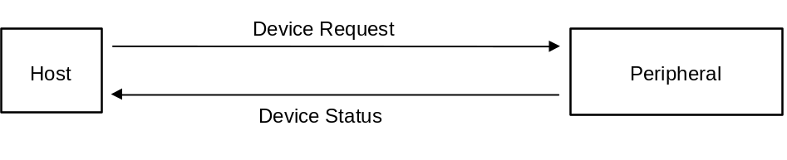

6.1.2 All Status Request
Issuing right :Host
Command code :02h
Data size :00h
Data field :None
Expected return value :[Device All Status]
Description :Requests peripheral of destination AP to return all device statuses (both Fixed Device
Status and Free Device Status).
Fixed Device Status data are obtained with the Device Request command.
This command is used when the Free Device Status data should be obtained.

Fig. 6-2 All Device Request
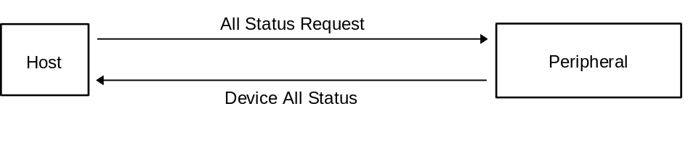

6.1.3 Device Reset
Issuing right :Host
Command code :03h
Data size :00h
Data field :None
Expected return value :Device Reply
Description :Peripherals specified by the destination AP can be initialized.
Order of operation :(1) Device Reply is returned.
(2) Peripheral is initialized.

Fig. 6-3 Device Reset
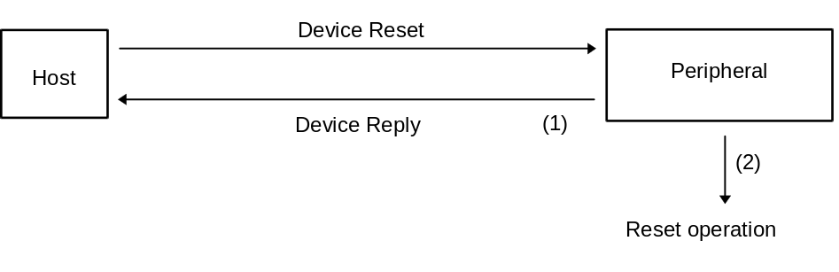

6.1.4 Device Kill
Issuing right :Host
Command code :04h
Data size :00h
Data field :None
Expected return value :Device Reply
Description :Operation is refused for the peripherals specified by the destination AP.
The peripherals stand by with standby current consumption, and accept no
commands whatsoever. To start operation, a hardware reset must be applied,
or the power must be turned off and on again.
Order of operation :(1) Device Reply is returned.
(2) Operation is stopped.

Fig. 6-4 Device Kill
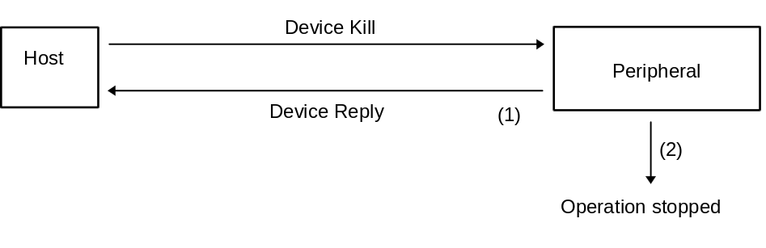

6.1.5 Device Status
Issuing right :Peripheral
Command code :05h
Data size :1Ch (28)
Data field :Device ID :16 bytes
Destination code :1 byte
Connection direction :1 byte
Product name :30 bytes
License :60 bytes
Low-consumption standby current :2 bytes
Maximum current consumption :2 bytes
Description :In response to the Device Request from the host, Fixed Device Status data is returned.
For details, see Chapter 7.
In addition, please refer to the peripheral device's specifications.

6.1.6 Device All Status
Issuing right :Peripheral
Command code :06h
Data size :1Ch+(n/4)
Data field :Fixed Device Status :112 bytes
Device ID :16 bytes
Destination code :1 byte
Connection direction :1 byte
Product name :30 bytes
License :60 bytes
Low-consumption standby current :2 bytes
Maximum current consumption :2 bytes
Free Device Status :n bytes
Description :In response to the All Status Request from the host, both Fixed Device Status and Free
Device Status are returned.
For details, see Chapter 7.
In addition, please refer to the peripheral device's specifications.

6.1.7 Device Reply
Issuing right :Peripheral
Command code :07h
Data size :00h
Data field :None
Description :Used as response from peripheral.

6.1.8 Data Transfer
Issuing right :Peripheral
Command code :08h
Data size :n (01h≦n≦FFh)
Data field :Function type :4 bytes
Data :(n-1) x 4 bytes
Expected return value :None
Description :The function type data specified from the host is returned.
Data varies with the requested command.
For more details, please refer to the specifications for each function type.

Fig. 6-5 Data Transfer
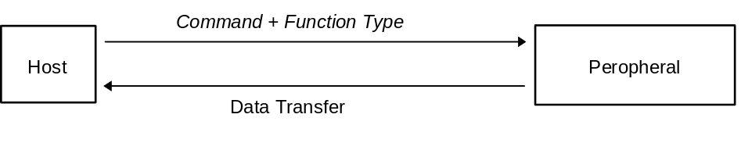

6.1.9 Get Condition
Issuing right :Host
Command code :09h
Data size :01h
Data field :Function type :4 bytes
Expected return value :[Data Transfer]
Description :The function type physical status specified by the peripheral function type is requested.
The peripheral returns the same function type sent from the host.
There is only one function type able to be specified once.
For more details, please refer to the specifications for each function type.

Fig. 6-6 Get Condition
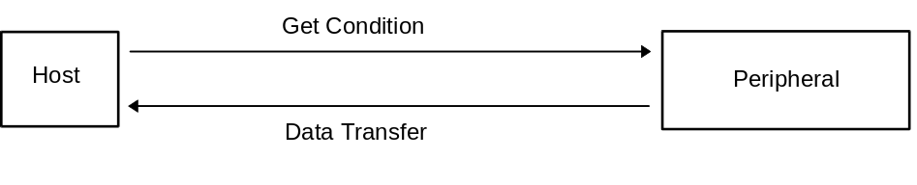

6.1.10 Get Media Info
Issuing right :Host
Command code :0Ah
Data size :02h
Data field :Function type :4 bytes
PT :4 bytes (3 dummy bytes)
Expected return value :[Data Transfer]
Description :The media data specified by the peripheral function type and PT are requested.
For details, see the respective specifications for each function type.

Fig. 6-7 Get Media Info
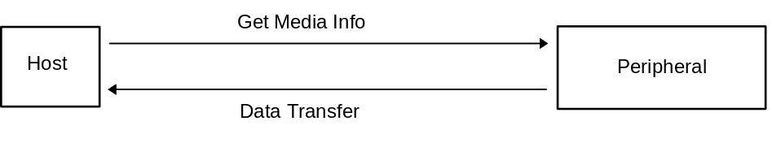

6.1.11 Block Read
Issuing right :Host
Command code :0Bh
Data size :02h
Data field :Function type :4 bytes
PT :1 byte
Phase :1 byte
Block No. :2 bytes
Expected return value :[Data Transfer]
Description :The location data specified by the peripheral function type and PT, Phase, and Block No. are requested.
For details, see the respective specifications for each function type.

Fig. 6-8 Block Read
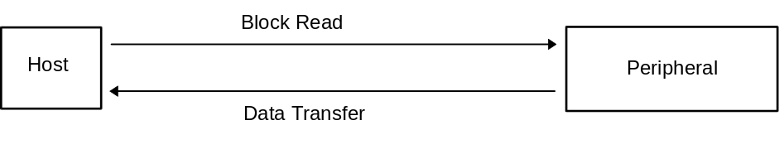

6.1.12 Block Write
Issuing right :Host
Command code :0Ch
Data size :02h+n
Data field :Function type :4 bytes
PT :1 byte
Phase :1 byte
Block No. :2 bytes
Written data :n x 4 bytes
Expected return value :[Device Reply]
Description :Data is written to the location specified by the peripheral function type and PT, Phase, and Block No..
For details, see the respective specifications for each function type.

Fig. 6-9 Block Write
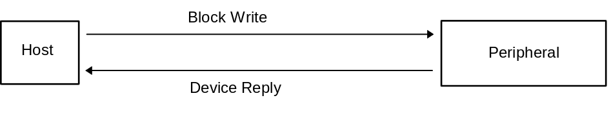

6.1.13 Get Last Error
Issuing right :Host
Command code :0Dh
Data size :02h
Data field :Function type :4 bytes
PT :1 byte
Phase :1 byte
Block No. :2 bytes
Expected return value :[Device Reply]
Description :Examines whether an error occurred in the immediately preceding command.
If there was no error, [Device Reply] is returned. If an error occurred, an error command is returned.
The command value for PT and Block No. remains the same. The command value for Phase is set to +1.
For details, see the respective specifications for each function type.
Fig. 6-10 Get Last Error
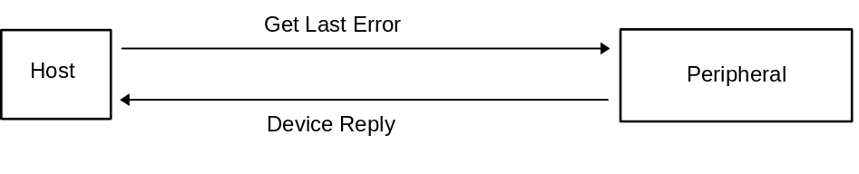

6.1.14 Set Condition
Issuing right :Host
Command code :0Eh
Data size :01h+n
Data field :Function type :4Byte
Write-in data :n×4Byte
Expected return value : [Device Reply]
Description :Specifies the physical status of the function specified in the function type of the peripheral device.
Only one function can be specified at a time.
For more details, please refer to the specifications for each function type.

Fig. 6-11 Set Condition
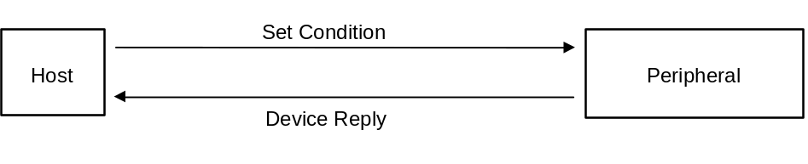

6.1.15 FT₄ Control
Issuing right :Host
Command code :0Fh
Data size :01h+n
Data field :Function type :4Byte
FT₄ data :n×4Byte
Expected return value :Please refer to the function specifications
Description :Function type: FT₄ specialized command.
For more details, please refer to the FT₄ function type specifications.

6.1.16 AR Control
Issuing right :Host
Command code :10h
Data size :01h+n
Data field :Function type :4Byte
Data :n×4Byte
Expected return value :Please refer to the function specifications
Description :Command for controllng AR (manmade retinal chip).
For more details, please refer to the function specifications.

6.2 Error Commands
Error commands use codes from E0h through FEh.
These commands notify the user when an error has occurred in the sending or receiving processes.
The various Function Libraries must not have different commands for the same command codes.
Before implementing any expansions, users must apply to Sega for approval.

6.2.1 Function Type Unknown
Issuing right :Peripheral
Command code :FEh
Data size :00h
Data field :None
Description :The peripheral issues this command when it does not have the function specified by the
sent function type.
Possible cause :(1) Mistaken specification of function type
(2) Data written incorrectly
(3) Data of device ID jumbled
(4) Data became jumbled during communication
Action :(1) Specify function type correctly.
(2) Write data correctly.
(3) Resend Device Request to obtain device ID.
(4) Try sending again (maximum of three times; subsequent tries are processed
as Time Out).

6.2.2 Command Unknown
Issuing right :Peripheral
Command code :FDh
Data size :00h
Data field :None
Description :Issued when the peripheral-side function is not ready for the sent command.
Possible cause :(1) Mistaken specification of command
(2) Data written incorrectly
(3) Data of device ID jumbled
(4) Data became jumbled during communication
Action :(1) Specify command correctly.
(2) Write data correctly.
(3) Resend Device Request to obtain device ID.
(4) Try sending again (maximum of three times; subsequent tries are processed
as Time Out).

6.2.3 Transmit Again
Issuing right :Host, Peripheral
Command code :FCh
Data size :00h
Data field :None
Description :When the sent data contains some type of error, this command is returned to request
that the same data be sent again.
Possible cause :(1) Parity error occurred
(2) Data overflow
(3) Data became jumbled during communication
Action :(1) Try sending again (maximum of three times; subsequent tries are processed
as Time Out).

6.2.4 File Error
Issuing right :Peripheral
Command code :FBh
Data size :01h
Data field :Function error code
Description :Issued when an error occurs in the File Function. (FT₁ = ‘1’)
Returns a detailed error based on the function error code.
Possible cause :

Fig. 6-12 Function Error Codes for File Function
bit | 7 | 6 | 5 | 4 | 3 | 2 | 1 | 0
1st Data | FE₃₁ | FE₃₀ | FE₂₉ | FE₂₈ | FE₂₇ | FE₂₆ | FE₂₅ | FE₂₄
2nd Data | FE₂₃ | FE₂₂ | FE₂₁ | FE₂₀ | FE₁₉ | FE₁₈ | FE₁₇ | FE₁₆
3rd Data | FE₁₅ | FE₁₄ | FE₁₃ | FE₁₂ | FE₁₁ | FE₁₀ | FE₉ | FE₈
4th Data | FE₇ | FE₆ | FE₅ | FE₄ | FE₃ | FE₂ | FE₁ | FE₀

The item where the error occurs is “1”. Items without errors are “0”.
FE₀: PT Error
FE₁: Phase Error
FE₂: Block Error
FE₃: Write Error
FE₄: Length Error
Other bits are reserved.
For more details, please refer to the specifications for each function type.

6.2.5 LCD Error
Issuing right :Peripheral
Command code :FAh
Data size :01h
Data field :Function error code
Description :Issued when an error occurs in the LCD Function. (FT₂ = ‘1’)
Returns a detailed error based on the function error code.
Possible cause :
Fig. 6-13 Function Error Codes for LCD Function
bit | 7 | 6 | 5 | 4 | 3 | 2 | 1 | 0
1st Data | FE₃₁ | FE₃₀ | FE₂₉ | FE₂₈ | FE₂₇ | FE₂₆ | FE₂₅ | FE₂₄
2nd Data | FE₂₃ | FE₂₂ | FE₂₁ | FE₂₀ | FE₁₉ | FE₁₈ | FE₁₇ | FE₁₆
3rd Data | FE₁₅ | FE₁₄ | FE₁₃ | FE₁₂ | FE₁₁ | FE₁₀ | FE₉ | FE₈
4th Data | FE₇ | FE₆ | FE₅ | FE₄ | FE₃ | FE₂ | FE₁ | FE₀

The item where the error occurs is “1”. Items without errors are “0”.
FE₀: PT Error
FE₁: Phase Error
FE₂: Block Error
FE₃: Write Error
FE₄: Length Error
Other bits are reserved.
For more details, please refer to the specifications for each function type.

6.2.6 AR Error
Issuing right :Peripheral
Command code :F9h
Data size :01h
Data field :Function error code
Description :Issued when an AR error occurs (manmade retinal chip : FT₅ = ‘1’).
Returns a detailed error in the function error code.
Possible causes :
Fig. 6-14 Function error codes of AR Function
Bit | 7 | 6 | 5 | 4 | 3 | 2 | 1 | 0
1st Data | FE₃₁ | FE₃₀ | FE₂₉ | FE₂₈ | FE₂₇ | FE₂₆ | FE₂₅ | FE₂₄
2nd Data | FE₂₃ | FE₂₂ | FE₂₁ | FE₂₀ | FE₁₉ | FE₁₈ | FE₁₇ | FE₁₆
3rd Data | FE₁₅ | FE₁₄ | FE₁₃ | FE₁₂ | FE₁₁ | FE₁₀ | FE₉ | FE₈
4th Data | FE₇ | FE₆ | FE₅ | FE₄ | FE₃ | FE₂ | FE₁ | FE₀
Items which have an error are '1', items without errors are '0'.
For more details, please refer to the specifications for each function type.

CHAPTER 7 INFORMATION ABOUT PERIPHERALS
This chapter explains information about specific devices (device statuses).
To prevent device statuses from being rewritten or erased, the data is recorded as is.

7.1 Types
Fixed Device Status
This is a set form of device status, consisting of 112 bytes in all, that must be designated.
Unless all items are designated, operation and connection are not guaranteed.
Free Device Status
The individual devices can use this status freely. It consists of 908 bytes.

7.2 Fixed Device Status
The Fixed Device Status has the following items, all of which must be designated.
(1) Device ID
Size :16 bytes
Description : Indicates functions and function definitions.
For more details, please refer to chapter 3.
(2) Destination code
Size :1 byte
Description : Indicates functions and function definitions.
For more details, please refer to chapter 3.

Fig. 7-1 Configuration of setting bits for destination
bit | 7 | 6 | 5 | 4 | 3 | 2 | 1 | 0
data | DES₇ | DES₆ | DES₅ | DES₄ | DES₃ | DES₂ | DES₁ | DES₀

Fig. 7-2 Setting bits for destination
Destination | Setting bit
North American region | DES₀=‘1’
Japan region | DES₁=‘1’
Asian region | DES₂=‘1’
European region | DES₃=‘1’
Reserved region 1 | DES₄=‘1’
Reserved region 2 | DES₅=‘1’
Reserved region 3 | DES₆=‘1’
Reserved region 4 | DES₇=‘1’
Worldwide : DES = "11111111" = FFh
For example, if destined for both Japan and Asia, the code will be DES = "00000110" = 06h.
Specification of DES = 00h is illegal.
(3) Connection direction
Capacity: 1 byte
Description: The information differs for devices and expansion devices.
For devices:
Indicates the direction of the expansion socket for expansion devices.
For expansion devices:
Indicates the direction of the connector for connection to the device.

Fig.7-2 Configuration of connected direction setting bits
bit | 7 | 6 | 5 | 4 | 3 | 2 | 1 | 0
data | SD4₁ | SD4₀ | SD3₁ | SD3₀ | SD2₁ | SD2₀ | SD1₁ | SD1₀

n Device
Specifies the direction of the expansion socket.
Non-installed sockets are indicated by "00".

Fig. 7-3 Socket direction setting
direction | SDx₁ | SDx₀
top | 0 | 0
bottom | 0 | 1
left | 1 | 0
right | 1 | 1
x = socket number

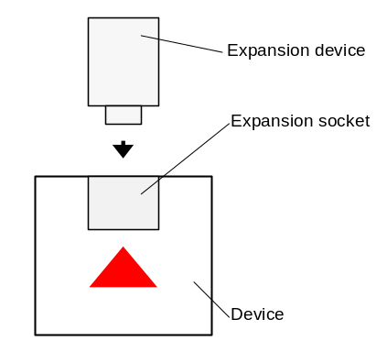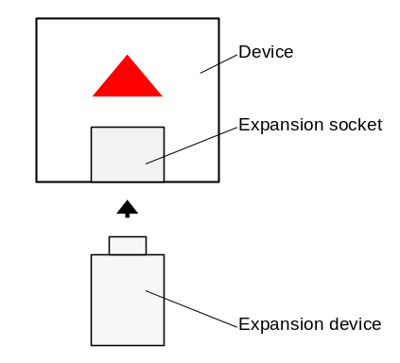
Fig. 7-4 Socket direction (top) Fig. 7-5 Socket direction (bottom)

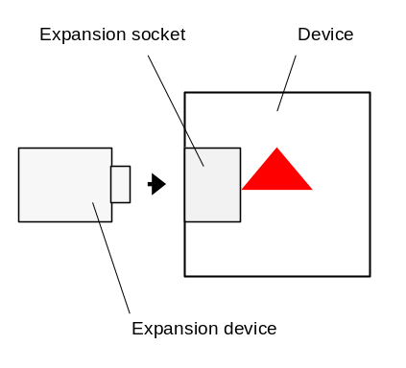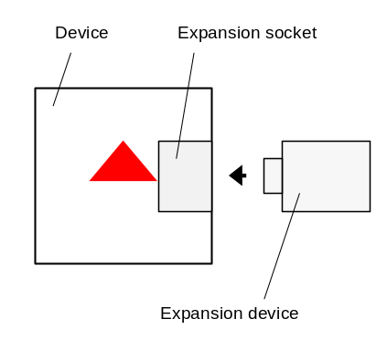
Fig. 7-6 Socket direction (left) Fig. 7-7 Socket direction (right)

n Expansion device
Specifies the direction of the socket.

Fig. 7-8 Connector direction setting
bit | 7 | 6 | 5 | 4 | 3 | 2 | 1 | 0
top | 0 | 0 | 0 | 0 | 0 | 0 | 0 | 0
bottom | 0 | 0 | 0 | 0 | 0 | 0 | 1 | 0
left | 0 | 0 | 0 | 0 | 0 | 1 | 0 | 0
right | 0 | 0 | 0 | 0 | 1 | 0 | 0 | 0

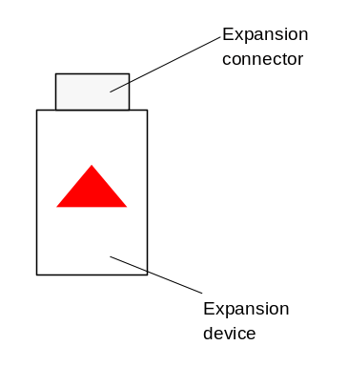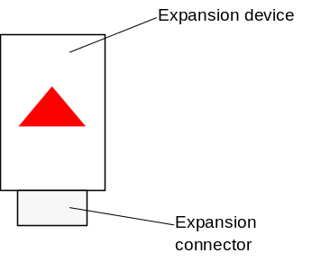
Fig. 7-9 Connector direction (top) Fig. 7-10 Connector direction (bottom)

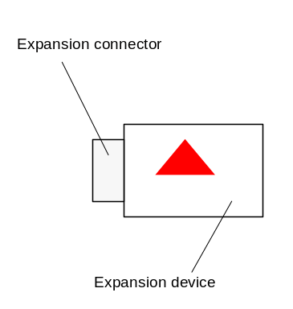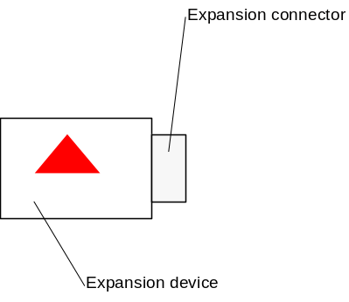
Fig. 7-11 Connector direction (right) Fig. 7-12 Connector direction (left)

(4) Product name
Size :30 bytes
Description :Designates the product name in English or romaji. Either full-width or half-width characters can be used.
A space code (20h) is inserted for unused space.
This product name must be registered beforehand.

(5) License
Size :60 bytes
Description :Designates the license in English or romaji using ASCII code.
A space code (20h) is inserted for unused space.
Generally, it designates "Produced By or Under License From SEGA ENTERPRISES, LTD."

(6) Standby current consumption
Space :2 bytes
Description :Standby current consumption when paused (during minimum power consumption), in units of 0.1 mA, is designated in
hexadecimal notation.
For example, 10.5 mA is designated by 00-69h.

(7) Maximum current consumption
Space :2 bytes
Description :Maximum current consumption, in units of 0.1 mA, is designated in hexadecimal notation.
For example, 127.9 mA is designated by 04-FFh.

7.3 Free Device Status
The Free Device Status area is available for product planners, developers, designers and programmers to enter any information they wish. The host obtains this status by the All Device Request.
When application software is to be used, aspects such as data arrays need to be addressed.

Unless there are special reasons for not doing so, the following 40 bytes of information should first be entered.

Versions (ROM, logic, etc.) :13 bytes E.g., “Version 1.000”
Recommended: The version orthography as shown in the example, three digits following the decimal point, and the first release is 1.000.
Release date :10 bytes E.g., “1998/05/11”
Recommended: Year in four digits, month in two digits, and day in two digits.
IC parts number :14 bytes E.g., “315-6125-AB ”
Recommended: Enter space (20h) in the empty area.
Each item should be separated by “,”.
Example: “Version 1.000,1998/05/11,315-6125-AB ,”

7.4 Usable Characters
The characters that can be used for Fixed Device Status and Device Status are described here.

The characters indicated in the following ASCII code diagram can be used.
Use of the items marked (P.) (= Prohibited) in the diagram is prohibited becomes the control code and characters differ depending on the country.
Use of characters beyond '80h' of the ASCII code is also prohibited.

Fig. 7-8 ASCII code table

Character code |  | Lower 4 bits
 |  | 0h | 1h | 2h | 3h | 4h | 5h | 6h | 7h | 8h | 9h | Ah | Bh | Ch | Dh | Eh | Fh
Up-per  4 bits | 0h | (P.) | (P.) | (P.) | (P.) | (P.) | (P.) | (P.) | (P.) | (P.) | (P.) | (P.) | (P.) | (P.) | (P.) | (P.) | (P.)
Up-per  4 bits | 1h | (P.) | (P.) | (P.) | (P.) | (P.) | (P.) | (P.) | (P.) | (P.) | (P.) | (P.) | (P.) | (P.) | (P.) | (P.) | (P.)
Up-per  4 bits | 2h | Space | ! | " | (P.) | (P.) | % | & | ' | ( | ) | * | + | , | - | . | /
Up-per  4 bits | 3h | 0 | 1 | 2 | 3 | 4 | 5 | 6 | 7 | 8 | 9 | : | ; | < | = | > | ?
Up-per  4 bits | 4h | (P.) | A | B | C | D | E | F | G | H | I | J | K | L | M | N | O
Up-per  4 bits | 5h | P | Q | R | S | T | U | V | W | X | Y | Z | (P.) | (P.) | (P.) | (P.) | _
Up-per  4 bits | 6h | (P.) | A | b | c | d | e | f | g | h | i | j | k | l | m | n | o
Up-per  4 bits | 7h | p | Q | r | s | t | u | v | w | x | Y | z | (P.) | (P.) | (P.) | (P.) | (P.)

Example: A is '41h' and g is '67h'.

CHAPTER 8 PHYSICAL SPECIFICATIONS OF BUS
This chapter explains the electrical and mechanical specifications.

8.1 DC Characteristics and Specifications (currently under evaluation and study)

8.1.1 Specification for ports on host side
Power source output voltage :+5 VDC *5%
Power source output current :Maximum of 1 A for all ports
Signal level :3.3 V type
Output H-Level :__V minimum
L-Level :__V maximum
Input H-Level :__V minimum
L-Level :__V maximum
Contact resistance :__OHM maximum

8.1.2 Specification on device side
Power source input voltage :+5 VDC *5%
Signal level :3.3 V type
Output H-Level :2.7 V minimum
L-Level :0.4 V maximum
Input H-Level :2.3 V minimum
L-Level :0.3 V maximum
Power source output :+5 VDC *10%
+3.3 VDC *10% maximum of 200 mA

8.1.3 Cable specification
Power source drop voltage :__ V/meter maximum
Signal drop voltage :__ V/meter maximum
Direct current resistance :__OHM/meter maximum
Impedance :__OHM/meter
Dielectric strength :__ V for 1 minute
Cross talk :___ dB

Fig. 8-1 DC characteristics (for reference)
Item |  | Code |  | Minimum | Maximum | Unit
Threshold voltage | H level | VP |  | 1.2 | 2.0 | V
Threshold voltage | L level | VN |  | 0.8 | 1.5 | V
 | The difference between the H level and the L level is 0.3V or greater.
Output voltage | H level | VOH | IOH = xxmA | 2.4 |  | V
Output voltage | L level | VOL | IOL = xxmA |  | 0.4 | V
Output current | H level | IOH |  |  |  | mA
Output current | L level | IOL |  |  | 6 | mA

8.2 AC Characteristics

8.2.1 Edge timing for SDCKA and SDCKB

Fig. 8-2 Edge timing waveform
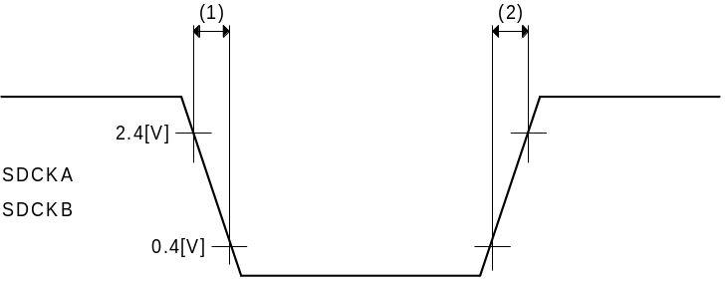

Fig. 8-3 Edge timing
No. | Parameter | Symbol | min | typ | max
(1) | SDCK Hi to Lo | tCr |  |  |  | ns
(2) | SDCK Lo to Hi | tCf |  |  |  | ns
"Min." is for when the load capacity is 50 pf (Tentative: From USB)
"Max." is for when the load capacity is 350 pf (Tentative: From USB)

8.2.2 Transition timing

Fig. 8-4 Transition timing waveform A
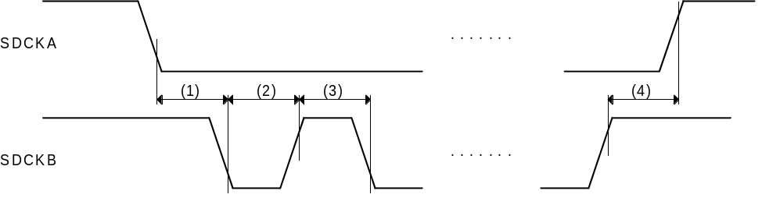

Fig. 8-5 Transition timing A
No. | Parameter | Symbol | min | typ | max
(1) | SDCKA Lo to SDCKB Lo | tALBL | 250 |  |  | ns
(2) | SDCKB Lo Width | tBL | 250 |  |  | ns
(3) | SDCKB Hi Width | tBH | 250 |  |  | ns
(4) | SDCKB Hi to SDCKA Hi | tBHAH | 250 |  |  | ns
Fig. 8-6 Transition timing waveform B
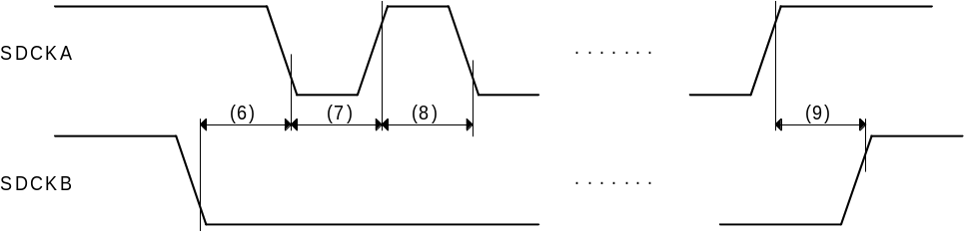

Fig. 8-7 Transition timing B
No. | Parameter | Symbol | min | typ | max
(6) | SDCKB Lo to SDCKA Lo | tBLAL | 250 |  |  | ns
(7) | SDCKA Lo Width | tAL | 250 |  |  | ns
(8) | SDCKA Hi Width | tAH | 250 |  |  | ns
(9) | SDCKA Hi to SDCKB Hi | tAHBH | 250 |  |  | ns

Fig. 8-8 Transition timing waveform C
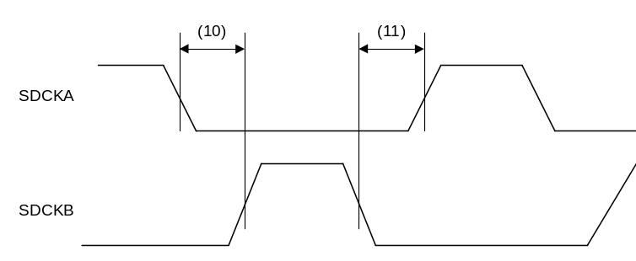

Fig. 8-9 Transition timing C
No. | Parameter | Symbol | min | typ | max
(10) | SDCKA Lo to SDCKA Hi | tALBH | 125 |  |  | ns
(11) | SDCKB Lo to SDCKA Hi | tAL | 125 |  |  | ns

8.2.3 Frame timing
Fig. 8-10 Frame timing waveform
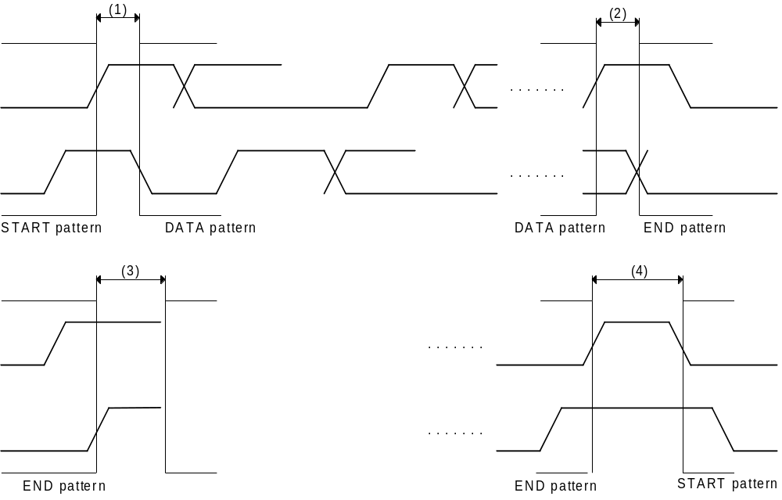

Fig. 8-11 Frame timing
No. | Parameter | Symbol | min | typ | max
(1) | START to DATA | tSTD | 125 |  |  | ns
(2) | DATA to END | tDTE | 250 |  |  | ns
(3) | END to Drive Open | tEDO | 125 |  | 500 | ns
(4) | END to START | tETS |  |  |  | ns
Timing for (3) and (4) must be done with care, as these switch the directions of the signal lines.
Also, for releasing line (3), this is the period for first driving it to high level.

8.3 Mechanical Specifications

8.3.1 Specifications for ports on host side
Number of pins :Five
Power source pins Two (for hot plugs)
Data pins Two
Shield pin One
Pitch : 2 mm
Plugging strength :__ g
Unplugging strength :__ g
Plugging times :10,000 times minimum
Pin arrangement :No.1 SDCKA
No.2 +5V
No.3 SHEILD
No.4 GND
No.5 SDCKB

8.3.2 Shape of the Host Side Maple-Bus Connector

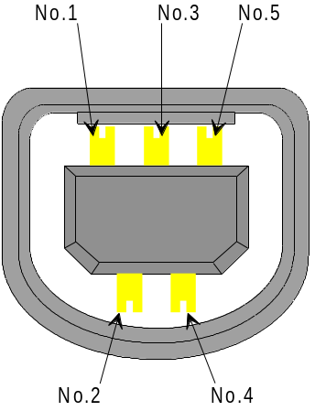

Fig. 8-12 Host Side Maple-Bus Connector

8.3.3 Specifications for connectors on device side
Number of pins :Five
Pitch :2 mm
Shape :Round pin
Pin arrangement :No.1 SDCKA
No.2 +5V
No.3 SHEILD
No.4 GND
No.5 SDCKB

8.3.4 Shape of the Device Side Maple-Bus Connector

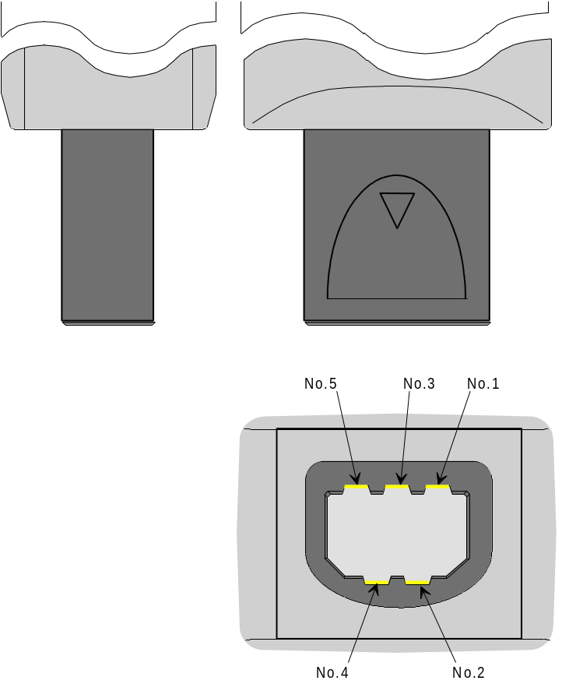
Fig. 8-13 Maple-Bus Plug

Cable
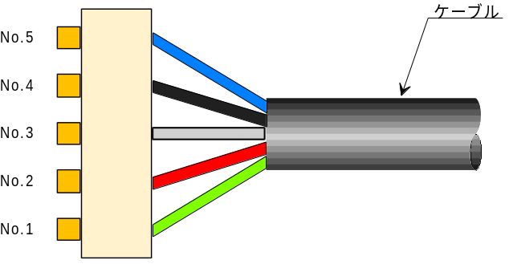
Fig. 8-14 Device Side Maple-Bus Connector

8.3.5 Specifications for expansion device connectors
Number of pins : 14
Male pins 7, covered
Female pins 7
Power source pins are for hot plugs
Pitch :1.5 mm, one row
Plugging strength :__ g
Unplugging strength :__ g
Plugging times :10,000 times minimum
Pin arrangement :No.1 +3.3V
No.2 +5V
No.3 SDCKA_EN
No.4 SDCKA_DS
No.5 SDCKA_US
No.6 ID1
No.7 GND
No.8 GND
No.9 ID2
No.10 SDCKB_DS
No.11 SDCKB_US
No.12 SDCKB_EN
No.13 ID0
No.14 N.C.

8.3.6 Shape of expansion device connectors

(1) Device side

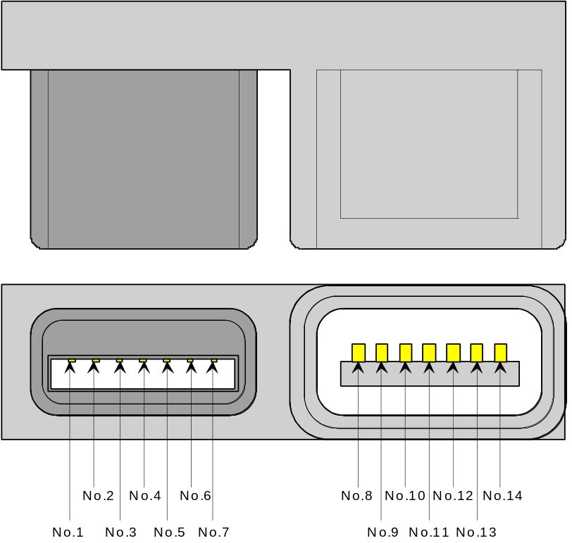
Fig. 8-15 Device side LM-Bus connector

(2) Expansion device side

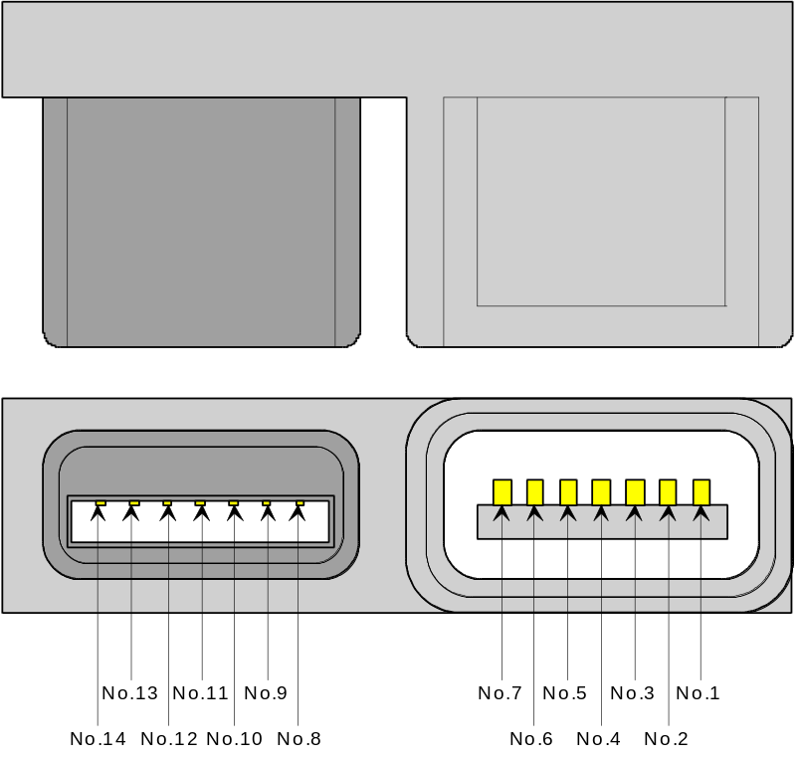
Fig. 8-16 Expansion device side LM-Bus connector

8.3.7 Cable specifications
Number of cores :Four
Conductor cables :Copper-core cables (power source and signal cables)
Quality of materia :0.08 mm/30 lines, thermal-insulation PVC coating, tetron-filled
Winding method :Four lines +inclusive line spiral(VCC, GND, SDCKA, SDCKB, cotton string)
, 35 mm pitch
External material :Thermal-insulation PVC coating
Shield :Included (planned)
Ferrite core :Included (planned)
Bending withstand times :10,000 times minimum (R4, 180°bending, 500 g load)
Twisting withstand times :5,000 times minimum ( 2 m, 180°twisting, 500 g load)

Fig. 8-17 Cable configuration diagram
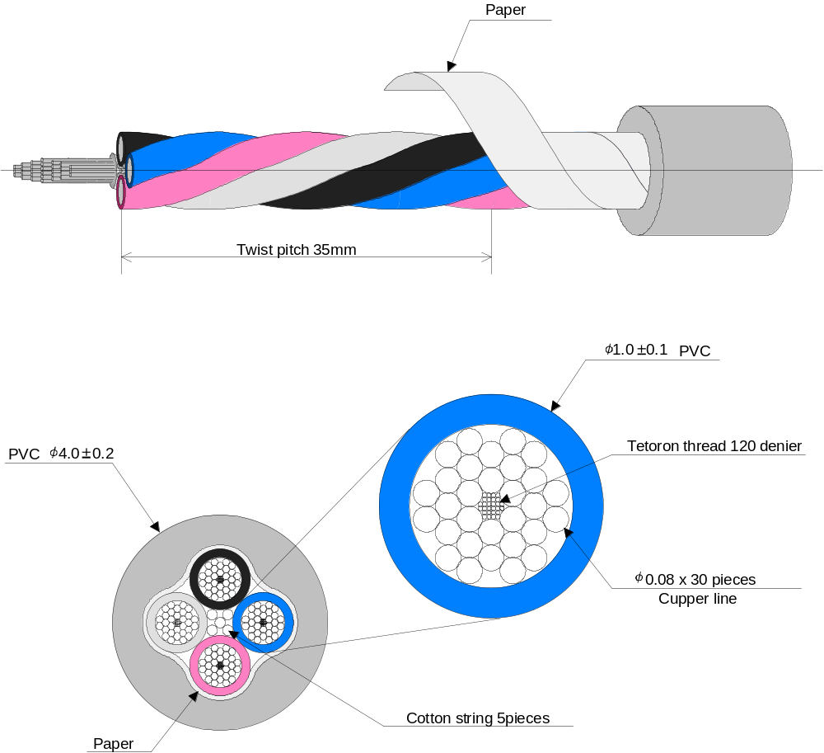Sectional Figure

CHAPTER 9 AFTERWORD

Until the official version (Rev. 1.0) is distributed, contents will be modified to a small or large extent.
There will be no major changes to the protocol.

In Rev. 0.8, the remaining function, "Timer", will be added. Commands will be added accordingly.

