Specifications

Model

GD-ROM Format Specification Details
Ver. 1.32

Model No.

Published: March 17, 1998
Created | Checked | Approved | Sega Enterprises, Ltd.
 |  |  |  Consumer Product Development Headquarters
 |  |  | First Development Group
 |  |  | THIS DOCUMENT MUST NOT BE COPIED IN ANY WAY.
 |  |  | TO BE RETURNED ON DEMAND.

<< Revisions >>

Rev | Change Order No. | Reasons for Revision | Date | No. Pages | Created | Exam | Apprv
C |  | First printing | 4/14/97 |  | Nakayama
E |  | Converted _0d.Doc to Word95 format | 4/23/97 |  | Nakayama
1.00 |  | Inserted "The Relationship between Frames and Sectors" | 5/16/97 |  | Nakayama
1.01 |  | Changed project name from DURAL to GUPPY and multiple revisions to each section | 7/24/97 |  | Nakayama
1.02 |  | Continued volume track numbers | 7/29/97 |  | Nakayama
1.03 |  | Added Highwits and YAMAHA comments | 8/1/97 |  | Nakayama
1.04 |  | Changed Figure 1 to Word format and slightly edited each part | 9/3/97 |  | Nakayama
1.05 |  | Deleted physical format, added absolute time | 10/13/97 |  | Nakayama
1.06 |  | Changed chapter organization | 11/20/97 |  | Nakayama
1.07 |  | Moved volume structure to different chapter | 12/2/97 |  | Nakayama
1.08 |  | Changed single density media information structure  Edited track structure and TOC structure | 1/6/98 |  | Nakayama
1.09 |  | Miscellaneous corrections in each section | 1/9/98 |  | Nakayama
1.10 |  | Instituted GD-ROM Format Specification (Ver. 0.08) for programmers | 2/2/98 |  | Nakayama
1.20 |  | Changed document format according to differences with GD-ROM Format Specification for programmers | 2/18/98 |  | Nakayama
1.20 |  | Changed title, but not version number.  Miscellaneous corrections in each section | 2/23/98 |  | Shoji
1.21 |  | Added 1sec of PostGap to the pattern III in the High-Density Area Track Structure (Figure 3-1) | 6/17/98 |  | Nakayama
1.27 |  | Added max value to both  single/double density area  Deleted 1 sec of PostGap from the  end of Audio in pattern III  Modified max value in high dens area  and gap location  Modified figures 2-1, 3-1, 4-4, 6-2, 6-3 | 7/1/98 |  | Nakayama
1.28 |  | Modified Figure 5-3 | 7/31/98 |  | Nakayama
1.31 |  | Added Figure 2-1  Modified Figure 3-1, 4-1, 5-1, 5-2, 5-3.  Added “note” on Page7  Changed Line3 on Page11  MODE0 -> MODE1 | 11/11/98 |  | Nakayama
1.32 |  | Modified Figure 2-1  Max/03:59:74 -> C2:29:11  Modified Figure 4-1 | 3/17/99 |  | Nakayama

Contents

1. Overview 4
2. GD-ROM Physical Layout Specification 5
3. Single-Density Area Format 6
3.1 Single-Density Area Track Structure 6
4. High-Density Area Format 7
4.1 High-Density Area Track Structure 7
5. Lead-In Area (TOC 1) 8
6. Sector Structure 11
6.1 Sectors 11
6.2 Frame/Sector Relationship 12
7. Subcode Information 14
7.1 Subcode Data Structures 14

Figure 2-1: Physical Layout Specification 5
Figure 3-1: Single-Density Area Track Structure 6
Figure 4-1: High-Density Area Track Structure 7
Figure 5-1: Subcode Q Channel 8
Figure 5-2: TOC 1 Values 8
Figure 5-3: Examples of Lead_In 1 TOC 10
Figure 6-1: CD-Audio Frame Format 11
Figure 6-2: CD-ROM Sector Format 11
Figure 6-3: Frame/Sector Relationship 13
Figure 7-1: P Channel Information 14
Figure 7-2: Q Channel Information (TOC) 14
Figure 7-3: Q Channel Information (Ex.) 14
Figure 7-4: R/W Channel Information 14

Overview

This document supplements the GD-ROM format specifications with information particular to hardware engineering.
The specifications include proprietary technological intellectual property of Sega which must be protected against disclosure to third parties.

GD-ROM Physical Layout Specification

<23.0㎜ |  | A TIme
 |  | 97:30:00 | ×1 Lead in Start
24.80㎜ | Lead-in ×1.0
～25.0㎜ |  | 99:59:74 | ×1 Lead in end
 |  | 00:00:00 | ×1 Program Start
 | Program Area (4min.) ×1.0
 | Area=Normal density
 |  | Max
27.89㎜ |  | 03:59:74 | ×1 Program end
 |  | 04:00:00 | ×1 Lead out Start
 | Lead-out (90 Sec) ×1.0
28.90㎜ |  | 05:29:74 | ×1 Lead out end
 |  | 05:30:00 | mirror #1 Start
 | Mirror #1 (50 um)
28.95㎜ |  | 05:34:40 | mirror #1 end
 |  | 05:34:41 | ×1 Logo Start
 | SEGA Logo ×1.0
30.95㎜ |  | 08:37:65 | ×1 Logo end
 |  | 08:37:66 | mirror #2 Start
 | Mirror #2 (50 um)
31.00㎜ |  | 08:46:52 | mirror #2 end
 |  | F0:00:00 | ×1.8 Lead in Start
 | Lead-in (0.5mm) ×1.8
31.50㎜ |  | F1:28:74 | ×1.8 Lead in end
 |  | 10:00:00 | ×1.8 Program Start
 | Program Area ( >1GB) ×1.8
 | Area=High density
min.: HEX BCD00～C8、F0，F1
Sec.: BCD BCD00～59
Fｒame: BCD BCD00～74
 |  | Max
58.00㎜ |  | C2:29:11 | ×1.8 Program end | (max value for write physically)
 |  | C2:29:12 | ×1.8 Lead out Start
 | Lead out ×1.8
59.00㎜ |  | C8:02:07 | ×1.8 Lead out end
Figure 2-1: Physical Layout Specification

Single-Density Area Format

3.1 Single-Density Area Track Structure

 | Single-Density Area
 | Lead_In 0 |  | Single-Density Program Area  Max 18000 Sectors  (Max. capacity: 36000 KB, 4 minutes) |  |  |  |  |  |  |  |  |  |  |  |  |  | Lead_Out 0
 | Data |  | Data (≧4sec) |  |  |  |  |  |  |  | Audio (≧4sec) |  |  |  |  |  | Audio
TNO | 00 |  | 01 |  |  |  |  |  |  |  | 02 |  |  |  |  |  | AA
Index  00:00:00  00:02:00  000000H  000096H  97:30:00  99:59:74  05:29:74  60ADH  Max 00464FH 00464FH  Max 03:59:74 03:59:74  2Sec  >2Sec  >2Sec  2Sec |  |  | 00 |  | 01 |  |  |  |  |  | 00 |  | 01 |  |  |  | 01
 |  |  |  |  |  | ←Pause Post Gap→ |  |  |  |  |  |  |  | ←Pause Silence→
Absolute
Time
FAD

Figure 3-1: Single-Density Area Track Structure

High-Density Area Format

4.1 High-Density Area Track Structure

2Sec  2Sec  >2Sec  >2Sec  2Sec  1Sec  2Sec  2Sec  10:00:00  10:02:00  00AFC8H  Max 0861B3H  00B05EH  Max C2:03:74  >2Sec  >2Sec  2Sec  2Sec  >2Sec |  |  | High-Density Area
 |  |  | Lead_In 1 | High-Density Program Area  Max 504300 Sectors  (Max. capacity: 1,008,600 KB, 112 minutes 4 seconds) |  |  |  |  |  |  |  |  |  | Lead_Out 1
Pattern I |  |  | Data | Data (≧4sec,≦112min +2sec) |  |  |  |  |  |  |  |  |  | Data
 |  | TNO | 00 | 03 |  |  |  |  |  |  |  |  |  | AA
 |  | Index |  | 00 | 01 |  |  |  |  |  |  |  |  | 01
(≧4sec) |  |  |  |  | ←Pause Post Gap→
 |  |  |  | (≧4sec)
Pattern II |  |  | Data | Data |  |  | Audio |  | Audio (≧4sec) |  |  |  |  | Audio
 |  | TNO | 00 | 03 |  |  | 04 |  | Max 99 |  |  |  |  | AA
 |  | Index |  | 00 | 01 |  | 00 | 01 | 00 |  | 01 |  |  | 01
(≧4sec) |  |  |  |  |  |  |  | ←Pause |  |  | ←Pause Silence→
 |  |  |  |  |  |  | (≧4sec)
Pattern III |  |  | Data | Data |  |  | Audio |  | Data (≧4sec) |  |  |  |  | Data
 |  | TNO | 00 | 03 |  |  | 04 |  | Max 99 |  |  |  |  | AA
 |  | Index |  | 00 | 01 |  | 00 | 01 | 00 | 00 |  | 01 |  | 01
PreGap↑ ↑Pause |  |  |  |  |  |  |  | ←Pause |  |  |  | Post Gap→
 |  | Absolute Time
 | FAD

Figure 4-1: High-Density Area Track Structure

Note: Max value for the real data in High-Density Area is defined as 112min 00sec 00. Therefore, max value for absolute time within High-Density program area is C2:03:74 (122 min 03 sec 74).

Lead-In Area (TOC 1)

The TOC (Table of Contents) consists of pointers to the recording locations in the Lead In Area's Subcode Q channel on the disc, following the Red Book standard.
The TOC DATA here describes TOC1 (Table of Contents 1) in the Lead-In Area (Lead_In 1) in the High-Density Area.
In TOC1, the same subcode block is repeated three times within the Lead-In 1 Area.
It does not support Mode2 format, so the PSec value of Point=A0 is 00.
The ZERO field member of the High-Density Area is 00h.

Q Channel | S0 | S1 | Control | ADR (address) | TNO (track no.) | Point | Time |  |  | Zero | PTime |  |  | CRC
 |  |  |  |  |  |  | Min | Sec | Frame | Zero | PMin | PSec | PFrame | CRC
bit | 1 | 1 | 4 | 4 | 8 | 8 | 8 | 8 | 8 | 8 | 8 | 8 | 8 | 16
Figure 5-1: Subcode Q Channel

 | Control/  ADR |  | TNO | Point |  | Min | Sec | Frame | Zero |  | PMin | PSec |  | PFrame
 | *1 | 1 | 00 | 03 to 99 |  | "Min, Sec, Frame" indicates the disc's absolute time. |  |  | 00 |  | Track starting frame address (BCD value) indicated by the Point value
 | *1 | 1 | 00 | A0 |  |  |  |  | 00 |  | Starting track number (BCD value 03 to 99) |  | 00 |  | 00
 | *1 | 1 | 00 | A1 |  |  |  |  | 00 |  | Last track number (BCD value 03 to 99) |  | 00 |  | 00
 | *1 | 1 | 00 | A2 |  |  |  |  | 00 |  | Lead_out 2 starting frame address (BCD value)
※1 Control |  |  |  |  | Description
MSB→00x0←LSB |  |  |  |  | 2 audio without pre-emphasis
00x1 |  |  |  |  | 2 audio with pre-emphasis
01x0 |  |  |  |  | data track
0x0x |  |  |  |  | digital copy prohibited
0x10 |  |  |  |  | digital copy permitted

Figure 5-2: TOC 1 Values

The "PMin, PSec, PFrame" values as they change with the "Point" value are shown below.
ADR＝1 (Mode1)
Point=03～99 The "PMin, PSec, PFrame" values give the start position of the track indicated by "Pointer".
Point=A0 "PMin" indicates the program area's first record track number value, 03.
"PSec" indicates 00 as the disc type is Mode1 and GD_DA.
"PFrame" indicates 00.
Point=A1 "PMin" indicates the program area's last record track number value.
"PSec, PFrame" indicate 00.
Point=A2 "PSec, PSrame, PFrame" indicate the Lead Out Area's start position.

Examples of the TOC in "Lead In 1" of the High-Density Area, with Pattern III track structure, are shown below.

Frame | CTL&  ADR | TNO | Point | M:S:F | Zero | PM:PS:PF
: | : | : | : | : | : | :
n+0  n+1  n+2 | 01  01  01 | 00  00  00 | A0  A0  A0 | F0:59:69  F0:59:70  F0:59:71 | 00  00  00 | 03:00:00  03:00:00  03:00:00
n+3  n+4  n+5 | 01  01  01 | 00  00  00 | A1  A1  A1 | F0:59:72  F0:59:73  F0:59:74 | 00  00  00 | 05:00:00  05:00:00  05:00:00
n+6  n+7  n+8 | 01  01  01 | 00  00  00 | A2  A2  A2 | F1:00:00  F1:00:01  F1:00:02 | 00  00  00 | C0:29:12  C0:29:12  C0:29:12
n+9  n+10  n+11 | 41  41  41 | 00  00  00 | 03  03  03 | F1:00:03  F1:00:04  F1:00:05 | 00  00  00 | 10:02:00  10:02:00  10:02:00
n+12  n+13  n+14 | 01  01  01 | 00  00  00 | 04  04  04 | F1:00:06  F1:00:07  F1:00:08 | 00  00  00 | 20:02:00  20:02:00  20:02:00
n+15  n+16  n+17 | 01  01  01 | 00  00  00 | 05  05  05 | F1:00:09  F1:00:10  F1:00:11 | 00  00  00 | A0:02:70  A0:02:70  A0:02:70
:  :  : | 01  01  01 | 00  00  00 | A0  A0  A0 | F1:00:12  F1:00:13  F1:00:14 | 00  00  00 | 03:00:00  03:00:00  03:00:00
: | : | : | : | : | : | :

Frame | CTL&  ADR | TNO | Point | M:S:F | Zero | PM:PS:PF |  | Lead_in 1
 |  |  |  |  |  |  |  | Pre Gap Time
n+0 | 01 | 00 | A0 |  | 00 | 03:00:00 | 10:02:00 | MODE1 03
n+3 | 01 | 00 | A1 |  | 00 | 05:00:00
n+6 | 01 | 00 | A2 | Absolute | 00 | C0:29:12 | 20:02:00 | GD-DA 04
n+9 | 41 | 00 | 03 | Time | 00 | 10:02:00
n+12 | 01 | 00 | 04 |  | 00 | 20:02:00 | A0:02:70 | MODE1 05
n+15 | 41 | 00 | 05 |  | 00 | A0:02:70
: | : | : | : | : | : | : | C0:29:12 | Lead_out 1

Figure 5-3: Examples of Lead_In 1 TOC

Sector Structure

6.1 Sectors
The GD-ROM sector structure complies with the Red Book and Yellow Book standards. The CD Audio sector structure is shown in Figure 6-1, and the CD-ROM sector structure is shown in Figure 6-2 below.
The GD-ROM data sector structure uses Mode1 in Figure 6-2, which does not support the MODE 2 data sector structure (XA, etc.).
The header values for Min, Sec, and Frame (sector, block) shown in Figure 6-1 are each two-digit BCD (4-bit base 10) displays. However, since the largest possible BCD Min value would be 99, in the high-density format area, the 10’s digit of minutes must be displayed in hexadecimal, and the maximum measurement is extended to F9 Min 59 Sec 74 Sectors (160 minutes).

Frame Format of CD-DA Audio
1 Sector, 98 Frames (2352 Bytes)
bits
16
16
L0 | R0 | L1 | R1 | ~~~ | L  587 | R  587

Figure 6-1: CD-Audio Frame Format

Sector Format of CD-ROM (MODE1)
1 Sector, 98 Frames (2352 Bytes)

MODE1 | Sync signal | Header (4) |  |  |  | User data | EDC | SPACE | ECC
MODE1 | [12] | Min  [1] | Sec  [1] | Frame  [1] | Mode  [1]=1 | DATA  [2048] | [4] | - 00 -  [8] | P Parity  [172] | Q Parity  [104]

MODE2  FORM1 | Sync signal | Header (4) |  |  |  | Subheader |  | User data |  | EDC |  | ECC
MODE2  FORM1 | [12] | Min  [1] | Sec  [1] | Frame  [1] | Mode  [1]=2 |  | [8] |  | DATA  [2048] |  | [4] |  | P Parity  [172] | Q Parity  [104]

MODE2  FORM2 | Sync signal | Header (4) |  |  |  | Subheader |  | User data |  | EDC
MODE2  FORM2 | [12] | Min  [1] | Sec  [1] | Frame  [1] | Mode  [1]=2 |  | [8] |  | DATA  [2324] |  | [4]
Figure 6-2: CD-ROM Sector Format

Data Sector Structure

MODE1: This mode consists of 2048-byte User Data a 4-byte error detection flag area and a 276-byte error correction area for flag error control.

MODE2: This mode consists of FORM1 for code data and FORM2 for voice and images. In Mode2, the SPACE area (8 bits) of Mode1 serves as a subheader between the Header and User data. Because FORM2 does not require strict additional error correction, the 276-byte ECC area, which uses P/Q parity in FORM1, is instead allocated to the 2324-byte User data area.

6.2 Frame/Sector Relationship

Each frame consists of 24 symbols, with a symbol being 8 data bits (1 byte). Interleaving is applied to this data to make an [F1] frame. Therefore, an [F1] frame consists of 24 symbols (bytes) or 192 data bits.
The [F1] frame is divided into groups of 12 symbols, and a four-symbol-long flag error correction CIRC (Cross Interleave Reed-Solomon Coding) is appended to each group of 12 symbols. The result is an [F2] frame. So an [F2] frame consists of 32 symbols (bytes) or 256 data bits.
In addition, an 8-bit-long subcode is appended as a control byte to form an [F3] frame. This includes a subcode data CIRC. Therefore, an [F3] frame consists of 33 symbols (bytes), or 264 data bits.
Each symbol of the [F3] frame is modulated using EFM (Eight-to-Fourteen Modulation), and each symbol (that is, 8 data bits) is converted into 14 channel bits. At this time, the arrangment of the [F3] frame is changed, and the final frame is made by adding a margin bit (connection bit), which becomes a 3-channel-bit-long gap, with each symbol having a 4-channel-bit-long synchronous header and control byte. Thus, the frame formed in this way is 588 channel bits long. Each frame created through the above processes has a set time length of 136 µS.
A sector is made by grouping 98 of the [F3] frames described above, so 1 sector consists of 57,624 channel bits or 7,203 bytes. Depending on the development environment, 1 sector may also be called a block.

The above relationships are shown in Figure 6-.

Note: CD Block Access Units are generally as follows:
Frame Address (FAD) ---Units of access counted in sector units immediately after the end of the Lead In 1 area.
Logical Sector No. (LSN) ---Counted in sector units with absolute time 00:02:00 as 0. Also called the Logical Block Number (LBN).
Absolute Time (ATime) ---Counted in units of time from 00:00:00 immediately after the end of the Lead In 1 area.
Frame Addresses (FAD) and Logical Sector Numbers (LSN) are related as follows:
Frame Address (FAD) = 96H + Logical Sector Number (LSN)
Absolute Time (ATime) and Sectors (1 sector = 2048 bytes) are related as follows:
1 second = 75 sectors

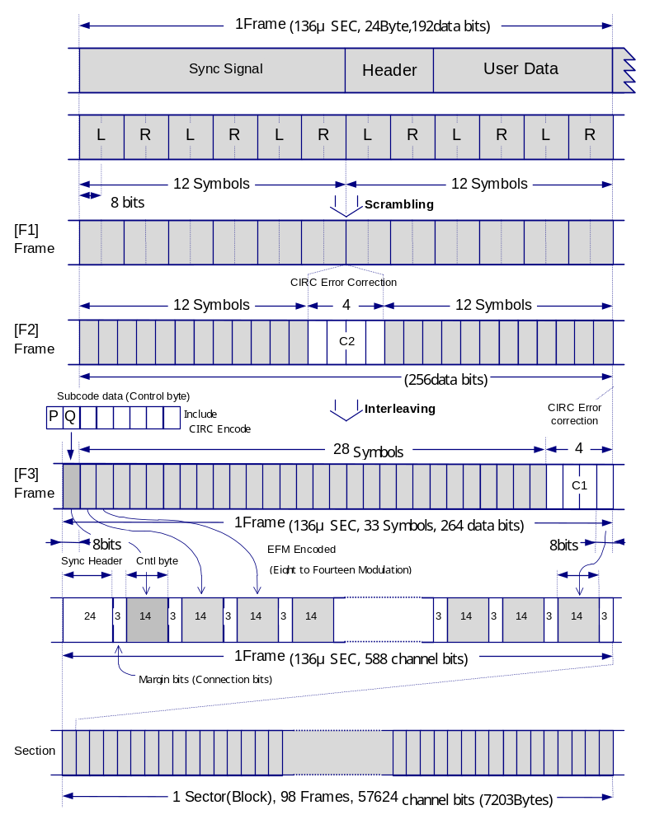

Figure 6-3: Frame/Sector Relationship

Subcode Information

7.1 Subcode Data Structures

P Channel Information

P Channel | S0 | S1 | Music Header Signal  (1-Filled for music separation, or 0-filled for other use)
 | 1 | 1 | 4 | 4 | 8 | 8 | 8 | 8 | 8 | 8 | 8 | 8 | 8 | 16
98 bits (Data in 1 sector)
Figure 7-1: P Channel Information
Q Channel Information (TOC)
Q Data Area
Q Channel | S0 | S1 | Control | Address | 00 | Point | TIME |  |  | - 00 - | PTIME |  |  | CRC
 |  |  |  |  |  |  | Min | Sec | Frame | - 00 - | PMin | PSec | PFrame | CRC
 | 1 | 1 | 4 | 4 | 8 | 8 | 8 | 8 | 8 | 8 | 8 | 8 | 8 | 16
98 bits (Data in 1 sector)
Figure 7-2: Q Channel Information (TOC)
Q Channel Information (Ex.)
Q Data Area
Q Channel | S0 | S1 | Control | Address | Track No. | X | TIME |  |  | - 00 - | ATIME |  |  | CRC
 |  |  |  |  |  |  | Min | Sec | Frame | - 00 - | AMin | ASec | AFrame | CRC
 | 1 | 1 | 4 | 4 | 8 | 8 | 8 | 8 | 8 | 8 | 8 | 8 | 8 | 16
98 bits (Data in 1 sector)
Figure 7-3: Q Channel Information (Ex.)
R/W Channel Information (Ex.)

R/W | S0 | S1 | Command | Instruction | Correction Flags | Address Color | For CD-G, each bit = 1 image data bit  (6 × 12 dots) | Correction Flags | ←  same | ←  same | ←  same
98 bits (Data in 1 sector)  ④  ③  ②  ① (24 Symbols) | 1 | 1 | 1 | 1 | 2 | 4 | 12 | 4 | 24 | 24 | 24

Figure 7-4: R/W Channel Information

